客流高峰预测
根据公交卡刷卡数据预测客流高峰
数据是最近一年的刷卡数据
数据格式如下：
单个数据分析的客流高峰，分周末和非周末
代码：
#FXKH（卡号）,ZKLX（路线）,XLBH（线路编号）,CZJBH（车辆）,YYSJ（刷卡时间）,CHSJ（传回时间）
import pandas as pd
import numpy as np
import seaborn as sns
import matplotlib.pyplot as plt
#读取数据
data = pd.read_csv('./data/201707.csv')
#整体的高峰预测
#时间格式转换object to datetime64[ns]
data['YYSJ']=pd.to_datetime(data['YYSJ'])
#分割日期和时间
data['time'] = data['YYSJ'].dt.time
#按时间段统计,分成24个时间段，若分钟数大于30，则小时按照小时+1统计。
data['time'] = data['time'].apply(lambda x:x.hour+1 if x.hour<23 and x.minute >= 30 else 0 if x.hour==24 else x.hour)
#绘图
sns.set(context="talk",font_scale=2, style='darkgrid')
f, ax= plt.subplots(figsize = (14, 10))
ax.set_title('Passenger Flow Peak Forecast')
sns.countplot(x=data['time'])
plt.show()
f.savefig('P_F_P_F.png', dpi=100, bbox_inches='tight')
#判断否周末
data['weekday_name']=pd.to_datetime(data['YYSJ']).dt.weekday_name
no_weekend_time = data[data['weekday_name']!='Saturday'][data['weekday_name']!='Sunday']['time']
#非周末高峰预测
f, ax= plt.subplots(figsize = (14, 10))
ax.set_title('Passenger Flow Peak Forecast Except Weekend')
sns.countplot(x=no_weekend_time)
plt.show()
f.savefig('P_F_P_F_E_W.png', dpi=100, bbox_inches='tight')
#周末高峰预测
#判断是周末
is_weekend_time = data.loc[~((data.weekday_name != 'Saturday')&(data.weekday_name != 'Sunday')),'time']
#非周末高峰预测
f, ax= plt.subplots(figsize = (14, 10))
ax.set_title('Passenger Flow Peak Forecast on Weekend')
sns.countplot(x=is_weekend_time)
plt.show()
f.savefig('P_F_P_F_W.png', dpi=100, bbox_inches='tight')
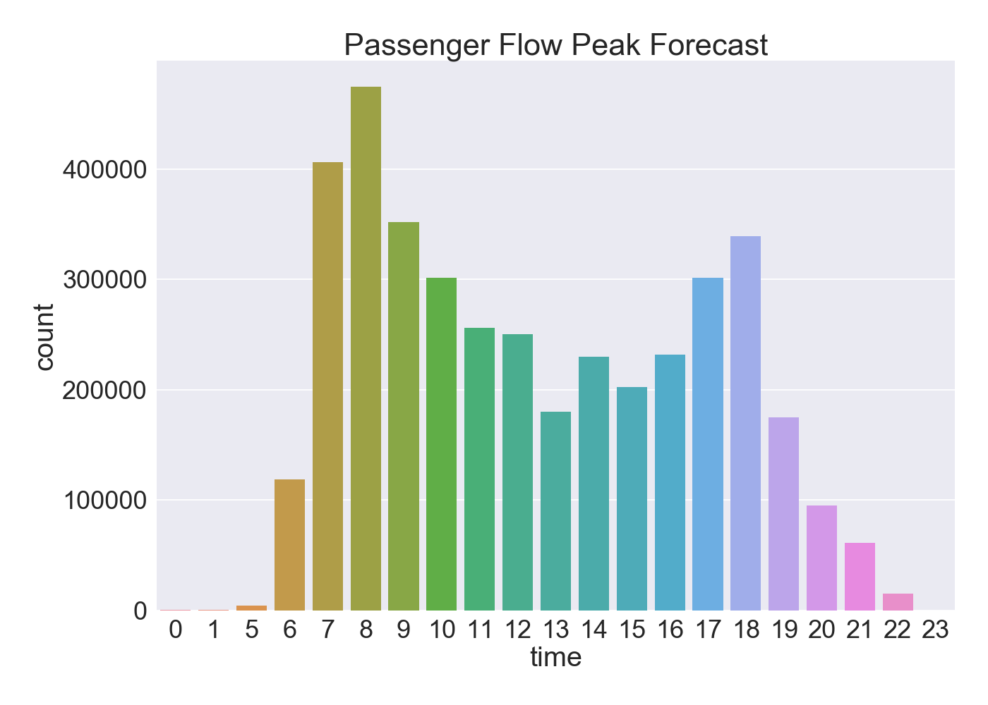
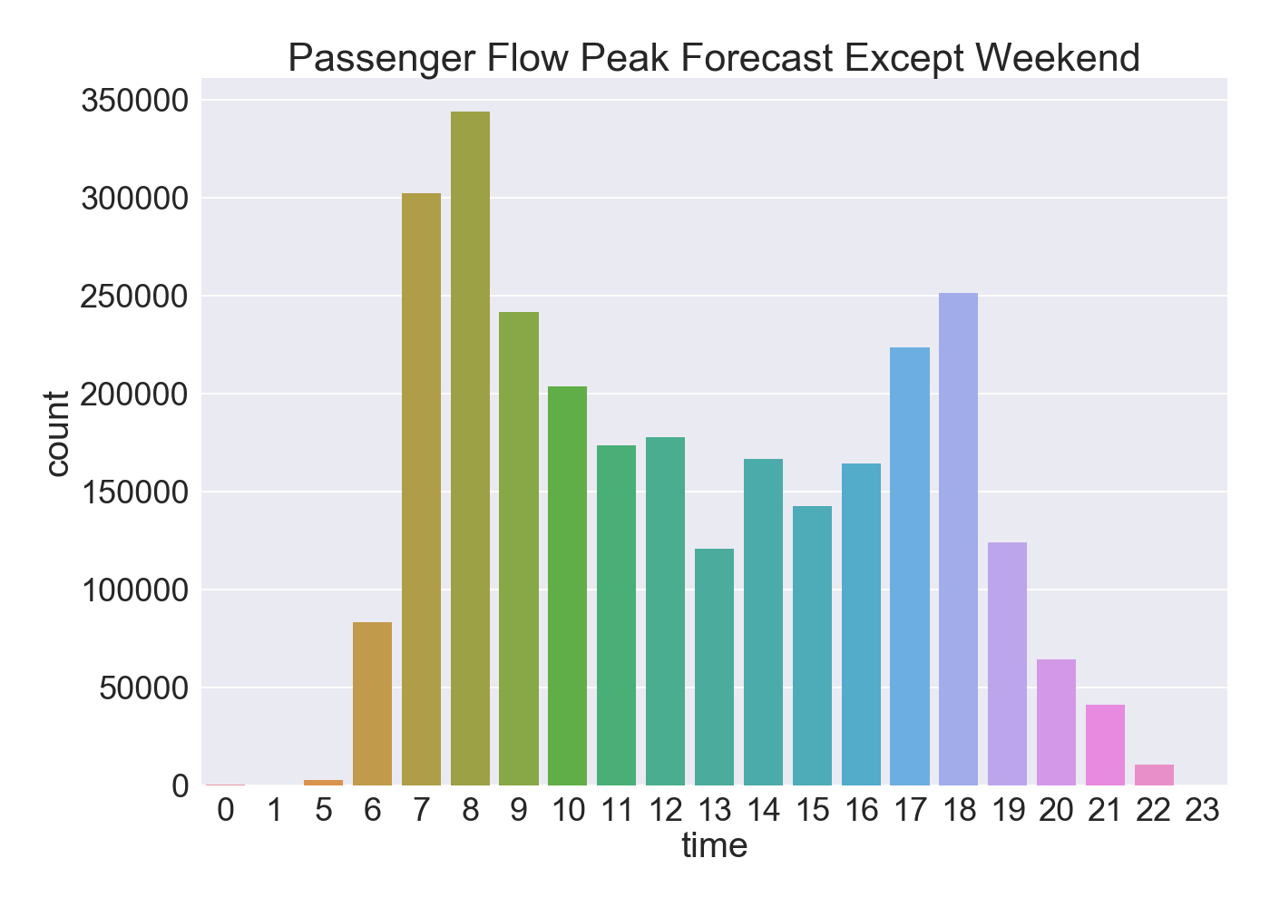
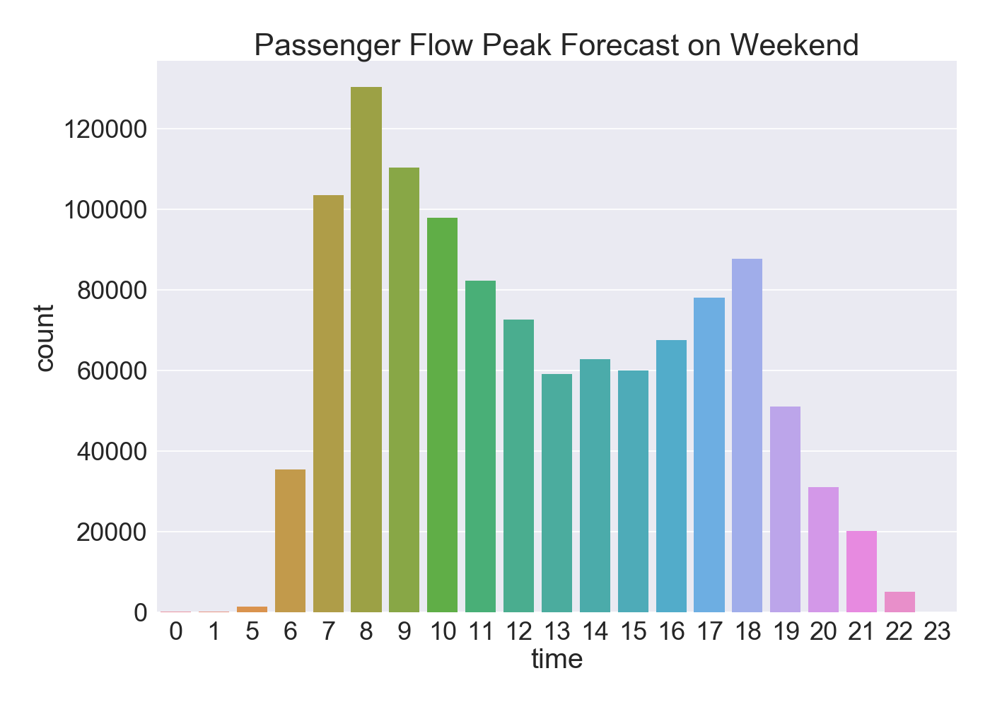
整体数据分析客流高峰，分周末和非周末
代码：

#FXKH（卡号）,ZKLX（路线）,XLBH（线路编号）,CZJBH（车辆）,YYSJ（刷卡时间）,CHSJ（传回时间）
import pandas as pd
import seaborn as sns
import matplotlib.pyplot as plt
import math
file_name_list=['201708.csv','201709.csv','201710.csv','201711.csv','201712.csv','201801.csv','201802.csv','201803.csv','201804.csv','201805.csv','201806.csv']
data = pd.read_csv('./data/201707.csv')
#整体的高峰预测
#时间格式转换object to datetime64[ns]
data['YYSJ']=pd.to_datetime(data['YYSJ'])
#分割日期和时间
data['time'] = data['YYSJ'].dt.time
#按时间段统计,分成24个时间段，若分钟数大于30，则小时按照小时+1统计。
data['time'] = data['time'].apply(lambda x:x.hour+1 if x.hour<23 and x.minute >= 30 else 0 if x.hour==24 else x.hour)
time_counts = data['time'].value_counts()
#判断非周末
data['weekday_name']=pd.to_datetime(data['YYSJ']).dt.weekday_name
no_weekend_time = data[data['weekday_name']!='Saturday'][data['weekday_name']!='Sunday']['time']
no_weekend_counts=no_weekend_time.value_counts()
#判断是周末
is_weekend_time = data.loc[~((data.weekday_name != 'Saturday')&(data.weekday_name != 'Sunday')),'time']
is_weekend_counts = is_weekend_time.value_counts()
for file in file_name_list:
data = pd.read_csv('./data/'+file)
# 整体的高峰预测
# 时间格式转换object to datetime64[ns]
data['YYSJ'] = pd.to_datetime(data['YYSJ'])
# 分割日期和时间
data['time'] = data['YYSJ'].dt.time
# 按时间段统计,分成24个时间段，若分钟数大于30，则小时按照小时+1统计。
data['time'] = data['time'].apply(lambda x: x.hour + 1 if x.hour < 23 and x.minute >= 30 else 0 if x.hour == 24 else x.hour)
time_counts = time_counts.add(data['time'].value_counts())
time_counts = time_counts.apply(lambda x:0 if math.isnan(x) else x)
# 判断非周末
data['weekday_name'] = pd.to_datetime(data['YYSJ']).dt.weekday_name
no_weekend_time = data[data['weekday_name'] != 'Saturday'][data['weekday_name'] != 'Sunday']['time']
no_weekend_counts =no_weekend_counts.add(no_weekend_time.value_counts())
no_weekend_counts = no_weekend_counts.apply(lambda x:0 if math.isnan(x) else x)
# 判断是周末
is_weekend_time = data.loc[~((data.weekday_name != 'Saturday') & (data.weekday_name != 'Sunday')), 'time']
is_weekend_counts = is_weekend_counts.add(is_weekend_time.value_counts())
is_weekend_counts = is_weekend_counts.apply(lambda x: 0 if math.isnan(x) else x)
time_counts = time_counts/(len(file_name_list)+1)
no_weekend_counts=no_weekend_counts/(len(file_name_list)+1)
is_weekend_counts=is_weekend_counts/(len(file_name_list)+1)
#绘图
sns.set(context="talk",font_scale=2, style='darkgrid')
f, ax= plt.subplots(figsize = (14, 10))
ax.set_title('Total Passenger Flow Peak Forecast')
sns.barplot(x=time_counts.index,y=time_counts.values)
plt.show()
f.savefig('T_P_F_P_F.png', dpi=100, bbox_inches='tight')
#非周末高峰预测
f, ax= plt.subplots(figsize = (14, 10))
ax.set_title('Total Passenger Flow Peak Forecast Except Weekend')
sns.barplot(x=no_weekend_counts.index,y=no_weekend_counts.values)
plt.show()
f.savefig('T_P_F_P_F_E_W.png', dpi=100, bbox_inches='tight')
#周末高峰预测
#判断是否周末
is_weekend_time = data.loc[~((data.weekday_name != 'Saturday')&(data.weekday_name != 'Sunday')),'time']
#非周末高峰预测
f, ax= plt.subplots(figsize = (14, 10))
ax.set_title('Total Passenger Flow Peak Forecast on Weekend')
sns.barplot(x=is_weekend_counts.index,y=is_weekend_counts.values)
plt.show()
f.savefig('T_P_F_P_F_W.png', dpi=100, bbox_inches='tight')
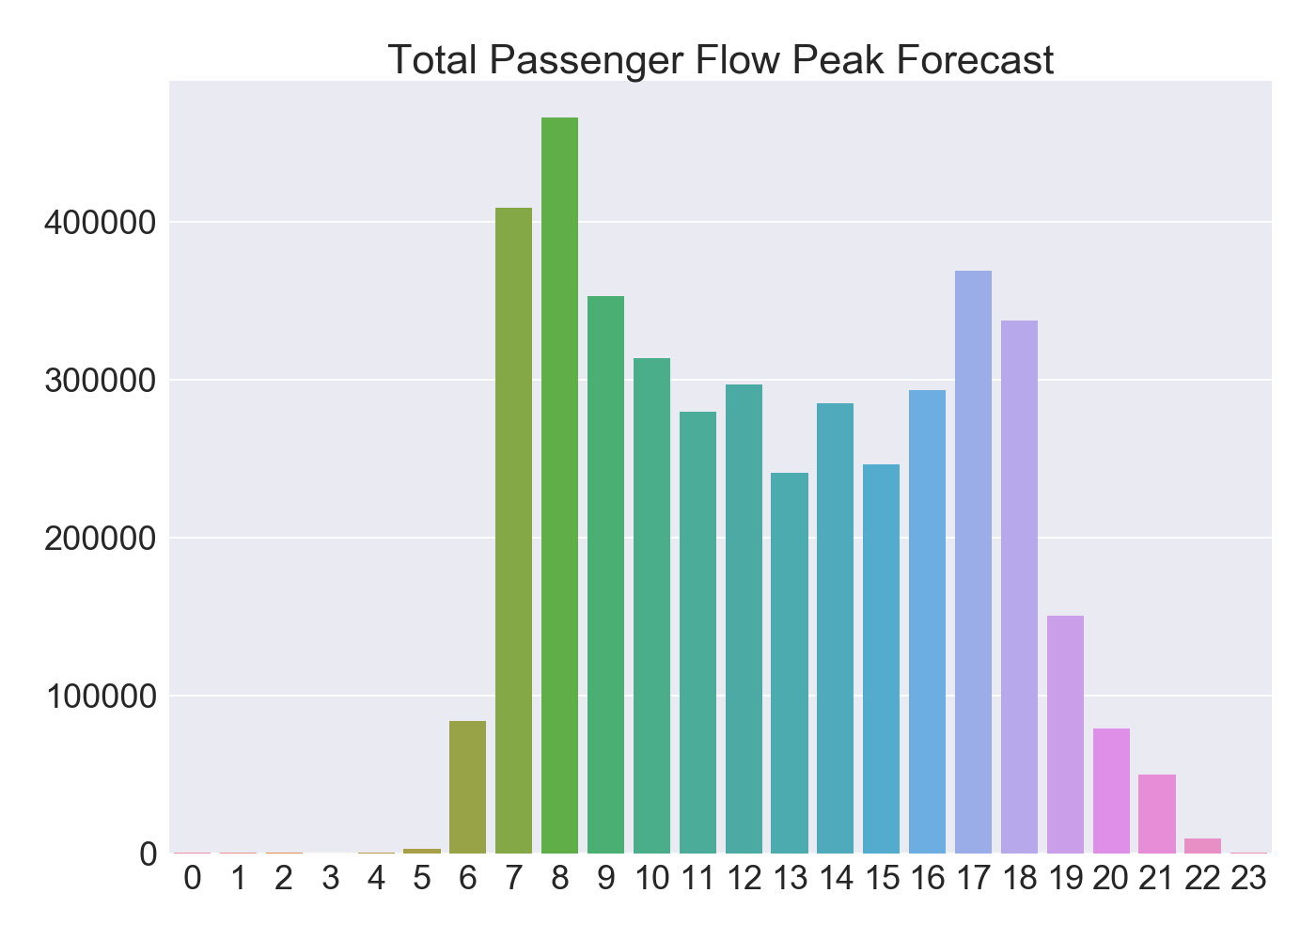
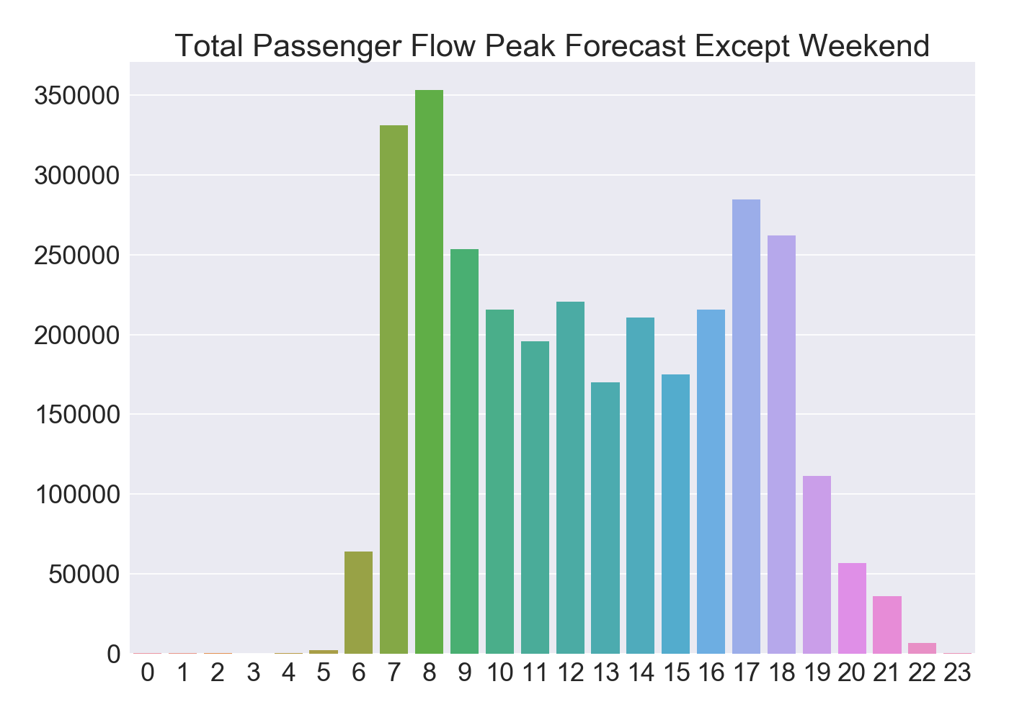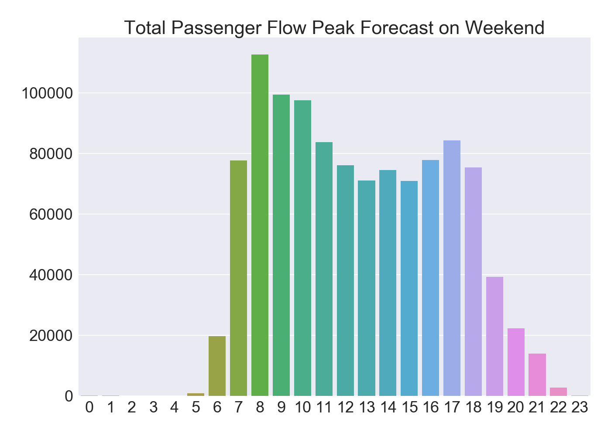
整体数据分析线路和bus载客量
代码：
#FXKH（卡号）,ZKLX（路线）,XLBH（线路编号）,CZJBH（车辆）,YYSJ（刷卡时间）,CHSJ（传回时间）
import pandas as pd
from pandas import DataFrame
import seaborn as sns
import matplotlib.pyplot as plt
import math
file_name_list=['201708.csv','201709.csv','201710.csv','201711.csv','201712.csv','201801.csv','201802.csv','201803.csv','201804.csv','201805.csv','201806.csv']
data = pd.read_csv('./data/201707.csv')
line_passenges_counts = data['XLBH'].value_counts()
bus_passenges_counts = data['CZJBH'].value_counts()
line_passenges_mothly_counts = data['XLBH'].value_counts()
bus_passenges_mothly_counts = data['CZJBH'].value_counts()
for file in file_name_list:
data = pd.read_csv('./data/'+file)
line_passenges_counts = line_passenges_counts.add(data['XLBH'].value_counts())
line_passenges_counts = line_passenges_counts.apply(lambda x:0 if math.isnan(x) else x)
bus_passenges_counts = bus_passenges_counts.add(data['CZJBH'].value_counts())
bus_passenges_counts = bus_passenges_counts.apply(lambda x: 0 if math.isnan(x) else x)
line_passenges_mothly_counts = pd.concat([line_passenges_mothly_counts,data['XLBH'].value_counts()],axis=1)
bus_passenges_mothly_counts=pd.concat([bus_passenges_mothly_counts,data['CZJBH'].value_counts()],axis=1)
line_passenges_counts = line_passenges_counts/(len(file_name_list)+1)
bus_passenges_counts = bus_passenges_counts/(len(file_name_list)+1)
line_passenges_mothly_counts=line_passenges_mothly_counts.fillna(0)
bus_passenges_mothly_counts=bus_passenges_mothly_counts.fillna(0)
#重新命名属性
line_passenges_mothly_counts.columns=['201707','201708','201709','201710','201711','201712','201801','201802','201803','201804','201805','201806']
bus_passenges_mothly_counts.columns=['201707','201708','201709','201710','201711','201712','201801','201802','201803','201804','201805','201806']
#存储线路和车在不同月份的载客量
line_passenges_mothly_counts.to_csv('line_passenges_mothly_counts.csv')
bus_passenges_mothly_counts.to_csv('bus_passenges_mothly_counts.csv')
#绘图
#seaborn如何解决无序柱状图的问题？
line_passenges_counts=line_passenges_counts.sort_values(ascending=False)
x=line_passenges_counts.values
y=line_passenges_counts.index
plot_df=DataFrame({'values':x,'ind':y})
sns.set(context="talk",font_scale=0.8, style='darkgrid')
f, ax= plt.subplots(figsize = (14, 10))
ax.set_title('line Passengers counts')
sns.barplot(plot_df['values'],plot_df['ind'],orient='h',order=plot_df['ind'])
ax.set_ylabel("Line Number",color='r')
ax.set_xlabel('Passengers',color='r')
plt.show()
f.savefig('line_passengers_counts.png', dpi=100, bbox_inches='tight')
f, ax= plt.subplots(figsize = (14, 10))
ax.set_title('bus passenges counts')
plot_df=DataFrame({'values':bus_passenges_counts.sort_values(ascending=False).head(80).values,'ind':bus_passenges_counts.sort_values(ascending=False).head(80).index})
sns.barplot(plot_df['values'],plot_df['ind'],orient='h',order=plot_df['ind'])
ax.set_ylabel("Bus Number",color='r')
ax.set_xlabel('Passengers',color='r')
plt.show()
f.savefig('bus_passengers_counts.png', dpi=100, bbox_inches='tight')

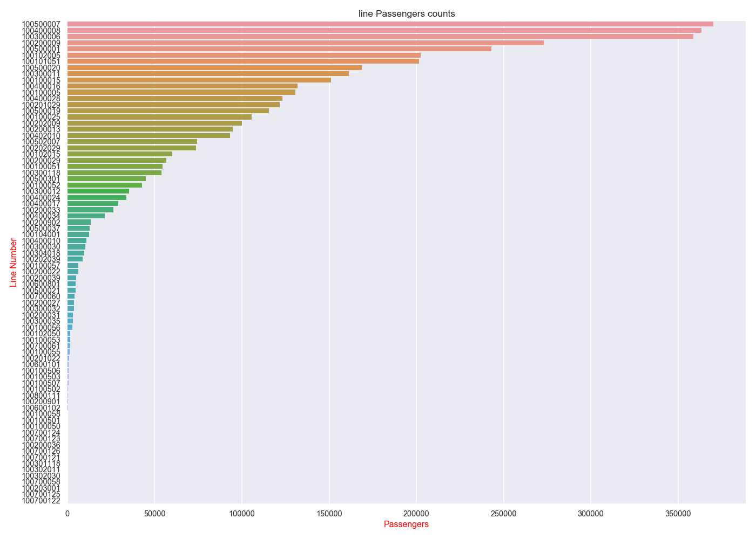
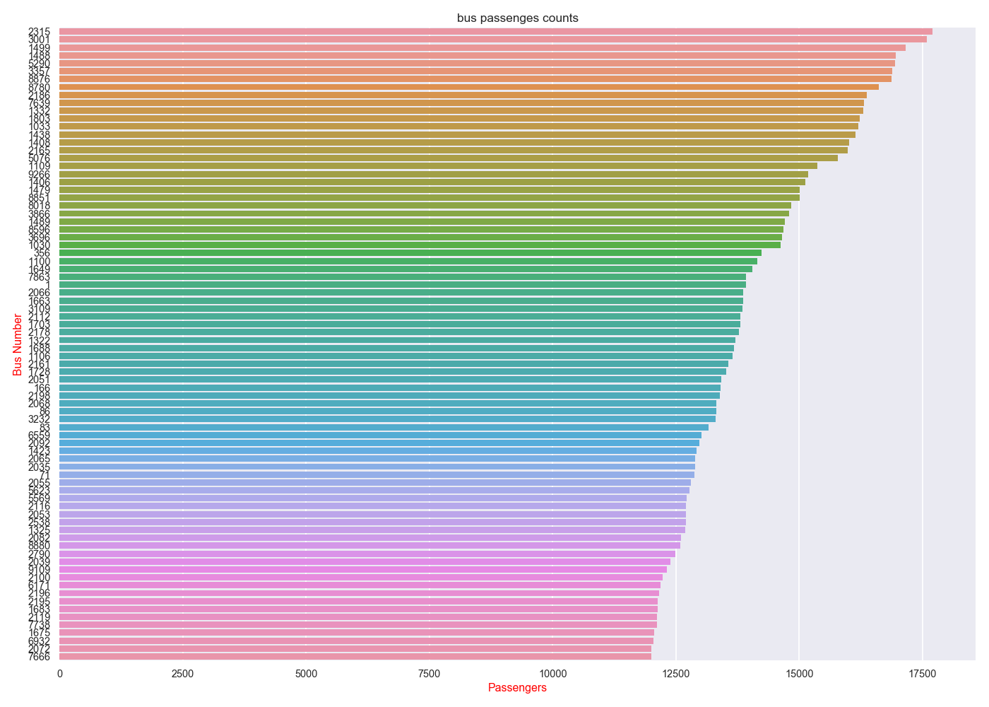
如何解决seaborn 在画barplot的时候柱状图无序显示：
Series是有序的（value_counts），尽管使用order参数，柱状图依旧是无序显示。将Series排序之后的index和value包装成DataFrame，利用DataFrame画bar，也使用order参数，柱状图实现有序展示。具体见代码。

