**ECGas: Point of Sales and Inventory Monitoring and Management**

Table of Contents

**I.****System Requirements and Information** 3

**a.** **System Requirements** 3

**b.** **System Information** 3

**II.** **Documentation and User Guide** 4

**a.** **Application Access** 4

**b.** **Login** 4

**c.** **Dashboard** 6

• **Application Side Navigation** 6

• **Application Top Navigation** 7

**d.** **Point of Sale** 8

• **Adding of Transaction in the POS** 8

• **Transaction Payment** 9

**e.** **Product Monitoring and Management pages** 10

• **Product Monitoring and Management page** 10

• **Inventory Monitoring and Management page** 13

**f.** **Client Monitoring and Management** 14

• **Product Alert Settings button** 15

• **Add Client button** 15

• **Client Details page** 16

**g.** **Records Monitoring and Management** 17

• **Sales Monitoring and Management page** 17

• **Expenses Monitoring page** 20

• **Returns/Refunds Monitoring page** 21

• **Issue Monitoring page** 22

**h.** **Settings** 23

**i.** **Users** 24

• **Add User** 24

• **User Details page** 25

**j.** **Dashboard Reports** 26

• **Simple Financial Reports** 26

• **Sales Count Overview and Sales Chart** 27

• **Client and Product Simple Report** 27

• **Latest Issues** 28

• **Low Inventory Products** 28

• **Possible Product Orders** 28

**k.** **Pointers, Reminders, and Additional Information** 29

1. **System Requirements and Information**
   1. **System Requirements**
      1. **Operating System:**
         * Windows 7
         * Windows 8.1
         * Windows 10
      2. **CPU/Processor:**
         * Intel Core i3
         * i5
         * i7
         * AMD equivalent is highly required
      3. **RAM/MEMORY:**
         * At least 4GB or higher
      4. **HDD:** 
         * At least 1 terabyte of memory or higher
      5. **Browser:**
         * Mozilla Firefox
         * Google Chrome
   2. **System Information**

Listed in this part are the Tools and Technologies that were used in the application development.

* + 1. **Languages, Frameworks, and Plugins**
       - Server-Side
         1. PHP 7.3.1
         2. CodeIgniter 3
       - Database
         1. MySql 5.7.24
       - Front-end
         1. JavaScript
         2. jQuery Framework

AJAX

DataTables plugin

* + - * 1. HTML5
        2. CSS3

Bootstrap 4.3

* + 1. **Server**
       - WAMPSERVER 3.1.7
       - APACHE 2.4.37
    2. **Database Management**
       - PhpMyAdmin
    3. **Text Editors** 
       - Sublime Txt 3
    4. **Browser**
       - Mozilla Firefox
       - Google Chrome

1. **Documentation and User Guide**
   1. **Application Access**

Access the application by typing the URL shown below in your browser. After typing the URL and pressing enter, you will be directed to the applications login page.

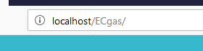

* 1. **Login**

This is the login page of the application which appears when you visit the application URL. Features of the application can only be accessed and used after a successful login.

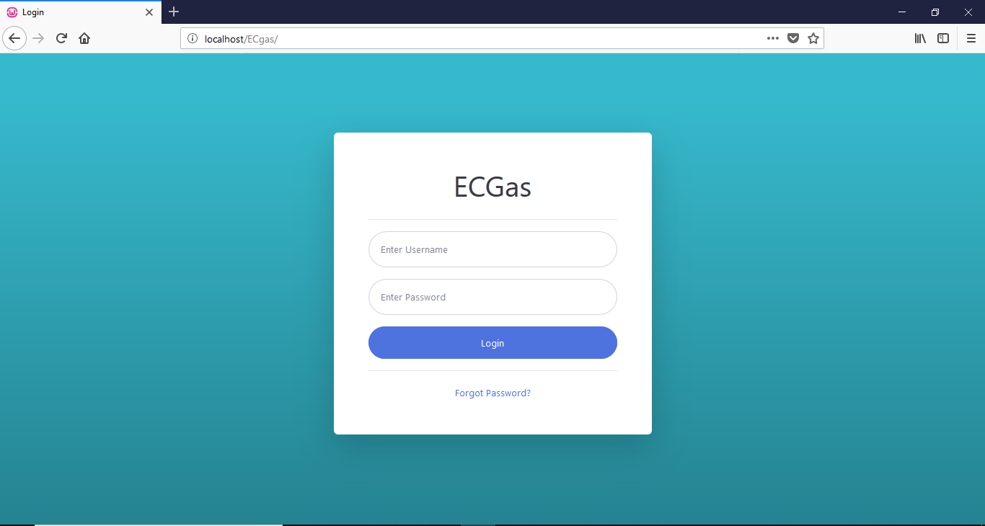

Type in your username and password in space provided then click on the login button. Unsuccessful login will result to an error message shown in the figure bellow.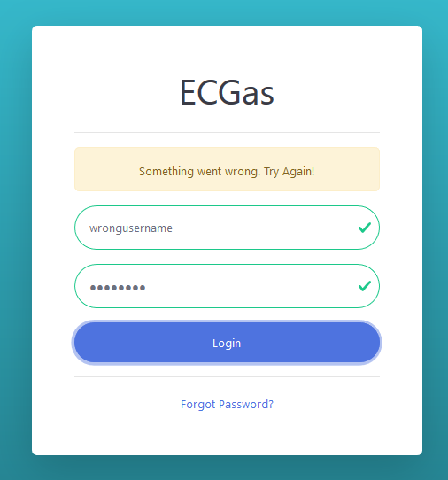



Clicking on Forgot Password will show the message bellow. An admin is able to make changes to a user’s details including the password. If a password is forgotten, talk to the system admin to change the password so a user can access his/her account again.

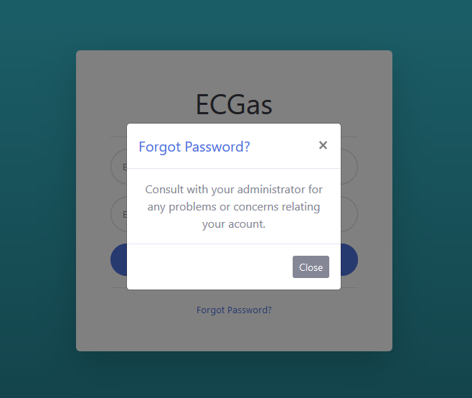

* 1. **Dashboard**

Upon successful login, you will be directed to the application dashboard. Refer to the screen shot bellow.

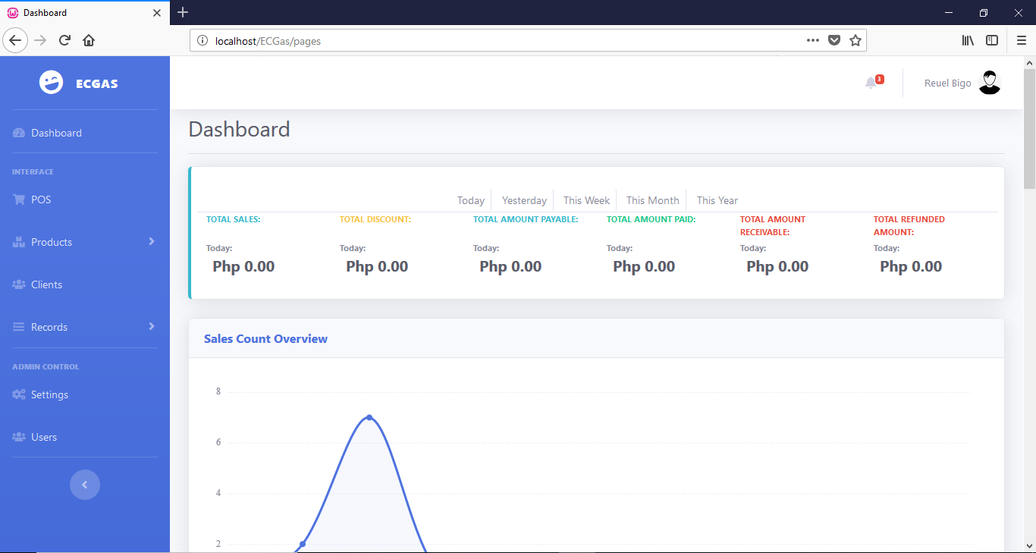

* **Application Side Navigation**

The application has two version of its side navigation, the normal and collapsed versions. The collapsed version compresses the navigation providing more space for the actual content. The Settings and Users menu items is only available to admin users and will not appear for employees.

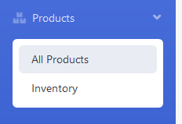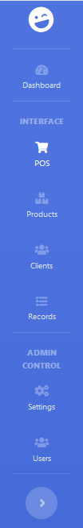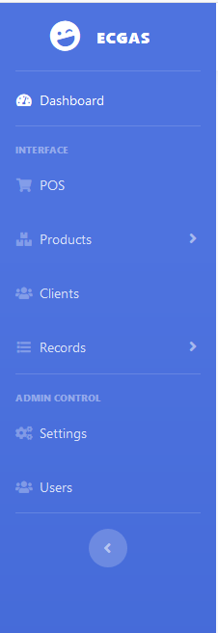

Normal

Normal

Collapsed

Collapsed

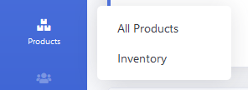

The **Products and Records** menu items have their own submenu. The submenu will show when the products or records menu item is selected or clicked. These submenu items will lead to different pages with their own use and contents.

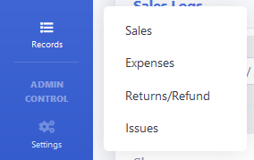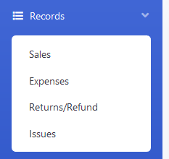

Collapsed

Normal

Click this button to collapse or return the side navigation to normal.

* **Application Top Navigation**

The top navigation contains two items, namely the alerts and user menu items. The alerts menu item has a collapsible body which shows the number of possible orders and the number of products with low inventory count. The user menu item has a submenu which allows the user to view his/her profile and to logout from the application.



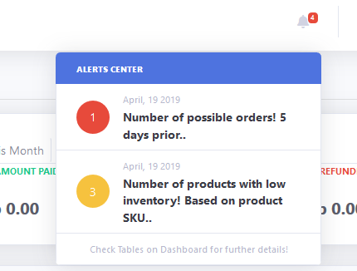

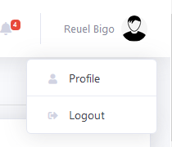

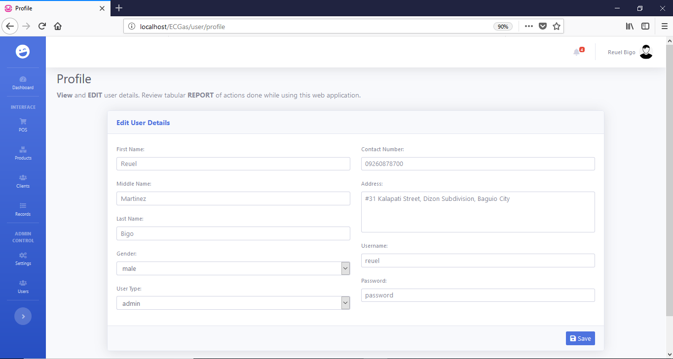

The user profile contains information’s about the user.

The save button allows for the editing of user information but is only available to admin users.

A modal view will appear when the logout button is selected or clicked in the user submenu. It is a user prompt asking the user if he/she is ready to logout of the application.

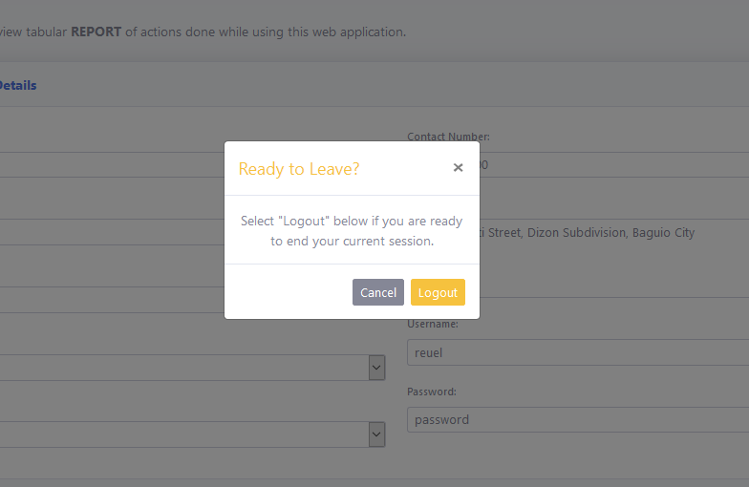

Clicking on this logout button will redirect the user to the login page successfully logging out the user from his/her current session.

1. **Point of Sale**

Entry of sales information is done using the Point of Sale. A user of the application will be able to add or remove products from a transaction, update product quantity per transaction, add or update costumer discount, select a customer, select payment method, and input the amount tendered. Payment is optional or partial for each transaction and will be recorded as credit in the sales records.

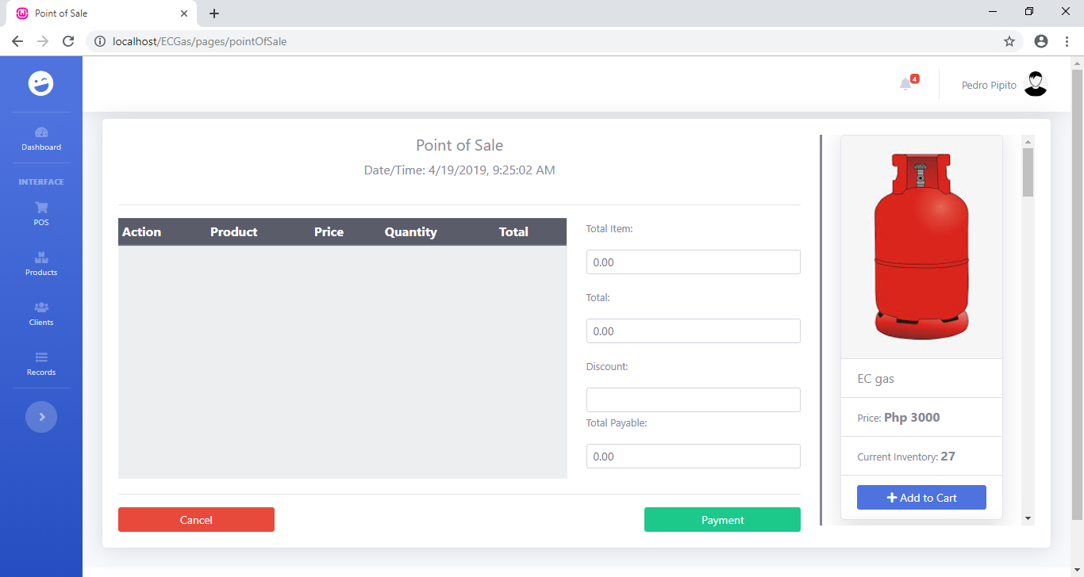

* **Adding of Transaction in the POS**

**2nd Step:** Check products for the transaction. Add quantity for the product by clicking on the up-arrow button, decrees quantity by clicking on the down-arrow button, and remove product from list by clicking the trash button.

**1st Step:** Select the product to add by clicking on the **Add to Cart** button in the product selection view, which is located in the left side of the screen.

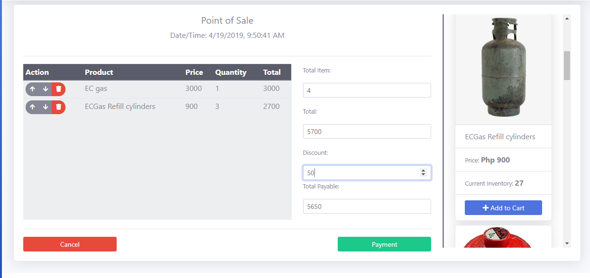

Alert: Cancel button will refresh the page resetting or removing transaction data.

**4th Step:** If products are all checked and discount amount is right. Click on payment button to proceed with the transaction.

**3rd Step:** Update transaction discount by placing the amount on the Discount input field.

* **Transaction Payment**

Clicking the payment button will show the payment modal which allows the user to select a customer, select a payment method and input the amount tendered.

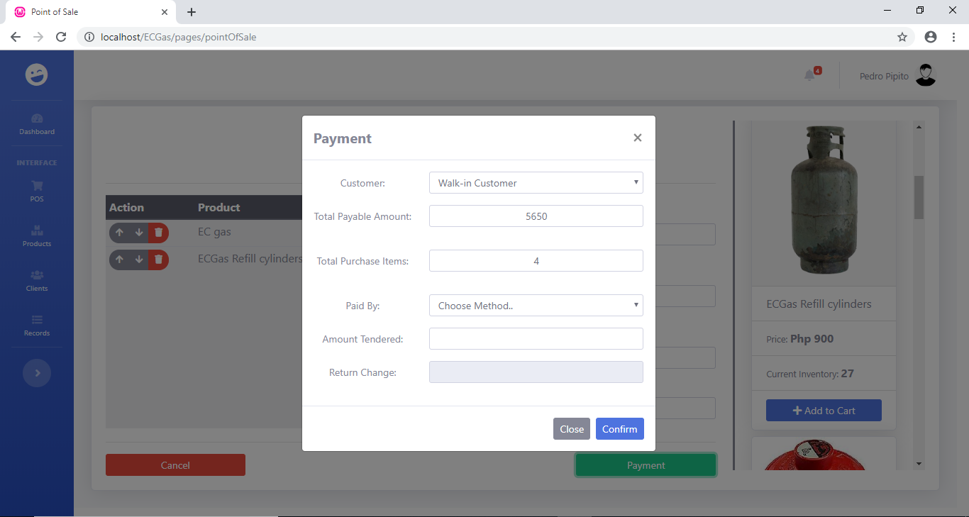

**2nd Step:** Select payment method of the transaction. This can be left blank by the user.

**1st Step:** Select the customer of the transaction. It can be left with its default value which is “Walk-in Customer”.

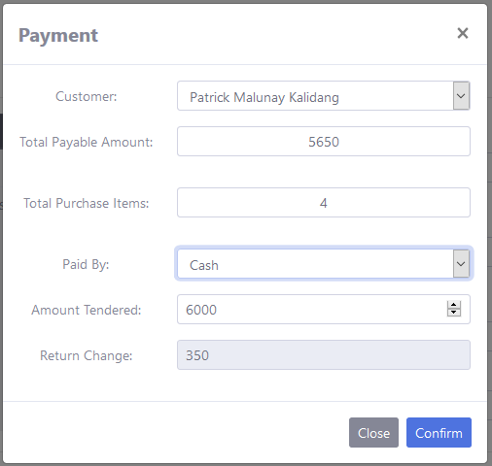

**4th Step:** Select or click on the confirm button to finish the transaction. The page will refresh after recording the sale/transaction details.

**3rd Step:** Enter the amount given by the customer in the amount tendered input field. The amount will be taken to calculate the return change for the customer. It may also be left blank for transactions on credit.

1. **Product Monitoring and Management pages**

Product Monitoring and management consist of Two (2) pages namely the Product Monitoring and Management page and Inventory Monitoring and Management page.

* **Product Monitoring and Management page**

The product monitoring and management page is accessible by clicking on the **All Products** link located in the Products menu item submenu. This page shows the total number of products in our record, the recently added product to our record, number of active products, and the number of inactive products. This page also shows a list of our products, dividing the active and inactive products in two separate tables. Each product/row on our tables will have three (3) action buttons located in the **Action** column. These action buttons are the **View Product Details button**, **Deactivate or Activate button**, and the **Delete Product button.** These buttons do exactly what is described by their names. The deactivate or activate button and delete product button are only visible or usable by an admin user. Lastly, this page enables the admin to add new product to our record. An admin will click on the **Add Product link** located in the upper left part of the page and will be redirected to a new page where the adding of product will happen.

Monitoring reports for this page.

**Add Product** linkavailable for the admin.

**All Products** link of the products submenu.

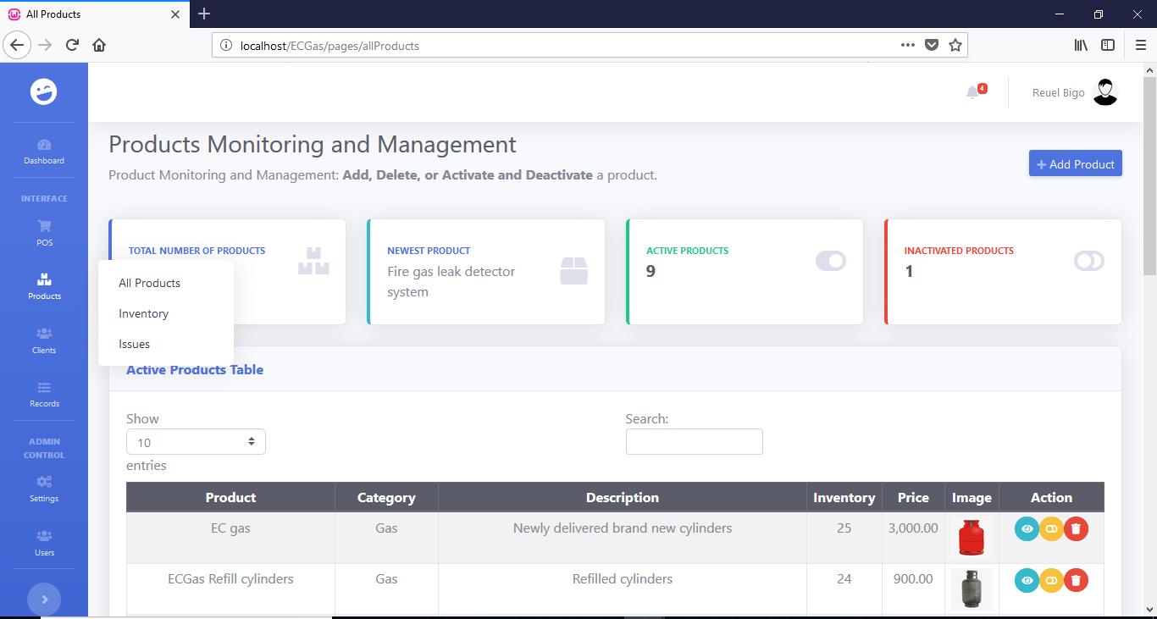

**Action Buttons**

* + **Activate/Deactivate button**

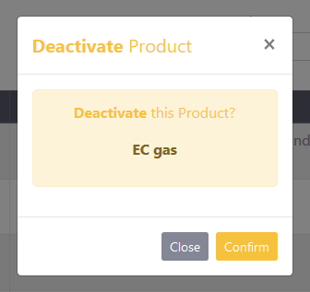 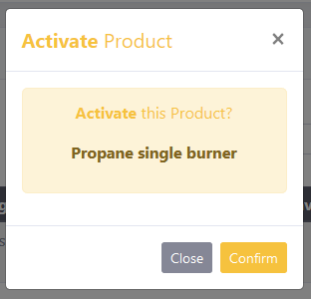

After clicking on the activate/deactivate button, a modal will appear with a prompt for the user to verify the action. Click on the confirm button to proceed with the activation or deactivation of a product.

* + **View Product Details button**

Clicking on the View Product Details button will direct the user to the Product Details page. The Product Details page shows the details of a product and allows an admin to update the product details and to Delete the product from the products record.

Click on this link to go back to the **Product Monitoring and Management** page.

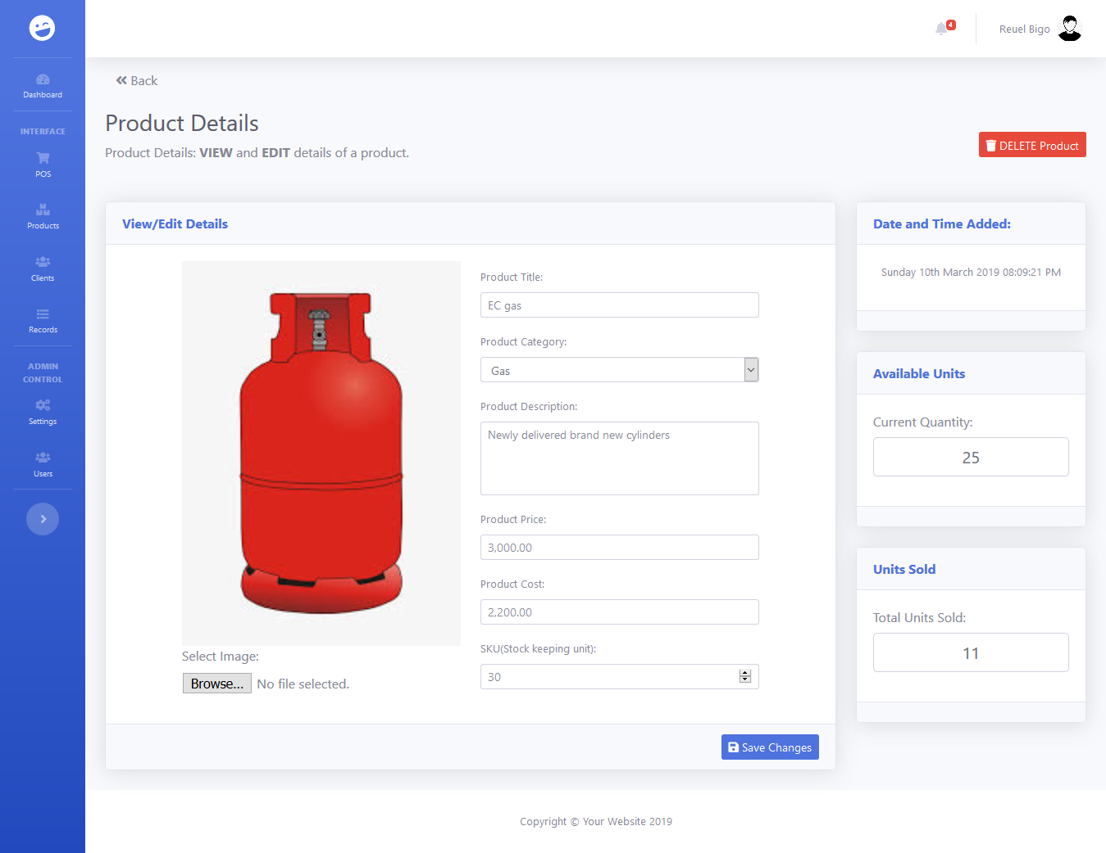

Input new values to the input fields of details you wish to update. Click on the **Save Changes** button to save the changes you have made.

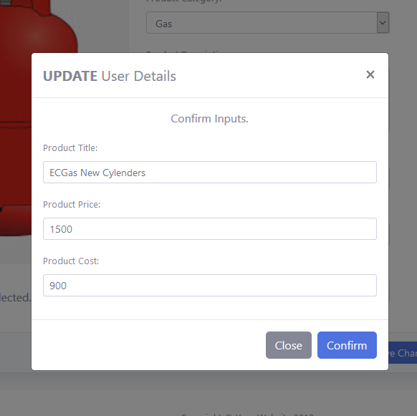

After clicking on the **Save Changes** button, a modal will show containing the updated details by the user. This is a prompt to confirm the user inputs before updating the official record on the database. If the user has confirmed the new values, click on the **Confirm** button to submit and save the new updates to the database. After confirmation, the page will reload showing the new updates to the product details.

* + **Delete Product button**

Clicking the **Delete Product** button will show a modal prompting the user if he/she wants to proceed with the action. If the user is certain in deleting a product, click on the **Confirm Delete** button to confirm the deletion. Successful deletion will cause a page refresh, if nothing happens after clicking the confirm button, it means that the product can’t be deleted. This is because the product is already associated with a sales record in the database.

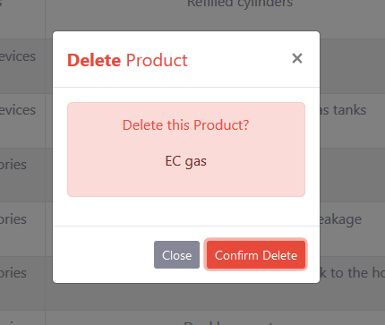

* + **Add Product link**

Clicking on the **Add Product** link will direct a user to the **Add Product** page. This page contains input fields of product details that will enable an admin to add a new product to our records. Not all input fields are required but the application will inform the user when a particular detail is required by placing a warning message bellow the input field if it is empty when a user attempts to save the new product.

Click the **Save** button to save the new product to the database. The page will redirect to the **Product Monitoring and Management page** after saving the new product.

Click to return to previous page.

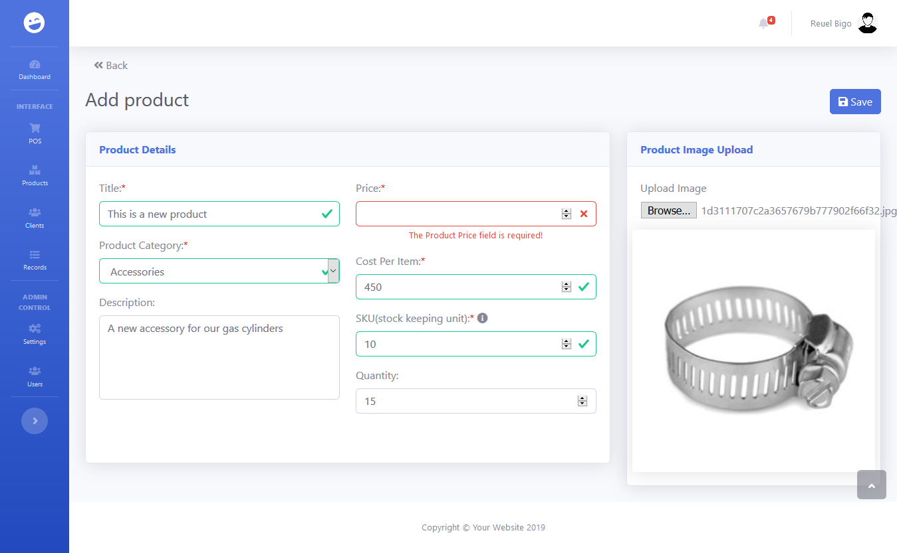

* **Inventory Monitoring and Management page**

Inventory Monitoring and Management page is where a user could monitor the current inventory of all products. Users could also set or add to the current inventory count of a product. This page has a function to filter the products displayed on the products table by product category. Each product/row has an action column containing the **View Product Information** button that leads to the **Product Details** page when clicked by a user.

Data is currently filtered with the **Gas** category. Simply choose another category then click on the search icon to display products of the chosen category on the products table. Remove filtering by leaving the category empty then click on the search icon to display all products.

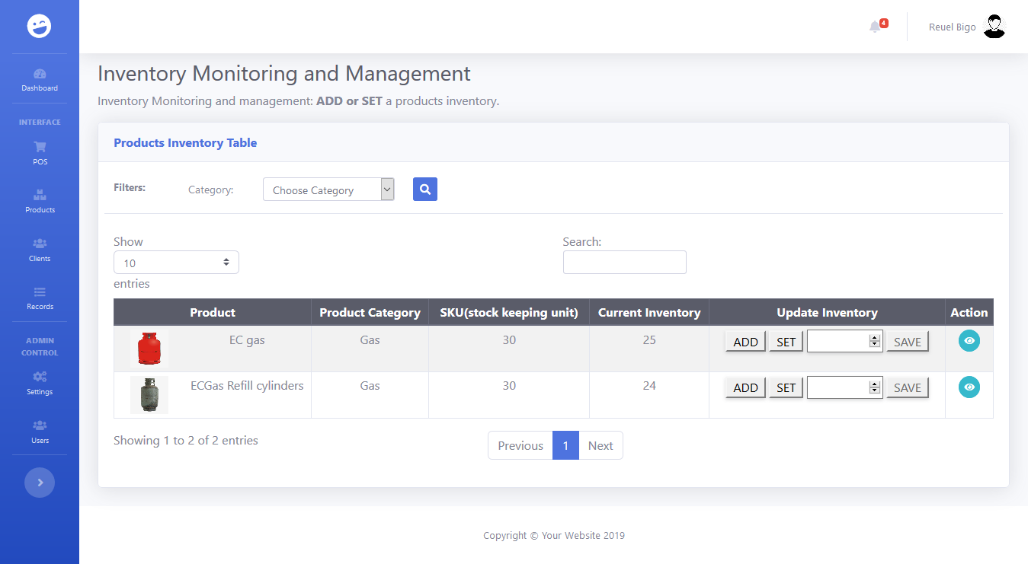

* + **Setting/adding Product Inventory**

Setting or adding on the current product inventory. Setting means replacing the current inventory with the value placed on the input field. Adding means adding the value on the input field to the current inventory.



**1st Step:** Input number on the input field



**3rd Step:** Click on **SAVE** to update inventory and to reset input field value.

**2nd Step:** Click on **ADD** or **SET** button. Selected button is highlighted in blue. Notice difference between the two.

1. **Client Monitoring and Management**

The Client Monitoring and Management page shows the total number of clients, the newest client, number of active clients, and number of inactive clients. The active and inactive clients are divided in to two separate tables for easier monitoring and management. Each client/row includes an action column with 3 to 4 action buttons. These action buttons are the following: **View Client Details** button, **Product Alert Settings** button, **Activate/Deactivate** button, and **Delete** button. Clicking on the **Add Client** button will open a modal that will allow a user to add a new client. Similar to our Product Monitoring and Management page, the view client button will lead to the client details page while the activate/deactivate and delete buttons will prompt the user if he/she would like to proceed with the action. The product alert settings will open a modal where a user can set the days of expected usage of a client per product. Alerts for expected purchase of products will depend on the records of product alert settings.

**Add Client** button which opens a modal to add new client.

Client reports for monitoring purposes.

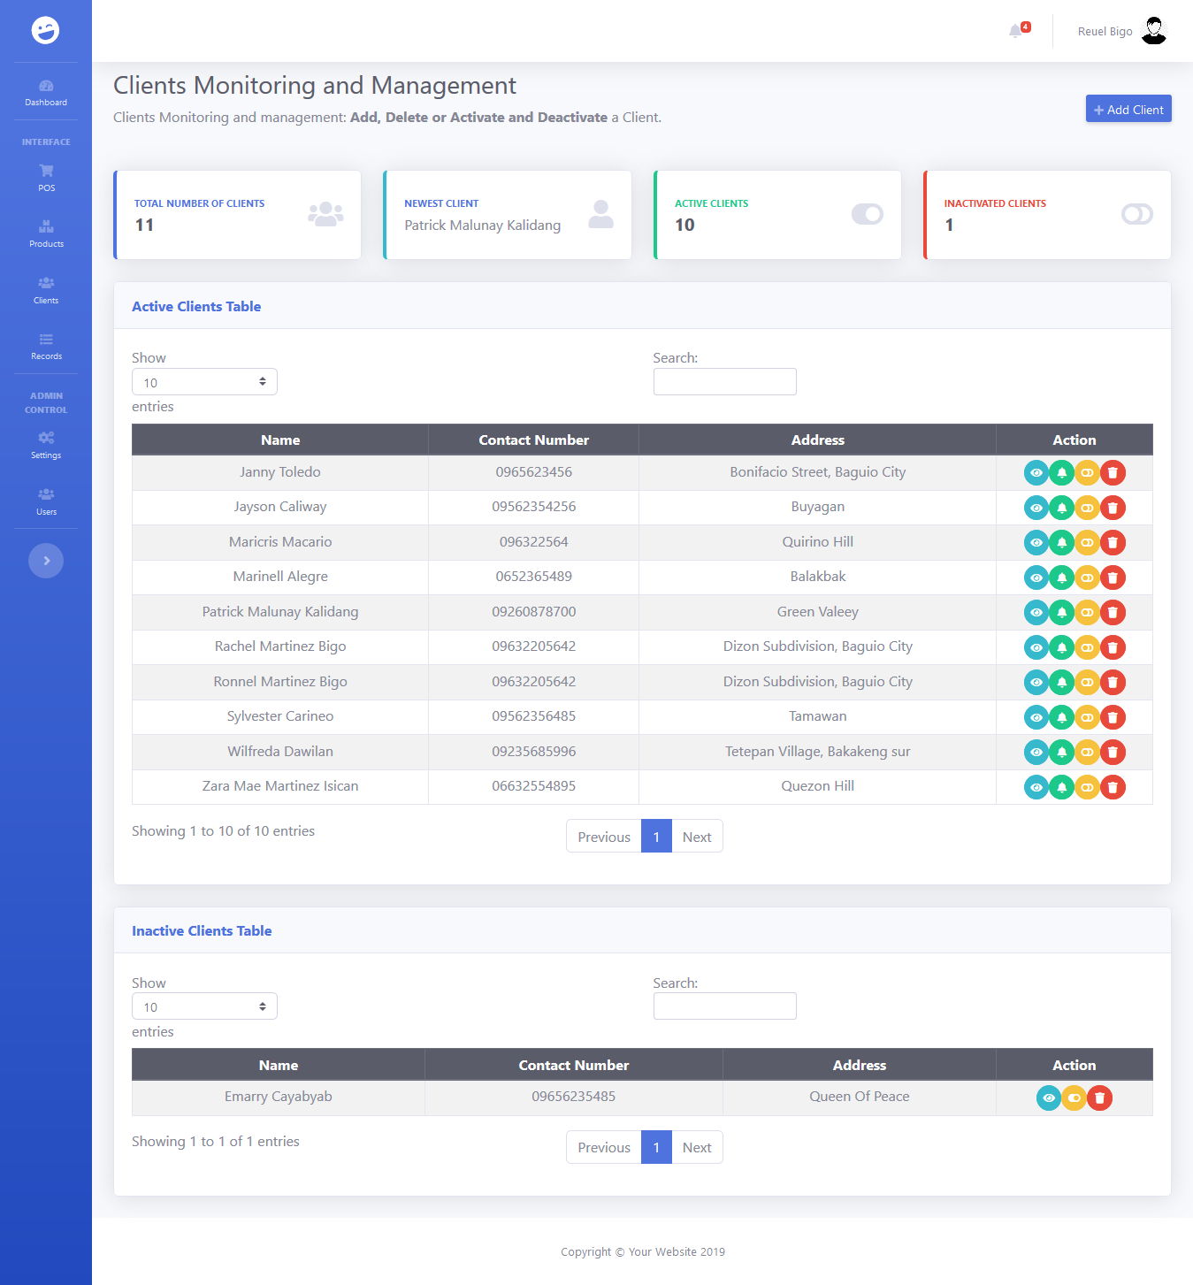

Action buttons.

* **Product Alert Settings button**

Both fields are required and will produce a warning message when the confirm button is clicked while any of the input field is/are empty. You can update a product alert settings record by selecting the same product and placing the new days of usage in the **Days till next order** field. Click on **Confirm** button to save record when all fields are field up. The page will reload when the record is saved.

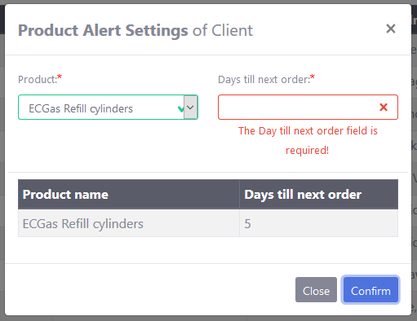

* **Add Client button**

Clicking the **Add Client** button will open a modal with input fields for client details. Not all fields are required but the application will check for required details which were left empty and will inform the user by placing warning messages bellow those fields. If all required field are field up, click on **Add Client** button to save the new client on the database. The page will reload after saving the new client.

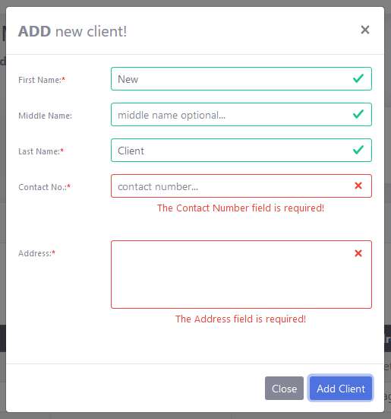

* **Client Details page**

The client details page is where a user can view the details of a client. It also allows any user to make changes to these details. A purchase logs table is available on this page so a user can monitor the sales transactions of a client. The action column on the table contains a button which shows a modal view that contains more details about each sale/row.

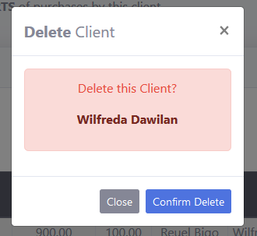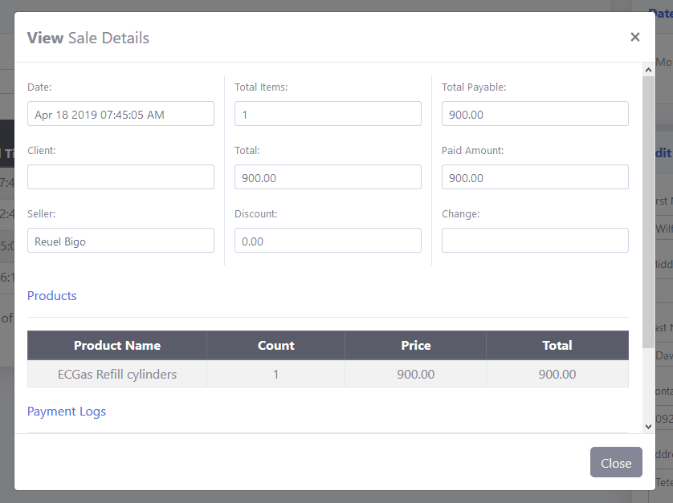

User prompt when deleting a client. Page will redirect to the **Client Monitoring and Management** page upon successful deletion.

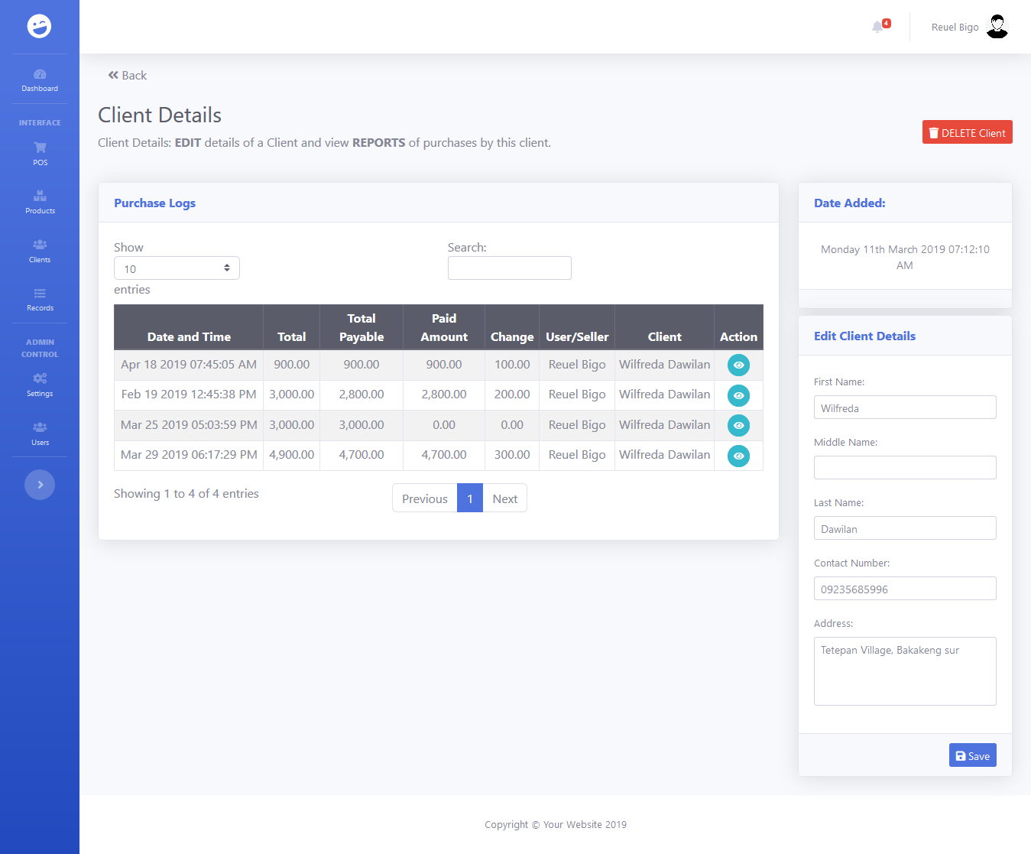

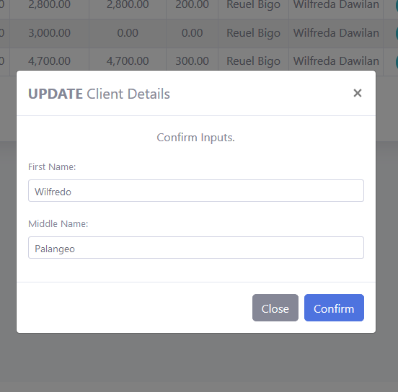

Clicking on the **Save** button will open this modal view which serves as a confirmation for the updates made by the user. Clicking on the Confirm button in the modal view will tell the application to push through with the updates. Successful update will reload the page to show the changes made by the user.

Clicking on the action button will show this modal view which contains more details for the sale. It also shows the list of products sold and list of payment logs.

1. **Records Monitoring and Management**

The records monitoring and management has four (4) pages in total namely the sales monitoring and management page, expenses monitoring page, returns/refunds monitoring page and the issues monitoring page.

* **Sales Monitoring and Management page**

Sales monitoring and management page is where our sales transactions are monitored and managed. This page contains a table that shows the daily sales of the company by default. But with the filter function of this page, a user is able to view the sales of any date or date range and status. There are reports available on the page which helps the user to know the total amount of sales, discounts, amount payable, amount paid, amount receivable, and refunded amount. An action button is provided per sale/row that leads the user to the **User Details** page which provides more features and functionalities for sales management.

Sales reports. Totals placed in this report will depend on the data placed on the Sales Logs table.

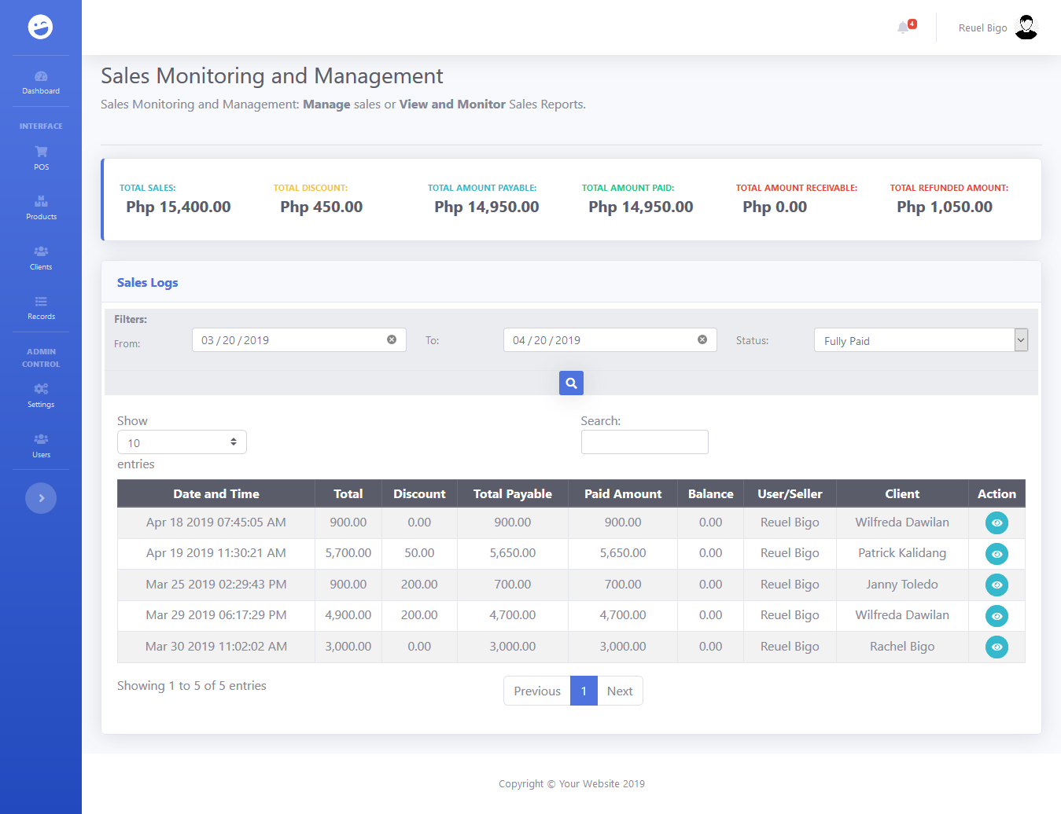

Button that leads to the **Sales Details** page.

Sales Logs filter. There are three fields on our filter namely the **from** date input, **to** date input, and the **Status** input. The from date should be earlier than the to date, or even the same with it to display a result for a single day. Leaving both date inputs empty will result in every sales record ever recorded. A user can play with combination and may pair it with the status filter. Sales status maybe credit, partially paid, or fully paid. A user may select the **All** option to display sales regardless of the status. The user must select the filter options then click on the search icon to display results on the table and report fields.

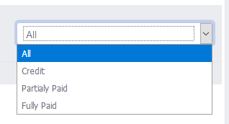

* + **Sales Details page**

The sales details page is where we will see all records related to a particular transaction. If a transaction is on credit or partially paid, the user can add payment using this page. The user will also see the products related to this transaction. Since a customer may pay their credit in installment, the application provides a table of payment logs. Since it is possible for a customer to initiate a return, or for a user to award a refund to a customer. A return/refund logs table is provided for monitoring purposes. A **Return/Refund** link is provided that when clicked, will lead to the **Return and Refunds** page which allows a user to record a refund and or return.

Return/Refund link that leads to the Return and Refunds page. A user will click this button to record a refund or product return.

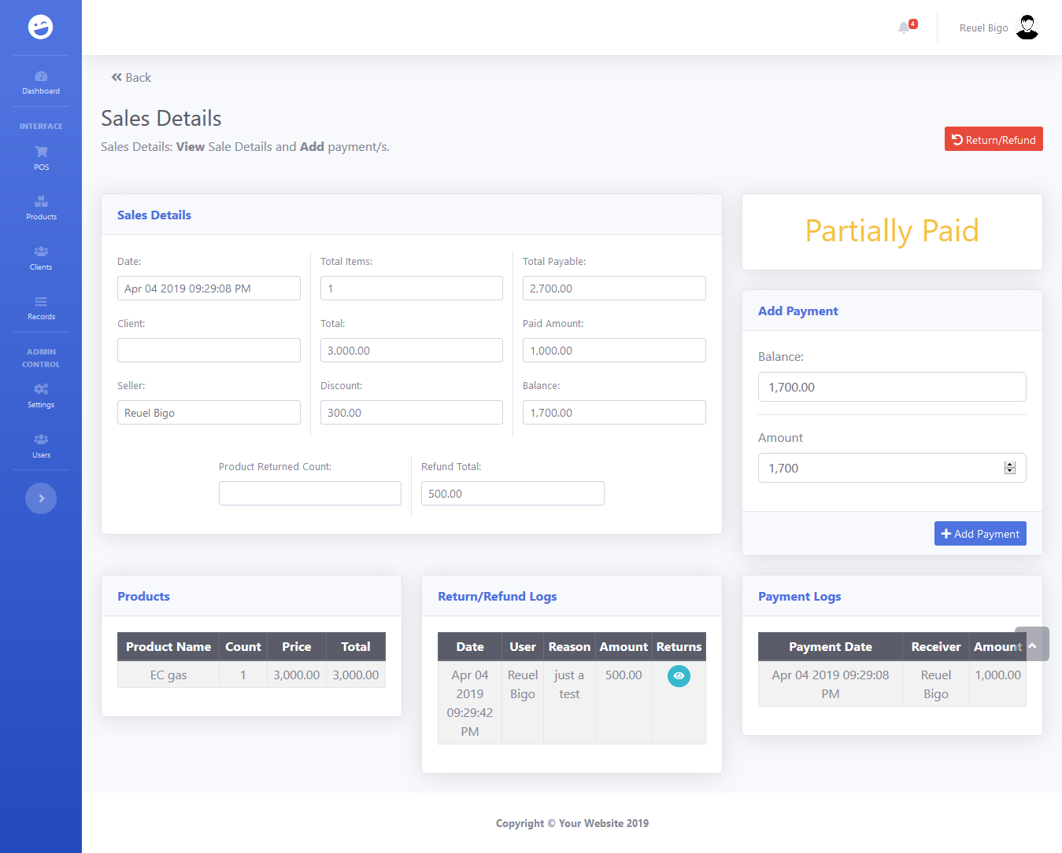

**Adding of payment**: When a user needs to add a payment for a transaction which is on credit or partially paid, he/she will visit the **Sales Details** page and go to this part of the user interface. The balance is provided so a user can be sure of how much a customer needs to pay. The user will input the amount paid by the user to the **Amount** input field. Click on the **Add Payment** button to record the payment. The page will reload after successfully recording the new payment. After the page reload, you will notice that the new payment is added to our **Payment Logs** table.

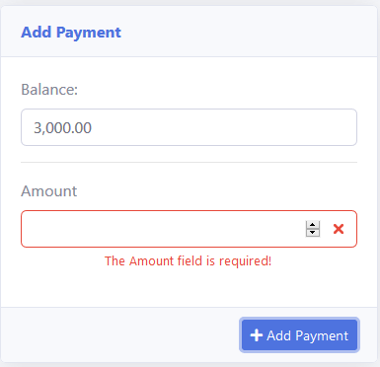

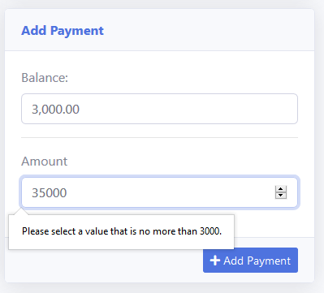

**EROR MESSAGE SAMPLES**

* + **Returns and Refunds page**

The returns and refunds page is used by a user to record returns of products by the customer or refunds awarded to a customer. A user may select any product from the product list to be refunded by checking the checkbox on the right side of the product image. The user is also required to provide how many units of this product is being returned by placing it on the input field on the left side of the product details. It is required to provide the reason for the return or refund by placing at the **Reason for refund/return** input field. If a refund is needed with the product return, simply provide the refund amount in the **Refund Amount** input field. if the user is ready to proceed with the refund/return, he/she may click on the **Confirm** button to record the refund/return. Successful recording will redirect the user to the **Sales Details** page. The newly recorded refund/return will be visible in the **Return/Refund Logs** table.

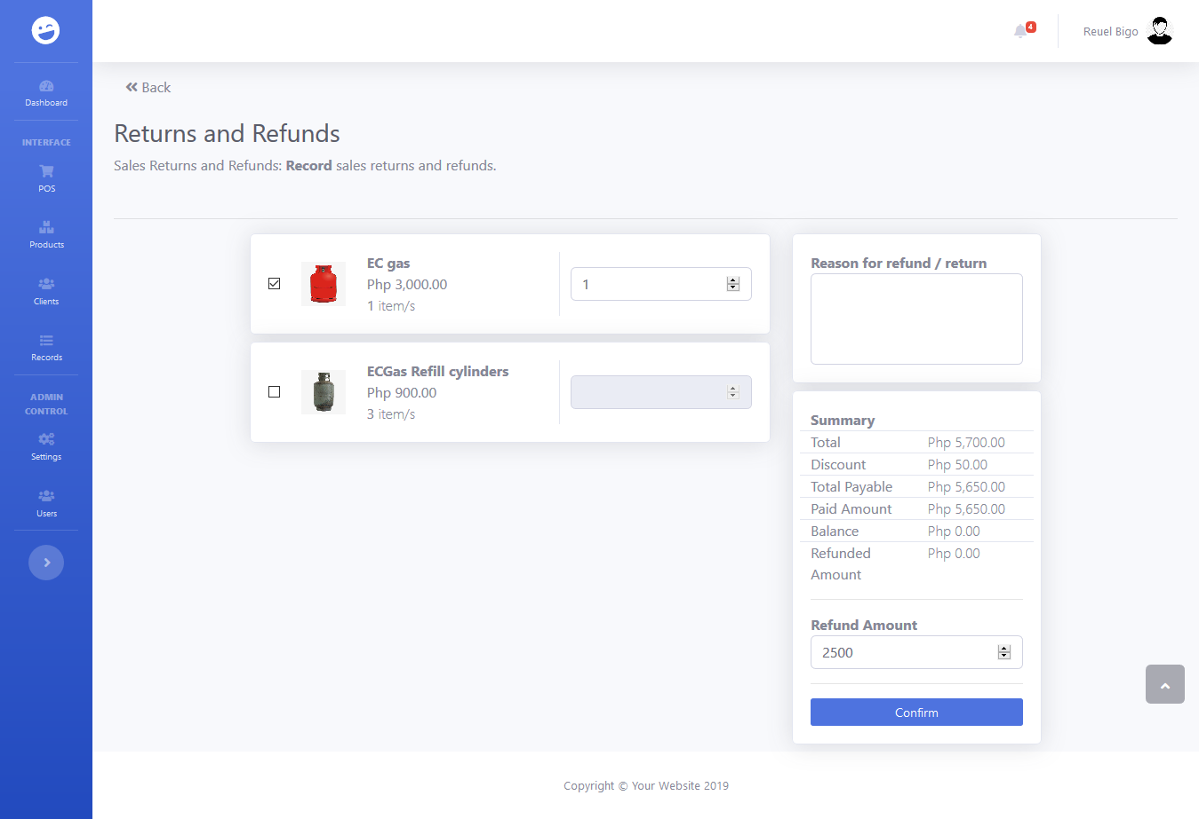

Product Unit Count Input Field

Required

Reason input field

Required

Product Checkbox

Refund Amount Input field

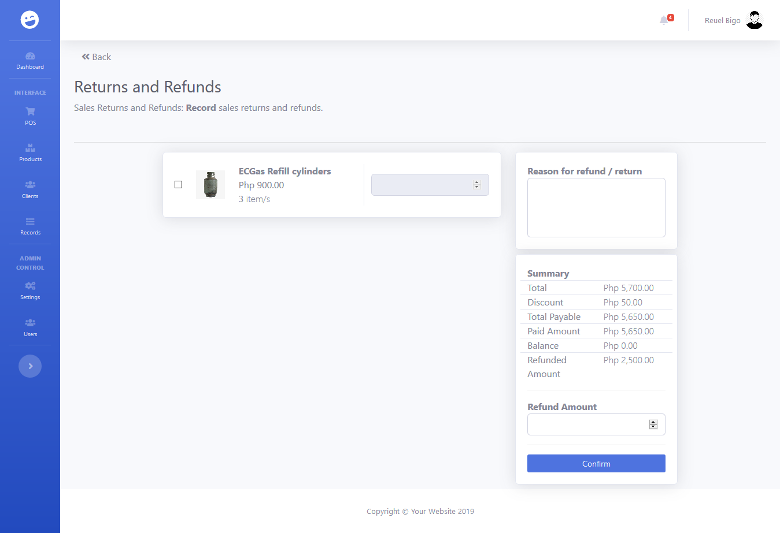

This is the same transaction where the sample refund was performed. Notice that after the product “EC gas” was returned, it is now unavailable in our product list in the **Return and Refunds** page.

Notice that the amount refunded is now shown on the summary of the page.

* **Expenses Monitoring page**

The expenses monitoring page allows a user to view records of expenses and to add new expenses. This page contains an **Expenses Table** that contains our expenses records. This table by default shows the expenses for the day but can be changed by using the expenses **Filters** where a user could select a specific date or date range. The selected date or date range will be used by the application to filter the expenses records and display only the expenses from these dates. This page includes these following reports of expenses: **TOTAL EXPENSES THIS YEAR, TOTAL EXPENSES THIS MONTH, TOTAL EXPENSES THIS WEEK, TOTAL EXPENSES YESTERDAY,** and **TOTAL EXPENSES FROM THE TABLE.** A user can add a new expense record by clicking on the **Add Expenses** button on the upper left of the screen.

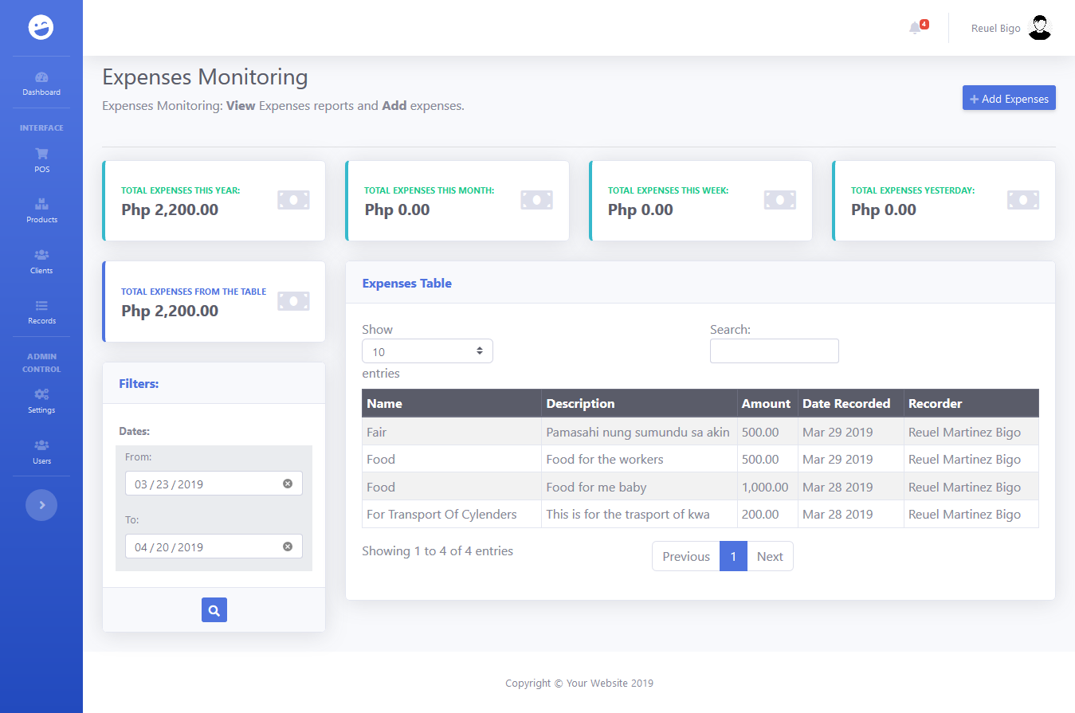

* + **Add Expenses**

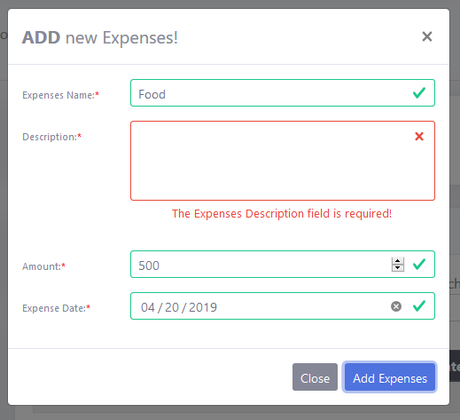

**2nd Step:** Click on **Add Expenses** button to procced.

**1st Step:** This modal will appear when the **Add Expenses** button is clicked. All fields are required and will cause an error message when left empty.

* **Returns/Refunds Monitoring page**

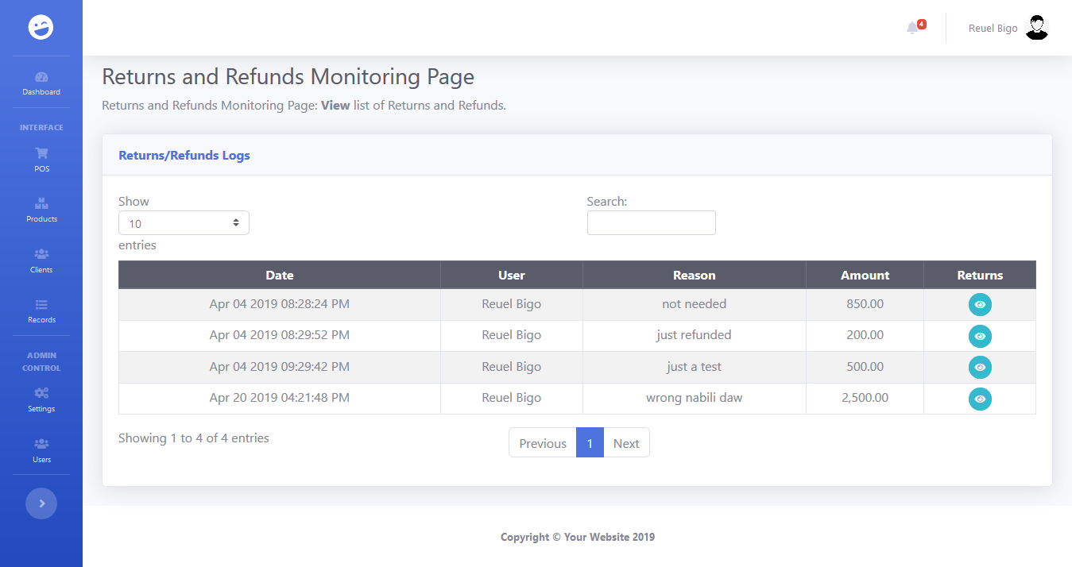

The Returns/Refunds Logs table includes a column named Returns which contains a button which displays a modal which contains the product/s returned.

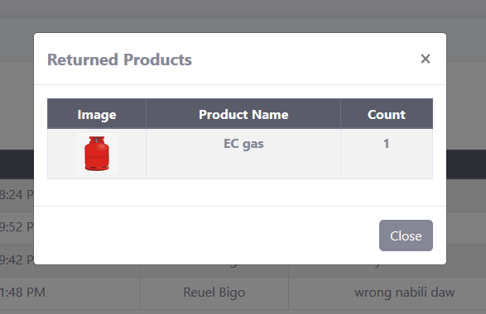

* **Issue Monitoring page**

The issue monitoring page is where a user can add new issue record and monitor past records of issues related to customers and products. Majority of the tables in this application has a search field on the upper part of the table. This function allows the user to search for specific data or group of data containing a specific pattern.

Click on the **Record Issue** button to add a new issue record.

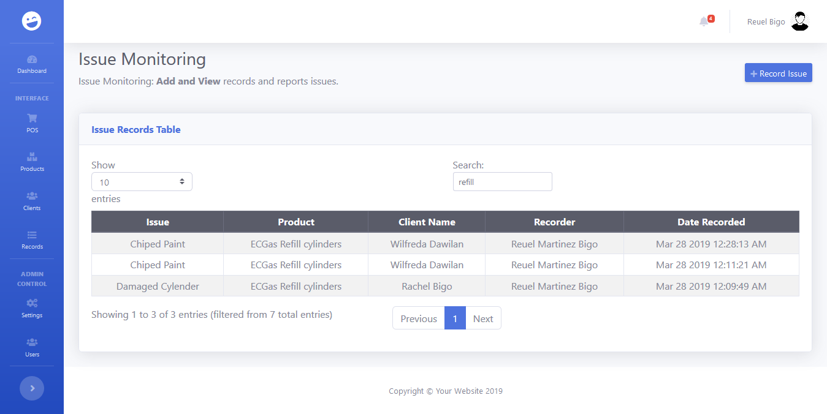

Search functionality: Simply type a word or pattern in the search input field to filter the data displayed in the table.

* + Adding of Issue Record

Clicking the **Record Issue** button will open a modal where a user could select the product, customer, and issue related to the issue record that’s being added. Each field is required and will result to a warning message when **Save** button is clicked with any of the inputs having an empty value. Click on the **Save** button to save the new issue record in the database. After clicking save, the page will reload showing your recently added record as the first item on the issue records table.

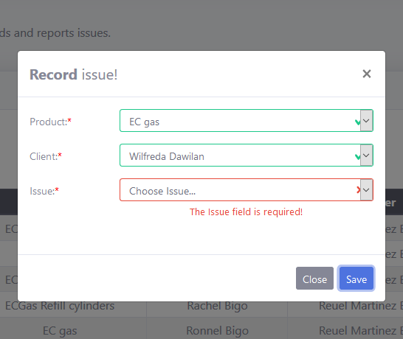

1. **Settings**

The admin settings page is used by the admin to add or remove product categories, payment methods and product/customer issues. These parameters are dynamic which means a user may need to add new values for them. An admin is allowed to delete values of these parameters provided that a value being deleted was never used on any of our existing records. Successful addition or deletion of values to these parameters will cause a page reload. Changes must be seen after the page reload.

Add buttons that will show a modal where a user can add values for each parameter.

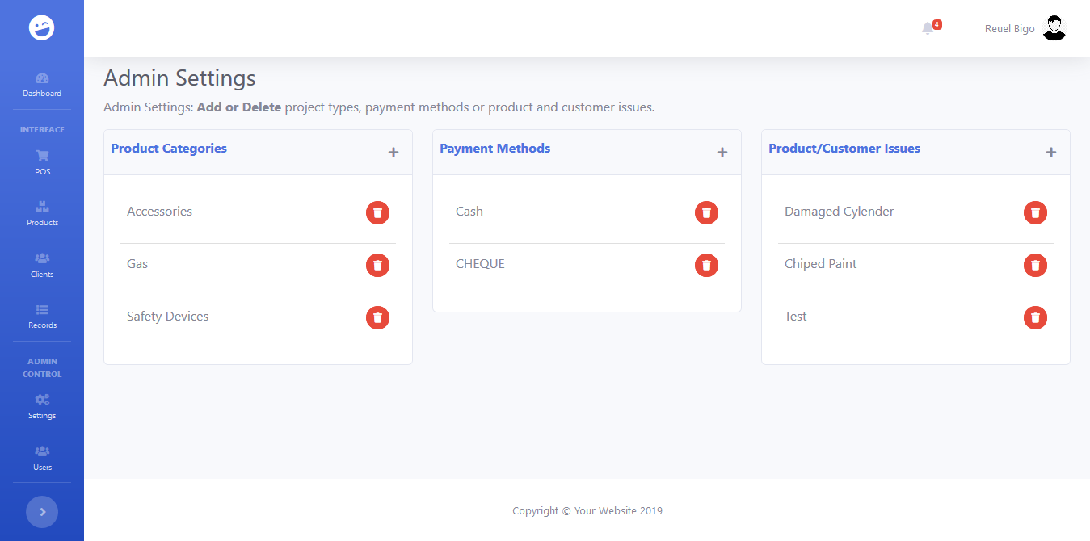

Delete button that will cause a page reload upon successful deletion.

Each parameter have its modal for adding new values. Input fields of these modals are requires so they will produce a warning message of left empty. Click on the **Add** button to proceed.

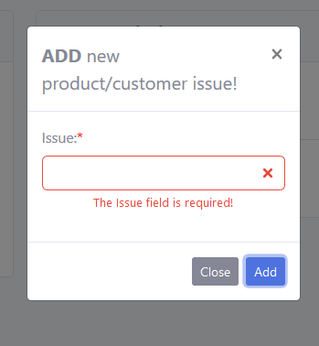

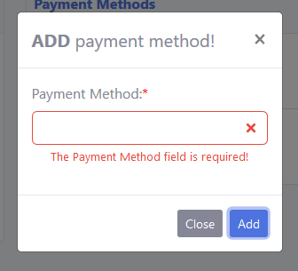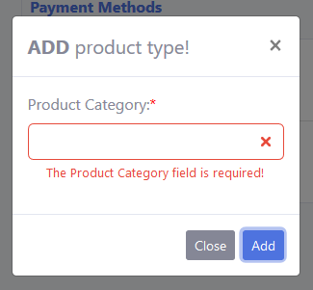

1. **Users**

The user management page can only be accessed by an admin user and is used to manage the users of this application. An admin can add or delete users, edit user details, and activate or activate an account. Simple reports about the users is also available on the top of the page.

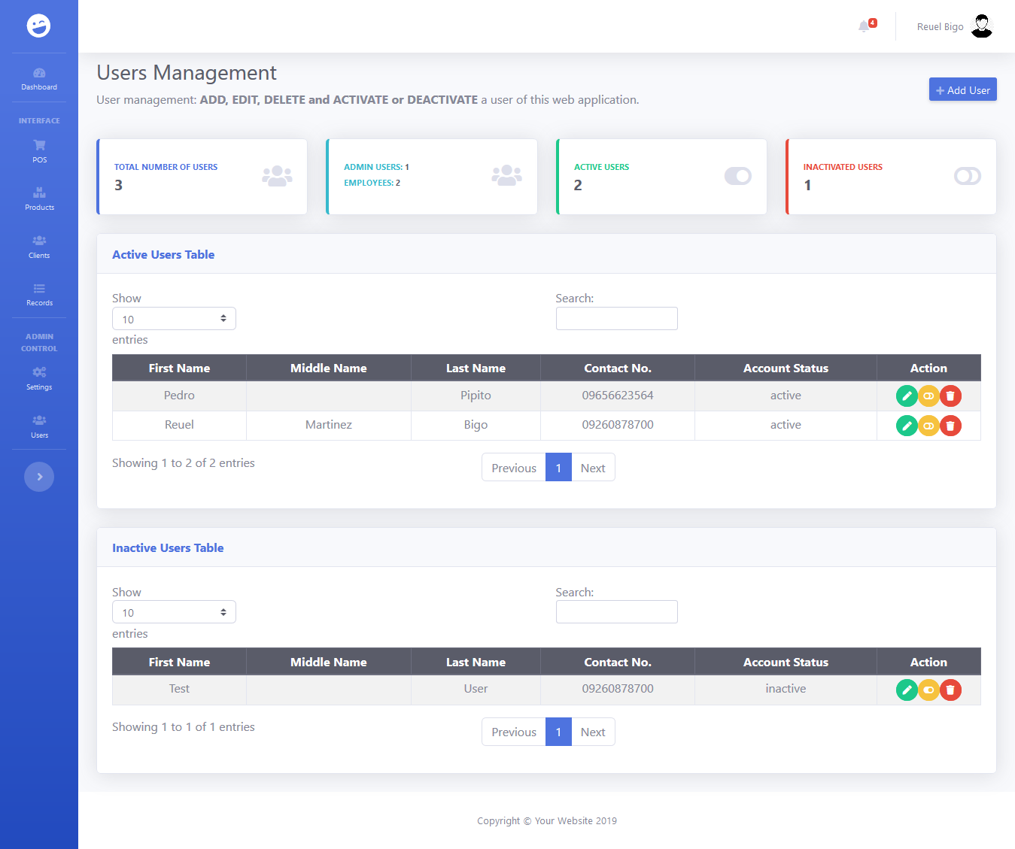

Admin action buttons:

**Edit, Activate/Deactivate, Delete**

**Add User** button when clicked will open a modal where an admin can add a user.

* **Add User**

Modal for adding of users. Required fields must be field up. Click on **Add User** button to record new user.

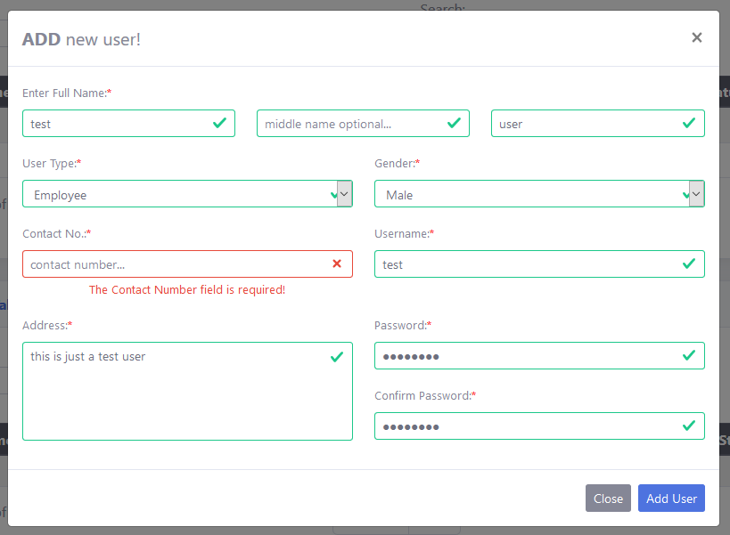

* **User Details page**

The user details page enables an admin to view and edit details of a user. A **Sales Logs** table is also provided for the admin to monitor the sales the user. The admin may edit/update user information by placing the new value in the input fields provided then clicking on the **Save** button.

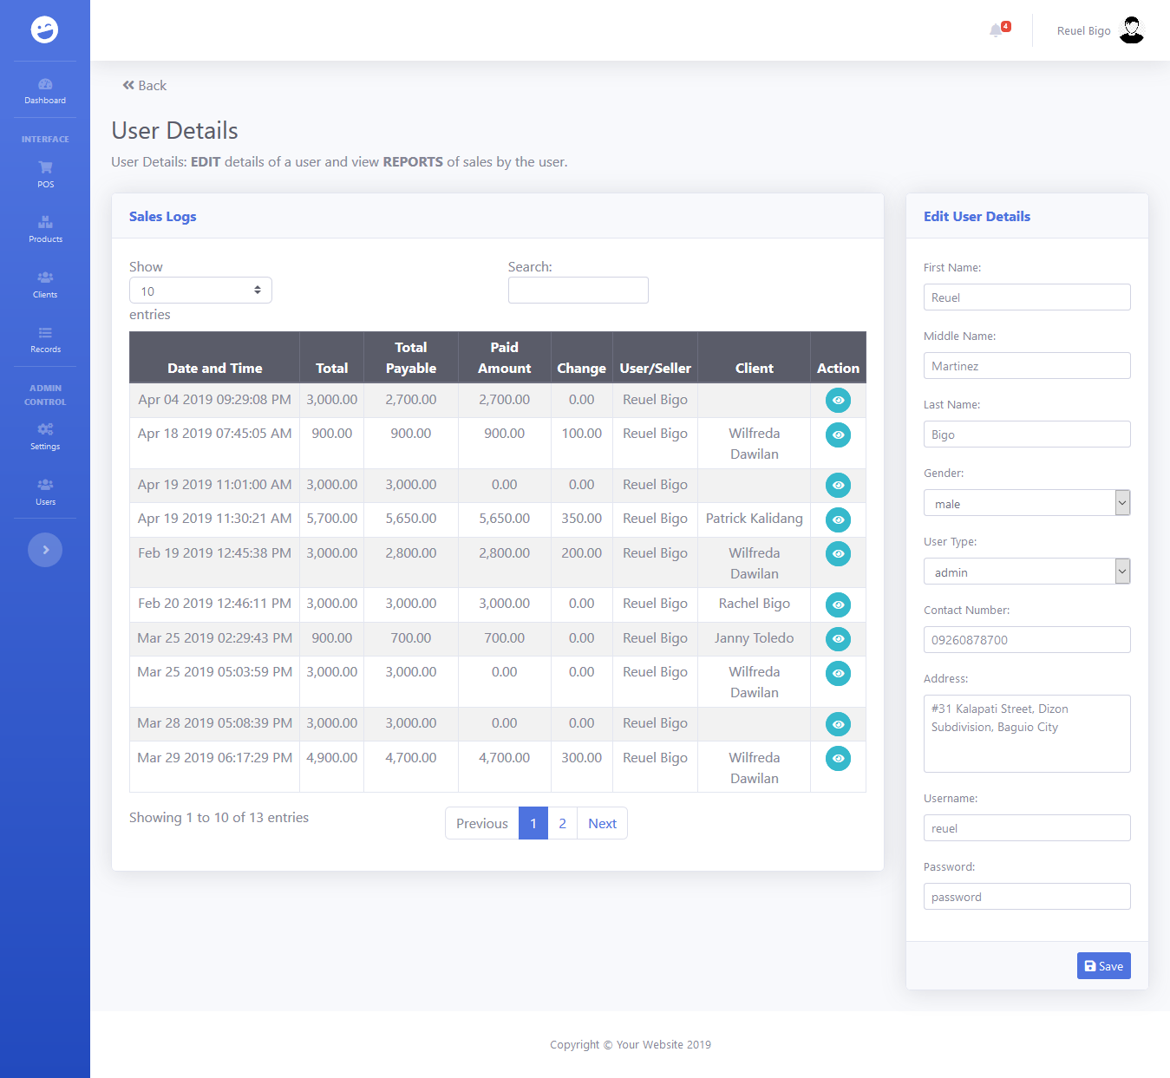

Simply place desired changes on the input fields located here.

Click on this button after a user admin input all desired changes.

* + **Edit User Details**

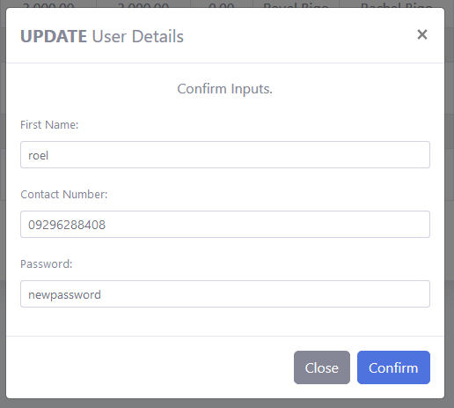

This modal will appear after the **Save** button is clicked. The modal will show the changes made by the admin user and will serve as confirmation before pushing through with the updates. The admin user is free to make changes before clicking on the **Confirm** button. Successful update will result in a page reload, finally showing the updated details of the user.

1. **Dashboard Reports**

All information depicted and shown by the reports placed on the dashboard will and always depend on the data entered on all pages discussed previously.

* **Simple Financial Reports**

This report contains the total of sales, discount, amount payable, amount paid, amount receivable and refunded amount. It shows totals of today, yesterday, this week, this month, and this year.

These are buttons used to change view from report of today till report of this year. The default is the report of today when the dashboard is opened.

* + **Today**

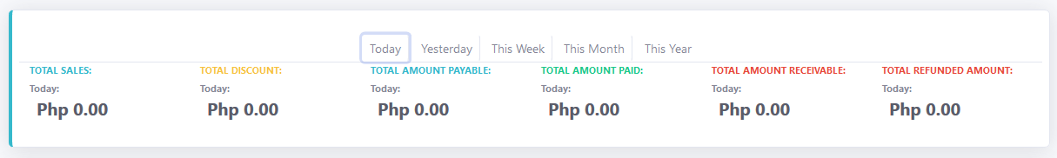

* + **Yesterday**

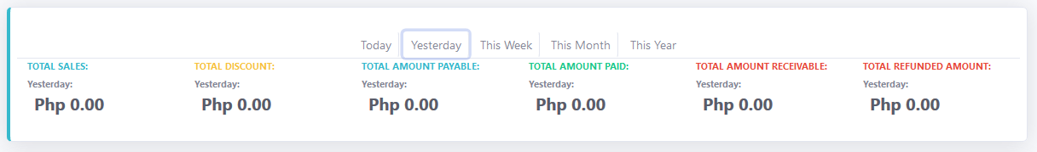

* + **This Week**

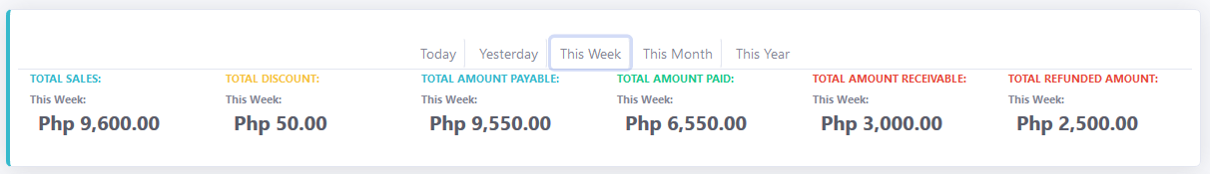

* + **This Month**

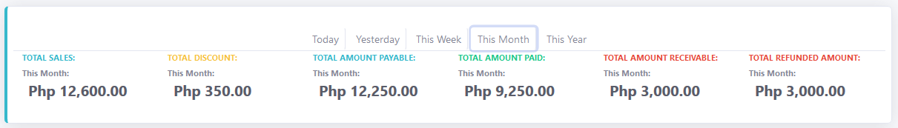

* + **This Year**

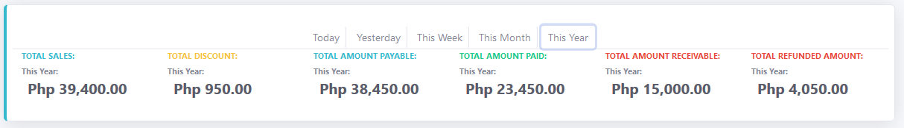

* **Sales Count Overview and Sales Chart**

These are visual reports showing the monthly difference of sales count and sales total amount of the current year.

* + **Sales Chart**

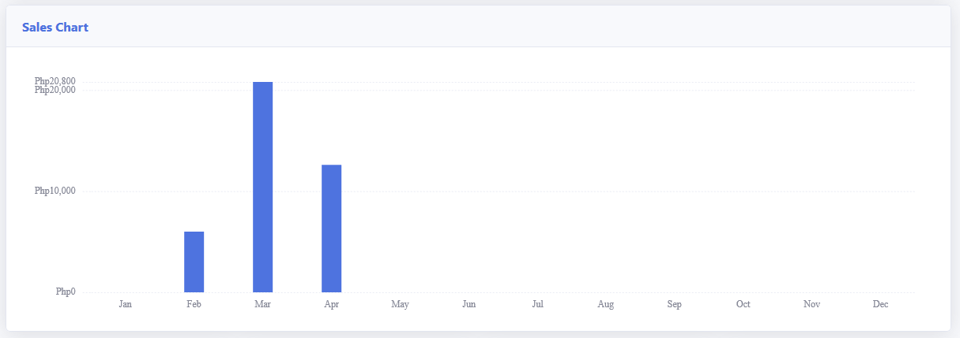

* + **Sales Count Overview**

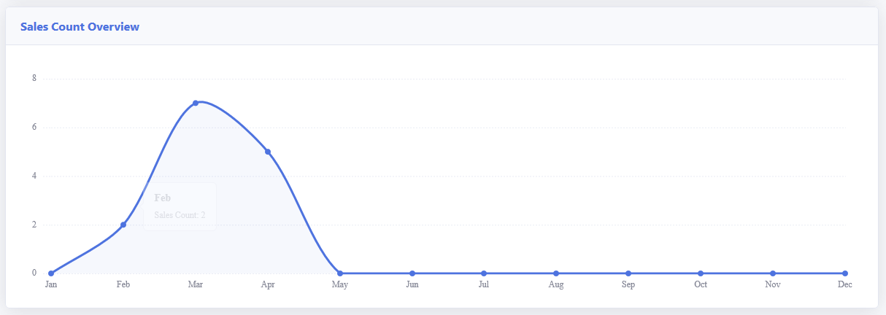

* **Client and Product Simple Report**

This report contains the current count of clients and products that are recorded in the system. It also shows the total of active or inactive clients or products, and the newest client or product that was recorded on the system.

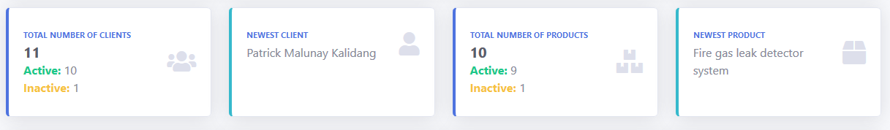

* **Latest Issues**

This report contains five (5) of the latest issues of products of customers that was recorded on the system.

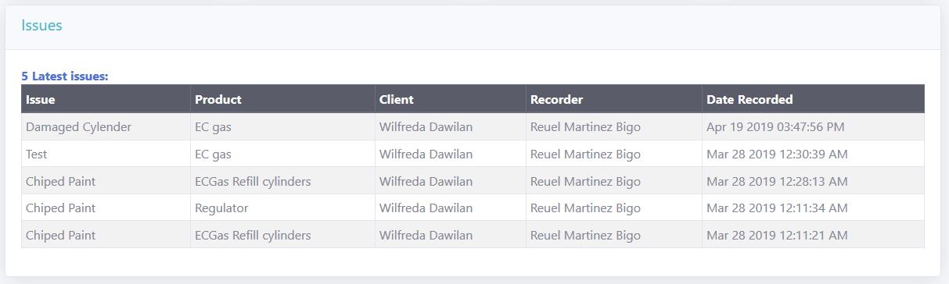

* **Low Inventory Products**

The products placed in tis table are those with inventory count is equal or lower with its SKU or Stock Keeping Unit value. The Stock Keeping Unit value of a product is set while adding a new product to the application. The SKU can be updated using the **Product Details** page. Updating the product inventory count with grater value than the product SKU will remove the product in this table. Number of rows in this table is the same as the number indicated on our alert section on the application top navigation.

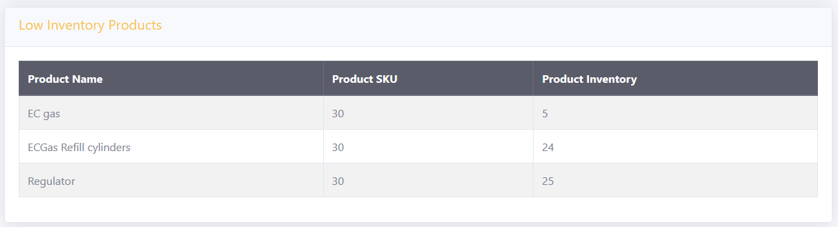

* **Possible Product Orders**

This table contains possible orders of products basing on the date a customer last ordered the product. It also uses the **Days till next order** value of each customer which can be set on the **Clients Monitoring and Management** page. The days till next order value signifies how long a customer will use the certain product. The reminder will appear here 5 days before until the expected order date. Number of rows in this table is the same as the number indicated on our alert section on the application top navigation.

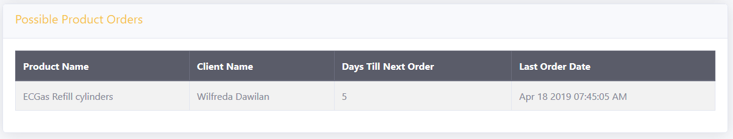

1. **Pointers, Reminders, and Additional Information**
2. All deactivated user accounts will not be able to login to the application.
3. All deactivated products will not appear in the POS.
4. All deactivated customers will not appear on the POS.
5. If the application is left to idle for a long period of time, its possible that it will redirect to the login page and will expect the user to login again.
6. This application is designed and created to be used on a desktop computer or a laptop.