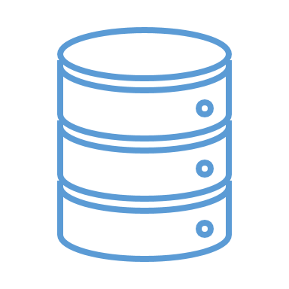

**Data Source**

**Repository**

**Business**

**Logic**

XXXApi

**Data Mapper**

**Query**

**Business** **Entity**

**Business** **Entity**

**Persist Query**



**_example_template_XXXModel**

**_example_template_XXXRepository**

**_example_template_XXXApi**

**XXXController**

**r**



**Route**