
FarmersAI Assist
Functional User Manual – Screens 1 to 9
Current demonstrative behavior and planned Rally MCP / AI / automation functionality.

Purpose and navigation
FarmersAI Assist is the QA intelligence layer between Rally requirements and the Java + Playwright automation project. Rally data is read-only until an approved publication action is executed. AI proposals always require human review.
- Screen 1: Dashboard. Screens 2–9: Dashboard + Previous/Next navigation.
- Dashboard from Screens 2–9 requires confirmation before unsaved information is discarded.
- Selection hierarchy: Project → Sprint/Iteration → Feature → User Story.
Screen inventory
Screen | Purpose
1. Dashboard | Selects the Rally hierarchy and starts analysis.
2. Rally Analysis | Read-only requirement analysis for the selected Rally User Story.
3. Test Case Proposals | Review queue of AI-proposed test cases; nothing is published automatically.
4. Test Case Editor | Human-review editor before approval and Rally publication.
5. Task Proposals | QA/automation activities proposed for the selected User Story.
6. Rally Publish Review | Final human approval gate before creating Test Cases and Tasks in Rally.
7. Automation Workspace | Maps an approved Test Case to the existing Java + Playwright automation project.
8. Reports & Analytics | QA execution, coverage and automation analytics across projects, sprints and environments.
9. Settings | User preferences, integrations, automation, security and application defaults.

1. Dashboard
Selects the Rally hierarchy and starts analysis.
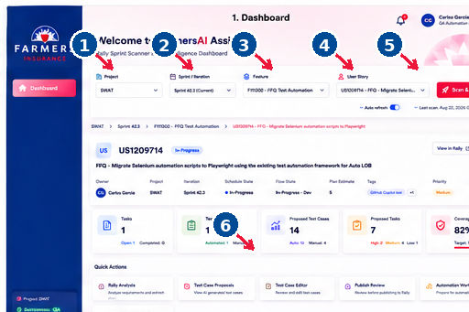
Numbered arrows identify the principal controls.
Controls and required fields
Control / Field | Requirement | Behavior / Purpose
Project | Required | Parent Rally project filter.
Sprint / Iteration | Required | Selects the sprint; refreshes Features.
Feature | Required | Selects the Feature; refreshes related User Stories.
User Story | Required | Selects the USXXXXXXX to analyze.
Scan & Analyze | Action | Starts the scan; later backed by Rally MCP.
Quick Actions | Navigation | Opens downstream workflow screens.
Key behavior
Child dropdowns refresh from their parent selection. Scan & Analyze should enable only after all required selections are valid.

2. Rally Analysis
Read-only requirement analysis for the selected Rally User Story.
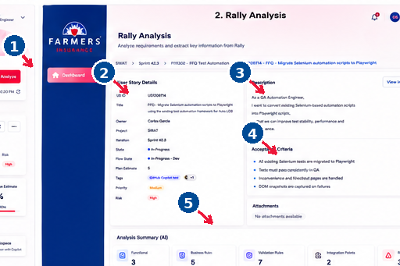
Numbered arrows identify the principal controls.
Controls and required fields
Control / Field | Requirement | Behavior / Purpose
Dashboard | Navigation | Returns to Screen 1 after confirmation.
User Story Details | Read-only | ID, title, owner, project, iteration, state, estimate, tags, priority and risk.
Description | Read-only | Primary requirement source from Rally.
Acceptance Criteria | Read-only | Expected business behavior used for test design.
AI Analysis Summary | Generated | Functional rules, validations, integrations and risks.
Key behavior
Maintains the Rally context selected on Dashboard. Previous/Next is demonstrative but functional. Dashboard requires confirmation before discarding unsaved information.

3. Test Case Proposals
Review queue of AI-proposed test cases; nothing is published automatically.
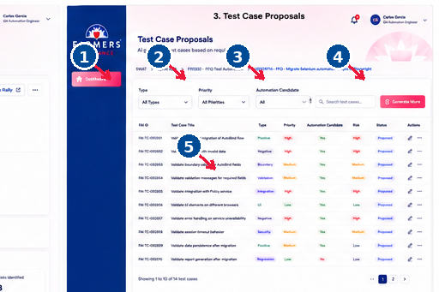
Numbered arrows identify the principal controls.
Controls and required fields
Control / Field | Requirement | Behavior / Purpose
Type | Filter | Functional, boundary, UI/UX, validation, integration, regression, E2E, etc.
Priority | Filter | Filters by priority/risk.
Automation Candidate | Filter | Filters automation suitability.
Search / Generate More | Action | Searches or requests additional proposals.
Proposal Table | Review | FarmersAI ID, title, type, priority, automation, risk, status and actions.
Key behavior
Maintains the Rally context selected on Dashboard. Previous/Next is demonstrative but functional. Dashboard requires confirmation before discarding unsaved information.

4. Test Case Editor
Human-review editor before approval and Rally publication.
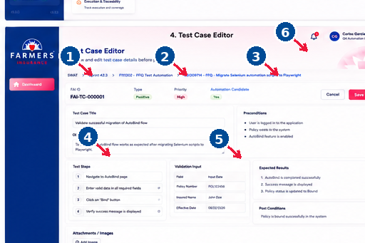
Numbered arrows identify the principal controls.
Controls and required fields
Control / Field | Requirement | Behavior / Purpose
Test Case Title | Required | Rally-ready test case name.
Objective | Required | Behavior/business outcome to validate.
Preconditions | Required if applicable | Required setup before execution.
Test Steps | Required | Ordered execution instructions.
Expected Results / Images | Required per validation | Expected behavior; images may support evidence.
Save Draft | Action | Saves in FarmersAI Assist; does not publish.
Key behavior
Required fields must be validated before Publish Review. Saving a draft does not publish to Rally.

5. Task Proposals
QA/automation activities proposed for the selected User Story.
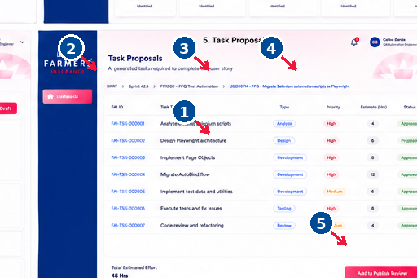
Numbered arrows identify the principal controls.
Controls and required fields
Control / Field | Requirement | Behavior / Purpose
Task Table | Review | FarmersAI Task ID, title, type, priority, estimate and status.
Type | Classification | Analysis, Design, Development, Testing or Review.
Priority | Required | Execution priority.
Estimate | Required to publish | Planned effort.
Add to Publish Review | Action | Moves selected Tasks to publication review.
Key behavior
Maintains the Rally context selected on Dashboard. Previous/Next is demonstrative but functional. Dashboard requires confirmation before discarding unsaved information.

6. Rally Publish Review
Final human approval gate before creating Test Cases and Tasks in Rally.
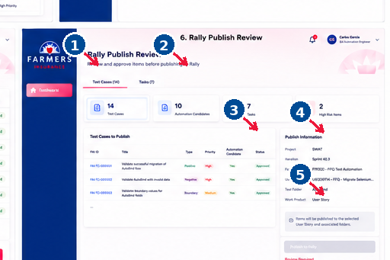
Numbered arrows identify the principal controls.
Controls and required fields
Control / Field | Requirement | Behavior / Purpose
Test Cases / Tasks | Navigation | Switches queued object type.
Summary Cards | Review | Counts and risk/automation indicators.
Items to Publish | Review | Exact approved objects to create.
Publish Information | Read-only | Project, Iteration, Feature, US, Test Folder and Work Product.
Publish to Rally | Action | Future MCP-backed create action after validation/approval.
Key behavior
No AI-generated object is published without human approval. Future Rally create operations are performed through the MCP integration.

7. Automation Workspace
Maps an approved Test Case to the existing Java + Playwright automation project.
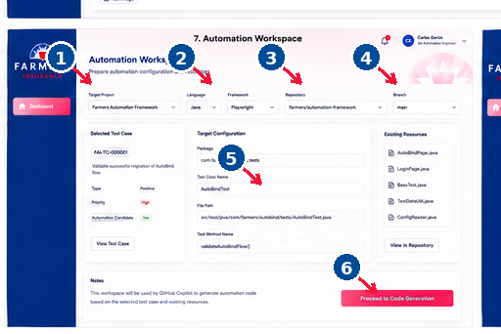
Numbered arrows identify the principal controls.
Controls and required fields
Control / Field | Requirement | Behavior / Purpose
Target Project | Required | Selects automation project/framework.
Language | Required | Java.
Framework | Required | Playwright.
Repository / Branch | Required | Target source repository and branch.
Target Configuration | Review/Edit | Package, class, file path and method mapping.
Proceed to Code Generation | Action | Sends reviewed context to the code-generation phase.
Key behavior
Maintains the Rally context selected on Dashboard. Previous/Next is demonstrative but functional. Dashboard requires confirmation before discarding unsaved information.

8. Reports & Analytics
QA execution, coverage and automation analytics across projects, sprints and environments.
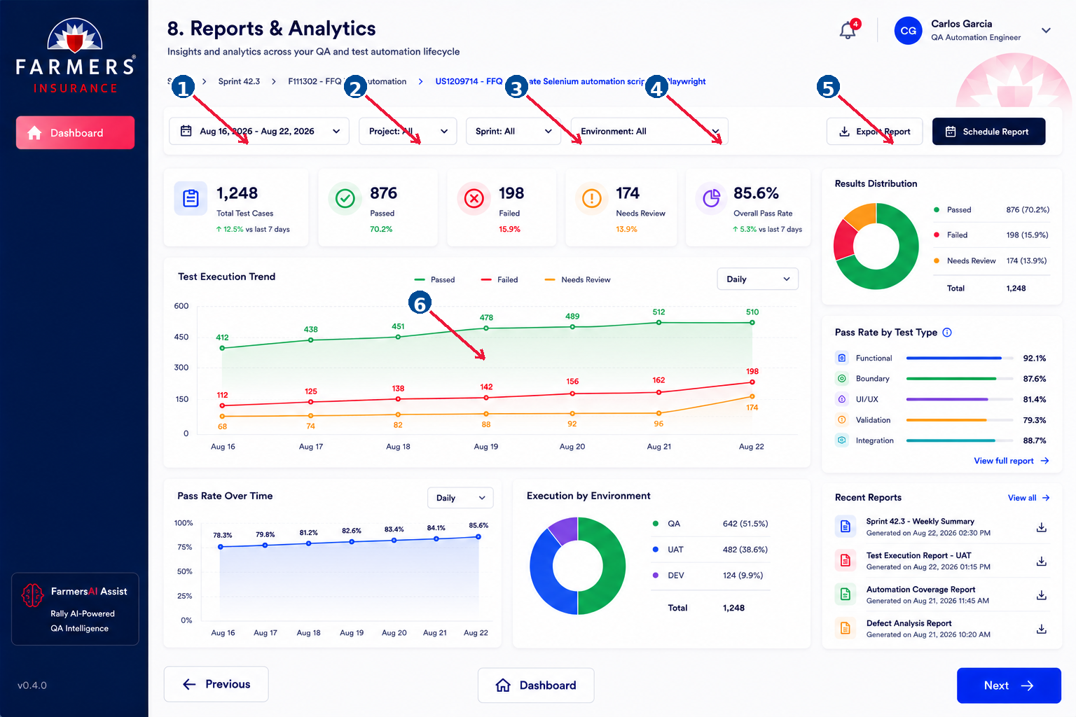
Numbered arrows identify the principal controls.
Controls and required fields
Control / Field | Requirement | Behavior / Purpose
Date Range | Filter | Reporting period.
Project | Filter | Project scope.
Sprint | Filter | Sprint scope.
Environment | Filter | QA/UAT/DEV or other environment.
Export / Schedule | Action | Exports or schedules future reports.
Charts / KPI Cards | Read-only | Totals, pass/fail, trends, distribution and pass rate.
Key behavior
Maintains the Rally context selected on Dashboard. Previous/Next is demonstrative but functional. Dashboard requires confirmation before discarding unsaved information.

9. Settings
User preferences, integrations, automation, security and application defaults.
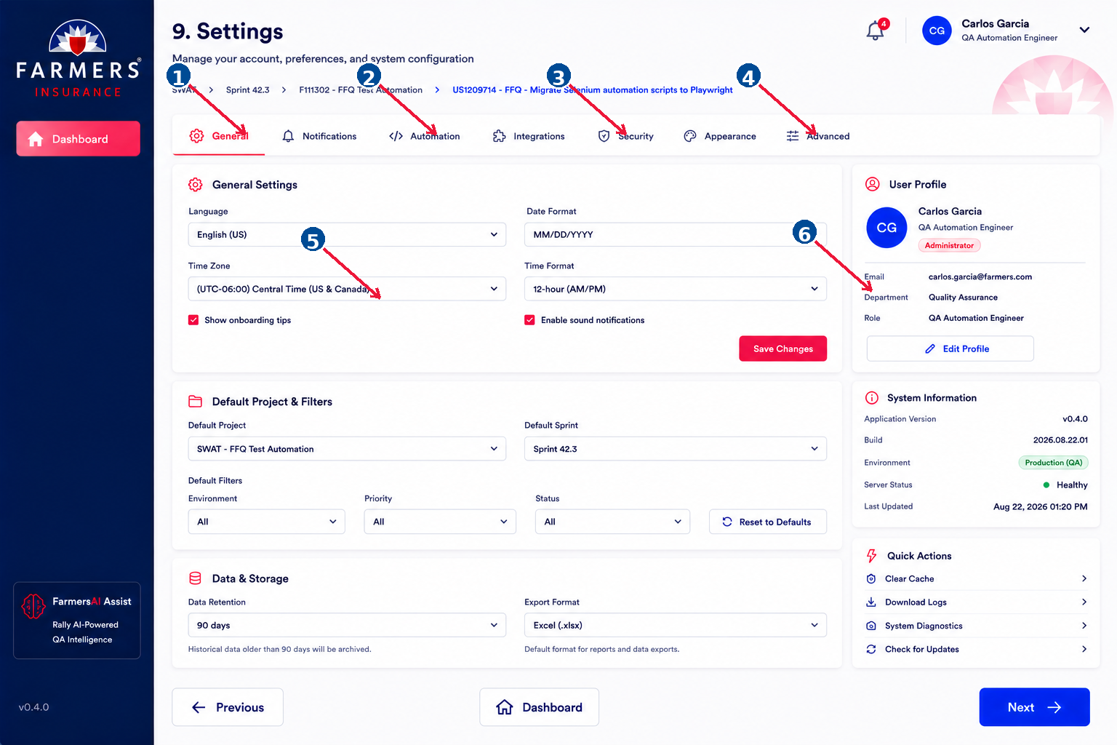
Numbered arrows identify the principal controls.
Controls and required fields
Control / Field | Requirement | Behavior / Purpose
Settings Tabs | Navigation | General, Notifications, Automation, Integrations, Security, Appearance, Advanced.
Language / Date / Time | Configurable | Localization/display preferences.
Default Project / Sprint | Configurable | Default Rally context.
Default Filters | Configurable | Environment, priority and status defaults.
Save Changes | Action | Saves editable settings.
Profile / System Info | Read-only/admin | Role, version, environment and health.
Key behavior
Maintains the Rally context selected on Dashboard. Previous/Next is demonstrative but functional. Dashboard requires confirmation before discarding unsaved information.

