**What is CSS?**

Cascading Style Sheets, fondly referred to as CSS, is a simple design language intended to simplify the process of making web pages presentable.

CSS handles the look and feel part of a web page. Using CSS, you can control the color of the text, the style of fonts, the spacing between paragraphs, how columns are sized and laid out, what background images or colors are used, as well as a variety of other effects. Most commonly, CSS is combined with HTML.

**Advantages of CSS**

•CSS saves time -

You can write one CSS rule and apply it to all the occurrences of a tag. So, less code means faster download times

•Easy maintenance - To make a global change, simply change the style, and all the elements in all the web pages will be updated automatically.

•Superior styles to HTML - CSS has a much wider array of swtyle attributes than HTML

•Multiple Device Compatibility - Style sheets allow content to be optimized for more than one type of device

There are four ways to associate styles with your HTML document.

• Embedding withing the HTML document (internal stylesheet)

• Linking with HTML document (external stylesheet)

• importing (External stylesheet)

• Writing directly into tag as attributes (inline stylesheet)

Most commonly used methods are inline CSS and External CSS.

Embedded CSS -

This is the easiest way to start out experimenting with stylesheets as a beginner. You create the style element in your document head

You can put your CSS rules into an HTML document using the <style> element. This tag is placed inside the <head>...</head> tags. Rules defined within this tag is available to all the elements available in the document

<head>

<style type="text/css" ...>

Style Rules

............

</style>

</head>

A style rule is made of three parts:

• Selector: A selector is a sequence of symbols that determines the HTML tag to which a style will be applied.

• Property: A property specifies an attribute of HTML tag to change. They could be color, border, etc.

•Value: Values are assigned to properties. For example, color property can have a value like red or #F1F1F1 etc.

You can put CSS Style Rule Syntax as follows:

selector {

property: value ;

property: value ;

property: value ;

...

}

Using Tag Selectors:

You can use the name of a tag as a selector:

Tag Selector

|  |  |  |
| --- | --- | --- |
|  | Tag | selector |
|  | <span> | Span |
|  | <h1> | h1 |
|  | <img > | Img |
|  | ... | .. |

As can be seen, the name of any tag can be used as a selector

**Examples**

using h1 as our selector and specifying color property to red we can makes the content of all <h1> tags to be rendered in red when the web page is previewed in a browser

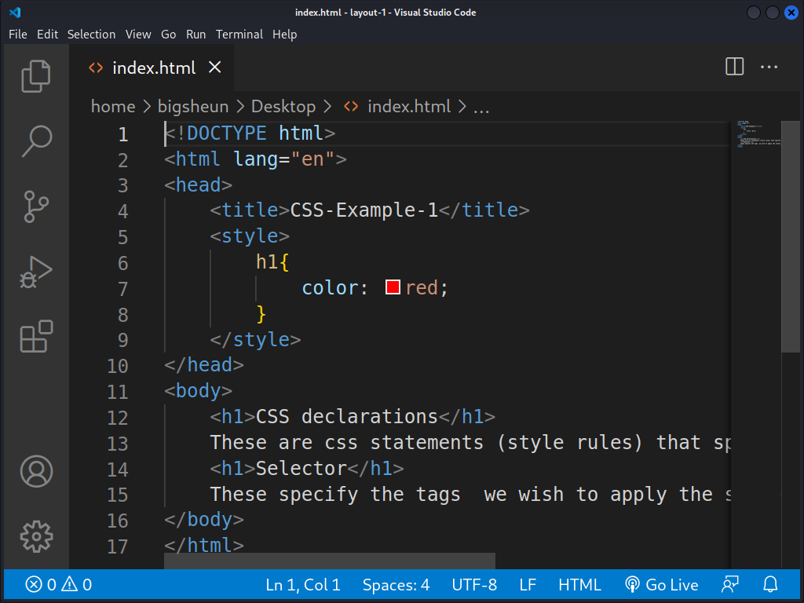

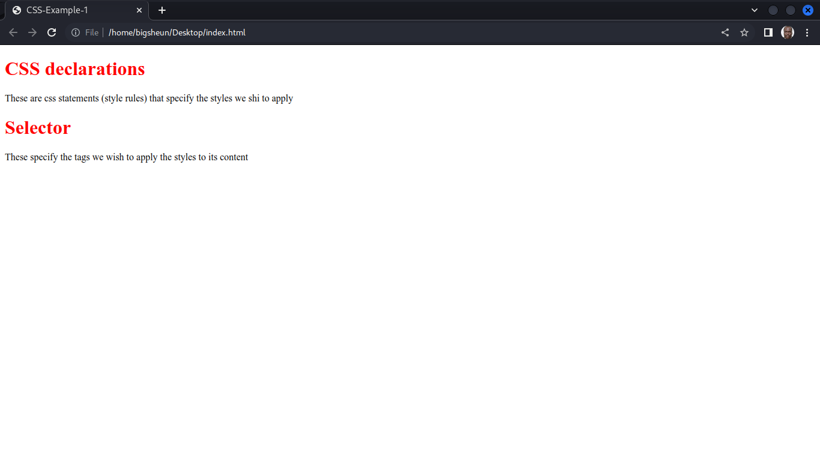

**CSS Rules Overriding**

We have discussed four ways to include style sheet rules in an HTML document. Here is the

rule to override any Style Sheet Rule.

•Any inline style sheet takes the highest priority. So, it will override any rule defined in

<style>...</style> tags or the rules defined in any external style sheet file.

•Any rule defined in <style>...</style> tags will override the rules defined in any

external style sheet file.

•Any rule defined in the external style sheet file takes the lowest priority, and the rules

defined in this file will be applied only when the above two rules are not applicable.