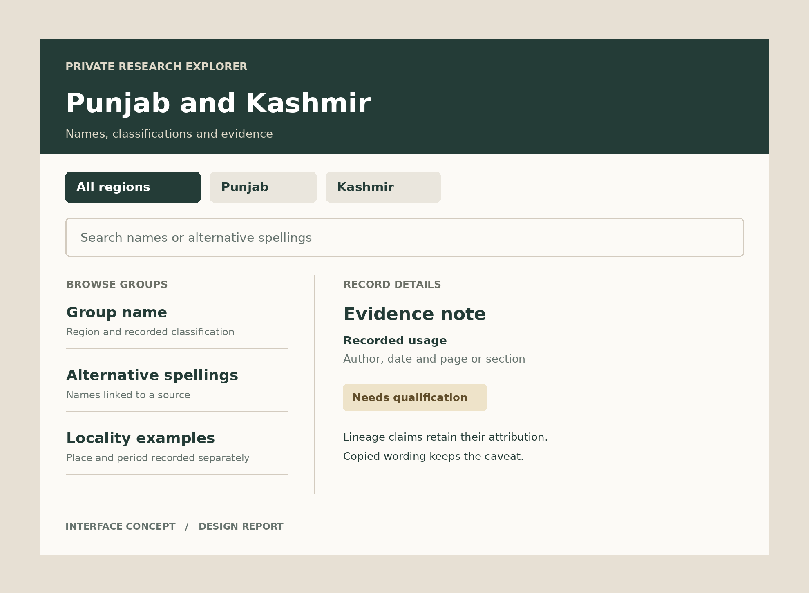

Tribes Clans and Biradaris
of Punjab and Kashmir
Private explorer design report |  | Project working draft  7 October 2026

Contents
Executive summary 3
Key findings 4
Recommendations 5
Appendix 6

How to use this report
Read the executive summary for the proposed scope. Use the findings to guide how claims appear in records. Use the recommendations as the implementation checklist and the appendix as the evidence policy.

Document status
This is a design specification for a private explorer. The cover shows an interface concept. Record research, website implementation and website validation remain separate work.

Coverage note
Initial coverage follows the Pakistani Punjab and AJK project material. A record appearing in more than one region should be discoverable in each relevant filter. The directory will be selected rather than exhaustive.

Executive summary
Build a private research explorer that helps you check community names, classifications, locality examples and source notes before preparing social posts. The first version should let you browse Punjab or Kashmir, search alternative spellings and open one clear record at a time.
The central design decision is to attach evidence and uncertainty to individual claims. A name, a classification and a lineage tradition can have different levels of support. The interface should preserve those differences when you read a record or copy its wording. This document specifies a proposed design. It does not certify a complete historical directory or a deployed website.

At a glance
- Purpose. Check project content before turning it into social posts.
- First version. Region browsing, name search, record details and qualified copy.
- Access. Owner only through Sites. Public access requires your explicit approval.

Scope and audience
Use Pakistani Punjab and Azad Jammu and Kashmir as the initial browsing scope because these are the areas represented in the available project posters. Label Kashmir as Kashmir with an AJK scope note. Keep the project title broad, but do not imply that the initial collection covers the Kashmir Valley or every part of the wider region.
The primary user is the project owner reviewing names and wording on a phone or desktop. Begin with a bounded selection of records from the existing material. State the coverage limits prominently and add further communities only after their claims have usable references.

Key findings
The existing project material gives a useful starting inventory, but poster wording is not enough to verify every historical statement. The current AJK directory explicitly treats locations as examples, describes the list as selected and warns that affiliations vary by family, locality and source. Preserve those qualifications in the explorer. [1]

Classifications need context
Store tribe, clan, biradari, title and broader community identity as separate descriptive fields where the source supports that distinction. Do not force every record into one fixed lineage tree. A study of biraderi terminology specifically cautions that its relationship to caste, quom and zat is often overlooked. This supports a design with source-specific labels rather than a universal hierarchy. [3]

The source has a limited reach
A Bhimber study records locally used ethnicity or caste categories in a defined district sample. It can support statements about the groups recorded in that study. It cannot establish a complete AJK inventory, the ancestry of those groups or their distribution across all of Kashmir. Record the place, date and study limits beside the citation. [4]
Editorial rule. A reported identity or lineage tradition remains attributed to its source. A shared surname alone does not prove common ancestry. Missing evidence should produce a clear research note.

Implications for the explorer
Use concise summaries for browsing and a fuller evidence section for checking. Search aliases together, but show whether an alias is a verified spelling or a possible related name. Keep localities as sourced examples with dates where available. Avoid clan emblems unless their provenance can be documented; the current AJK directory labels its motifs as decorative. [1]
Theme | Observation | Implication
Names | Spellings vary in the working material. | Search aliases and retain their source.
Localities | Directory locations are examples. | Avoid exclusive territory labels.
Lineage | The brief requires qualified claims. | Keep attribution in copied wording.

Recommendations
Build one focused view with region filters, a search field and a list of matching records. Opening a record should reveal its classification, aliases, locality examples, claim notes and sources. Keep all of this available without hover interactions so the same workflow works on a phone.
- Make the record readable. Show the preferred name first, followed by alternative spellings and the source-specific classification. Use short paragraphs, visible headings, dark text and generous spacing. Display unresolved claims beside the affected wording rather than hiding them in a general disclaimer.
- Keep review simple. Provide a Needs review filter and a Copy qualified summary action. Copy the concise description together with its necessary caveat and source reference. If a record lacks adequate support, offer wording that describes the research gap. Do not label it verified.
- Deliver a bounded first version. Use a curated static dataset and browser-side search for the initial collection. A later version can add editing and synchronised notes if needed. If review flags use browser storage, label them as local to that browser and do not imply that they sync across devices.

Validation before private release
Check that preferred names and documented aliases return the same intended record, region filters handle records found in both regions, and a search with no matches offers a clear reset. Confirm that copied summaries retain their qualification and reference. Review the wording of every seeded record against the cited passage.
Check layouts at 320 and 390 pixels wide, readable text at 200 percent zoom, keyboard navigation, visible focus, labels for controls and touch targets of at least 44 pixels. Deploy only through the owner-private Sites path and confirm successful deployment. These are acceptance criteria for the future website, not completed website test results.

Appendix

Evidence and review rules
For each record, retain a stable identifier, preferred name, documented spellings, browsing regions, sourced classification, locality examples, concise summary and claim-specific references. Each reference needs an author or organisation, title, date, URL where available, and a page, table or section locator. Store original source wording separately from the edited summary.
Use three evidence labels: Supported in cited context, Reported tradition and Needs verification. Keep these separate from editorial progress such as Needs review or Reviewed. A reviewed record can still contain a disputed claim. Sources that report a tradition demonstrate that the tradition was recorded, not that its genealogy is proven.

Sources and their limits
- [1] Project material. AJK Biradari Localities Directory and Ornate AJK Biradaris Locality Guide. Current supplied images, inspected 7 October 2026. Use for the project inventory and its stated caveats. Text extraction was incomplete, so verify names against the images before importing them.
- [2] Project material. Major Rajput Clans of Pakistan. Current supplied image, inspected 7 October 2026. Use as a working inventory. Its classifications, locality examples and emblem claims still need individual references before publication.
- [3] Bittles, A H, and N A Small. Consanguinity genetics and definitions of kinship in the UK Pakistani population. Journal of Biosocial Science 48(6), 2016, pp 844 to 854. Abstract consulted for the terminology caution. https://pubmed.ncbi.nlm.nih.gov/26707179/
- [4] Jabeen, Nazish, and Sajid Malik. Consanguinity and Its Sociodemographic Differentials in Bhimber District Azad Jammu and Kashmir Pakistan. Journal of Health Population and Nutrition 32(2), 2014, pp 301 to 313. Consult Table 1 and the methods for local sample limits. https://pmc.ncbi.nlm.nih.gov/articles/PMC4216966/
Research next step. Resolve source passages for each selected name before treating the dataset as ready for social posts. Historic census works and gazetteers may help, but their administrative categories and period boundaries need explicit context. Keep the website owner private unless you approve a change in access.

