QC MEMBER QUICK GUIDE
Login & Sign Attendance
Follow the numbered boxes beside each screenshot.
STEP 1
Log in
Use the email registered with QC and your private password.
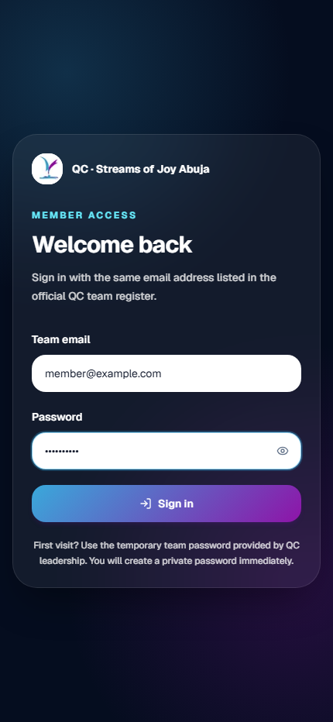 | 1 Click Team email Enter your registered email.  2 Click Password Enter shared password (QCSOJA)  3 Click Sign in Wait for the homepage to open.  IMPORTANT  First visit? Use the temporary password supplied by QC leadership, then create your private password.

STEP 2
Sign attendance
Only sign when you are physically at church and ready to serve.
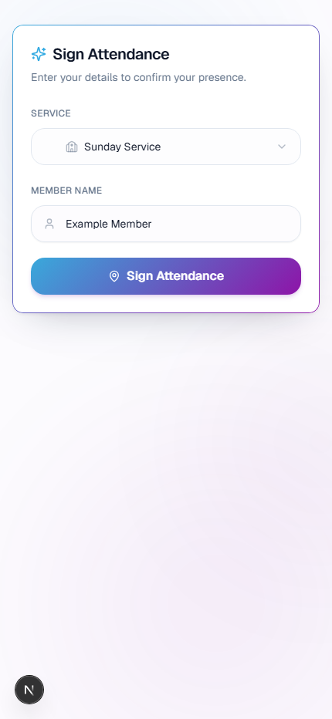 | 1 Click Service Choose the correct service.  2 Check Member Name Confirm that your linked name is correct.  3 Click Sign Attendance Allow location access when your phone asks.  IMPORTANT  Keep GPS/Location Services on. Wait for “Attendance Confirmed” before closing the page.
If attendance is closed, your name is wrong, or location fails, contact your QC team lead.

