QC SERVICE OPERATIONS
Service Tools & Reports
Picture-led quick guide
1  Service Post | 2  Timer | 3  Observer | 4  Emergency | 5  Manager
Choose the tool assigned to your role
Open Service Tools, select the correct card, complete the form immediately after the service activity, review it, and submit only once.
Rule: Use factual entries, correct service/date, and example-free real data when submitting. Never share manager passwords.

REPORT 1
Service Post Report
Headcount, standards and incidents for one assigned observation area.
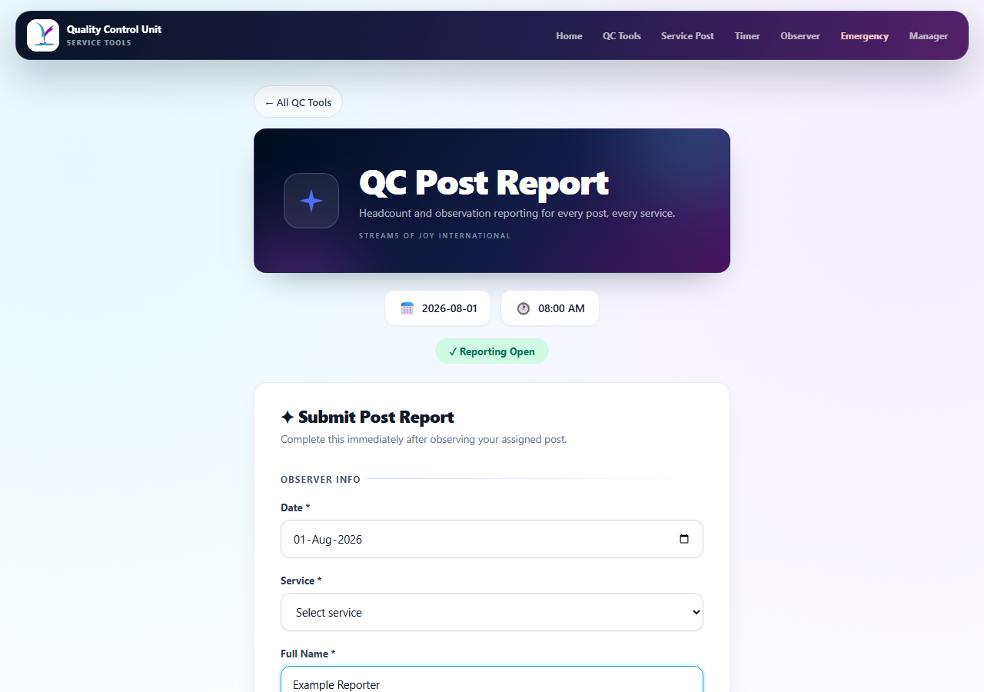
1 Choose service and area  Select the correct service and your assigned observation area. | 2 Enter reporter and headcount  Add your full name, adults and children observed.
3 Rate the post  Complete every required preparedness, neatness, orderliness, conduct, compliance, coordination and overall rating. | 4 Review and submit  Add observations/incidents, tick the accuracy confirmation, then click Submit Report.
Function: Creates the post-level evidence used in the compiled leadership report.

REPORT 2
Service Timer
Track actual timing and every early, late or on-time program segment.
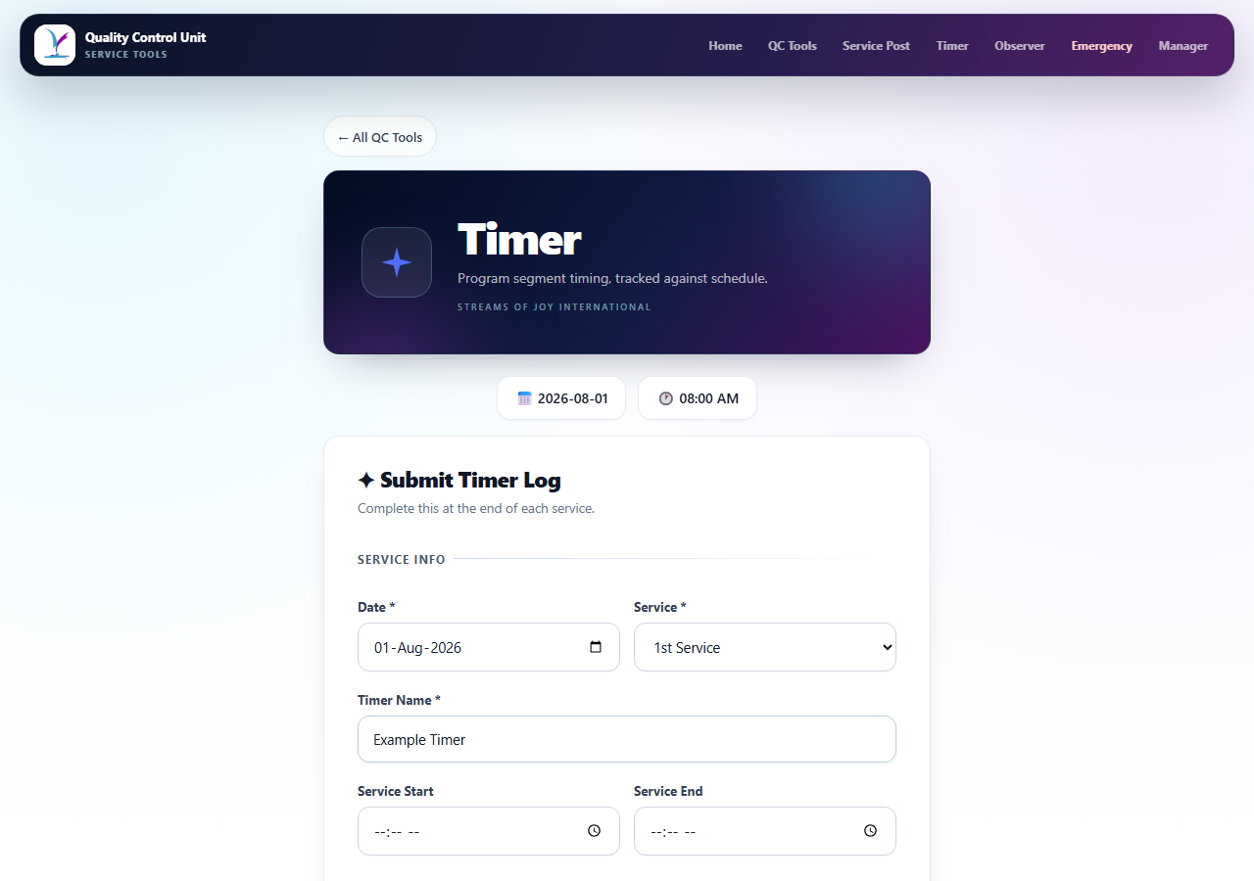
1 Identify the service  Confirm the date, service and timer name. | 2 Enter start and end  Record the actual service start and service end times.
3 Mark every segment  Choose On Time, Overshot or Finished Early; enter minutes and seconds for any variance. | 4 Submit the timer log  Add the general observation, review all segments and click Submit Timer Log.
Function: Produces a segment-by-segment timing record for leadership review.

REPORT 3
Observer Report
One structured report covering every unit visited during the service.
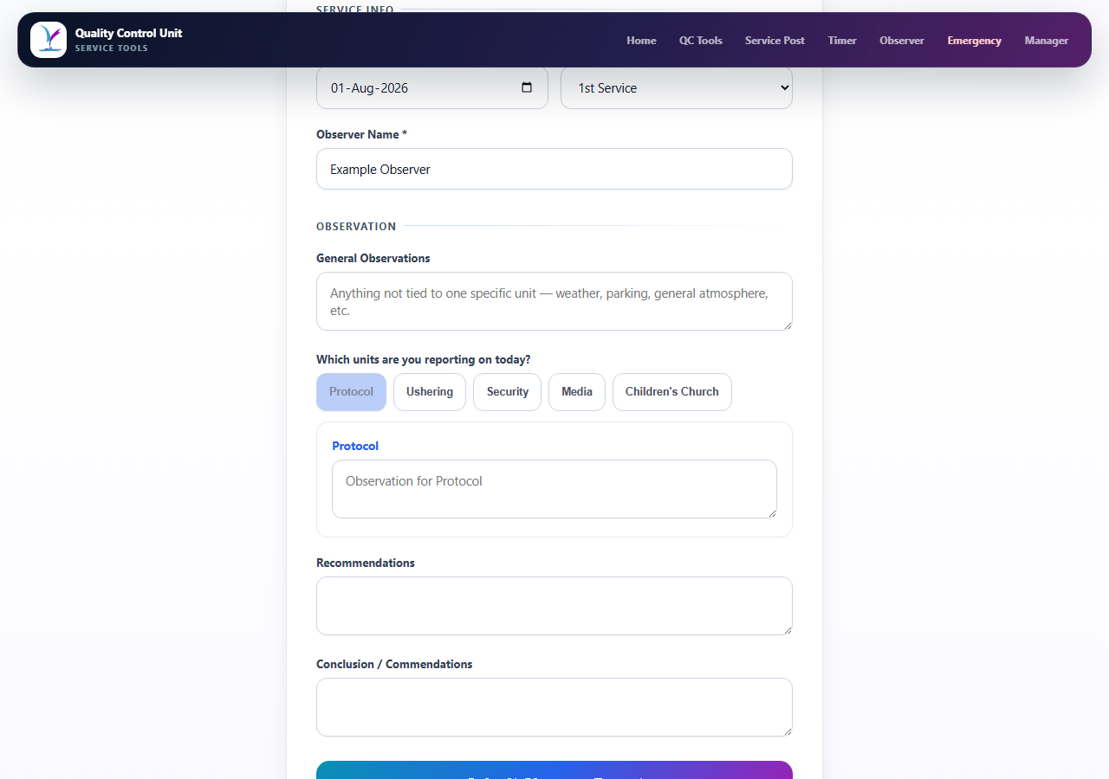
1 Enter service details  Confirm date, service and observer name. | 2 Write the general view  Record the service atmosphere or issue not tied to one unit.
3 Select units visited  Click each unit actually observed; a separate text box opens for each one. | 4 Conclude and submit  Add recommendations and commendations, then click Submit Observer Report.
Function: Combines cross-unit observations into one leadership-ready report.

URGENT TOOL
Emergency Flag
Immediately alert connected QC users about an urgent incident.
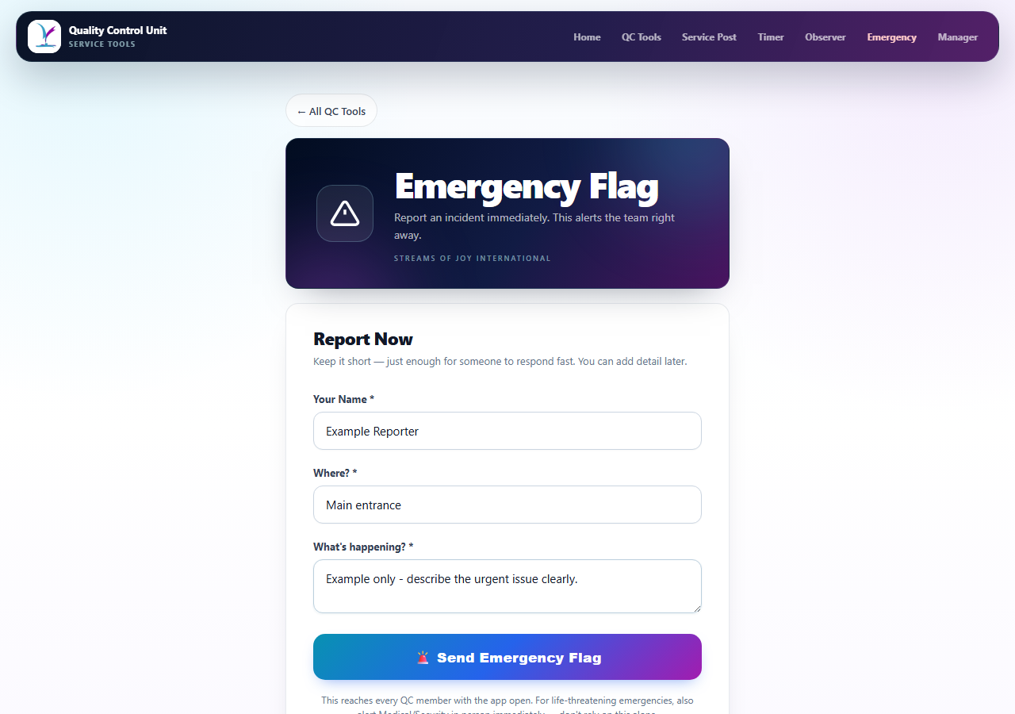
1 Enter your name  Use a name responders can identify quickly. | 2 Give the exact location  State the entrance, aisle, gallery, class, gate or post.
3 Describe the incident  Keep it short and factual: what is happening and what help is needed. | 4 Send immediately  Click Send Emergency Flag, then follow the physical escalation procedure.
Safety: For a life-threatening incident, alert Medical or Security in person immediately. Do not rely on the app alone.

LEADERSHIP
Service Manager
Restricted workspace that combines all submitted reports into one service view.
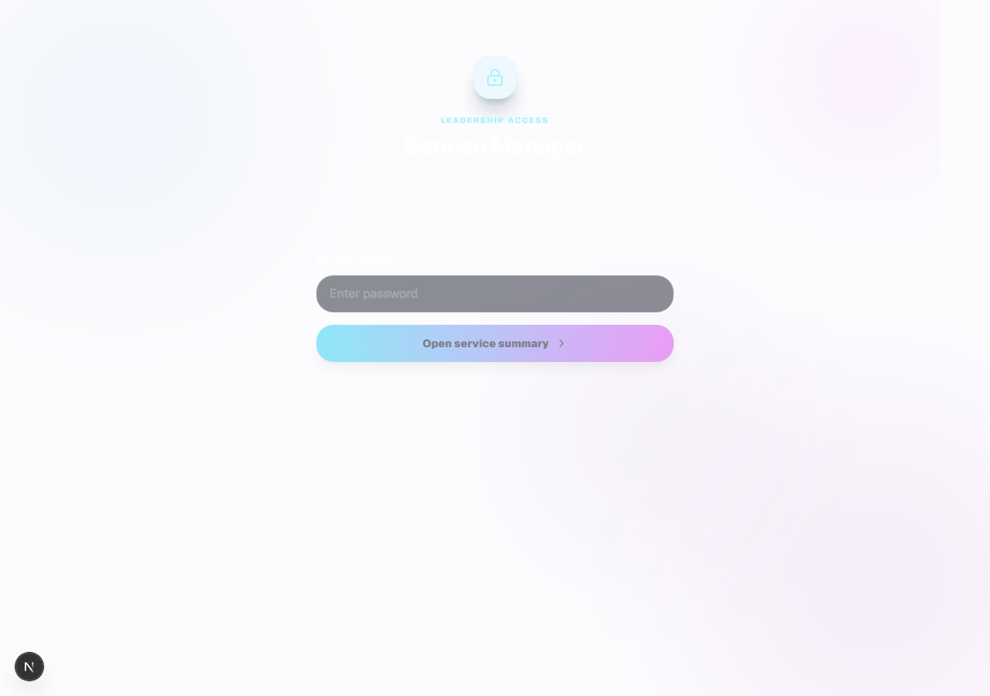
1 Unlock  Enter the authorised manager password and click Open service summary. | 2 Choose date and service  Review the all-services overview, then click View report for one service.
3 Read the compiled report  Check headcount, post ratings, timer status, observer notes, incidents and emergency flags. | 4 Generate or email  Click Generate report for the workbook; use Email report only for an approved recipient.
Function: Turns the Service Post, Timer, Observer and Emergency submissions into a single operational picture.

FINAL CHECK
Before You Submit Any Report
A 20-second accuracy check prevents duplicate or misleading records.
Correct date and service
The selected service matches the one you observed.
Correct identity and area
Reporter name and observation area are accurate.
Complete required fields
Every required rating, unit note or timing segment is complete.
Factual wording
Observations describe what happened, where and the operational impact.
One submission
Wait for the success message; do not submit duplicates unless instructed.
Support: If a form fails, capture the exact error message and contact the QC team lead. Do not send passwords or sensitive incident details through an unauthorised channel.

