1. Requirement Analyze

By reading the task sheet,

1. Design

为了保证功能间的解耦，应该要拆分函数，不应把函数写的过于复杂。对于循环的处理应该尽早捕获异常，尽早捕获异常。

* 1. Total Design

Total design has already mention in task sheet, which should contain Market, Company, Investor, BasicStrategy.

Market has a static object

Company has these objects

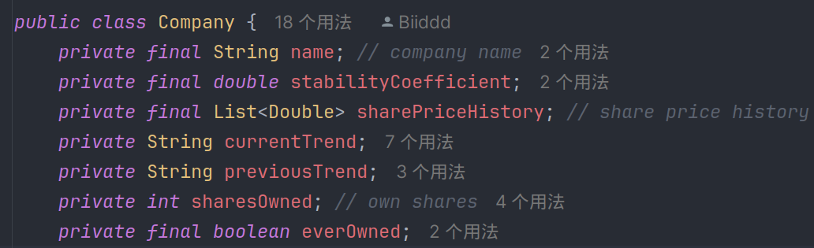

Investor has these objects

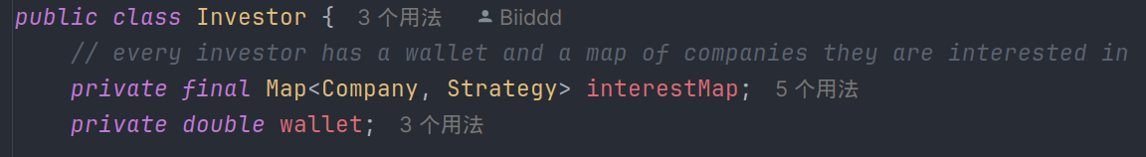BasicStrategy has these objects

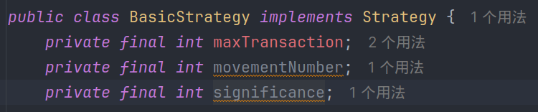

* 1. OOP

功能设计遵循面向对象的原则，在这个项目中，不适合使用继承，市场应该作为一个单独的类和对象来管理公司。Market类中，公司链表为private, 保证了链表对象不能被随意访问而是只能通过方法进行修改。有三个公共方法对市场增加，删除，获取公司

1. Test
   1. Market class
   2. Company class
   3. Investor class
   4. BasicStrategy class