Systems Development Report

Table Of Contents

**1.0** - Introduction …………………………………………………………………………………..…… 1

**2.0** - Mission Statement …………………………….……………………………….…………………. 1

**3.0** - Stakeholder Analysis ……………………………………………………………….………….... 1/2

**3.1** -Employees ……………………………….…………………………….…………………. 2

**3.2** - Technical Staff …………………....………………………………………….……………. 2

**3.3** - Suppliers ……………………………….…………………………….…………….…….2/3

**3.4** - General Public ………………………………………....…………………….……………. 3

**4.0** - Prioritised Requirements ………………………………………………………………………………………………….….... 3/4

**5.0** - Use Cases

**5.1** - Use Case List Based on Requirements ………………………………………………………………………… 4/5

**5.2** - Use Case Diagram ……………………………………………………………………………………………………….... 6

**5.3** - Textual Use Case …………………………………………………………………………………………………….….. 6/7

**6.0** - Management Approach …………………………………………………………………………………………………….… 7/8/9

**7.0** - Outline Project Plan (Gantt Chart) …………………………………………………………………………………………….. 9

**8.0** - Lo-Fi Prototypes ……………………………………………………………………………………………………………. 10/11/12

**9.0** - Critical Success Factors ……………………………………………………………………………………………………….……. 13

**10.0** - Evaluation Plan …………………………………………………………………………………………………………...…… 13/14

**10.1** - Verification Testing ………………………………………………………………………………………………. 13/14

**10.2** - Validation Testing ..…………………………………………………………………………………………………14/15

**11.0** - Professional Considerations ……………………………………………………………………………………………… 15/16

**12.0** - Summary ………………………………………………………………………………………………………………….……… 16/17

**13.0** - Inserts ………………………………………………………………………………………………………………………………….. 18

**13.0** - References ……………………………………………………………………………………………………………………………. 19

**Introduction:**

This report delivers the collection of tasks carried out by team members in order to help explain the components which make up our helpdesk system, and how we will implement it within the working environment. As well as this we will mention specific issues we must keep in mind when dealing with personal data such as ethics, and legal issues which are explained in more detail. The helpdesk is situated within a banking environment, and the functionality is explained thoroughly within the mission statement along with our goals, and how we aim to reach these.

**Mission Statement:**

Our aim is to contribute to the successful growth of our banking business by providing consistent, flexible and high quality, technical support for all employees. We strive to uphold a high level of satisfaction as well as maintaining a strong relationship with other employees through exceeding expectations. Our team is the first, and only point of contact for any IT related issues within the organisation, and therefore we create a welcoming and supportive environment to those individuals who seek support. The helpdesk team is made up of six technicians, each with an individual speciality, and by combining these talents we aim to uphold and deliver the quality service we promise.

We seek to achieve this through carrying out a number of activities, including:

* Provide helpful and friendly support as the first point of contact for the bank without being condescending towards other employees in different departments.
* Provide varying levels of support depending on the complexity of the problem.
* Log all problems and respond to them all in relation to potential impact they can cause the business as a whole, with major problems being highlighted and given priority.
* Provide necessary information regarding upgrades/replacement of hardware.
* Offer a FAQ service for employees to refer to quickly.
* Aim to fix all issues within 24 hours of logging the problem.
* Carry out all jobs with care and attention, and ensuring problem is resolved and explained to the individual before leaving.
* Have an online form enabling individuals to review and comment on our level of service.

**Stakeholder Analysis:**

There are numerous stakeholders that are involved within our help desk. The individuals seeking help and solutions to their problems known as employees. The technical staff which work behind the help desk providing these different levels of support. The technical staff themselves will have suppliers who they rely on in regards to supplying both soft/hardware to the organisation. Another stakeholder which can be considered is the general public, who will in turn be affected if the helpdesk technicians cannot provide sufficient help to employees within the bank.

This analysis shows how the different stakeholders are dependent on one another, and if one group fails to deliver, then it will create further problems for other groups, and the business itself.

**Employees –**

The services provided by the helpdesk as mentioned in our mission statement is available to all employees, at all levels within our banking business. The helpdesk should be a point of communication for employees if they incur a technical problem during their working day. Employees should not hesitate to contact the helpdesk as often small problems are both easier, and quicker to solve. On top of this problems which are ignored or worked around, generally get worse before getting better.

Examples of some problems employees may face include:

* Printer issue – faulty connection, printing too slow, documents going to wrong printer etc.
* Software problem – program crashed, data lost, can’t open downloads etc.
* Hardware problem – computer failure to turn on, keyboard/mouse doesn’t work etc.

Before ringing the helpdesk, employees can check a list of frequently asked questions if they have a minor problem. This list of FAQ’s is made up of recurring simple problems which the technicians have grouped together with solutions, enabling employees to attempt at fixing minor problems. The problems received by the help desk are tiered depending on two key factors. The level of complexity, as well as their severity in relation to the business as a whole. Therefore technical issues with a higher overall ranking will be dealt with first by the helpdesk.

**Technical Staff –**

The technical staff are the individuals whose role within the organisation is to provide support to other employees with less technical expertise. There is a team of six internal technicians within the business, all who share a basic skill set but each have their own specialities. When technicians initially receive an enquiry, first they log the problem in the records. This enables them to see if this problem has occurred before, and if it has then the appropriate solution will ideally be stored alongside it, therefore the issue can be solved quicker. However, if this is a new problem then the technicians will have to decipher the level of impact this can have on the business as a whole if not solved quickly. Once this has been decided a technician will be assigned the job and in due time will provide the adequate level of support necessary in order to eradicate the issue. Support is offered in a tiered system with the first level of support will be a response in the form of email or phone call as these tend to be simple problems. Second level of support is where a technician will take remote control of the device and fix the problem this way. And lastly the third level of support is in the form of an onsite visit, and this is in response to the most complex issues faced by the employees.

**Suppliers –**

The business is very up to date with technology in order to maintain a competitive advantage with our customers. As a result we are often updating both software and hardware which we source from a small group of suppliers. We have built up these relationships over many years of trading and secured good contracts as a result. When we suffer technical issues within the banking environment which require a new piece of equipment, our suppliers can quickly provide us with a certain product or part, often within 24 hours, showing the level of reliability.

**General Public -**

The general public will not be interacting directly with the help desk system. However, they can still be influenced depending on the level of effectiveness. If the technicians are unable to fix problems then this will leave employees of the business unable to carry out their work effectively, or to the full extent. As a result the general public may not be make to make the most of the facilities the bank has to offer, and may be unsatisfied with the level of service. This shows how the efficiency of the helpdesk system, can influence the business as a whole, and potentially result in loss of customers and market share if nothing is done to improve the way in which the helpdesk operates.

**Prioritised Requirements List:**

MoSCoW analysis is a framework which enables developers of systems to evaluate stakeholders requirements and prioritise them in a way which enables developers to deliver the greatest and most effective system.

It involves ‘must have’, ‘should have’, ‘could have’ and ‘won’t have’ requirements.

* Must have requirements are those that involve absolutely critical requirements which are essential to the system.
* Should have requirements are those that the system ideally should include.
* Could have requirements are often requirements considered as optional extras.
* Won’t have requirements therefore are features that the system will not include. Developers must be explicit in what they system will be lacking, and enforce the fact that customers cannot assume things.

|  |  |  |  |  |
| --- | --- | --- | --- | --- |
|  | **Must Have** | **Should Have** | **Could Have** | **Won’t Have** |
| **Employees** | A notification system to enable users to know when their problem has been logged.  Technical staff which can accurately fix problems, and not half heartedly carry out the job.  A section of FAQ’s for users.  A reasonable response time - up to 24 hours. | A straightforward way of declaring you have a problem - telephone call.  Technical staff which are friendly and welcoming, making you feel comfortable in approaching them with any tech issues. | A system which provides the employee with an estimated waiting time. | Won’t log problems based on the employee's level of status, therefore managers and directors may become frustrated due to waiting. |
| **Technical Staff** | A good relationship with suppliers a number of different suppliers so they always have someone they can rely on to replace faulty software/hardware relatively quickly.  A sufficient budget for the team to work with, in order to maintain and update the bank's technology - in regards to both software and hardware. | Employees within the bank which are not demanding, and understand the technicians workload.  Once the third layer of support has failed to solve the problem it should be outsourced to an external provider of IT support. | The scope to communicate and select their own suppliers, as they are the people with technical knowledge to provide a more efficient help desk system. | Won’t include requirements which haven’t been agreed by all stakeholders. |

**Use Cases:**

Use cases will allow us to document the interactions which take place within our help desk system from an external point of view. As a result this will provide us with an insight into who uses the system and how they interact with it.

**Use Case List Based on Requirements:**

The use case list based on our Help Desks requirements include:

**Search FAQs:** Bank employee firstly goes to the FAQ page designed by the tech staff that answers common questions to problems that have previously been reported. If the employee cannot fix the problem themselves they can then go on to report the problem.

**Report problem:** Bank employee emails the IT staff reporting what their problem is or a description of what is wrong.

**Run through checks with employee:** IT staff runs through checks with the employee to rule out the common problems. For example, if they are trying to send send an email make sure the computer has internet connection.

**Identify problem:** If the basic checks haven’t worked, the tech staff then use the information given to determine what the problem could be, creating a few scenarios and solutions to solve it.

**Use appropriate tier to fix:** IT staff sorts the problem into an appropriate tier which will determine how they will go about fixing it. This includes:

1st Tier: Telephone/Email response

2nd Tier: Remote hands on support

3rd Tier:  On site visit from support staff

**Fix problem:** The problem is fixed by using the tier that has been previously decided.

**Check if problems resolved:** Bank employee logs on their online portal to say if the problem has been fixed or not. If the bank employee is not confident the problem has been resolved the problem goes to a higher tier.

**Provide new software:** The supplier provides the latest software for the IT staff to use. This is important as logging the problems reported is vital in giving the bank employees an efficient service.

**Use Case Index:**

|  |  |  |  |  |
| --- | --- | --- | --- | --- |
| ID | **Use case** | Primary | Complexity | Priority |
| 1 | **Search FAQs** | employee | high | 1 |
| 2 | **Report Problem** | employee | low | 3 |
| 3 | **Run through checks with employee** | tech staff | high | 1 |
| 4 | **Logs Problem** | tech staff | low | 2 |
| 5 | **Use appropriate tier to fix** | tech staff | high | 2 |
| 6 | **Fix problem** | tech staff | med | 1 |
| 7 | **Check if problem is resolved** | tech staff | med | 1 |
| 8 | **Provide new software** | supplier | low | 3 |

**Use Case Diagram:**



**(Figure 1)**

**Textual Use Case:**

**Name of the case:** Fix problem

**Version:** 1.0

**Goal:** For the help desk to fix the IT problem given by the employees of the bank, efficiently and effectively.

**Summary:** Technical staff have to work out what Tier the problem will be categorised under and in turn how they propose to fix it.

**Actors:** Technical staff (primary actor), Bank employee (secondary actor), Computer system (secondary actor)

**Stakeholders:** Bank employees, Technical staff, Suppliers

**Preconditions:** A problem must have been reported, The IT desk must have been contacted

**Triggers:** A bank employee telephones the help desk

|  |  |
| --- | --- |
| **Success path:** | **Failure Path:** |
| * The problem is sorted into the right tier * Help is then given depending on the severity of the problem * Employee feeds back to say whether problem has been fixed or not * Problem was fixed | * Problem was sorted into wrong tier therefore not resolved effectively or not at all |
|  | * System might not log report (user error) |
|  | * Technician doesn’t check their emails |
|  | * Too many problems reported at one time therefore not enough IT staff on hand to help |

**Postconditions:** Problem is fixed and the bank employee is satisfied, being able to continue with their work.

**Notes**: In periods where there are many problems reported at once a hierarchy system could be put in place to make sure the most urgent issue is fixed first.

**Authors**: F.L.E.X : Samphire Reeve, Maria Faud, Jack Patten, Bijan G.A

**Management Approach:**

While planning the creation of our help desk, we collectively reviewed and discussed a range of development approaches to identify which agile method would be most suitable for our needs. After some deliberating, we decided that Crystal Methodology would be appropriate to satisfy our needs.

Crystal Methodology, also known as lightweight methodology, is a development approach that is a collection of smaller methodologies, depending on the severity or importance of the task at hand. Each of these methodologies is named after a colour. This labelling system ranges from crystal clear to crystal sapphire. One of the main principles of this specific development approach is the use of frequent delivery. This is the idea that after a certain time period (ranging from weekly up to quarterly), designers will share what they have done, showing the progress and helps to evaluate how the project is coming along. This is an incredibly beneficial feature as it allows project managers to keep on top the project's status. We saw this as a useful tool to ensure our help desk is following the correct path, and if any issues are identified, we will be able to deal with these before they become too problematic. 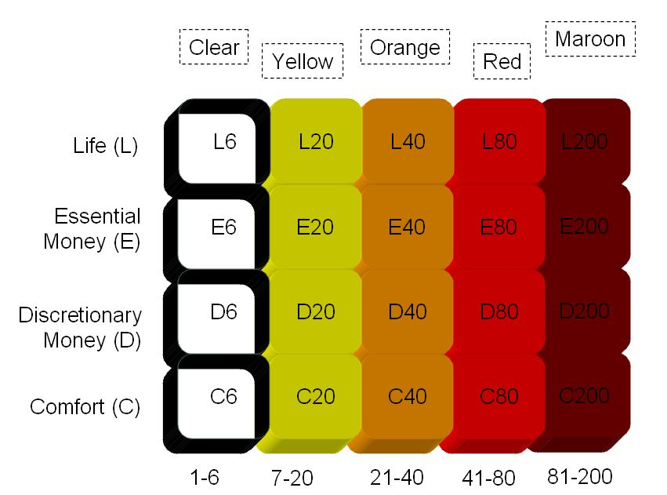

**(Figure 2)**

As well as the reasons already discussed, we also decided that the reflective development side of the crystal methodology approach was a great way to ensure that a quality project would be developed by the end of the development cycle. A common problem found with developers is that they are easily caught up in their work, and they cannot see where they are going wrong. This is where reflective improvement proves invaluable, giving designers a chance to step back and view at their work from a different angle, potentially enabling them to find a superior way of accomplishing their goals .

In smaller methodologies, ‘*Osmotic Communication*’ is used. This involves the whole team being in one room whilst working. Normally in groups of 8 or less. This allows people who are working on different facets of the project to ask another developer for there opinion on a particular issue they may have. This can save time by wasting time by either communicating electronically or having to physically move in order to get the information they required. More importantly however, it can allow groups of developers to start working together in a way which would be less likely to occur if the only form of communication is through electronic mediums.

The leading reason for selecting crystal methodology, was its focus on personal safety. Everyone in the design team has something to offer, a new idea or a different of approaching an issue. The focus on personal safety encourages these individuals, who may not be most confident socially, to share their ideas without the fear of mockery or embarrassment. This allows all ideas to be discussed and appreciated. This creates an environment which promotes creativity, and a comfortable workplace for the developers.

**Outline Project Plan (Gantt Chart):**

**(Refer to Report Inserts, Page 16 for Gantt Chart - Figure 3)**

We were able to plan the project through the use of a Gantt chart. This was split into three distinctive areas; the design, prototype and final phase. Each of these phases are dependant on the previous one’s completion and approval. For example, the systems design being approved for the prototype phase to commence, and the final prototype being approved for the final phase to begin.

During the design phase the team initially determines the needs of the bank, and then follows this up by drafting the design of the system. The draft design then needs to be both reviewed and approved, before we move onto the prototype phase. The prototype phase begins with the creation of the prototype. This will then be tested within a suitable environment, such as a bank. After this testing period, the necessary changes will be made to fix all flaws which became apparent. Similarly to the design stage, this phase ends with a review of the prototype, which is hopefully followed by approval and then the final phase. This involves rolling the finished product into the bank on a trial period to determine whether or not the final design is effective and efficient in carrying out the required role.

The critical path of the project all depends upon the review stage of each individual phase. If this approval of each phase is not granted, the product as a whole would be deemed a failure. This is unless each stage was revisited until approval was gained, enabling the project to move onto the next stage.

**Lo-Fi Prototypes:**

Below is the lo-fi design of our banking help desk, which is split into three sections.

**(Figure 4)**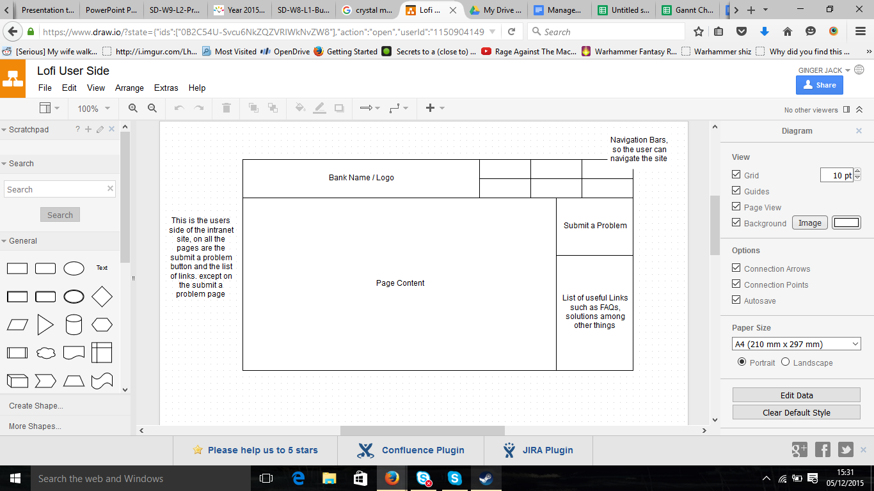

The first section, (Figure 4) is a standard page found on the intranet site for the bank. On the right hand side are two buttons contained within a banner, a feature present on all pages on the site. These two buttons enable users to *‘Submit a problem’,* one of the main features within our system. The second displays a list of FAQ’s, as well as contact information when clicked.

If users were to click the *‘Submit a problem’,* they would be taken to the following page. (Figure 5).

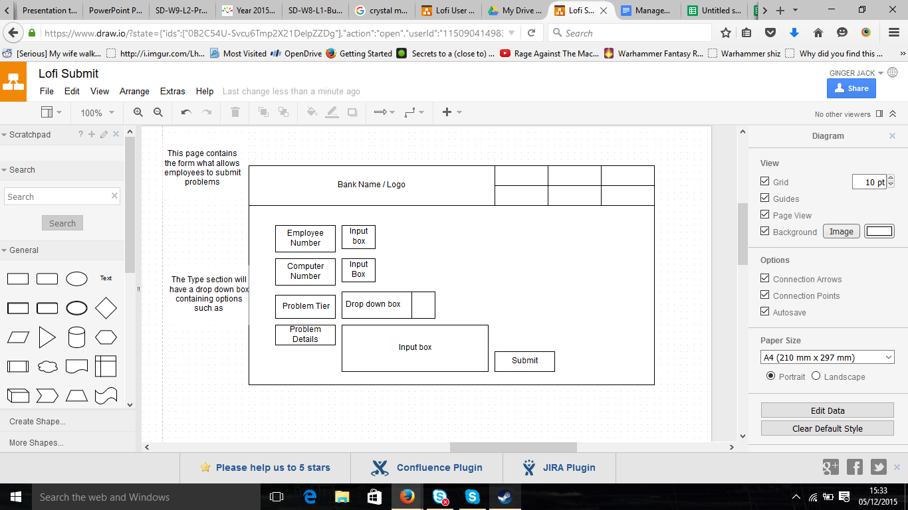

**(Figure 5)**

Figure 5 is a diagram of what the form would potentially look like. It contains four sections for the employee to fill out. The first two, require the input of both the employee and computer number. This is so the IT technicians can successfully identify who has encountered the problem and on which computer. This saves time in the long run, and therefore allows for a more efficient process. The last two are the problem name and the problem description. The problems are sorted by their name for the IT technicians and when clicked, will open a new tab with the description of the problem on. This can be seen below in (Figure 6).

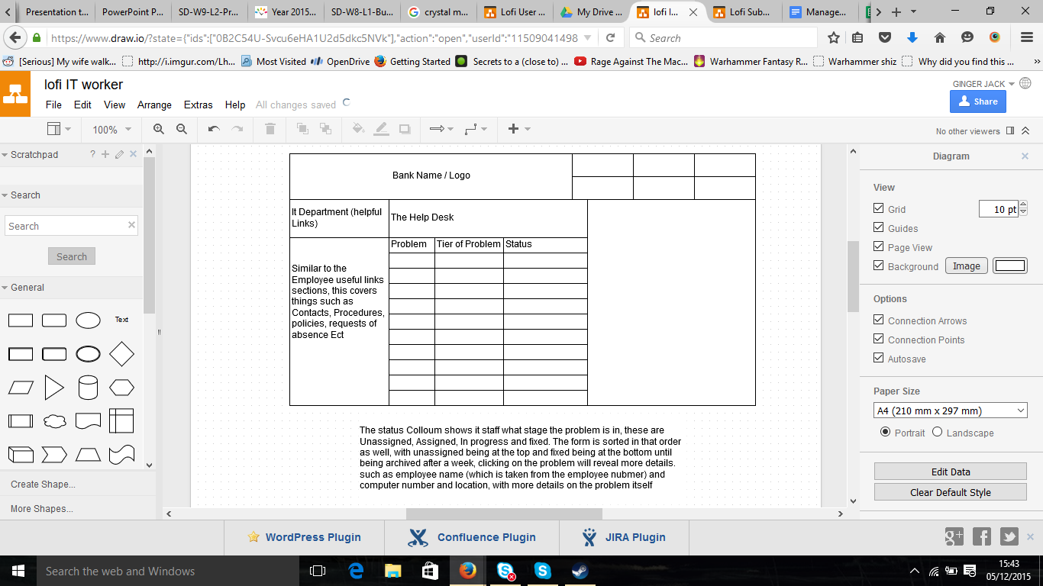

**(Figure 6)**

The final section of this prototype is the helpdesks staff interface. This is how problems are viewed. There is a table located in the centre of page with three headings; *‘Problem’*, ‘*Tier of the problem*’ and ‘*Status*’. The problem is the name inputted early by the staff suffering the problem. The tier of the problem is assigned when they first get the problem, and tells the IT staff what response method they will use when solving the problem, as well as the severity of the situation itself. The last heading is the status. This value is what sorts the order in which the problems are displayed on screen. The possibilities include; *‘unassigned, assigned, on going, completed’* and are sorted in that order. This allows for the least solved problems to be displayed first, therefore the first problems the IT technicians see as a result this prompts them to take action. As well as this completed problems are removed from table within 1 week of solving in order to create space for new problems.

**Critical Success Factors:**

Below we have listed our helpdesks critical success factors, as well as outlining an evaluation plan for the proposed system once implemented.

* Staff (Specialists, Telephonists, Technicians)
* Database
* Logging portal ( Email, Fax, Phone, Website )
* Staff tools ( Computers, Software, Hardware, printer, scanner )
* The process

**Evaluation Plan -**

The evaluation plan has been formatted into a table, making it easier to read what is being measured, at what stage of the system, as well as the tools that are being used to to carry out these evaluations. This has been split into two tables, one for verification testing and the other for validation testing.

**Verification Testing -**

|  |  |  |  |  |
| --- | --- | --- | --- | --- |
| **Stage** | **Key evaluation questions** | **Type of data collection** | **Test Tools** | **Type of evaluation measures** |
| Staff employment | Do staff have sufficient knowledge? | The staff will need to undertake a pre-test designed by our system specialists | Test case (Acceptance testing)  &  Checklist | Results from the pre-tests will be graded and compared using this measure |
| Logging portal installation | Does the logging portal work properly enough? | The technical staff will do a number of tests on our logging portals and check them with general standards | Test case  &  Dedicated Tester | The general standards and acceptance of our stakeholders |
| Database installation | Does the database handle the data and cope with the banking system database well? | The technical staff will carry out a number of tests on the database | Test case  and  dedicated tester | The general standards of a database and coping with other databases available in the system |
| Staff tools installation | Do staff tools work properly? | The technical staff will carry out a number of tests on staff tools and check them with general standards | Test case  and  dedicated tester | The general standards and acceptance of our users |

**Validation Testing -**

|  |  |  |  |  |
| --- | --- | --- | --- | --- |
| **External Attributes** | **Key evaluation questions** | **Type of data collection** | **Test Tools** | **Type of evaluation measures** |
| Reliability | What percentage of the problems get fixed? (SLA) | Both the number of problems reported by stakeholders, as well as the number of resolved problems reported by staff are stored in the database. These figures can then be compared, and evaluated. | Checklist | More SLA means that the helpdesk is able to fixed more problems which makes it reliable |
| Functionality | How well does the current system resolve a problem? | Sufficient feedback is collected from stakeholders and then monitoring of the system is carried out by the users. | Checklist  and  surveys | If feedback from our stakeholders is of a greater quality it means problem can be fixed both quicker, and more efficiently reflecting the functionality of the system. |
| Usability | How much does the helpdesk assist the banking system as a whole? | Feedback from our stakeholders via short surveys | Checklist  and  surveys | The more positive feedback received from our stakeholders shows that the helpdesk is easily usable by the bank and its employees |
| Efficiency | How much time is wasted during each process? | Feedback from our users via short surveys | Surveys | The less time wasted during during specific processes the more efficient the system works |
| Maintainability | How well does the system respond to changes? | Feedback from our stakeholders and users via short surveys after a number of changes have been applied | Surveys | A maintainable system is capable of responding to changes |

**Professional Considerations:**

Within businesses there are always professional considerations to keep in mind when designing systems and security policies including: legality, ethics and privacy. Banking systems are an example of organisations which store a large amount of personal data. This is therefore a sensitive matter for the majority of people, and data which they do not want shared amongst others. Examples of this data may include, any current or previous loans, their level of income and password/answers to various security questions.

When creating the helpdesk system, a number of ethical issues were kept in mind. The Computer Ethics Institute’s ‘role is to anticipate the ethical dilemmas that may arise and provide users with an understanding of the consequences’ and to ‘facilitate the examination and recognition of ethics in the development and use of computer technologies’ {CEI, 2015}. By abiding to the rules and regulations set by the institution we are ensuring our system follows guidelines and as a result should not suffer from any consequences.

However the service we offer as a helpdesk system to the bank is to solve problems. Some of these technical problems incurred by employees may result in technicians viewing secure data stored on the banks computers, or other devices in order to resolve the problem. Due to this, the number of people viewing ‘private’ data of customers increases, which thus increases the chances of a security breach. Such situations could be highlighted as a concern. Although unlikely, it is possible that the technical staff may misuse the stored data on a device, and by doing so will harm the privacy of the data owner.

This behaviour however is also not acceptable in relation to the BCS code of conduct, public interest, number 1, and the ACM code of ethics, general moral imperatives, number 1.7 and 1.8 {Smith, 2015}. To ensure the bank to keep its customers well-being at heart they must therefore take a number of precautions to protect their customers data, and ensure none is leaked. One way to avoid such unprofessional activities is to monitor the data flow by constantly ensuring no type of data, especially personal data is being misused. As well as this, ensuring employees and technicians working within the helpdesk agree to company contracts and security policies will reduce the likeliness of any problem.

As mentioned previously in the report, the helpdesk system consists of three levels with a different level of support being offered at each level, depending on the severity of the problem. All six technicians hold the same knowledge base, despite having individual specialities. As a result of this, all technicians should comply to the same rules and regulations regarding private data, and none will find themselves exempt.

To avoid any kind of unprofessional activity within our system, we shall support these greater policies in our system as well as creating the opportunities for our staff to be aware of these wider policies and principles outside of the organisation itself. In accordance to the ACM code of ethics, Organizational Leadership Imperatives and Compliance with the Code, number 3.5 and 3.6 and 4.1, it is the organisation’s responsibility {Smith 2015}. However, despite our efforts, staff are also expected to read the and learn the principles of these policies that have been highlighted by the BCS Code of Conduct, Professional Competence and Integrity, number 4 {Smith 2015}.

The gathering requirements stage of our project is another key moment as we need to ensure that our staff articulate their needs clearly enough as they are directly affected by the system (ACM Code of Ethics, Organizational Leadership Imperatives, number 3.4) {Smith 2015}.

As mentioned, we will be dealing with a large amount of personal data, and therefore we must be aware, and consider the legal issues which surround this topic when designing creating the helpdesk system, along with security policies and terms of use. One of the legalities considered was The Data Protection Act, 1998. This law regards the ‘processing of data on identifiable living people’ {Wikipedia, 2015}. The DPA has a number of rules which should be followed. The main principles, and most related to our system include; ensuring information is ‘used fairly and lawfully’, ‘for limited, specifically stated purpose’, ‘used in a way that is adequate, relevant and not excessive’, kept safe and secure’, ‘accurate’ and ‘kept for no longer than absolutely necessary’ {GOV, 2015}. Thus, our employees working within the helpdesk system must abide to these legal policies. If any of these are breached then punishments can result in legal action, and large penalties, depending on the situation.

Another professional consideration of our helpdesk system is the data protection regarding the legal issues. According to the data protection action principles the personal data must be protected properly enough that the system will not Offence the personal data which is against the legislation(Data protection, 2015). Thus, As it has been mentioned before our employees at the helpdesk system have no right to use the other's personal data. This act is legally and ethically unacceptable and will be considered as an illegal act.

**Summary:**

In summary our helpdesk has been created to provide a reliable IT service for a bank to ensure that their employees can run efficiently on a day-to-day basis. Our main stakeholders include; employees, technicians, suppliers and the general public, and each have individual needs depending on the role they play. The use of the Gantt chart enabled us to create specific milestones, to ensure the project stayed on track, as well as providing goals, which also acted as a motivator. The development method used to create our helpdesk will be Crystal Methodology, due to it’s reflective development approach. This was the best way for us to ensure that the helpdesk system delivered at the end of the development and was of high quality, meeting stakeholders needs. The critical success factors of our system included the process itself, staff tools, databases, the logging portal and of course the staff themselves. If any of these factors were to fail, then the project would be deemed a fail. We plan on developing our system within 6 months as can be seen on the Gantt chart, and form here will begin implementation.

**Inserts: (Refer to Page 9, Gantt Chart of System Development and Implementation)**

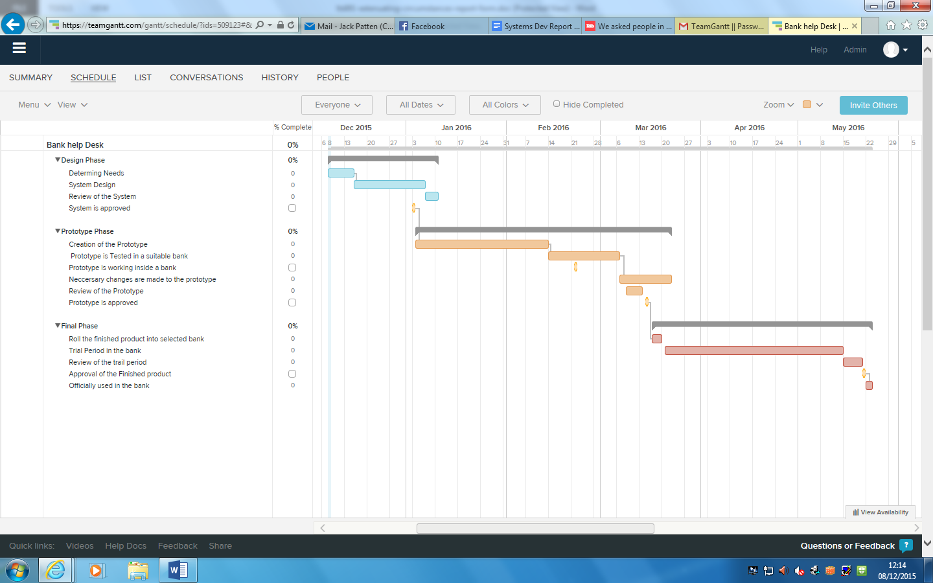

**References:**

Smith, D (2015), ‘Professional activity’, *lecture notes distributed in Lecture theatre 3 at The University of East Anglia, Norwich*

CEI (Computer Ethics Institute), ‘What is CEI?’

[Accessed On: 3rd December 2015]

Avaliable From: <http://computerethicsinstitute.org/aboutcei/whatiscei.html>

GOV.UK. (2015) ‘*Data protection’.*

[Accessed On: 7th December 2015]

Available From:<https://www.gov.uk/data-protection/the-data-protection-act>.

Wikipedia, (2015), *‘Data Protection Act 1998’*

[Accessed On: 8th December]

[https://en.wikipedia.org/wiki/**Data**_**Protection**_**Act**_**1998**](https://en.wikipedia.org/wiki/Data_Protection_Act_1998)