Fazeli Bijan Screen Shots and UML Diagram

Faculty screenshot

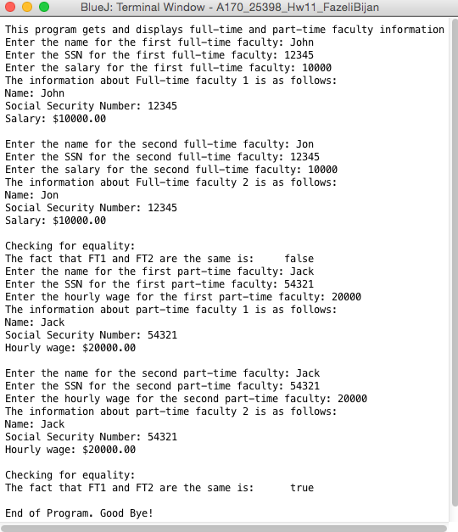

Faculty UML



Doctor screenshot

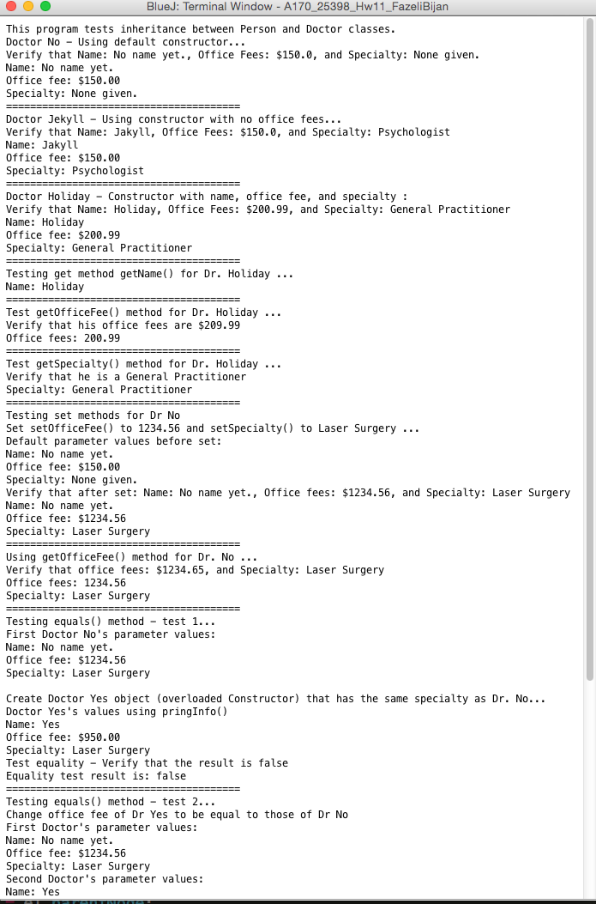

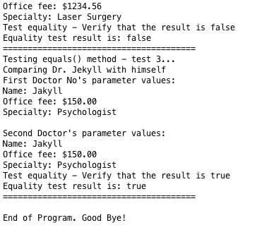

Doctor UML

