# Revision

## Section1

1. What is the significance of Generalization in a uml diagram

* In Uml diagram a generalization is a relationship in which one model element (child) is based on another model element(parent).

1. Specifies a inheritance relationship

* In simple, Inheritance relationship means the relationship where parents class has subclasses.

To show inheritance in UML diagram, a solid line from the child class to parent class is drawn using a unfilled arrow head.

1. Specifies that two classes are linked to each other

* Association are represented by a solid line between classes.

1. Specifies that the object are related to each other

* Association is used to describe that one object can be associated with another object.

1. Specifies that a class has multiple subclasses

* In Multiple inheritance the parent class has multiple Subclasses. to show in UML diagram, a solid line from the multiple child classes to one parent class is drawn using a unfilled arrow head.

1. What is the difference between private and protected access modifiers

|  |  |  |
| --- | --- | --- |
| S.N | Private | Protected |
| 1 | It makes the member of class accessible onto the class itself. | It makes the member of the class accessible to only itself and to its subclasses. |
| 2 | It makes the member of the class accessible to all other classes. | It makes the member of the class accessible to only itself. |
| 3 | It makes the member of the class accessible within a package. | It makes the member of the class accessible to only files within the package. |

## Section 2

3.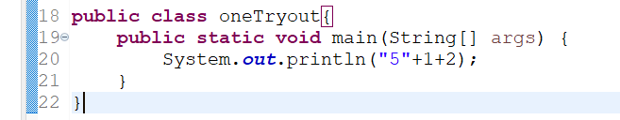

It prints 512

4.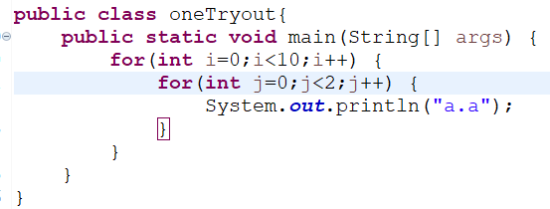

It prints a.a 20th times.

5.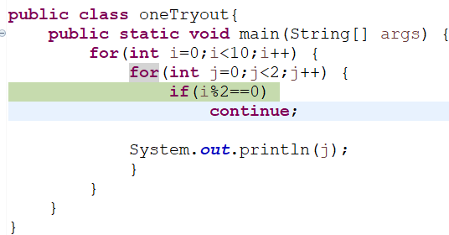

It prints 0101010101

6.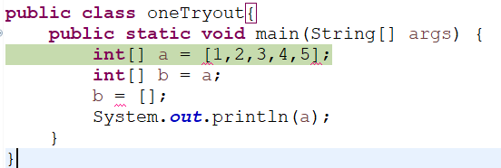

It prints Syntax error. To store value in array the syntax should be:

Int[] a = {1,2,3,4,5};

## Section 3

7. Write a program to know if the sum of all the digits of the number is even or not. The program should return true or false.