Title

Author

Abstract

Keywords [contactroshankoju@gmail.com](mailto:contactroshankoju@gmail.com)

Goto google scholor

->Chatbot review paper

->range from 2019-2023

1. Introduction and Background
   1. Chabot and Its history.

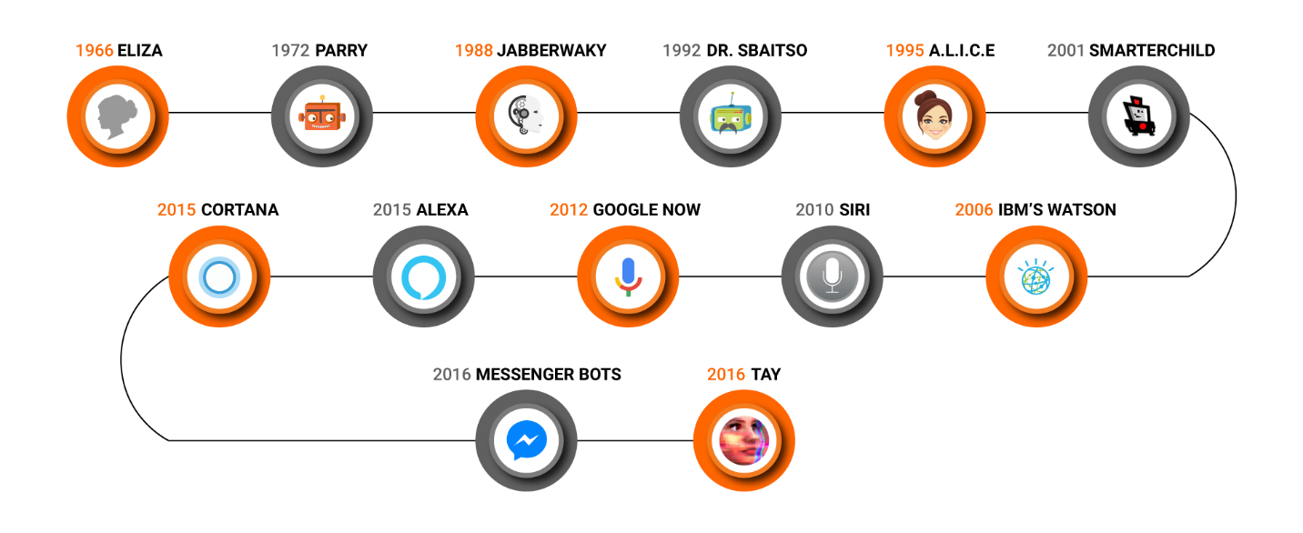

Fig 1. Brief History of Chabot.

An artificial intelligence (AI) program known as a Chabot is created to mimic a conversation with consumers via text messages, speaking instructions, or both of them. To give clients details, carry out activities, or communicate with clients, Chabot’s can be embedded into messaging services, web pages, or mobile apps. In order to understand and react to user inputs, they employ natural language processing (NLP) algorithms. They may also use machine learning to develop better replies over time depending on input from users. [1] Simple or complicated, question-and-answer models to sophisticated virtual assistants that can carry out intricate activities and offer tailored suggestions, Chabot’s can be anything from simple to advanced.

Alan Turing questioned if a computer program could communicate with a group of people in 1950 without the participants recognizing that the other person was artificial. Many people believe that the Turing test is the seed that led to the development of chatbots.

In 1966, the first Chabot with the name ELIZA was created. When delivering the user's phrases, ELIZA mimicked the actions of a psychotherapist by using the questionable tense. It has inadequate communication skills.

In 1972, PARRY made its debut; it portrayed a schizophrenic sufferer. Due to its ''personality'' and superior command structure, PARRY is thought to be more sophisticated than ELIZA. It establishes his replies based on a set of presumptions and ''emotional responses'' that are brought on by a shift in the relative importance of the user's words [2].

Since the creation of Jabberwacky in 1988, intelligent technology became initially applied in the field of chatbots. CleverScript, a programming system for creating chatbots inspired by spreadsheets, was applied to create Jabberwacky, which employed contextual pattern matching to answer depending on past conversations.

The creation of SmarterChild in 2001, which was accessible on platforms like America Online (AOL) and Microsoft (MSN), marked a significant advancement in the field of Chabots.

For the initial time, a Chabot could assist users with actual daily chores by retrieving data from databases including movie times, sports scores, market prices, news, and weather.

Apple created Siri (Siri) in 2010, paving the way for individual helpers. It provides interaction with video, audio, and pictures, and consumers may communicate with it via speaking instructions via Messengers. [3]

Early in 2016, there was an advancement in artificial intelligence technology that fundamentally altered how consumers interact with firms. Developers might build chatbots for a company or service on social media networks, giving users the ability to carry out particular daily tasks using messaging programs. 34.000 chatbots were in operation by the end of 2016 in a variety of industries, including marketing, assisting frameworks, medical services, entertainment, schooling, and historic preservation. Numerous text-based chatbots with specialized capabilities have been created for research, commercial applications, and well-known messaging services.

* 1. Significance of Chabot in the field of natural.

Chatbots should have the ability able to read and respond in human natural language.

Modern chatbots that operate automatically typically combine machine learning (ML) and natural language processing (NLP) within the field of artificial intelligence (AI).

We discovered that the human anatomy of chatbots used for information-seeking typically consists of three parts: Natural Language Understanding to classify the user's intent, Dialogue Management to ascertain the user's intent, and Natural Language Generation to produce a response in spoken language. [4]

To solve the two most frequent issues in computational linguistics, NLP and ML are employed. Emotion analysis is the first issue. It seeks to first isolate emotions among the inputted material, which may consist of papers, words, or sentences, and then organize these sentiments into one of three polarity categories: positive, negative, or neutral. NLP techniques, including n-grams, adjectives with labels, reliance relations, and objective terms, can be used to classify polarities. Linguistic closeness is the other issue. With the help of several lexicalization stages, including words, and stems, called groups, and furthermore, it tries to express linguistics. The Chabot’s answers ought to be correct in grammar and display humanoid feelings and behaviors. Chatbots ought to develop the ability to adjust their writing style to the user's needs and the circumstances of the discussion, as well as must train to speak in specific manners depending on the consumer's mental state and behavior. Quick as well as genuine answers. If answering the user's inquiry entails browsing the internet, the Chabot ought to do so as swiftly as the majority of search engines.

* 1. Types of Chabot.

A Chabot’s content domain is determined by the variety of data it can retrieve. Generic chatbots are those that can respond to any user enquiry across any website. Interpersonal chatbots are those that provide services like restaurant or airline reservations or FAQ inquiries despite becoming cuddly companions. Chatbots that are intrapersonal are intimate friends who reside in the user's domain and are aware of his wants. They frequently have connections to messaging services like WhatsApp and Slack. Chatbots that interact with other chatbots are known as inter-agent chatbots. Two chatbots, Alexa and Cortana, were combined to speak with one another. [5]

* 1. About ChatGPT.

1.5 Overview of the research methodology (how ChatGPT works explain with diagram).

1. Literature Review

All write in paragraphs.

Review of current research on ChatGPT, including its development and evolution

Discussion of ChatGPT's unique features, capabilities and its comparison with other AI based chat bots

Analysis of existing applications of ChatGPT in various domains, such as healthcare, education, and customer service i.e. its pros/cons and limitations.

NLP >> content generation, text summarization, mahchine translations, qa

1. Analysis

Analyze using 10 or more papers

Critically analyze >> cross-check statement presented in one paper with that in another paper, present your opinion as well.

* 1. Ethical issues
  2. Trust issues
  3. Accountability issue

1. Methodology
   1. Description of the research design and methodology used to gather and analyze data
   2. Explanation of the data collection process and sampling techniques
   3. Description of the tools and techniques used to analyze the data
2. Conclusion

* Summary of the main findings of the research
* Discussion of the significance of the research for the field of natural language processing and artificial intelligence
* Recommendations for future research on ChatGPT

1. References

Fig1 FROM ONLINE: https://automationedge.com/wp-content/uploads/2018/02/TheHistoryofChatbot.png [accessed on 15th April 2023].

[1]

[3] Matthew B. Hoy and Ariel F. Pomputius “about siri” 12 jan 2018. Medical Reference Services Quarterly. <https://doi.org/10.1080/02763869.2018.1404391>