**Recommend most suitable neighbourhood for homebuyers**

Bijay Kumar Gupta

29 July 2020

1. **Introduction**
   1. **Background**

During different phases of life, a person sees many changes and accordingly they move around different locations within a city or to a different city. People move around based on their requirement of change in work location, to live in a neighbourhood which is better suited to their current and future needs or change in living preference. When someone goes from school to job or changes job location or family members needs change e.g. kids going to specific schools or family member needing some assistance or change in interest around their living space – they need to decide to move to a neighbourhood which would fit their new requirements. It takes a lot of time and effort in identifying the right location to move in.

* 1. **Problem**

When facing this situation of changing location it is quite a time consuming task to identify the best location that fits the requirement. Once a decision is made then reversing is often impossible. So, it is very important to make the best choice of location. Location of restaurants, gyms, schools, offices, hospitals, play-area, parks, bars/pubs etc. are some of the examples of facilities which one has to keep in mind while making the decision.

* 1. **Service/Interest**

One can offer a service to identify the best location for a home buyer/renter for them. Based on the places of interest within the vicinity of home, neighbourhoods can be classified in different categories and therefore applicable to that class of people. This kind of service would be of interest to home buyers/renter.

1. **Data** 
   1. **Sources**

We can work on any city for which data can be found. I have decided to work on “New Orleans, Louisiana”. We will need list of all the neighbourhoods of the city along with their latitude and longitude. This data can be found on the Wikipedia page ([link](https://en.wikipedia.org/wiki/Neighborhoods_in_New_Orleans)). Next, we need data of venues in a neighbourhood and their names/categories. We can use Foursquare API for this purpose. We need to pass the latitude and longitude data of a neighbourhood to the API and it provides the information of all the places around that location within a specified radius.

* 1. **Description**

Data on neighbourhoods in “New Orleans” is in a tabular format with 3 columns as shown below in figure1.

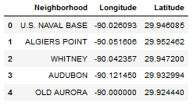

Figure1. Neighbourhoods in New Orleans

A snapshot of data from Foursquare API is shown in figure2, it displays few places with names and categories within the vicinity of 500 meters of one of the neighbourhood.

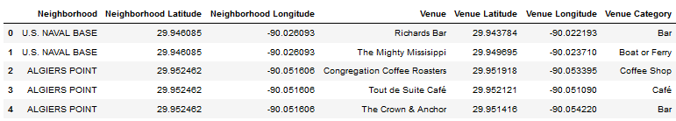

Figure2. Places around neighbourhoods “US NAVAL BASE” & “ALGIERS POINT”

* 1. **How will this data help in providing the service**

Using data of venues in a neighbourhood we can classify a neighbourhood. With this approach all the neighbourhoods in the city can be categorized, which will be used to help people make the selection of neighbourhood.