WindFlow — Technical Reference
Oct 29, 2026 · Bijay Karki
WindFlow ranks design options for natural and mechanical ventilation on one building model and one grid; it does not certify a single absolute airflow number. This reference sets out the method behind each result, the equations the solver uses, every benchmark it has been checked against, and every known limit with its measured size.

About this document
The one rule. Compare design options on the same model, the same grid and the same quality level. A change of cell size alone can move one room's air-change rate by up to about 35 % and the whole building by about 20 % (chapter 11).
Where the numbers come from. Every measured figure is taken from the project's test records, last re-run in October 2026. Equations labelled standard form are the textbook form of the named method; where the records do not state an implementation detail, the text says so instead of guessing.
Status. WindFlow is a design-stage tool. Its results are estimates with stated uncertainty, not a substitute for a ventilation engineer or a code-compliance calculation.

Notation
Symbol | Meaning | Unit
f_i | population moving in lattice direction i | lattice
c_i, w_i | lattice velocity and weight of direction i (D3Q19: i = 0…18) | lattice
c_s | lattice speed of sound, 1/√3 | lattice
τ | relaxation time of the collision | time steps
ν, ν_t | molecular and turbulent (sub-grid) kinematic viscosity | m²/s or lattice
Δx, Δt | cell size and time step | m, s
ρ, u | density and velocity | kg/m³, m/s
a | local age of air (time since the air was outdoors) | s
⟨a⟩ | volume-mean age of air in a room | s
V | room volume (nominal, as drawn) | m³
Q | volume flow | m³/s
C_d | discharge coefficient of an opening | –
A | open area of an opening | m²
U_H | wind speed at building height | m/s
H | building height | m
T, β | temperature and thermal expansion coefficient | K, 1/K

1. What WindFlow computes, and what it does not
WindFlow solves the wind-driven air flow through and around a building, then reads every room result off that solved air. Pressures on the façades are not looked up from a pressure-coefficient table: they emerge from the flow.
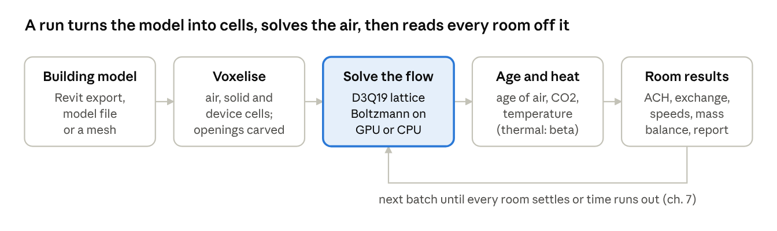
Figure 1 · from building model to report
Only the solve and tracer steps repeat: the solver keeps stepping and averaging in batches until each room's result settles or the time budget runs out.

Outputs per room
Output | What it measures | Notes
Fresh-air ACH | 3600 ÷ the room's mean age of air (chapter 6) | The headline number. Air that reaches the room through other rooms counts at its real age.
Total exch. ACH | Every m³/h entering the room volume, from outside and from other rooms | Not a ventilation rate.
Thru open. | Air entering through the room's own listed windows and doors | Measured on fixed opening planes, not the ragged room boundary.
Net outdoor air | Net flow through the room's exterior openings only
Mean speed | Mean air speed in the occupied zone, 0.1 to 1.8 m above the floor | m/s
Stagnant share | Share of the occupied zone below 0.10 m/s | %
Thermal (beta) | Temperature, heater or cooler duty, CO2, PMV within ±0.5, draught rate above 20 % | Chapter 9
Openings | Flow through each opening and its direction | m³/s
Devices | Measured flow of each fan, AC unit, hood or diffuser | m³/h
Mass balance | Air in against air out; drives the trust line and the report cover box | Chapter 13

What it does not do
- Not a certification tool. Results are comparative design guidance.
- Not validated against a physical building. Treat absolute ACH, comfort fraction and room temperature as comparative and self-consistent.
- Not validated at all: single-sided ventilation (one opening per room), openings narrower than 4 cells, absolute ACH in a real building.
- Planned, not done: IEA Annex 20 3-D rooms with temperature; the Architectural Institute of Japan (AIJ) guideline cases.
- Thermal model unchecked against a measured room. No measured, heated, occupied room has been simulated; one heat test (the filling box) still fails.
- Fresh-air numbers unchecked against tracer gas measured in a real building.
- No wall heat loss. Ordinary walls, floors, roofs and glazing are adiabatic: no U-values.
- No IFC import. Only a Revit export, WindFlow's own model file, or a mesh. Revit OBJ exports are recognised from their file header and read as feet and Z-up automatically. Before reading a model file, the app warns when the file looks too large for the free memory.

2. The solver
WindFlow is a D3Q19 lattice-Boltzmann solver with regularized BGK collision and a Smagorinsky sub-grid model (constant 0.16). The same kernel runs on the GPU (CUDA or OpenCL) and the CPU, and the two agree to 0.0 % on flow and thermal results.

Lattice Boltzmann in plain words
The air is split into cubic cells. Each cell holds 19 populations f_i: packets of air moving in one of 19 fixed directions. Every time step has two moves: stream (each packet hops to the neighbouring cell it points at) and collide (the packets in each cell relax towards an equilibrium set by the local density and velocity). Density, velocity and pressure are sums over the packets; nothing else is solved.
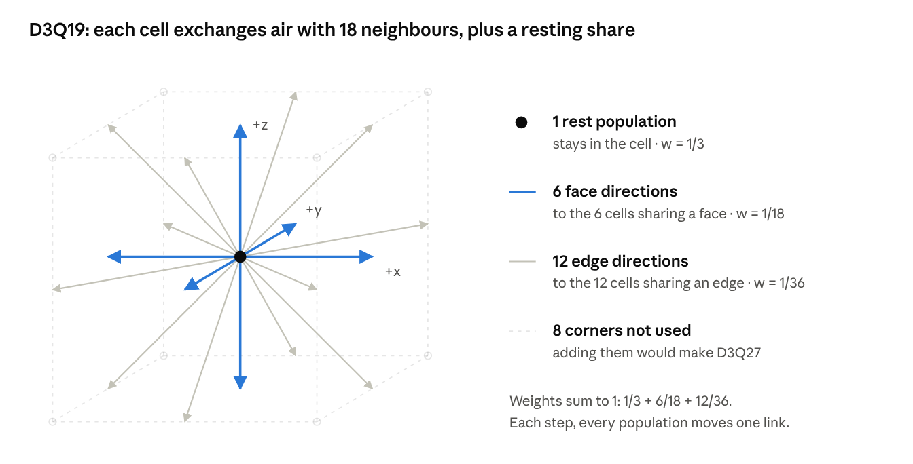
Figure 2 · the D3Q19 velocity set (oblique view of one cell and its neighbours)
The weights w_i are the equilibrium shares of a cell at rest; face neighbours get twice the share of edge neighbours (1/18 against 1/36) because they are closer.

Equations (standard form)
Stream and collide, for each direction i:
$$f_{i}(x+c_{i}Δt,t+Δt)=f_{i}^{eq}(x,t)+\left(1 − \frac{1}{τ_{eff}}\right)f_{i}^{neq,reg}(x,t)$$
Density and velocity are moments of the populations:
$$ρ=\sum_{i=0}^{18}{f_{i}}, ρu=\sum_{i=0}^{18}{f_{i}}c_{i}, p=c_{s}^{2}ρ, c_{s}=1/\sqrt{3}$$
The equilibrium is the second-order expansion of a Maxwell distribution:
$$f_{i}^{eq}=w_{i}ρ\left[1+\frac{c_{i}⋅u}{c_{s}^{2}}+\frac{{\left(c_{i}⋅u\right)}^{2}}{2c_{s}^{4}}−\frac{u⋅u}{2c_{s}^{2}}\right], w_{0}=\frac{1}{3},w_{1…6}=\frac{1}{18},w_{7…18}=\frac{1}{36}$$
Regularized BGK rebuilds the non-equilibrium part from its stress moment before collision, which removes higher-order noise that destabilises plain BGK at low viscosity:
$$f_{i}^{neq,reg}=\frac{w_{i}}{2c_{s}^{4}}Q_{i}:Π^{neq}, Q_{i}=c_{i}c_{i}−c_{s}^{2}I, Π^{neq}=\sum_{i}{c_{i}}c_{i}(f_{i}−f_{i}^{eq})$$
The relaxation time sets the viscosity, and the Smagorinsky eddy viscosity is added to it cell by cell:
$$ν=c_{s}^{2}\left(τ − \frac{1}{2}\right)Δt, ν_{t}=(C_{s}Δx)^{2}|\overline{S}|, |\overline{S}|=\sqrt{2{\overline{S}}_{αβ}{\overline{S}}_{αβ}}, C_{s}=0.16$$

$$τ_{eff}=\frac{1}{2}+\frac{ν+ν_{t}}{c_{s}^{2}Δt}$$
The records state the collision type and C_s = 0.16; the regularization and eddy-viscosity forms above are the standard ones for those names. In WindFlow the effective relaxation time is computed in closed form from the non-equilibrium stress: τ_eff = ½[τ₀ + √(τ₀² + 18√2 C_s² |Π^neq| / ρ)] in lattice units, with τ₀ = ½ + 3ν and ν the larger of air's viscosity and the floor.

Walls: interpolated (Bouzidi) links
A wall that cuts the link between two cell centres at fraction q of the link is placed at its true position by interpolation, from both sides. That is why a wall thinner than a cell stays leak-tight. Standard linear form, with ī the direction opposite to i and f* the post-collision value:
$$f_{\overline{ı}}(x_{f},t+Δt)=\left\{\begin{matrix}2qf_{i}^{∗}(x_{f})+(1−2q)f_{i}^{∗}(x_{f}−c_{i}Δt), & q<\frac{1}{2} \\ \frac{1}{2q}f_{i}^{∗}(x_{f})+\frac{2q−1}{2q}f_{\overline{ı}}^{∗}(x_{f}), & q≥\frac{1}{2}\end{matrix}\right.$$
Thermal walls use plain halfway bounce-back (the wall at q = ½ regardless of its true position). In a channel test the interpolated wall reads the width to within 5 % (5.37 against 5.40 cells); halfway bounce-back is 9.2 % off.

Speed
Measure | Value
Isothermal throughput, RTX 5070 Ti, Accurate grid | about 1,300 to 3,400 MLUPS depending on load and grid (about 3,390 in a clean benchmark)
With thermal on | about 1,300 MLUPS
Online age-of-air cost | +6 to 8 % per step, about 17 bytes per cell on the GPU
Live display refresh | up to about 10 per second, particles advected through the field
MLUPS = million lattice-cell updates per second. Steps per second follow directly:
$$\text{ steps/s }=\frac{MLUPS×{10}^{6}}{N_{cells}}$$
For the sample house at Standard (5.09 M cells) that is, at a clean 3,100 MLUPS, about 3,100 × 10⁶ ÷ 5.09 × 10⁶ ≈ 610 steps per second isothermal (about 255 steps per second at 1,300), before the online age.

3. The viscosity floor
For stability the solver never lets its lattice viscosity fall below 5 × 10⁻⁴ (lattice units). On building-scale grids that makes the simulated air about 150 to 850 times more viscous than real air, so jets through windows and supplies behave like laminar jets with an effective Reynolds number of a few hundred instead of about 10⁵. Treat absolute air changes and jet reach as indicative.

Why the penalty grows with cell size
Lattice and physical viscosity are linked through the cell size and time step. The time step is set by keeping the lattice wind speed U_lat (a lattice Mach number) fixed, so:
$$ν_{phys}=ν_{lat}\frac{Δx^{2}}{Δt}, Δt=\frac{U_{lat}Δx}{U} ⟹ ν_{phys}=ν_{lat}\frac{UΔx}{U_{lat}}∝Δx$$
At a fixed floor, the simulated viscosity grows in proportion to the cell size. The records bear this out: Preview cells (254.5 mm) are 1.50 times Standard cells (169.6 mm), and the viscosity penalty is about 470 times against about 310 times, a ratio of 1.52. The validation cases, at much finer cells, run at only 4 to 28 times.

What it does to jets
The Reynolds number of a jet through an opening N cells across depends on the cell count, not on the physical width:
$${Re}_{eff}=\frac{UL}{ν_{phys}}=N\frac{U_{lat}}{ν_{lat}}, N=L/Δx$$
With openings 4 to 16 cells across this lands at a few hundred, where a real window jet sits near 10⁵. Laminar jets spread and decay differently from turbulent ones, which is the main reason jet reach and absolute ACH are indicative only. In the Annex 20 room the effective Reynolds number before the sub-grid term is about 1,280 against the specification's 5,000.

Measured sensitivity
Lowering the floor from 5 × 10⁻⁴ to 1 × 10⁻⁴ changes results substantially, and not all in one direction.
Case | Floor 5e-4 | Floor 1e-4 | Effect of lowering
Sample house, Living ACH | 13.4 | 9.4 | −30 %
Sample house, Kitchen ACH | — | — | −15 %; Kitchen window flow reverses
IEA Annex 20, hit rate q | 0.453 | 0.557 | Better on all four metrics
Cross-ventilation, hit rate q | 0.746 | 0.587 | Worse on q and NMSE
MINIBAT ceiling jet | — | — | Worse on all four metrics
The decision rule's verdict (October 2026 re-run) was “WORSE: keep 5e-4”, because one validation case improved and two got worse.

4. Building geometry and openings
The model (metres; X and Y horizontal, Z up) is turned into a grid of air, solid, fixed and device cells, with an outdoor margin so the wind passes over the roof and around the façades. Openings are the most grid-sensitive part of the model: an opening's effective discharge coefficient depends on how many cells fit across it and where it falls on the grid.

Voxelisation
Check | Result
Room air volume against nominal, Preview (254.5 mm cells) | −6.3 to +2.1 %
Room air volume against nominal, Accurate (169.6 mm cells) | −5.1 to +3.7 %
50 mm partition on a 255 mm grid | 0.0000 m³/s leak; 0 of 60 probes leaked
Interpolated wall position in a channel | within 5 % (5.37 against 5.40 cells)
Room ACH divides by the nominal (drawn) volume; the report's Nominal column says which volume was used. Cells are classified by their centre point.

The orifice model
An opening's flow is the normal velocity integrated over the throat cells the voxelizer actually carved:
$$Q=\sum_{\text{throat cells}}{u}⋅nΔx^{2}$$
The discharge coefficient compares that flow with the ideal flow through the same area under the same pressure drop (the orifice equation):
$$Q=C_{d}A\sqrt{\frac{2Δp}{ρ}} ⟺ C_{d}=\frac{Q}{A\sqrt{2Δp/ρ}}$$
A sharp-edged opening has C_d ≈ 0.61 at high Reynolds number (Idelchik; ISO 5167; Etheridge & Sandberg 1996). The carved hole is rounded to whole cells and is 0 to 15 % larger than drawn at the checked grids.

Calibration to C_d = 0.61
On a coarse lattice the hole resolves its own C_d, which depends on the cells across it and the wall thickness. The default Calibrated model adds a sub-grid loss in the throat cells wherever the lattice resolves above the requested value (0.61 by default). Losses in series add in the head, so the equivalent loss coefficient is:
$$\frac{1}{C_{d,target}^{2}}=\frac{1}{C_{d,lat}^{2}}+K ⟹ K=\frac{1}{{0.61}^{2}}−\frac{1}{C_{d,lat}^{2}}(K≥0)$$
The loss is applied as a quadratic drag on the through-flow only, in the one-cell throat layer, F = −c ρ |u_n| u_n with c = K/2; C_d,lat comes from a table indexed by cells across (hydraulic diameter) and wall thickness. The relation above is the equivalent series-loss form. Where the lattice resolves below 0.61, K would be negative, so nothing is added and the flow is short by the ratio C_d,lat ÷ 0.61: for 4 cells across, 0.48 to 0.60 ÷ 0.61 gives 1 to 21 % low.
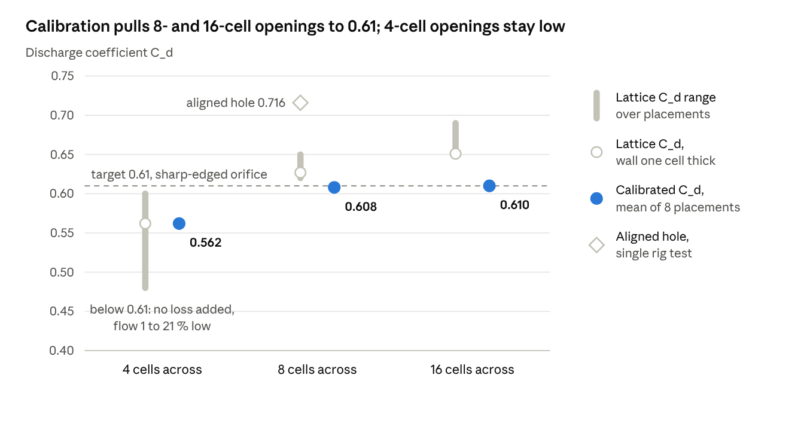
Figure 3 · WindFlow test records, wall-built openings, October 2026
At 8 and 16 cells across, calibration lands within ±1.3 % of 0.61. At 4 cells the lattice already resolves below the target, so the opening passes less air than drawn and a note gives the shortfall.

Placement scatter
The same window moved by a fraction of a cell changes the C_d the lattice resolves by up to the figures below (scatter over eight placements). The app warns when the scatter exceeds 5 %.
Cells across ↓ / wall thickness → | 0.5 cell | 1 cell | 2 cells | 3 cells | 4 cells
4 | ±30.1 % | ±10.2 % | ±7.1 % | ±6.5 % | ±7.0 %
8 | ±21.1 % | ±7.7 % | ±3.2 % | ±2.6 % | ±3.0 %
16 | ±14.3 % | ±5.1 % | ±1.6 % | ±2.1 % | ±2.3 %
Two placements lie outside this table: a hole aligned to the grid (edge on a cell face) and one with its edge on a cell centre. An aligned hole 8 cells across in a one-cell wall reads C_d 0.716 against the requested 0.61 (+17 %). Openings much wider than 16 cells, rounded or thick-reveal openings, and rotated (non-axis-aligned) openings are not calibrated separately.

Opening warnings
Condition | Warning | Meaning
Under 4 cells across | “is only N cells across” | Flow unreliable
4 to 6 cells across, Preview | size quantised to the grid | ±1 cell row is 15 to 25 % of the area
Effective C_d outside 0.42 to 0.8, at least 4 cells wide | C_d warning | Check the opening
Placement scatter above 5 % | scatter note | Result sensitive to grid position

Imports, rooms and edits
- Room volume. A room is the air inside its outline, filled up to the storey top. A double-height room needs a storey height covering its full height; a void opening into the storey above counts in the lower room.
- Room band. Detected rooms get a 2-cell band from core to walls. Imported rooms read total exchange 37 to 45 % higher than the same building drawn by hand. Compare imported models with each other, not with drawn ones.
- Too few cells. A room under 3 cells across is marked “unreliable (too few cells)” with a dagger.
- Exchange instead of ACH. When counted inflow through openings is under 5 % of what crosses the room outline, the row shows an exchange in m³/s with a grey dot and is left out of Best/Least ventilated.
- Glass removal is per material. A glass material shared by a curtain wall and windows is removed as a whole.
- Model checks. Coordinates within ±1 × 10⁵ m, sizes in (0, 1000] m; a broken file is refused with a reason. A model more than 10 km from the origin is centred in plan with a note.
- Editing. Toggling a window is a warm restart, not a rebuild. Deleting an opening in an imported mesh seals it with a fill solid; adding a room, merging rooms or adding an opening re-voxelises and restarts the live solve.
- Naming. Rooms detected on a mesh are named Room 1, Room 2…, and detected openings Window 1, Door 1…. A direction-and-area suffix, for example “Kitchen (east, 18 m²)”, is added only when two rooms share the same real name.

5. Wind and the outdoor domain
The default Compact domain is fast but tight: on the sample house it blocks 10.5 % of the wind's cross-section, and room flows read about 11 to 14 % high per room (newest run, after the age-of-air fix; an older run read 8 to 33 %) against the Full (COST 732) domain. Use Compact to compare options and Full for a final check.

The boundary ring
Boundary | Treatment
Inflow (upwind) | Non-equilibrium velocity inflow, the default, with an absorbing sponge
Outflow (downwind) | Constant density, with an absorbing sponge
Top | Prescribed-velocity lid
Ground | Smooth, no-slip
Open-top user boxes | Older equilibrium ring (a velocity inflow through a cut wall diverged in the checks)
The report states the wind at 10 m height.
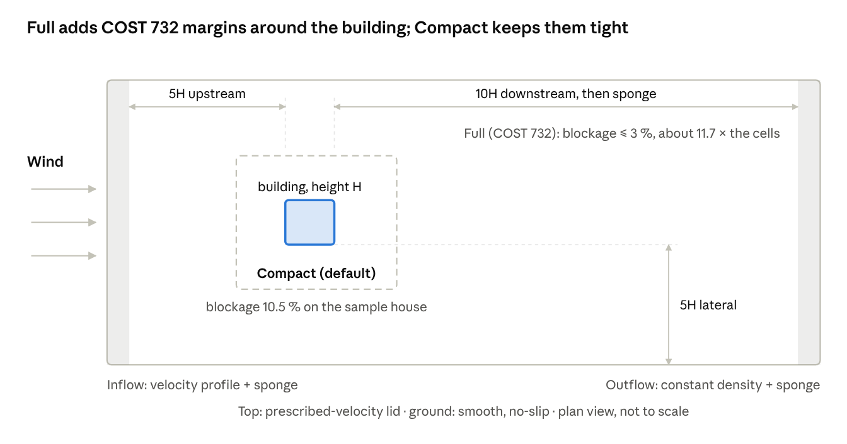
Figure 4 · outdoor domain in plan, Compact against Full, with the boundary ring
The tinted strips are the absorbing sponges that stop reflected waves at inflow and outflow; the Full domain costs about 11.7 times the cells of Compact.

Blockage and the two domains
Blockage is the share of the domain's cross-section taken up by the building's frontal area:
$$B=\frac{A_{frontal}}{A_{domaincross\text{-}section}} (\text{COST 732 asks }B≤3\%)$$
Domain | Margins | Blockage, sample house | Cells
Compact (default) | small | 10.5 % | 1 ×
Full (Expert → Settings → Domain) | 5H upstream, 10H downstream plus sponge, 5H lateral | ≤ 3 % (COST 732 domain ≈ 2.4 %) | about 11.7 ×
What Compact costs, measured against Full on the sample house:
Comparison | Before the age-of-air fix | After the fix
Room total exchange, Compact over Full | +8 to +33 % (median about +16 %) | +11.0 to +13.9 % per room
Building fresh-air rate | 12.1 against 9.7 ACH (+25 %) | +22 %
The app adds a note whenever blockage exceeds 3 %.

Wind profile and ground
Eurocode EN 1991-1-4 gives the mean wind as a logarithmic profile over terrain roughness z₀ (standard form):
$$v_{m}(z)=c_{r}(z)c_{o}(z)v_{b}, c_{r}(z)=k_{r}ln\left(\frac{z}{z_{0}}\right), I_{v}(z)=\frac{σ_{v}}{v_{m}(z)}=\frac{k_{I}}{c_{o}(z)ln(z/z_{0})}$$
WindFlow's ground is smooth and no-slip, so wind near the ground is too weak: about 54 % under the EN profile at 1 m. For oblique winds the profile drifts 10.8 to 15.9 % at 2 m.

Slow settling of the inflow
The inflow settles slowly (about 40,000 steps) and its steady state depends on how the run started. In a 10-minute run results land about 1.5 to 3 % high, and two starts settle 0.5 to 4 % apart (0.47 % at 60 thousand cells, 4.3 % at 400 thousand). Two of the solver's own tests fail for this reason (chapter 10).
A simpler equilibrium inflow was tried as the default and reverted in October 2026. It failed its cold-versus-warm-start bound (CPU 30 batches 1.4 % / 2.7 %; GPU 120 batches 1.03 % / 3.3 %), and the 40-cell cross-ventilation case failed with it (q 0.619 against a bound of 0.66, against 0.746 with the default). Every published validation number uses the default inflow.

Gusts (High quality)
Standard and Preview use a steady profile. High adds gusty approach turbulence after EN 1991-1-4, generated as a synthetic field with Smirnov decorrelation so gusts evolve in time, plus turbulent supply jets. The generated gust intensity reads 0.94 to 0.97 of the EN target.
- Each room's ACH then moves from batch to batch, so High's ranges are wide and the run usually ends at its time budget.
- Standard under-reads rooms ventilated mainly by gusts (one opening, or openings only on walls parallel to the wind); the app flags such rooms.
- Never mix a Standard number with a High one.

Optional wall model
A Werner–Wengle wall function sits under Expert → Settings. It is off by default, wind-only, and greyed out while Thermal is on. Results were mixed and grid-dependent (Annex 20 passes at 4 cells across the slot, fails at 8), and its laminar-flow test fails (2.57 % against 2 %), so it stays experimental.

6. Age of air and air changes per hour
A room's headline number, fresh-air ACH, is 3600 divided by the mean age of the air in that room. Because it is built from age, air that reaches a room second-hand through a neighbour counts at its real age, so a room fed by another room reads low even when plenty of air passes through it.

Definitions
The local age of air a(x) is the time since the air at x was last outdoors. Outdoor air has age 0. The room mean age and the fresh-air rate are:
$$⟨a⟩=\frac{1}{V}\int_{V}{a}dV, {ACH}_{fresh}=\frac{3600}{⟨a⟩[s]}[h^{−1}]$$
Fresh-air ACH does not use the room volume. It equals a true air-change rate only for fully mixed air, where the mean age equals the nominal time constant:
$$\text{ fully mixed: }⟨a⟩=τ_{n}=\frac{V}{Q} ⟹ {ACH}_{fresh}=\frac{3600Q}{V}$$
Otherwise it is the room's mean-age equivalent (Etheridge & Sandberg 1996; Hurraß 2026). Total exchange counts every inflow, whatever its origin:
$${ACH}_{total}=\frac{3600Q_{in,allfaces}}{V_{nominal}}$$
Air-change efficiency (ISO 16000-8) compares the exhaust age with the room mean; it is reported only for a room fed at least 90 % straight from outside:
$$ε_{a}=\frac{a_{exhaust}}{2⟨a⟩} 0.5=\text{ fully mixed}, 1.0=\text{ piston flow }$$
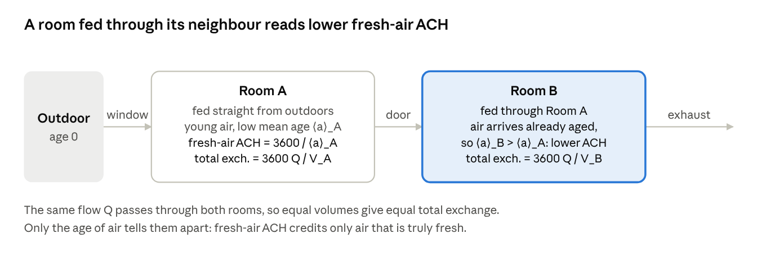
Figure 5 · two rooms in series: total exchange against fresh-air ACH
This is why a bedroom ventilated through a hall can show high total exchange and a modest fresh-air ACH at once; read the two columns together.

Display states
Shown | Meaning
— | Age not solved, or the room outline is drawn through open air
sealed | No air path reaches the room; its age sits at the solver's 24-hour cap
(steady) | This room's online age had not settled; the steady age is shown, with no ±
(drifting) | The averaged batches had not levelled off
Outdoor air counts as age 0, so exhaust that leaves a room and is drawn back in counts as fresh. The region where age and CO2 are solved includes a 1 m outdoor ring. On the sample house the online age agrees with a tracer within 9 % in every room; strong re-entry at a façade has not been tested.

Two ways to get the age
Steady age solves Sandberg's steady mean-age equation on the time-averaged flow ū. It is cheap but carries no resolved turbulent mixing:
$$∇⋅(\overline{u}a)=∇⋅(D∇a)+1, a=0\text{ in outdoor air }$$
Online age is carried by the solver every step, through the instantaneous turbulent flow, and then time-averaged:
$$\frac{∂a}{∂t}+∇⋅(ua)=∇⋅(D∇a)+1$$
The “+1” source makes age grow by one second per second wherever the air is. The steady form is biased: it reads fresh air lower in slowly recirculating rooms and higher in fast-flushed ones, by about 30 % either way per room. Online age costs 6 to 8 % more per step and about 17 bytes per cell on the GPU. The exhaust-age check against V ÷ Q reads 106.2 s against 100.8 s (5.3 % error, band ≤ 10 %).
Run | Headline fresh-air ACH | Shown beside it
Preview | Steady age on the mean flow | Nothing; muted, marked “~”
Standard (fine grid, steady wind) | Online age where it settled; steady age, marked “steady age”, where it did not | No ± for a steady-age room
High (fine grid, gusty wind) | Online age through the gusts | “Fresh-air (steady age)”, which ignores gust mixing and usually reads lower

Why High uses the online age
In gusty wind the steady age misses most of the mixing. On the sample house, one High run printed both ages on the same mean flow. The building fresh-air rate was 27.0 ACH from the online age against 13.3 from the steady age; before this change High read below Standard (13.7 against 18.3 ACH). No tracer-proven reference exists for a gusty case.
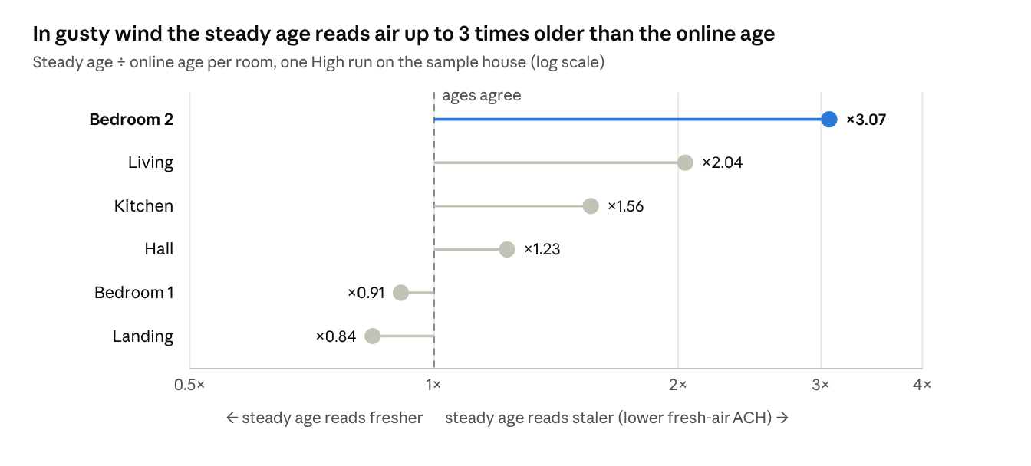
Figure 6 · WindFlow test records, High run, sample house, same mean flow for both ages
The steady age can err in both directions: it reads air older in four rooms and younger in two. In High the steady value read about 50 % low overall (Living −51 %, Bedroom 2 −67 % in fresh-air ACH), which is why High carries the online age.

7. How a run decides it is done
An Accurate run averages each room's ACH over batches and stops only when a strict 99 % test says the mean has settled. With the online age that test usually needs 160 to 310 batches, so the default 10-minute Standard run normally ends at its time budget and shows ranges, not settled values.
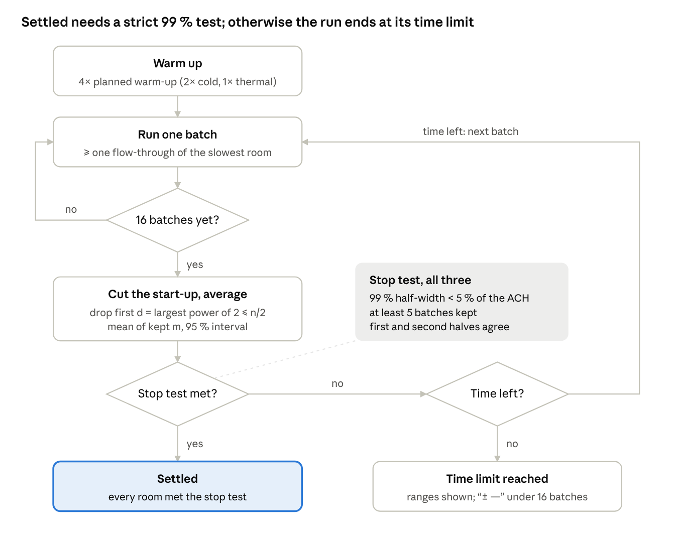
Figure 7 · the Accurate-run stop rule
The range shown on screen is the 95 % interval; the stop test uses the wider 99 % width, so a room can show a tight range and still not read Settled.

The rule, step by step
- Batches. Each batch lasts at least one flow-through of the slowest room. No run stops before 16 batches.
- Cut the start-up. Of n batches so far, drop the first d, where d is the largest power of two not above n/2. Keep m = n − d.
- Mean and interval. Each room's ACH is the mean of the kept batches, with a Student-t interval widened for correlation between neighbouring batches.
- Stop test. The 99 % half-width is under the aim (5 % of the room's ACH, with a floor), at least 5 batches are kept, and the first and second halves of the kept batches agree. Only then does the room read Settled.
In symbols:
$$d=2^{\left\lfloor \log_{2}(n/2)\right\rfloor }, m=n−d, \overline{x}=\frac{1}{m}\sum_{k=d+1}^{n}{x_{k}}$$

$$h_{p}=t_{p,m−1}\frac{s}{\sqrt{m}}κ, report \overline{x}±h_{0.975}, stop when h_{0.995}<max(0.05\overline{x},\text{ floor}),m≥5,\text{ halves agree }$$
For example, at n = 16 the first 8 batches are dropped; at n = 40, the first 16. The interval is widened for batch-to-batch correlation. WindFlow uses κ = √((1+ρ)/(1−ρ)), with ρ the bias-corrected lag-1 correlation of batch means, clamped to 0 to 0.9 (0 below 8 batches), and Student-t degrees of freedom from m(1−ρ)/(1+ρ). The stop test's floor is 0.2 ACH. The factor is shown below, with the effective number of independent batches it implies:
$$κ=\sqrt{\frac{1+ρ}{1−ρ}}, m_{eff}=m\frac{1−ρ}{1+ρ}$$
The online age has ρ = 0.85 to 0.97. By this form, each independent batch then costs about 12 to 19 real batches (ρ is clamped at 0.9, so at most about 19). The 160 to 310 batches the records report are an observed figure (27 to 53 minutes at 5 M cells).

What the rule guarantees, and what it does not
- Checked on simulated correlated batch means: at ρ = 0.7 the 95 % intervals covered the truth 96 % of the time.
- Not shown to be right for every building.
- Settled cannot exclude a drift of up to about 1.5 times the aim; a room whose batches still drift is marked “(drifting)”.
- The ± is statistical only. Grid, inflow and model error are not in it, and it excludes slow age drift.

Outcomes on screen
Shown | When
Settled | Stop test met for every room
“Time limit reached: ranges shown” | Time budget ran out first
“± —” | Fewer than 16 batches in all, or fewer than 5 kept
(drifting) | A room's kept batches had not levelled off
(steady) | A room's online age never settled; steady age shown instead

Why a run takes 30 to 50 minutes
The default Standard run stops after 600 s of stepping.
Test | Result
7 Standard runs, 10 min | Settled in none; only Bedroom 1 and the sealed bathroom settled
One 60-minute run (328 batches) | Kitchen, Bedroom 2 and Landing still not settled
10-minute numbers against the 60-minute run | Within about 3 % for 5 of 6 rooms (Bedroom 2 +14 %)
20-minute Standard run | Online age landed in Bedroom 1 only
The online age cannot settle faster than about one room fresh-air age; Bedroom 2 was still rising after 2,000 s of physical time. This is not a defect and the rule is unchanged. In practice a short run mostly reports the steady age, marked “steady age”. For a final check use High or a longer time limit.

8. Quality levels and run times
Preview is for direction and a first look, Standard is the default comparison run, and High (gusty wind) is the final check on a real site. Never compare numbers across levels.
Level | Grid | Wind | Time | Use it for
Preview | about 1.5 M cells on the high tier (1.54 M at 254.5 mm on the sample house) | Steady | settles in about 3 to 30 s | Direction and first look; room numbers muted, marked “~” and “preview”
Standard (default Accurate run) | Finer whole-building grid; budget per tier: high 5 M, medium 3 M, low 1.2 M, CPU 0.6 M cells (5.09 M at about 170 mm on the sample house) | Steady, no added turbulence | up to 600 s of stepping | “What does a perfectly steady wind of this speed and direction do”
High | Fine grid, Compact domain, optional fine box | Gusty (EN 1991-1-4), turbulent supply jets | Budget you pick: 5, 10, 20 or 30 min | A real site; rooms ventilated mainly by gusts; final check

Ultra (new, October 2026; not separately validated)
Ultra is wind-only (isothermal) and uses a finer uniform grid aimed at 16 cells across the narrowest open opening (cell size = narrowest opening ÷ 16, floor 25 mm), limited by the GPU's free memory and never coarser than Standard. It uses the Full outdoor domain when that fits finer than Standard, otherwise Compact, with a note. It runs for up to 6, 12, 20 or 24 hours and stops early when every room's online age settles; its time estimate uses the GPU speed measured on your computer. It keeps the computer awake, saves its progress about every 20 minutes and can resume after a crash or close; on a GPU fault it retries once from the last save, with no CPU fallback. On the sample house with a 16 GB GPU it reaches about 76 to 83 mm cells (10 to 11 cells across the narrowest window). At 16 cells across, the measured opening flow is within about 1 to 3 % of its target; finer grids were not measured. No Ultra accuracy result has been measured.

How the levels chain
- Preview, then Accurate. Once Preview settles, the Accurate run starts on its own at the finer grid, from rest. It settles for 4 times the planned warm-up (2 times for a cold start, 1 for a thermal run), then averages in batches until every room's range closes or the budget runs out.
- Cell budgets. The tier is chosen from a short start-up solver run and the graphics card's memory, clamped to what that memory holds next to the Preview grid.
- Which grid to trust. Compare options on the same grid and quality level; run Full domain and High for a final check.

Timings on the sample house (RTX 5070 Ti)
Run | Timing
Standard, 5.09 M cells | settles for about 12 s, then batches of about 10 s
Accurate at Preview cell size, 1.54 M cells, 10 min cap | converged after 256 batches in 509 s
These timings predate some later fixes.

The fine box
An optional 2:1 finer grid around one room sharpens the local view only: particles, slices and probes. Room ACH and opening flows always come from the whole-building run, because a two-way coupled box was built and did not beat it. Against a uniform run at the box's cell size, one hall opening read 14.7 % off with the box and 11.1 % off whole-building; the Hall's total ACH read 12.7 % off against 3.3 %. The box is isothermal only.

9. Thermal (beta), heat sources and devices
Thermal is a hybrid: the 3-D lattice flow plus a finite-volume energy equation that uses the flow solver's own mass fluxes. It passes its textbook cases (heated cavity within 1 %), but small heat sources are under-stratified by about 25 to 40 %, and it has never been checked against a measured room, hence beta.

Equations
Energy (finite volume, van Leer–limited advection, face fluxes from the flow solver):
$$\frac{∂T}{∂t}+∇⋅(uT)=∇⋅((α+α_{t})∇T)+\frac{\overset{˙}{q}}{ρc_{p}}$$
Buoyancy (Boussinesq), added to the flow as a body force:
$$F=−ρ_{0}β(T−T_{ref})g$$
A uniform temperature stays uniform, and a sealed room conserves its energy to 0.004 to 0.07 %. Body forces enter the lattice through the Guo forcing scheme (standard form), which also drives every device:
$$F_{i}=\left(1 − \frac{1}{2τ}\right)w_{i}\left[\frac{c_{i}−u}{c_{s}^{2}} + \frac{(c_{i}⋅u)c_{i}}{c_{s}^{4}}\right]⋅FΔt, ρu=\sum_{i}{f_{i}}c_{i}+\frac{1}{2}FΔt$$
WindFlow's variant weights the momentum term by ½ instead of (1 − 1/2τ), keeping (1 − 1/2τ) on the second-moment term.

Held temperature and walls
- Ideal heater or cooler (default on). Each room's volume-mean temperature is held at the indoor setting. The report's “Duty W” shows + for heating, − for cooling, “—” for a free-running room. A stratified room's occupied zone can differ (a note appears above 1 K); a room with its own split AC is not held.
- Free-running. With the hold off, the typed indoor temperature is only the starting air temperature, and the stack effect decays during the run.
- Adiabatic walls. Only Surface heat sources (a panel, or a cold window drawn as one) exchange heat.

Surface convection (Alamdari–Hammond)
Surface sources use the Alamdari–Hammond natural-convection correlations (standard forms below; WindFlow combines natural and forced convection as h = (h_n³ + h_f³)^(1/3) with h_f = 3.8 |u_t|, and uses h_n = 0.6 (|ΔT| / D²)^(1/5) for a stable (cooled-up or heated-down) horizontal surface, with D = 4A/P). For a vertical surface of height H and an upward-facing heated horizontal surface of hydraulic diameter D:
$$h_{vert}={\left[{\left(1.5{\left(\frac{ΔT}{H}\right)}^{1/4}\right)}^{6} + {\left(1.23ΔT^{1/3}\right)}^{6}\right]}^{1/6}, h_{up}={\left[{\left(1.4{\left(\frac{ΔT}{D}\right)}^{1/4}\right)}^{6} + {\left(1.63ΔT^{1/3}\right)}^{6}\right]}^{1/6}$$
These reproduce the records' hand-check values: a 20 K vertical plate with H = 3 m gives 3.413 W/m²K, and a 20 K hot floor with D = 2 m gives 4.448 W/m²K.

Small heat sources and the plume model
The sealed filling-box test (a 500 W area heater in a sealed 3.0 m room) reads a vertical temperature difference of 1.30 K against the Baines & Turner / Worster & Huppert reference of 1.8 to 8.6 K, and stays a FAIL. The heater delivers 99.3 % of its energy and nothing leaks: the plume is under-resolved and not grid-converged.
An opt-in plume model (experimental, October 2026, off by default) releases a small heater's power as a rising Morton–Taylor–Turner plume one cell layer above the heater whenever the plume is too small for the grid. Its two inputs are the buoyancy flux of the heater and the entrainment hypothesis, with α = 0.12 taken from the literature, not fitted:
$$B=\frac{gβP}{ρc_{p}}, u_{e}=αw, b(z)=\frac{6}{5}αz, w(z)∝B^{1/3}z^{−1/3}$$
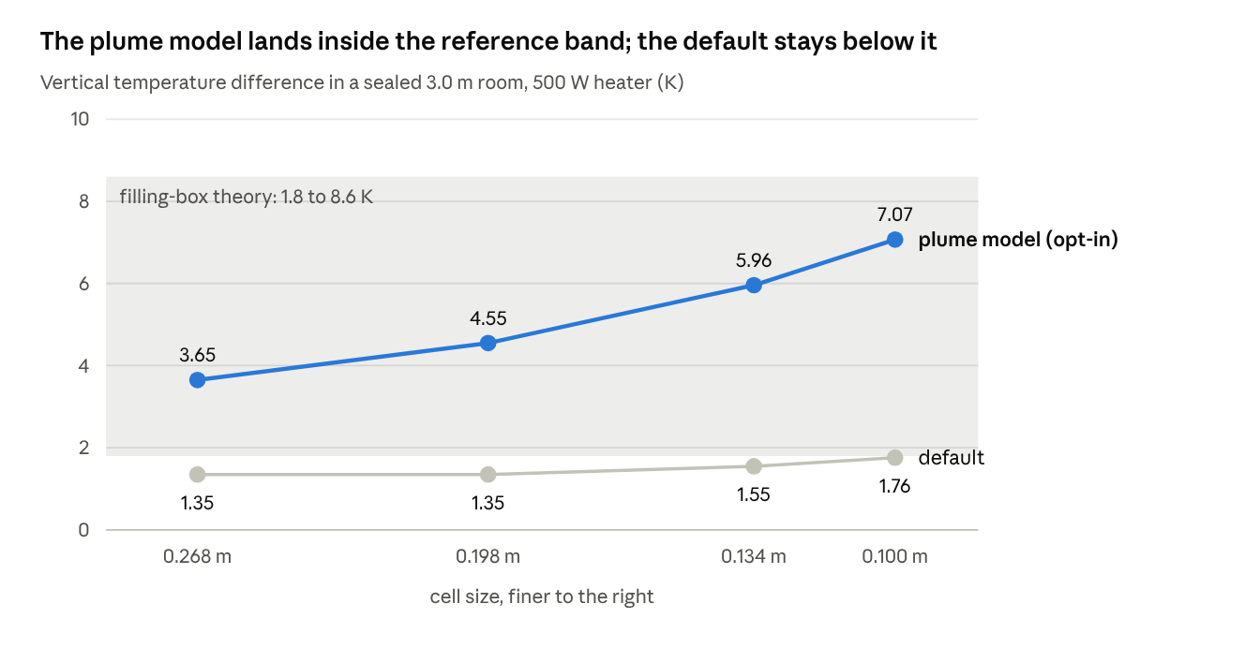
Figure 8 · WindFlow test records, sealed filling box, October 2026 (plume model run on CPU)
The default creeps up as cells shrink but stays under 1.8 K at every size; the plume model is in the band throughout but doubles across the range, so it is not grid-independent either.
The plume model lands inside the reference band at every cell size, with energy within 1 %, but it is not grid-independent: it roughly doubles across the range. It does not cover wall-mounted or Surface sources, wind does not bend it, and it has run on the CPU only.
A separate energy-balance check heats a sealed room and compares the mean temperature rise with the closed-form value; it reads 5.4 % error (band ≤ 20 %):
$$Δ\overline{T}=\frac{Pt}{ρc_{p}V}$$

Devices
Ceiling fans, pedestal fans, split and cassette AC, exhaust fans, hoods and diffusers are body-force regions (Guo) that accelerate air already in the cell, so they conserve mass by construction. A diffuser moves room air and adds no fresh air; in a sealed room it brings in no outdoor air.
Device behaviour | Measured
Ceiling fan disc against rated 1.200 m³/s | −3.5 %
Split AC delivered against set flow | about 3 % low (0.145 against 0.15 m³/s)
Supply patches against set flow | 0.5 to 1 % low
Split AC duty against room enthalpy loss | 0.2 %
Split AC steady return temperature | +0.30 K (at the ±0.3 K band edge)
- Resolution chip. A fan disc, or an outlet's short side, under 8 cells across reads “refine needed”. A split AC's 120 mm slot needs 15 mm cells and reads “too small to resolve”.
- Sealed rooms with unbalanced devices have no pressure anchor, so the app scales the extract to the supply and adds a room note.
- Input caps. Flow ≤ 5 m³/s, radius ≤ 1.5 m, supply temperature clamped to 5 to 40 °C.

10. Validation
The latest whole test-suite run reads 258 PASS and 3 FAIL (the filling-box test and the two start-up drift tests), after an earlier 253 PASS and 3 FAIL; the app's separate self-check reads 189 PASS, 0 FAIL. Of the measured-room cases, only cross-ventilation at 40 cells per building height passes all four metrics; Annex 20 and MINIBAT each miss on the hit rate, and absolute cross-ventilation flow rates read 1.6 to 2.2 times the published tracer values while ranking the layouts correctly.

How measured cases are scored
Four metrics after Chang & Hanna (2004), with the hit rate after VDI 3783-9 and COST 732. O is the measurement, P the prediction, overbars are means over the N points:
$$FAC2=\frac{1}{N}\sum_{j=1}^{N}{n_{j}}, n_{j}=\left\{\begin{matrix}1 & 0.5≤P_{j}/O_{j}≤2 \\ 0 & \text{ otherwise }\end{matrix}\right.$$

$$FB=\frac{\overline{O}−\overline{P}}{\frac{1}{2}(\overline{O}+\overline{P})}, NMSE=\frac{\overline{{\left(O−P\right)}^{2}}}{\overline{O}\overline{P}}$$

$$q=\frac{1}{N}\sum_{j=1}^{N}{n_{j}}, n_{j}=\left\{\begin{matrix}1 & \left|\frac{P_{j}−O_{j}}{O_{j}}\right|≤D\text{ or }|P_{j}−O_{j}|≤W \\ 0 & \text{ otherwise }\end{matrix}\right., D=0.25$$
Pass band: FAC2 ≥ 0.5, |FB| ≤ 0.3, NMSE ≤ 1.5, q ≥ 0.66. With this sign convention a positive FB means WindFlow reads low on average. W is an absolute tolerance chosen per case, not published. FAC2 here counts pairs where both values are below W as hits (Hanna & Chang 2012); by the strict definition (van Hooff, Blocken & Tominaga 2017) FAC2 is 0.942 (MINIBAT), 0.619 (cross-ventilation, 40 cells) and 0.538 (Annex 20).
↗ Figure 9 · WindFlow test records, measured-room cases re-run October 2026
MINIBAT misses only on hit rate, by 0.017; Annex 20 misses hit rate and, narrowly, bias; the 20-cell cross-ventilation run fails because it is under-resolved.

Measured rooms and wind tunnels, case by case
- IEA Annex 20, 2-D isothermal room (Nielsen 1990; LDA data of Restivo 1979; 8 cells across the slot, 106 points). Fails q (0.453) and FB (0.308, just past 0.3); FAC2 0.613 and NMSE 0.356 pass. The ceiling jet decays about 25 % too fast at every grid tried; this is the open gap. The room is scaled (slot 4 cells of 0.1 m, H = 7.1 m against 3.0 m) to keep the Reynolds number similar, and the inlet follows the specification's sine profile with 4 % turbulence. An earlier row (q 0.471) used a different set-up, so the change is not a like-for-like regression.
- Cross-ventilation, isolated building (Tominaga & Blocken 2015 wind tunnel; 40 cells per building height, 63 points). Passes all four (FAC2 0.778, FB 0.119, NMSE 0.216, q 0.746), and the opening flux Q/(U_H A) = 0.498 sits inside its 0.36 to 0.52 band. At 20 cells per height it fails (q 0.286; every earlier 20-cell run read 0.24 to 0.33): known under-resolution. The pass is for that one case at that grid. q is sensitive to W: 0.365 at W = 0, 0.540 at 0.025, 0.667 at 0.05 on an older run.
- MINIBAT isothermal ceiling jet (Kuznik, Rusaouen & Brau 2008; data Gresse, Merlier & Kuznik 2020; 3.1 × 3.1 × 2.5 m room, 25 mm cells, 1,419 points). FAC2 0.942, FB 0.051, NMSE 0.083 pass; q 0.643 is 0.017 short. Going from 6 to 8 cells across the nozzle leaves q flat (0.654 to 0.646) while the others improve, which suggests but does not prove a remaining model gap.

Tracer cross-ventilation, five layouts
The flux ratio normalises the flow through the building by the wind at building height and the opening area:
$$\overset{^}{Q}=\frac{Q}{U_{H}A}$$
Tominaga & Blocken 2016 layouts A to E were run at 40 cells per height on a 24.8 M-cell domain (4H margins, 3.0 % blockage; 230 minutes on the GPU). WindFlow's tracer flow equals its own velocity-integrated flux to about 1 %, and the set-up and normalisation match the paper.
↗ Figure 10 · WindFlow test records, 24.8 M cells, 4H margins, October 2026; reference values from the papers named
All five fail the ±20 % band; the ranking is right, with A first (that criterion passes). The reference itself reads low: for layout E the paper's tracer value is 37 % below its PIV opening flux (about 0.40), and an LES gives 0.44 to 0.47; against those, E reads 1.11 to 1.33 times high. Layouts A to D have no PIV or LES value. About +6 % of the gap is the 4H domain; an earlier breakdown put 91 % of the error (in log units) on the opening's discharge coefficient and 7 % on the domain. The band was not changed. The primary sources disagree on the flow rate itself: 0.25 (tracer), 0.50 (van Hooff et al. 2017), and an opening-flux band of 0.40 to 0.47 (Karava PIV; Hwang & Gorlé LES).

Analytic and textbook references
Case | Reference | WindFlow | Band | Status
Two windows in series, effective C_d | orifice equation; sharp-edged 0.6 to 0.65 | 0.559 | 0.37 to 0.80 | PASS
Per-opening C_d, cross-ventilation scene | same | west 0.585, east 0.564 | 0.42 to 0.8 | PASS
Isolated sharp square orifice, 8 cells, aligned | C_d ≈ 0.61 (Idelchik; ISO 5167) | 0.716 | 0.65 to 0.72 (moved: aligned hole) | PASS
Wall-built opening, 4 / 8 / 16 cells, resolved C_d | same | 0.562 / 0.627 / 0.651 | information | NOTE
Wall-built opening, 8 cells, calibrated, mean of placements | requested 0.61 | 0.6093 | within 3 % | PASS
One-offset rig, calibrated, 4 / 8 / 16 cells | requested 0.61 | 0.739 / 0.716 / 0.670 | within 3 % | none within 3 %
Two-storey house, windward-to-leeward Δp | self-consistent pressure-driven flow | 1.018 | 0.5 to 1.6 × | PASS
Stack flow | orifice, Reynolds-corrected (C_d 0.421 at Re 149) | ratio 1.213, head error 7.9 % | 0.6 to 1.4 × | PASS
Exhaust age against V ÷ Q | Sandberg 1981 | 106.2 s against 100.8 s (5.3 %) | ≤ 10 % | PASS
Two-room age ordering | ASHRAE 129 | downstream above upstream | qualitative | PASS
CO2 cap and rise | mass balance; ASHRAE 129 | within band | 0.4 to 2.5 × | PASS
CO2 with no source stays uniform | no decay | 419.9997 to 420.0002 ppm | 419.5 to 420.5 | PASS
Open-air room loop | internal exchange is not fresh air | exchange 2.498 m³/s, inflow 0.0000 | qualitative | PASS
Channel, interpolated wall | Bouzidi et al. 2001 | 5.37 against 5.40 cells | ≤ 5 % | PASS
Channel, halfway bounce-back | same | 9.2 % off | documents the gap | PASS (contrast)
50 mm partition, 255 mm grid | sub-cell wall seals | 0.0000 m³/s | leak = 0 | PASS
Box face inside a partition | must solve | solves | no divergence | PASS
Laminar channel, wall model on vs off | no change expected | 2.5718 % | ≤ 2 % | FAIL
Heated cavity, Ra 1e4, 48 cells | Fusegi et al. 1991, Nu 2.05 | 2.059 (0.4 %) | within 20 % | PASS
Heated cavity, Ra 1e5, 48 cells | Fusegi et al. 1991, Nu 4.34 | 4.382 (1.0 %) | within 20 % | PASS
Heated cavity, 160 cells, GPU | Tric et al. 2000, Nu 2.054 / 4.337 | 2.056 / 4.358 (0.1 / 0.5 %) | within 5 % | PASS
Sealed filling box, 3.0 m room | Baines & Turner 1969; Worster & Huppert 1983 | 1.30 K | 1.8 to 8.6 K | FAIL
Sealed-room heating energy balance | P t ÷ (ρ c_p V) | 5.4 % | ≤ 20 % | PASS
The Nusselt number is heat transfer relative to pure conduction; a conduction-limit geometry check reads Nu 1.00. At an older 48-cell grid the two Rayleigh cases read 8 to 10 % low, before a test-geometry fix.

Self-consistency, devices, nested box and starts
Case | WindFlow | Band | Status
Cross-ventilation, CPU against GPU | 0.0 % | ≤ 3 % flow, ≤ 5 % ACH | PASS
Orifice rig: CPU/GPU parity, mirror and offset symmetry | 0.6528 both; 0 mismatches; within band | ≤ 1 %; = 0; ≤ 0.5 % | PASS
Thermal, 3 kW room in wind, GPU against CPU | max ΔT 5.9e-5 K; energy 0.0000 to 0.0002 % | ≤ 1e-3 K; ≤ 0.01 % | PASS
Heated cavity Nusselt, CPU against GPU | 0.0 % | ≤ 10 % | PASS
Ceiling fan disc against rated 1.200 m³/s | −3.5 % | ±25 % | PASS
Ceiling fan: sealed-room mass; CPU against GPU | residual 3.65e-5; equal | ≤ 1e-3; ≤ 1 % | PASS
Split AC duty against its own flow and ΔT | 0.0 % | ≤ 15 % | PASS
Split AC duty against room enthalpy loss | 0.2 % | ≤ 20 % | PASS
Split AC thermal, CPU against GPU | 25.372 / 25.372 °C; 2360 / 2360 W | 0.05 K; 2 % | PASS
Split AC steady return temperature | +0.30 K (17.62 against 17.32 °C) | ±0.3 K | PASS (edge)
Exhaust fan counted once in the mass ledger | residual 1.2 % | ≤ 10 % | PASS
Nested box = whole domain at half the cell size | 2.6 % | ≤ 10 % | PASS
Nested box round living room and landing | 15 % / 10 % (whole-building alone 11.1 / 17.5 %) | ≤ 25 % | PASS
Nested box: CPU against GPU; mass ledger | 0.00 %; 0.2 / 4.4 % | ≤ 1 %; ≤ 10 % | PASS
Supply inlet at 1 / 2 / 4 / 6 cells | 0.995 / 0.993 / 0.999 / 0.997 | ±2 % | PASS
Two-cell corner supply patch | 0.991, scale 1.200 | ±2 %; 1.2 ± 0.02 | PASS
Return and fan boundary cells | neighbour flip 7.2e-7 / 2.0e-4; GPU = CPU | flip ≤ 1e-4; ≤ 1e-3 | PASS
Warm start, 1.04 M cells, GPU | 1.05 % from cold | ≤ 2 % | PASS
Warm start, 423 k cells, CPU | 3.08 % from cold | ≤ 2 % | FAIL
Older convergence loop, 250 k cells | capped after 587,955 steps, 36.04 ± 1.043 ACH | converged | FAIL (retired)
Steps to converge, warm against cold | 429,804 against 735,972 | warm < cold | PASS
The two start-up failures share one cause: the inflow drifts slowly (about 40k steps) and its steady state depends on the start. The gap between two starts is 0.47 % at 60k cells and 4.3 % at 400k cells (0.1 to 0.2 % with an equilibrium inflow). Nothing shipped calls the older loop. The device tests are mass and energy balances, not comparisons with measured devices.

Room-ACH checks on the sample house
Check | Result | Band | Status
Command line against app (Standard, 10 min, 5.09 M cells) | largest per-room fresh-air gap 6.7 % (Bedroom 2: 12.8 against 12.0) | ≤ 10 % per room | PASS
Imported mesh against hand-drawn, fresh-air | 4 of 7 rooms within 25 % (Kitchen +72.0, Bedroom 2 −27.6, Landing +55.9 %) | ≤ 25 % per room | FAIL
Imported mesh against hand-drawn, total exchange | 4 of 7 (Living +45.1, Kitchen +39.4, Bedroom 1 +37.2 %) | ≤ 25 % per room | FAIL
Rotated model, steady wind (270° against 180°), total exchange | 6 of 6 (largest 3.1 %) | ≤ 8 % per room | PASS
Rotated model, High (gusty), total exchange | 4 of 6 (Hall −10.0, Bedroom 2 −16.7 %) | ≤ 8 % per room | FAIL (gust noise)
Compact against Full, total exchange | +11.0 to +13.9 % on 6 of 6 | +7 to +16 % | PASS
Grid dependence, cell size ±2 % | chapter 11 | design bounds | FAIL

11. Grid dependence
Room ACH is not grid-converged. Across 2.4, 5.2 and 11.4 M cells only two of six rooms hold their fresh-air rate within 5 %, and a 0.6 % change in cell size can move a room by 20 % or more. Compare design options on one grid, and expect up to about 35 % for a single room and about 20 % for the building between grids.

Grid series (October 2026)
Standard run, steady wind, sample house, three cell budgets: 2.38 M cells at 220 mm, 5.19 M at 169 mm and 11.41 M at 130 mm (refinement ratio about 1.30). The first two converged; the finest hit its cap with 5 rooms not settled.
↗ Figure 11 · WindFlow test records, grid series, October 2026
Only Hall and Bedroom 1 stay inside ±5 % at both grids. The table below adds total exchange, which converges for none of the six rooms.
Room | Fresh-air ACH, 220 / 169 / 130 mm | Behaviour | Total exchange, 220 / 169 / 130 mm | Behaviour
Living | 9.8 / 10.8 / 16.1 | divergent | 22.6 / 24.8 / 32.1 | divergent
Kitchen | 21.8 / 26.9 / 39.0 | divergent | 57.6 / 62.9 / 84.0 | divergent
Hall | 48.3 / 48.2 / 50.4 | within 5 % | 85.2 / 97.9 / 125.4 | divergent
Bedroom 1 | 112.4 / 110.4 / 111.6 | within 2 % | 115.4 / 168.0 / 139.0 | oscillatory
Bedroom 2 | 11.3 / 11.4 / 9.1 | oscillatory | 32.2 / 33.6 / 23.1 | oscillatory
Landing | 51.6 / 57.1 / 32.6 | oscillatory | 111.5 / 134.6 / 89.3 | oscillatory
A grid-convergence index needs a monotone series; for a divergent or oscillatory one it cannot be computed. In the usual three-grid test (standard form), with φ the result on fine (1), medium (2) and coarse (3) grids:
$$R=\frac{φ_{2}−φ_{1}}{φ_{3}−φ_{2}}: 0<R<1\text{ monotone convergence}, R<0\text{ oscillatory}, R>1\text{ divergence }$$

Cell-size jitter
The same house and wind at 170.4 mm and at 169 mm (a 0.6 % change in cell size):
Room | Metric | 170.4 mm | 169 mm | Change
Living | Fresh-air ACH | 12.3 | 10.8 | −12 %
Kitchen | Fresh-air ACH | 33.5 | 26.9 | −20 %
Landing | Fresh-air ACH | 46.0 | 57.1 | +24 %
Bedroom 1 | Total exchange | 123.3 | 168.0 | +36 %
Both runs had tight ranges, so this is not noise. Openings are only a few cells wide, so where the grid falls across a window changes its flow (chapter 4, placement scatter).

Re-check after the age-of-air fix
Nine runs on the same build, sample house, wind 4 m/s from 270°, about 5 M cells, all ending Converged.
↗ Figure 12 · WindFlow test records, re-check after the age-of-air fix, October 2026
Shifting the grid origin or rotating the model on the same cell size keeps the building rate in bound; changing the cell size does not. Red points fall outside the bound.
Test | Result against the design bound
Same grid run twice | 0.0 % on every metric: the spread is not run-to-run noise
Cell size ±2 % | Outside on 10 of 13 metrics; building fresh-air 18.8 % (bound 6 %); single rooms up to 33.9 % (Kitchen fresh-air)
Grid origin shifted 0.25 cell | Building fresh-air 4.2 %, within bound; Kitchen fresh-air 13.8 %, Bedroom 1 and 2 total 11.3 % and 14.3 % outside (bound 10 %)
Model and wind rotated | Within bound on all 13 metrics (building 3.6 %)
Verdict: FAIL (13 failing lines). The spread is in the flow itself, not the age calculation: total exchange moves as much as fresh air, which matches how walls and envelope land on the grid (openings 5 to 6 cells across, thin partitions about 1 cell).

Paired comparison
WindFlow can run two design options on the same set of K sub-cell grid offsets (2 to 8, default 4) and report, per room, the B − A difference: mean %, min to max over pairs, wins k of K, and better / worse / unclear. Two criteria were fixed in advance and tested at 4 offsets with 5-minute Standard runs:
Criterion | Result | Status
Sign stable in every pair where the mean difference exceeds 15 % | 3 of 3 (Kitchen fresh-air −27 %, Living total −18 %, Kitchen total −16 %) | PASS
Paired spread at most 50 % of unpaired | met in 5 of 13 rows; median ratio about 0.6; building fresh-air 0.74 | FAIL
The comparison stays; the claim that pairing “largely cancels” grid noise was corrected to “partly”.

Experiments not merged
- Partial cells at wall edges (PSM). Tested on six grids (5.40 / 5.23 / 5.09 / 4.96 / 4.82 M cells plus a shifted origin), aiming at a room total-exchange spread under 10 %. With PSM the spread was 16.5 to 38.7 % against 8.2 to 17.8 % without, worse in all six rooms; building fresh-air spread 43.7 % against 16.2 %; and the 40-cell cross-ventilation case fell to q 0.651 (FAIL, default 0.746). Coarse CPU tests that looked favourable did not carry over to the GPU grid. Not merged.
- Plume model. Merged as an opt-in and disclosed (chapter 9).
- Online age in Standard. Merged, per room, where settled.

12. Known biases and limits
Three limits matter most (October 2026): room numbers depend on the grid (up to about 35 % per room, 20 % per building); the default 10-minute Standard run settled in none of 7 test runs; and the wind inflow settles slowly, landing results about 1.5 to 3 % high. Every other limit is listed below with its measured size and what to do about it.
# | Limit | Measured size | What to do | Chapter
1 | Per-room results depend on the grid | up to ~35 % per room, ~20 % per building; no convergence across 2.4 / 5.2 / 11.4 M cells | Compare options on one grid; use paired offsets | 11
2 | Standard run rarely settles in 10 min | 0 of 7 runs settled | Read ranges; use High or a longer limit for a final check | 7
3 | Inflow settles slowly, depends on start | +1.5 to 3 % in 10 min; starts 0.5 to 4 % apart | Keep runs alike when comparing | 5
4 | Viscosity floor | air 150 to 850 × too viscous; jets laminar | Treat jet reach and absolute ACH as indicative | 3
5 | Smooth ground | wind at 1 m ~54 % under EN profile; oblique drift 10.8 to 15.9 % at 2 m | Expect low near-ground speeds | 5
6 | Compact domain blockage | 10.5 %; flows likely about 11 to 14 % high per room against Full (newest run, after the age-of-air fix; an older run read 8 to 33 %) | Use Full for a final check | 5
7 | Small openings | C_d 0.48 to 0.60 at 4 cells (flow 1 to 21 % low); placement scatter; rotated openings uncalibrated | Keep openings ≥ 8 cells across where it matters | 4
8 | Adiabatic walls | no U-values, no wall heat loss | Model cold windows as Surface sources | 9
9 | Small heat sources under-stratified | 1.30 K against 1.8 to 8.6 K | Try the opt-in plume model; treat as indicative | 9
10 | Outdoor air counts as fresh | façade re-entry untested | Watch rooms near exhausts | 6
11 | Open-top box keeps older boundary ring | — | — | 5
12 | Pressure noisier without gusts | density fluctuation 9.6e-5 against 6.3e-5 (1.5 ×) | — | 5
13 | Supply turbulence tuned for 4 to 16-cell patches | factors 2.06 / 1.41 / 1.31 / 1.17 / 1.22 at 4 / 6 / 8 / 12 / 16 cells; a 3-cell patch delivers ~0.35 to 0.5 of the request | Keep supply patches ≥ 4 cells; Revit air terminals under High only | 9
14 | Fine box is local view only | never supplies a room or opening number | Read ACH from the whole-building run | 8
15 | Diffuser adds no fresh air | by construction | Model outdoor-air supply explicitly | 9
16 | Age estimator | steady vs online ~30 % either way per room; High's steady age up to ~3 × lower | Read which age a result carries | 6
17 | Glass removal is per material | shared material removed as a whole | Split glass materials before export | 4
18 | Cross-ventilation flow reads high | 1.6 to 2.2 × paper tracer; ~10 to 35 % above PIV/LES | Trust the ranking more than the number | 10
19 | Imported rooms read high | total exchange 37 to 45 % above hand-drawn | Compare imported with imported | 4

Other known limits
- Thermal is beta; the wall model is experimental; the nested box is isothermal only.
- The ± is statistical only (chapter 7).
- The mass-balance warning errs towards alarm: it compares inflow and outflow relative to the larger, so a building ventilated through one side can show red on a sound result:
$$r=\frac{\left|Q_{in} − Q_{out}\right|}{max(Q_{in},Q_{out})}$$
- Stairs and double-height spaces can count a void's air in two rooms.
- The older convergence-loop test and the warm-start CPU test fail (chapter 10).
- The installer is not yet code-signed.

13. How to read the report
Read the result line first: it says whether the run settled or ran out of time, which grid and wind it used, and which age of air the numbers carry. Every room number below it inherits those conditions.

Cover page
- Summary paragraph: wind, openings open, building fresh-air rate, best and least ventilated room, rooms with no air path, the result's status.
- An optional 3-D view. A Preview result says so on the cover.
- Key numbers: Result, Wind “… at 10 m height”, Quality / backend, Grid, Steps / solve time, Rooms analysed, Best ventilated, Least ventilated, Building fresh-air rate, Air age used, Total inflow.
- Mass-balance box: green when the residual is physical, amber with the solver's notes when it is not.
- Notes come last, in dark ink, with repeats grouped into one line. There is no guidance page; definitions and reference values are in the separate “How WindFlow works” sheet.

Result line
Result line reads | Grid and wind
Preview | coarse grid, steady wind
Fine grid, steady wind (Standard) | Standard grid, steady wind
Fine grid, gusty wind (High) | fine grid, EN 1991-1-4 gusts
“Air age used” says whether the numbers carry the steady or the online age.

Rooms table
Column | Meaning
Level, Name | Storey and room name
Vol m³ | Room volume used to turn flows into air changes
Voxel m³ | Air-cell volume the solver actually counted in the room
Nominal | yes = the drawn volume was used for ACH
Fresh-air ACH | 3600 ÷ mean age; “—” not solved, “sealed” no air path, “†” under 3 cells across, “(steady)” online age not settled, “(drifting)” batches not levelled
± | Spread of the per-batch time-averaged age as fresh-air ACH (95 %, or the 99 % width a settled room was tested at); model error not included
Total exch. | All air entering the room, including from other rooms
Thru open. | Air entering through the room's listed windows and doors
Speed m/s | Mean occupied-zone speed (0.1 to 1.8 m)
Stagnant % | Share of the occupied zone below 0.10 m/s
Temp °C, Duty W | Thermal: occupied-zone temperature; heater (+) or cooler (−) duty, “—” free-running
CO2 ppm | Occupied-zone CO2
Age occ. min | Mean age in the occupied zone, minutes (“sealed” at the cap)
Air-change eff. | Exhaust age ÷ (2 × mean age); 0.5 fully mixed; needs ≥ 90 % outdoor feed
Comfort %, Draught % | Share with PMV within ±0.5; share with draught rate above 20 %
Openings table: name, level, kind, open or closed, flow in and out (m³/s). Sources table: each device's set and measured flow (m³/h; “—” if off). Figures: captioned plan and section images. Notes: where the result is less certain; they do not mean it is wrong, and repeats are grouped into one line.

Trust line and comfort words in the app
The trust line under the panel shows the mass balance as a dot and a phrase, plus “N notes” that open to plain sentences.
Word on a room | Trigger
stuffy | red fresh-air band
draughty | mean occupied-zone speed above 0.8 m/s
uneven | plenty of air but over 40 % of the room still
open air | room outline drawn through open air

The age wording on each variant
- Preview or a steady-age result: fresh-air ACH comes from the steady age on the averaged flow; it can differ from the age followed through time by about 30 % either way per room, reading lower in slowly recirculating rooms and higher in fast-flushed ones.
- Standard on a fine grid: fresh-air ACH is the age followed through time, with turbulent mixing, in each room whose age settled. A room marked “steady age” did not settle in time and uses the steady age, with no ±.
- High: in gusty wind the headline is the age followed through the gusts. The steady-age value ignores gust mixing and usually reads lower, up to about 3 times, though not in every room.
- Every variant: a small change of grid size can move one room by up to about 35 % and the building by about 20 %. Compare design options on the same grid.

14. Reference values and references

Reference values (design guidance, not compliance)
Quantity | Guidance | Source
Outdoor air, offices | about 2.5 L/s per person plus 0.3 L/s per m² | ASHRAE 62.1-2022, Table 6-1
Thermal comfort | |PMV| ≤ 0.5 and PPD ≤ 10 % | ASHRAE 55
Draught | draught rate DR below 20 % | ISO 7730 (not ASHRAE 55)
CO2 as a ventilation indicator | about 1,000 ppm often used | common practice

References
- Age of air and air-change efficiency: Sandberg (1981); Sandberg & Sjöberg (1983); ISO 16000-8; ASHRAE 129; Etheridge & Sandberg (1996); ASHRAE Fundamentals, chapter 16; Hurraß (2026).
- Lattice Boltzmann and walls: Bouzidi, Firdaouss & Lallemand (2001), interpolated walls; Ladd, moving-wall bounce-back; Guo, body-force model; Werner & Wengle, wall function; Smagorinsky, sub-grid model.
- Orifices: Idelchik; ISO 5167.
- Measured rooms: Nielsen (1990), IEA Annex 20; Restivo (1979) LDA data; Kuznik, Rusaouen & Brau (2008), Build. Simul. 1:72–82; Gresse, Merlier & Kuznik (2020), Data in Brief 29:105382.
- Cross-ventilation: Tominaga & Blocken (2015), Build. Environ. 92:452–461; Tominaga & Blocken (2016), JWEIA 155; van Hooff, Blocken & Tominaga (2017), Build. Environ. 114; Karava et al. (PIV); Hwang & Gorlé (2022), LES; Costola et al. (2009); Ramponi & Blocken (2012); Swami & Chandra.
- Heated cavity: de Vahl Davis (1983); Fusegi et al. (1991); Tric, Labrosse & Betrouni (2000).
- Plumes and filling box: Baines & Turner (1969); Worster & Huppert (1983); Morton, Taylor & Turner; van den Bremer & Hunt (2010), JFM 644:165; Alamdari & Hammond, convection correlation.
- Model evaluation: Chang & Hanna (2004); Hanna & Chang (2012); VDI 3783-9; COST 732; Law & Kelton, batch means.
- Wind: EN 1991-1-4; Smirnov, turbulence decorrelation.
- Guidance values: ASHRAE 62.1-2022; ASHRAE 55; ISO 7730.
For developers: WindFlow has a command-line mode, documented in the source repository (github.com/Bijaykars/Windflow) with the test suite; the validation results are summarised in VALIDATION.md there.

