Name: Bijoy Ahmed
St id: 202338060096
1. Calculate Distances
The Euclidean distance formula is:
$$d\left(Q , P_{i}\right)=\sqrt{{\left(x_{Q}-x_{i}\right)}^{2}+{\left(y_{Q}-y_{i}\right)}^{2}}$$
Distance from Q to P1
P1 = (2,3)
$$d\left(Q , P1\right)=\sqrt{{\left(5-2\right)}^{2}+{\left(6-3\right)}^{2}} \\ =\sqrt{3^{2}+3^{2}} \\ =\sqrt{18}≈4.243$$
Distance = 4.243

Distance from Q to P2
P2 = (4,5)
$$d\left(Q , P2\right)=\sqrt{{\left(5-4\right)}^{2}+{\left(6-5\right)}^{2}} \\ =\sqrt{1^{2}+1^{2}} \\ =\sqrt{2}≈1.414$$
Distance = 1.414

Distance from Q to P3
P3 = (9,8)
$$d\left(Q , P3\right)=\sqrt{{\left(5-9\right)}^{2}+{\left(6-8\right)}^{2}} \\ =\sqrt{{\left(-4\right)}^{2}+{\left(-2\right)}^{2}} \\ =\sqrt{16+4} \\ =\sqrt{20}≈4.472$$
Distance = 4.472

Distance from Q to P4
P4 = (8,9)
$$d\left(Q , P4\right)=\sqrt{{\left(5-8\right)}^{2}+{\left(6-9\right)}^{2}} \\ =\sqrt{{\left(-3\right)}^{2}+{\left(-3\right)}^{2}} \\ =\sqrt{9+9} \\ =\sqrt{18}≈4.243$$
Distance = 4.243

Distance from Q to P5
P5 = (5,2)
$$d\left(Q , P5\right)=\sqrt{{\left(5-5\right)}^{2}+{\left(6-2\right)}^{2}} \\ =\sqrt{0^{2}+4^{2}} \\ =\sqrt{16}=4$$
Distance = 4.000

Distance from Q to P6
P6 = (7,8)
$$d\left(Q , P6\right)=\sqrt{{\left(5-7\right)}^{2}+{\left(6-8\right)}^{2}} \\ =\sqrt{{\left(-2\right)}^{2}+{\left(-2\right)}^{2}} \\ =\sqrt{4+4} \\ =\sqrt{8}≈2.828$$
Distance = 2.828

Distance Summary
Point | Class | Distance from Q
P2 | A | 1.414
P6 | B | 2.828
P5 | A | 4.000
P1 | A | 4.243
P4 | B | 4.243
P3 | B | 4.472
Sorted from nearest to farthest:
P2, P6, P5, P1, P4, P3

2. Make Predictions
(a) k = 1
For k = 1, we consider only the nearest neighbor.
The nearest point to Q is:
$$P2=\left(4 , 5\right)$$
P2 belongs to Class A.
Therefore:
$$\boxed{\text{Q is predicted as Class A}}$$
Answer for k = 1:
Class A
(b) k = 3
For k = 3, we consider the three closest points.
The three nearest neighbors are:
- P2 → Class A — distance 1.414
- P6 → Class B — distance 2.828
- P5 → Class A — distance 4.000
So the votes are:
- Class A = 2 votes
- Class B = 1 vote
Since Class A has the majority:
$$\boxed{\text{Q is predicted as Class A}}$$
Answer for k = 3:
Class A

Final Answers
k value | Nearest Neighbors | Votes | Prediction
k = 1 | P2 (A) | A = 1 | Class A
k = 3 | P2 (A), P6 (B), P5 (A) | A = 2, B = 1 | Class A
Final conclusion
For both k = 1 and k = 3, the kNN algorithm predicts that the new point
$$\boxed{Q=\left(5 , 6\right)}$$
belongs to:
Class A.

Part II.
Setup and Data Splitting
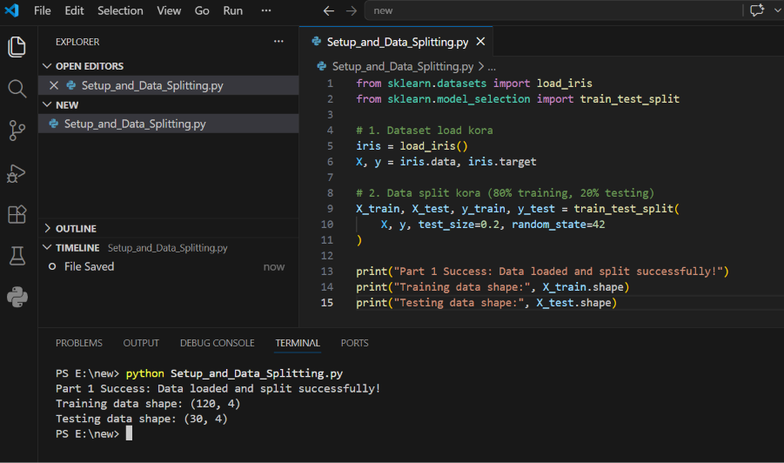
1.Load the Iris dataset from sklearn.datasets: To load the Iris dataset, import the load iris function from the sklearn.datasets module and call it to retrieve the dataset features (X) and target labels (y).

Python code:
from sklearn.datasets import load_iris

# Load the Iris dataset
iris = load_iris()
X, y = iris.data, iris.target
- Split the dataset into Training and Testing sets (80/20 split): Use the train_test_split function from sklearn.model_selection to divide the dataset into 80% training data and 20% testing data, ensuring a random_state is set for reproducibility.
Python code:
from sklearn.model_selection import train_test_split

# Split data into 80% training and 20% testing sets
X_train, X_test, y_train, y_test = train_test_split(
X, y, test_size=0.2, random_state=42
)
Model Training and Evaluation:
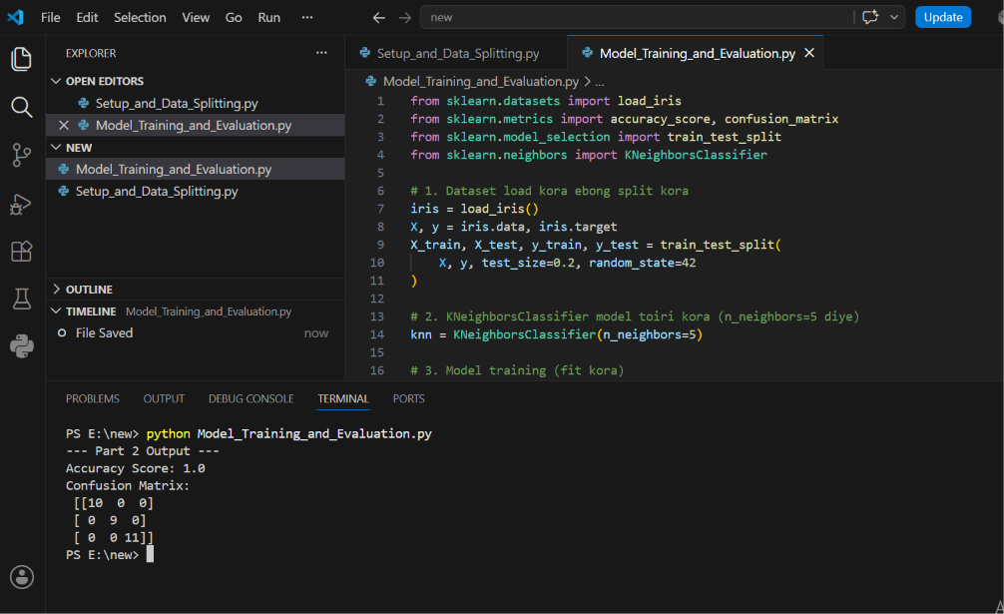

1)Initialize a KNeighborsClassifier with n_neighbors=5.
To classify the Iris dataset, the K-Nearest Neighbors algorithm is used. The classifier is initialized with the number of neighbors set to 5 (n_neighbors=5), and then it is trained using the training feature data (X_train) and training target labels (y_train).
Python code:
from sklearn.neighbors import KNeighborsClassifier

# Initialize the KNeighborsClassifier with n_neighbors=5
knn = KNeighborsClassifier(n_neighbors=5)

# Train (fit) the model using the training data
knn.fit(X_train, y_train)

2)Train (i.e., fit()) the model on your training data:
Model Training, Prediction, and Performance Evaluation
- Training the Model: The kNN classifier is trained by passing the training features (X_train) and target labels (y_train) to the .fit() method. This enables the algorithm to learn the underlying feature patterns from the training dataset.
- Making Predictions: Once trained, the model generates class predictions for the unseen testing dataset (X_test) using the .predict() method.
- Performance Evaluation: The model's effectiveness is evaluated by computing the accuracy_score, which determines the overall ratio of correct predictions, and generating a confusion_matrix, which provides a detailed breakdown of correct versus incorrect classifications for each Iris species.
Python Code:
from sklearn.metrics import accuracy_score, confusion_matrix
from sklearn.neighbors import KNeighborsClassifier

# 1. Initialize and train the model
knn = KNeighborsClassifier(n_neighbors=5)
knn.fit(X_train, y_train)

# 2. Make predictions on the testing data
y_pred = knn.predict(X_test)

# 3. Evaluate performance (Accuracy and Confusion Matrix)
print("Accuracy Score:", accuracy_score(y_test, y_pred))
print("Confusion Matrix:\n", confusion_matrix(y_test, y_pred))
Output / Verification:
- Accuracy Score: 1.0 (indicates 100% correct predictions on the test set).
- Confusion Matrix: Displays a diagonal matrix showing flawless classification across all three classes.
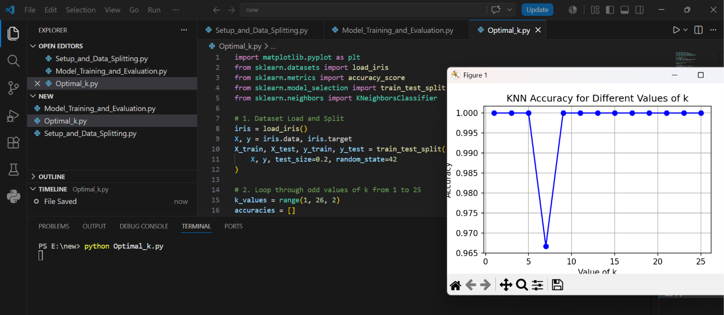
Finding the Optimal 'k' and Performance Visualization:
1. Loop Implementation for Iteration and Evaluation:
To find the best value for $k$, a for loop is implemented to train and evaluate the kNN model for every odd value of $k$ ranging from $1$ to $25$. For each iteration, the accuracy on the testing set is calculated and stored in a list.
Code:
# Loop through odd values of k from 1 to 25
k_values = range(1, 26, 2)
accuracies = []

for k in k_values:
knn = KNeighborsClassifier(n_neighbors=k)
knn.fit(X_train, y_train)
y_pred = knn.predict(X_test)
accuracies.append(accuracy_score(y_test, y_pred))
2. Line Plot Visualization:
Using matplotlib, a line plot is generated to display the relationship between the different values of $k$ (on the x-axis) and their corresponding test accuracies (on the y-axis).
Code:
import matplotlib.pyplot as plt

plt.figure(figsize=(8, 5))
plt.plot(k_values, accuracies, marker="o", linestyle="-", color="b")
plt.title("KNN Accuracy for Different Values of k")
plt.xlabel("Value of k")
plt.ylabel("Accuracy")
plt.grid(True)
plt.show()
3. Optimal Value of $k$ and Conclusion:
Based on the generated accuracy plot and evaluation results, the model maintains a high and stable accuracy across most odd values of $k$ (e.g., $1$ through $5$, and $9$ through $25$), while experiencing a brief dip at $k=7$. The optimal values of $k$ that yield the maximum performance for this dataset are $1,3,5$, and from $9$ onwards (up to $25$), achieving a peak accuracy score of $1.0$ (100%).

