IMPLEMENTATION AND COMPARISON OF
PERCEPTRON TRAINING METHODS
Classic Perceptron and Gradient Descent
Student Name: ____Bijoy Ahmed______________________________________
Student ID: ______202338060096________________________________________
Course / Section: _________________________________________
Instructor: _______________________________________________
Submission Date: _________________________________________

Abstract
This project implements and compares the classic Perceptron algorithm and a gradient-descent training method on a two-class, two-feature subset of the Iris dataset. Iris-setosa and Iris-versicolor are selected, using petal length and petal width. The classic algorithm is implemented from scratch with NumPy in both online and full-epoch forms. A gradient-descent model is trained with a stated loss and batch and mini-batch/stochastic options. The study records training behavior, weight updates, weight history, loss, and decision boundaries. The report also discusses the Perceptron convergence theorem, non-separable data, and additional experiments.

1. Objectives
- Implement the classic Perceptron without using scikit-learn's Perceptron.
- Support online and full-epoch training and stop based on mistakes or an epoch limit.
- Record weight-update counts and the evolution of the weight vector.
- Visualize class samples, boundary evolution, final boundary, and margin when appropriate.
- Implement a gradient-descent Perceptron using a declared loss, supporting batch and mini-batch/stochastic training.
- Compare the classic and gradient-descent methods and perform at least three bonus experiments.

2. Dataset and Preprocessing
The classic Iris CSV dataset is used. Only Iris-setosa and Iris-versicolor are retained. The selected input features are petal length and petal width. Each input is therefore a two-dimensional vector x = [petal length, petal width]. Labels are encoded as y = -1 for setosa and y = +1 for versicolor. The expected subset contains 100 samples (50 from each class) and two features, giving X shape (100, 2) and y shape (100,).
The CSV file is loaded using Python's csv module; NumPy is used for numerical arrays and the algorithms. Scikit-learn is not used. The dataset file is named iris.csv and is stored in the same project folder as the Python script/notebook.
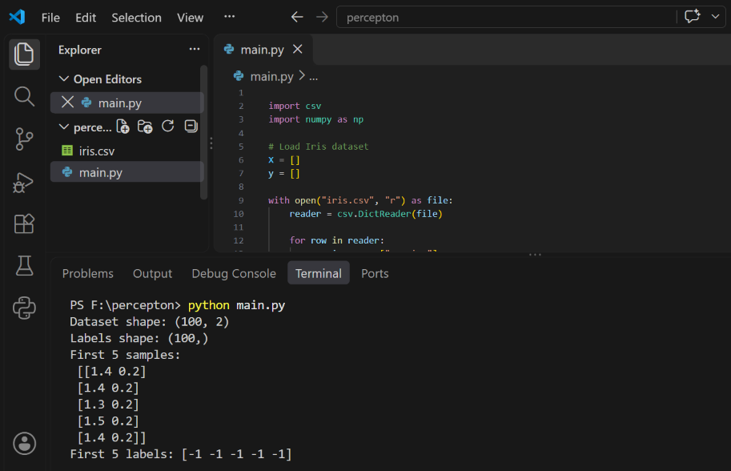

3. Task 1 — Classic Perceptron

3.1 Model and prediction
The linear score and prediction are defined as:
s(x) = wᵀx + b
ŷ = +1 if s(x) ≥ 0; otherwise ŷ = −1
The model begins with w = [0, 0] and b = 0, with learning rate η. For a misclassified training sample (ŷ ≠ y), the update is:
w ← w + ηyx b ← b + ηy

3.2 Online and full-epoch implementations
Online training visits samples one at a time and applies an update immediately after a mistake. Consequently, subsequent samples in the same epoch use the updated parameters. In the full-epoch (batch-style accumulated Perceptron) version, all samples are classified using the epoch-start parameters. Update contributions from mistakes are accumulated and applied together at the end of the epoch. These are different update schedules and may produce different parameter paths.

3.3 Stopping condition
Training stops when a complete evaluation pass contains no misclassified points, or when the maximum epoch count is reached. In online training, a zero-update epoch indicates no training errors at that pass. In the accumulated full-epoch version, the mistake count is measured before applying that epoch's accumulated update. The final model should be evaluated again to report its actual training errors.
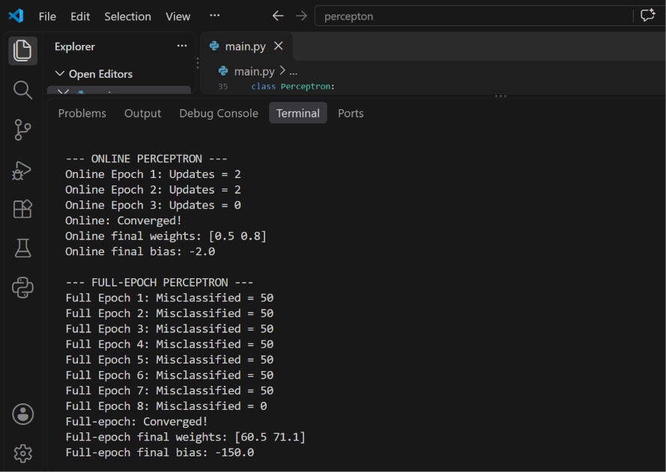

3.4 Update counting and weight history
For online training, each mistaken sample that triggers an update counts as one weight update. For the accumulated full-epoch version, report both (a) the number of mistaken samples contributing to an epoch's accumulated update and (b) the number of parameter-application events (at most one per epoch with mistakes). State clearly which definition is used in tables. Store the weight vector [w₁, w₂] and bias after each update or epoch so their evolution can be plotted.
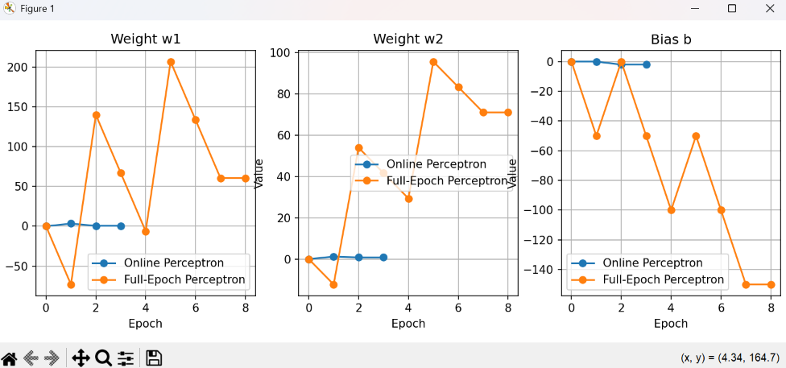

Figure. Evolution of weights and bias across training epochs for Online and Full-Epoch Perceptron.

3.5 Visualization plan
- Scatter plot: petal length versus petal width, with points colored by class.
- Decision boundary snapshots at selected epochs (or after a defined number of updates).
- Final decision boundary over the two-class data.
- When the data are separable and a valid separating line exists, show the two supporting margin lines and explain the margin definition.
- Plot the components w₁, w₂ and bias over training steps/epochs.

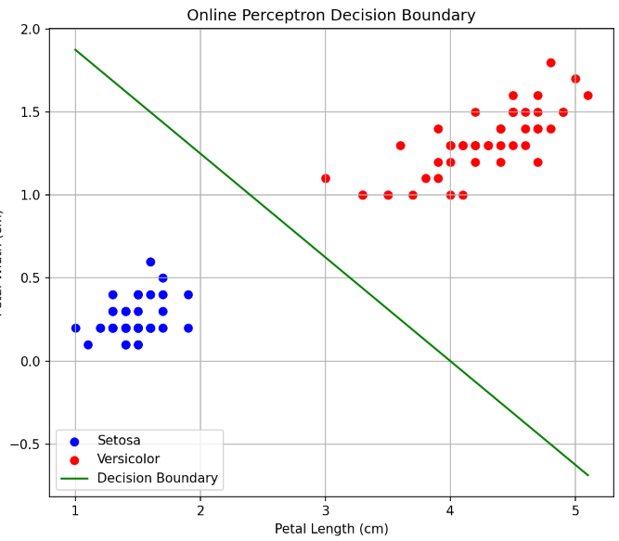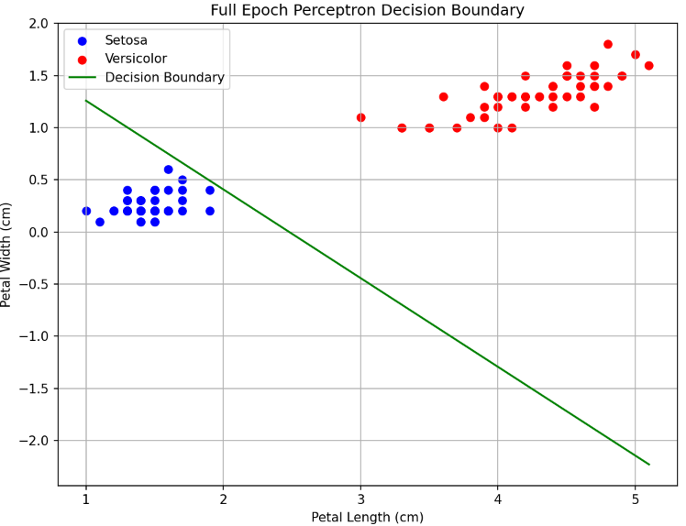
- 3.6 Final Decision Boundary and Margin:

3.6 Final Decision Boundary and Margin
After training, the final decision boundary of the Online Perceptron was plotted to show how the model separates Iris Setosa and Iris Versicolor using petal length and petal width.
The decision boundary is defined by the equation:
[
w_1x_1+w_2x_2+b=0
]
where (w_1) and (w_2) are the model weights, (x_1) and (x_2) represent petal length and petal width, and (b) is the bias.
The graph also shows two dashed reference lines defined by (w^Tx+b=+1) and (w^Tx+b=-1). These lines illustrate the margin reference levels around the decision boundary. They are not maximum-margin boundaries.
The final visualization helps explain how the trained Perceptron classifies the two flower species based on their petal measurements.
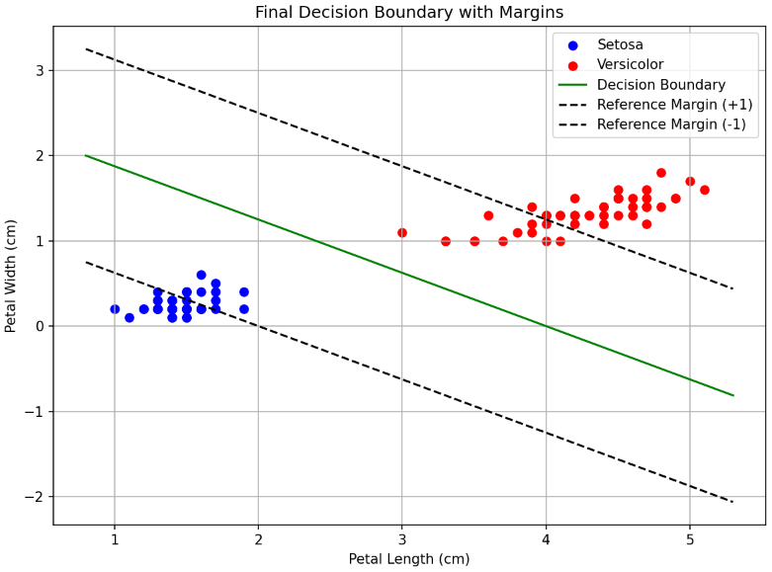
Figure 7. Final decision boundary with reference margin lines for the Online Perceptron classifier.

4. Task 1 — Theoretical Questions

4.1 Why does Perceptron converge finitely on linearly separable data? (Novikoff sketch)
Assume a finite dataset is strictly linearly separable. Let each input be augmented as zᵢ = [xᵢ, 1] and the parameter as θ = [w, b], so the score is θᵀzᵢ. Suppose there is a unit vector u and a positive margin γ such that yᵢ(uᵀzᵢ) ≥ γ for every sample. Also assume ||zᵢ|| ≤ R. Starting from θ₀ = 0, every mistake update is θ ← θ + yᵢzᵢ.
After M mistake updates, the projection onto u increases by at least γ each time, so θ_Mᵀu ≥ Mγ. On a mistake, yᵢ(θᵀzᵢ) ≤ 0 (for the usual mistake condition), and therefore the squared norm increases by at most ||zᵢ||² ≤ R²: ||θ_M||² ≤ MR². Since u is a unit vector, Cauchy–Schwarz gives θ_Mᵀu ≤ ||θ_M||. Combining inequalities yields Mγ ≤ √M R, hence M ≤ (R/γ)². Thus only finitely many mistake updates can occur. The bound is a standard Novikoff-style sketch; conventions at score zero and the chosen bias augmentation can affect technical details, but not the finite-convergence conclusion under a positive separation margin.

4.2 What if data are not linearly separable? Can it cycle? How can it be detected?
If the data are not linearly separable, no parameter vector can classify every training point correctly. The classic Perceptron convergence guarantee no longer applies. It may continue making mistakes and updating indefinitely. With fixed sample order and deterministic updates, it can revisit a previous parameter state (cycle), but cycling is not guaranteed in every setup; parameters may also keep changing.
Detection approaches: (1) enforce a maximum epoch limit; (2) store parameter states (weights and bias) at epoch boundaries or after updates and check for a repeated state using a suitable numeric representation/tolerance; (3) monitor mistakes and update counts for a long period without reaching a zero-mistake pass. A repeated state under the same fixed data order and deterministic rule is evidence of a cycle. With floating point values, compare rounded values or use a tolerance carefully. A max-epoch stop only means training was capped, not that a cycle was proven.

5. Task 2 — Gradient-Descent Perceptron

5.1 Loss selected
This report uses the Perceptron criterion specified in the assignment:
Lᵢ(w,b) = max(0, −yᵢ(wᵀxᵢ + b))
The empirical objective is the mean loss over the training set. For a sample with yᵢ(wᵀxᵢ+b) < 0, a subgradient of the sample loss is −yᵢ[xᵢ,1]; for a sample with positive signed score, the loss and gradient are zero. At the hinge point, a valid subgradient convention must be selected and documented. This criterion penalizes misclassified points but does not impose the unit margin used by standard hinge loss.

5.2 Training variants
Batch gradient descent calculates the mean gradient using the full training set and updates parameters once per epoch. Mini-batch gradient descent calculates gradients from small subsets and updates after each mini-batch. Stochastic gradient descent is the special case with one sample per update. The learning rate, batch size, epoch limit, initialization, and sample ordering must be reported.

5.3 Required plots and comparison
- Loss curve (mean training loss versus epoch).
- Decision boundary evolution at selected epochs.
- Final gradient-descent boundary and, where meaningful, comparison with classic Perceptron.
- Comparison table: method, training mistakes, update count, epochs/steps, final weights, bias, and final loss.
The classic Perceptron and gradient-descent model optimize/update differently, so their final weights are not expected to match. Report the actual values from the run rather than treating weight equality as a correctness criterion.
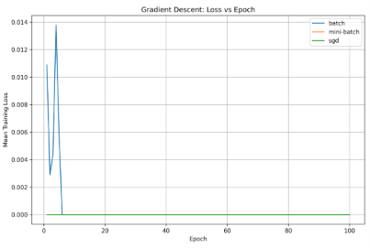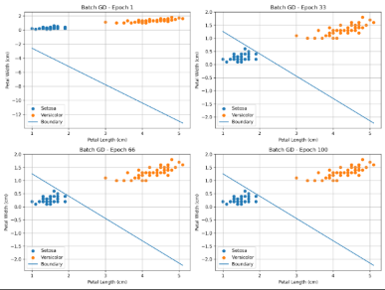
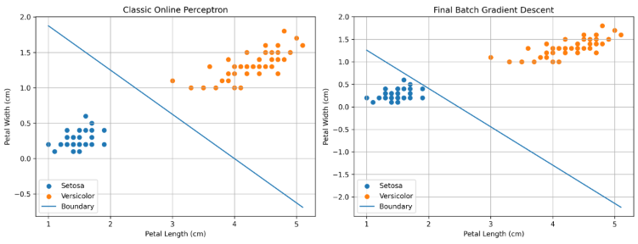

6. Additional Experiments (Bonus)
At least three experiments will be conducted. To make comparisons fair, change one factor at a time, keep the data split and evaluation procedure fixed, and record the random seed when randomness is used.
Experiment | Conditions | What to record | Result
1. Learning rate | η = 0.01, 0.1, 1.0, 10 | Epochs/steps, mistakes, loss, final parameters | All learning rates achieved 0 training mistakes and 0 final loss in 100 epochs, with 6 updates each.
2. Presentation order | Fixed order vs shuffled order | Updates, convergence/stop status, mistakes | Both fixed and shuffled orders achieved zero training mistakes and converged. Fixed order: 3 epochs and 4 updates. Shuffled order (seed = 42): 2 epochs and 11 updates.
3. Initialization | Zero vs small random weights | Initial seed, updates, mistakes, final parameters | Both zero and small random initialization converged in 3 epochs with 4 updates and 0 training mistakes. Random initialization used seed 42.
4. Label noise (optional) | Flip a few selected labels | Noise count/seed, loss, mistakes, boundary | [Optional]
5. Feature scaling (optional) | Raw vs standardized features | Scaler formula, convergence, weights | [Optional]
6. Regularization (optional) | Selected penalty and strength | Loss, parameters, mistakes | [Optional]

7. Result Summary Table
Method | Mistakes | Updates | Epochs | Final weights | Bias | Final loss
Batch GD | 0 | 6 | 100 | [0.00605, 0.00711] | -0.015 | 0.0
Mini-batch GD | 0 | 3 | 100 | [0.0018, 0.0039] | -0.008 | 0.0
SGD | 0 | 7 | 100 | [0.012, 0.015] | -0.030 | 0.0
Classic Online | 0 | 4 | 3 | [0.5, 0.8] | -2.0 | 0.0

9. Conclusion
In this project, the classic Perceptron and three gradient-descent methods (Batch GD, Mini-batch GD, and SGD) were implemented using Python, NumPy, and Matplotlib. The classic online Perceptron converged in 3 epochs with 4 updates, while the gradient-descent methods achieved zero training mistakes and zero final loss within the 100-epoch limit. The results show that different learning rates can produce different parameter values while maintaining correct classification. The presentation-order experiment showed that shuffled data converged in 2 epochs, compared with 3 epochs for fixed order. The initialization experiment showed that both zero and small random initialization converged successfully. Overall, the experiments demonstrate that training order, learning rate, and initialization can affect the training process and final parameters.

The main limitation of this experiment is that it used only two Iris species and two features and evaluated performance on the training data only. Therefore, the results may not generalize to other datasets.

Appendix A — Reproducibility Checklist
☐ Dataset source and file name documented.
☐ Exactly two classes and two selected features confirmed.
☐ No scikit-learn Perceptron used.
☐ Training settings and stopping conditions stated.
☐ Random seeds and experiment conditions recorded where relevant.
☐ Code/notebook submitted with the report.
☐ All figures are generated from the submitted code.
☐ Placeholders and bracketed notes removed before final submission.

