**GIT**

Git is a client side tool for Version control.

GIT INIT- this commands initializes a git repository. Following is an exmaple of a local git repository.

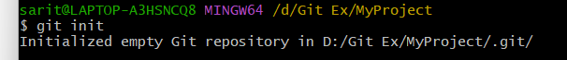

In VS Code it looks like below:

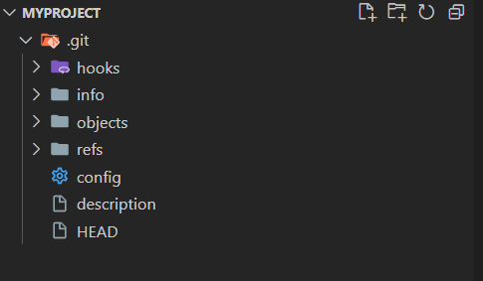

In local repository we have three areas

1. Working area

2. Staging Area

3. Local repository

Changes are made in working area and pushed to staging area using git add command.

Changes are then commited to local repository using git commit -m command.

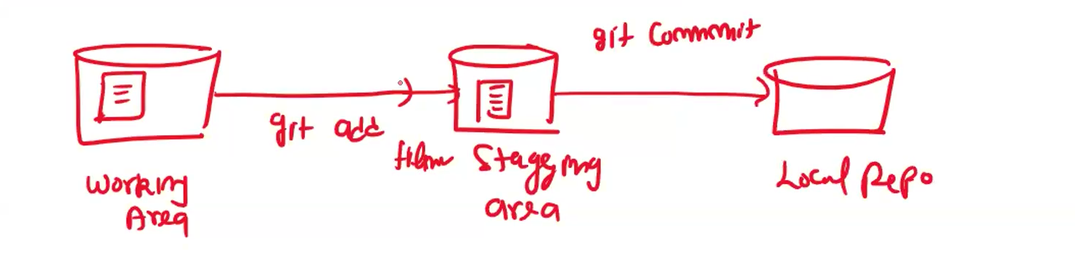

git status tells us at what stage our code is at.

For working area it is red

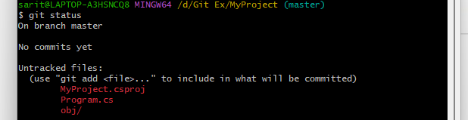

for staging area it is green

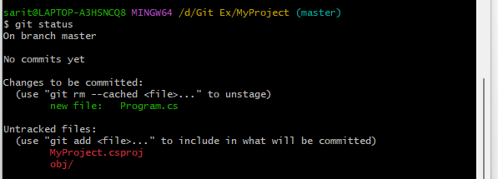

to add all files to staging area we can use command

git add .

To remove file from staging area we can use git rm –cached filename command to move file back to working area

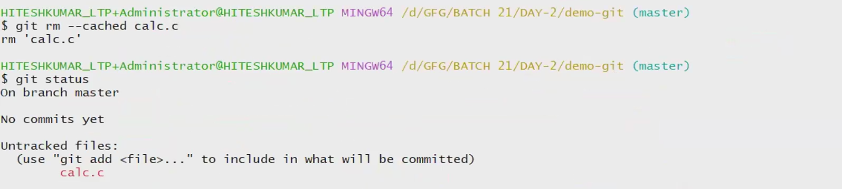

to move the file to local repository we use git commit and use git log to see if file has commited

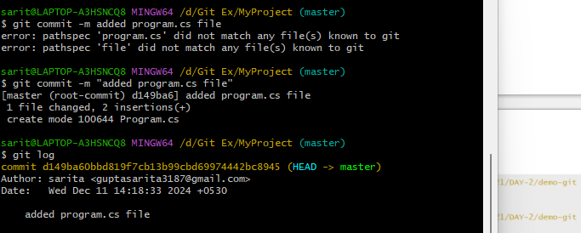

to add new gitignore file to git we use command dotnet add gitignore.

Gitignore file defines objects that should not be added to git repository. It will not show the files and folders in working area for file types defined in gitignore.

After few commits git log will give output something like below

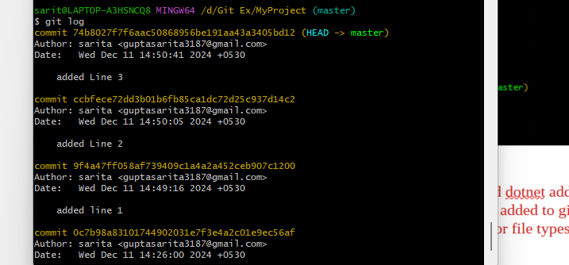

git restore –staged – this command will remove file from staging area and move it back to working area

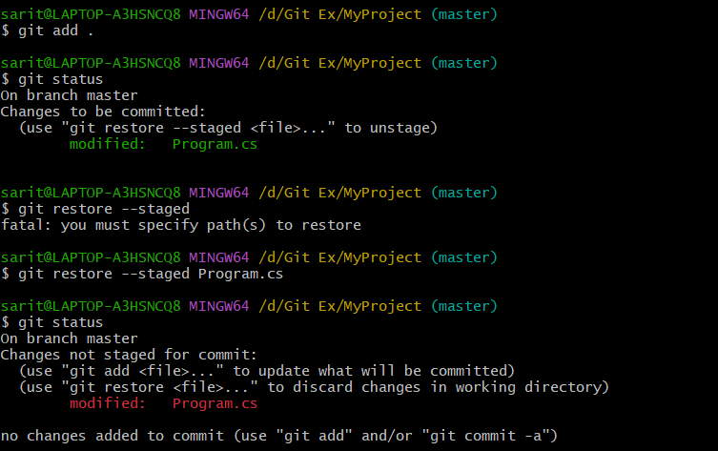

To revert a commit we can use git revert:

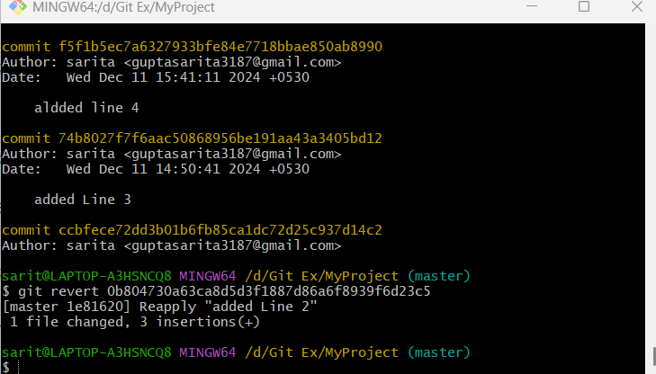

try revert twice to get code back

to delete commit permanently we use git reset --hard

git reset –hard commit-id – deletes commit ids, does not preserve history of commits.

git reset –soft commit-id – deletes commit ids but preserves commit history and can be reverted to commit id later

GITHUB

To share and collaborate code we need to push our code to online git repository.

One such free to use public online repository is Github. Bitbucket is an example of private online git repository.

Steps:

1. Create empty repository: Each repo has unique url.

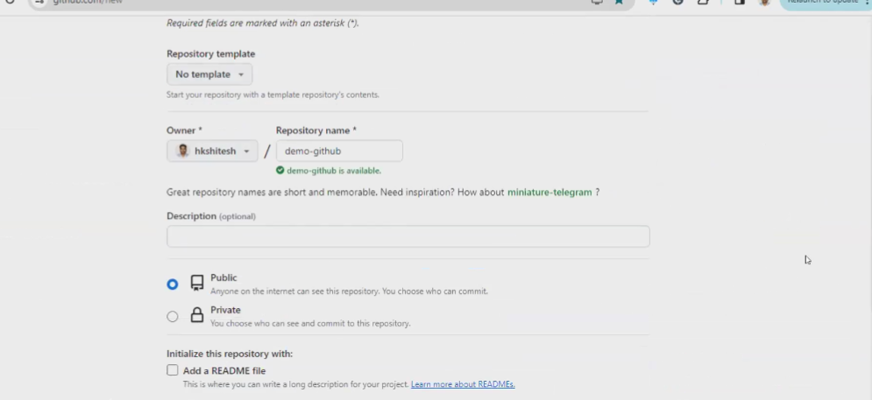

2. Add remote origin

git remote add origin url https://github.com/Bijoy1505/GitTest.git

git push -u origin master

git remote -v will give origin url on local git bash

Add token authentication

-- Settings – developer settings – Personal access token – g --generate new token---generate new token classic – copy token

2. Fork repository

search for repo url and click fork

3. Clone Repository

Click on Code and copy URL

git clone url.

4. contributor- Change code , Commit, Push and create pull request.

To create pull request go to github repo – pull request – new pull request – create pull request – add title and description and click on create pull request.

5. Owner can now view pull request and merge changes if ok.

Branching in Git:

In Git, a branch is a new/separate version of the main repository.

Branches allow you to work on different parts of a project without impacting the main branch.

When the work is complete, a branch can be merged with the main project.

You can even switch between branches and work on different projects without them interfering with each other.

1. Create a new branch

Git branch branchname



1. Check branches available

Git branch

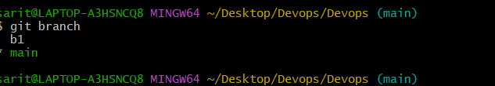

1. To change to new branch

Git checkout branchname

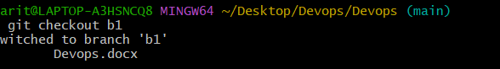

1. Do some work on branch and main branch and then to merge we use git merge command

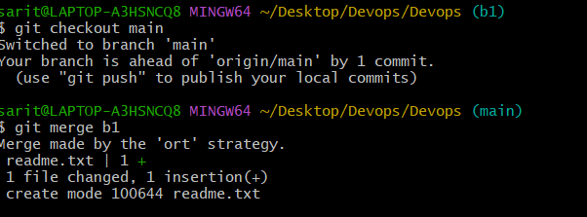

1. To merge conflicts use code editor