INTERVIEWMATE
Software Requirements Specification (SRS)
AI-Powered Interview & Viva Preparation Platform
Document Information | Details
Project Name | InterviewMate
Version | 2.0
Project Phase | Week 2
Target Users | Students, job seekers, interview and viva candidates
Primary Platform | Web Application
Prepared By

Bijoy Kumar Paul
Student ID – 220234

Suvro Dev Mojumder
Student ID – 220237

Computer Science And Engineering Discipline
Khulna University

Contents
1. Introduction 4
1.1 Purpose 4
1.2 Problem Statement 4
1.3 Purpose of the System 4
1.4 Intended Audience 4
2. Overall Description 4
2.1 Product Perspective 4
2.2 High-Level System Flow 5
2.3 Key Product Functions 5
2.4 User Characteristics 5
2.5 System Architecture Overview 6
3. System Scope 6
3.1 In-Scope Features 6
3.2 Out-of-Scope for MVP 7
3.3 Project Objectives 7
4. Stakeholders and User Roles 7
4.1 User Role: Examinee 8
4.2 Optional Administrator Role 8
5. Functional Requirements 8
6. Non-Functional Requirements 9
7. External Interface Requirements 10
7.1 User Interface 10
7.2 Backend/API Interface 10
7.3 AI Service Interface 10
8. Data Requirements 11
8.1 User Data 11
8.2 Interview Data 11
8.3 Question and Answer Data 11
8.4 Data Relationship 12
9. AI and Agentic Behavior Requirements 12
9.1 AI Objectives 12
9.2 Agentic Workflow 12
9.3 Adaptive Interview Example 12
9.4 AI Output Requirements 13
10. Use Cases 13
11. System Constraints and Assumptions 13
11.1 Constraints 13
11.2 Assumptions 13
12. MVP Scope and Future Enhancements 14
12.1 MVP Features 14
12.2 Future Enhancements 14
13. Technology Stack 14
14. Project Development and GitHub Workflow 15
14.1 Development Method 15
14.2 GitHub Branching Strategy 15
14.3 Pull Request and Review Process 15
14.4 GitHub Project Board 15
14.5 Definition of Done 15
14.6 AI-Assisted Development 16
15. Acceptance Criteria 16
16. Risks and Mitigation 16
17. Conclusion 17

1. Introduction

1.1 Purpose
This Software Requirements Specification (SRS) defines the requirements, scope, expected behavior, interfaces, constraints, priorities, and initial development plan for InterviewMate. InterviewMate is a free, AI-powered, context-aware web application designed to help students, job seekers, and viva candidates practice interviews using user-provided documents or text as the primary interview context.

1.2 Problem Statement
Students and job seekers often prepare for interviews using static question lists, videos, or generic chatbots. These approaches may not provide structured practice based on the specific company, job, project, course, or other context relevant to the candidate. InterviewMate addresses this problem by allowing a user to provide a document or text containing interview-related context, after which an AI agent analyzes the context, conducts an adaptive interview, evaluates answers, provides feedback, and selects subsequent questions based on both the supplied context and the user's performance.

1.3 Purpose of the System
- Provide free and accessible context-aware interview and viva practice through a web browser.
- Accept a user-provided document or text and generate context-aware interview questions using an AI service.
- Evaluate user answers and provide understandable feedback and scores.
- Adapt subsequent questions based on the supplied context, previous answers, performance, topic coverage, and remaining interview time.
- Maintain interview history and performance statistics.
- Provide a practical demonstration of full-stack web development and agentic AI.

1.4 Intended Audience
- Students preparing for academic viva examinations.
- University students preparing for internships and entry-level interviews.
- Job seekers practicing technical and HR interviews.
- Project supervisors, instructors, and evaluators reviewing the system.
- Developers maintaining or extending the application.

2. Overall Description

2.1 Product Perspective
InterviewMate will be implemented as a client-server web application. The frontend will provide the user interface for authentication, document/text submission, interview configuration, live interview interaction, timer display, early exit, results, and history. The backend will manage authentication, document processing, interview sessions, database operations, AI-agent coordination, and AI-service integration. A database will persist user, context, interview, question, answer, evaluation, and result information.

2.2 High-Level System Flow
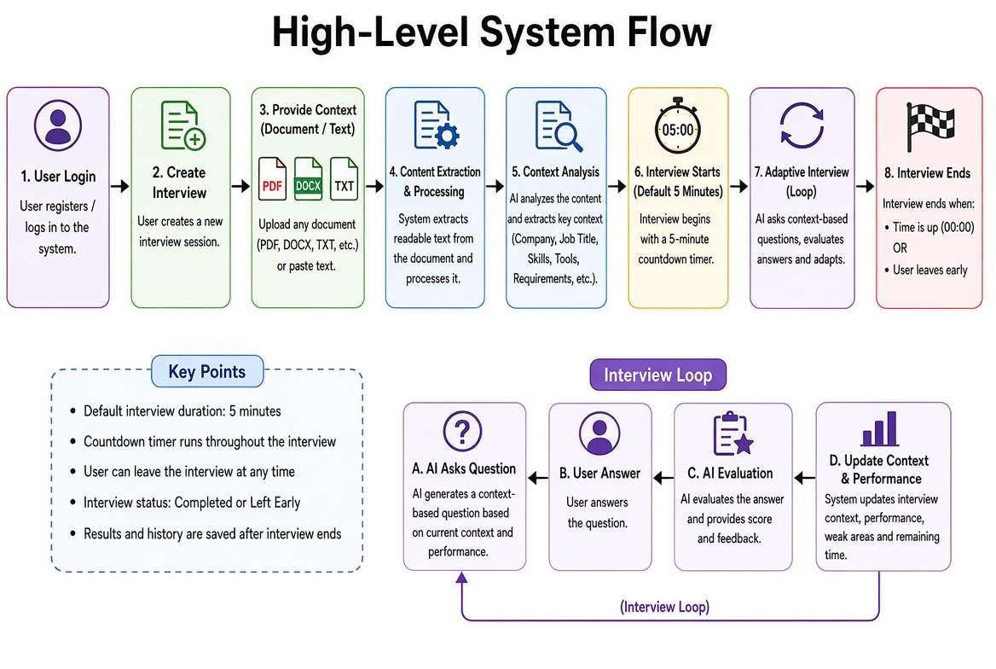
The intended user flow is:

2.3 Key Product Functions
- Account registration and authentication.
- Interview creation, context submission, configuration, and session management.
- Context analysis and AI-based question generation.
- Text-based answer submission during a timed interview.
- AI-based answer evaluation, scoring, and feedback.
- Personalized feedback and improvement suggestions.
- Adaptive question selection based on context, previous performance, topic coverage, and remaining time.
- Interview result generation.
- Interview history and progress dashboard.

2.4 User Characteristics
The primary users are students and job seekers with basic computer and web-browsing skills. No specialized technical knowledge is required to use the application.

2.5 System Architecture Overview
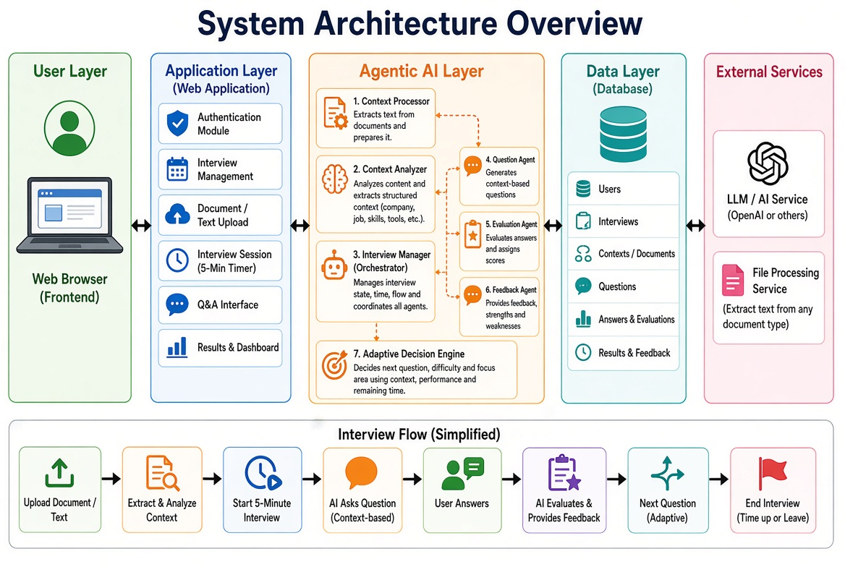
The diagram below summarizes the end-to-end architecture of InterviewMate. Users (examinees and an optional administrator) interact with the frontend web application, which communicates with the backend application over its API layer. The backend coordinates authentication, interview session management, question management, answer evaluation and analytics, and delegates AI-specific work to a dedicated AI and Agentic Services layer (question generation, evaluation, adaptive difficulty and feedback agents). All persistent data is kept in the data storage layer, and external services such as the LLM/AI model API, email, cloud storage and monitoring/logging are integrated at the edges of the system.

3. System Scope

3.1 In-Scope Features
- User registration, login and logout.
- Secure password storage and authenticated access.
- Interview type selection: Viva, Technical and HR.
- Optional interview focus/topic and initial difficulty selection; the AI may adapt difficulty during the interview.
- Default 5-minute interview duration; question count is determined dynamically by the interview flow and available time.
- AI-generated interview questions.
- Text-based answer submission.
- AI-based answer scoring on a defined scale.
- Answer-level feedback, strengths and weaknesses.
- Adaptive selection of subsequent questions.
- Final interview summary and overall score.
- Interview history.
- Basic performance dashboard.

3.2 Out-of-Scope for MVP
- Voice-based interviews and speech recognition.
- Video interviews and facial-expression analysis.
- Real-time emotion detection.
- AI interviewer avatar.
- Automatic resume parsing.
- Mobile application.
- Advanced multilingual speech interaction.
- Complex administrator analytics.

3.3 Project Objectives
- Develop a functional web-based interview and viva preparation platform.
- Apply modern full-stack web development practices.
- Integrate an AI service into a practical web application.
- Implement an adaptive agentic interview workflow.
- Provide meaningful scoring and personalized feedback.
- Maintain interview records for performance tracking.
- Demonstrate Agile planning, GitHub collaboration, code review, testing and documentation.

4. Stakeholders and User Roles
Stakeholder / Role | Description | Primary Needs
Examinee / User | Student or job seeker using InterviewMate | Practice interviews, receive feedback, track progress
Project Team | Students developing and maintaining the application | Clear requirements, modular architecture, GitHub workflow
Instructor / Evaluator | Lab instructor assessing the project | Working system, documentation, AI usage, testing and development evidence
AI Service Provider | External AI model/service used by the application | Valid API requests, safe prompts and error handling

4.1 User Role: Examinee
- Create and manage an account.
- Configure and start an interview.
- Answer generated questions.
- View scores and feedback.
- Review completed interview sessions.
- Monitor overall performance.

4.2 Optional Administrator Role
An administrator role may be introduced in a later release to manage topics, monitor system usage, and review aggregated statistics. Administrator functionality is not required for the MVP.

5. Functional Requirements
The following requirements define the core behavior of the MVP.
ID | Requirement | Description | Priority
FR-01 | User Registration | The system shall allow a new user to create an account using a name, email address and password. | High
FR-02 | User Login | The system shall authenticate registered users using valid credentials. | High
FR-03 | Password Security | The system shall store passwords using a secure hashing mechanism and shall not store plain-text passwords. | High
FR-04 | Logout | The system shall allow an authenticated user to log out. | High
FR-05 | Protected Access | The system shall restrict private user data, uploaded context, and interview history to the authenticated owner. | High
FR-06 | Context Submission | The system shall allow an authenticated user to provide interview context by uploading a supported document or entering/pasting text. | High
FR-07 | Document Processing | The system shall extract readable text/content from supported uploaded documents and make it available to context analysis. | High
FR-08 | Context Analysis | The system shall analyze submitted context and identify relevant information such as company/organization, job title, skills, tools, technologies, responsibilities, requirements, topics, or other interview-relevant information when available. | High
FR-09 | Interview Configuration | The system shall allow the user to select an interview type and optional focus/topic before starting the interview. | Medium
FR-10 | Interview Creation | The system shall create a new interview session from the submitted context and selected configuration and initialize a default 5-minute timer. | High
FR-11 | Context-Based Question Generation | The system shall generate interview questions using the submitted context, interview type, current interview state, and AI service. | High
FR-12 | Question Display | The system shall display the current interview question to the user during an active interview. | High
FR-13 | Answer Submission | The system shall allow the user to submit a text answer for the current question. | High
FR-14 | Answer Evaluation | The system shall evaluate the submitted answer using an AI-based evaluation process that considers the question and relevant interview context. | High
FR-15 | Answer Scoring | The system shall generate a numerical score for each evaluated answer using a defined scoring scale. | High
FR-16 | Feedback | The system shall provide feedback describing answer strengths, weaknesses, and possible improvements. | High
FR-17 | Adaptive Interview | The system shall use context, previous answers, scores, weaknesses, covered topics, and remaining interview time to influence the next question's difficulty or focus. | High
FR-18 | Interview Timer | The system shall display and maintain a countdown timer for the default 5-minute interview duration. | High
FR-19 | Early Exit | The system shall allow the user to leave the interview at any time before the timer expires. | High
FR-20 | Interview Completion | The system shall automatically end the interview when the 5-minute duration expires or when the user voluntarily leaves. | High
FR-21 | Interview Status | The system shall distinguish at least in-progress, completed-by-time, and voluntarily-ended interview states. | Medium
FR-22 | Interview Summary | The system shall calculate and display an overall interview result and performance summary based on answers evaluated during the session. | High
FR-23 | Interview History | The system shall store interview sessions and allow users to view previous sessions, including sessions ended early. | High
FR-24 | Performance Dashboard | The system shall display basic statistics such as total interviews, average score, recent results, and relevant progress information. | Medium
FR-25 | AI Failure Handling | The system shall show a user-friendly error or recovery message when document processing or the AI service is unavailable or returns an invalid response. | High

6. Non-Functional Requirements
ID | Requirement | Description | Priority
NFR-01 | Usability | The user interface should be simple, clear and suitable for students and job seekers, including clear document submission and interview controls. | High
NFR-02 | Performance | Under normal conditions, common page loads, document-processing requests, and backend/AI requests should complete within a reasonable response time. | High
NFR-03 | Security | Authentication, authorization, password handling, uploaded-content handling, and secret management shall follow standard secure practices. | High
NFR-04 | Reliability | The application should handle invalid input, unsupported/corrupted documents, database failures, timer/session errors, and AI-service errors gracefully. | High
NFR-05 | Maintainability | Frontend, backend, document processing, AI-agent logic, and database logic should be organized into modular components. | High
NFR-06 | Scalability | The architecture should allow additional document formats, interview types, context-extraction capabilities, subjects, and AI capabilities to be added later. | Medium
NFR-07 | Compatibility | The application should support current versions of major modern web browsers and commonly used document formats supported by the implementation. | Medium
NFR-08 | Privacy | Personal information, uploaded documents/text, extracted context, answers, and interview records shall not be exposed to unauthorized users. | High
NFR-09 | AI Transparency | The system should inform users that AI-generated questions, evaluations, and feedback are automated and may contain inaccuracies. | Medium
NFR-10 | Availability | The deployed system should be accessible through a standard internet-connected web browser when required external services are available. | Medium
NFR-11 | Timer Accuracy | The interview timer should provide consistent session-duration behavior and should terminate an interview when the default duration expires. | High
NFR-12 | Data Integrity | The system should preserve interview context, question/answer records, evaluations, status, duration, and results consistently when an interview ends normally or early. | High

7. External Interface Requirements
• Context/Document Upload and Text Input Page
• Interview Setup Page
• Live Interview Page with countdown timer and Leave Interview control

7.1 User Interface
- Landing/Home Page
- Registration Page
- Login Page
- Dashboard
- Answer Evaluation/Feedback View
- Interview Result Page
- Interview History Page
- Profile Page

7.2 Backend/API Interface
The frontend and backend are expected to communicate using REST-style HTTP APIs. Initial API groups may include:
API Group | Example Operations
Authentication | POST /api/auth/register, POST /api/auth/login
Contexts / Documents | POST /api/contexts, POST /api/contexts/upload, GET /api/contexts/:id
Interviews | POST /api/interviews, GET /api/interviews, GET /api/interviews/:id, POST /api/interviews/:id/leave
Questions / Answers | POST /api/interviews/:id/questions, POST /api/questions/:id/answer
Dashboard | GET /api/dashboard

7.3 AI Service Interface
The backend will communicate with an external AI service through an API. AI requests should contain only the context required for the current operation, such as interview type, subject, difficulty, previous performance and the user's answer. API credentials shall be stored securely on the server side and shall not be exposed in the frontend.

8. Data Requirements

8.1 User Data
Field | Purpose
userId | Unique user identifier
name | User's display name
email | Login and account identification
passwordHash | Securely stored password hash
createdAt / updatedAt | Account timestamps

8.1.1 Context / Document Data
The system should maintain the source type, original file name where applicable, extracted text/content, structured context, and timestamps for each submitted interview context. Sensitive uploaded content shall be accessible only to the authenticated owner.

8.2 Interview Data
Field | Purpose
interviewId | Unique interview identifier
userId | Owner of the interview
interviewType | Viva, Technical or HR
subject | Selected subject/topic
difficulty | Easy, Medium or Hard
totalQuestions | Configured question count
overallScore | Final interview score
status | In-progress or Completed
startedAt / completedAt | Interview timestamps

8.3 Question and Answer Data
Field | Purpose
questionId | Unique question identifier
interviewId | Related interview
question | Generated interview question
difficulty | Difficulty used for the question
userAnswer | Answer submitted by the user
score | AI-generated answer score
feedback | Evaluation and improvement feedback
createdAt | Question timestamp

8.4 Data Relationship
The initial data model follows a one-to-many relationship:
User (1) ───< Interview (1) ───< InterviewQuestion

9. AI and Agentic Behavior Requirements

9.1 AI Objectives
- Generate relevant interview questions from the selected context.
- Evaluate answers against the intent and expected concepts of the question.
- Provide numerical scores and concise explanations.
- Identify strengths and weaknesses in the user's response.
- Recommend areas for improvement.
- Support adaptive question selection based on performance.

9.2 Agentic Workflow
InterviewMate will implement an agentic workflow rather than a single one-shot chatbot interaction. The workflow will use the submitted document/text context, structured context information, interview state, previous performance, topic coverage, and remaining time to decide what question or interview action should occur next.
Component | Responsibility
Interview Manager | Controls the interview state, question count, performance context and next action.
Question Agent | Generates an appropriate question using topic, interview type and target difficulty.
Evaluation Agent | Analyzes the user's answer and produces a score and evaluation.
Feedback Agent | Produces strengths, weaknesses and actionable improvement advice.
Adaptive Decision Logic | Uses performance signals to influence the next question's difficulty or focus.

9.3 Adaptive Interview Example
If a user repeatedly scores low on questions related to a skill found in the supplied context, the Interview Manager may select simpler or more foundational questions on that skill. If the user performs strongly, the system may increase difficulty or move to another relevant topic from the context. The agent should also consider the remaining interview time when selecting the next question.

9.4 AI Output Requirements
- AI outputs should follow a structured format that can be safely parsed by the backend.
- Scores should remain within the defined scoring range.
- AI responses should be validated before being stored or displayed.
- Invalid or incomplete AI responses should trigger a controlled retry or error-handling path.
- The system should avoid presenting AI feedback as an absolute human judgment.

10. Use Cases
Use Case | Actor | Precondition | Main Flow | Outcome
UC-01 Register | User | User has no account | Enter details → validate → create account | Account created
UC-02 Login | User | Registered account exists | Enter credentials → authenticate | User dashboard opens
UC-03 Start Interview | User | User is authenticated | Select type/topic/difficulty/count → start | Interview session created
UC-04 Answer Question | User | Interview is active | Read question → enter answer → submit | Answer sent for evaluation
UC-05 Evaluate Answer | AI System | Answer received | Analyze answer → score → feedback | Evaluation stored/displayed
UC-06 Continue Interview | Interview Manager | Evaluation completed | Analyze performance → select next question | Next question displayed
UC-07 Complete Interview | User/System | All questions answered | Calculate summary → store result | Final result available
UC-08 View History | User | Completed interviews exist | Open history → select session | Previous result displayed

11. System Constraints and Assumptions

11.1 Constraints
- The application depends on an external AI API for intelligent question generation and evaluation.
- AI API quotas, latency and availability may affect system behavior.
- The MVP is primarily text-based for user answers and uses document/text context as the input source.
- Development time is limited to the lab project schedule.
- The application must be implementable with available student-level resources.

11.2 Assumptions
- Users have internet access and a modern web browser.
- Users provide genuine answers during practice sessions.
- The selected AI service can analyze supplied context, generate interview-related content, evaluate answers, and support structured outputs.
- The development team will follow Git/GitHub collaboration practices.
- The AI evaluation is treated as an educational aid rather than a formal hiring decision.

12. MVP Scope and Future Enhancements
• Context/document submission and processing
• 5-minute default interview timer
• User-controlled early interview exit

12.1 MVP Features
- Authentication
- Dashboard
- Interview configuration
- AI question generation
- Text answer submission
- AI answer evaluation
- Scoring and feedback
- Adaptive questioning
- Interview result
- Interview history

12.2 Future Enhancements
- Voice-based interview and speech-to-text.
- Text-to-speech AI interviewer.
- Video interview simulation.
- Facial-expression and non-verbal behavior analysis.
- Resume-based personalized interview generation.
- Multilingual interview practice.
- AI interviewer avatar.
- Advanced analytics and learning recommendations.
- Mobile application.

13. Technology Stack
Layer | Technology
Frontend | React.js (Vite), plain CSS / Tailwind CSS
Backend | Node.js, Express.js
Database | MongoDB (mongoose)
Auth | JWT, bcrypt
AI | External LLM API (e.g. Claude), with structured prompt/response handling
Version Control | Git + GitHub
API Testing | Free
UI Design | Figma / AI-assisted design tool
Deployment | Vercel (frontend) + Render/Railway (backend), or equivalent

14. Project Development and GitHub Workflow

14.1 Development Method
The project will follow an Agile, sprint-based workflow aligned with the laboratory instructions. Requirements will be defined in Week 1, architecture and wireframes in Week 2, core development in Weeks 3–4, and CRUD/API/AI functionality in Weeks 5–6.

14.2 GitHub Branching Strategy
- main – stable release branch.
- develop – integration branch for completed sprint work.
- feature/* – individual feature development branches.

14.3 Pull Request and Review Process
- Create or select a GitHub Issue.
- Create a feature branch.
- Implement and locally test the feature.
- Commit changes using a clear commit message.
- Open a Pull Request.
- A different team member reviews the changes.
- Fix review comments if required.
- Merge after approval and successful testing.

14.4 GitHub Project Board
Recommended workflow columns:
- Backlog
- Todo
- In Progress
- Code Review
- Testing
- Done

14.5 Definition of Done
- Requirement implemented.
- Code committed to the appropriate branch.
- Relevant tests completed.
- Pull Request created and reviewed.
- Critical review comments resolved.
- Feature merged into the integration branch.
- Documentation updated where necessary.

14.6 AI-Assisted Development
- AI tools may assist with requirement drafting, README creation, code scaffolding, test generation, diagram generation and weekly summaries.
- Generated code and documentation must be reviewed by the team before inclusion.
- The team remains responsible for correctness, security, testing and final decisions.
- An AI usage log will be maintained to document how AI tools contributed to the project.
• A user can submit a supported document or text as interview context.
• The system can extract and analyze relevant information from the submitted context.
• The system starts interviews with a default duration of 5 minutes.
• A user can leave an active interview at any time before the timer expires.
• The interview automatically ends when the 5-minute duration expires.
• Early-ended interviews preserve the available session progress and result information.

15. Acceptance Criteria
- A user can successfully register and log in.
- An authenticated user can configure and start an interview.
- The system can generate relevant questions through the AI service.
- A user can submit text answers.
- The system can evaluate answers and provide scores and feedback.
- The interview can adapt subsequent questions based on performance.
- The system can produce a final interview result.
- Completed interviews are stored and visible in the user's history.
- Users cannot access another user's private interview data.
- The application handles AI/API errors without crashing.
- The codebase follows the agreed GitHub branching and Pull Request workflow.

16. Risks and Mitigation
Risk | Impact | Mitigation
AI API quota or cost limitations | High | Use controlled request counts, caching where appropriate, and define a fallback/demo mode.
AI response inconsistency | High | Use structured prompts, validate outputs and retry invalid responses.
Team integration conflicts | Medium | Use feature branches, Pull Requests and regular code reviews.
Scope expansion | High | Freeze MVP requirements and move non-essential features to future scope.
Database/API bugs | Medium | Use modular APIs, Postman testing and unit/integration tests.
Security mistakes | High | Hash passwords, protect secrets, validate input and enforce authorization.
Limited development time | High | Prioritize authentication, interview flow and AI evaluation before advanced features.

17. Conclusion
InterviewMate is proposed as a practical, student-focused web application that combines full-stack web programming with AI-assisted and agentic behavior. The MVP focuses on the complete interview preparation loop: configuration, AI question generation, answer submission, evaluation, adaptive questioning, feedback and performance tracking. The defined requirements and Agile workflow provide a clear foundation for the Week 2 design phase and the subsequent development sprints.

UI/UX Design Alignment & Product Experience Requirements

1. Product Positioning
InterviewMate shall be presented as an AI-powered preparation platform for any interview or viva, rather than as a recruitment-only product. Supported preparation contexts include job interviews, course/subject viva, academic oral examinations, internships, scholarship/admission interviews, certification preparation, and custom preparation.

2. Context-Aware Preparation
Before an interview starts, the user shall select a preparation purpose and may provide a custom description. Supported purposes shall include Job Interview, Course/Subject Viva, Internship Interview, Academic/Oral Exam, Scholarship/Admission Interview, Certification Preparation, and Custom/Other. Users shall be able to upload supported context materials such as PDF, DOCX, TXT, images, resumes/CVs, notes, lecture/course materials, job descriptions, study materials, project documents, and portfolio documents where supported by the implementation. The interface shall show file name, processing status, and controls to add, remove, preview, and upload multiple files. Selected purpose and processed context shall influence the interview session.

3. Interview Configuration
The setup experience shall use a clear step-by-step flow covering preparation purpose, interview type, difficulty, experience/academic level, duration, number of questions, interaction mode, context materials, and interview preview. Difficulty options shall include Easy, Medium, Hard, and Adaptive, with Adaptive recommended where appropriate. Duration and question-count choices shall be configurable while preserving the SRS-defined MVP default of a 5-minute interview.

4. Interaction Modes
The MVP remains text-first as defined in the SRS. The product UX shall nevertheless use a reusable interaction architecture that can support Voice Interview in a future release, including microphone, recording state, waveform, duration, stop, playback/replay, submit, and switch-to-text controls. Voice, speech recognition, text-to-speech, and related advanced interaction remain future enhancements unless the MVP scope is formally expanded.

5. Adaptive AI Interview Experience
The live interview shall communicate that questions are adaptive rather than a fixed list. Adaptation may use previous answers, answer quality, confidence signals where available, technical accuracy, communication quality, difficulty handling, strengths and weaknesses, uploaded context, preparation purpose, selected difficulty, experience/academic level, topic coverage, and remaining interview time. The UI may show subtle AI states such as “Analyzing your answer…”, “Preparing a follow-up question…”, “Adjusting difficulty…”, and “Using your uploaded course material…” .

6. Application Shell & Navigation
The application shall use a consistent product shell across authenticated screens. Primary navigation shall include Dashboard, Start Interview, Mock Interviews, Practice, Performance, Career/Academic Readiness, Profile, and Settings, with Help, User Profile, and Logout available in the lower navigation area. Responsive behavior shall support a 1440px desktop design target and adapt to tablet/mobile layouts. Mobile application development itself remains out of scope for the MVP.

7. Visual Design System
The UI shall follow a professional modern AI-SaaS visual language: light/white backgrounds, blue/indigo primary accents, subtle gradients, soft neutral surfaces, rounded cards and buttons, modern sans-serif typography, consistent spacing, minimal professional icons, accessible contrast, generous whitespace, and clear visual hierarchy. Excessive futuristic or cyberpunk styling shall be avoided. Reusable components shall cover buttons, inputs, textareas, search, selects, toggles, cards, badges, tags, progress indicators, charts, tabs, modals, dialogs, tooltips, toasts, file upload, AI states, loading, empty, success, and error states.

8. Required Product Screens
The UI/UX design shall cover Landing Page, Login, Sign Up, Dashboard, Start Interview/Configuration, Interview Preview, AI Mock Interview, Interview Completed, AI Feedback & Results, Performance Analytics, Practice Questions, Career/Academic Readiness, Profile & Personalization, and Settings. The Landing Page shall clearly communicate support for both job and academic/viva preparation. The Dashboard shall surface readiness/performance, recent sessions, recommendations, and goals.

9. Live Interview Screen
The core interview screen shall be distraction-free and display interview title, question progress, progress bar, timer, and an End/Leave Interview action. The central area shall show the current AI question, category/type, difficulty, and adaptive status. In text mode, a large answer area shall provide Submit Answer and Skip Question controls. Processing states shall be visible without blocking the user unnecessarily. Early exit shall preserve session information in accordance with the SRS.

10. Results, Analytics & Readiness
After completion, the product shall provide an overall score, concise summary, metric breakdown, strengths, improvement areas, personalized AI feedback, question-level performance, and recommended practice. Performance Analytics shall include overall score trend and available communication, technical, confidence, and relevance trends. Career/Academic Readiness shall not be job-only; it shall adapt to preparation history and may surface Interview Readiness, Communication Readiness, Technical Readiness, Subject Knowledge Readiness, Resume Readiness when relevant, Academic Preparation Readiness when relevant, strengths, skill gaps, and personalized recommendations.

11. Profile, Personalization & Settings
Profile shall support name, email, profile photo, university, department, degree, year, skills, experience, target job roles, academic subjects, interests, resume, and context documents where applicable. Settings shall include Account, Profile, Notifications, Interview Preferences, AI Preferences, Voice Settings, Privacy, Change Password, Data/Context Management, and Logout.

12. UX States, Accessibility & Trust
The interface shall include clear loading, processing, success, empty, warning, and error states. AI-generated questions, evaluations, and feedback shall be presented as automated assistance and not as absolute human judgment. The product shall maintain accessible contrast, understandable labels, consistent interaction patterns, and clear feedback for document-processing and AI-service failures.

13. Realistic Product Data
The interface shall avoid Lorem Ipsum and use realistic examples representing both academic and professional contexts, including Software Engineer Mock Interview, Database Systems Viva, Computer Networks Viva, Machine Learning Internship Interview, Operating Systems Oral Exam, Behavioral Job Interview, and Scholarship Interview.

14. Scope Reconciliation
Where the UI/UX design prompt describes capabilities that the current SRS places outside the MVP—such as voice interviews, speech recognition, AI interviewer avatar, video interviews, facial-expression analysis, automatic resume parsing, multilingual speech interaction, mobile applications, or advanced analytics—the design shall represent these as future-ready concepts or clearly marked future enhancements unless the project team formally expands the MVP scope. The current SRS remains the source of truth for MVP implementation priorities.

15. End-to-End Experience
The intended product experience shall communicate the complete journey: Choose Purpose → Configure Interview → Add Context → Choose Text/Voice when available → AI Asks → User Responds → AI Analyzes → AI Adapts → Complete → Feedback → Analytics → Practice → Improved Readiness.

UI/UX-to-SRS Traceability Summary
UI/UX Area | SRS Alignment | MVP Status
Authentication & Dashboard | FR-01–FR-05, FR-24 | MVP
Context Upload & Processing | FR-06–FR-08 | MVP
Interview Configuration | FR-09–FR-10 | MVP
Adaptive Questions & Evaluation | FR-11–FR-17 | MVP
Timer & Early Exit | FR-18–FR-21 | MVP
Results, History & Analytics | FR-22–FR-24 | MVP
AI Error/Trust States | FR-25, NFR-04, NFR-09 | MVP
Voice Interview UX | Future enhancement in SRS | Future
Video/Avatar/Emotion Analysis | Future enhancement in SRS | Future
Career/Academic Readiness | UI/UX product layer; extend analytics as implemented | Planned/Extensible

