StockSense AI: An AI Powered Stock Market Prediction Web Application

BY
Bijoy Bhadra (123231110209)
Swarojit Mondal (123231110221)
Tania Samajpati (123231110222)

List of Figures

Figure 1: Single Historical stock closing price over time 14
Figure 2: Multi Historical stock closing price over time 14
Figure 3: The overall workflow of the proposed model 18
Figure 4: The workflow of Multi-Stock model 18
Figure 5: Single-Stock training & validation loss curve 19
Figure 6: Multi-Stock training & validation loss curve 19
Figure 7: Comparative analysis of Models 21
Figure 8: Actual vs. predicted stock prices using the GRU model. 21
Figure 9: Residual error distribution over time for the GRU model. 22
Figure 10: Rolling directional accuracy of the GRU model. 22
Figure 11: Prediction error density for the GRU model. 23
Figure 12: Actual vs. predicted direction of stock price movement using the GRU model. 23
Figure 13: Comparative analysis of models for multi-stock prediction. 25
Figure 14: Actual vs predicted stock prices using the LSTM model for
multi-stock prediction. 25
Figure 15: Residual error distribution for the LSTM model in the
multi-stock prediction. 26
Figure 16: Rolling directional accuracy for the LSTM model in
multi-stock prediction. 26
Figure 17: Prediction error density for the LSTM model in
multi-stock prediction 27
Figure 18: Actual vs predicted direction of stock price movement
using the LSTM model. 27
Figure 19: SHAP interaction analysis showing the contribution
of historical input features to stock price prediction. 28

List of Tables

Table 1: Comparative Literature Survey on Stock Market Prediction 9-10
Table 2: Performance Comparison of Models 20
Table 3: Performance Comparison of Models of Multi-Stock 24

CONTENTS

Title page 1
Certificate 2
Acknowledgement 3
List of Figures & Tables 4-5

Abstract 7
1. Introduction 7-9
2. Literature Survey 9-13
3. Methodology 13-16
4. Proposed Method 16-20
5. Result and Discussion 20-29
6. Conclusion 29-30
7. Future Scope 30
Reference 31-32 PUBLICATIONS FROM THE WORK 33

ABSTRACT
Stock market prediction is complex and difficult because of the constantly changing non-linear and time dependent financial data which is volatile and non-linear. Stereotypical statistical and Machine Learning based models typically have difficulties in generalizing long term time dependence and latent patterns inherent in time series stock prices that result in poor predictive performance. Deep Learning models have become a strong alternative that occupies an automated feature extraction and an effective study of sequences in recent years.
The paper involves introducing an AI Powered Stock Market Prediction Web Application based on Deep Learning and hybrid Deep Learning models that predict stock prices of individual stocks. The proposed system takes advantage of the historical data of stock market and uses sequence-based neural network models including Long Short-Term Memory (LSTM), Gated Recurrent Unit (GRU), and hybrid CNN based Deep Learning models to learn the complex time variations in stock price. The models are incorporated into a web application giving interactive visualization to real and estimated stock prices which is a better usability and decision support.
Within the enhanced mode of the system, it is presented with a multi-stock prediction framework in which one deep learning system is trained through various stocks. The benefit of this approach is that it enables the model to require more general market trends, and enhance the scalability and generalization ability of the prediction system. Moreover, Explainable Artificial Intelligence (XAI) algorithms based on SHAP (SHapley Additive Explanations) are also included to explain the model predictions and what input features contribute to them. The experimental findings indicate that the improved framework has strengths in terms of prediction scalability and model low interpretability as compared to its predictive performance.

Keywords: Stock Market Prediction, Deep Learning, LSTM, GRU, Hybrid Neural Networks, Time Series Forecasting, Explainable AI (XAI).

- INTRODUCTION
Stock market is among the most powerful constituents of the world financial system, which is significant in terms of capital formation, investment planning as well as in economic growth. There are numerous factors which influence the prices of stock such as the performance of the company, economic indicators, the behavior of the investor as well as world events[1]. Because of this sophistication, stock market action has been found to be very volatile, not linear and hard to predict. Predicting the stock price effectively with great degree of reliability is thus a matter of huge concern to investors, analysts and researchers since even a small advance in the accuracy of the prediction would yield improved decision making and risk management methods[1], [2].
Historically, stock market prediction has had to require the use of statistical and econometric models including the use of linear regression, moving averages, or autoregressive. The underlying assumptions of these approaches are high levels of linearity and stationarity, which are not true in the real world of financial markets[2]. This means that they do not work when subjected to complicated and dynamic market environments. To address these drawbacks, support vector regression, random forest, and ensemble-based models of Machine Learning (ML) have been presented[3]. Although ML models are able to increase the accuracy of predictions to a certain extent, they generally require manual feature engineering and assume stock prediction is a stationary regression issue and thus do not capture important long term temporal correlation of financial time series data[4].
During recent years, Deep Learning (DL) has managed to become a strong competitor in terms of time series forecasting activities. Deep Learning models can automatically discover hierarchical feature representations without the help of manually designed features, which are learned out of raw data. Recurrent neural network (RNN) and its versions, including Long Short-Term Memory (LSTM) and Gated Recurrent Unit (GRU) neural networks have shown good results in the modelization of serial data[5]. The models carry an advantage of capturing long term dependencies, hence preserving the internal memory states which is very appropriate in predicting a stock price, where past trends and patterns play a major role on the future directions.
Moreover, a global interest in hybrid Deep Learning models as a tool to harness the benefits of a number of neural architectures has emerged. The hybrid models, like CNN based recurrent networks, use Convolutional Neural Networks (CNNs) in extracting features and recurrent layers to model time. The combination of this type of model improves its performance in capturing the local trends and long run relationships within stock price data to give better predictive performance than other individual models[6].
The paper introduces an AI Powered Stock Market Prediction Web Application that is founded on the Deep Learning and hybrid Deep Learning models to predict prices of stocks using historical data of the market. The suggested system deploys sequence-based neural networks models, including Long Short-Term Memory (LSTM), Gated Recurrent Unit (GRU), and hybrid CNN-based ones that are trained to acquire intricate time-dependent rules that relate to stock price variations[7]. Unlike the conventional methods which seek to predict the stocks of the individual stocks one at a time, the proposed framework presents a multi-stock prediction system where only one deep learning system is being trained using information of two or more stocks. The model can be used to view a larger market dynamics and helps to scale and generalize prediction system.
Also, the system implements Explainable Artificial Intelligence (XAI) methods based on SHAP (SHapley Additive Explanations) to give explanations to the model predictions. The SHAP framework is applicable in determining the contribution of various input features and historical price patterns in prediction and therefore enhances transparency and trust of user in the system[8], [9]. The trained models are incorporated in a web based application which enables the users to visualize past trends and forecast stock prices interactively which serves as a convenient decision support tool to investors and analysts.

- LITERATURE SURVEY
The idea of stock market prediction has been actively studied since a number of decades, involving contributions of finance, statistics, and artificial intelligence. The technique of predicting stock prices suggested by researchers has been discussed in a broad spectrum since using conventional statistical methods to using more sophisticated Deep Learning models. The section is a review of available literature that builds on the methodologies of prediction, datasets utilized or experimental results, and the limitations that motivate the proposed approach. Table 1 providing a comparative overview of typical research with objectives, methodology, dataset, and limitations is given on representative studies as one can observe the development of stock market forecasting methods as well as the research gaps this study will focus on.
Table 1: Comparative Literature Survey on Stock Market Prediction
Author & Year | Objective of Study | Methodology Used | Dataset Used | Limitations Reported
Adeleye et al. (2024) | To review Machine Learning models for stock market forecasting and evaluate prediction accuracy | Review of ML models such as SVR, Random Forest, Decision Trees, and ensemble methods | Secondary datasets collected from previously published stock market studies | Inability of ML models to capture long-term temporal dependencies; dependence on manual feature engineering
Chang et al. (2024) | To predict economic trends and stock prices using Deep Learning and advanced ML techniques | Deep Learning models combined with advanced ML approaches | Historical stock market and economic datasets from public financial repositories | High computational complexity; lack of model interpretability
Si et al. (2024) | To model opening price spread using hybrid ARIMA–GRU/LSTM models | Hybrid statistical and Deep Learning models | Shanghai Composite Index historical price data | Dependence on ARIMA assumptions; limited adaptability to different markets
Dahal et al. (2023) | To study the impact of news sentiment on stock price prediction | Deep Learning architectures integrated with sentiment analysis | Historical stock price data combined with financial news datasets | Heavy reliance on external textual data; complex preprocessing pipeline
Jaiswal & Singh (2022) | To propose a hybrid CNN-GRU model for stock price prediction | Hybrid Deep Learning model (CNN-GRU) | Historical daily stock price data of selected companies | Increased training complexity; higher computational cost
Ji et al. (2021) | To develop a Deep Learning-based stock price prediction method | Deep Neural Network architectures | Historical stock price data of listed companies | Limited interpretability; challenges in real-world deployment

- Datasets Used in Stock Market Prediction
The dataset used is a very important factor in predicting stock market and its accuracy. The majority of the studies conducted previously are based on past stock market statistics, and they usually contain the following attributes; open price, high price, low price, close price, adjusted close price, and trading volume. These data sets are usually obtained through free financial sites like Yahoo Finance, Google Finance and stock exchange websites[10]. A number of studies use individual stock data to investigate time-resolved behavior and minimize the complexity of cross-stock correlations. Multi-stock or index-level data are used in other studies to compare data or predict each portfolio. The duration of datasets used in the studies is quite different as it can range between a few months to some years based on the forecasting horizon and complexity of the model[2]. Besides numerical price data, other researchers use external data sources like financial news, sentiment on social media and macroeconomic indicators. Although such multimodal data may be useful to improve performance on predictions, these data also involve more complexity in the preprocessing stage, alignment of features, and understandability of models[11]. Consequently, numerous researches limit their analyses to historical price data so as to ensure stability and reproducibility of models. Nevertheless, numerous researches are simplified on single-stock data and hence, fails the capability of the models to grasp broader market trends among numerous firms. This drives the design of multi stock based learning models that have the ability to represent generalized correlations among stocks.
- Traditional Statistical Approaches
Early research on predicting the stock market has mainly used statistical and econometric models including the linear regression model, moving averages and the autoregressive integrated moving average (ARIMA) models. Such techniques are aimed at approximateing past price pattern through mathematical equations along a set of predetermined assumptions. Such methods are easy and interpretable, but the methods presumes linearity and stationarity in data[6]. The actual stock market data, however, is highly non-linear and volatile and these assumptions fail to hold and prediction accuracy is limited.
- Machine Learning Models for Stock Market Prediction
Machine Learning (ML) methods have gained popularity in order to address the weaknesses of the statistical models. Support Vector Regression (SVR), Decision Trees, Random Forest and ensemble algorithms like XGBoost are shown to be increasingly better as they are able to pick non-linear correlation in the financial data. Numerous studies include technical indicators and developed functions in order to increase the precision of models[12]. The existing advances notwithstanding, the current trend of using ML-based models defines the prediction of stock prices as a fixed-point regression carefully relying on a significant part of the manual feature encoding. Besides, they do not include embedded systems to model temporal dependence of long term, which are essential in forecasting time-series[13]. This results in a low performance as they are more frequently applied to the very volatile sequential data of stock markets.
- Deep Learning Models for Stock Market Prediction
The recent developments in the field of Deep Learning have a tangible impact on the research of predicting the stock market. Deep Learning models also learn the complex feature representations automatically by using raw data, eliminating the need to develop features irregularly. RNNs (and variants thereof) are especially useful in the sequential representation of data. Long Short-Term Memory (LSTM) networks are an extension of the RNNs that aims to eliminate the vanishing gradient problem by simply adding memory cells and gating mechanisms to the traditional network[14]. It has been established in numerous studies that LSTM-based models do not only outperform their more traditionalML counterparts, but also have higher capability of covering long-term price dependencies in time series of stock prices. GRU models offer an easier architecture that has comparable performance and reduced computational cost, which makes them appealing to time-series forecasting problems[15]. Overall, deep learning models cannot be criticized notwithstanding their excellent predictive capability because many of them lack interpretability as the users find it hard to comprehend the decision-making process of such models.
- Hybrid Deep Learning Models
Recent studies have also investigated hybrid Deep Learning architectures that are a combination of several neural network elements to enhance the accuracy of prediction. CNN-LSTM or CNN-GRU is a hybrid model that combines convolutional layers to extract local features with recurrent layers to model time[16]. CNNs model short time trends and noise insensitive characteristics, whereas recurrent networks are used to model long-term relationships. Empirical experiments have shown that hybrid models typically show better performances in comparison with standalone Deep Learning models taking advantage of learning spatial and temporal features[17]. Such architectures work especially well with stock market data, which are noisy and have complicated patterns at various different time scales.
- Machine Learning Model Vs. Deep or Advance Architecture
A comparative review of literature shows that, although the Machine Learning models are better than the use of traditional statistical models, they are not able to capture sequential dependencies as the time-series data represents[12]. Deep Learning models and recurrent and hybrid architectures in particular take stock price prediction as a sequence learning task instead of a single regression task. This difference allows Deep Learning methods to learn more complex non-linear patterns and each relation of time[18], [19].
- Research Gap
Despite large amount of research having been done on predicting stock markets using the Machine Learning and Deep Learning methods, there are still a number of limitations associated. Numerous studies that have been carried out concentrate on the prediction of single stocks and hence limit the capacity of models to develop general market trends among different companies[10]. Moreover, the majority of Deep Learning models are not transparent; they are created as black-box systems, and thus their users cannot understand the ways in which predictions are produced, which decreases transparency and trust. Also, a significant portion of solutions is restricted to offline and experimental setup without real-world implementation and end-user engagement [15], [17]. To overcome those constraints, this paper suggests AI-powered Stock Market Prediction Web Application, which contains a multi-stock learning framework and incorporates Explainable Artificial Intelligence (XAI) via SHAP in order to enhance not only the scalability of the stock price predictions but also their resolution.

- METHODOLOGY
The approach that would be used in this study would focus on how to methodically solve the problem of stock market time-series prediction using the advantages of the Deep Learning and hybrid Deep Learning architectures. Since stock price data can be extremely non-linear, volatile and also sequential, methodology can be applied to create suitable data preparation, sequence modeling and objective performance evaluation[20]. The method is based on the offline experimentation that utilizes the past stock price data, which guarantees controlled analysis and the repeatability of the obtained outcomes.
The workflow that can be proposed is divided into several steps, among which information can be obtained through trustworthy financial sources, preprocessing to enhance the quality of data, and its learning modules, creation of sequence-based Deep Learning and hybrid architectures, and intensive training and validation to standard evaluation metrics. In addition to predicting stock prices, the methodology also aims to compare the predictive behavior of models trained on a single stock with models trained on multiple stocks simultaneously. This comparison helps evaluate whether training on broader market data improves the generalization capability of the prediction system. Furthermore, the framework provides a scalable foundation for future enhancements such as explainable artificial intelligence and deployment through a web-based application.
- Data Acquisition
Historical stock market data are collected using the yfinance Python library, which provides programmatic access to financial data from Yahoo Finance [9]. Instead of manually selecting individual stocks, the stock tickers are first obtained from a CSV file containing a list of company symbols. These tickers are then used to automatically download historical stock price data through the yfinance API. For each ticker, the dataset includes daily stock price records such as open price, high price, low price, close price, adjusted close price, and trading volume [8]. The downloaded data from multiple stocks are then combined into a unified dataset, allowing the Deep Learning models to be trained on a broader representation of market behavior. The long-term trend and volatility characteristics of a representative stock are illustrated in Figure 1, which shows the historical closing price movement over time. To analyze market behavior across multiple companies, Figure 2 presents the closing price trends of ten selected stocks. This combined multi-stock dataset enables a comparative evaluation between single-stock prediction models and models trained using multi-stock data, improving the scalability and generalization capability of the prediction system.
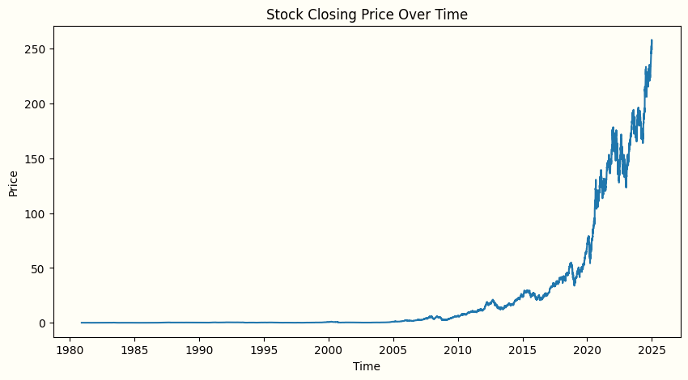
Figure 1: Single Historical stock closing price over time
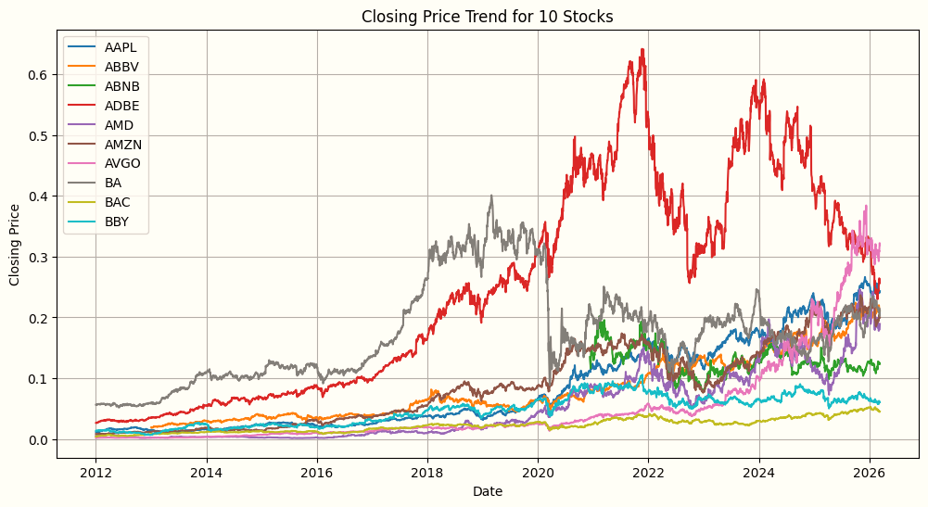
Figure 2: Multi Historical stock closing price over time
- Data Preprocessing
Yfinance retrieved raw stock market data can include noises, scale variations, and missing values which can influence model performance. Thus, preprocessing of data is an important consideration in the proposed methodology[15]. First, the records that are missing or absent are determined and processed to find their quality. The choice of relevant features focuses on the closing price which is a common selection feature in time-series forecasting. Norming of the selected data in the form of feature scaling to enhance training stability and convergence are made. An offsetting manner of time-series data is consequently converted to a supervised learning format, where a diverse quantity of historical data is utilized to foresee the following price of stocks. This conversion allows the Deep Learning models to be efficient in the capturing of the temporal relationships in the stock price sequence[11].
For the multi-stock experiment, the same preprocessing steps are applied individually to each stock before combining the processed sequences into a unified dataset for model training.
- Deep Learning Model Development
The sequence-based Deep Learning models used in the proposed system are highly applicable in the time-series forecasting activity. The main predictive models with LSTM and Gated Recurrent Unit (GRU) architecture are employed because they have the capability to store historical data in the form of internal memory[10],[13].
Along with standalone recurrent models, there is also a hybrid Deep Learning architecture, applied in order to improve the predictive results. The hybrid model is based on the combination of Convolutional Neural Network (CNN) layers to extract the features automatically and recurrent layers to model the time. CNN layers detect short-term trends and depression of noises whereas LSTM or GRU layers predict long-term correlations in price fluctuation[6],[8].
These models are also trained and tested in this paper in two experimental conditions: Single-stock prediction where the model is equipped on historical data of a single stock. Multi-stock prediction, in which the model has been trained on the combined data of several stocks of the past. The comparative method will be used in the study to examine the issues of exposure to various stock data that can enable the model to learn more generalized patterns on the market.
- Model Training and Validation
The preprocessed data is further split into train and test sets according to the chronological order of data in order to maintain the temporal structure of the data. The training dataset is used to train the models whereas the performance evaluation is done using the testing dataset[2]. Training is done by minimizing the loss function which is the mean squared error (MSE) and the optimization algorithms are appropriately used to achieve reduced prediction error[4].
Vary many measures of model performance are used such as Mean Absolute Error (MAE), Mean Squared Error (MSE), Root Mean Squared Error (RMSE), and the coefficient of determination (R² score). These metrics are a complete evaluation of prediction power and model strength[3].
- Methodological Summary
The scheme of the presented methodology leverages the historical data of stock price obtained through yfinance and advanced Deep Learning and hybrid architectures to cope with the issues of stock market time-series prediction[5],[7]. The experimental design facilitates a comparative analysis between single stock prediction models (and models that are trained on multi stock data) and this enables the study to explore impacts that larger market information has on prediction. The methodology guarantees the validity of experimentation and the consistency of the findings since it combines methodological AI data preprocessing, sequence modeling and stringent performance assessment[6]. The framework also offers a platform of scalability when it comes to additional extensions which may include explainable artificial intelligence approaches and administration via an interactive web based application.

- PROPOSED METHOD
The suggested approach will predict the future stock prices by training the Deep Learning and hybrid Deep Learning models with a historical stock market to learn temporal patterns of the market. Considering the non-linearity of stock prices and the fact that they evolve over time, it is presented as a time-series forecasting problem and is not a linear regression problem[1],[14]. The architecture is made of a systematic process comprising of data gathering, preprocessing, sequence creation, model training, evaluation and prediction generation. The overall workflow of the proposed system is illustrated in Figure 3 for the single-stock prediction framework, while the extended workflow for multi-stock prediction is shown in Figure 4.
- Framework of Single-Stock and Multi-Stock Prediction
The proposed system initially implements a single-stock prediction framework in order to establish a controlled learning environment for analyzing stock price behavior. The model is able to concentrate on the intrinsic dynamics of prices without same-market stock or sector correlations by limiting the analysis to one stock[16]. The design option is useful because it prevents the occurrence of inter-stock noise that frequently occurs as a result of sectoral variations or macroeconomic impacts on or influence on several stocks at once[12]. Consequently, the learning process will be more stable, and the analysis of the model performance would be clearer and more reliable.
The system initially implements a single-stock prediction framework, where the model is trained using historical data from one stock in order to learn detailed temporal price patterns without the influence of other market variables. The workflow of this process is illustrated in Figure 3.
To extend the capability of the system, a multi-stock prediction framework is also implemented. In this approach, historical data from multiple stocks are combined and used to train a single deep learning model. This allows the model to capture broader market dynamics and improves its generalization capability across different companies. The workflow of this process is illustrated in Figure 4.
- Deep Learning Model Architecture
To model the sequential nature of stock price data, the proposed method employs Recurrent Neural Network (RNN) based architectures, specifically Long Short-Term Memory (LSTM) and Gated Recurrent Unit (GRU) networks[20]. These models are well suited for time-series prediction as they are capable of retaining historical information through internal memory mechanisms.
Long Short-Term Memory (LSTM) model is employed as a recurrent basic structure in the suggested method. The LSTM networks are also created to address the constraints of the conventional recurrent neural networks through the application of memory cells, and gating processes[18],[19]. The structure allows the model to store historical data over a long period, and it is therefore appropriate to learn long-term dependencies in the stock price variations.
Gated Recurrent Unit (GRU) model is also a computationally efficient substitute of LSTM. GRU networks make use of the lower count of gates and parameters thus providing quicker training while holding on to the capacity to identify temporal associations. This efficiency is especially important when time-series data, especially financial ones, are encountered quick convergence and the stable learning aspect are highlighted[5].
The network architecture is a series of stacked recurrent layers with fully connected (dense) layers after that to generate the final price prediction. The network uses non-linear activation functions which allow it to learn complicated patterns[11]. It trains the models with the loss function as Mean Squared error (MSE) and this is suitable in the case of regression problems of continuous values and penalizing bigger errors the model commits in the process of prediction[18].
- Hybrid Model Design
Besides autonomous Deep Learning predictors, hybrid Deep Learning architecture is adopted to serve better predictive purposes. The hybrid model will use Convolutional Neural Network (CNN) layers with recurrent layers (LSTM or GRU)[8]. Under this design, CNN layers automatically extract features by detecting short term patterns and eliminating noise among the input time-series data[16]. These obtained features are then sent to LSTM or GRU layers, which is modeling of long-term temporal relationships. The hybrid model is capable of using both local feature learning and sequential pattern recognition due to this combination which gives it better robustness and accuracy[17].
- Workflow of the Proposed System
The flowchart of the proposed system is this: the historical price of stocks would be collected by using yfinance library. The preprocessing is initially done to address the missing data and even the scale of the feature. Once the time-series has been preprocessed, a sliding window method is used to transform the preprocessed time-series into sequential input-output pairs[10].
The ready dataset is then divided into testing and training dataset keeping the chronological order. Models The training data is used to train Deep Learning and hybrid models and then the performance at the testing data is measured using standard regression measures[13]. The most suitable model is based on results of evaluating and it is utilized to make future price predictions. This is an end-to-end process, starting with data acquisition up to prediction generation as illustrated in Figure 3 for the single-stock workflow and Figure 4 for the multi-stock workflow.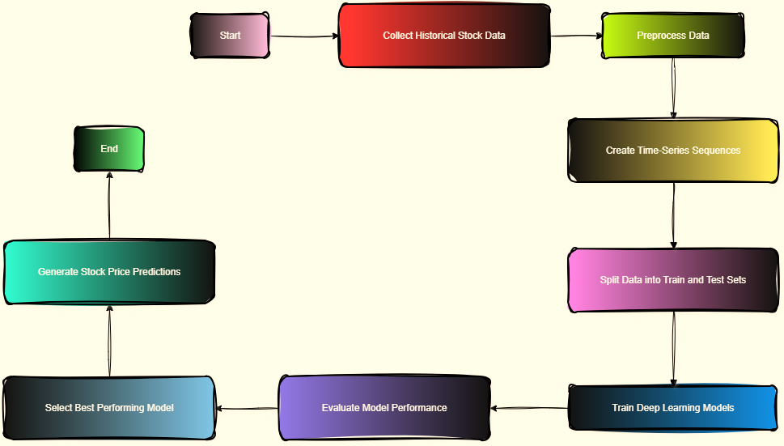
Figure 3: The overall workflow of the proposed model
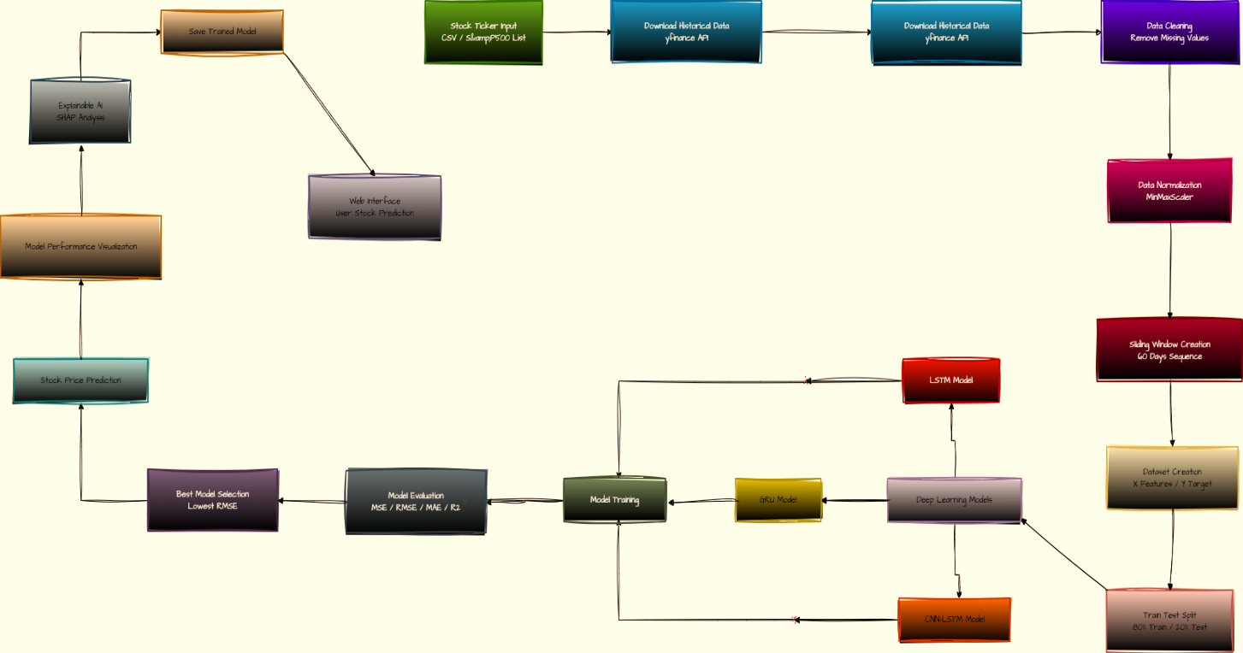
Figure 4: The workflow of Multi-Stock Model
- Model Training and Validation
During model training, the objective is to minimize prediction error while ensuring good generalization on unseen data. To monitor the learning behavior and prevent overfitting, both training loss and validation loss are tracked across epochs for all implemented models[1],[15]. The convergence behavior of the LSTM, GRU, and hybrid CNN–LSTM models for the single-stock prediction experiment is illustrated in Figure 5.
Figure 5 shows the training and validation loss curves for the single-stock prediction experiment. The loss values decrease rapidly during the early epochs and stabilize as training progresses, indicating that the models successfully learn temporal patterns from the historical stock price data while maintaining stable convergence.
To evaluate the scalability of the proposed framework, the models are also trained using multi-stock datasets where historical data from multiple companies are combined during training. The training and validation loss curves for this experiment are presented in Figure 6, showing stable convergence behavior even when the models are exposed to more diverse market data.
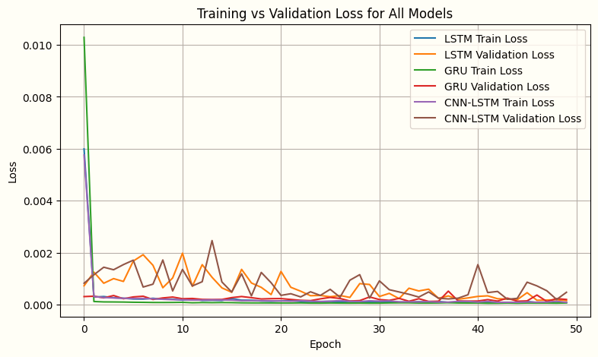
Figure 5: Single-Stock training & validation loss curve
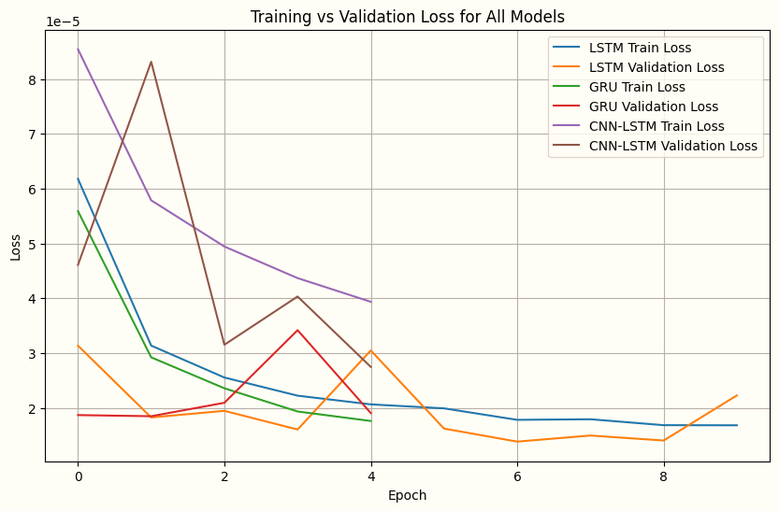
Figure 6: Multi-Stock training & validation loss curve
- Overview of the Proposed Method
The proposed method integrates robust data preparation techniques with Deep Learning and hybrid neural network architectures to address the challenges of stock market time-series prediction[10],[16]. By evaluating both single-stock and multi-stock forecasting frameworks, the proposed method provides a more comprehensive approach to stock market time-series prediction, the approach ensures controlled analysis and reproducible results. The structured workflow and modular design provide a strong foundation for future extensions such as multi-stock prediction, explainable artificial intelligence, and deployment through a user-friendly web-based interface.

- RESULT & DISCUSSIONS
The effectiveness of the suggested Deep Learning-based system of predicting stock market is measured on the historical stock price data and the outcomes of various models are compared in relation to numeric accuracy, directional prediction capacity as well as error response. The performance evaluation is based on three models: LSTM, GRU, and hybrid CNN-LSTM. Table 2 comprises the comparative performance of these models whereas the graphical analysis has been provided in Figures 7-12.
- Single-Stock Prediction
The quantitative comparison presented in Table 2 shows clear differences in prediction accuracy among the evaluated models. GRU model has the lowest values of the errors with the Mean Squared Error (MSE) of 10.38, Root Mean Squared Error (RMSE) of 3.22, and Mean Absolute Error (MAE) of 2.16. Also, the GRU model possesses the best R² score of 0.9975 among the three and therefore, the predicted and the actual stock prices have a very strong fit to each other. Another model that works quite well is the LSTM model with R² score exceeding 0.99 but the error values are significantly larger when compared to that of the GRU model. The hybrid CNN-LSTM model shows the numerical errors are greater and this may be attributed to the fact that more architectural complexity may not mean a better regression performance in the data under consideration.
Table 2: Performance Comparison of Models of Single-Stock
Model | MSE | RMSE | MAE | R² Score
LSTM | 37.97 | 6.16 | 4.04 | 0.9908
GRU | 10.38 | 3.22 | 2.16 | 0.9975
CNN-LSTM | 172.35 | 13.13 | 8.69 | 0.9584
Index: Mean Square Error (MSE), Root Mean Square Error (RMSE), Mean Absolute Error (MAE).

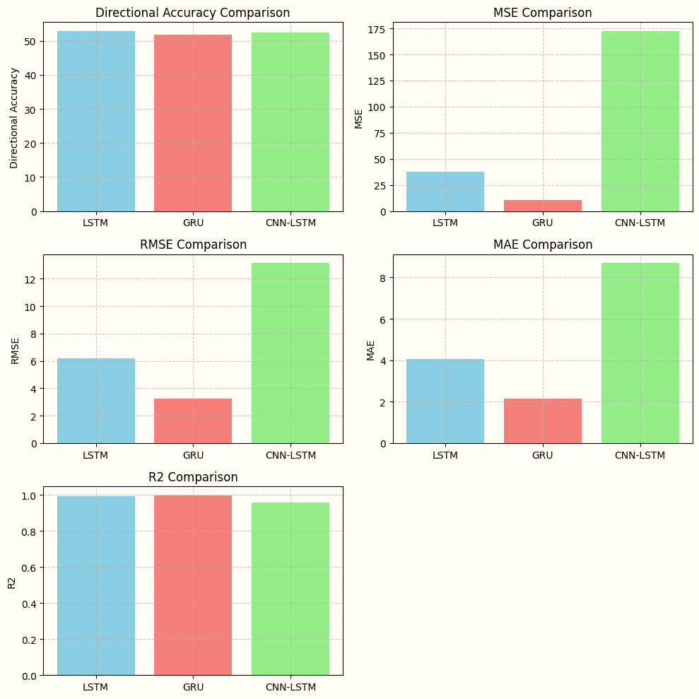
Figure 7: Comparative analysis of Models for Single-Stock.
A visual comparison of Directional Accuracy, MSE, RMSE, MAE, and R² score across the three models is illustrated in Figure 7. Based on this number it is apparent that all the models in question give relatively similar values of directional accuracy defined as approximately 52% but the numeric prediction accuracy is vastly different. GRU model tends to perform better in error-based metrics as compared to the other models and this indicates its usefulness when modeling temporal dependencies in fewer parameters and quickly convergent. This fact justifies the appropriateness of GRU structures to stock market time-series prediction problems.
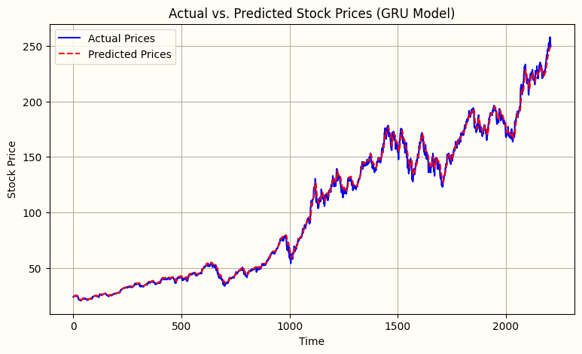
Figure 8: Actual vs. predicted stock prices using the GRU model.
The predictive capability of the best-performing model is further examined through the actual versus predicted stock price plot shown in Figure 8. The figure illustrates that the GRU model shows a close trend to the real stock price movement over the period of time and records not only the long run trend, but also the short run variation. The good correlation between the predicted price and the real price graphically proves the high R² score of the model and the capability of the model to learn any significant temporal relationships to historical stock stocks.
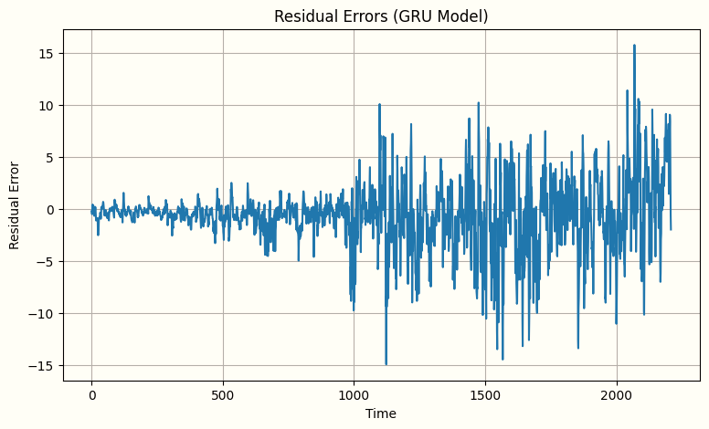
Figure 9: Residual error distribution over time for the GRU model.
To analyze prediction deviations, the residual error plot for the GRU model is presented in Figure 9. The residuals are mostly concentrated on zero which means that the model does not have systemic biasness regarding its predictions. Even though, larger residual spikes are also noted to be present in times of high market volatility, the constant distribution of errors implies that the model is steadfast with different market conditions.
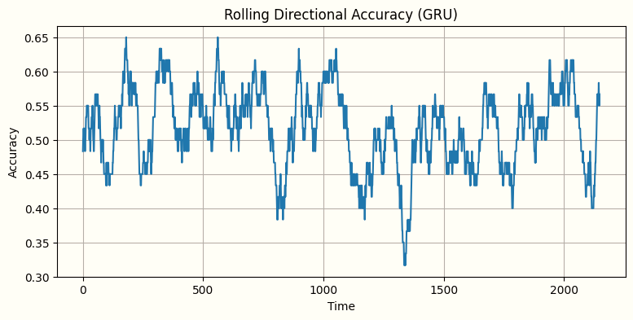
Figure 10: Rolling directional accuracy of the GRU model.
Directional prediction performance is analyzed using rolling directional accuracy, as shown in Figure 10. This fluctuation in the rolling accuracy has a moderate range over time as it is the difficulty of forecasting the short-term direction of the market prices in volatile markets. However, the model has a constant directional prediction ability that is also justified by directional accuracy measures as shown in Table 2.
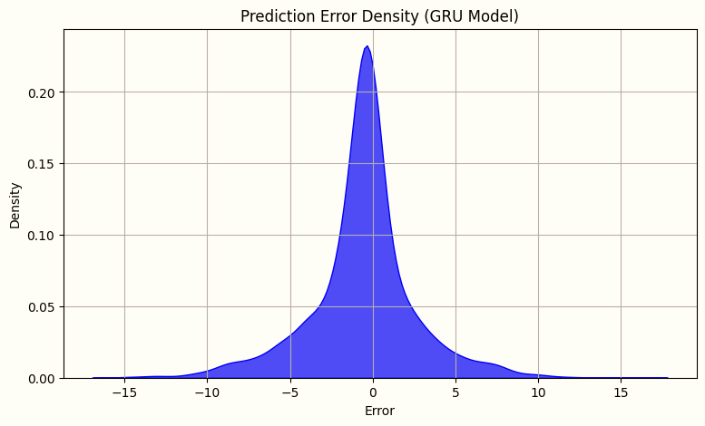
Figure 11: Prediction error density for the GRU model.
The distribution of prediction errors for the GRU model is illustrated in Figure 11. The error density plot has a high concentration of errors at the center and the distribution is decreasing towards the tails. This distribution shows that, deviant predictions are quite uncommon, which supports the numerical stability and reliability of the model. Furthermore, Figure 12 compares the actual and predicted directions of stock price movement. The near parallelism between the two signals indicates that the model can build the directional tendencies in the short term, even with inaccurate values of prices changing.
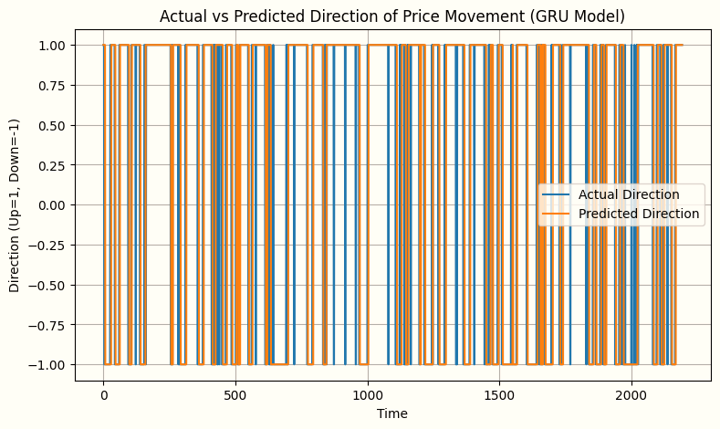
Figure 12: Actual vs. predicted direction of stock price movement using the GRU model.
Overall, the results of the experiment indicate that Deep Learning predictors can make good predictions of the time-series of the stock market, and the GRU model performed better than the rest of the considered models. The results indicate that less sophisticated recurrent architecture can be better than more sophisticated hybrid models, which are trained by single-stock historical information. The findings support the suggested methodology and prove the efficiency of sequence-based Deep Learning models in the ability to model non-linear and temporal relationships in stock prices.
- Multi-Stock Prediction
To further evaluate the scalability and generalization capability of the proposed prediction system, the Deep Learning models were also trained using a multi-stock dataset, where historical price data from multiple companies were combined during the training process. This approach allows the models to learn broader market patterns rather than focusing on the dynamics of a single stock. The quantitative performance comparison of the models in the multi-stock prediction experiment is presented in Table 3.
Table 3: Performance Comparison of Models of Multi-Stock
Model | MSE | RMSE | MAE | R² Score
LSTM | 0.000014 | 0.003720 | 0.001580 | 0.998605
GRU | 0.000019 | 0.004322 | 0.002029 | 0.998116
CNN-LSTM | 0.000046 | 0.006787 | 0.003973 | 0.995354
Index: Mean Square Error (MSE), Root Mean Square Error (RMSE), Mean Absolute Error (MAE)
The results show that all models achieve very high prediction accuracy when trained on multi-stock datasets. The LSTM model provides the best performance, achieving the lowest Mean Squared Error (MSE) of 0.000014, Root Mean Squared Error (RMSE) of 0.003720, and Mean Absolute Error (MAE) of 0.001580, along with the highest R² score of 0.998605. These values indicate that the LSTM model can effectively capture temporal relationships across multiple stocks. The GRU model also demonstrates strong predictive capability, with slightly higher error values compared to LSTM. Its simplified architecture enables efficient learning while maintaining high accuracy. The CNN-LSTM hybrid model shows comparatively larger error values, which may be due to increased model complexity when trained on multiple stock datasets.
The graphical comparison of the model performance metrics for the multi-stock experiment is illustrated in Figure 13. The figure compares the MSE, RMSE, MAE, and R² scores across the LSTM, GRU, and CNN-LSTM models.
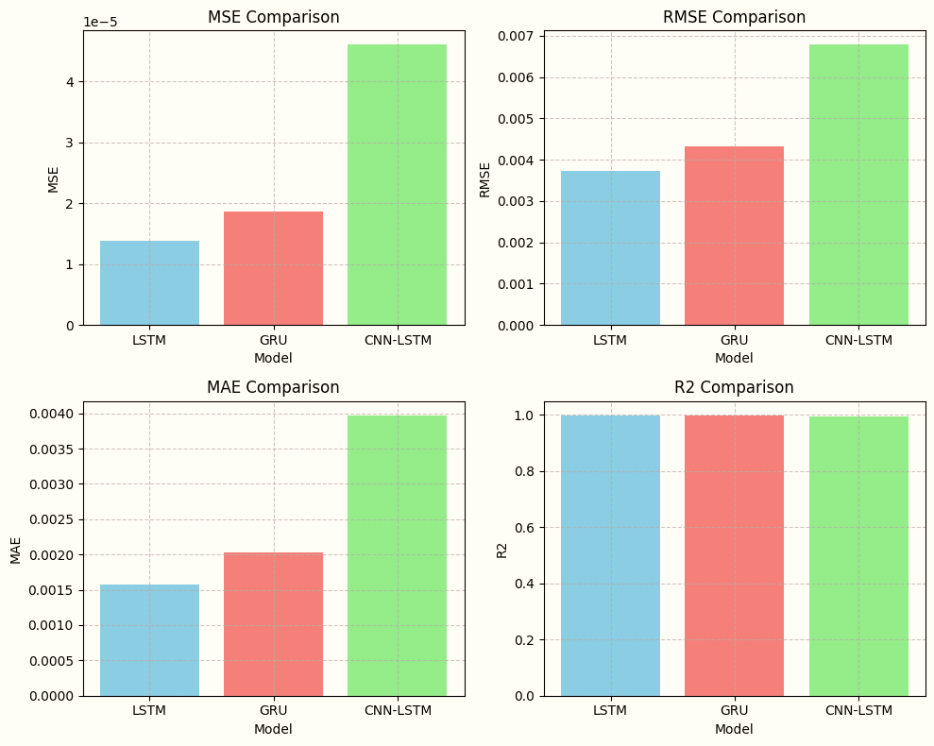
Figure 13: Comparative analysis of models for multi-stock prediction.
From the figure, it can be observed that the LSTM model consistently achieves lower error values, indicating its effectiveness in capturing complex sequential dependencies in multi-stock financial data.
The predictive capability of the best performing model is further examined through the comparison between actual and predicted stock prices, as shown in Figure 14.
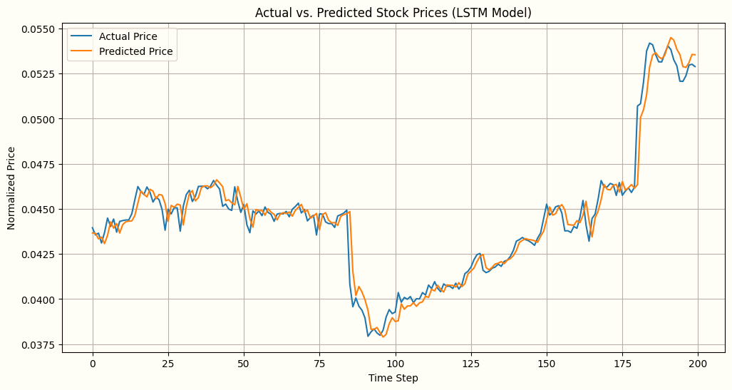
Figure 14: Actual vs predicted stock prices using the LSTM model for multi-stock prediction.
The predicted curve closely follows the actual price trend, demonstrating that the model successfully captures both long-term trends and short-term fluctuations in stock prices. The high similarity between the two curves visually supports the strong R² score observed in Table 3.
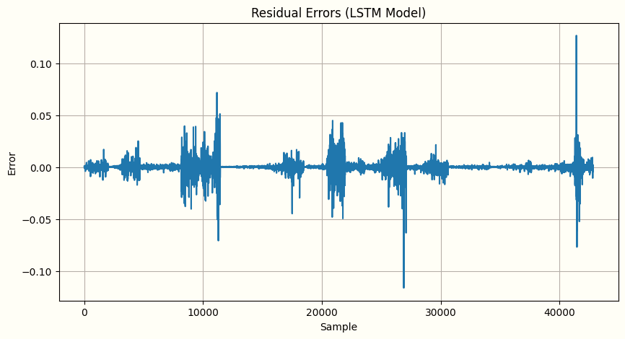
Figure 15: Residual error distribution for the LSTM model in the multi-stock prediction.
To further evaluate prediction reliability, the residual error distribution is analyzed in Figure 15. The residual values are concentrated around zero, indicating that the model predictions do not exhibit systematic bias. Although occasional spikes appear during periods of high market volatility, the overall error distribution suggests that the model maintains stable performance across different market conditions.
In addition to numerical accuracy, the ability of the model to predict the direction of stock price movement is analyzed. The rolling directional accuracy is illustrated in Figure 16.
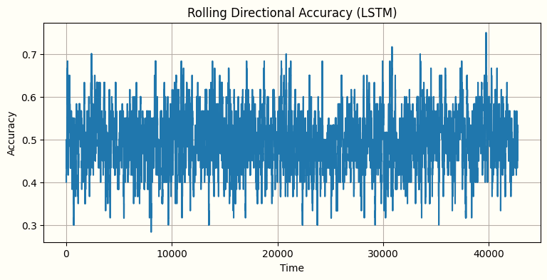
Figure 16: Rolling directional accuracy for the LSTM model in multi-stock prediction.
The rolling accuracy fluctuates over time due to the inherent volatility of financial markets. However, the model maintains a relatively stable directional prediction capability, demonstrating its effectiveness in capturing short-term market trends.
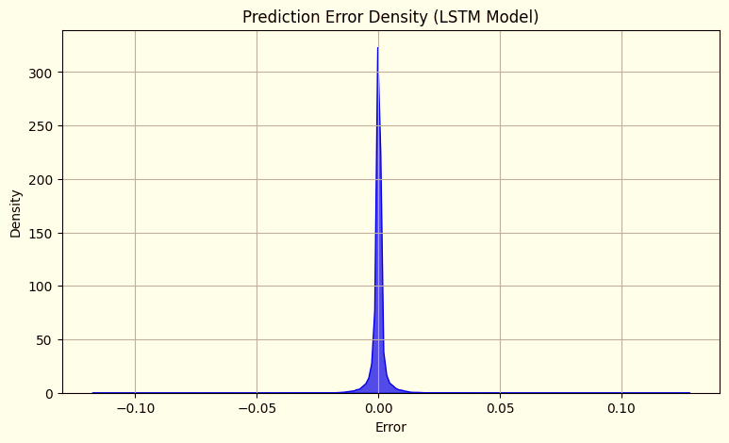
Figure 17: Prediction error density for the LSTM model in multi-stock prediction
The density distribution of prediction errors is illustrated in Figure 17. The plot shows a strong concentration of errors around zero with minimal spread toward the tails. This indicates that the majority of predictions have small deviations from the actual values, confirming the numerical stability and reliability of the model.
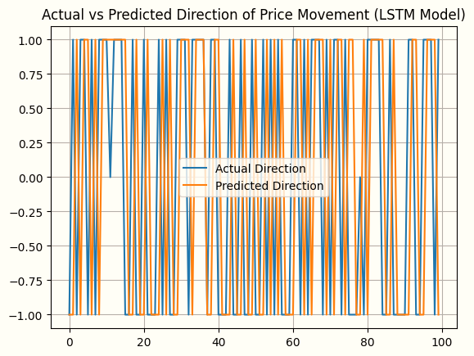
Figure 18: Actual vs predicted direction of stock price movement using the LSTM model.
The comparison between actual and predicted directions of stock price movement is shown in Figure 18. The predicted directional movements closely align with the actual movements, demonstrating that the model can effectively identify upward and downward market trends even when predicting exact price values is challenging.
To improve the interpretability of the Deep Learning prediction system, Explainable Artificial Intelligence (XAI) techniques were incorporated using SHAP (SHapley Additive exPlanations). SHAP provides insight into how different input features contribute to the model’s prediction. The SHAP interaction plot for the trained model is illustrated in Figure 19.
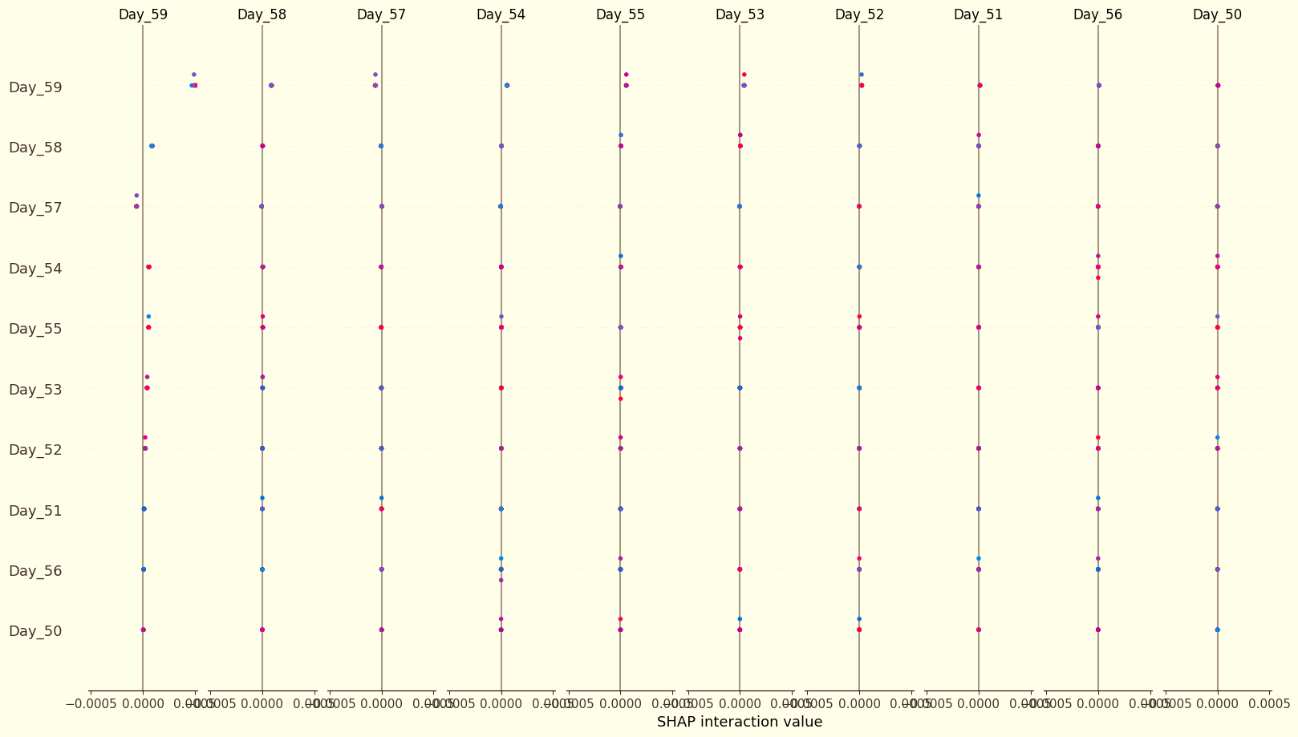
Figure 19: SHAP interaction analysis showing the contribution of historical input features to stock price prediction.
The SHAP visualization highlights the contribution of different historical time-step features (Day_50 to Day_59) used in the sliding window input sequence. Each point represents the impact of a particular historical price value on the final prediction. Features with higher SHAP values contribute more significantly to the prediction outcome. The analysis reveals that recent time-step features (closer to the prediction point) tend to have a stronger influence on the predicted stock price. This observation aligns with financial time-series behavior, where recent price movements often carry more predictive information than distant historical values.
By incorporating SHAP explainability, the proposed system not only provides accurate predictions but also enhances model transparency and interpretability, allowing users to better understand the reasoning behind the predictions generated by the Deep Learning models.
Overall, the experimental results from both single-stock and multi-stock prediction experiments demonstrate the effectiveness of Deep Learning models in forecasting stock market time-series data. While the GRU model showed strong performance in the single-stock experiment, the LSTM model achieved the best performance in the multi-stock scenario, indicating its superior ability to capture complex relationships across diverse financial datasets. The integration of SHAP-based explainability further improves the practical usability of the system by providing insights into the internal decision-making process of the prediction models.

- CONCLUSION
This paper introduced a stock market prediction framework developed using the Deep Learning and Deep Learning hybrid architectures to provide a forecast of stock prices that uses historical time-series data. The system was tested on two experimental conditions, i.e. single-stock prediction and multi-stock prediction, which enables a complete analysis of the predictive potential and scalability of the model.
The Deep Learning models were trained on the historical data of a single stock in the single-stock prediction experiment. The findings showed that model sequence based designs like LSTM and GRU can successfully capture time reliance in financial time-series information. The GRU architecture was found to be the most successful with respect to numerical performance as it generated lesser error measures and a greater coefficient of determination than both LSTM and CNN-LSTM models. Results of the graphical analysis of the prices, residual errors and directional accuracy of the predicted prices also confirmed that the GRU model can effectively follow the stock price movement and ensure the consistency of predictions.
In order to test the scalability of the prediction system, a multi-stock prediction model was used in which the models were and trained on multiple stocks at the same time with their historical data. The findings have shown that the LSTM model had the highest performance in the multi-stock scenario as it generated the least error values and the highest R2 score. It proves that LSTM networks can be extremely useful as far as the complex time-dependences in various financial data are concerns. The training model based on multi-stock also allows the model to acquire more knowledge of the market dynamics that enhance the generalization of the prediction system.
In addition, the research also involved Explainable Artificial Intelligence (XAI) on the basis of SHAP (SHapley Additive Explanations) in order to enhance the interpretability of the Deep Learning models. The SHAP analysis has shown that recent historical price values play a more important role in the outcome of the prediction, as is the case with financial time-series data where the contribution of the recent movement in the future direction plays a major role. SHAP integration is effective to increase the model transparency and give useful observations into the decision-making process of the prediction system.
All in all, the findings of the experiment indicate that Deep Learning models can be successfully used to predict the time-series of the stock market as well as single-stock prediction with GRU and multi-stock prediction with LSTM being the most efficient models. The proposed framework is effective in integrating both correct forecasting, scalability through the use of multi-stock learning and interpretability through SHAP analysis, which contributes to making it a strong and viable system of intelligent prediction of the stock market.

- FUTURE SCOPE
Despite successful outcomes of the proposed AI-based stock market prediction system on Deep Learning models of single-stock and multi-stock prediction, there are some opportunities that can be used to enhance and expand the system.
A possible area of enhancement would be the design of a comprehensive web based application interface that will enable users communicate with the prediction system in real time. This kind of interface would allow users to pick stocks, see their historical trends, and see forecasted stock price values in interaction dashboard and graphical representations. The availability of the models to predict and the ability to integrate them into a web based platform will go a long way in making the models much more accessible and the system a viable decision support tool by the investors, analyst, and researchers.
The other way of how I can use the future is to use data streaming of the stock market at real time rather than only using the history of the market data. The prediction models could provide real-time predictions by connecting the system to live financial APIs and updating the predictions every time new market data is being received.
It is also possible to enhance the prediction framework by adding other data sources like social media sentiments, macroparent economic indicators and financial news. Natural Language Processing (NLP) methods used to understand market sentiment would help improve the accuracy of prediction by identifying other external variables that determine the movement of stock prices.
Moreover, further studies, including more sophisticated architectures, like Transformer-based models, attention models, and ensemble learning can be also developed and assessed in the future to enhance the forecasting performance and generalize the long-term relationships in financial data in a time-series.
Lastly, the system can be expanded to portfolio level analysis and automated trading policies to which prediction results are utilized to help investors make informed investment choices.
All in all, these future improvements can make the proposed framework an all-inclusive intelligent financial forecasting platform, which is a combination of predictive analytics, interpretability, and real time decision support.
REFERENCES
- X. Ji, J. Wang, and Z. Yan, “A stock price prediction method based on deep learning technology,” IJCS, vol. 5, no. 1, pp. 55–72, Mar. 2021, doi: 10.1108/ijcs-05-2020-0012.
- X. Li and P. Tang, “Stock index prediction based on wavelet transform and FCD‐MLGRU,” Journal of Forecasting, vol. 39, no. 8, pp. 1229–1237, Apr. 2020, doi: 10.1002/for.2682.
- G. Bathla, “Stock Price prediction using LSTM and SVR,” Institute Of Electrical Electronics Engineers, Nov. 2020, pp. 211–214. doi: 10.1109/pdgc50313.2020.9315800.
- E. K. Ampomah, G. Nyame, and Z. Qin, “Evaluation of Tree-Based Ensemble Machine Learning Models in Predicting Stock Price Direction of Movement,” Information, vol. 11, no. 6, p. 332, June 2020, doi: 10.3390/info11060332.
- Y. Gao, R. Wang, and E. Zhou, “Stock Prediction Based on Optimized LSTM and GRU Models,” Scientific Programming, vol. 2021, pp. 1–8, Sept. 2021, doi: 10.1155/2021/4055281.
- Y. Si, S. Nadarajah, Z. Zhang, and C. Xu, “Modeling opening price spread of Shanghai Composite Index based on ARIMA-GRU/LSTM hybrid model.,” PLoS ONE, vol. 19, no. 3, p. e0299164, Mar. 2024, doi: 10.1371/journal.pone.0299164.
- D. Selvamuthu, A. Mishra, and V. Kumar, “Indian stock market prediction using artificial neural networks on tick data,” Financ Innov, vol. 5, no. 1, Mar. 2019, doi: 10.1186/s40854-019-0131-7.
- R. Jaiswal and B. Singh, “A Hybrid Convolutional Recurrent (CNN-GRU) Model for Stock Price Prediction,” Institute Of Electrical Electronics Engineers, Apr. 2022, pp. 299–304. doi: 10.1109/csnt54456.2022.9787651.
- K. R. Dahal et al., “A comparative study on effect of news sentiment on stock price prediction with deep learning architecture.,” PLoS ONE, vol. 18, no. 4, p. e0284695, Apr. 2023, doi: 10.1371/journal.pone.0284695.
- R. Kumar, Y. Kumar, and P. Kumar, “Analysis of Financial Time Series Forecasting using Deep Learning Model,” Institute Of Electrical Electronics Engineers, Jan. 2021, pp. 877–881. doi: 10.1109/confluence51648.2021.9377158.
- V. Chang, Q. A. Xu, H. Wang, and A. Chidozie, “Predicting Economic Trends and Stock Market Prices with Deep Learning and Advanced Machine Learning Techniques,” Electronics, vol. 13, no. 17, p. 3396, Aug. 2024, doi: 10.3390/electronics13173396.
- R. Adeleye, B. Bello, N. Ndubuisi, O. Owolabi, T. Tubokirifuruar, and O. Asuzu, “MACHINE LEARNING FOR STOCK MARKET FORECASTING: A REVIEW OF MODELS AND ACCURACY,” Financ. account. res. j., vol. 6, no. 2, pp. 112–124, Feb. 2024, doi: 10.51594/farj.v6i2.783.
- Z. Li, J. Han, and Y. Song, “On the forecasting of high‐frequency financial time series based on ARIMA model improved by deep learning,” Journal of Forecasting, vol. 39, no. 7, pp. 1081–1097, Mar. 2020, doi: 10.1002/for.2677.
- A. M. N. C. Ribeiro, T. Lynn, D. Sadok, P. R. X. Do Carmo, P. T. Endo, and I. R. Rodrigues, “Short-Term Firm-Level Energy-Consumption Forecasting for Energy-Intensive Manufacturing: A Comparison of Machine Learning and Deep Learning Models,” Algorithms, vol. 13, no. 11, p. 274, Oct. 2020, doi: 10.3390/a13110274.
- D. Xiao and J. Su, “Research on Stock Price Time Series Prediction Based on Deep Learning and Autoregressive Integrated Moving Average,” Scientific Programming, vol. 2022, pp. 1–12, Mar. 2022, doi: 10.1155/2022/4758698.
- Y. Zhao and Z. Chen, “Forecasting stock price movement: new evidence from a novel hybrid deep learning model,” JABES, vol. 29, no. 2, pp. 91–104, Aug. 2021, doi: 10.1108/jabes-05-2021-0061.
- K. Yan, Y. Du, H. Huang, X. Wang, H. Zhou, and N. Jin, “Multi-Step Short-Term Power Consumption Forecasting with a Hybrid Deep Learning Strategy,” Energies, vol. 11, no. 11, p. 3089, Nov. 2018, doi: 10.3390/en11113089.
- S. Siami-Namini, N. Tavakoli, and A. Siami Namin, “A Comparison of ARIMA and LSTM in Forecasting Time Series,” Institute Of Electrical Electronics Engineers, Dec. 2018, pp. 1394–1401. doi: 10.1109/icmla.2018.00227.
- S. Siami‐Namini and A. Namin, “Forecasting Economics and Financial Time Series: ARIMA vs. LSTM,” Jan. 01, 2018, Cornell University. doi: 10.48550/arxiv.1803.06386.
- K. Olorunnimbe and H. Viktor, “Deep learning in the stock market—a systematic survey of practice, backtesting, and applications,” Artif Intell Rev, vol. 56, no. 3, pp. 2057–2109, June 2022, doi: 10.1007/s10462-022-10226-0.

PUBLICATIONS FROM THE WORK
The research work carried out in this project has contributed to an academic review paper titled “AI Powered Stock Market Prediction Web Application - A Review.” The paper was accepted and presented at the International Conference on Frontiers of Engineering, Science and Technology, with Paper ID: 121, held on 12/12/2025. At the time of submission of this project report, the paper is under the publication process and yet to be formally published. The insights obtained from this research provided a strong theoretical foundation for the development of the proposed AI Powered Stock Market Prediction System.



