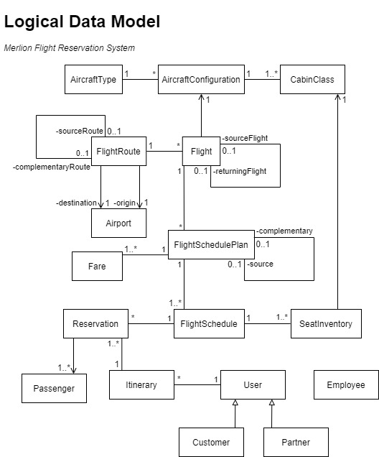

**Business Rules***Assumptions and rules not mentioned in project specifications*

|  |  |
| --- | --- |
| **Merlion Flight Reservation System Management Client** | |
| Create Flight Route | * Flight routes will always come as a pair with it complementary (since the complementary flight of the complementary is the current flight itself).   + complementaryFlight.originFlight = currentFlight   + complementaryFlight.complementaryFlight = curentFlight   + currentFlight.originFlight = complementaryFlight   + currentFlight.complementaryFlight = complementaryFlight * Should the newly created flight route have the same flight route as a disabled flight route, the disabled flight route will be enabled rather than making a new flight route. |
| Create Flight | * For the creation of flight number, user will only have to input the numbers. The preceding ‘ML’ will be automatically appended by the system. * Should the newly created flight have the same flight number and same flight route as a disabled flight, the disabled flight will be enabled rather than making a new flight. |
| Update Flight | * User will only be able to update the flight route, assigned aircraft configuration and pairing return flight of an existing flight. * Should a user want to change the flight number, the user should be making a new flight. * Only flights with no existing source flight and opposite flight route to the flight being updated will be available for pairing as a return flight. |
| Create Flight Schedule Plan | * For the creation of weekly recurrent plans, the first flight schedule will be create to depart on the first departure date/time given by the user. Following that, flight schedules will be created on every day of the week given by the user following that initial departure date. * For creation of fare basis codes, user will only have to input the fare basis code number. The letter preceding the fare basis code number will be automatically appended by the system based on the cabin class type. |
| Update Flight Schedule Plan | * User will be allowed to update fare prices and update information of flight schedules under the selected flight schedule plan   + For updating of flight schedule, user will be allowed to either edit its details or remove it     - Editing of flight schedule involves editing of its departure date/time and its flight duration   + For updating of fares, user will be allowed to update the fare amount |

|  |  |
| --- | --- |
| **MFRS Reservation Client/Holiday Reservation System** | |
| Search Flight | * If user has no preference for cabin class, all available cabin class will be shown to the user.   + In the event that connecting flights are being displayed, system will show all combinations of cabin classes for the 2 flights.     - Display example (where both flights have 2 cabin classes):  *Flight A/First Class ⬄ Flight B/First Class Flight A/First Class ⬄ Flight B/Economy Class Flight A/Economy Class ⬄ Flight B/First Class Flight A/Economy Class ⬄ Flight B/Economy Class* * If user has no preference for direct or connecting flight, both direct and connecting flights will be shown to the user. * A connecting flight will be deemed suitable if the departure time of the second flight is between 2 to 12 hours after the arrival time of the first flight. * In the event that a certain cabin class for a certain flight is fully booked or has not enough seats for the user, the result will still be shown in the search results but the balance seats will be reflected appropriately so that the user is aware of its unavailability. |
| Reserve Flight | * Following *Scoot Airlines©* Online Reservation Platform design, users will only be allowed to book for one type of cabin class per transaction (regardless of how many passengers). Should a user want to book different cabin class seats for different passengers, user has to complete separate reservation transaction for the different cabin classes.   + This would mean that the different bookings for the different cabin classes will be under different itineraries, which will be displayed under the *View My Flight Reservations* section. |