Figure S1. Microbial community structure of the unfiltered dataset. All three experiments are included in the same analysis. Sample types: doliolids (FG and EG), fecal pellets (FP2h and FP24h), seawater (SW), and controls. The nMDS ordination is based on the Bray-Curtis similarity constructed from the relative abundance of ASVs (square root transformed).

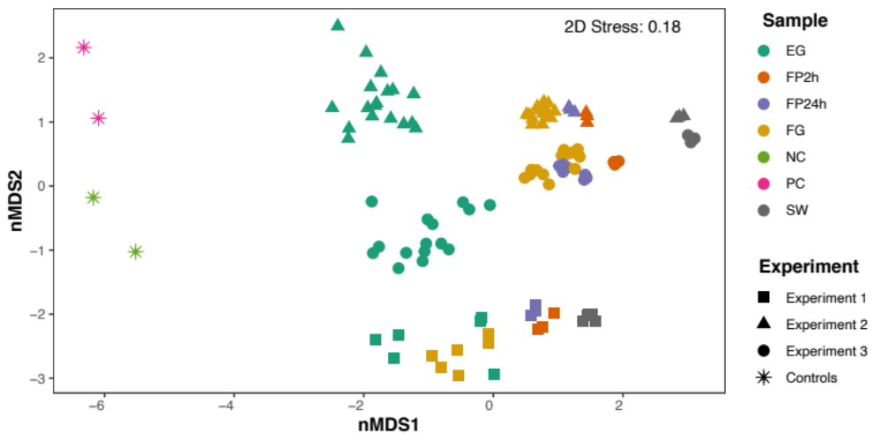

Figure S2. Venn diagram showing the number of unique (highlighted in bold) and shared ASVs among sample types for (A) experiment 1, (B) experiment 2, and (C) experiment 3. Doliolids: FG and EG, fecal pellets: FP2h and FP24h, seawater: SW.
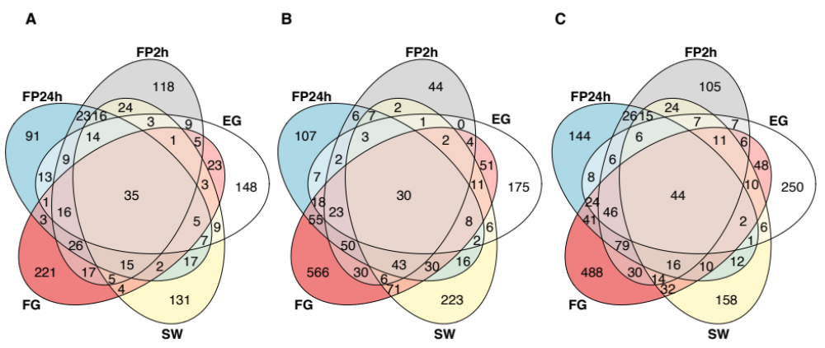

Figure S3. Relative abundance of six dominant classes associated with doliolids (FG and EG), fecal pellets (FP2h and FP24h), and seawater (SW) samples in different feeding experiments (1–3). Relative abundance of taxa contributing to ≥5% is displayed in the barplots. Phyla abbreviations as follows: Bacteroidota (Bact.), Cyanobacteria (Cyanob.), Planctomycetota (Planct.), Proteobacteria (Proteo.).

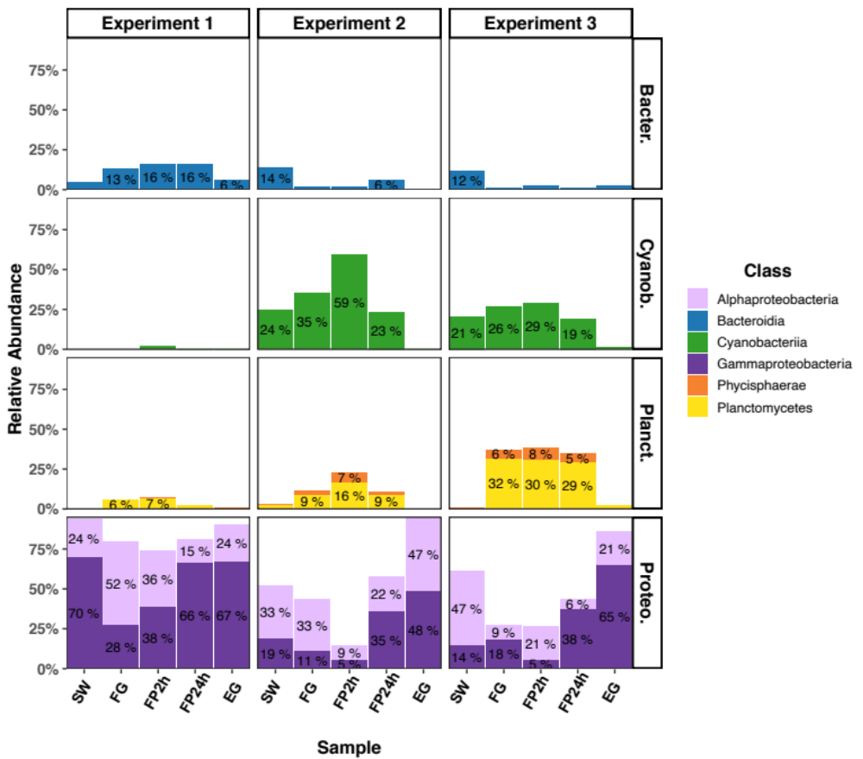

Figure S4. Heatmap of the most differentially abundant microbial taxa (genus level) across sample types (EG: empty gut, FG: full gut, FP24h: fecal pellet 24h, FP2h: fecal pellet 2h, SW: seawater) and experiments (1–3). Taxon abundance was transformed using the centered-log ratio (CLR). For each taxon, warm colors indicate high abundance whereas cold colors indicate low abundance. A complete list of taxa differentially abundant for each taxonomic rank across sample types is provided in Table S6.

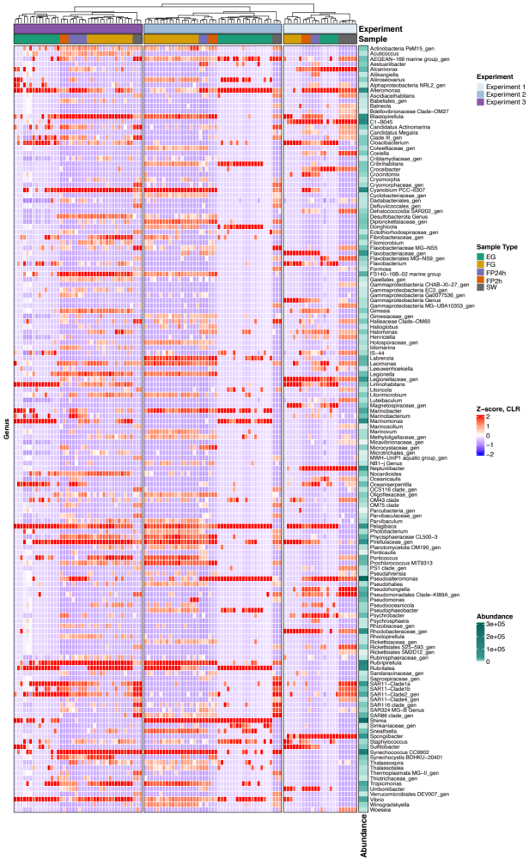

Figure S5. Microbial community composition associated with doliolids (FG and EG), fecal pellets (FP2h and FP24h), and seawater (SW) samples in different feeding experiments (1–3). Taxonomy of the 19 most abundant bacterial families (A) and genera (B) are given. Low abundance taxa were grouped into the “Others” category. Relative abundance of taxa contributing to ≥5% is displayed in the barplots.
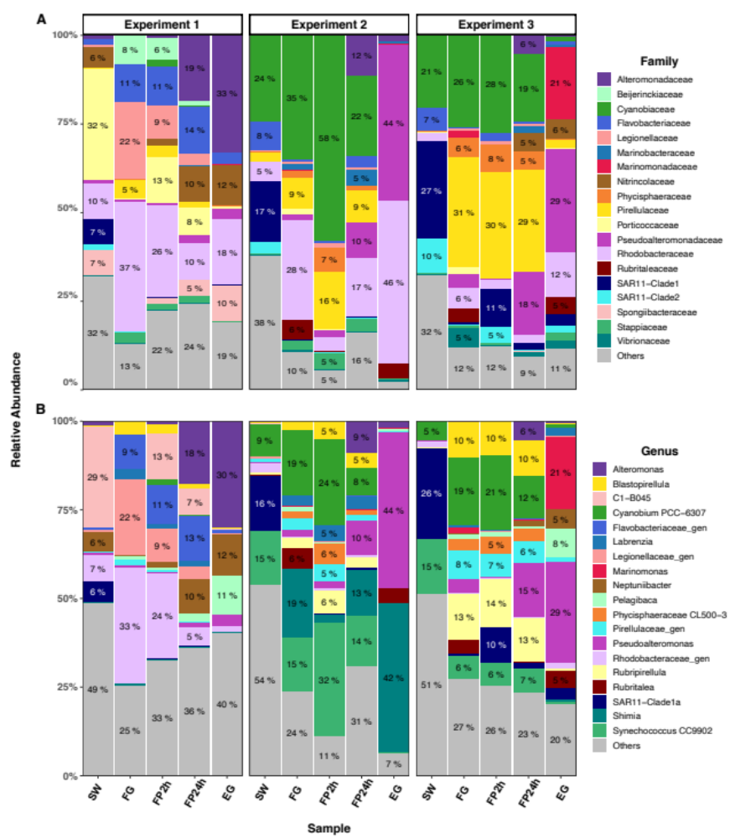

Figure S6. Heatmap of the most differentially abundant predicted functional genes (top 100) across sample types (EG: empty gut, FG: full gut, FP24h: fecal pellet 24h, FP2h: fecal pellet 2h, SW: seawater) and experiments (1–3). The abundance of different functions/genes was transformed using the centered-log ratio (CLR). Warm colors indicate high abundance whereas cold colors indicate low abundance. A complete list of functions/genes differentially abundant, including their description, for each experiment and across sample types is provided in Table S7.

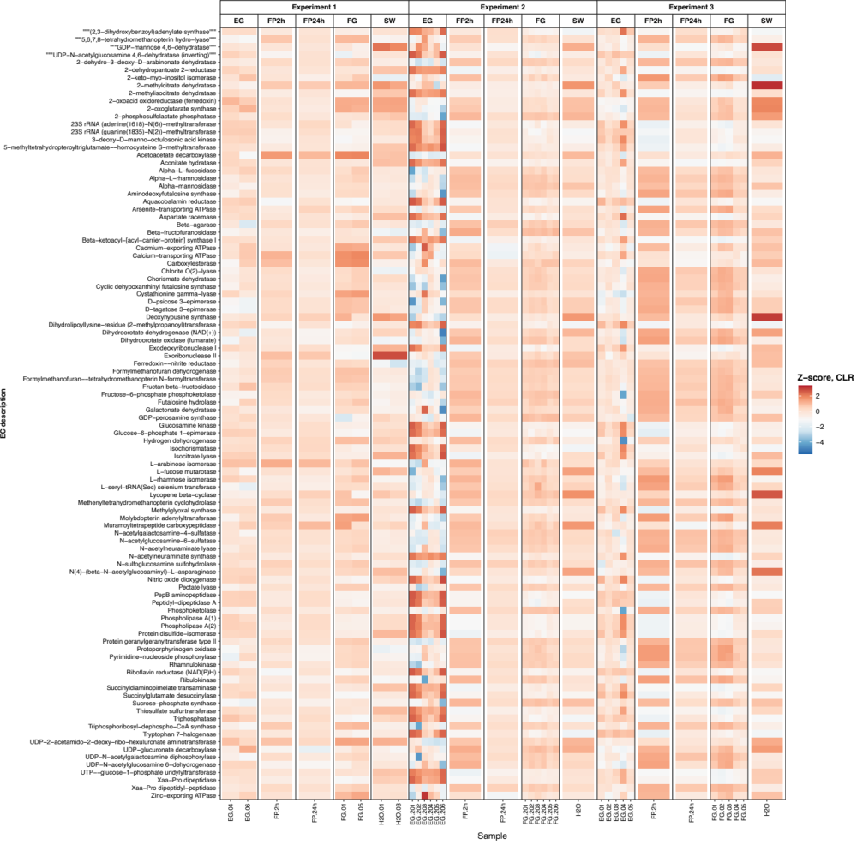

Figure S7. nMDS based on differentially abundant predicted functional genes according to experiment (A: experiment 1, B: experiment 2, C: experiment 3) and sample types: doliolids (FG and EG), fecal pellets (FP2h and FP24h), and seawater (SW). The nMDS ordination is based on the Bray-Curtis similarity constructed from the relative abundance of predicted functional genes (square root transformed) identified by ALDEx2.

