

 

Faculty of Electrical engineering & Informatics

Budapest university of technology and economics

**Document of**

**Book Bank**

By

**Bikash Kumar Mahanti**

**O8F1L9**

## **Class Diagram:**

* Library
* Admin Login
* AdminMenu
* Enterlibraryuserdata
* viewLibrarian
* RemoveLibraryUser
* LibraryUserManager
* Librarian
* libraryUserlogin
* LibraryUsermenu
* enterBookData
* CheckBook
* IssuedBookForm
* CheckIssuedBook
* Returnbook
* BookManager
* returnBookManager
* issuedBookManager
* BookManager
* Book
* IssuedBook

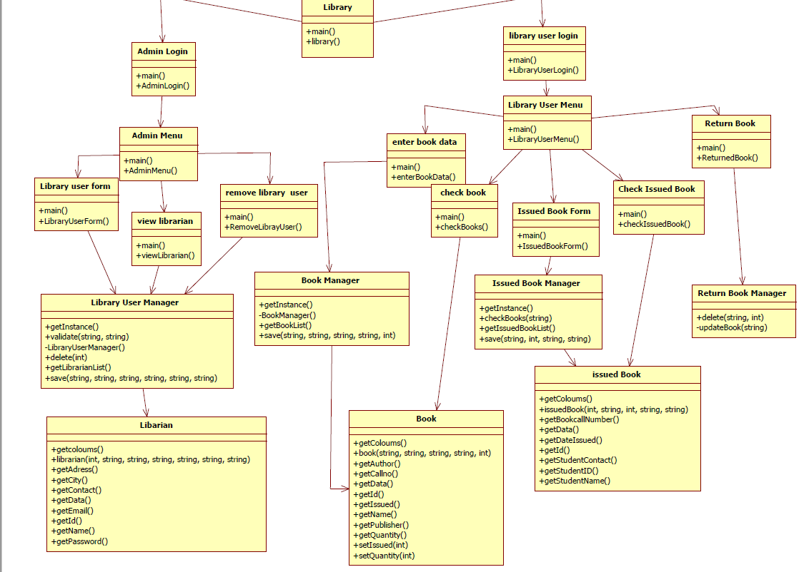

## **Sequence diagram:**

### **Admin login**

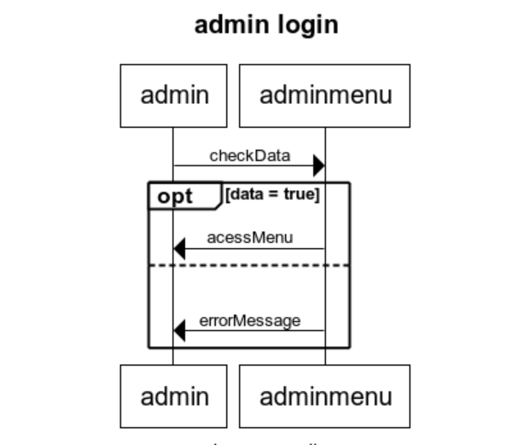

### **Library user login**

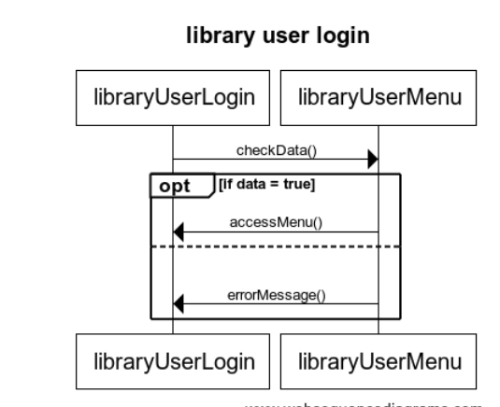

### **Remove librarian**

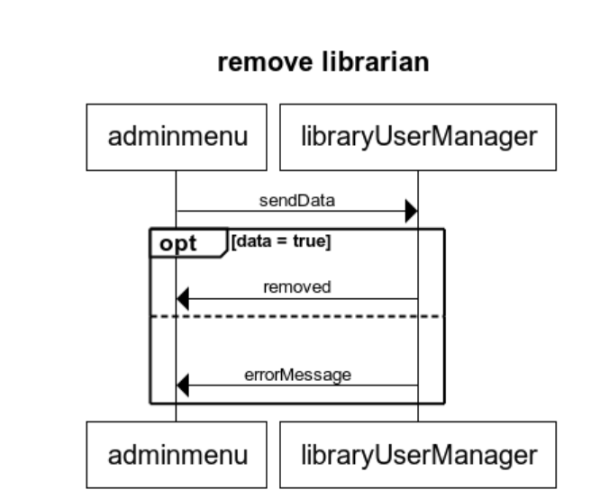

### **View librarian**

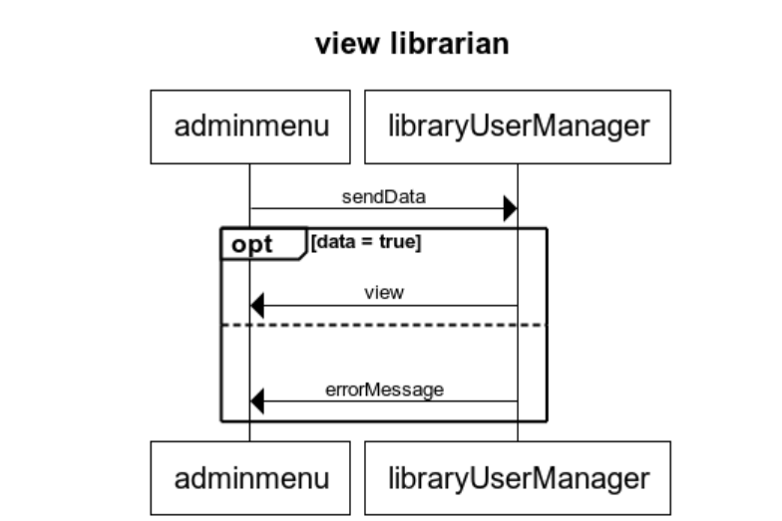

### **Enter Book Data**

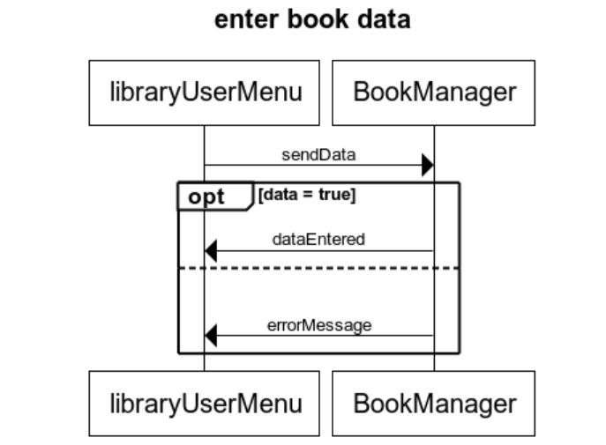

### **Check Book**

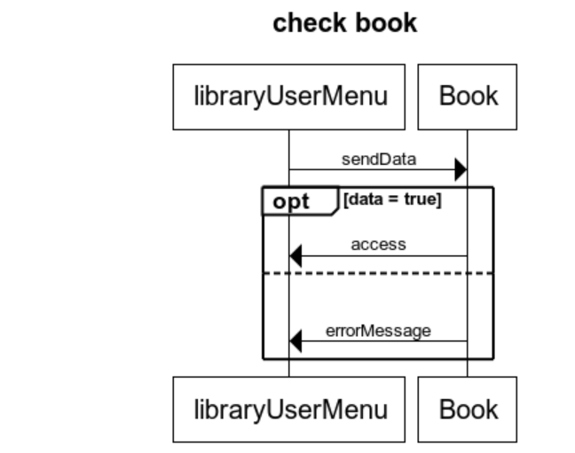

### **Issued Book Form**

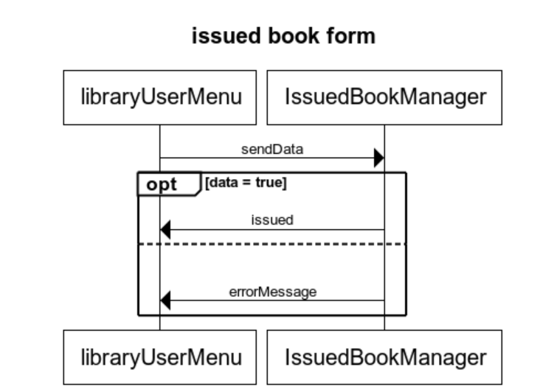

### **Checked issued book**

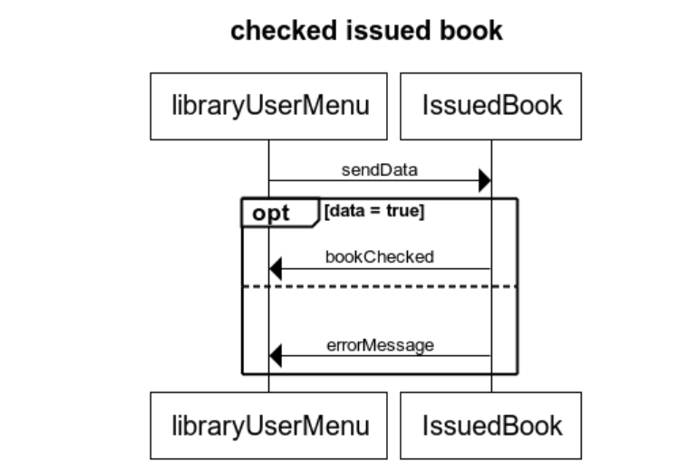

### **Return Book**

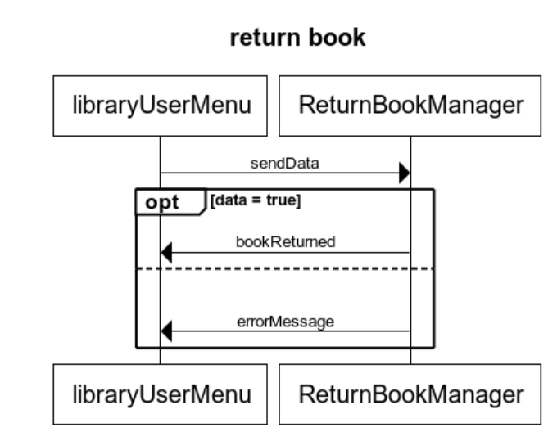

## **Test cases:**

### addBook():void

given are the test values for add book.

* String name = "testName";
* String pass = "testPw";
* String email = "testEmail";
* String addr = "testAddr";
* String city = "testCity";
* String contact = "testContact";

### addLibrarian():void

given are the test values for addLibrarian.

* String name = "testName";
* String pass = "testPw";
* String email = "testEmail";
* String addr = "testAddr";
* String city = "testCity";
* String contact = "testContact";

### deleteLibrarian():void

given are the values for the delete librarian,

* String name = "testName";
* String pass = "testPw";
* String email = "testEmail";
* String addr = "testAddr";
* String city = "testCity";
* String contact = "testContact";

### issueBook():void

given are the values for the issue book,

* String callno = "testNo";
* String name = "testName";
* String author = "testEmail";
* String publisher = "testAddr";
* **int** quantity = 9999;

### returnBook():void

given are the values to test return Book,

* String bookCallNo = "test";
* **int** studentId = 9999;
* String studentName = "testName";
* String studentContact = "testContact";