Coursework for SCC 311: Auctioning System
1. Description of the Problem
You are asked to design and implement a simple distributed auctioning system using Java RMI. Crucially, this overall problem is organised into three sub-problems of increasing difficulty: basic auctioning system (level 1), secure auctioning system (level 2a), and dependable auctioning system (level 2b). Each problem builds on the previous one. The level you reach determines the maximum mark you can possibly obtain for the coursework. How well you reach a level determines your actual mark.
Achieving level 1 satisfactorily is sufficient to obtain a reasonably good 2.2 mark if you completed the project retrieval exercise. Outline marking sheets for each level will be provided on Moodle.

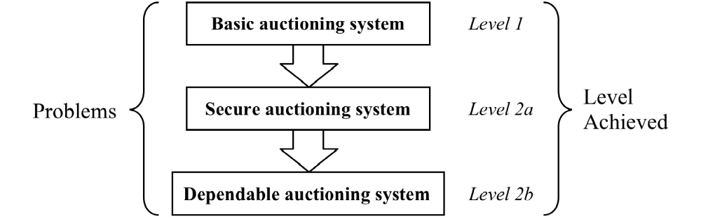

  - Basic Auctioning System (Level 1) – Friday, Week 6
You are asked to implement a distributed auctioning system. This auctioning system should consist of a central auctioning server and two separate client programs:
- The first client program should enable a seller to create a new auction for an item offered for sale. The seller should be able to provide a starting price, a short description of the item, and a minimum acceptable price (reserve price). Creating the auction will return an auction id. A seller can create multiple auctions. At some point in the future, the seller should be able to close the auction using the same client program, by quoting the auction id. When the seller closes an auction, the client program should either indicate who the winner is, along with their details (see below), or else indicate that the reserve price has not been reached.
- The second client program should enable potential buyers to bid for auctioned items. Firstly, the program should enable buyers to browse the list of currently active auctions with their current highest bid (but not the reserve price, which is secret). The client program should then enable a buyer to bid for a selected item, by entering the auction id and the buyer’s details (name and e-mail).
- The auctioning server should then deal with requests from the two client programs and maintain the state of the ongoing auctions. The system should support multiple seller and buyer clients to create or bid simultaneously.
- Note that we do NOT expect you to use a database system (e.g. MYSQL) to store the auction data. In memory Java containers, e.g. Lists or Hash Tables, should be sufficient for this task.
- Remember to apply principals of objective oriented programming, such as identity separation and encapsulation. We'll be marking on how elegant, clean and efficient your code is, so do your best to make it perfect.
- You should also pay attention to corner cases as we will test these during marking. 😊
2.2 Advanced Features for Auctioning System -- Friday, Week 9
Now, suppose this Auctioning system is a big success, and attracts a dramatic increase in traffic, along with threats from a powerful global crime organisation. You are asked to consider and implement techniques to enhance the security and availability of your system
Level 2a: Secure Auctioning System
The implementation of level 1 is insecure: for instance, it has no mechanism to protect the system against external attacks such as tampering with bids (one buyer modifying or stopping another buyer’s bid), or bidding in another buyer’s name (see discussion on security vulnerabilities in the Security lectures).

Modify your system to provide a level of security. In particular, you are expected to provide the following properties:
- cryptographic authentication - in particular, you should use an appropriate challenge-response protocol based on either symmetric or asymmetric cryptosystems (and be prepared to defend your choice). Note that secure communication after authentication is not a requirement for this task because this is assessed in the retrieval exercise. In other words, the client-server communication AFTER authentication does not need to be encrypted in this exercise.
- access control - in particular, ensuring the right level of access for different users, e.g. only the initiator and hence owner of an auction can close the auction, etc.

It is to note that for both above, you can assume that several users have already registered with the system and the associated keys as required by your authentication solution have also already been distributed to the clients and servers. For examples, the user ids and keys can be stored to and loaded from a file.

Level 2b: Dependable Auctioning System
To ensure a larger scale use of the auctioning system you are required to enhance the availability of your system by using replication techniques.

You should implement an active replication system to meet these requirements (thereby increasing both dependability and scalability). Please refer to the lectures on Fault Tolerance & Dependability for the definition of active replication. The client and auction servers should communicate using Java RMI.

Auction data, such as the list of available auction items and the current highest bid for each item etc., are hold by replicas. The server implementation should support at least three replicas and should allow the user to easily add a new replica.

All replicas must maintain a consistent view of the auction data (i.e. consistency). JGroups can provide a useful foundation for this purpose through its reliable group communication service. Therefore, you are expected to use JGroups to implement group communications among replicas to ensure the replicas have a consistent view of the auctions.

Servers may crash from time to time due to either hardware or software faults. Therefore, your solution should be able to handle the failure of server replicas. As long as there is one replica remains alive, the auctioning system should function correctly. You should be prepared to justify your choice of design for failure detection and handling.

For demonstration, your solution MUST allow the marker to close an arbitrary replica, e.g. through sending a command to the replica manager, or by closing the console window where a replica process runs.

Figure 1 gives a conceptual design of the system. Note that you do NOT have to follow this example! Here, the front-end java RMI server and the replicas belong to the same communication group (you will need to figure out how to do this using Java RMI and JGroups). Upon receiving a Java RMI request from the client, the front-end forwards the request (using group communication) to the replicas; it waits for the replies from the replicas, and then sends back a response to the client after performing a sanity check. In this example, you can assume the front-end sever is reliable will never crash (or if it crashes it will cause little damage as the auction data are not stored on the front-end).

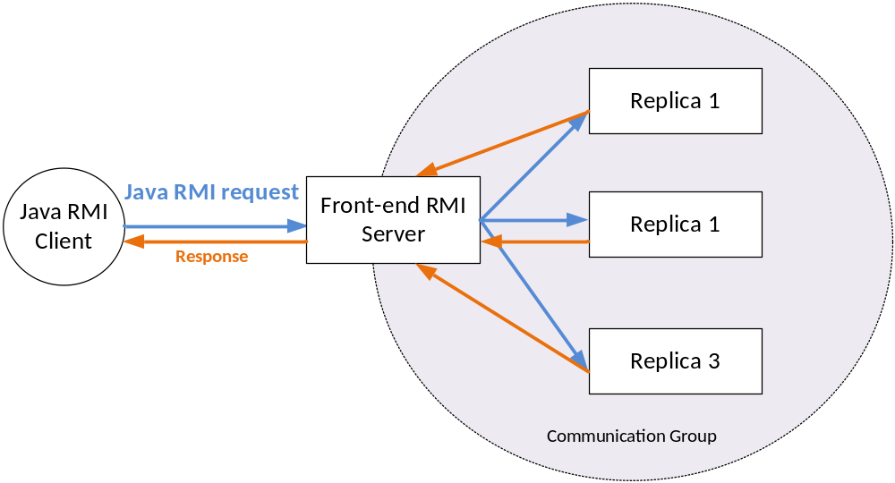
Figure 1 A Conceptual Architecture for Level 2b.

Note:
  - You are NOT expected to provide a sophisticated user interface for the two client programs (a simple text based interface will suffice). In fact, we suggest you focus on implementing the core requirements of the tasks. Having a fancy GUI will not give you extra marks.
  - Crucially, this overall problem is organised into three sub-problems of increasing difficulty: basic auctioning system (level 1), and secure & dependable auctioning system (levels 2a & 2b).
  - Each problem builds on the previous one. The level you reach determines the maximum mark you can possibly obtain for the coursework. How well you reach a level determines your actual mark.
  - As you might expect, Level 2 is much harder. So start working on it ASAP.
  - Use the lab sessions to ask for help. You are welcomed to go to as many lab sessions as you need.
  - Please do NOT send us your code via emails as we won’t be able to debug your code outside the lab sessions (e.g. we don’t know what’s your running environment, how to launch your program, what’s the input etc). Alternatively, you can arrange a meeting with one of our TAs.
- Marking Scheme
The coursework mark for SCC 311 will be calculated as follows:
Overall Component | Additional Information | Weighting (%)
Coursework Retrieval | Week 3 | 20%
 | Use of username/password authentication | 10%
 | Or Use of key-based authentication | 20%
Basic Server (Level 1) | Week 6 | 35%
 | Completion of clients and server as specified | 30%
 | Quality of the solution | 5%
Secure & Dependable Server (Level 2a & Level 2b) | Week 9 | 45%
Level 2 | Secure communication + authentication | 22.5%
Level 3 | Implementation of Replication | 22.5%
TOTAL |  | 100
This mark will then be combined with the exam mark in a ratio of 60% exam: 40% coursework to provide an overall grading for the course.
- Deadline, marking, and submission:

IMPORTANT NOTE:
Your solution must be formally submitted through Moodle by
Friday (4pm) of week 6 for level 1 and of week 9 for level 2.
You will be asked to demonstrate your work from your Moodle submission.
Level 1 will be marked in the practical sessions of week 7. Levels 2a and 2b will be marked in the practical sessions of week 10.
- You need to demonstrate your work to a member of the course team. Failing to do so will result in a grade of 0.
- You need to come to the marking session with your exercise completed. We will not provide any support during marking sessions.
- You should be able to explain what you have done clearly, to show that you understand the concepts introduced.
- Checks for plagiarism and collusion will be carried out on all work (you are advised to see the university student handbook if you’re not sure about the potential consequences of plagiarism).

