Online Book Store

by

A Report Submitted in partial fulfillment of the requirements of the degree of Bachelor in computer application

TINSUKIA COLLEGE

DEPARTMENT OF BCA

Committee Members

(Major Professor).

1

Acknowledgements

I would like to thank my major professor --- who persuaded and continuously guided me during the whole course of my project. I would also like to thank my friends for their assistance and insightful comments, and who willingly shared their expertise with me.

I sincerely acknowledge and thank my family members who gave moral support for me from my childhood.

2

Abstract

The main objective of the project is to create an online book store that allows users to search and purchase a book online based on title, author and subject. The selected books are displayed in a tabular format and the user can order their books online through credit card payment. Using this Website the user can purchase a book online instead of going out to a book store and wasting time.

There are many online book stores like Powell’s, Amazon which were designed using Html. I want to develop a similar website using .NET, SQL Server.

Online Book store is an online web application where the customer can purchase books online. Through a web browser the customers can search for a book by its title or author, later can add to the shopping cart and finally purchase using credit card transaction. They should give the details of their name, contact number and shipping address. The books are divided into many categories based on subject like Software, Database, English, Architecture etc.

The Online Book Store Website provides customers with online shopping through a web browser. A customer can, create, sign in to his account, and purchase using his credit card details.

The Administrator will have additional functionalities when compared to the common user. He can add, delete and update the book details, book categories, member information and also confirm a placed order.

This application is developed using Ajax, HTML and PHP programming language. The Master page, data sets, data grids, user controls are used to develop the Online Book store.

3
Table of Contents

Section.1 Vision Document

1. Introduction |  |  | 7
1.1 Purpose and Motivation |  |  | 7
2. | Project Overview |  | 7
2.1 Background |  |  | 7
3. | Requirement Specifications |  | 9
3.1 Main Requirements |  |  | 9
3.2 Critical Use Case Requirements |  |  | 9
3.3 Environment |  |  | 11
Section.2 Project Plan
1. | Task Breakdown |  | 15
 | 1.1. | Inception Phase | 15
 | 1.2. | Elaboration Phase | 15
 | 1.3. | Production Phase | 16
2. | Cost Estimate |  | 16
 | 2.1. | COCOMO | 16
3. | Architecture Elaboration Plan |  | 17
 | 3.1. | Vision Document 1.0 Revision | 17
 | 3.2. | Project Plan 1.0 Revision | 17
 | 3.3. | Formal Requirement Specification | 18
 | 3.4. | Architectural Design | 18
 | 3.5. | Test Plan | 18
 | 3.6. | Formal Technical Inspection | 18
 | 3.7. | Architecture Prototype | 19
Section 3.Architecture Design
1. Introduction |  |  | 20
2. | Architecture |  | 21
3. | Presentation Tier |  | 23
4. | Middle Tier |  | 26
5. | Data Tier |  | 29
6. | References |  | 31

4

Section.4 Formal Requirement Specification |  | 32
Section.5 Formal Technical Inspector Checklist
1. | Introduction | 37
2. | Items to be Inspected | 37
2.1. UML Diagrams |  | 37
2.2. Formal Specification |  | 38
3. | Formal Technical Inspectors | 38
4. | Formal Inspection Checklist | 39
5. | Formal Technical Inspection Report | 39

Section.6 Software Quality Assurance Plan

1. | Purpose | 40
2. | Reference Documents | 40
3. | Management | 40
3.1 Organization and Responsibilities |  | 40
3.2 Tasks |  | 40
4. | Documentation | 41
5. Standards, Practices, Conventions, and Metrics |  | 42
6. | Reviews and Audits | 43
7. | Test and Problem Reporting | 44
8. | Tools, Techniques, and Methodologies | 44
9. | Records collection, Maintenance, and Retention | 44

10. Deliverables |  |  | 44
Section.7.Test Plan
1. | Test plan identifier |  | 45
2. Introduction |  |  | 45
3. | Features to be tested |  | 45
5. | Approach |  | 48
 | 5.1 | Unit testing | 48
 | 5.2 Load testing |  | 49
 | 5.3 | System Testing | 49
 | 5.4 | Performance Testing | 49

5

6. | Pass/fail criteria |  | 49
7. | Suspension criteria and resumption requirements |  | 49
 | 7.1 | Suspension criteria | 49
 | 7.2 | Resumption requirements | 50
8. | Test deliverables |  | 50

Section.8 Assessment Evaluation

1. Introduction |  | 51
2. | Manual Testing | 51
3. | Test Cases | 52
3.1 User |  | 52
3.2 Admin |  | 53
4. | Performance Testing | 54
5. | Observation | 55
6. | References | 56
Section.9 User Manual |  | 59
Section.10 References |  | 76

6

Section.1 Vision Document

1. Introduction

1.1 Purpose and Motivation

The main objective of the project is to create an online book store that allows users to search and purchase a book based on title, author and subject. The selected books are displayed in a tabular format and the user can order their books online through credit card payment. The Administrator will have additional functionalities when compared to the common user.

The motivation to create this project has many sources

- Interest to develop a good user friendly website with many online transactions using a database.

- To increase my knowledge horizon in technologies like .NET, SQL, CSS, HTML.

- To gain good experience in .NET before joining in a full time job.

- To gain expertise using Data Grid, Data Set, Data Table, Data Adapter and Data Readers.

- Project Overview 2.1 Background

There are many online book stores like Powell’s, Amazon which were designed using Html. I want to develop a similar website using .NET, SQL Server.

Online Book store is an online web application where the customer can purchase books online. Through a web browser the customers can search for a book by its title or author, later can add to the shopping cart and finally purchase using credit card transaction. The user can login using his account details or new customers can set up an account very quickly. They should give the details of their name, contact number and shipping address. The user can also give feedback to a book by giving ratings on a score of five. The books are divided into many categories based on subject Like Software, Database, English, Architecture etc.

7

This project has the following functionalities:

1) A Home page with product catalog

This is the page where the user will be navigated after a successful login. It will display all the book categories and will have a search keyword option to search for the required book. It also includes some special sections like recommended titles, weekly special books.

2) Search

A search by keyword option is provided to the user using a textbox .The keyword to be entered should be the book title.

3) Advanced Search

Advanced search helps the user to search for a book based on Title, Author, Category and price range. All the books which match the particular search criteria and their total count will be displayed .From here the user can select a book and add to the shopping cart.

4) Book Description

If the user would like to know details about a book he can click on the title from where he will be directed to a Book description page. It includes the notes on the book content and also a link to Amazon.com to get the book review.

5) User Voting

The user can give rating to a book based on his interest. He can rate it by giving a score of five as Excellent, four for very good, three for good, two for regular and one for deficient. The final rating of a book will depend on all the individual user rating.

6) Shopping Cart

The user can manage a shopping cart which will include all the books he selected. The user can edit, delete and update his shopping cart. A final shopping cart summary is displayed which includes all the items the user selected and the final total cost.

7) Managing user accounts

Each user should have an account to access all the functionalities of website. User can login using login page and logout using the logout page. All the user sessions will be saved in the database.

8) Administration
The Administrator will be provided with special functionalities like
- Add or delete a book category
- Add or delete a member
- Manage member orders.
- Add or delete a Credit Card type.

8

3. Requirement Specifications

All the requirements are specified using OCL a software specification language in the second phase of my presentation.

3.1 Main Requirements

The Main Requirements include Microsoft Visual Studio 2005 and ASP.NET to develop the web application, SQL Server 2005 to design the database and Mozilla as a main web browser to run the website.

3.2 Critical Use Case Requirements

User and Administrator are the two actors included in the Online Book Store.Fig.2 shows the use case diagram for this website.
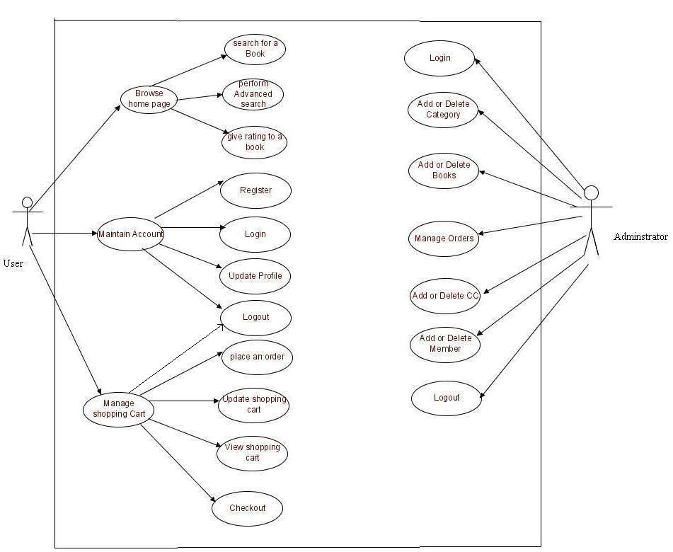

Fig.2 Use Case Diagram

9

Use Cases:

Browse Catalog

- Search for a Book

  - Purpose: A user can search for a book of his choice by selecting category and title. Then a select query is used to retrieve data from the database and display the selected information.

  - Actor: User
  - Input: The user will select a category and enter title in a text box provided.

  - Output: The system will display the books which matches the selected search criteria. A dataset is created as a result of select query. Later the dataset is binded to the data repeater to display the selected data.

- Perform Advanced Search

  - Purpose: If the user wants to perform an advanced search he can search for a book of his choice by selecting category, title, author and price range. Then a select query is used to retrieve data from the database and display the selected information.

  - Actor: User

  - Input: The user will select a category and enter title, author, and price range in a text box provided.

  - Output: The system will display the books which matches the selected search criteria. A dataset is created as a result of select query. Later the dataset is binded to the data repeater to display the selected data.

10

Maintain Account

- Register

  - Purpose: If the user doesn’t have an account then he will be asked to register.
  - Actor: User

  - Input: The user will enter details in the registration form according to the required fields. The fields include

- Username
- Password
- confirm password
- first name
- last name
- email
- Address
- Phone
- CC details

  - Output: After registration the user will be directed to the main home page.

- Login

  - Purpose: If the user wants to get access to all the functionalities of Online Book Store he should login using his username and password.

  - Actor: User
  - Input: The user will enter his username and password.

  - Output: If it is a successful login the user will be directed to the main home page. Else if the user enters invalid information he will be asked to check the entered information.

- Update Profile

  - Purpose: If the user wants to change his personal account information then he can update his selected fields and the entire data will be updated in the data base through an update query.

  - Actor: User
  - Input: The user will update his account information.

  - Output: The system will update the entered information in the database using an update query.

- Logout

  - Purpose: If the user wants to end his session and sign out of the website then he can use the logout option.

  - Actor: User

11
- Input: The user will click the logout button.

- Output: The user’s account session comes to an end and he should login again if he wants to enter into the website.

Manage Shopping Cart

- Place an order

  - Purpose: If the user wants to purchase a book then he can place an order by selecting the add to shopping cart button and entering the quantity required under the book description.

  - Actor: User

  - Input: The user will enter the quantity required and click the add to shopping cart button.

  - Output: The order will be added to the user’s shopping cart.

- Update Shopping Cart

  - Purpose: If the user wants to change the quantity of a book or change a book then he can update his shopping cart.

  - Actor: User

  - Input: The user will click the details button in the shopping cart summary to edit and update his order details..

  - Output: The updated order details are reflected in the shopping cart summary.

- View Shopping Cart

  - Purpose: If the user wants to view the items he added to the shopping cart then he can click the shopping cart link at the top of the page.

  - Actor: User
  - Input: The user will click the shopping cart link at the top of every page.

  - Output: The user’s shopping cart summary will be displayed in the form of a tabular format with all the books and their quantity. A total cost of all the items is also displayed at the bottom.

Administrator

- Login

  - Purpose: If the Administrator wants to get access to all the functionalities of Online Book Store he should login using his username and password.

  - Actor: Administrator
  - Input: The Administrator will enter his username and password.

12

  - Output: If it is a successful login the Administrator will be directed to his menu page. Else if the Administrator enters invalid information he will be asked to check the entered information.

- Add or Delete Category

  - Purpose: If the Administrator wants to add or delete a book category then he can insert or delete a book category using his administration rights and the category table will be updated in the database.

  - Actor: Administrator

  - Input: If the Administrator wants to add a book category the he should click the insert link button in the category page else he can delete a particular selected book category.

  - Output: The updated categories list will be displayed in the main home page.

- Add or Delete Book

  - Purpose: If the Administrator wants to add or delete a book then he can insert or delete a book using his administration rights and the book table will be updated in the database.

  - Actor: Administrator

  - Input: If the Administrator wants to add a book the he should click the insert link button in the book page and fill the following fields related to the book.

    - Title
    - Author
    - Price
    - Category
    - Notes
    - Product url

If he wants to delete a book he can click the delete button to remove it from the database.

  - Output: The updated books list will be displayed in the main home page under their particular category.

- Manage Orders

  - Purpose: If the Administrator wants to add or delete an order then he can insert or delete an order using his administration rights.

  - Actor: Administrator

  - Input: If the Administrator wants to add an order the he should click the insert link button in the orders page else he can delete a particular selected order Output: The updated orders list will be processed to the users.

13

- Add or Delete CC (Credit Card)

  - Purpose: If the Administrator wants to add or delete a CC type then he can insert or delete a CC type using his administration rights and the CC table will be updated in the database.

  - Actor: Administrator

  - Input: If the Administrator wants to add a CC type the he should click the insert link button in the CC page else he can delete a particular selected CC type..

  - Output: The updated CC list will be displayed in registration page where the user will select it for his future transactions.

- Add or Delete Member

  - Purpose: If the Administrator wants to add or delete a book category then he can insert or delete a book category using his administration rights and the category table will be updated in the database.

  - Actor: Administrator

  - Input: If the Administrator wants to add a book category the he should click the insert link button in the category page else he can delete a particular selected book category.

  - Output: The updated categories list will be displayed in the main home page.

- Logout

  - Purpose: If the Administrator wants to end his session and sign out of the website then he can use the logout option.

  - Actor: Administrator
  - Input: The Administrator will click the logout button.

  - Output: The Administrator’s account session comes to an end and he should login again if he wants to enter into the website.

3.3 Environment

- The Online Book store will be developed in php environment.
- php will be used as the programming language.

14

Section.2 Project Plan

- Task Breakdown

- Inception Phase

The inception phase will define all the project’s requirements. This phase will include the production of a Vision Document, a Project Plan, a Software Quality Assurance Plan, and a Demonstration.

Vision Document will include the project’s requirements and overview. It includes overview of the project, its purpose, goals, risks, constraints, and direction. It gives a listing of the main requirements and their respective Use case models to illustrate the functionality. Project Plan will detail the phases, iterations, and milestones that will comprise the project. It will include a timeline for the project and a cost estimate for completing this project. It includes the Architecture Elaboration plan will define the activities and actions that must be accomplished before the Architecture Presentation.

Software Quality Assurance Plan describes the required documentation, standards and conventions test tracking and problem reporting, and tools used during the project. The plan will also identify the set of quality metrics used to assess product reliability.

Demonstration of at least one executable prototype is required. Projects with a graphical user interface will include an executable prototype of the user interface.

This phase will be complete once the supervisory committee has approved all the above work.

1.2. Elaboration Phase

The elaboration phase defines the project’s architecture. This phase will include the production of revisions to the Project Plan and the Vision Document, an Architecture Design Plan, a formal specification, Test Plan, Formal Technical Inspection and Architecture Prototype.

Revision of Vision Document will be an updated version to provide a complete representation of all requirements. These requirements will be ranked according to importance, and a set of critical requirements identified. Appropriate changes that were suggested by the committee at the end of phase one will also be updated in the updated version of Vision Document. Revision of Project Plan will include updated timeline and cost estimate for the project. It also includes The Implementation plan which will define the activities and actions that must be accomplished during implementation.Formal Specification will include OCL.Architecture Design Plan will include the complete architectural design documentation using appropriate diagrams such as class diagrams, sequence/collaboration diagrams, etc. It also includes documentation of reuse of commercial or pre-existing components. Test Plan will address the required tests to show that the product satisfies the requirements. The test plan will identify a set of test cases,

15

the types of tests that will be used for these test cases, the data that will be used for each case, and the requirement traces for each test case. Formal Technical Inspection will include inspections by two MSE students. One of the designs, formal requirement or executable prototype is subjected to inspection. Architecture Prototype will address all critical requirements identified in the vision document.

This phase will be complete once the supervisory committee has approved all the above work.

1.3. Production Phase

The production phase defines the project implementation and testing. This phase includes the user manual, component design, assessment evaluation, project evaluation, references, and formal technical inspection.

User Manual includes an overview and explanations of common usage, user commands, error messages, and data formats. Component Design The internal design of each component will be documented using sequence/collaboration diagrams and state chart/activity diagrams.Source Code which corresponds to architecture and component design will be submitted.Assessment Evaluation will include a document detailing the testing done on the project. And Project Evaluation includes evaluation of the project ideas and quality. References and Formal Technical Inspection Letters will also be documented.

This phase will be complete once the supervisory committee has approved all the above work.

2. Cost Estimate

The Cost Estimate is done using the COCOMO model.

2.1. COCOMO

Project effort and time will be estimated using the COCOMO estimation model (Barry Boehm).

The Online Book store has an average complexity and fair flexibility. Therefore, it is classified as an organic mode project under the COCOMO model. The following formula is the COCOMO model for cost estimation for organic mode projects: Effort = 3.2 * EAF * (Size) ^ 1.05

Time = 2.5 * (Effort) ^ 0.38
Where Effort = number of staff months (PM)
EAF = effort adjustment factor

Size = number of lines of code for completed product. It is measured in KLOC (thousands of lines of codes)

Time = total number of months.

16

The Effort Adjustment Factor is the product of the 15 adjustment parameters. Each adjustment parameter is categorized as very low, low, nominal, high, or very high. All the adjustment parameters are listed below:

- RELY Required reliability 0.75 – 1.40
- DATA Database size 0.94 – 1.16
- CPLX Product complexity 0.70 – 1.65
- TIME Execution time constraint 1.00 – 1.66

- STOR Main storage constraint 1.00 – 1.56
- VIRT Virtual machine volatility 0.87 – 1.30
- TURN Computer turnaround time 0.87 – 1.15
- ACAP Analyst capability 1.46 – 0.71
- AEXP Applications experience 1.29 – 0.82
- PCAP Programmer capability 1.42 – 0.70

- VEXP Virtual machine experience 1.21 – 0.90
- LEXP Language experience 1.14 – 0.95
- MODP Use of modern practices 1.24 – 0.82
- TOOL Use of software tools 1.24 – 0.83
- SCED Required development schedule 1.23 – 1.10

Adjustment factors for the Online Book Store are listed below:

- RELY 1.00 Nominal
- DATA 1.00 Nominal
- CPLX 0.85 Low
- TIME 1.00Nominal

- STOR 1.00 Nominal
- VIRT 0.87 Low
- TURN 0.87 Low
- ACAP 1.00 Nominal
- AEXP 1.13 Low
- PCAP 1.00 Nominal

- VEXP 1.00 Nominal
- LEXP 1.00 Nominal
- MODP 0.91 High
- TOOL 0.91 High
- SCED 1.00 Nominal

The EAF value evaluated to 0.60. I have estimated the size to be around 3.00.
From the calculation I got
EFFORT = 6.08
TIME = 4.96

17

3. Architecture Elaboration Plan

All the activities to be done before the Architecture Presentation are defined here.

3.1. Vision Document 1.0 Revision

Vision Document 1.0 will be revised and updated to Vision Document 2.0. The revisions will contain a complete representation of project requirements and these requirements will be ranked according to importance, and a set of “critical” requirements identified. It also contain changes suggested by the committee members following presentation one. This revision will be approved by the Major Professor.

3.2. Project Plan 1.0 Revision

Project Plan 1.0 will be revised and updated to Project Plan 2.0. The revisions will contain Implementation plan. The Implementation plan will define the activities and actions that must be accomplished during implementation. It also contain changes suggested by the committee members following presentation one. This revision will be approved by the major professor.

3.3. Formal Requirement Specification

One part of the project will be formally specified using OCL. The specification will represent the formal requirements of the project, described in the Vision Document. This will be approved by the major professor.

3.4. Architectural Design

Architectural Design will be documented using UML diagrams such as class, sequence, and state chart diagrams. All architectural components will be documented at interface level. This will be approved by the major professor.

3.5. Test Plan

Test Plan will be developed. The document will follow the requirement listings found in Vision Document 2.0. It will also identify a set of test cases, the types of tests that will be used for these test cases, the data that will be used for each case, and the requirement traces for each test case. This will be approved by the major professor.

3.6. Formal Technical Inspection

18

Two MSE students will act as technical inspectors. The technical inspection will assess the project architecture. It will also include a formal checklist to be used by the inspectors. This will be approved by the major professor.

3.7. Architecture Prototype

An executable prototype will be built including all critical requirements described in the vision document.

19

Section.3 Architecture Design

1. Introduction

The purpose of this document is to provide an architectural design for the Online Book Store. The design will show the presentation tier, the middle tier consisting of classes, sequence diagrams, and the data tier consisting of the database design diagram.

2. Architecture

Three-tier (layer) is a client-server architecture in which the user interface, business process (business rules) and data storage and data access are developed and maintained as independent modules or most often on separate platforms.

The Architecture of Online Book Store is based on three-tier architecture. The three logical tiers are
- Presentation tier - ASP.NET Web forms, Master Pages, Images.
- Middle tier – C# classes.
- Data tier- Database
Fig.1 below shows the model of 3-tier architecture.

The main reason for considering three-tier architecture for the Online Book store is as follows:

Flexibility:

- Management of data is independent from the physical storage support,

- Maintenance of the business logic is easier,
- Migration to new graphical environments is faster.

- If there is a minor change in the business logic, we don’t have to install the entire system in individual user’s PCs.

Reusability:

- Reusability of business logic is greater for the presentation layer. As this component is developed and tested, we can use it in any other project and would be helpful for future use.

20

Security:

- More secured architecture since the client cannot access the database directly.
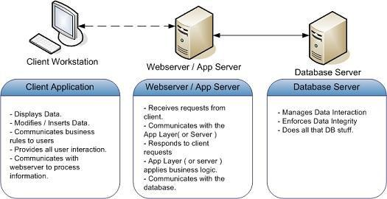

Fig.1 3-tier Architecture

21

3. Presentation tier

The presentation tier for the Online Book Store is ASP.NET Web Forms with Master Pages. The presentation tier takes care of the user interaction and the visual part of the website. The various Web forms used by clients are listed below.

Web Forms | Definition
Index.php | This web page is used | to browse the entire website and
 | also displays different categories, offers available
Registration.php | This web page is used by a new user to register his
 | personal information.
Login.php | This web page is used for a user to login and enter the
 | website.
Logout.php | This web page is used | for a user to logout from the
 | website
Books.php | This web page is used to search for books and displays
 | books which matched the search criteria..
Advsearch.php | This web page is used to display an advanced search to
 | find books.
BookDetail.php | This web page is used for displaying all the details of a
 | book.
ShoppingCart.php | This web page is used to display the shopping cart and
 | user information details.
ShoppingCartRecord.php | This web page is used to edit shopping cart.

22

The diagram below captures the page flow for user in the Online Book Store System.
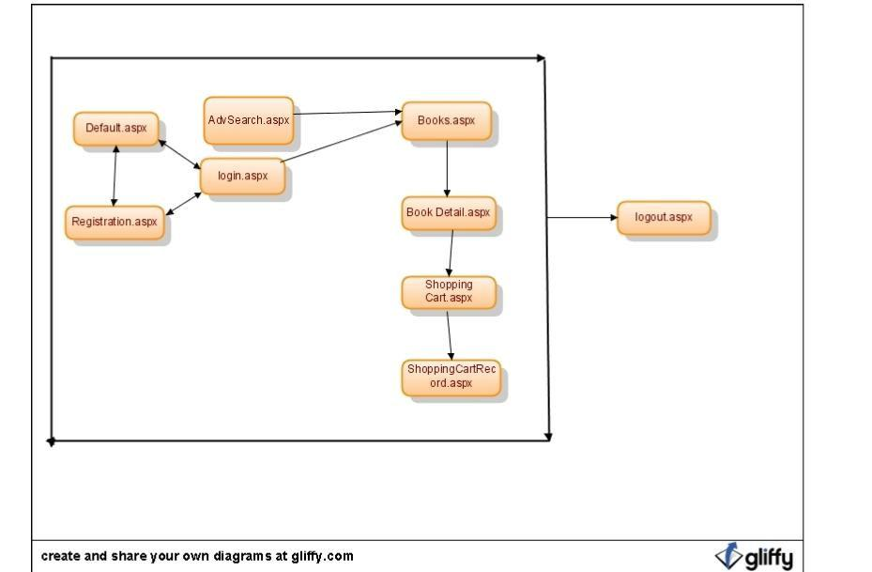

Fig.2 User-Page Flow

23

24

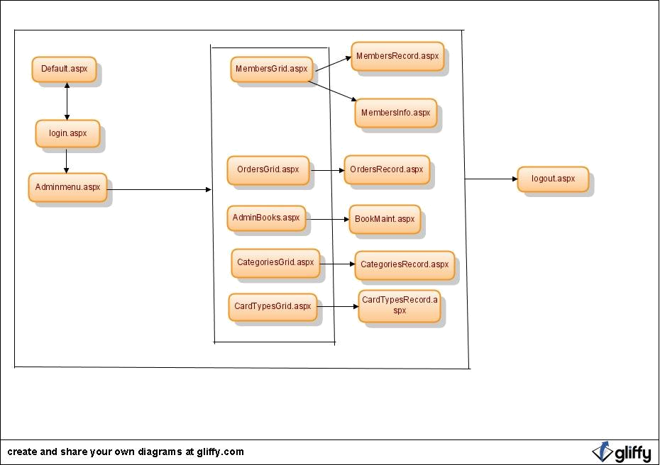

Fig.3 Administrator-Page Flow

25

4. Middle Tier

The Middle Tier or Business Logic layer consists of eleven classes User, Customer, Adminstrator, SessionManager, Category, BookSet, Book, BooksOrder, Search, Advanced Search and Shopping Cart.

Class Diagram
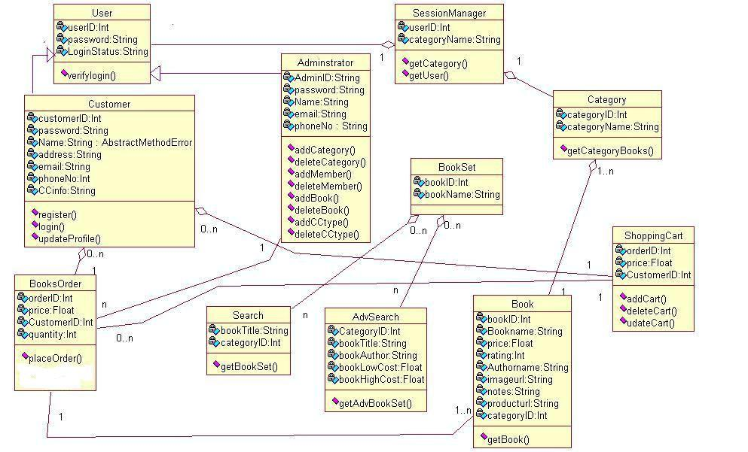

Fig.4 Class Diagram

26

Sequence Diagrams

1) User Login
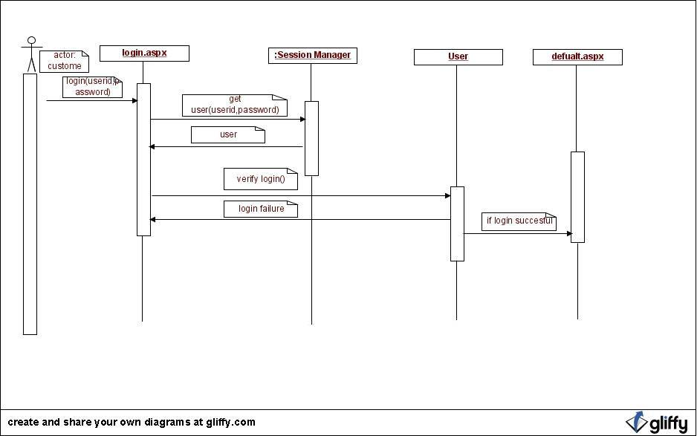

Fig.5 User-Login Sequence Diagram

27

2) Book Search
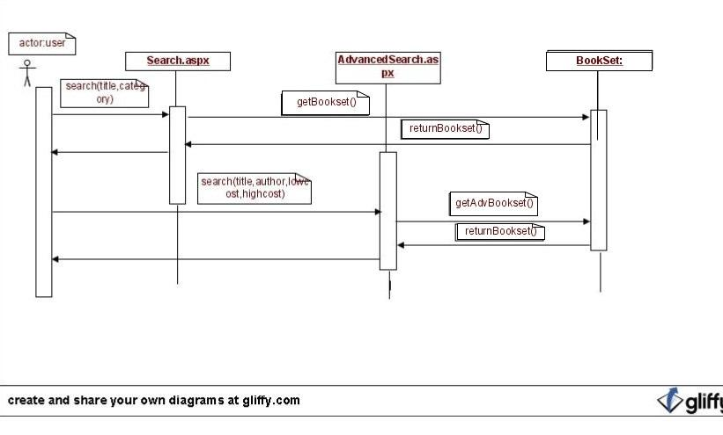

Fig.6 User-Book Search Sequence Diagram

28

3) Add to shopping cart
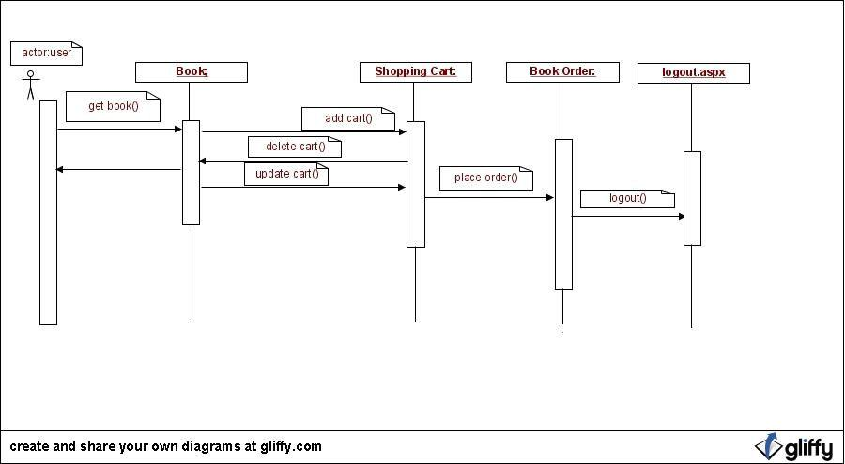

Fig.8 User-Add to Cart Sequence Diagram

29

4) Administrator
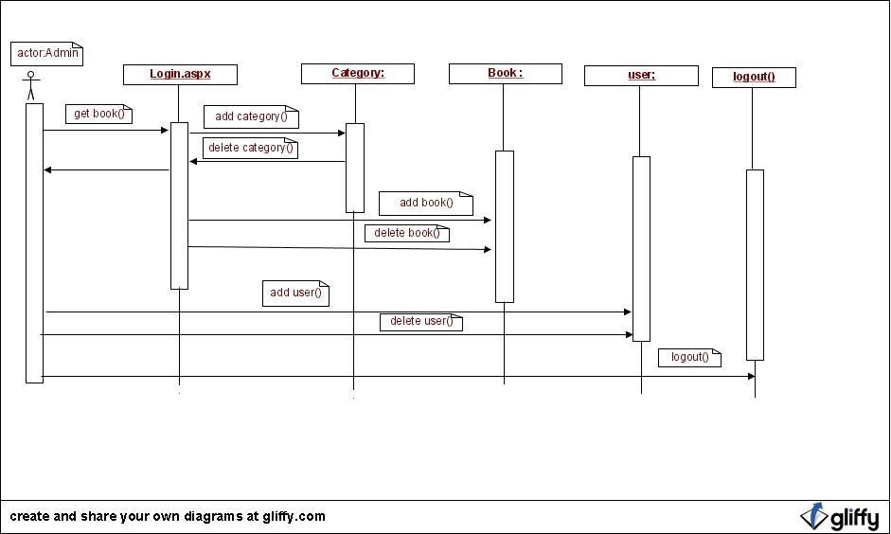

Fig.9 Adminstrator- Sequence Diagram

30

4. Data Tier

The system database has five tables Categories, Items, Orders, Members and Card types. The system database design is shown below.

Table Name | Definition
Categories | Contains the Book Categories Information
Items | Contains the Book Information.
Members | Contains the Members Information
Orders | Contains the Book Orders Information
Card Types | Contains the Credit Card Information
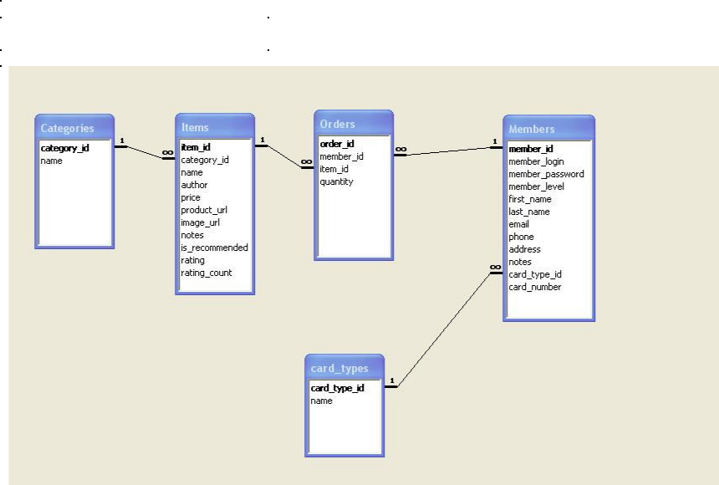

Fig.10 System Database Design

31

Section.4 Formal Requirement Specification

model OnlineBookstore

-- Classes

class User
attributes

UserID: string
password: string
LoginStatus: string

operations
Verifylogin (): Boolean

end

class Administrator < User
attributes

AdminID: string
password: string
Name: string
email: string
phoneNo: integer

operations
addCategory(): Boolean
deleteCategory:Boolean
addMember():Boolean
deleteMember():Boolean
addBook():Boolean

deleteBook():Boolean
addCCtype():Boolean
deleteCCtype():Boolean

end

class Customer < User
attributes
customerID:string
password:string
Name:string

address:string
email:string
phoneno:integer
CCInfo: string

operations
register(): Boolean
login(): Boolean

--updateprofile is used to update user information updateProfile(customerID: string, Name:string, address:string, email:string, phoneno: integer, CCInfo: string):Boolean

32

--Customer already has an customerID
pre: Customer.allInstances.customerID->includes (customerID)

post: Customer.allInstances.customerID = user.allInstances.customerID@pre --Customer name has been created

post: Customer.allInstances.Name =user.allInstances->select(C:Customer | C.customerID
<>customerID).Name@pre->includes (Name)
--Customer address has been created
post: Customer.allInstances.email= Customer.allInstances->select(C:Customer

- C.customerID<>customerID).email@pre->includes(email) post: Customer.allInstances.address = Customer.allInstances->select(C:Customer | C.customerID<>customerID).address@pre->includes(address) --Customer Phoneno has been created

post: Customer.allInstances.phoneno = Customer.allInstances->select(C:Customer | C.customerID<>customerID).phoneno@pre->includes(phoneno) post: Customer.allInstances.CCInfo = Customer.allInstances->select(C:Customer | C.customerID<>customerID). CCInfo @pre->includes(CCInfo)

end

class Category
attributes
categoryID:integer
categoryName:string

operations
getCategoryBooks(bookID:int):Set(Book) =
Book.allInstances->select(b:Book| b. bookID = bookID)
end

class Book
attributes
bookID:integer
categoryID:integer
bookName:string

authorName:string
notes:string
price:float
imageurl:string
producturl:string

rating:int

operations
getBook():Boolean
end

class ShoppingCart
attributes
orderID:integer
customerID:integer
price:float

33

operations
addCart():Boolean
deleteCart():Boolean
updateCart():Boolean

end

class BookOrder
attributes

orderID:integer
customerID:integer
price:float
quantity:integer
operations
placeOrder(BO:BookOrder):Boolean

--User authentication is verified
pre: BO.User. Verifylogin (BO.User. UserID, BO.User.password)=true
pre: BookOrder.allInstances->excludes(BO)
--Check whether customerid and customerid in Order is same

post: Customer.allInstances -> forAll(C:Customer | C.customerID=BO.customerID implies BO.orderID = C.orderID)

post: BookOrder.allInstances.orderID = BookOrder.allInstances.orderID@pre->includes(BO.orderID) end

class Search
attributes
bookTitle:String
categoryID:integer
operations
getBookset():Boolean
end

class AdvSearch
attributes
bookTitle:String
categoryID:integer
bookAuthor:String

bookLowCost:float
bookHighCost:float
operations
getBooksetbyAdv():Boolean
end

class BookSet
attributes
bookID:Int
bookName:String
end

-- Assosiations

--Each book should belong to only one Category

34

association bookCategory between
Category[1] role subCategory
Book[1..*] role allBook
end

--Each BooksOrder should contain atleast one Book
association BooksOrderHasBook between
BooksOrder[1] role theBookOrder
Book[1..*] role theBook
end

--Each BooksOrder should belong to exactly one Customer association CustomerHasOrder between Customer[1] role belongstocustomer

BooksOrder[0..*] role thecustomerbook
end

--Each Shopping cart should belong to only one Customer association CustomerrelatedtoShoppingCart between Customer[1] role thecustomer ShoppingCart[0..*] role thecart

end

--Each shoppingcart should have atleast one BooksOrder association ShoppingCartHasOrder between ShoppingCart[1] role thebookCart BooksOrder [1..*] role theorder

end

--Each search should result some bookset
association searchhassomebookset between
Search[1] role thesearch

BookSet[0..*] role thesearchset
end

--Each Advsearch should result some bookset
association Advsearchhassomebookset between
AdvSearch[1] role theAdvsearch

BookSet[0..*] role theAdvsearchset
end

--Constraints

- Each user should have different userID context User
inv distinctuserID:

User.allInstances -> forAll(user1, user2 |user1 <> user2 implies user1.userID <> user2.userID)

35

- Each Book should belong to exactly one Category context Category
inv BookHasoneCategory:

Category.allInstances -> forAll(C1,C2 |C1<>C2 && C1. getCategoryBooks -> includes(book) implies C2. getCategoryBooks -> excludes(book))

--Each Book should have a different bookID
context Book
inv DistinctBookID:

Book.allInstances -> forAll(B1, B2 |B1 <> B2 implies B1.bookID<>
B2.bookID)

--The OrderID for each Order must be different
context BookOrder

inv DistinctOrderID:

BookOrder.allInstances -> forAll(BO1, BO2 |BO1 <> BO2 implies BO1.orderID<>
BO2.orderID)

--Each BookOrder should have some books
context BookOrder

inv BookOrderHasbooks
self.contains -> notEmpty()

- Each BookOrder belongs to exactly one customer context BookOrder

inv OrdertoOneCustomer

Order.allInstances -> forAll (BO1, BO2 | BO1.orderID <> BO2.orderID implies BO1.customerID <> BO2.customerID)

- Quantity should always be a positive value
context BookOrder

inv BookOrder Positive
self.quantity > 0

--Each Shopping cart belongs to only one customer
context ShoppingCart
inv CarthasOneCustomer
ShoppingCart.allInstances -> forAll (SC1, SC2 | SC1.orderID <> SC2.orderID
implies SC1.customerID <> SC2.customerID)

--In search Low price should be less than High Price
context AdvSearch
inv PriceCompare
self. bookLowCost < self. bookHighCost

- Price should always be a positive value context Book

inv BookPricePositive: self.price > 0

36

Section.5 Formal Technical Inspectors Checklist

1. Introduction

The document specifies checklist to be inspected by the technical inspectors of

Online Book Store. The main purpose of the formal technical inspection process is to ensure quality of the software design. Two MSE students will perform the inspection and provide the formal report on the result of their inspection.

2. Items to be inspected

2.1. UML Diagrams
- Class diagrams
- Sequence diagrams

2.2. Formal Specification
  - USE Model

- Formal Technical Inspectors
  - Phaninder Surapaneni
  - Snehal Monterio

- Formal Inspection Checklist

Item to be Inspected | Pass/Fail/ Comments
 | Partial

All the symbols used in the class diagrams are according to the UML standards.

All the classes in the class diagram are clear as to what they represent in the architecture design document.

The symbols used in the sequence diagram correspond to UML standards.

Sequence diagram matches class diagram.

All the classes in the USE model are represented in the class diagram.

The multiplicities in the USE model have been depicted in the class diagram.

All the requirements in the Software Requirements
Specification have been covered in the

37

Architecture Design Document.

5. Formal Technical Inspection Report

Dr.Amtoft,Dr. Andresen,Dr.Neilsen

I have completed the Formal Technical Inspection for Vamsi Mummaneni’s Online Book Store project. All the items in the checklist passed the test criteria.

Item to be Inspected | Pass/Fail/ | Comments
 | Partial
All the symbols used in the class diagrams are | Pass
according to the UML standards.
All the classes in the class diagram are clear as to | Pass
what they represent in the architecture design
document.
The symbols used in the sequence diagram | Pass
correspond to UML standards.
Sequence diagram matches class diagram. | Pass
All the classes in the USE model are represented in | Pass
the class diagram.
The multiplicities in the USE model have been | Pass
depicted in the class diagram.
All the requirements in the Software Requirements | Pass
Specificationhavebeencoveredinthe
Architecture Design Document.

Thanking you,
Phaninder Surapaneni

38

Dr.Amtoft,Dr. Andresen,Dr.Neilsen

I have completed the Formal Technical Inspection for Vamsi Mummaneni’s Online Book Store project. All the items in the checklist passed the test criteria.

Item to be Inspected | Pass/Fail/ | Comments
 | Partial
All the symbols used in the class diagrams are | Pass
according to the UML standards.
All the classes in the class diagram are clear as to | Pass
what they represent in the architecture design
document.
The symbols used in the sequence diagram | Pass
correspond to UML standards.
Sequence diagram matches class diagram. | Pass
All the classes in the USE model are represented in | Pass
the class diagram.
The multiplicities in the USE model have been | Pass
depicted in the class diagram.
All the requirements in the Software Requirements | Pass
Specificationhavebeencoveredinthe
Architecture Design Document.

Thanking you,
Snehal Monterio

39

Section.6 Software Quality Assurance Plan

1. Purpose

The purpose of Software Quality Assurance Plan is to define all the techniques, procedures, and methodologies that will be used in the project to assure timely delivery of the software that meets specified requirements within project resources. Software Quality Assurance involves reviewing and auditing the software products and activities to verify that they comply with the applicable procedures and standards and providing the software project and other appropriate managers with the results of these reviews and audits.

- Reference Documents

  - Project Plan 1.0

  - Vision Document 1.0

  - IEEE standard for Software Quality Assurance plans, IEEE STD 730-1998.

- Management

3.1 Organization and Responsibilities

The organization consists of supervisory committee, major professor, developer and formal technical inspectors.

Supervisory Committee

- Dr. Torben Amtoft

- Dr. Daniel Andresen

- Dr. Mitchell Neilsen

40
The committee will be responsible for attending the presentations and reviews at the end

of each phase. After each presentation, the committee will provide feedback and

suggestions regarding the project.

Major Professor

- Dr. Torben Amtoft

The major professor will be responsible for supervising and evaluating the work and

progress done by the developer on a weekly basis.

Developer

- Vamsi Mummaneni

The developer should submit all the deliverables and complete the project functionalities

on time. He should keep updating his weekly progress to the Major Professor.

Formal Technical Inspectors

The formal technical inspectors will be responsible for a technical review of the

architecture design artifacts and the formal requirements specifications and will also be

required to submit a formal report based on their findings.

Formal Technical Inspection Checklist

Item to be Inspected | Pass/Fail/ Comments
 | Partial

All the symbols used in the class diagrams are according to the UML standards.

All the classes in the class diagram are clear as to what they represent in the architecture design document.

The symbols used in the sequence diagram correspond to UML standards.

Sequence diagram matches class diagram.

All the classes in the USE model are represented in the class diagram.

The multiplicities in the USE model have been

41

depicted in the class diagram.

All the requirements in the Software Requirements
Specification have been covered in the
Architecture Design Document.

3. 2 Tasks

All tasks to be performed are mentioned in the Project Plan1.0.After the first phase if any changes are required the Major Professor will discuss with the developer.

4. Documentation

The documentation will consist of all the deliverables. They are vision document, project plan, software quality assurance plan, formal requirements specification, architecture design, test plan, formal technical inspection, prototype, user manual, component design, source code, assessment evaluation, project evaluation, references, and formal technical inspection letters. The committee members will review all documentation for final approval.

All documentation will be posted on the developer’s website at http://people.cis.ksu.edu/~vamsim/mseproject.html

5. Standards, Practices, Conventions, and Metrics

- Documentation Standards

The IEEE standards are used as reference for all the documents of Online Book Store project. IEEE Standard for Software Quality Assurance Planning is used for SQA 1.0.

- Coding Standards

The project coding standards follow C# .As the project is developed using the C# language.

- Testing Standards

The various types of testing performed would be mentioned in the Test Plan document at the end of second phase.

42

6. Reviews and Audits

All the deliverables produced in each phase of project development are reviewed by the major professor and supervising committee. These are evaluated by the committee, at the end of each phase and provide comments on the software prototype as well as suggestions for any changes or addition to the requirements specification. The two formal technical inspectors will assess the architecture design artifacts and submit a formal report based on their findings.

7. Test and Problem Reporting

All the testing procedures used for the project would be mentioned in the test plan document at the end of second phase. The results would be reviewed and all the unresolved problems will be reported to the committee members.

8. Tools, Techniques and Methodologies

The following tools, tecnniques and methods would be used for the project for the

specified purpose:

  - Coding: - C#, CSS, HTML, ASP.Net, Microsoft VisualStudio.Net 2005 IDE, Microsoft SQL Server 2005

  - Testing:-Junit

  - Documentation:-MS Word, Rational Rose, MS Project, OCL.

- Records collection, Maintenance, and Retention

Three sets of design documentation would be produced and distributed to the University Library, Major Professor and developer. The source code, documentation and web pages are submitted to the Major Professor in the form of a CD.

10. Deliverables

The deliverables for all the three phases are listed below:

Phase I

- Vision Document 1.0

- Project Plan 1.0

43
• Software Quality Assurance Plan

Phase II

- Action Items –identified during phase I

- Vision Document 2.0

- Project Plan 2.0

- Formal Requirements Specification

- Architecture Design

- Test Plan

- Formal Technical Inspection

- Executable Architecture Prototype

Phase III

- Action Items - identified during phase I

- User Manual

- Component Design

- Source Code

- Assessment Evaluation

- Project Evaluation

- References

- Formal Technical Inspection

44

Section.7 Test Plan

1. Test plan identifier

CIS 895-MSE Project Test plan Online Book Store V1.0

2. Introduction

The goal of this document is to develop a test plan for the Online Book Store design system. This document defines all the procedures and activities required to prepare for testing of the functionalities of the system which are specified in Vision document. The objectives of the test plan are to define the activities to perform testing, define the test deliverables documents and to identify the various risks and contingencies involved in testing.

3. Features to be tested

The following list describes the features to be tested:

USER:
- Registration
- Login
- Add To Cart

- Edit Cart

ADMIN:
- Create and Delete book from Category
- Create and Delete a Category
- Manage Orders
- Manage Members

45

- Test Cases 4.1 USER

Registration
ID | TEST CASE |  | USER INPUT |  |  | PASS CRITERIA
U_REG_1 | User Registration | User | selects |  | already | Display |  | message |  | to
 |  | existing user name |  |  |  | choose |  | different |  | user
 |  |  |  |  |  | name
U_REG_2 | User Registration | User | enters |  | different | Display message |  |  |  | that
 |  | passwordin |  |  | password | Password and Confirm
 |  | confirm field |  |  |  | Password fields don't
 |  |  |  |  |  | match
U_REG_3 | User Registration | User forgets to enter a |  |  |  | Display |  | message |  | The
 |  | particular required fields |  |  |  | value |  | in | field | is
 |  |  |  |  |  | required
U_REG_4 | User Registration | User enters all the details |  |  |  | User account created
 |  | successfully
Login
ID | TEST CASE |  | USER INPUT |  |  | PASS CRITERIA
U_LOG_1 | User Login | User | enters | a | wrong | Display message Login
 |  | username |  |  |  | or | Password |  |  | is
 |  |  |  |  |  | incorrect.
U_LOG_2 | User Login | User | enters | a | wrong | Display message Login
 |  | password |  |  |  | or | Password |  |  | is
 |  |  |  |  |  | incorrect.
U_LOG_3 | User Login | User | enters |  | correct | User |  | logs |  | in
 |  | username and password |  |  |  | successfully
Add to Cart
ID | TEST CASE |  | USER INPUT |  |  | PASS CRITERIA
U_AC_1 | Add to Cart | User selects a book and |  |  |  | Book is added to the
 |  | clicks add to cart button |  |  |  | shopping cart
U_AC_2 | Add to Cart | Guest selects a book and |  |  |  | User | should |  | create an
 |  | clicks add to cart button |  |  |  | account.

46

Edit Cart
ID | TEST CASE |  | USER INPUT | PASS CRITERIA
U_EC_1 | Edit Cart | User changes the Quantity |  | Quantity and total cost
 |  |  |  | of Cart should be
 |  |  |  | updated
U_EC_2 | Edit Cart | User deletes a book from |  | Books and total cost of
 |  | shopping Cart |  | Cart should be updated
U_EC_3 | Edit Cart | User selects a new book to |  | Books and total cost of
 |  | shopping Cart |  | Cart should be updated

4.2 ADMIN

Create and Delete a Book from Category

ID | TEST CASE |  |  |  |  | ADMIN INPUT |  |  | PASS CRITERIA
AD_CDB_1 | Create | and | Delete | a | Admin adds a new book to |  |  |  | Book | should | be
 | Book from Category |  |  |  | category |  |  |  | updated | in Categories
 |  |  |  |  |  |  |  |  | list
AD_CDB_2 | Create | and | Delete | a | Admin | deletes | a | book | Book should be deleted
 | Book from Category |  |  |  | from category |  |  |  | in Categories list
Create and Delete a Category
ID | TEST CASE |  |  |  |  | ADMIN INPUT |  |  | PASS CRITERIA
AD_CDC_1 | Create | and | Delete | a | Admin | adds | a | new | Category | should | be
 | Category |  |  |  | category |  |  |  | updated to system
AD_CDC_1 | Create | and | Delete | a | Admin deletes a category |  |  |  | Category | should | be
 | Category |  |  |  |  |  |  |  | deleted from system

47

Manage Orders
ID | TEST CASE | ADMIN INPUT | PASS CRITERIA
AD_MO_1 | Manage Orders | Admin accepts an order | Order is processed
AD_MO_2 | Manage Orders | Admin deletes an order | Order is not processed

Manage Members

ID | TEST CASE |  | ADMIN INPUT | PASS CRITERIA
AD_MM_1 | Manage Members | Admin accepts Members |  | Member is accepted
AD_MM_2 | Manage Members | Admin deletes Members |  | Member | is | not
 |  |  |  | accepted

5. Approach

This section describes the overall approach of the testing which ensures that the each feature and the combination of the features are adequately tested. The major tasks that are used are

5.1 Unit testing

Unit testing is a method of testing that verifies the individual units of source code are working properly. The goal of unit testing is to isolate each part of the program and show that the individual parts are correct. The NUnit a testing tool for C# will be used for unit testing.

48

5.2 Load testing

Load testing is the process of creating demand on a system or device and measuring its response. It generally refers to the practice of modeling the expected usage of a software program by simulating multiple users accessing the program concurrently. As such, this testing is most relevant for multi-user systems; often one built using a client/server model, such as web servers

5.3 System Testing

Once the entire system has been built then it has to be tested against the Software Requirement Specification and System Specification to check if it delivers the features required. System testing can involve a number of specialist types of test to see if all the functional and non-functional requirements have been met.

5.4 Performance Testing

The system should meet the performance requirements as mentioned in the Vision document. The performance will be evaluated based on the response time of the GUI and the database commands. Using JMETER tool performance testing will be done.

5.5 Manual Testing

Manual Testing will be done to ensure the correctness of various parts of the code using test cases generated by the tester.

6. Pass/fail criteria

The system should satisfy all the functional requirements, in the Vision document. Each feature to be tested will be evaluated against its requirement as stated in the Vision Document. The pass or fail of a test depends on whether the system meets with all the particular post conditions.

Test cases executed on the Online Book Store will pass if they meet the specific requirements as mentioned in the Vision Document.

- Suspension criteria and resumption requirements 7.1 Suspension criteria

49

If the system contains one or more critical defects like the defects in the GUI editor which provides the editing features for one line diagrams and database locking, unlocking and sharing features which provides the environment for multiple users to work in parallel, the entire system should be suspended.

The testing may also be suspended if the hardware and software components required are not available on time.

The failed test cases should be recorded along with the description for failure.

7.2 Resumption requirements

When a new version of the system is transmitted to the test group after a suspension of testing has occurred, all previous tests will be rerun to ensure program changes have not inadvertently affected other portions of the program.

8. Test deliverables

The following documents are the available test deliverables:-

- Test plan
- Test case specifications
- Test input and output data
- Test procedure specifications
- Test logs

50
Section.8 Assessment Evaluation

1. Introduction

The goal of this document is to present all the test results using the test cases defined in the Test Plan Document. I have performed Manual and Performance testing for my Online Book store project.

2. Manual Testing

Manual testing is done to test the correctness of all the functionalities by manually entering the data.

Test case functionalities for manual testing include:

USER:
- Registration
- Login

- Add To Cart
- Edit Cart

ADMIN:
  - Create and Delete book from Category
  - Create and Delete a Category
  - Manage Orders
  - Manage Members

- Test Cases

3.1 USER

 | Registration
ID | TEST CASE |  | USER INPUT | RESULT | PASS CRITERIA
U_REG_1 | User Registration | User selects already existing user |  | PASSED | Display message to
 |  | name |  |  | choose | different
 |  |  |  |  | user name
U_REG_2 | User Registration | User enters different password in |  | PASSED | Display | message
 |  | password confirm field |  |  | that Password and

51

 |  |  |  | Confirm | Password
 |  |  |  | fields don't match
U_REG_3 | User Registration | User forgets to enter a particular | PASSED | Display | message
 |  | required fields |  | The value in field is
 |  |  |  | required
U_REG_4 | User Registration | Userentersallthedetails | PASSED | User | account
 |  | successfully |  | created

 | Login
ID | TEST CASE |  | USER INPUT |  |  | RESULT | PASS CRITERIA
U_LOG_1 | User Login | Userentersawrong |  |  |  | PASSED | Display | message | Login | or
 |  | username |  |  |  |  | Password is incorrect.
U_LOG_2 | User Login | Userentersawrong |  |  |  | PASSED | Display | message | Login | or
 |  | password |  |  |  |  | Password is incorrect.
U_LOG_3 | User Login | User |  | enters | correct | PASSED | User logs in successfully
 |  | username and password

Add to Cart

ID | TEST CASE |  | USER INPUT | RESULT | PASS CRITERIA
U_AC_1 | Add to Cart | User selects a book and |  | PASSED | Book is added to the shopping cart
 |  | clicks add to cart button
U_AC_2 | Add to Cart | Guest selects a book and |  | PASSED | User should create an account.
 |  | clicks add to cart button

 | Edit Cart
ID | TEST CASE |  | USER INPUT | RESULT | PASS CRITERIA
U_EC_1 | Edit Cart | User changes the Quantity |  | PASSED | Quantity and total cost
 |  |  |  |  | of Cart should be updated
U_EC_2 | Edit Cart | User deletes a book from |  | PASSED | Books and total cost of Cart should
 |  | shopping Cart |  |  | be updated
U_EC_3 | Edit Cart | User selects a new book to |  | PASSED | Books and total cost of Cart should
 |  | shopping Cart |  |  | be updated

52

3.2 ADMIN

Create and Delete a Book from Category

ID | TEST CASE |  |  |  |  | ADMIN INPUT | RESULT | PASS CRITERIA
AD_CDB_1 | Create | and | Delete | a | Admin adds a new book to |  | PASSED | Book should be updated
 | Book from Category |  |  |  | category |  |  | in Categories list
AD_CDB_2 | Create | and | Delete | a | Admin deletesa book |  | PASSED | Book should be deleted
 | Book from Category |  |  |  | from category |  |  | in Categories list

Create and Delete a Category
ID | TEST CASE |  | ADMIN INPUT | RESULTS | PASS CRITERIA
AD_CDC_1 | Create and Delete | Admin adds a new |  | PASSED | Category | should | be
 | a Category | category |  |  | updated to system
AD_CDC_1 | Create and Delete | Admindeletesa |  | PASSED | Category | should | be
 | a Category | category |  |  | deleted from system

Manage Orders

ID | TEST CASE |  | ADMIN INPUT | RESULTS | PASS CRITERIA
AD_MO_1 | Manage Orders | Admin accepts an order |  | PASSED | Order is processed
AD_MO_2 | Manage Orders | Admin deletes an order |  | PASSED | Order is not processed

53

 | Manage Members
ID | TEST CASE |  | ADMIN INPUT | RESULTS | PASS CRITERIA
AD_MM_1 | Manage Members | Admin accepts Members |  | PASSED | Member is accepted
AD_MM_2 | Manage Members | Admin deletes Members |  | PASSED | Member is not accepted

4. Performance Testing

The system should meet the performance requirements as mentioned in the Vision document. The performance will be evaluated based on the response time of the GUI and the database commands. Using JMETER tool performance testing will be done.

Apache JMETER is a 100% pure Java desktop application designed to load test functional behavior and measure performance. Originally designed to test web applications, it is now a general tool for testing client/server applications like database servers, FTP servers and others. It lets you test your applications under different work loads, and graphically represent the application's behavior.

I have tested the performance of three different pages of my Online Book Store Website as mentioned in the Test Plan document during Phase-2.

Pages Tested

- Home Page
- Search Page
- Shopping Cart Page

The Performance testing has been done using a sample of 8 threads which are generated with a loop of 100.

54

Home Page

http://localhost:3062/vamsi-bookstore/Default.aspx

The graph below in Fig.1 shows the test results of Homepage of Online Book Store Website.

Performance Graph
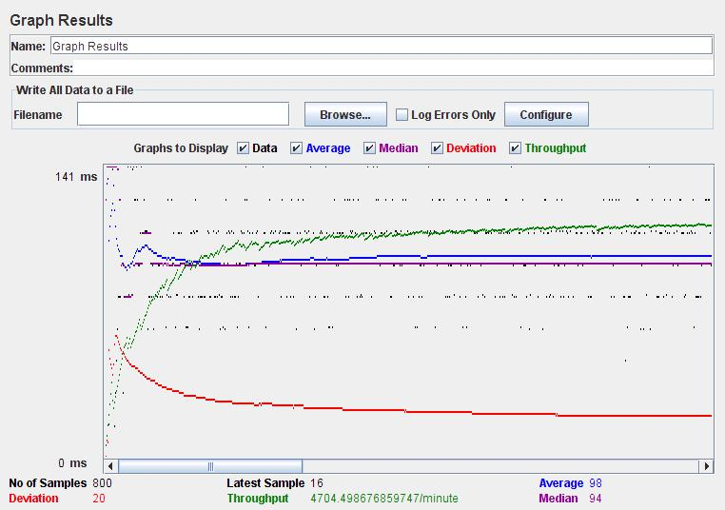

Fig.1

55

Search Page

http://localhost/book_store/

The graph results below in Fig.2 shows the test results of Search Page of Online Book Store Website.

Performance Graph
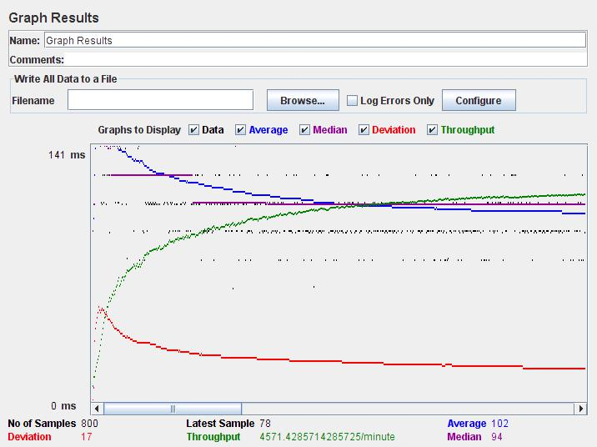

Fig.2

56

Shopping Cart Page

http://localhost:3062/bookstore/ShoppingCart.aspx?

The graph results below in Fig.3 shows the test results of Shopping Cart Page of Online Book Store Website.

Performance Graph
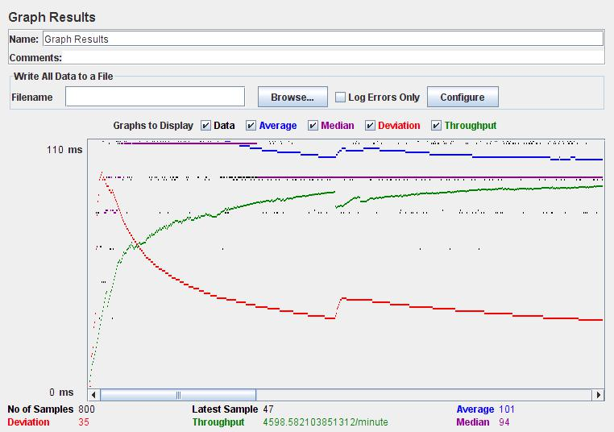

Fig.3

57
- Observations

  - Average response time is more for search page when compared to the Home page.

  - Average response time is low for home page because it doesn’t many database interactions.

  - Average response time for Search page is more since it should wait for the results from the database.

58

70

Section.10 Project Evaluation

1. Introduction

This document evaluates the experience of the development of the Online Book Store project. A brief description of the tools, process, techniques employed as well as the mistakes made is presented so that lessons are documented and learned.

2. Problems faced

The following are the problems faced during the design of Online Boos Store Website.

2.1 C# language

The main problem encountered during the process was my inexperience in the ASP.NET and C# Language and environment.

So I used the videos in asp.net website to get basic experience in C#.NET.I tried to solve some sample applications which helped me to design the website easily. It was difficult for me to format the home page of my website using the C#.NET code. So finally I choose to use the html div tags which made my work easier. I also didn’t have good experience of using the J-Meter testing tool for performance testing. So I learnt about it using some tutorials which I found using google.com.

2.2 Security

I also had some security issues to be resolved.

- Only the user who will login can order for a book and checkout.
- And also the user should not be able to access the Administrative options.

It was easy for me to create the user security options for checkout but I faced problems with protecting Admintrative options from the user. But later I was able to figure it out using Google search engine and some videos about C# security.

3. Metrics

3.1 Lines of Code

My initial estimate was 3000 LOC during Phase-1.This was calculated in the COCOMO model in Project Plan 1.0 document.

But now I found the total to be 3203 LOC after the coding part is completed. I used the LOC metrics tool to count the total number of Lines of Code.

71

The reason for increase in the size of the project may be due to my inexperience in programming in C# and using extra functions for functionality. And it was difficult for me to estimate the exact number of lines of code during the initial phase of my Project.

3.2 Time

The project took 27120 minutes, which is 452 hours, at 22 hours a week that is 19

weeks or 4.8 months. The initial estimate for my project using the COCOMO model analysis has come to 4.96 staff months.

Table below shows the time spent for each task at each phase. Design is the most important task that was performed at last two phases .Coding was performed in last two phases but mainly in the implementation phase.

Phases | Start Date | End Date
Inception | July 15th 2008 | Aug 18th 2008
Implementation | Aug 20th 2008 | Nov 20th 2008
Elaboration | Nov 21st 2008 | Dec 11th 2008

Table.1 Project Phase Schedule

The Table below shows the break down of time spent in each phase for Research, Design, Coding, Testing and Documentation.

 | Inception(Hours) | Implementation(Hours) | Elaboration(Hours) | Total
Research | 20 | 25 | 5 | 50
Design | 17 | 20 | 5 | 42
Coding | 0 | 210 | 37 | 247
Testing | 0 | 15 | 30 | 45
Documentation | 20 | 28 | 20 | 68
Total | 57 | 298 | 97 | 452

Table.2 Phase Breakdown

72

The Pie chart in Fig.1 shows the hour break down for each phase.
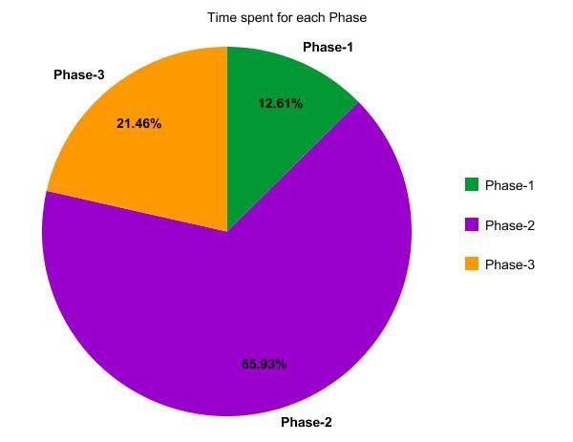

Fig.1 Project Phase Schedule

73

The pie chart in Fig.2 shows the Time allocated for various tasks during the Project Implementation.
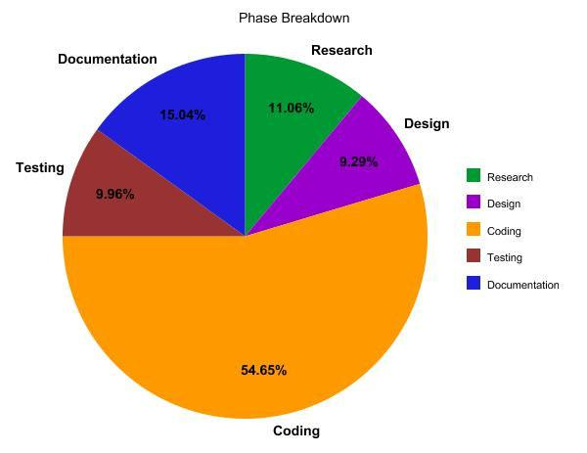

Fig.2 Task breakdown

- Lessons Learned Programming

The Online Book Store Project helped me to improve my confidence level in C# Programming. Though I have made many mistakes during the initial phase I have learnt how to use user controls, master pages, data grid, data set and other data base functionalities.

Time Management

Since MSE Project is done as an individual I have learnt how to manage time during the Software Life Cycle Process. I have also learned how o face tense situations and meet the deadlines .This would add as a good experience for me for my future job prospective.

74

UML and Software Lifecycle

As software student though I have good knowledge in UML and Software LIFE cycle I never had any good practical experience regarding them. Through this project I have learnt how to develop a project following the various stages in Software Life Cycle.

Documentation

I always had a feeling that I am not good at documentation .But through this project and suggestions from my committee members I believe that I have improved my Documentation skills.

75

76

