**ER-DIAGRAM:**

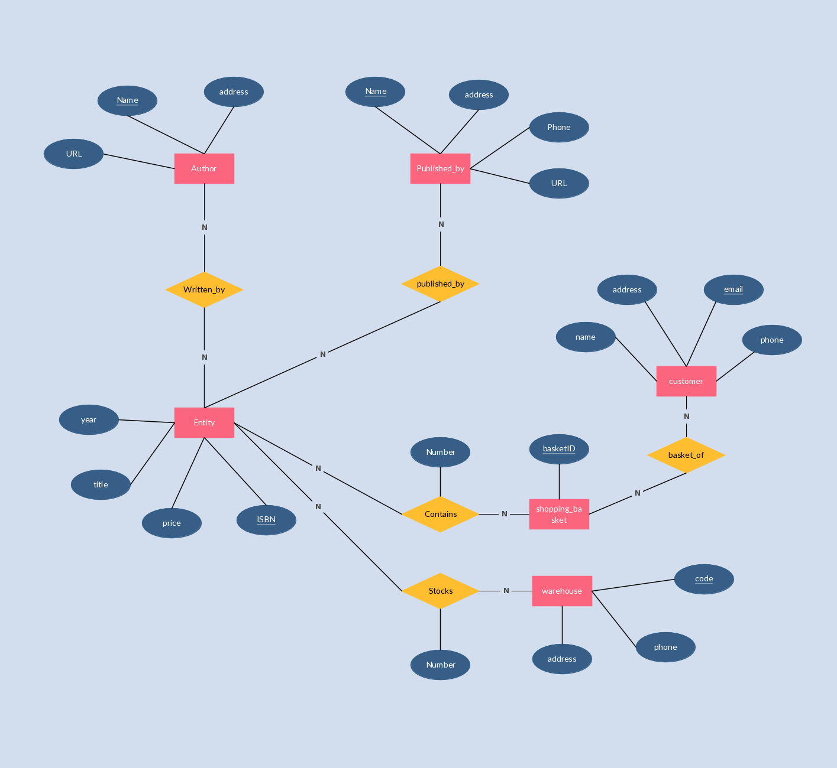

**DFD-DIAGRAM(1ST LEVEL):**

