**OLAP Design – Day 1**

**Logical modeling for Health Care System.**

In the logical modeling process, data are represented in details as much as possible. Thus, Logical modeling is the base for designing physical model.

In the logical phase, the attributes of the entity are listed and defined their business mode. Here, we have selected the project name as Health Care System because the sample data file contains the data of employees working in a health sector through out the region of Kathmandu, Pokhara and Hetauda. The dimension tables are made accordingly to their domains like date is allocated to dimDate where all dates fields are stored and employee data are stored in dimEmployee.

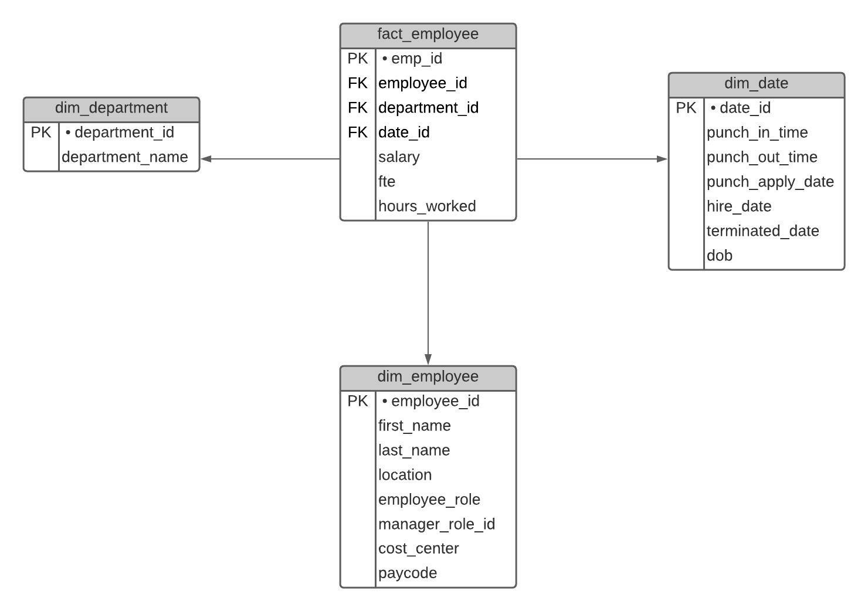

Figure 1: Logical Representation of Health Care System

In the above figure, we have extracted the one fact table named as factEmployee and other three dimension table which stores the qualitative data of factEmployee table. The main concept for the attributes of the table is that it must give how much or how many answer of some dimensions. The other three dimension table dimDepartment, dimDate and dimEmployee stores the data of department, date and employess respectively. We have chosen the factEmployee as a fact table because it contains data that can be aggregated like sum, count and others as well.

**Physical Implementation of Health Care System**

For the physical implementation of Health Care System, we have selected following database,

Database Engine: PostgreSQL

Database Name : healthCareSystem

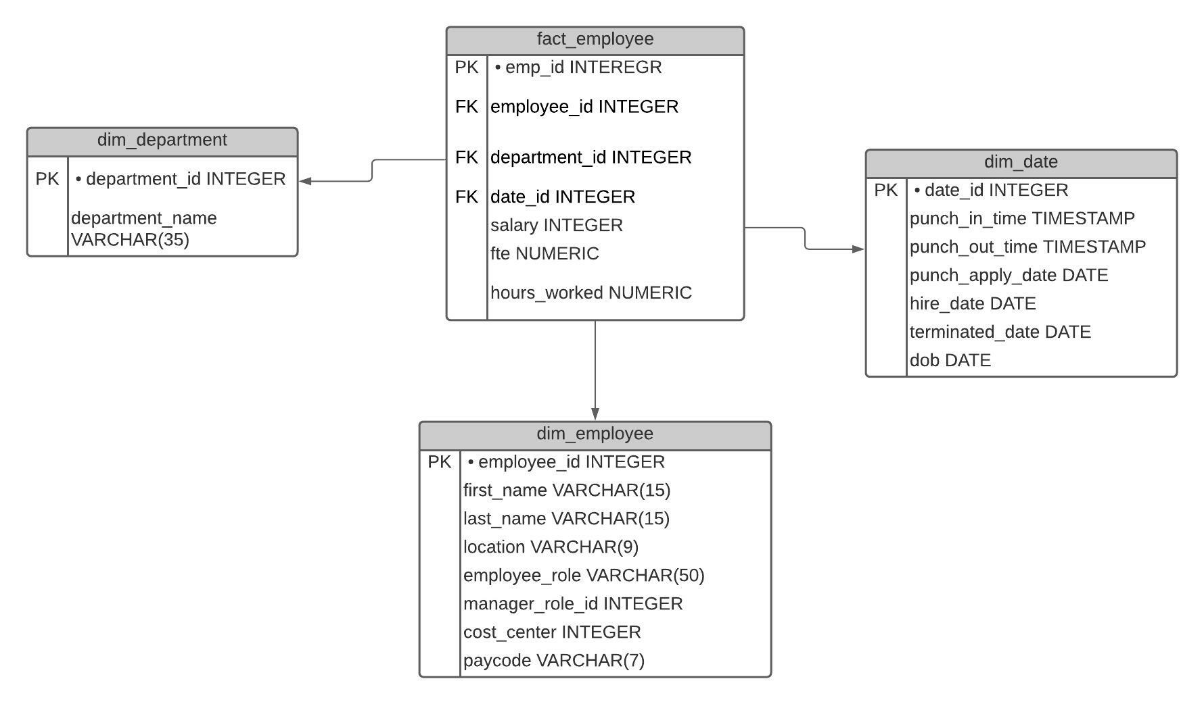

Figure 2: physical Implementation of Health Care System.

In the above figure, all possible datatypes of all attributes in each dimension table and fact table is listed accordingly so that it can be helpful for the physical implementation of those figure into the database.