**VISVESVARAYA TECHNOLOGICAL UNIVERSITY**  
“JnanaSangama”, Belgavi-590014, Karnataka, India   
 

A MINI PROJECT REPORT ON

**“Demonstration of cancer cells and its causes”**

|  |  |
| --- | --- |
| **Bikash Acharaya**  **Suman Regmi** | **[1IC17CS005]**  **[1IC17CS041]** |

Submitted in partial fulfillment of the requirements of   
**Computer Graphics and Visualization Laboratory**

**For the sixth semester Bachelor of engineering degree**

Submitted by

Under the guidance of   
**Mr. Sijin P**

Professor

Dept. of CSE



IMPACT COLLEGE OF ENGINEERING AND APPLIED SCIENCE

SAHAKAR NAGAR, BANGALORE-560092

2019-2020

IMPACT COLLEGE OF ENGINEERING AND APPLIED SCIENCES  
 SAHAKARNAGAR, BANGALORE -560092  
 

**Department of computer Science and Engineering**

**CERTIFICATE**

This is to certify that the project entitled “**Demonstration of cancer cells and its causes**” carried out by **Mr. BIKASH ACHARAYA[1IC17CS005]** and **Mr. SUMAN REGMI [1IC17CS041** bonafide students of **Impact College of Engineering And Applied Sciences** has been submitted in partial fulfillment of requirements in Computer Graphics and Visualization Laboratory of VI semester **Bachelor Of Engineering degree in Computer Science &Engineering** as prescribed by VISVESVARAYA TECHNOLOGICAL UNIVERSITY during the academic year of 2019-2020.

|  |  |  |
| --- | --- | --- |
| ___________________ |  | ___________________ |
| Signature of the Guide |  | Signature of HOD |
| **Ms. Sijin P** |  | **Mr. Sijin P** |
| Professor  Dept. of CSE |  | Professor & HOD  Dept. of CSE |
|  |  |  |
| Name of Examiner |  | Signature with date |
| 1.___________________  2.___________________ |  | 1.___________________  2.___________________ |

**ABSTRACT**

**Cancer** is a group of diseases involving abnormal [cell growth](https://en.wikipedia.org/wiki/Cell_growth) with the potential to invade or spread to other parts of the body. Not all tumors are cancerous; [benign tumors](https://en.wikipedia.org/wiki/Benign_tumor) do not spread to other parts of the body Possible [signs and symptoms](https://en.wikipedia.org/wiki/Cancer_signs_and_symptoms) include a lump, abnormal bleeding, prolonged cough, unexplained [weight loss](https://en.wikipedia.org/wiki/Weight_loss) and a change in [bowel movements](https://en.wikipedia.org/wiki/Bowel_movement). While these symptoms may indicate cancer, they may have other causes. Over 100 cancers affect humans.

In this mini project we are demonstrating about cancer cells and its causes. We have shown from basic illustration of cancer to how it spreads, different types of cancer to its causes. It’s a 4 slide basic demonstration of cancer as a disease

In first frame we have showed how cancer is just a uncontrolled division of cells. Cells divide and self destroy when its age is over. There is perfect balance between new born cells and old dying cells. But when it comes to cancer, they divide uncontrollably. This results in uneven shape and not having a proper functionality. Large family of uneven cells will harm the other body tissues and functioning of other organs surrounding it.

In second frame we have shown two main classification of cancer.

* Malignant Tumor
* Benign Tumor

In Malignant tumor are cancerous and are made up of cells that grow out of control. We have shown how cancer cells get into blood stream and spread to other parts of the body affecting other parts or other organs in the body.

In Benign Tumor it forms just one huge mass at a particular site. They do not spread or affect the neighboring cells.

In third frame is the extension of the second. We have demonstrated the malignant tumor getting into blood stream and developing cancer in other part of the body.

In last frame we have shown the causes of cancer. External factors like alcohol, cigarette, exposure to sun, and exposure to asbestos and radioactive material.

**Acknowledgement**

The satisfaction and euphoria that accompany the successful completion of any task would be incomplete without the mention of the people who made it possible and whose constant encouragement and guidance crowned our efforts with success.

I consider myself proud, to be part of **Impact College Of Engineering And Applied Sciences** family, the institution which stood by our way in endeavors.

I express my deep and sincere thanks to our Principal **Dr. Khaleel Ahmed** for his support.

I am grateful to **Mr. Sijin,** Professor and HOD, Dept of CSE who is source of inspiration and of invaluable help in channelizing my efforts in right direction.

I wish to thank my internal guide **Mr Sijin**, Professor, Dept of CSE for guiding and correcting various documents of mine with attention and care. She has taken lot of pain to go through the document and make necessary corrections as and when needed.

I would like to thank the faculty members and supporting staff of the Department of CSE, GAT for providing all the support for completing the Project work.

Finally, I am grateful to my parents and friends for their unconditional support and help during the course of my Project work.

***Bikash Acharaya [1IC17CS005]***

***Suman Regmi [1IC17CS041]***

**Table of contents**

1. Introduction………………………………………………………… ……. 1
   1. Computer Graphics…………………………………………………… 1
   2. Application of Computer Graphics…………………………………... 2
   3. OpenGL……………………………………………………………… 2
   4. Problem Statement…………………………………………………… 3
   5. Objective Of The Project …….……………………………………… 3
   6. Organization Of The Report..………………………………………… 4
   7. Problem Statement ………………………………………………….. 4
   8. Objective of the project ……………………………………………… 4
2. System Specification …………………………………………………….. 5
   1. Software Requirements……………………………………………….. 5
   2. Hardware Requirements……………………………………………… 5
3. Analysis…………………………………………………………………… 6
4. Design…………………………………………………………………….. 6

4.1 Flow Diagram………………………………………………………… 6

4.2 Description of Flow Diagram………………………………………… 7

1. Implementation…………………………………………………………… 8
   1. Built In Functions…………………………………………………….. 8
   2. User Defined Functions With Modules………………………………. 11
2. Testing…………………………………………………………………….. 15-53
3. Snapshots………………………………………………………………….. 54
4. Conclusion………………………………………………………………… 58

Future Enhancement………………………………………………………. 58

Appendix………………………………………………………………….. 59

Bibliography……………………………………………………………….. 59

**1. INTRODUCTION**

**1.1 Introduction to OpenGL**

OpenGL is a rendering library available on almost any computer which supports a graphics monitor. It is a library for creating computer graphics. By using it, we can create interactive applications which render high quality color images composed of 3D geometric objects.

OpenGL is window and operating system independent. As such, the part of our application which does rendering is platform independent. However, in order for OpenGL to be able to render, it needs a window to draw the objects into. Generally, this is controlled by the operating system on whatever platform we are working on.

**What is OpenGL?**

**Graphics rendering API**

* High quality color images composed of geometric and image primitives.
* Window system independent.
* Operating system independent.

As OpenGL is platform independent, we need a way to integrate OpenGL into each operating system. Every operating system where OpenGL is supported has additional API calls for managing OpenGL windows, color maps and other features. These additional APIs are platform dependent.

For the sake of simplicity, we’ll use an additional freeware library for simplifying interacting with windowing system, GLUT. GLUT, the OpenGL Utility Toolkit is a library to make writing OpenGL programs regardless of windowing systems much easier.

**1.2 OpenGL Architecture**

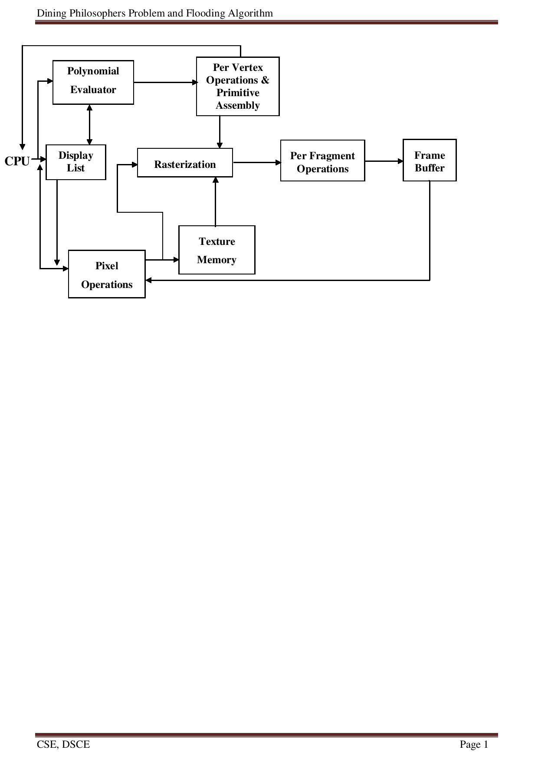

**Figure 1.1 OpenGL Architecture**

This is the most important diagram we see, representing the flow of graphical information, as it is processed from CPU to the frame buffer.

There are two pipelines of data flow. The upper pipeline is for geometric, vertex-based primitives. The lower pipeline is for pixel-based, image primitives. Texturing combines the two types of primitives together.

**1.3 OpenGL as a Renderer**

**1.3.1 Geometric primitives**

* Points, lines and polygons.

**1.3.2 Image primitives**

* Images and bitmaps.
* Separate pipeline for images and geometry.
* Linked through texture mapping.
  + 1. **Rendering depends on state**
* Colors, materials, light sources, etc.

As mentioned, OpenGL is a library for rendering computer graphics. Generally, there are two operations that we do with OpenGL:

* Draw objects.
* Change the state of how OpenGL plots.

OpenGL has two types of things that it can render: geometric primitives and image primitives. *Geometric primitives* are points, lines and polygons. *Image primitives* are bitmaps and graphics images(i.e. the pixels that you might extract from a JPEG image after you’ve read into your program.)

Additionally, OpenGL links image and geometric primitives together using *texture mapping,* which is an advanced topic that we will discuss.

The other common operation that we do with OpenGL is *setting state.* ”Setting state” is the process of initializing the internal data that OpenGL uses to render our primitives. It can be as simple as setting up the size of points and color that we want a vertex to be, to initializing multiple bitmap levels for texture mapping.

**1.4 OpenGL and Related APIs**

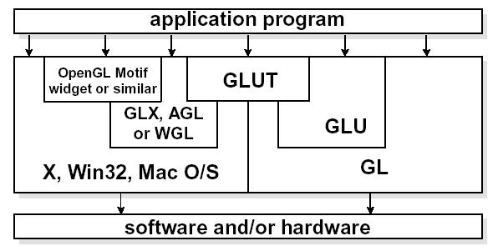

**Figure 1.2 OpenGL and Related APIs**

The above diagram illustrates the relationships of the various libraries and window system components.

Generally, applications which require more user interface support will use a library designed to support those types of features (i.e. buttons, menu and scroll bars, etc.) such as Motif or the Win32 API.

**1.5 OpenGL CONTRIBUTIONS**

It is very popular in the video games development industry where it competes with Direct3D (on Microsoft Windows).OpenGL is also used in CAD, virtual reality, and scientific visualization programs. OpenGL is very portable. It will run for nearly every platform in existence, and it will run well. It even runs on Windows NT 4.0 etc. The reason OpenGL runs for so many platforms is because of its Open Standard.

OpenGL has a wide range of features, both in its core and through extensions. Its extension feature allows it to stay immediately current with new hardware features, despite the mess it can cause.

* 1. **LIMITATIONS of OpenGL**
* OpenGL is case sensitive.
* Line Color, Filled Faces and Fill Color not supported.
* Bump mapping is not supported.
* Shadow plane is not supported
* Navigation Renderer is not supported.
* 3D measurement is not supported.
* Streaming of individual 3D objectives is not supported.

**1.7 Problem Statement**

To create an OpenGL project on “**Dining Philosophers Problem & Flooding Algorithm”.** We had to emulate the dining philosophers problem and the flooding algorithm, in a manner, which can be used effectively for better understanding of the concepts of computer science.

**1.8 Objective of the project**

To make the problem statements better understandable using OpenGL graphics. The main objective of the project is to simplify the understanding of concepts pertaining to the applications of computer science & engineering.

**2. REQUIREMENT SPECIFICATION**

The graphics editor has been programmed in C. It makes use of Turbo C Graphics library package for creating the user interface. This is a subroutine library for terminal independent screen painting and input event handling. **Class of user:** Any user with prior experience of working in any editor.

**2.1 Software Requirements**

* Code::Block 20.03
* OpenGL package:glut-3.7.6-bin(this consists of glut.h,glut32.lib,glut32.dll)
* Window Installer 3.1(KB893803)
  1. **Hardware Requirements**
* 512MB RAM and other as required for Code::Block 20.03
* 40GB Hard Disk.
* VGA graphics card
* Pentium 4 Processor
* The minimum hardware requirements for .Net 3.0

**3.FLOW DIAGRAM**

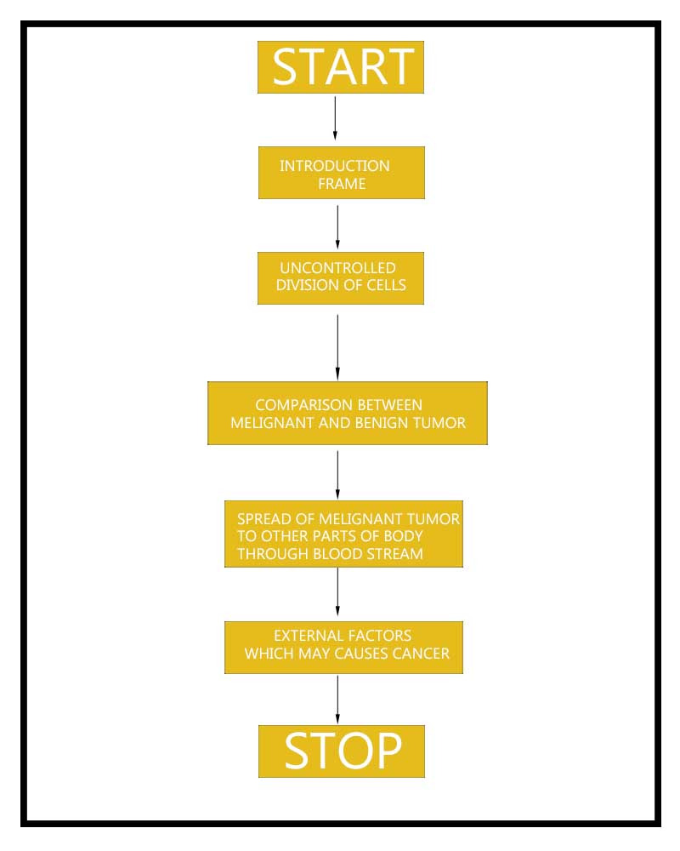

**4.FLOW ANALYSIS**

1. The program execution starts with the introduction page. The viewer can continue by pressing 'c' key to go to starting frame.
2. On pressing the key, the next page is displayed the first frame.
3. Viewer can press 'a' to see the animation of uncontrolled cell division.
4. After the animation press c to go next scene of next stage of cancer and its types.
5. Now user can press 'c' for third frame in which in the melignant tumor cells travel in blood vessels which leads in spreading of cancer in other parts of the body.
6. Now press 'c' for next frame to go to last frame which shows us different causes of cancer .

**5. IMPLEMENTATION**

**3.1 Built-In-Functions**

**OpenGL Program Utilities**

**glutInit()**

The first thing we need to do is call the “glutInit()” procedure. It should be called before any other GLUT routine because it initializes the GLUT library. The parameters to “glutInit()” should be the same as those to the main(), specifically “main(int argc, char** argv)” and “glutInit(&argc, argv)” .

**glutInitDisplayMode()**

The next thing we need to do is call the “glutInitDisplayMode()” procedure to specify the display mode for a window. We must first decide whether we want to use the RGBA (GLUT_RGBA) or color-index (GLUT-INDEX) color model. The RGBA mode stores its color buffers as red, green, blue and an alpha color components. The fourth color component, alpha, corresponds to the notion of opacity. An alpha value of 0.0 gives complete transparency. Color-index mode, in contrast, stores color buffers in 0.0 indices.

Another decision we need to make when setting up the display mode is whether we want to use single buffer (GLUT_SINGLE) or double buffer(GLUT_DOUBLE).Applications that use both front and back color buffers use double-buffer.

**glutInitWindowSize() and glutInitWindowPosition()**

We need to create the characteristics of our window. A call to “glutInitWindowSize()”, will be used to specify the size, in pixels, of our initial window. The arguments indicate the height and width (in pixels) of the desired window. Similarly, “glutInitWindowPosition()” is used to specify the screen location for the upper-left corner of our window. The arguments, x and y, indicate the location of the window relative to the entire display.

**glutCreateWindow()**

To actually create a window, with the previously set characteristics (display mode, size, location, etc.), the programmer uses the “glutCreateWindow( )” function. It takes a string as a parameter, which appears in the tittle bar of the window that we desire. The window is not actually displayed until the “glutMainLoop( )” is called.

**glutDisplayFunc()**

The glutDisplayFunc() procedure is the first and most important event callback function. A callback function is one where a programmer-specified routine can be registered to be called in response to a specific type of event.

**glutMainLoop()**

For the code to run, we must call “glutMainLoop()”. All windows that have been created can now be shown, and rendering the windows is now effective. The program will now be able to handle events as they occur (mouse clicks, windows resizing, etc.). In addition, the registered display callback (from our “glutDisplayFunc()”) is triggered. Once this loop is entered, it never exits!

**glClearColor( ) and glClear()**

Drawing on a computer screen is different from drawing on paper, in the way that the paper starts out white, and all that we have to do is draw the picture. On the computer, the memory holding the picture is usually filled with the last picture we draw, so we typically need to clear it to some background color before we start drawing the new scene. To change the background color, we call and specify the color we select for the background. The default clearing color is (0,0,0, 0) which is black. A subsequent call to “glClear()” will clear the specified buffers to their current clearing values. To clear the color buffer,we use the argument “GL_COLOR_BUFFER_BIT”.

**Viewing Transformation**

**glLoadIdentity()**

To start with, we will initialize the viewing matrix by loading it with the identity matrix, using the command “glLoadIdentity()”, and continue to combine it with new matrices according to where we want to place the “camera”.

**Projection**

Specifying the projection transformation is like choosing a lens for a camera. We can think of this transformation as determining the field of view and therefore which objects are inside it and, to some extent, how they should look. There are two basic types of projections provided for us by OpenGL, orthographic and perspective, respectively.

**glFrustum(),glMatrixmode()**

1. **Perspective:**

We will use the perspective projection to get a more realistic rendering of an object. The object(s) will have the unmistakable characteristic of foreshortening: the further an object is from the camera, the smaller it appears in the final image. This is because the viewing volume of perspective projection is a

frustum (a truncated pyramid whose top has been cut off by a plane parallel to its base). The command to define this frustum is “glFrustum()”, which takes the values for left, right, top, bottom, near and far edges. The same set of functions to set the projection transformation, but instead of using the “glOrtho( )” function, the “glFrustum( )” function is given.

**Translation:** The translation function “glTranslate( )” multipliesthe current matrix by a matrix that moves (translates) an object by the given x, y, and z values (or moves the local coordinate system by the same amounts).

**3.2 User Defined Functions**

**void setBackgroundColor();**

**void frame0();**

This displays introduction scene. It contains name of the developers and small information

**void frame1();**

This displays 1st scene. It contains bunch of normal cell and upon pressing 'a' key displays un controlled division of cells

**void frame2();**

This displays 2nd scene. It shows two types of cancer cells

**void frame3();**

This displays 3rd scene. It is a extension of 1st scene. It shows spreading of melignant tumor cells

**void frame4();**

This displays 4th scene. It shows causes of cancer.

**void output(int, int ,const char *);**

This function is used to write English characters on the scene.

**void verticleLine(int ,int ,int );**

Draws vertical line on the screen.

**void hexagonCancer(int ,int);**

Draws hexagon shaped cells affected by cancer.

**void drawCircle(GLfloat , GLfloat , GLfloat,int ,int ,int );**

Draws circle on the screen

**void drawCircleCancer(GLfloat , GLfloat , GLfloat,int ,int ,int );**

Draws circle shaped cancer cells.

**void drawFilledCircle(GLfloat , GLfloat , GLfloat);**

Draws circle which is filled. Filling the whole object by the color mentioned.

**void drawHollowCircle(GLfloat , GLfloat , GLfloat,int ,int ,int );**

Draws just hollow circle which signifies the nucleus of the cell.

**void CellCancer(int,int);**

The collection of many objects of a cancer into one cell.

**void cell(int,int);**

Draws a cell which in turn calls many functions to draw a cell object

**void cancerCellM(int,int);**

Draws cancer cells of Melignant type.

**void cancerCellB(int,int) ;**

Draws cancer cell of Begnign type

**void melignant();**

Draws one melignant type cancer cell.

**void secondSet();**

Draws collection of Melignant type cancer cell on the right side of the 2nd scene.

**void firstSet();**

Draws collection of Benign type cancer cell on the left side of the 2nd scene.

**void humanBody();**

Draws a representation of human body.

**void blobAnimation();**

This animates the cancer blob when melignant type travel in blood vessels to spread across the body.

**void bloodVessel();**

Draws enlarged scale cross section of a blood vessel on right.

**void normalCells();**

Draws normal cells which are not cancer affected.

**void DrawEllipse(float, float,int,int);**

Draws a simple ellipse to form part structure of a cell.

**void hexagon(int,int);**

Draws a simple hexagon.

**void horzontalLine(int,int,int);**

Draws a simple horizontal line

**void drawGlass();**

Draws a glass which represents a alcohol glass.

**void drawCig();**

Draws a single of cigarette buds.

**void drawCigs();**

Draws collection of cigarette buds

**void drawSun();**

draws sun in the scene

**void drawFan();**

draws a fan shaped object which represents radio active ratiation

**voidArrow(GLdouble,Gldouble,Gldouble,Gldouble,Gldouble,GLdouble ,GLdouble );**

Draws arrow to point to different objects which represent the causes of cancer.

**void cancerCell(int ,int);**

Draws a simple cancer cell

1. **SOURCE CODE**

#include<GL/glut.h>

#include<stdio.h>

#include<stdlib.h>

#include <math.h>

#include<string.h>

#define DEG2RAD 3.14159/180.0

float hexagon_r=20;

float op=0;

float hexagon_dx,hexagon_dy,hexagon_gx,hexagon_gy;

#define RADPERDEG 0.0174533

double theta=0;

int frameNumber =0;

int f=0,a=0,b=0,c=0,d=0;

void *fonts[] = { GLUT_BITMAP_9_BY_15,

GLUT_BITMAP_TIMES_ROMAN_10,

GLUT_BITMAP_TIMES_ROMAN_24,

GLUT_BITMAP_HELVETICA_18,

GLUT_BITMAP_HELVETICA_12 };

typedef struct Point {

GLfloat x;

GLfloat y;

} Point;

float yLocation = 0.0f;

float bloby=0,blobx=0,cx1=0,cy1=0,cx2=0,cy2=0;

int c0=0,c1=0,c2=0,c3=0;

void init();

void draw_hexagon(float,float);

void drawCircle(float, float , float , int);

void drawCancerCells(float,float,int,int);

void setBackgroundColor();

void frame0();

void frame1();

void frame2();

void frame3();

void frame4();

void output(int, int ,const char *);

void verticleLine(int ,int ,int );

void hexagonCancer(int ,int);

void drawCircle(GLfloat , GLfloat , GLfloat,int ,int ,int );

void drawCircleCancer(GLfloat , GLfloat , GLfloat,int ,int ,int );

void drawFilledCircle(GLfloat , GLfloat , GLfloat);

void drawHollowCircle(GLfloat , GLfloat , GLfloat,int ,int ,int );

void CellCancer(int,int);

void cell(int,int);

void cell(int ,int ,int );

void cancerCellM(int,int);

void cancerCellB(int,int) ;

void melignant();

void secondSet();

void firstSet();

void humanBody();

void blobAnimation();

void bloodVessel();

void normalCells();

void cellanimation1();

void DrawEllipse(float, float,int,int);

void hexagon(int,int);

void horzontalLine(int,int,int);

void drawGlass();

void drawCig();

void drawCigs();

void drawSun();

void drawFan();

void Arrow(GLdouble,GLdouble,GLdouble,GLdouble,GLdouble ,GLdouble ,GLdouble );

void cancerCell(int ,int);

void drawBitmapText(const char *string, void *font,float x,float y){

int len, i;

glRasterPos2f(x, y);

len = (int)strlen(string);

for (i = 0; i<len; i++)

{

glutBitmapCharacter(font, string[i]);

}

}

void frame0(){

setBackgroundColor();

glColor3f(0.545098039, 0.211764705, 0.149019607);

drawBitmapText( "Cancer Awarness", fonts[2],0, 280);

glColor3f(0.545098039, 0.270588235, 0.074509803);

drawBitmapText("SUBMITTED BY", fonts[0],15, 180 );

glColor3f(0.545098039, 0.270588255, 0.0);

drawBitmapText( "Abhishek Kori", fonts[3],-50, 100);

drawBitmapText( "Diksha Kushwaha", fonts[3],-50, 10);

glColor3f(0.545098039, 0.270588255, 0.0);

drawBitmapText( "1DS13CS007", fonts[0],120, 100);

drawBitmapText( "1DS13CS034", fonts[0],120, 10);

glColor3f(0.545098039, 0.270588235, 0.074509803);

drawBitmapText( " Press c to continue", fonts[0],-10, -100);

}

void frame2(){

glClear(GL_COLOR_BUFFER_BIT);

setBackgroundColor();

firstSet();

secondSet();

output(-150,400,"BENIGN TUMOR");

verticleLine(-100,380,150);

if(op<=0.3)

{

op+=0.008;

}else{

output(250,400,"MELIGNANT TUMOR");

verticleLine(320,380,250);

}

}

void frame3(){

humanBody();

blobAnimation();

bloodVessel();

normalCells();

cellanimation1();

}

void setBackgroundColor(){

glBegin(GL_POLYGON);

glColor3f(.9492f, .9255f, .8745f );

glVertex2f(-499,-499);

glVertex2f(499,-499);

glColor3f(1.0,1.0,1.0);

glVertex2f(499,499);

glVertex2f(-499,499);

glEnd();

glFlush();

}

void frame4(){

glColor3f( .725f, .933f, .871f);

// drawGlass(0,0,0);

int x, y;

x=350;

y=250;

glColor3f( .725f, .933f, .871f);

// drawGlass(0,0,0);

double radius=85;

glPushMatrix();

glScalef(1,1.4,1);

drawFilledCircle(450-x,480-y+25,radius);

drawFilledCircle(250-x+10,420-y,radius);

drawFilledCircle(650-x-10,420-y,radius);

drawFilledCircle(100-x+40,290-y-10,radius);

drawFilledCircle(800-x-40,290-y-10,radius);

glPopMatrix();

//drawing glass

glPushMatrix();

glTranslated(100-x+40,275-y-10,0);

glScalef(5,5.5,1);

drawGlass();

glPopMatrix();

//drawing sun

glPushMatrix();

glTranslated(250-x+10,420-y+70,0);

glScalef(1,1.5,1);

glRotated(-frameNumber*.9,0,0,1);

drawSun();

glPopMatrix();

//drawing cigarette

glPushMatrix();

glTranslated(385-x,455-y+100,0);

glScaled(2,5,1);

drawCigs();

glPopMatrix();

//drawing fan

glPushMatrix();

glTranslated(800-x-40,290-y-10,0);

glRotated(-frameNumber*.9,0,0,1);

glScaled(90,100,0);

drawFan();

glPopMatrix();

//print asbest

glPushMatrix();

//glScaled(2,2,0);

glTranslated(600-x-10,410-y+70,0);

drawBitmapText("ASBEST",fonts[2],1,1);

glPopMatrix();

//draw arrow

glPushMatrix();

glScalef(.5,.5,0);

glTranslated(150-x,-(y+70),0);

Arrow(400,120,0,90,290,0,8);

glPopMatrix();

glColor3f(0.545098039, 0.211764705, 0.149019607);

drawBitmapText( "Drinking a lot of alcohol,too much sun exposure,smoking,", fonts[2],-160, -180);

drawBitmapText( "carcinogens like asbestos or radioactive radiations", fonts[2],-130, -210);

}

void bloodVessel()

{

//blood vessel cross section start

glPushMatrix();

glBegin(GL_POLYGON);

glColor3f(1,0,0);

glVertex2f(300,200); //1

glVertex2f(310,20);

glVertex2f(270,-150); //2

glVertex2f(230,-300);

glVertex2f(290,-300); //3

glVertex2f(330,-150);

glVertex2f(350,20); //4

glVertex2f(360,200);

glVertex2f(410,300); //5

glVertex2f(460,330);

glVertex2f(510,350); //6

glVertex2f(510,430);

glVertex2f(400,360); //7

glVertex2f(360,320);

glVertex2f(300,500); //8

glVertex2f(180,500);

glEnd();

glPopMatrix();

glPushMatrix();

glBegin(GL_LINE_LOOP);

glColor3f(0,0,0);

glVertex2f(300,200); //1

//glVertex2f(310,20);

//glVertex2f(270,-150); //2

glVertex2f(230,-300);

glVertex2f(290,-300); //3

glVertex2f(330,-150);

glVertex2f(350,20); //4

glVertex2f(360,200);

glVertex2f(395,270); //5

//glVertex2f(460,330);

glVertex2f(510,350); //6

glVertex2f(510,430);

glVertex2f(400,360); //7

glVertex2f(360,320);

glVertex2f(300,500); //8

glVertex2f(180,500);

glEnd();

glPopMatrix();

glPushMatrix();

glColor3f(0,0,0);

output(30,-100,"BLOOD VESSEL");

horzontalLine(175,300,-90);

output(30,450,"MELIGNANT");

glPopMatrix();

}

void cell(int x,int y,int r){

hexagon(x,y);

drawCircle(x,y,r,1,0,0);

//drawCircle(x+10,y+5,10,1,0.5,0);

}

void init(){

glEnable(GL_BLEND);

glBlendFunc(GL_SRC_ALPHA, GL_ONE_MINUS_SRC_ALPHA);

glClearColor(1,1,1,1);

glMatrixMode(GL_PROJECTION);

glLoadIdentity();

gluOrtho2D(-300,500,-300,500);

}

void keyboard(GLubyte key, GLint x, GLint y){

switch(key){

case 'c':f++;

glutPostRedisplay();break;

case 'a':if(f==1){

d=1;

}

}

}

void initialize(){

hexagon_dx=hexagon_r*cos(30.0*M_PI/180.0);

hexagon_dy=hexagon_r*sin(30.0*M_PI/180.0);

hexagon_gx=2.0*hexagon_dx;

hexagon_gy=2.0*hexagon_dx*sin(60.0*M_PI/180.0);

// printf("%d %d %d %d\n",hexagon_dx,hexagon_dy,hexagon_gx,hexagon_gy );

}

void drawFilledCircle(GLfloat x, GLfloat y, GLfloat radius){

int i;

int triangleAmount = 20; //# of triangles used to draw circle

//GLfloat radius = 0.8f; //radius

GLfloat twicePi = 2.0f * M_PI;

glBegin(GL_TRIANGLE_FAN);

glVertex2f(x, y); // center of circle

for(i = 0; i <= triangleAmount;i++) {

glVertex2f(

x + (radius * cos(i * twicePi / triangleAmount)),

y + (radius * sin(i * twicePi / triangleAmount))

);

}

glEnd();

}

void draw_hexagon(float x,float y){

glBegin(GL_LINE_LOOP);

glVertex2f(x-hexagon_dx,y-hexagon_dy);

glVertex2f(x-hexagon_dx,y+hexagon_dy);

glVertex2f(x ,y+hexagon_r );

glVertex2f(x+hexagon_dx,y+hexagon_dy);

glVertex2f(x+hexagon_dx,y-hexagon_dy);

glVertex2f(x ,y-hexagon_r );

glEnd();

//glFlush();

drawCircle(x,y,4.0,20);

}

void drawCancerCell(float x,float y,float dx,float dy)

{

// int r =( rand() % 20)/10.0f;

glColor3f(0.831f,0.608f,0.627f);

glBegin(GL_POLYGON);

glVertex2f(x-hexagon_dx-2*dx,y-hexagon_dy+dy);

glVertex2f(x-hexagon_dx+dx,y+hexagon_dy+dy);

glVertex2f(x +dx ,y+hexagon_r );

glVertex2f(x+hexagon_dx-dx,y+hexagon_dy-dy);

glVertex2f(x+hexagon_dx-dx,y-hexagon_dy+dx);

glVertex2f(x ,y-hexagon_r );

glEnd();

glColor3f(0.612f,0.220f,0.290f);

glBegin(GL_LINE_LOOP);

glVertex2f(x-hexagon_dx-2*dx,y-hexagon_dy+dy);

glVertex2f(x-hexagon_dx+dx,y+hexagon_dy+dy);

glVertex2f(x +dx ,y+hexagon_r );

glVertex2f(x+hexagon_dx-dx,y+hexagon_dy-dy);

glVertex2f(x+hexagon_dx-dx,y-hexagon_dy+dx);

glVertex2f(x ,y-hexagon_r );

glEnd();

glColor3f(0.596f,0.537f,0.494f);

drawFilledCircle(x,y,4);

glFlush();

}

void drawCancerCells(float x,float y,int ni,int nj){

int i,j; float x0,shiftP=2.0;

float x1,y1;

x-=((float)(ni-1))*hexagon_gx*0.5; // just shift x,y to start position (i=0,j=0)

x-=((float)(nj-1))*hexagon_dx*0.5;

y-=((float)(nj-1))*hexagon_gy*0.5;

x1=x+15*hexagon_gx*0.5,y1=y+9*hexagon_gx*0.5;

glColor3f(1.0,1.0,0.0);

shiftP+=2;

/* cancer cells are drawn here

add amination here*/

for (x0=x1,j=5; j<nj-2; j++){

for (i=5; i<ni-2; i++){

float dx[]= {2,3,1,2,3,4,5,6};

float dy[]={7,4,5,3,2,5,7,8,3,2,3};

drawCancerCell(x1,y1,dx[j-5],dy[j-5]);

x1+=hexagon_gx+shiftP-.3*i;

}

x0+=hexagon_dx+shiftP +.5*i;

x1=x0+shiftP;

y1+=hexagon_gy+shiftP;

}

}/*

void Timer(int iUnused)

{

//glutPostRedisplay();

drawCancerCells(-100,-100,10,10);

glutTimerFunc(90, Timer, 0);

}*/

void humanBody(){

glColor3f(1,0.87,0.77);

glPushMatrix();

glRotatef(-10,0,0,1);

DrawEllipse(10,50,0,0); //left leg

glPopMatrix();

glPushMatrix();

glRotatef(10,0,0,1);

DrawEllipse(10,50,25,-7); //right leg

glPopMatrix();

DrawEllipse(20,50,12,70); //center torso

glPushMatrix();

glRotatef(60,0,0,1);

DrawEllipse(40,10,60,55); // left arm

glPopMatrix();

glPushMatrix();

glRotatef(-60,0,0,1);

DrawEllipse(40,10,-50,75);// right arm

glPopMatrix();

DrawEllipse(15,25,12,135); //head

glPushMatrix();

glColor3f(1,0,0);

glBegin(GL_LINES);

glVertex2f(12,30); // center blood vessel

glVertex2f(12,120);

glVertex2f(12,118); // left line

glVertex2f(-8,90);

glVertex2f(-8,90); // left arm

glVertex2f(-30,60);

glVertex2f(12,118); // right vessel

glVertex2f(50,65);

glVertex2f(12,35); // right down blood vessel

glVertex2f(25,10);

glVertex2f(25,10); // right down calf blood vessel

glVertex2f(30,-20);

glVertex2f(12,35); // left down blood vessel

glVertex2f(2,10);

// left down blood vessel

glVertex2f(2,10);

glVertex2f(-5,-30);

glEnd();

}

void blobAnimation(){

//glPopMatrix();

//glPushMatrix();

glColor3f(1,0,0);

glTranslatef(blobx,bloby,0);

DrawEllipse(5,5,10,35);

glPopMatrix();

//update();

if(c0<31)

{

bloby+=0.5*5;

c0++;

}else if(c1<7)

{

bloby-=0.7*5;

blobx-=0.5*5;

c1++;

}else{

glPushMatrix();

glColor3f(0.5,0,0);

//glTranslatef(blobx,bloby,0);

DrawEllipse(5,5,blobx+9,bloby+35);

glPopMatrix();

glColor3f(0,0,0);

output(-270,70,"New tumour");

output(-270,40,"METASTASIS");

horzontalLine(-110,-15,85);

glPopMatrix();

}

}

void horzontalLine(int Lx1,int Lx2,int Ly){

glBegin(GL_LINES);

glVertex2f(Lx1,Ly);

glVertex2f(Lx2,Ly);

glEnd();

}

void DrawEllipse(float radiusX, float radiusY,int posx,int posy)

{

int i;

glBegin(GL_POLYGON);

for(i=0;i<360;i++)

{

float rad = i*DEG2RAD;

glVertex2f(posx+cos(rad)*radiusX,

posy+sin(rad)*radiusY);

}

glEnd();

}

void drawHollowCircle(GLfloat x, GLfloat y, GLfloat radius,int r,int g,int b){

int i;

int lineAmount = 100; //# of triangles used to draw circle

//GLfloat radius = 0.8f; //radius

GLfloat twicePi = 2.0f * 3.14;

glColor3f(r,g,b);

glBegin(GL_POLYGON);

for(i = 0; i <= 300;i++) {

glVertex2f(

x + (radius * cos(i * twicePi / lineAmount)),

y + (radius* sin(i * twicePi / lineAmount))

);

}

glEnd();

}

void cancerCell(int x,int y){

int r=15,R=1,G=1,B=0;

drawHollowCircle(x,y,r,R,G,B);

drawHollowCircle(x+15,y,r,R,G,B);

drawHollowCircle(x+5,y-15,r,R,G,B);

drawHollowCircle(x+13,y-3,r,R,G,B);

drawHollowCircle(x,y+16,r,R,G,B); // nucleus

drawHollowCircle(x+3,y,5,0,1,1);

}

void cellanimation1(){

// int x1=0,y1=0,ctr1=0,ctr2=0;

glPushMatrix();

glTranslatef(cx1,cy1,0);

cancerCell(300,100);

cancerCell(335,120);

glPopMatrix();

glPushMatrix(); // second set of cells

glTranslatef(cx2,cy2,0);

cancerCell(330,35);

cancerCell(320,0);

glPopMatrix();

if(c2<15)

{

cy1+=0.5*15;

cx1+=0.08*15;

c2++;

}

else if(c2<835){

cy1+=0.5*15;

cx1-=0.15*15;

c2++;

}

if(c3<47){

cy2+=0.5*10;

cx2+=0.01*10;

c3++;

}else if(c3<30){

cy2+=0.69*15;

cx2+=0.45*15;

c3++;

}else if(c3<700){

cy2+=0.50*15;

cx2+=0.70*15;

c3++;

}

}

void normalCells(){

cell(80,30,5);

cell(80,65,5);

cell(135,65,5);

cell(170,65,5);

cell(195,65,5);

cell(265,85,5);

cell(280,120,5);

cell(100,100,5);

cell(130,130,5);

cell(160,160,5);

cell(190,190,5);

cell(220,220,5);

cell(260,240,5);

cell(170,105,5);

cell(215,145,5);

cell(100,185,5);

cell(110,215,5);

cell(120,255,5);

for(int i=0;i<7;i++)

{

cell(100+(i*35),0,5);

}

}

void draw_hexagon_grid(float x,float y,int ni,int nj){

int i,j; float x0,shiftP=2.0;

x-=((float)(ni-1))*hexagon_gx*0.5; // just shift x,y to start position (i=0,j=0)

x-=((float)(nj-1))*hexagon_dx*0.5;

y-=((float)(nj-1))*hexagon_gy*0.5;

//x1=x+15*hexagon_gx*0.5,y1=y+9*hexagon_gx*0.5;

for (x0=x,j=0;j<nj;j++,x0+=hexagon_dx+shiftP,x=x0+shiftP,y+=hexagon_gy+shiftP)

for (i=0;i<ni;i++,x+=hexagon_gx+shiftP){

draw_hexagon(x,y);

}

/* x-=((float)(ni-1))*hexagon_gx*0.5; // just shift x,y to start position (i=0,j=0)

x-=((float)(nj-1))*hexagon_dx*0.5;

y-=((float)(nj-1))*hexagon_gy*0.5;*/

}

void display(){

glClear(GL_COLOR_BUFFER_BIT);

glColor3f(0.5, 0.0, 0.0);

//setBackgroundColor();

switch (f) {

case 0:frame0();break;

case 1: frame1();break;

break;

case 2: if(c==0) {op=0;c++;}

frame2();break;

case 3:

if(b==0)

{

yLocation = 0.0f;

bloby=0,blobx=0,cx1=0,cy1=0,cx2=0,cy2=0;

c0=0,c1=0,c2=0,c3=0;

b=1;

}

frame3();

break;

case 4:

if(a==0){

frameNumber=0;

a=1;

}

frame4();break;

// default:printf("boo"); /* value */:

}

// glFlush();

glutSwapBuffers();

}

void frame1(){

int c1=0;

draw_hexagon_grid(-10,-10,10,10);

if(d==1)

{

drawCancerCells(-10,-10,10,10);

}

}

void drawCircle(float cx, float cy, float r, int num_segments){

glBegin(GL_LINE_LOOP);

for(int ii = 0; ii < num_segments; ii++)

{

float theta = 2.0f * 3.1415926f * (float)ii / (float)(num_segments);//get the current angle

float x = r * cosf(theta);//calculate the x component

float y = r * sinf(theta);//calculate the y component

glVertex2f(x + cx, y + cy);//output vertex

}

glEnd();

}

void hexagon(int x,int y){

float rad;

float hexagon_r=20;

float hexagon_dx=hexagon_r*cos(30.0*M_PI/180.0);

float hexagon_dy=hexagon_r*sin(30.0*M_PI/180.0);

float hexagon_gx=2.0*hexagon_dx;

float hexagon_gy=2.0*hexagon_dx*sin(60.0*M_PI/180.0);

glColor3f(0,0.8,0);

glBegin(GL_POLYGON);

glVertex2f(x-hexagon_dx,y-hexagon_dy);

glVertex2f(x-hexagon_dx,y+hexagon_dy);

glVertex2f(x ,y+hexagon_r );

glVertex2f(x+hexagon_dx,y+hexagon_dy);

glVertex2f(x+hexagon_dx,y-hexagon_dy);

glVertex2f(x ,y-hexagon_r );

glEnd();

}

void output(int x, int y,const char *string){

//char string[100]="GLUT_BITMAP_TIMES_ROMAN_10";

int len, i;

glRasterPos2f(x, y);

len = (int)strlen(string);

for (i = 0; i<len; i++)

{

glutBitmapCharacter(GLUT_BITMAP_TIMES_ROMAN_24,string[i]);

}

}

void verticleLine(int x,int y1,int y2){

glBegin(GL_LINES);

glVertex2f(x,y1);

glVertex2f(x,y2);

glEnd();

}

void hexagonCancer(int x,int y){

float rad;

float hexagon_r=15;

float hexagon_dx=hexagon_r*cos(30.0*M_PI/180.0)-5;

float hexagon_dy=hexagon_r*sin(30.0*M_PI/180.0)+2;

float hexagon_gx=2.0*hexagon_dx;

float hexagon_gy=2.0*hexagon_dx*sin(60.0*M_PI/180.0)+10;

glColor3f(1,0.5,0);

glBegin(GL_POLYGON);

glVertex2f(x-hexagon_dx,y-hexagon_dy);

glVertex2f(x-hexagon_dx,y+hexagon_dy);

glVertex2f(x ,y+hexagon_r );

glVertex2f(x+hexagon_dx,y+hexagon_dy);

glVertex2f(x+hexagon_dx,y-hexagon_dy);

glVertex2f(x ,y-hexagon_r );

glEnd();

}

void drawCircle(GLfloat x, GLfloat y, GLfloat radius,int r,int g,int b){

int i;

int lineAmount = 100; //# of triangles used to draw circle

//GLfloat radius = 0.8f; //radius

GLfloat twicePi = 2.0f * 3.14;

glColor3f(r,g,b);

glBegin(GL_POLYGON);

for(i = 0; i <= 300;i++) {

glVertex2f(

x + (radius * cos(i * twicePi / lineAmount)),

y + (radius* sin(i * twicePi / lineAmount))

);

}

glEnd();

}

void drawCircleCancer(GLfloat x, GLfloat y, GLfloat radius,int r,int g,int b){

int i;

int lineAmount = 100; //# of triangles used to draw circle

//GLfloat radius = 0.8f; //radius

GLfloat twicePi = 2.0f * 3.14;

glColor4f(r,g,b,op);

glBegin(GL_POLYGON);

for(i = 0; i <= 300;i++) {

glVertex2f(

x + (radius * cos(i * twicePi / lineAmount)),

y + (radius* sin(i * twicePi / lineAmount))

);

}

glEnd();

}

void CellCancer(int x,int y){

hexagonCancer(x,y);

drawCircle(x,y,2,1,0,0);

}

void cell(int x,int y){

hexagon(x,y);

drawCircle(x,y,5,1,0,0);

//drawCircle(x+10,y+5,10,1,0.5,0);

}

void cancerCellM(int x,int y){

drawCircleCancer(20+x,10+y,13,1,1,0);

drawCircleCancer(35+x,10+y,13,1,1,0);

drawCircleCancer(30+x,20+y,10,1,1,0);

drawCircleCancer(20+x,25+y,13,1,1,0);

drawCircleCancer(15+x,10+y,10,1,1,0);

drawCircleCancer(23+x,14+y,5,1,0,0);

}

void cancerCellB(int x,int y){

drawCircle(20+x,10+y,13,1,1,0);

drawCircle(35+x,10+y,13,1,1,0);

drawCircle(30+x,20+y,10,1,1,0);

drawCircle(20+x,25+y,13,1,1,0);

drawCircle(15+x,10+y,10,1,1,0);

drawCircle(23+x,14+y,5,1,0,0);

}

void melignant(){

cancerCellM(230,100);

cancerCellM(210,140);

cancerCellM(174,170);

cancerCellM(170,215);

cancerCellM(195,255);

cancerCellM(230,280);

cancerCellM(270,270);

cancerCellM(290,230);

cancerCellM(275,120);

cancerCellM(300,160);

}

void secondSet(){

for(int i=0;i<5;i++)

{

hexagon(100+(i*30),100);

drawCircle(100+(i*30),100,5,1,0,0);

}

for(int i=0;i<4;i++)

{

hexagon(110+(i*30),140);

drawCircle(110+(i*30),140,5,1,0,0);

}

for(int i=0;i<3;i++)

{

hexagon(100+(i*30),180);

drawCircle(100+(i*30),180,5,1,0,0);

}

for(int i=0;i<2;i++)

{

hexagon(100+(i*30),220);

drawCircle(100+(i*30),220,5,1,0,0);

}

for(int i=0;i<4;i++)

{

hexagon(80+(i*30),260);

drawCircle(80+(i*30),260,5,1,0,0);

}

for(int i=0;i<5;i++)

{

hexagon(100+(i*30),310);

drawCircle(100+(i*30),310,5,1,0,0);

}

melignant();

glPushMatrix();

CellCancer(230,200);

CellCancer(250,200);

glPopMatrix();

glPushMatrix();

CellCancer(280,220);

CellCancer(270,180);

glPopMatrix();

glPushMatrix();

CellCancer(230,250);

CellCancer(290,170);

glPopMatrix();

glPushMatrix();

CellCancer(250,240);

CellCancer(270,150);

glPopMatrix();

//cell(265,250);

// hexagon(230,100);

// hexagon(210,140);

// hexagon(174,170);

// hexagon(170,215);

// hexagon(195,255);

// hexagon(230,280);

// hexagon(270,270);

// hexagon(290,230);

// hexagon(275,120);

// hexagon(300,160);

}

void firstSet(){

for(int i=0;i<5;i++)

{

hexagon(-250+(i*30),310);

drawCircle(-250+(i*30),310,5,1,0,0);

}

for(int i=0;i<4;i++)

{

hexagon(-250+(i*30),260);

drawCircle(-250+(i*30),260,5,1,0,0);

}

for(int i=0;i<3;i++)

{

hexagon(-250+(i*30),220);

drawCircle(-250+(i*30),220,5,1,0,0);

}

for(int i=0;i<2;i++)

{

hexagon(-250+(i*30),170);

drawCircle(-250+(i*30),170,5,1,0,0);

}

for(int i=0;i<2;i++)

{

hexagon(-250+(i*30),130);

drawCircle(-250+(i*30),130,5,1,0,0);

}

for(int i=0;i<2;i++)

{

hexagon(-250+(i*30),90);

drawCircle(-250+(i*30),90,5,1,0,0);

}

for(int i=0;i<4;i++)

{

hexagon(-250+(i*30),40);

drawCircle(-250+(i*30),40,5,1,0,0);

}

for(int i=0;i<5;i++)

{

hexagon(-250+(i*30),0);

drawCircle(-250+(i*30),0,5,1,0,0);

}

cell(-90,10);

cell(-60,40);

cell(-45,80);

cell(-85,290);

cell(-65,250);

cell(-45,220);

cancerCellB(-130,65);

cancerCellB(-170,90);

cancerCellB(-170,140);

cancerCellB(-140,160);

cancerCellB(-150,110);

cancerCellB(-130,120);

cancerCellB(-100,130);

}

void drawHollowElipse(GLfloat x, GLfloat y, GLfloat radiusx,GLfloat radiusy){

int i;

int lineAmount = 100; //# of triangles used to draw circle

//GLfloat radius = 0.8f; //radius

GLfloat twicePi = 2.0f * M_PI;

glBegin(GL_LINE_LOOP);

for(i = 0; i <= lineAmount;i++) {

glVertex2f(

x + (radiusx * cos(i * twicePi / lineAmount)),

y + (radiusy* sin(i * twicePi / lineAmount))

);

}

glEnd();

}

void drawFilledElipse(GLfloat x, GLfloat y, GLfloat radiusx,GLfloat radiusy){

int i;

int triangleAmount = 20; //# of triangles used to draw circle

//GLfloat radius = 0.8f; //radius

GLfloat twicePi = 2.0f * M_PI;

glBegin(GL_TRIANGLE_FAN);

glVertex2f(x, y); // center of circle

for(i = 0; i <= triangleAmount;i++) {

glVertex2f(

x + (radiusx * cos(i * twicePi / triangleAmount)),

y + (radiusy * sin(i * twicePi / triangleAmount))

);

}

glEnd();

}

void drawCig(){

int xLL=20,yLL=40,xLR,yLR;

/*Point p1={85,230},

p2={115,230},

p3={135,350},

p4={65,350},*/

double factor=8.0f/9.0f;

Point p1={-5,-5},

p2={5,-5},

p3={5,15},

p4={-5,15},

p5={(p3.x+p2.x)/2.0f,(p3.y+p2.y)*factor},

p6={(p1.x+p4.x)/2.0f,(p1.y+p4.y)*factor};

double radiusy=1.1;

//filled part

glColor3f(.894f, .925f,.89f );

glBegin(GL_POLYGON);

glColor3f( .953, .933,.824);

glVertex2f(p5.x,p5.y);

glVertex2f(p6.x,p6.y);

glVertex2f(p3.x,p3.y);

glVertex2f(p4.x,p4.y);

glEnd();

// drawFilledElipse((p1.x+p2.x)/2, p1.y, (p2.x-p1.x)/2, 4);

drawFilledElipse((p5.x+p6.x)/2.0f,p5.y,(p6.x-p5.x)/2.0f,radiusy);

glColor3f(0,0,0);

// drawHollowElipse((p3.x+p4.x)/2,p3.y,(p4.x-p3.x)/2,8);

glEnd();

// outlline of the quadrilateral

glLineWidth(2.0f);

glBegin(GL_LINE_LOOP);

glColor3f( 0,0,0);

glVertex2f(p1.x,p1.y);

glVertex2f(p2.x,p2.y);

glVertex2f(p3.x,p3.y);

glVertex2f(p4.x,p4.y);

glEnd();

//lower outline

drawHollowElipse((p1.x+p2.x)/2, p1.y, (p2.x-p1.x)/2, radiusy);

glLineWidth(1.0f);

//filled polygon

glBegin(GL_POLYGON);

glColor3f( .953, .933,.824);

glVertex2f(p1.x,p1.y);

glVertex2f(p2.x,p2.y);

glVertex2f(p3.x,p3.y);

glVertex2f(p4.x,p4.y);

glEnd();

//lower ellipse

drawFilledElipse((p1.x+p2.x)/2, p1.y, (p2.x-p1.x)/2, radiusy);

drawFilledElipse((p3.x+p4.x)/2,p3.y,(p4.x-p3.x)/2,radiusy);

glColor3f(0,0,0);

drawHollowElipse((p3.x+p4.x)/2,p3.y,(p4.x-p3.x)/2,radiusy);

//filled area

glBegin(GL_POLYGON);

glColor3f(0.855f,0.651f,0.322f);

glVertex2f(p4.x,p4.y);

glVertex2f(p3.x,p3.y);

glVertex2f(p5.x,p5.y);

glVertex2f(p6.x,p6.y);

glEnd();

//upper filled elipse

drawFilledElipse((p5.x+p6.x)/2.0f,p5.y,(p6.x-p5.x)/2.0f,radiusy);

drawHollowElipse((p5.x+p6.x)/2.0f,p5.y,(p6.x-p5.x)/2.0f,radiusy);

drawFilledElipse((p3.x+p4.x)/2,p3.y,(p4.x-p3.x)/2,radiusy);

glColor3f(0,0,0);

drawHollowElipse((p3.x+p4.x)/2,p3.y,(p4.x-p3.x)/2,radiusy);

}

void drawCigs(){

// glTranslated(-5,0,0);

for (int i = 0; i < 4; i++) {

glTranslated(i+12, 0, 0);

drawCig();

}

}

void drawFan() {

int i,frameNumber =0;

glRotated(frameNumber * (180.0/46), 0, 0, 1);

glColor3f(.349f, .267f, .231f );

for (i = 0; i < 3; i++) {

glRotated(120, 0, 0, 1); // Note: These rotations accumulate.

glBegin(GL_POLYGON);

glVertex2f(0,0);

glVertex2f(0.5f, 0.4f);

//glVertex2f(1.5f,0);

glVertex2f(0.5f, -0.4f);

/*(glVertex2f(0.3,0.2);

// glVertex2f(0.5f, 0.1f);

glVertex2f(0.7f,0.2);

glVertex2f(0.5f, -0.1f);*/

glEnd();

drawFilledElipse(.5,0,.15,.4);

}

double r=.1;

glColor3f( .725f, .933f, .871f);

drawFilledCircle(0,0,(r+.05));

glColor3f(.349f, .267f, .231f );

drawFilledCircle(0,0,r);

}

void drawGlass(){

int xLL=20,yLL=40,xLR,yLR;

/*Point p1={85,230},

p2={115,230},

p3={135,350},

p4={65,350},*/

Point p1={-5,-5},

p2={5,-5},

p3={5,15},

p4={-5,15},

p5={(p3.x+p2.x)/2.0f,(p3.y+p2.y)/2.0f+1.6},

p6={(p1.x+p4.x)/2.0f,(p1.y+p4.y)/2.0f+1.6};

double radiusy=1.5;

//filled part

glColor3f(.894f, .925f,.89f );

glBegin(GL_POLYGON);

glColor3f( .953, .933,.824);

glVertex2f(p1.x,p1.y);

glVertex2f(p2.x,p2.y);

glVertex2f(p5.x,p5.y);

glVertex2f(p6.x,p6.y);

glEnd();

// drawFilledElipse((p1.x+p2.x)/2, p1.y, (p2.x-p1.x)/2, 4);

drawFilledElipse((p5.x+p6.x)/2.0f,p5.y,(p6.x-p5.x)/2.0f,radiusy);

glColor3f(0,0,0);

// drawHollowElipse((p3.x+p4.x)/2,p3.y,(p4.x-p3.x)/2,8);

glEnd();

glLineWidth(2.0f);

glBegin(GL_LINE_LOOP);

glColor3f( 0,0,0);

glVertex2f(p1.x,p1.y);

glVertex2f(p2.x,p2.y);

glVertex2f(p3.x,p3.y);

glVertex2f(p4.x,p4.y);

glEnd();

drawHollowElipse((p1.x+p2.x)/2, p1.y, (p2.x-p1.x)/2, radiusy);

glLineWidth(1.0f);

glBegin(GL_POLYGON);

glColor3f( .953, .933,.824);

glVertex2f(p1.x,p1.y);

glVertex2f(p2.x,p2.y);

glVertex2f(p3.x,p3.y);

glVertex2f(p4.x,p4.y);

glEnd();

//drawFilledElipse((p1.x+p2.x)/2, p1.y, (p2.x-p1.x)/2, 4);

drawFilledElipse((p3.x+p4.x)/2,p3.y,(p4.x-p3.x)/2,radiusy);

glColor3f(0,0,0);

drawHollowElipse((p3.x+p4.x)/2,p3.y,(p4.x-p3.x)/2,radiusy);

//filled area

glBegin(GL_POLYGON);

glColor3f(0.757f ,0.471f,0.071f);

//glColor3f(.89f,.92f,.89f );

glVertex2f(p1.x,p1.y);

glVertex2f(p2.x,p2.y);

glColor3f(.965f,0.733f,0.133f);

glVertex2f(p5.x,p5.y);

glVertex2f(p6.x,p6.y);

glEnd();

drawFilledElipse((p1.x+p2.x)/2, p1.y, (p2.x-p1.x)/2, radiusy);

drawFilledElipse((p5.x+p6.x)/2.0f,p5.y,(p6.x-p5.x)/2.0f,radiusy);

glColor3f(0.918f,0.675f,0.118f);

drawHollowElipse((p5.x+p6.x)/2.0f,p5.y,(p6.x-p5.x)/2.0f,radiusy);

}

void drawDisk(double radius) {

int d;

glBegin(GL_POLYGON);

for (d = 0; d < 32; d++) {

double angle = 2*M_PI/32 * d;

glVertex2d( radius*cos(angle), radius*sin(angle));

}

glEnd();

}

void drawSun() {

int i;

//glColor3f(1,1,0);

// glColor3f( .953, .933,.824);

glColor3f(.98,.850,.36);

glLineWidth(3.0f);

for (i = 0; i < 13; i++) { // Draw 13 rays, with different rotations.

glRotatef( 360 / 13, 0, 0, 1 ); // Note that the rotations accumulate!

glBegin(GL_LINES);

glVertex2f(0, 0);

glVertex2f(75, 0);

glEnd();

}

glLineWidth(1.0f);

drawDisk(40);

glColor3f(0,0,0);

}

void Arrow(GLdouble x1,GLdouble y1,GLdouble z1,GLdouble x2,GLdouble y2,GLdouble z2,GLdouble D){

double x=x2-x1;

double y=y2-y1;

double z=z2-z1;

double L=sqrt(x*x+y*y+z*z);

glColor3f(.694f,.859f,.133f); //69.4, 85.9, 13.3

GLUquadricObj *quadObj;

glPushMatrix ();

glTranslated(x1,y1,z1);

//rotation

if(theta<=120){

theta= (frameNumber * (180.0/46));

}

glRotated(-theta, 0, 0, 1);

if((x!=0)||(y!=0)) {

glRotated(atan2(y,x)/RADPERDEG,0.,0.,1.);

glRotated(atan2(sqrt(x*x+y*y),z)/RADPERDEG,0.,1.,0.);

} else if (z<0){

glRotated(180,1.,0.,0.);

}

glTranslatef(0,0,L-4*D);

quadObj = gluNewQuadric ();

gluQuadricDrawStyle (quadObj, GLU_FILL);

gluQuadricNormals (quadObj, GLU_SMOOTH);

gluCylinder(quadObj, 2*D, 0.0, 4*D, 32, 1);

gluDeleteQuadric(quadObj);

quadObj = gluNewQuadric ();

gluQuadricDrawStyle (quadObj, GLU_FILL);

gluQuadricNormals (quadObj, GLU_SMOOTH);

gluDisk(quadObj, 0.0, 2*D, 32, 1);

gluDeleteQuadric(quadObj);

glTranslatef(0,0,-L+4*D);

quadObj = gluNewQuadric ();

gluQuadricDrawStyle (quadObj, GLU_FILL);

gluQuadricNormals (quadObj, GLU_SMOOTH);

gluCylinder(quadObj, D, D, L-4*D, 32, 1);

gluDeleteQuadric(quadObj);

quadObj = gluNewQuadric ();

gluQuadricDrawStyle (quadObj, GLU_FILL);

gluQuadricNormals (quadObj, GLU_SMOOTH);

gluDisk(quadObj, 0.0, D, 32, 1);

gluDeleteQuadric(quadObj);

glPopMatrix ();

}

void drawAxes(GLdouble length){

glPushMatrix();

glTranslatef(-length,0,0);

Arrow(0,0,0, 2*length,0,0, 0.2);

glPopMatrix();

glPushMatrix();

glTranslatef(0,-length,0);

Arrow(0,0,0, 0,2*length,0, 0.2);

glPopMatrix();

glPushMatrix();

glTranslatef(0,0,-length);

Arrow(0,0,0, 0,0,2*length, 0.2);

glPopMatrix();

}

void doFrame(int v) {

frameNumber++;

glutPostRedisplay();

glutTimerFunc(180,doFrame,0);

}

int main(int argc, char** argv)

{

glutInit(&argc,argv);

initialize();

glutInitDisplayMode(GLUT_DOUBLE|GLUT_RGB);

glutInitWindowSize(1000,1000);

// glutInitWindowPosition(0,0);

glutCreateWindow("Polygon");

//glutTimerFunc(10, Timer, 0);

glutDisplayFunc(display);

glutKeyboardFunc(keyboard);

glClearColor(1.0,1.0,1.0,1.0);

gluOrtho2D(-300,500.0,-300,500.0);

glEnable(GL_BLEND);

glBlendFunc(GL_SRC_ALPHA, GL_ONE_MINUS_SRC_ALPHA);

glutTimerFunc(500,doFrame,0);

glutMainLoop();

return 1;

}

**7.SNAPSHOTS**

Introduction Scene :

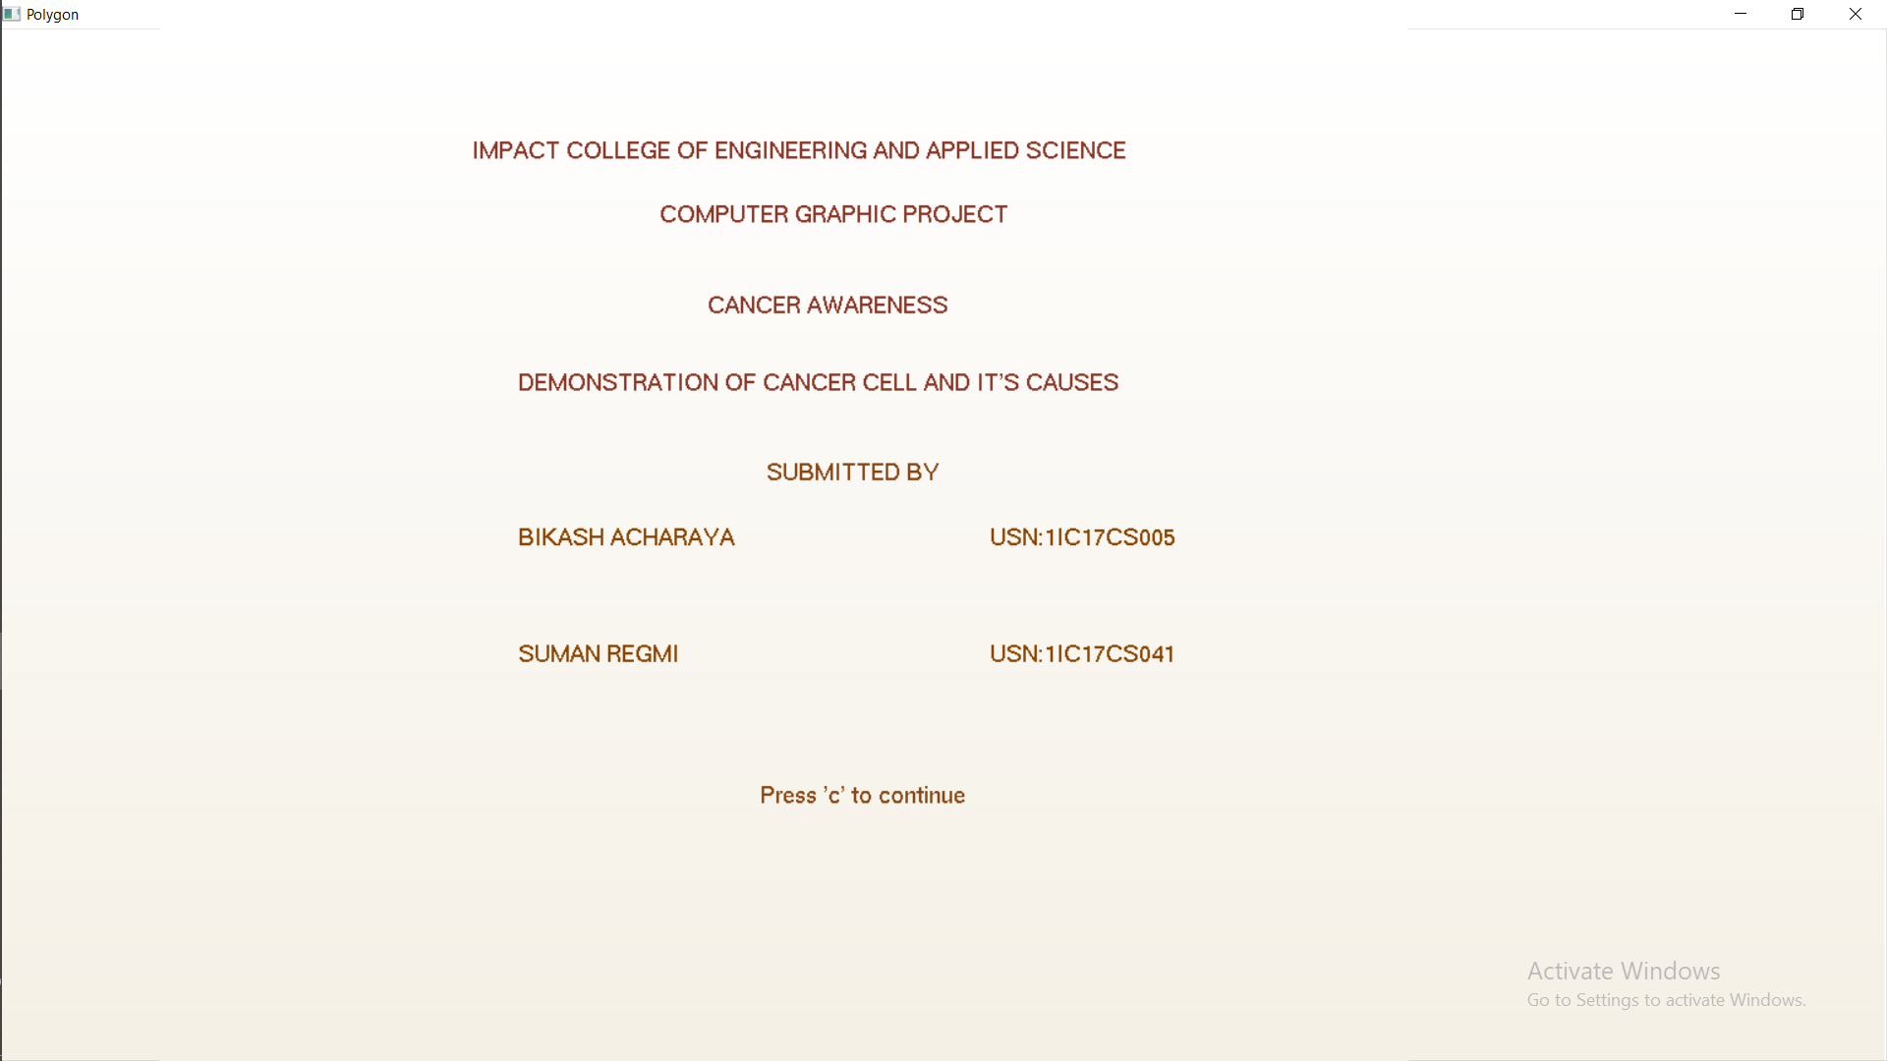

Scene 1

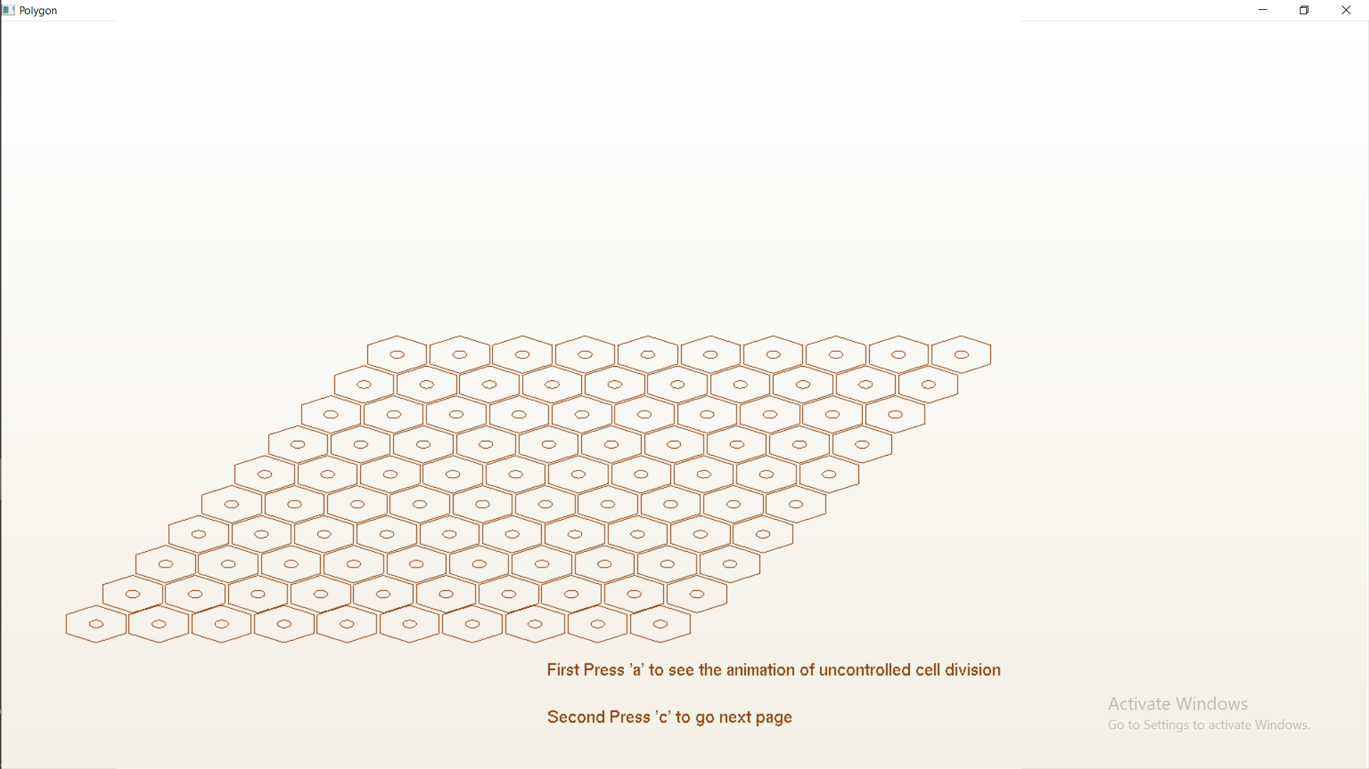

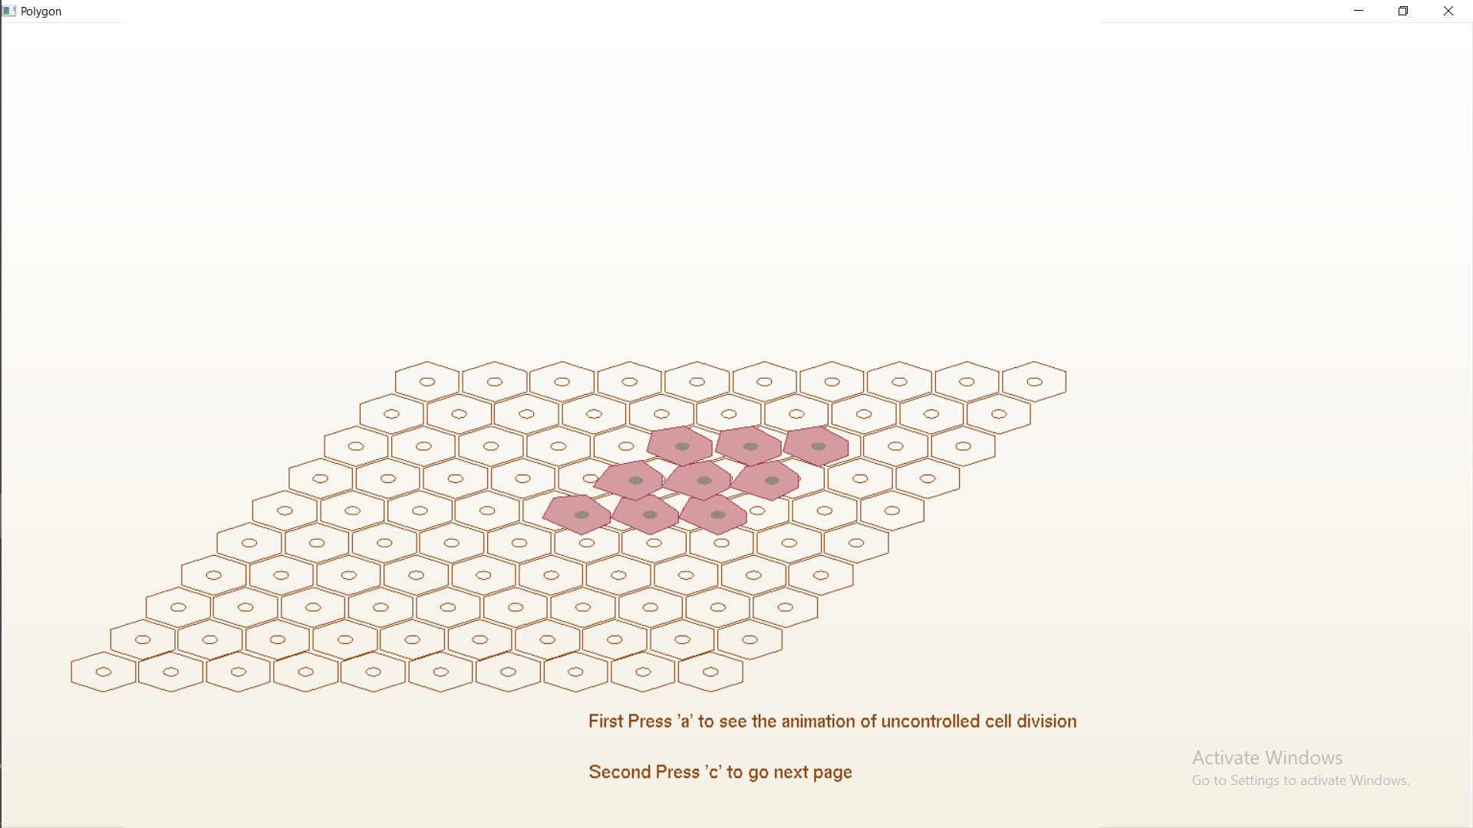

Scene 2

Scene 3

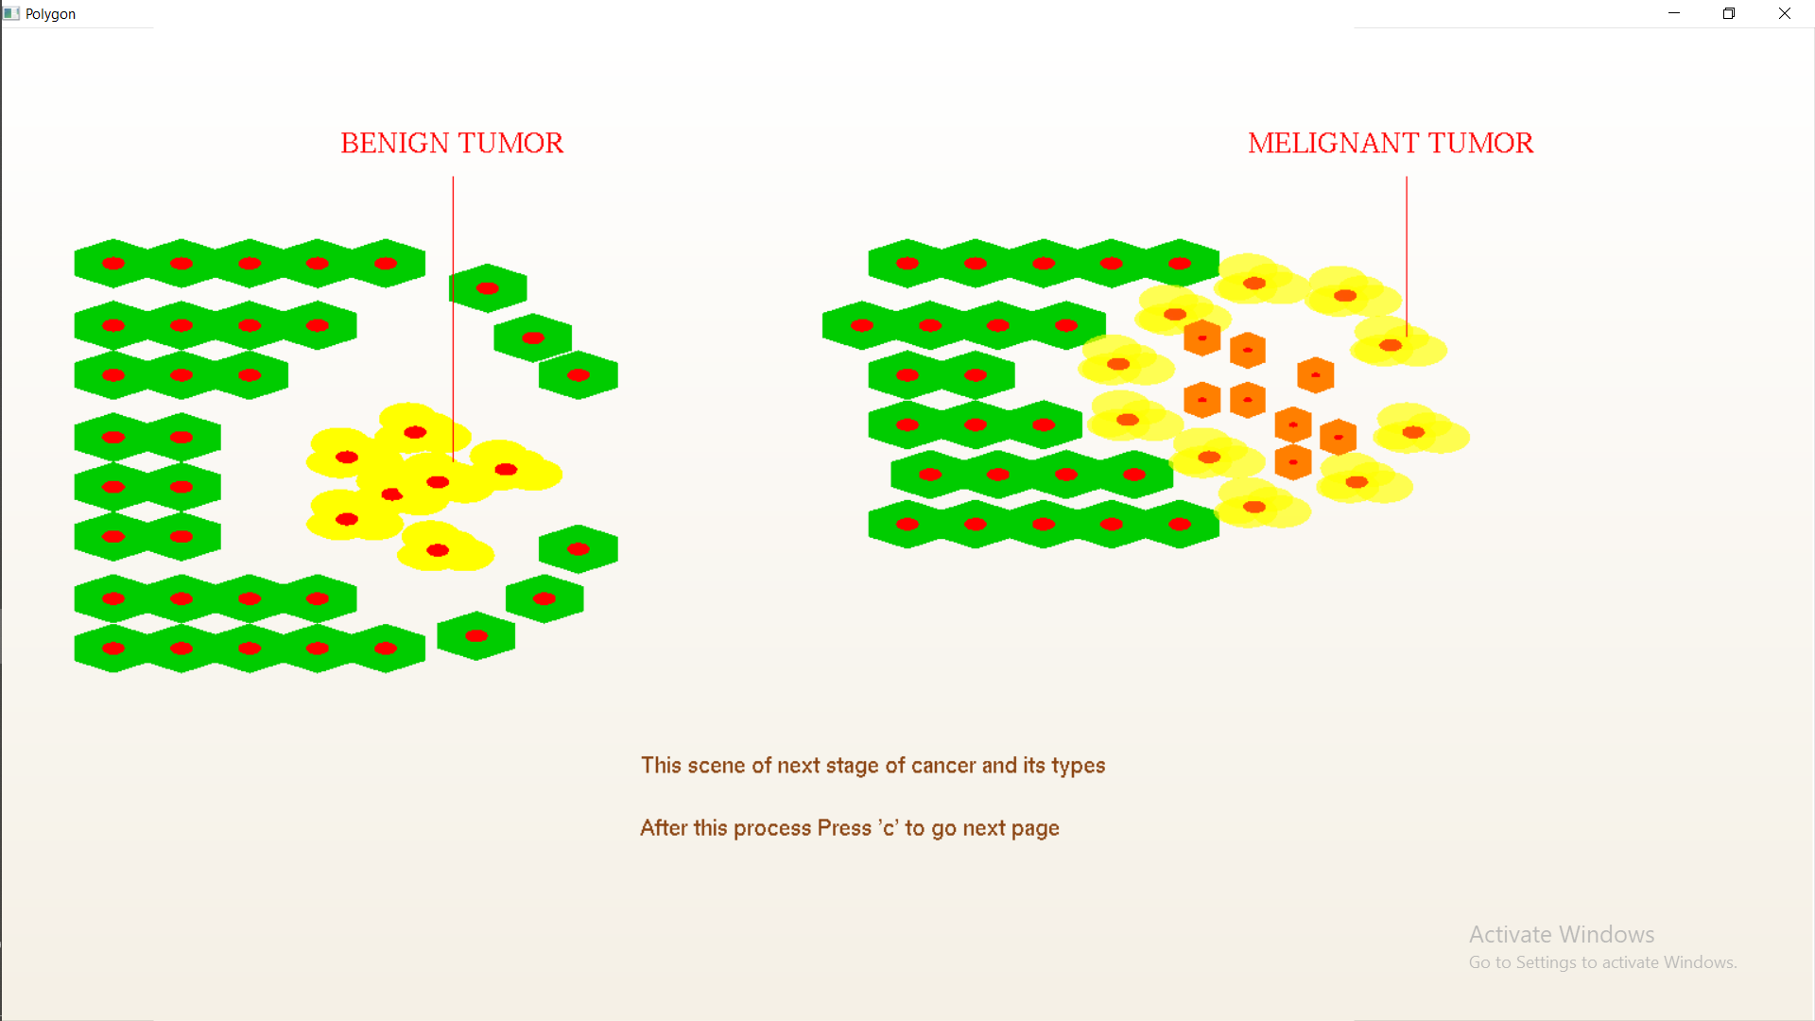

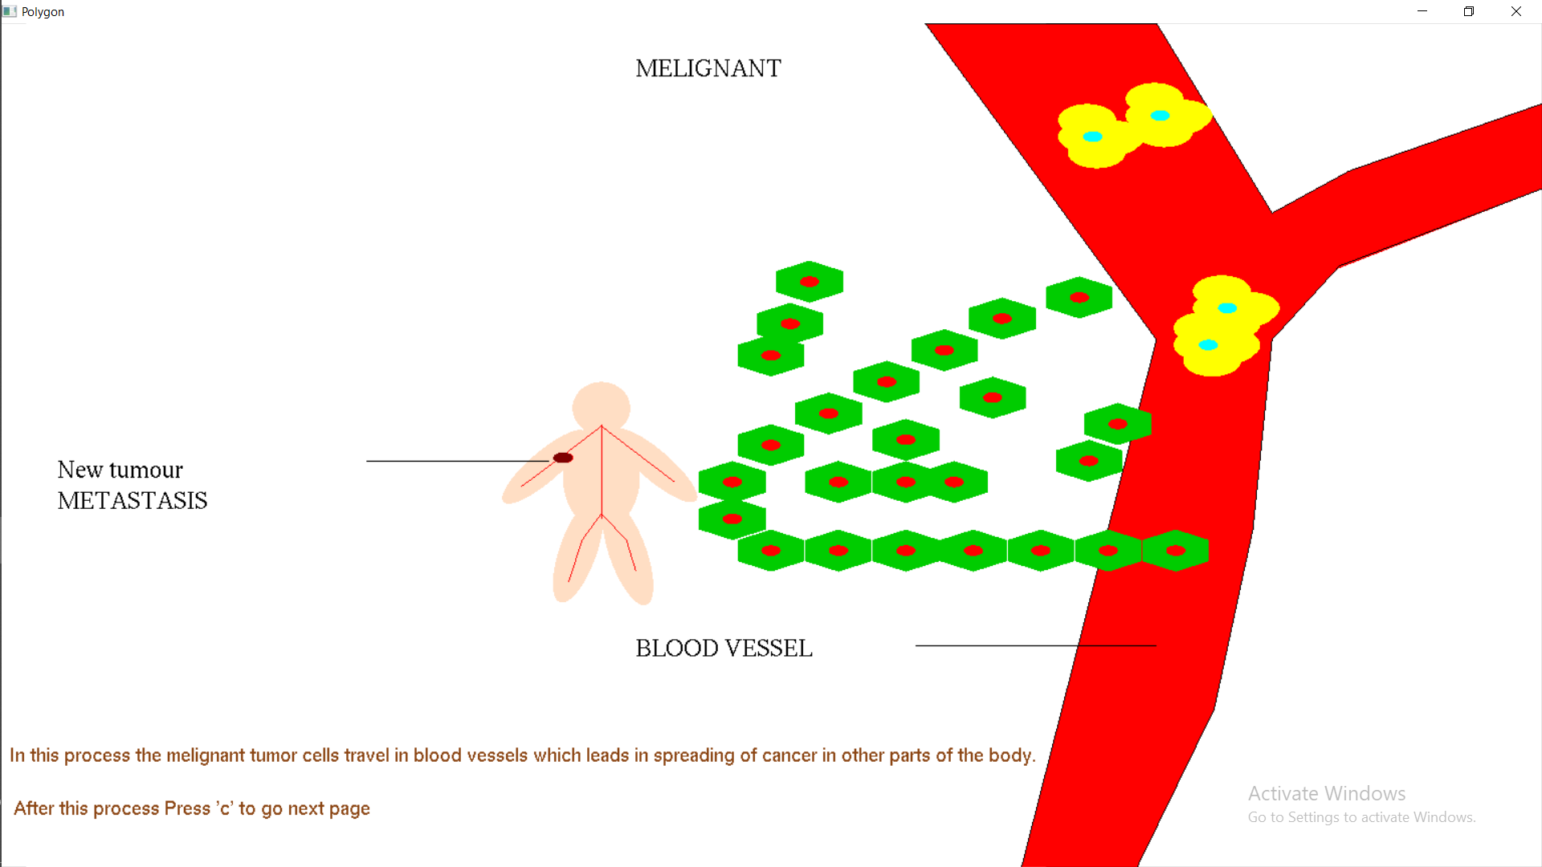

Scene 4

Scene 5:

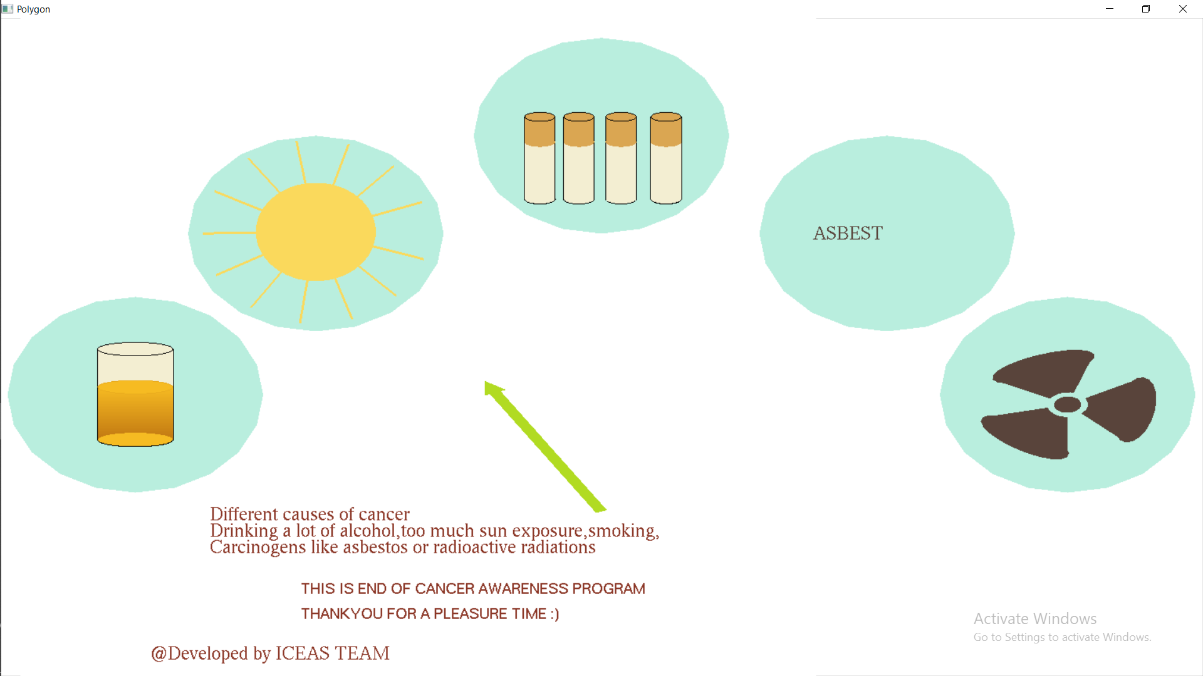

**8.CONCLUSION**

The source code developed is relatively simple, easy to comprehend and works effectively. A simple working model of the famous dining philosophers problem has been implemented. Also the flooding algorithm used in computer networks has been developed to explain the concept with relative ease.

Development of this computer graphics project has given us a better understanding of the topics and concepts learnt in theory. The project increased our knowledge in the field of computer graphics.

The hands on experience of developing a graphics project has helped us inculcate the good practices and principles of software engineering. This project has imbibed within us the spirit of teamwork.

**9.BIBLIOGRAPHY**

**Computer Graphics Principles and Practice –** Foley, VanDam, Feiner, Huges

**Graphics in C –** Y. P. Kanetkar

**Interactive Computer Graphics –** Edward Angel

**Websites Referred:**

* www.stackoverflow.com
* www.opengl.org
* http://www.aksiom.net/rgb.html
* http://en.wikipedia.org/wiki/List_of_colors:_A-F