Lab 1

Application Name: Todo_First

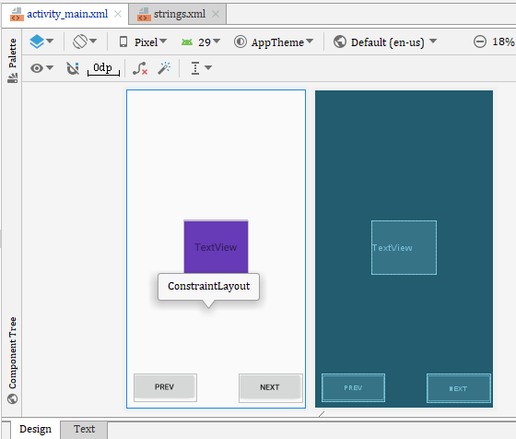

Codes

|  |
| --- |
| *<?*xml version="1.0" encoding="utf-8"*?>* <androidx.constraintlayout.widget.ConstraintLayout xmlns:android="http://schemas.android.com/apk/res/android"  xmlns:app="http://schemas.android.com/apk/res-auto"  xmlns:tools="http://schemas.android.com/tools"  android:layout_width="match_parent"  android:layout_height="match_parent"  tools:context=".MainActivity">   <Button  android:id="@+id/btnprev"  android:layout_width="144dp"  android:layout_height="64dp"  android:layout_marginStart="8dp"  android:layout_marginTop="8dp"  android:layout_marginEnd="8dp"  android:layout_marginBottom="8dp"  android:onClick="btnprev"  android:text="Prev"   android:textSize="18sp"  app:layout_constraintBottom_toBottomOf="parent"  app:layout_constraintEnd_toEndOf="parent"  app:layout_constraintHorizontal_bias="0.031"  app:layout_constraintStart_toStartOf="parent"  app:layout_constraintTop_toTopOf="parent"  app:layout_constraintVertical_bias="0.987" />    <TextView  android:id="@+id/textView"  android:layout_width="148dp"  android:layout_height="123dp"  android:layout_marginStart="8dp"  android:layout_marginEnd="8dp"  android:layout_marginBottom="8dp"  android:background="#673AB7"  android:gravity="center"  android:text="TextView"  android:textSize="24sp"  app:layout_constraintBottom_toBottomOf="parent"  app:layout_constraintEnd_toEndOf="parent"  app:layout_constraintStart_toStartOf="parent"  app:layout_constraintTop_toTopOf="parent" />   <Button  android:id="@+id/btnnext"  android:layout_width="145dp"  android:layout_height="65dp"  android:layout_margin="8dp"  android:layout_marginStart="8dp"  android:layout_marginTop="8dp"  android:layout_marginEnd="8dp"  android:layout_marginBottom="8dp"  android:onClick="btnnext"  android:text="Next"  android:textSize="18sp"  app:layout_constraintBottom_toBottomOf="parent"  app:layout_constraintEnd_toEndOf="parent"  app:layout_constraintHorizontal_bias="1.0"  app:layout_constraintStart_toStartOf="parent"  app:layout_constraintTop_toTopOf="parent"  app:layout_constraintVertical_bias="0.989" /> </androidx.constraintlayout.widget.ConstraintLayout> |

String.xml

|  |
| --- |
| <**resources**>  <**string name="app_name"**>Todo_First</**string**>  <**string name="todo_first"**>To_First</**string**>  <**string name="next"**>Next</**string**>  <**string name="pevious"**>prev</**string**>  <**string-array name="todo_first"**>  <**item**>wake up</**item**>  <**item**>Exercise</**item**>  <**item**>Drink Coffee</**item**>  <**item**>Go to work</**item**>  </**string-array**> </**resources**> |

|  |
| --- |
|  |

|  |
| --- |
|  |

|  |
| --- |
|  |