Android fundamentals 01.2 Part A: Your first interactive UI

Application Name: Hello Toast

Screenshots of activity_main.xml

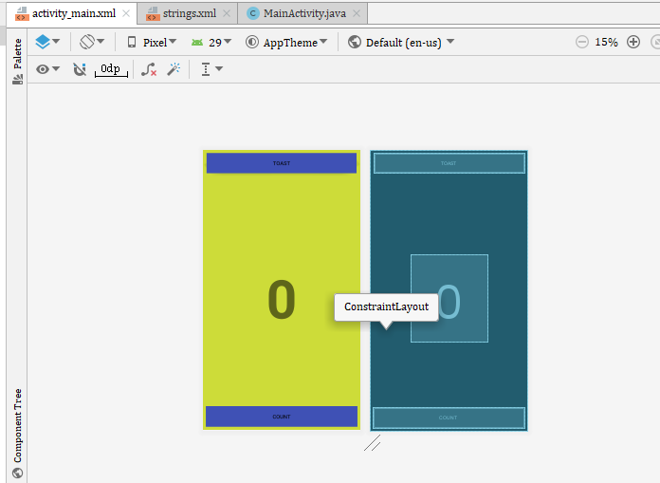

|  |
| --- |
| package com.example.hello_toast;  import androidx.appcompat.app.AppCompatActivity;  import android.os.Bundle; import android.view.View; import android.widget.TextView; import android.widget.Toast;   public class MainActivity extends AppCompatActivity {   private int mCount = 0;  private TextView mShowCount;   @Override  protected void onCreate(Bundle savedInstanceState) {  super.onCreate(savedInstanceState);  setContentView(R.layout.*activity_main*);  mShowCount = (TextView) findViewById(R.id.*show_count*);  if (mShowCount != null)  mShowCount.setText(Integer.*toString*(mCount));  }   public void showToast(View view) {  Toast toast = Toast.*makeText*(this, R.string.*toast_message*,  Toast.*LENGTH_SHORT*);  toast.show();   }   public void countUp(View view) {  mCount++;  if (mShowCount != null)  mShowCount.setText(Integer.*toString*(mCount));  }  } |

|  |
| --- |
| *<?***xml version="1.0" encoding="utf-8"***?>* <**androidx.constraintlayout.widget.ConstraintLayout xmlns:android="http://schemas.android.com/apk/res/android"  xmlns:app="http://schemas.android.com/apk/res-auto"  xmlns:tools="http://schemas.android.com/tools"  android:layout_width="match_parent"  android:layout_height="match_parent"  android:background="#CDDC39"  tools:context=".MainActivity"**>   <**TextView  android:id="@+id/show_count"  android:layout_width="201dp"  android:layout_height="228dp"  android:gravity="center_vertical"  android:text="@string/count_initial_value"  android:textAlignment="center"  android:textSize="140sp"  android:textStyle="bold"  app:layout_constraintBottom_toBottomOf="@+id/button_toast"  app:layout_constraintLeft_toLeftOf="parent"  app:layout_constraintRight_toRightOf="parent"  app:layout_constraintTop_toTopOf="@+id/button_count"  app:layout_constraintVertical_bias="0.476"** />  <**Button  android:id="@+id/button_toast"  android:layout_width="392dp"  android:layout_height="53dp"  android:layout_marginStart="8dp"  android:layout_marginTop="8dp"  android:layout_marginEnd="8dp"  android:layout_marginBottom="8dp"  android:background="#3F51B5"  android:text="@string/button_label_toast"  app:layout_constraintBottom_toTopOf="@+id/textView"  app:layout_constraintEnd_toEndOf="parent"  app:layout_constraintHorizontal_bias="0.482"  app:layout_constraintStart_toStartOf="parent"  app:layout_constraintTop_toTopOf="parent"  app:layout_constraintVertical_bias="0.027"  android:onClick="showToast"** />   <**Button  android:id="@+id/button_count"  android:layout_width="396dp"  android:layout_height="54dp"  android:layout_marginStart="8dp"  android:layout_marginTop="8dp"  android:layout_marginEnd="8dp"  android:layout_marginBottom="8dp"  android:background="#3F51B5"  android:text="@string/button_label_count"  app:layout_constraintBottom_toBottomOf="parent"  app:layout_constraintEnd_toEndOf="parent"  app:layout_constraintHorizontal_bias="0.529"  app:layout_constraintStart_toStartOf="parent"  app:layout_constraintTop_toBottomOf="@+id/textView"  app:layout_constraintVertical_bias="0.971"  android:onClick="countUp"** />  </**androidx.constraintlayout.widget.ConstraintLayout**> |

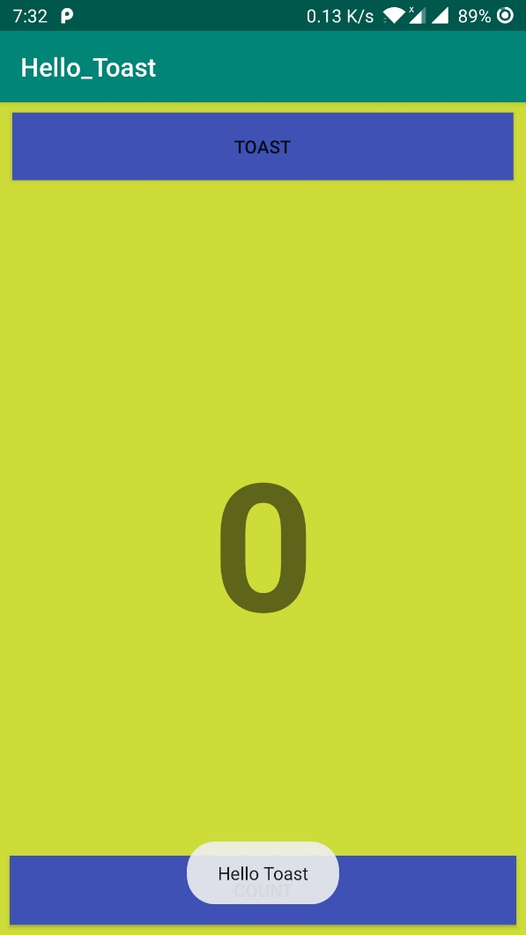 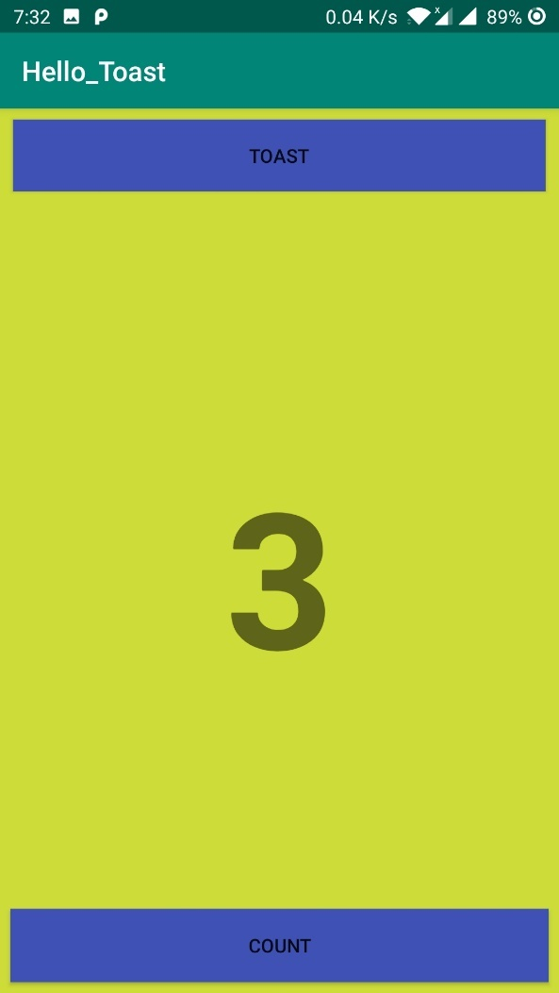

After rotating the phone the count value is restored

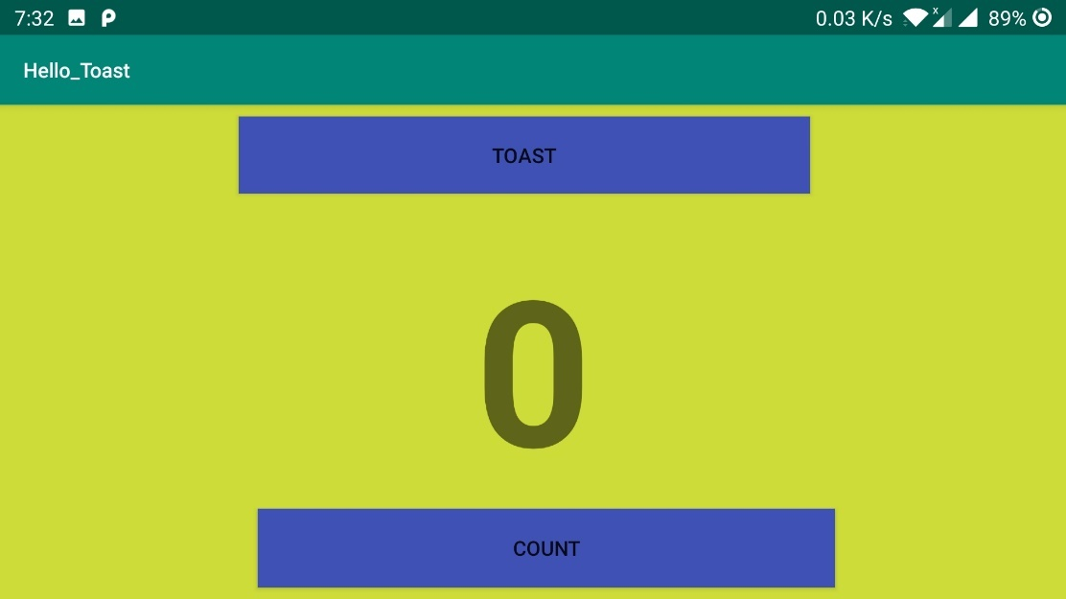

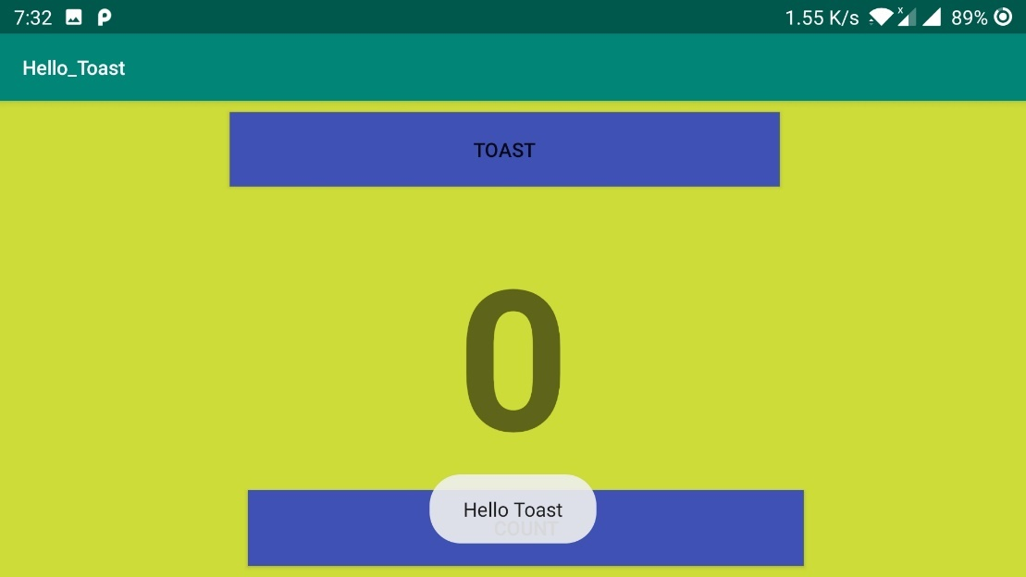

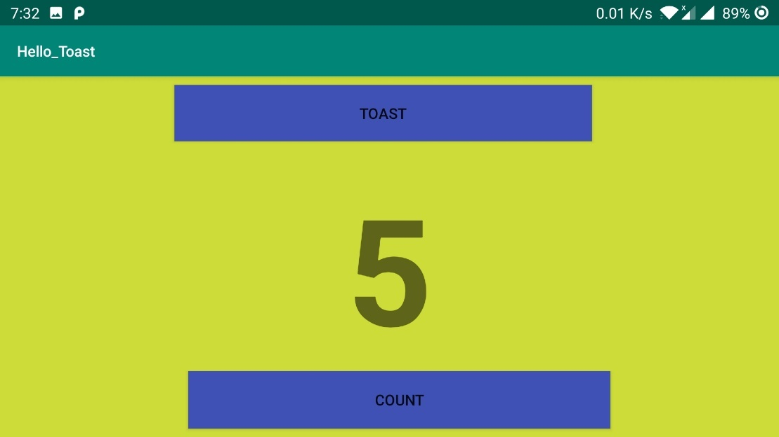

Application Name: HelloToast Challenge

Layout/activity_main.xml

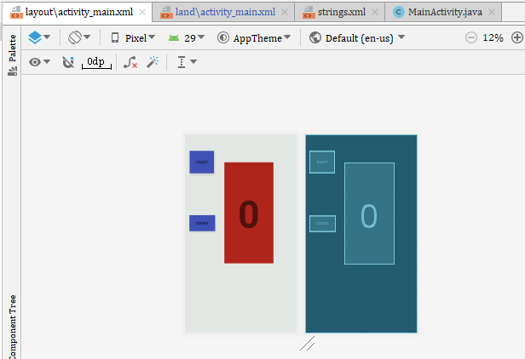

|  |
| --- |
| *<?***xml version="1.0" encoding="utf-8"***?>* <**androidx.constraintlayout.widget.ConstraintLayout xmlns:android="http://schemas.android.com/apk/res/android"  xmlns:app="http://schemas.android.com/apk/res-auto"  xmlns:tools="http://schemas.android.com/tools"  android:layout_width="match_parent"  android:layout_height="match_parent"  android:background="#E3E7E3"  tools:context=".MainActivity"**>   <**Button  android:id="@+id/button_toast"  android:layout_width="90dp"  android:layout_height="83dp"  android:layout_marginStart="16dp"  android:layout_marginTop="91dp"  android:layout_marginEnd="38dp"  android:layout_marginBottom="92dp"  android:background="#3F51B5"  android:onClick="showToast"  android:text="@string/button_label_toast"  app:layout_constraintBottom_toTopOf="@+id/button_count"  app:layout_constraintEnd_toStartOf="@+id/show_count"  app:layout_constraintHorizontal_bias="1.0"  app:layout_constraintStart_toStartOf="parent"  app:layout_constraintTop_toTopOf="parent"** />   <**Button  android:id="@+id/button_count"  android:layout_width="95dp"  android:layout_height="59dp"  android:layout_marginStart="16dp"  android:layout_marginTop="92dp"  android:layout_marginEnd="34dp"  android:layout_marginBottom="405dp"  android:background="#3F51B5"  android:onClick="countUp"  android:text="@string/button_label_count"  app:layout_constraintBottom_toBottomOf="parent"  app:layout_constraintEnd_toStartOf="@+id/show_count"  app:layout_constraintStart_toStartOf="parent"  app:layout_constraintTop_toBottomOf="@+id/button_toast"** />   <**TextView  android:id="@+id/show_count"  android:layout_width="181dp"  android:layout_height="373dp"  android:background="#AF251B"  android:gravity="center_vertical"  android:text="@string/count_initial_value"  android:textAlignment="center"  android:textSize="140sp"  android:textStyle="bold"  app:layout_constraintBottom_toBottomOf="parent"  app:layout_constraintHorizontal_bias="0.63"  app:layout_constraintLeft_toLeftOf="parent"  app:layout_constraintRight_toRightOf="parent"  app:layout_constraintTop_toTopOf="parent"  app:layout_constraintVertical_bias="0.287"** />  </**androidx.constraintlayout.widget.ConstraintLayout**> |

Land/activity_main.xml

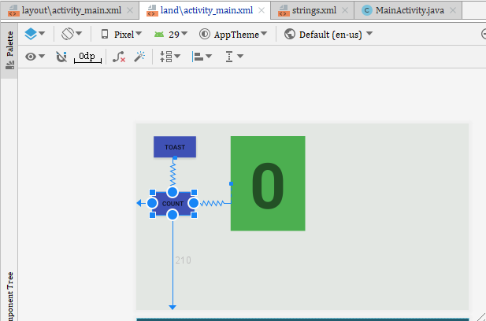

|  |
| --- |
| *<?***xml version="1.0" encoding="utf-8"***?>* <**androidx.constraintlayout.widget.ConstraintLayout xmlns:android="http://schemas.android.com/apk/res/android"  xmlns:app="http://schemas.android.com/apk/res-auto"  xmlns:tools="http://schemas.android.com/tools"  android:layout_width="match_parent"  android:layout_height="match_parent"  android:background="#E3E7E3"  tools:context=".MainActivity"**>   <**Button  android:id="@+id/button_toast"  android:layout_width="93dp"  android:layout_height="47dp"  android:layout_marginStart="8dp"  android:layout_marginTop="28dp"  android:layout_marginEnd="8dp"  android:background="#3F51B5"  android:onClick="showToast"  android:text="@string/button_label_toast"   app:layout_constraintEnd_toEndOf="parent"  app:layout_constraintHorizontal_bias="0.049"  app:layout_constraintStart_toStartOf="parent"  app:layout_constraintTop_toTopOf="parent"** />     <**TextView  android:id="@+id/show_count"  android:layout_width="164dp"  android:layout_height="209dp"  android:background="#4CAF50"  android:gravity="center_vertical"  android:text="@string/count_initial_value"  android:textAlignment="center"  android:textSize="140sp"  android:textStyle="bold"  app:layout_constraintBottom_toBottomOf="parent"  app:layout_constraintHorizontal_bias="0.366"  app:layout_constraintLeft_toLeftOf="parent"  app:layout_constraintRight_toRightOf="parent"  app:layout_constraintTop_toTopOf="parent"  app:layout_constraintVertical_bias="0.138"** />   <**Button  android:id="@+id/button_count"  android:layout_width="91dp"  android:layout_height="51dp"  android:layout_marginStart="36dp"  android:layout_marginEnd="81dp"  android:layout_marginBottom="210dp"  android:background="#3F51B5"  android:onClick="countUp"  android:text="Count"  app:layout_constraintBottom_toBottomOf="parent"  app:layout_constraintEnd_toStartOf="@+id/show_count"  app:layout_constraintHorizontal_bias="1.0"  app:layout_constraintStart_toStartOf="parent"  app:layout_constraintTop_toBottomOf="@+id/button_toast"  app:layout_constraintVertical_bias="1.0"** />  </**androidx.constraintlayout.widget.ConstraintLayout**> |

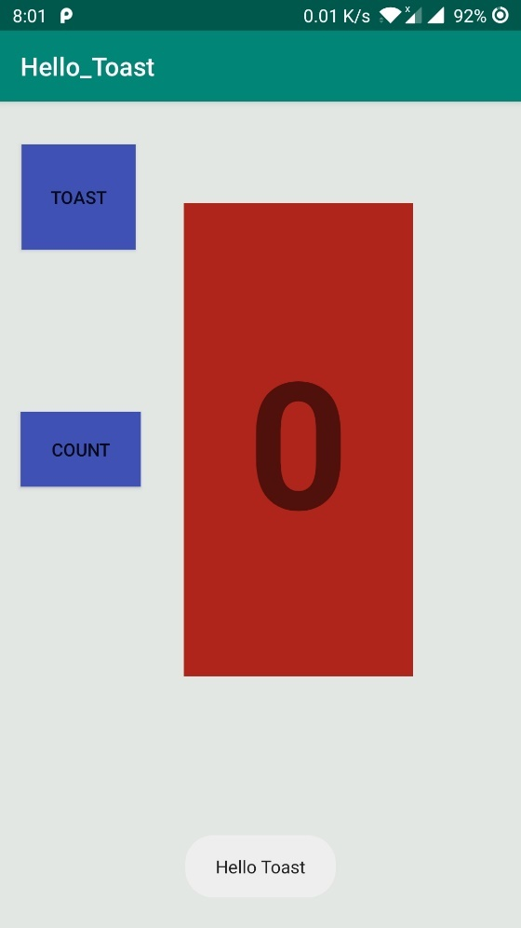 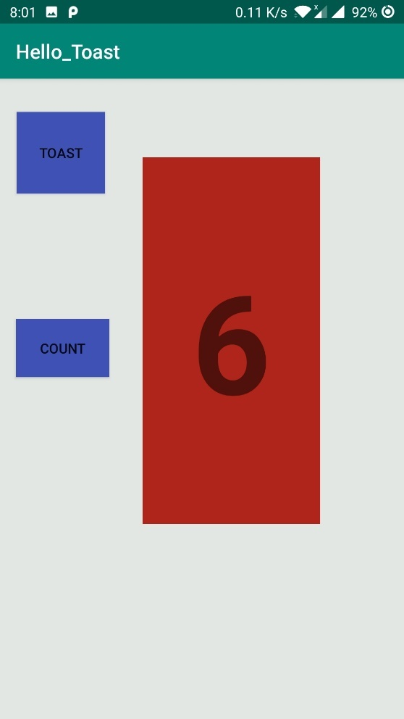

After rotation of the screen the working mechanism is still same but the colors looks different

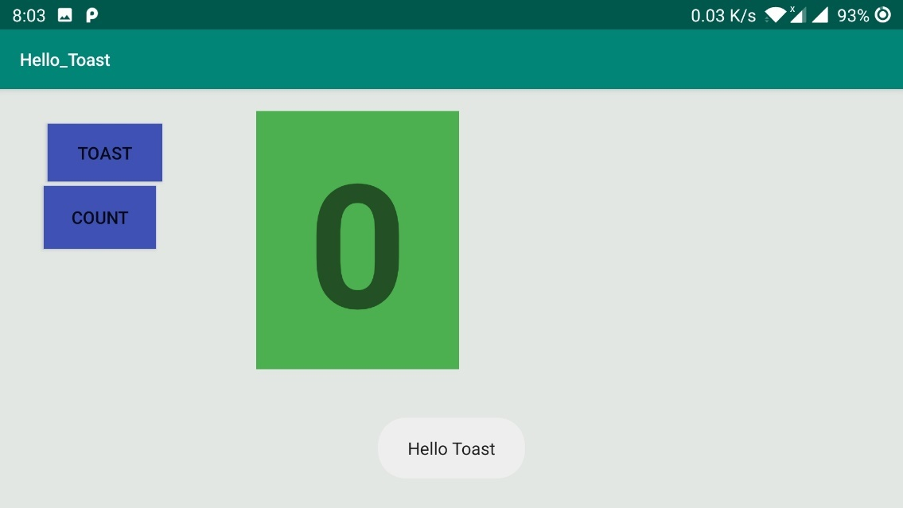

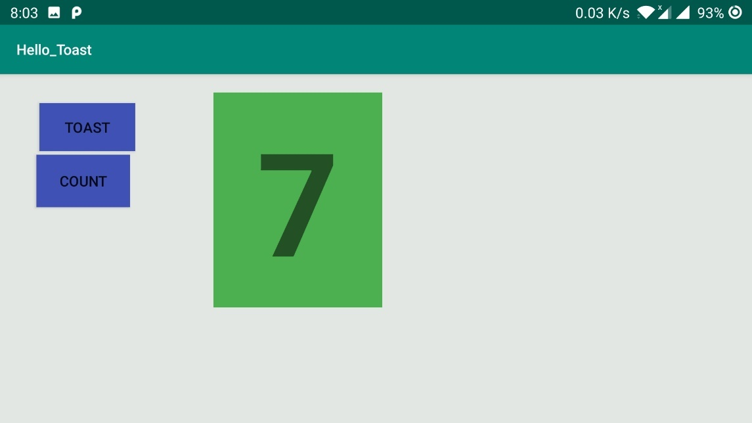

Android fundamentals 01.2 Part B: The layout editor

Application Name: HelloConstraint

Layout/activity_main.xml

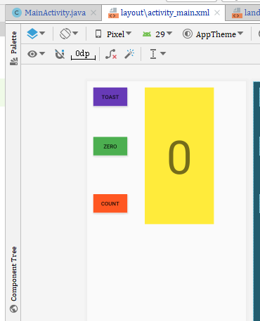

Land/activity_main.xml

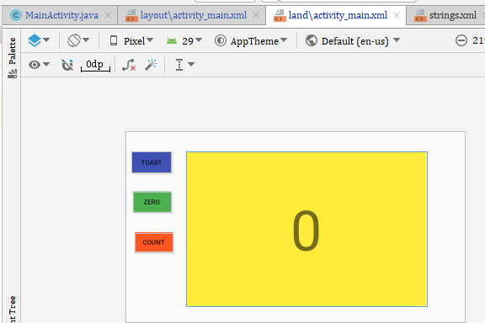

Codes for both layout

|  |
| --- |
| *<?***xml version="1.0" encoding="utf-8"***?>* <**androidx.constraintlayout.widget.ConstraintLayout xmlns:android="http://schemas.android.com/apk/res/android"  xmlns:app="http://schemas.android.com/apk/res-auto"  xmlns:tools="http://schemas.android.com/tools"  android:layout_width="match_parent"  android:layout_height="match_parent"  tools:context=".MainActivity"**>   <**TextView  android:id="@+id/textView"  android:layout_width="179dp"  android:layout_height="354dp"  android:layout_marginTop="16dp"  android:layout_marginEnd="83dp"  android:background="#FFEB3B"  android:gravity="center"  android:text="0"  android:textSize="120sp"  app:layout_constraintEnd_toEndOf="parent"  app:layout_constraintHorizontal_bias="1.0"  app:layout_constraintStart_toEndOf="@+id/btn_count"  app:layout_constraintTop_toTopOf="parent"** />   <**Button  android:id="@+id/btn_toast"  android:layout_width="wrap_content"  android:layout_height="wrap_content"  android:layout_marginStart="16dp"  android:layout_marginTop="16dp"  android:background="#673AB7"  android:onClick="showtoast"  android:text="TOAST"  app:layout_constraintStart_toStartOf="parent"  app:layout_constraintTop_toTopOf="parent"** />   <**Button  android:id="@+id/btn_zero"  android:layout_width="wrap_content"  android:layout_height="wrap_content"  android:layout_marginStart="16dp"  android:layout_marginTop="80dp"  android:background="#4CAF50"  android:onClick="showzero"  android:text="ZERO"  app:layout_constraintStart_toStartOf="parent"  app:layout_constraintTop_toBottomOf="@+id/btn_toast"** />   <**Button  android:id="@+id/btn_count"  android:layout_width="wrap_content"  android:layout_height="wrap_content"  android:layout_marginStart="16dp"  android:layout_marginTop="100dp"  android:background="#FF5722"  android:text="COUNT"  android:onClick="countup"  app:layout_constraintStart_toStartOf="parent"  app:layout_constraintTop_toBottomOf="@+id/btn_zero"** /> </**androidx.constraintlayout.widget.ConstraintLayout**>  *<?***xml version="1.0" encoding="utf-8"***?>* <**androidx.constraintlayout.widget.ConstraintLayout xmlns:android="http://schemas.android.com/apk/res/android"  xmlns:app="http://schemas.android.com/apk/res-auto"  xmlns:tools="http://schemas.android.com/tools"  android:layout_width="match_parent"  android:layout_height="match_parent"  tools:context=".MainActivity"**>   <**TextView  android:id="@+id/textView"  android:layout_width="518dp"  android:layout_height="334dp"  android:layout_marginTop="44dp"  android:layout_marginEnd="83dp"  android:background="#FFEB3B"  android:gravity="center"  android:text="0"  android:textSize="120sp"  app:layout_constraintEnd_toEndOf="parent"  app:layout_constraintHorizontal_bias="1.0"  app:layout_constraintStart_toEndOf="@+id/btn_count"  app:layout_constraintTop_toTopOf="parent"** />   <**Button  android:id="@+id/btn_toast"  android:layout_width="86dp"  android:layout_height="46dp"  android:layout_marginStart="13dp"  android:layout_marginTop="44dp"  android:background="#3F51B5"  android:text="TOAST"  android:onClick="showtoast"  app:layout_constraintStart_toStartOf="parent"  app:layout_constraintTop_toTopOf="parent"** />   <**Button  android:id="@+id/btn_zero"  android:layout_width="82dp"  android:layout_height="44dp"  android:layout_marginStart="16dp"  android:layout_marginTop="40dp"  android:background="#4CAF50"  android:text="ZERO"  android:onClick="showzero"  app:layout_constraintStart_toStartOf="parent"  app:layout_constraintTop_toBottomOf="@+id/btn_toast"** />   <**Button  android:id="@+id/btn_count"  android:layout_width="82dp"  android:layout_height="42dp"  android:layout_marginStart="20dp"  android:layout_marginTop="44dp"  android:background="#FF5722"  android:text="COUNT"  android:onClick="countup"  app:layout_constraintStart_toStartOf="parent"  app:layout_constraintTop_toBottomOf="@+id/btn_zero"** /> </**androidx.constraintlayout.widget.ConstraintLayout**> |

MainActivity.Java

Codes

|  |
| --- |
| **package** com.example.helloconstraint;  **import** androidx.appcompat.app.AppCompatActivity;  **import** android.os.Bundle; **import** android.view.View; **import** android.widget.TextView; **import** android.widget.Toast;  **public class** MainActivity **extends** AppCompatActivity {  **private int mCount** = 0;  **private** TextView **mShowCount**;  **public static final** String ***KEY*** = **"com.example.key"**;   @Override  **protected void** onSaveInstanceState(Bundle outState) {  **super**.onSaveInstanceState(outState);  outState.putInt(**"KEY"**,**mCount**);  }    @Override  **protected void** onCreate(Bundle savedInstanceState) {  **super**.onCreate(savedInstanceState);  setContentView(R.layout.***activity_main***);   **mShowCount** = (TextView) findViewById(R.id.***textView***);  **mShowCount**.setText(**""**+**mCount**);  **if** (savedInstanceState != **null**){  **mCount** = savedInstanceState.getInt(**"KEY"**, 0);   }   }   **public void** showtoast(View view) {  Toast toast = Toast.*makeText*(**this**, R.string.***toast_message***, Toast.***LENGTH_SHORT***);  toast.show();  }   **public void** showzero(View view) {  **mCount** = 0;  **mShowCount**.setText(Integer.*toString*(**mCount**));  }   **public void** countup(View view) {  **mCount**++;  **if** (**mShowCount** != **null**)  **mShowCount**.setText(Integer.*toString*(**mCount**));  } } |

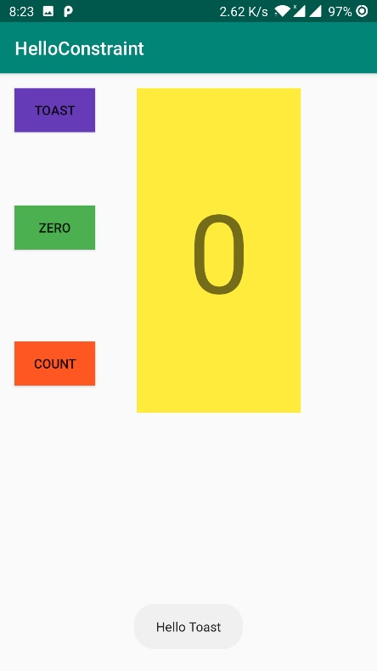 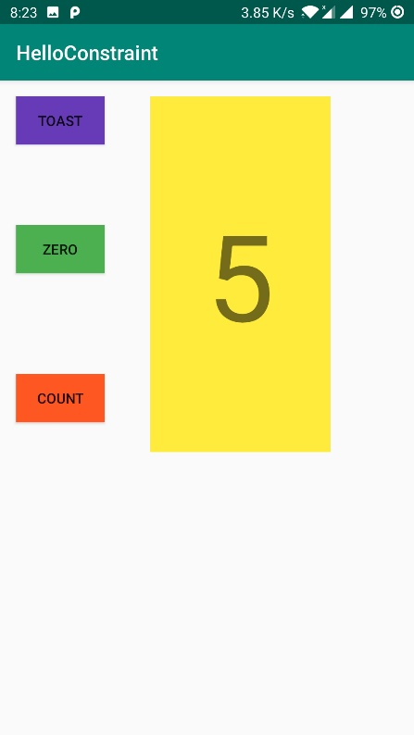

After clicking the zero button the value is reset

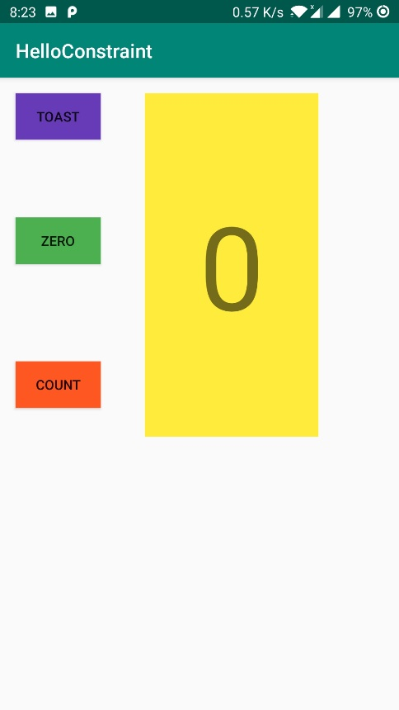

Android fundamentals 01.3: Text and scrolling views

Application Name: Scrolling Text

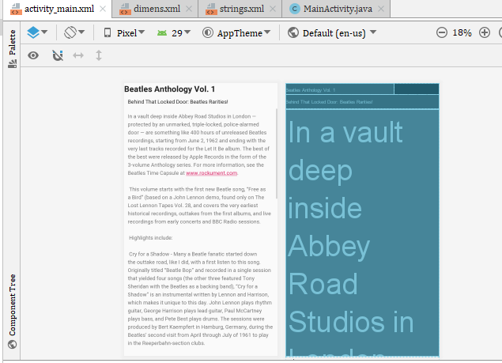

|  |
| --- |
| *<?***xml version="1.0" encoding="utf-8"***?>* <**RelativeLayout xmlns:android="http://schemas.android.com/apk/res/android"  xmlns:app="http://schemas.android.com/apk/res-auto"  xmlns:tools="http://schemas.android.com/tools"  android:layout_width="match_parent"  android:layout_height="match_parent"  android:orientation="vertical"  tools:context=".MainActivity"**>   <**TextView  android:id="@+id/article"  android:layout_width="289dp"  android:layout_height="wrap_content"  android:text="@string/article_heading"  android:textAppearance="@android:style/TextAppearance.DeviceDefault.Large"  android:textStyle="bold"** />  <**TextView  android:id="@+id/article_subheading"  android:layout_width="match_parent"  android:layout_height="wrap_content"  android:layout_below="@id/article"  android:padding="@dimen/padding_regular"  android:text="@string/article_subtitle"  android:textAppearance="@android:style/TextAppearance.DeviceDefault"** />   <**ScrollView   android:layout_width="wrap_content"  android:layout_height="wrap_content"  android:layout_below="@id/article_subheading"**>   <**TextView  android:id="@+id/articletext"  android:layout_width="wrap_content"  android:layout_height="wrap_content"  android:autoLink="web"  android:lineSpacingExtra="@dimen/line_spacing"  android:padding="@dimen/padding_regular"  android:text="@string/article_text"** />  </**ScrollView**>   </**RelativeLayout**> |

 