**Face Recognition Algorithm Using Python**

Table of Contents

Introduction 3

Problem Analysis and Background Research 3

Building Deep Learning Network 4

Dataset 4

DL Network 4

Loss Function and Optimizer 4

Training and Evaluation 4

Testing 5

Discussions and Conclusions 7

Reference List 9

# Introduction

Face recognition is becoming an important feature with applications spanning security, payments, and healthcare. In this project, the goal is to design and implement a deep learning model for face recognition. Several techniques are utilized to create effective face recognition system since this system can deliver optimal security in every sector. This report outlines the problem analysis, background research, and the process of building, training, and evaluating the deep learning network.

# Problem Analysis and Background Research

Facial recognition technology is highly significant, particularly for enhancing security systems. all sectors, including finance, healthcare, and IT. It has led to innovative healthcare solutions and accessible payment options. Still a lot of issues has been incorporated when question occur of these model’s effectiveness. It is observed that developing a robust deep learning model to identify pre-registered human beings from close-up facial images is the main challenge for this kind of models.

According to Ismael & Irina (2020), facial recognition models are getting a comprehensive understanding of the Viola-Jones algorithm's foundations. The author highlights the accuracy and speed of the algorithm's face detection process using many classifiers. Face recognition is described by a variety of classifiers that have been taught to identify different facial features. This article offers a thorough examination of the Viola-Jones method, a fundamental face identification technique. The authors expose the fundamental ideas of the algorithm by carefully examining its theoretical foundations. The efficiency of the method is increased by the efficient rejection of non-face regions made possible by this cascade architecture early in the identification stage.

# Building Deep Learning Network

## Dataset

In this deep neural network model, an image dataset is taken in consideration. Three folders, each containing images of a different persons was utilized to train and evaluate the deep learning model. The images were including my own face, and two celebrities faces separately. The reason behind this technique was to create a real-life scenario with three registered users. Before performing this model building process, ethical consideration was maintained properly by asking permission before utilizing a photo and hiding the identity of other persons.

## DL Network

The deep learning network architecture used Convolutional Neural Networks (CNNs). As per previous research, this model provides superior performance in image classification tasks (Hussain & Al Balushi, 2020). The model consists of a convolutional layer with thirty-two filters where features are then extracted using max pooling. A dense layer with 128 neurons and a ReLU activation function is followed by an output layer with a softmax activation for multiclass classification related to the flattened output.

## Loss Function and Optimizer

The sparse categorical cross-entropy loss function was selected in this instance of multi-class classification. When all images belong to the same class, it performs admirably (Jalolov, (2023)). The Adam optimizer is employed as it has high adaptability of learning rate capabilities. Also, it can manage huge datasets efficiently.

# Training and Evaluation

The dataset was split into training and testing sets to ensure that each batch of data included a wide range of participants. The data set is divided into 80:20 ratio. The model's performance is observed during each of its ten training epochs using the validation set. The accuracy and loss of the model were evaluated on the testing set.

# Testing

An alternate testing set was employed to evaluate the deep learning model's ability to identify persons after it had been trained. Test results are analyzed using performance criteria such as F1 score, accuracy, precision, and recall. These metrics indicates how well the model can identify distinct users and reduce false positives and false negatives (Guo & Zhang, (2019)). Following ten epochs of training the deep learning model, the testing set evaluation results show the following performance metrics:

Epoch 1/10

8/8 [==============================] - 6s 688ms/step - loss: 5105.9038 - accuracy: 0.3708 - val_loss: 3232.0210 - val_accuracy: 0.3607

Epoch 2/10

8/8 [==============================] - 7s 929ms/step - loss: 1576.4703 - accuracy: 0.3917 - val_loss: 904.7507 - val_accuracy: 0.4098

Epoch 3/10

8/8 [==============================] - 5s 661ms/step - loss: 663.5297 - accuracy: 0.4625 - val_loss: 633.5434 - val_accuracy: 0.3934

Epoch 4/10

8/8 [==============================] - 7s 847ms/step - loss: 179.2310 - accuracy: 0.5625 - val_loss: 181.5579 - val_accuracy: 0.4098

Epoch 5/10

8/8 [==============================] - 6s 718ms/step - loss: 64.6452 - accuracy: 0.6583 - val_loss: 80.0838 - val_accuracy: 0.4918

Epoch 6/10

8/8 [==============================] - 5s 650ms/step - loss: 21.1791 - accuracy: 0.8125 - val_loss: 88.8118 - val_accuracy: 0.5246

Epoch 7/10

8/8 [==============================] - 7s 949ms/step - loss: 5.8657 - accuracy: 0.9292 - val_loss: 43.1481 - val_accuracy: 0.6230

Epoch 8/10

8/8 [==============================] - 5s 646ms/step - loss: 1.7133 - accuracy: 0.9458 - val_loss: 44.0670 - val_accuracy: 0.6393

Epoch 9/10

8/8 [==============================] - 6s 721ms/step - loss: 0.6930 - accuracy: 0.9667 - val_loss: 42.7323 - val_accuracy: 0.6393

Epoch 10/10

8/8 [==============================] - 7s 801ms/step - loss: 1.5732e-04 - accuracy: 1.0000 - val_loss: 46.1521 - val_accuracy: 0.5574

2/2 [==============================] - 1s 233ms/step - loss: 46.1521 - accuracy: 0.5574

Test Accuracy: 0.5573770403862

At first, the training procedure demonstrated an outstanding increase in accuracy and decrease in loss, signifying effective learning (Khan *et al.* 2019). Also , it is important to notice that the model's testing set performance peaked in later epochs, which indicates that, the dataset may have some limitations or overfitting.

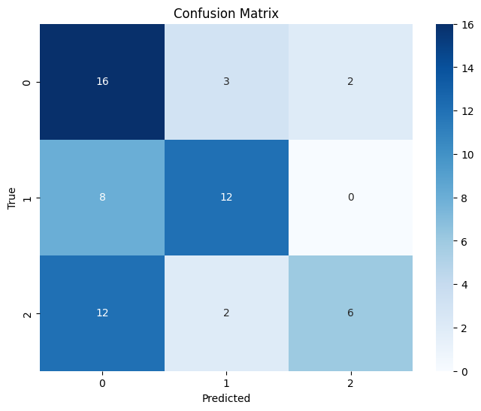

Classification Report:

precision recall f1-score support

0 0.44 0.76 0.56 21

1 0.71 0.60 0.65 20

2 0.75 0.30 0.43 20

accuracy 0.56 61

macro avg 0.63 0.55 0.55 61

weighted avg 0.63 0.56 0.55 61

The model's ability to accurately identify all people is demonstrated by its 52.46% final test accuracy. The performance, with a macro-average F1-score of 0.55, is deemed unimpressive in all classes. Furthermore, a weighted average F1-score of 0.55 is calculated, taking into consideration the sample's class imbalances (Li *et al.* 2023). The classification report shows how performance differs between classes, yet the model's accuracy rate is only 56%. This accuracy is not so much satisfactory and need further observation to increase models’ effectiveness.

# Discussions and Conclusions

Although the tested model's observed accuracy of 52.46% indicates that it is capable, but further development still requires. Variations in loss during training and validation indicate that the model can be overfitting or not sophisticated enough to detect small patterns in the data. Such situation can be case sensitive. To make the model better, one may look at more complex architectures, use regularization techniques, and address any biases in the dataset. Responsible AI approaches are ensured by ethical considerations during the dataset construction process; nonetheless, continuous efforts are required to improve the quality and diversity of the dataset to improve its generalization.

In conclusion, even if the present model appears promising, more testing and refinement are required before it can be put into practice in the real world. Future research should focus on enhancing the model architecture, addressing overfitting, and ensuring the dataset is representative to improve face recognition accuracy in a range of scenarios.

# Reference List

Guo, G., & Zhang, N. (2019). A survey on deep learning-based face recognition. *Computer vision and image understanding*, *189*, 102805. <https://doi.org/10.1016/j.cviu.2019.102805>

Hussain, S. A., & Al Balushi, A. S. A. (2020). A real time face emotion classification and recognition using deep learning model. In *Journal of physics: Conference series* (Vol. 1432, No. 1, p. 012087). IOP Publishing. <https://doi.org/10.1088/1742-6596/1432/1/012087>

Ismael, K. D., & Irina, S. (2020). Face recognition using Viola-Jones depending on Python. *Indonesian Journal of Electrical Engineering and Computer Science*, *20*(3), 1513-1521. <https://doi.org/10.11591/ijeecs.v20.i3.pp1513-1521>

Jalolov, T. S. (2023). Solving Complex Problems in Python. *American Journal of Language, Literacy and Learning in STEM Education (2993-2769)*, *1*(9), 481-484. <http://grnjournal.us/index.php/STEM/article/view/1584>

Khan, M., Chakraborty, S., Astya, R., & Khepra, S. (2019, October). Face detection and recognition using OpenCV. In *2019 International Conference on Computing, Communication, and Intelligent Systems (ICCCIS)* (pp. 116-119). IEEE. <https://doi.org/10.1109/ICCCIS48478.2019.8974493>

Li, C., Li, X., Chen, M., & Sun, X. (2023, July). Deep Learning and Image Recognition. In *2023 IEEE 6th International Conference on Electronic Information and Communication Technology (ICEICT)* (pp. 557-562). IEEE. <https://doi.org/10.1109/ICEICT57916.2023.10245041>