

UNIVERSITY OF RWANDA
College of Science and Technology
Department of Computer Science

Course: Ubiquitous and Pervasive Computing

StudySpace IoT
Smart Study Room Monitoring System

Project Report

Group 4 — Members

Registration Number | Full Name

Academic Year: 2025 / 2026
Date: May 2026

1. Introduction
StudySpace IoT is a full-stack IoT system designed to monitor and improve the study environment in university classrooms and libraries. Five environmental sensors mounted on an ESP32 microcontroller continuously measure temperature, humidity, ambient sound, light intensity, and occupancy movement. Every five seconds these readings are transmitted over WiFi to a FastAPI backend, stored in PostgreSQL, and made available through a React dashboard for students and facility managers.
The system goes beyond raw data collection. Each reading is automatically classified into one of eight comfort categories (comfortable, humid, noisy, crowded, warm, dim, moderate, poor) using a rule engine running on the backend. A composite comfort score (0–100) is computed from three physiologically-grounded components: thermal comfort, acoustic comfort, and visual comfort. Machine learning models trained on this labelled dataset then power the Insights page — providing real-time predictions and feature importance explanations.
System Architecture
The system follows a layered architecture: the firmware layer collects and transmits sensor data; the backend layer transforms, stores, and classifies readings; the frontend layer visualises and presents the data; and the analysis layer trains machine learning models offline and exports them back to the backend.

2. Firmware — ESP32 Sensor Node
The firmware is written in C++ for the Arduino framework and runs on an ESP32 development board. It coordinates four sensors, handles WiFi connectivity, synchronises time with NTP, and sends sensor payloads to the backend every five seconds.
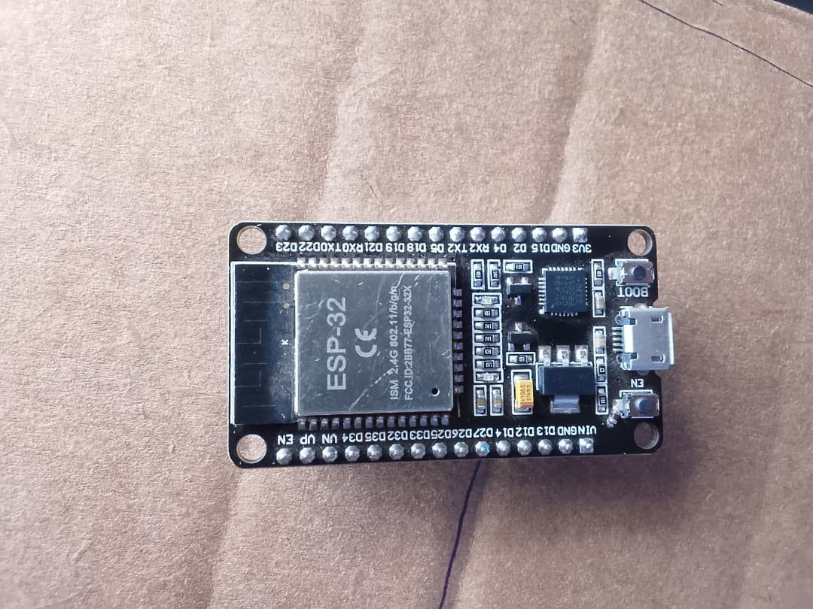
Figure 1 — ESP32 Development Board

2.1 Sensors
Each sensor is chosen for its suitability in an indoor study environment. The table below lists the sensors, their measurement targets, and the GPIO pins used.
Sensor | Measures | GPIO Pins
DHT22 | Temperature (°C) and Relative Humidity (%) | GPIO 4 (single-wire, 10 kΩ pull-up to 3.3 V)
HC-SR501 | Passive infrared motion (PIR) — counting movement events | GPIO 27 (rising-edge interrupt)
GL5528 LDR | Ambient light via voltage divider | GPIO 34 (ADC1, input-only)
INMP441 | Sound pressure via I2S digital microphone | GPIO 14 (SCK), 15 (WS), 32 (SD)

2.2 Sensor Hardware
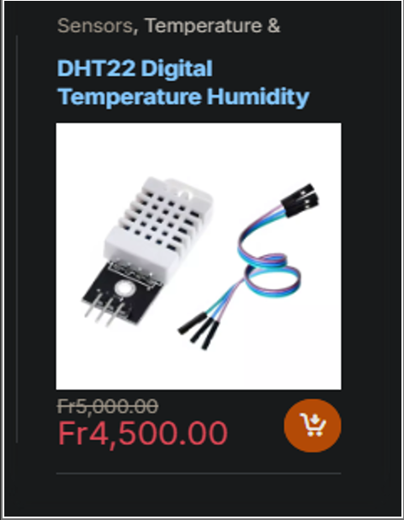
Figure 2 — DHT22 Temperature & Humidity Sensor
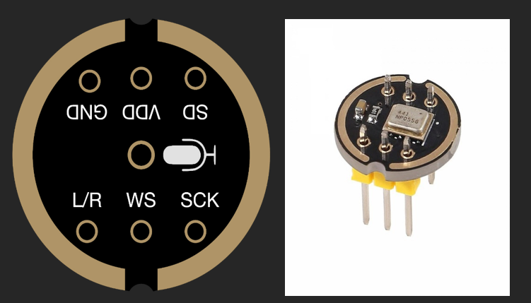
Figure 3 — INMP441 I2S Microphone
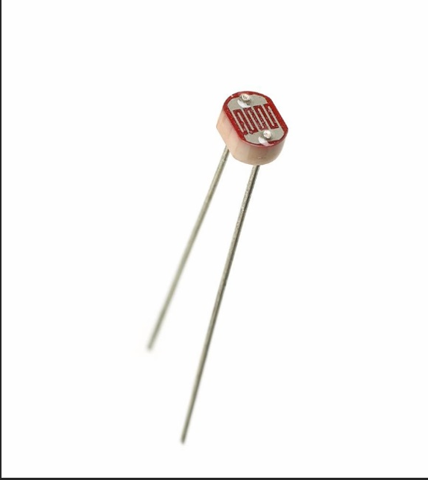
Figure 4 — GL5528 LDR Light Sensor
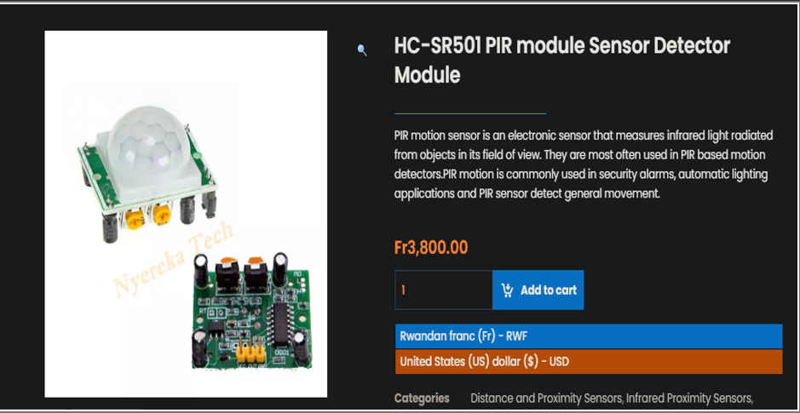
Figure 5 — HC-SR501 PIR Motion Sensor

2.3 Wiring
All sensors operate at 3.3 V logic, which matches the ESP32's GPIO voltage. The key wiring points are:
- DHT22: DATA → GPIO 4, with a 10 kΩ pull-up resistor between DATA and 3.3 V. Without the pull-up the single-wire protocol fails.
- HC-SR501: OUTPUT → GPIO 27 configured as a rising-edge interrupt so every detected motion burst increments a counter in IRAM without blocking the main loop.
- GL5528 LDR: Wired as a voltage divider with a 10 kΩ fixed resistor between 3.3 V and GND. The ADC reads the mid-point. Higher light → lower LDR resistance → higher voltage → higher ADC count.
- INMP441: SCK → GPIO 14, WS → GPIO 15, SD → GPIO 32. The L/R pin is tied to GND so the mic always outputs on the left I2S channel.

2.4 Configuration (config.h)
All user-configurable constants live in a single header file so the firmware can be re-flashed for any room without touching the core logic.
#define WIFI_SSID "your_wifi_name"
#define WIFI_PASSWORD "your_wifi_password"
#define BACKEND_URL "http://192.168.x.x:8000/api/ingest"
#define ROOM_ID "your_room_slug"
#define SEND_INTERVAL 5000 // ms between readings
#define DHT_PIN 4
#define PIR_PIN 27
#define LDR_PIN 34
#define I2S_SCK_PIN 14
#define I2S_WS_PIN 15
#define I2S_SD_PIN 32
#define I2S_SAMPLE_COUNT 1024 // ~23 ms of audio at 44100 Hz
#define CAT_OFFSET_SEC 7200 // UTC+2, no DST

2.5 Main Loop
The main loop uses non-blocking timing so the PIR interrupt counter is never frozen by a long delay. Every 5 seconds it:
- Reads all sensors via readSensors()
- Builds a JSON payload manually (no ArduinoJson dependency needed)
- Checks WiFi is still connected before attempting the HTTP call
- HTTP POSTs the payload to /api/ingest and logs the response code
- Calls http.end() to release the TCP socket — skipping this exhausts the ESP32 socket table after ~4 hours

2.6 Key Code: Reading the INMP441 Microphone
The microphone uses the I2S digital protocol. The firmware reads 1024 samples into a buffer, then computes the Root Mean Square (RMS) amplitude. The INMP441 left-justifies 24-bit audio in a 32-bit I2S frame, so each sample is right-shifted by 8 before squaring to remove the zero-padding.
int32_t samples[I2S_SAMPLE_COUNT];
size_t bytesRead = 0;
i2s_read(I2S_NUM_0, samples, sizeof(samples), &bytesRead, portMAX_DELAY);
int64_t sumSquares = 0;
for (int i = 0; i < samplesRead; i++) {
int32_t sample = samples[i] >> 8; // remove 8-bit zero padding
sumSquares += (int64_t)sample * sample;
}
data.soundRms = (int)sqrt((double)sumSquares / samplesRead);

2.7 NTP Time Synchronisation
The ESP32 has no real-time clock battery. On first boot it contacts pool.ntp.org to sync its internal clock to Central Africa Time (UTC+2). Every payload timestamp is formatted as ISO 8601 with an explicit +02:00 offset so the backend's Pydantic parser interprets it correctly and PostgreSQL stores it normalised to UTC.
strftime(buf, sizeof(buf), "%Y-%m-%dT%H:%M:%S+02:00", &timeinfo);

3. Backend — FastAPI & PostgreSQL
The backend is a Python FastAPI application backed by a PostgreSQL database. It receives raw sensor payloads from the ESP32, applies physical unit conversions, computes a comfort score, classifies the reading, detects anomalies, and exposes a REST API consumed by the React frontend.

3.1 Tech Stack
Component | Role
FastAPI | Async Python web framework — automatic OpenAPI docs at /docs
SQLAlchemy (async) | ORM for database access with asyncpg driver
PostgreSQL | Time-series sensor readings storage
Pydantic v2 | Request/response validation and serialisation
joblib + scikit-learn | Load trained ML models at startup for /predict endpoint

3.2 Sensor Transforms (transforms.py)
This module converts raw ESP32 values into meaningful physical units. It has no database imports — every function is independently testable.
adc_to_lux(adc_value) — Converts the 12-bit LDR ADC count to lux using the GL5528 inverse power-law: lux ≈ 500 / (R_kΩ ^ 0.7). First recovers the voltage from the ADC count, then back-calculates the LDR resistance from the voltage divider equation, then applies the empirical curve.
rms_to_db(rms_value) — Converts raw INMP441 RMS amplitude to dB SPL. Anchored so that 420,426 RMS reads as 94 dB SPL (INMP441 datasheet sensitivity at 1 kHz, 1 Pa). Formula: dB_SPL = 20 × log10(rms / 420426) + 94
compute_movements_per_min(motion_count) — Scales the 5-second PIR interrupt count to per-minute rate: count × 12 (because 60 s / 5 s = 12 windows per minute).
apparent_temperature(T, RH) — Australian Bureau of Meteorology formula: AT = T + 0.33 × e − 4.0 where e is partial vapour pressure. Combines temperature and humidity into a single physiological heat perception value.
compute_comfort_score(...) — Three-component composite score (0–100): Thermal (40 pts) from apparent temperature, Acoustic (35 pts) from sound dB with crowding amplifier, Visual (25 pts) from lux. Based on ASHRAE 55-2023 and WHO Noise Guidelines.
classify_reading(...) — Applies priority-ordered rules to assign one of eight labels: poor, warm, humid, noisy, dim, crowded, moderate, comfortable.
run_all_transforms(payload, thresholds) — Single entry point called by the ingest route — runs all conversions and returns a dict ready to merge into the database row.

3.3 API Endpoints
Endpoint | Description
POST /api/ingest | Main endpoint consumed by the ESP32. Validates the payload with Pydantic, confirms the room_id exists, runs all transforms, writes the reading to sensor_readings, then runs anomaly detection and writes any flags to the anomalies table. Returns HTTP 201 on success.
GET /api/rooms | Lists all registered rooms ordered by creation date.
POST /api/rooms | Creates a new room. The room name is automatically slugified (e.g. 'Library Floor 2' → 'library_floor_2') for use as the room_id.
DELETE /api/rooms/{room_id} | Removes a room and all associated readings (cascade).
GET /api/rooms/{room_id}/readings | Returns paginated raw readings for a room (limit/offset query params).
GET /api/rooms/{room_id}/latest | Returns the single most recent reading — used by the dashboard live tile.
GET /api/rooms/{room_id}/summary | Returns avg/min/max for all six metrics over the last 24 hours.
GET /api/rooms/{room_id}/label-distribution | Returns label counts for the last 24 hours — used by pie/bar charts.
GET /api/rooms/{room_id}/correlation | Computes and returns the 5×5 Pearson correlation matrix for the last N readings.
GET /api/rooms/{room_id}/predict | Runs the latest reading through the trained Random Forest classifier and returns the predicted label, confidence, and feature importances.
GET /api/anomalies | Returns recent anomaly events with metric name, value, and plain-English reason.
GET /api/thresholds | Returns the current comfort thresholds used in scoring and classification.
PUT /api/thresholds | Updates thresholds — changes take effect immediately for all future readings.

3.4 Anomaly Detection
After every successful ingest, the backend checks whether any metric exceeds wider 'anomaly bounds' — deliberately set beyond the comfort thresholds to catch physically unusual events rather than minor discomfort:
- Apparent temperature > temp_max + 5 °C or < temp_min − 5 °C → possible HVAC failure
- Humidity > 78% → condensation/mould risk | < 28% → excessively dry air
- Sound > sound_max + 18 dB → acoustic spike event
- Light < 100 lux → lamp failure | > 900 lux → direct sunlight / fixture fault
- Movement > motion_max × 3 → unusual occupancy event

4. Frontend — React Dashboard
The dashboard is built with React, TypeScript, and Tailwind CSS. It runs entirely in the browser and communicates with the backend through the REST API. Five pages cover all monitoring and management needs.

4.1 Rooms (Home)
Lists all registered rooms with their current comfort score and label. Colour-coded badges show the label at a glance. Clicking a room opens the Room Detail page.
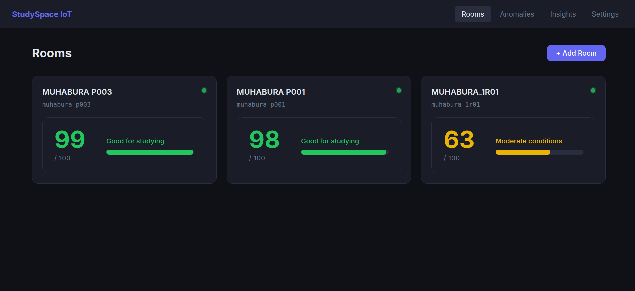
Figure 6 — Rooms overview page

4.2 Room Detail
Shows live sensor readings for a selected room: temperature, humidity, sound, light, and motion tiles update from the /latest endpoint. Includes a 24-hour summary table with avg/min/max for every metric and a label distribution chart.
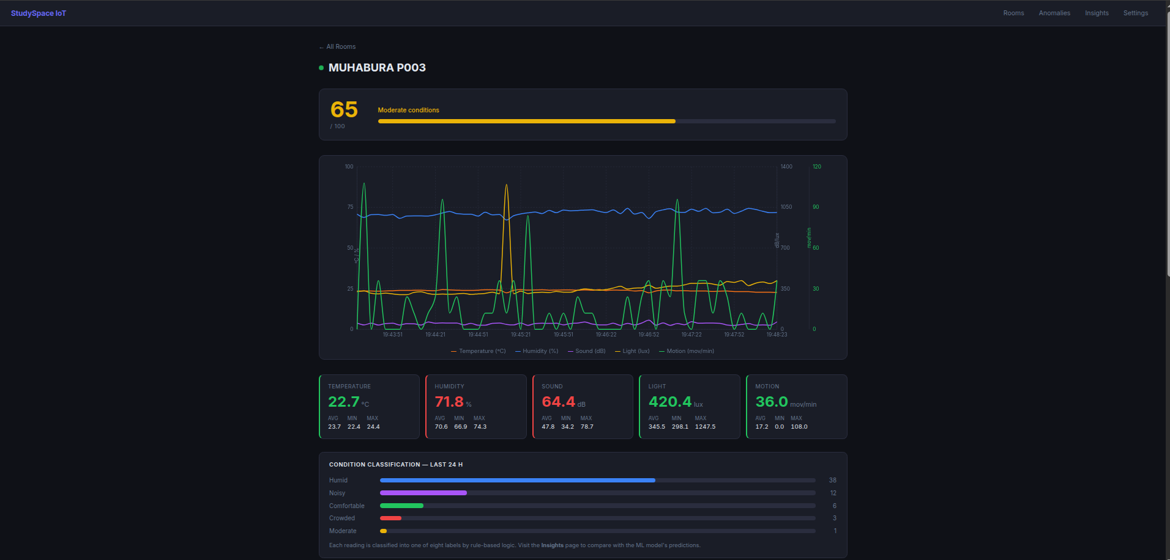
Figure 7 — Room detail page

4.3 Metric Detail
Drill-down page for a single metric. Shows a time-series chart of the last N readings and the 24-hour summary statistics.
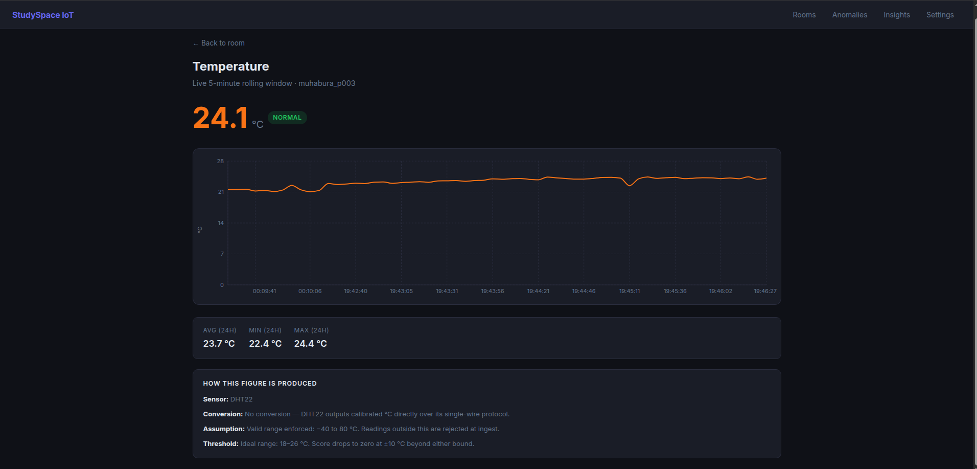
Figure 8 — Temperature metric detail page

4.4 Insights
ML-powered page. Fetches predictions from /predict and displays the predicted label, confidence percentage, and a horizontal bar chart of feature importances showing which sensor drove the prediction.
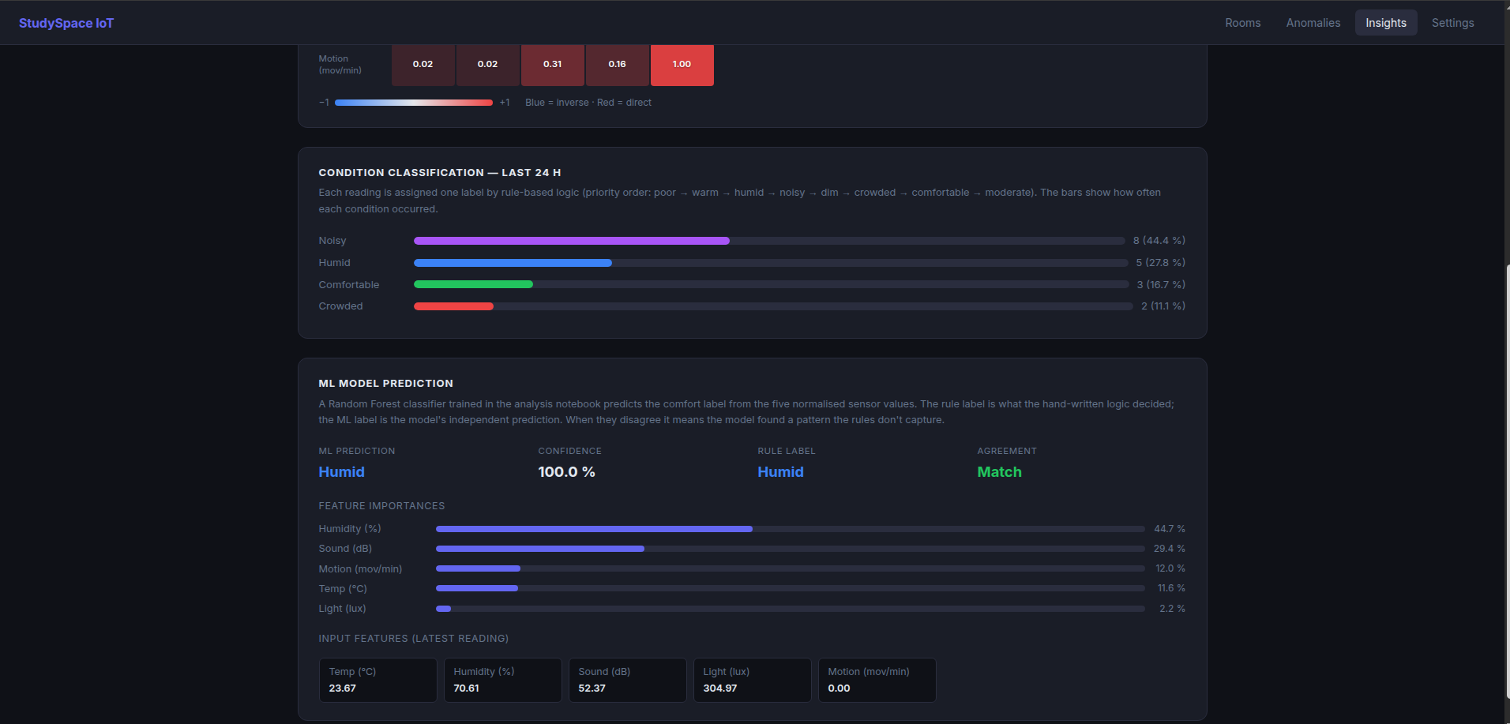
Figure 9 — Insights page with ML predictions

4.5 Anomalies
Lists all anomaly events in reverse chronological order. Each card shows the metric name, the measured value, and a plain-English reason generated by the backend's anomaly detection logic.
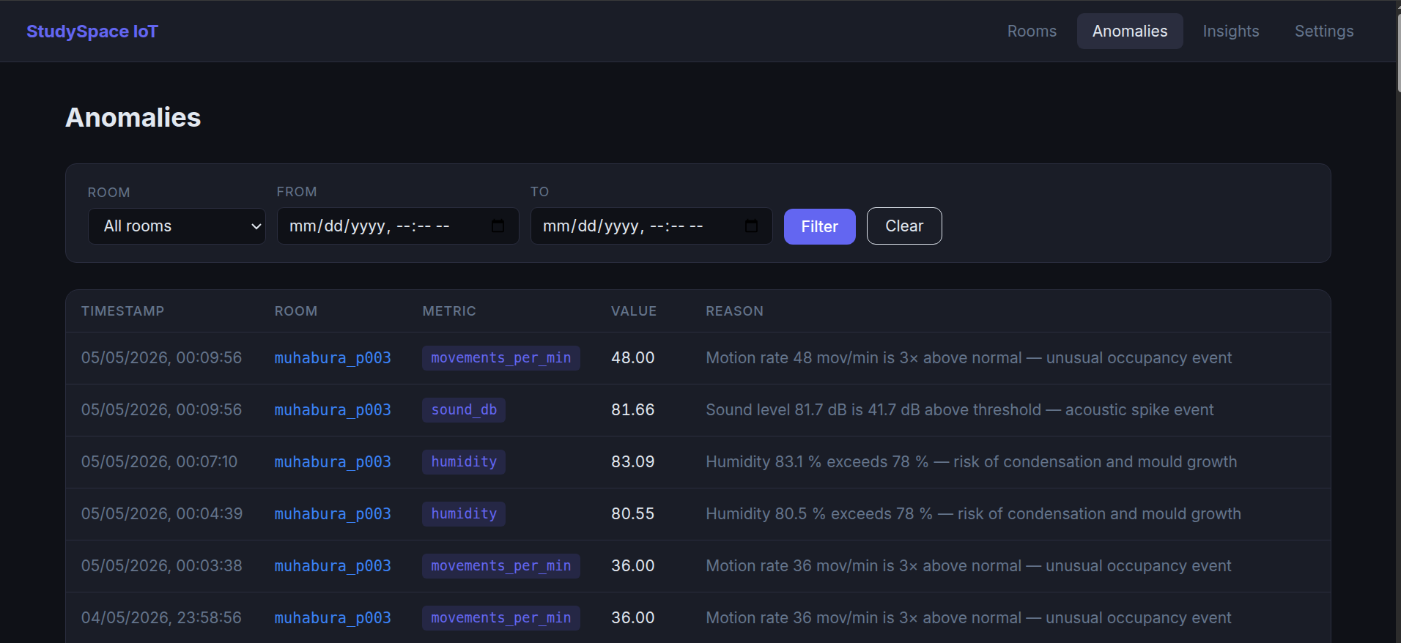
Figure 10 — Anomalies page

4.6 Settings
Form to update the comfort thresholds (temp range, humidity, sound, light, motion limits). Changes take effect immediately via PUT /api/thresholds.
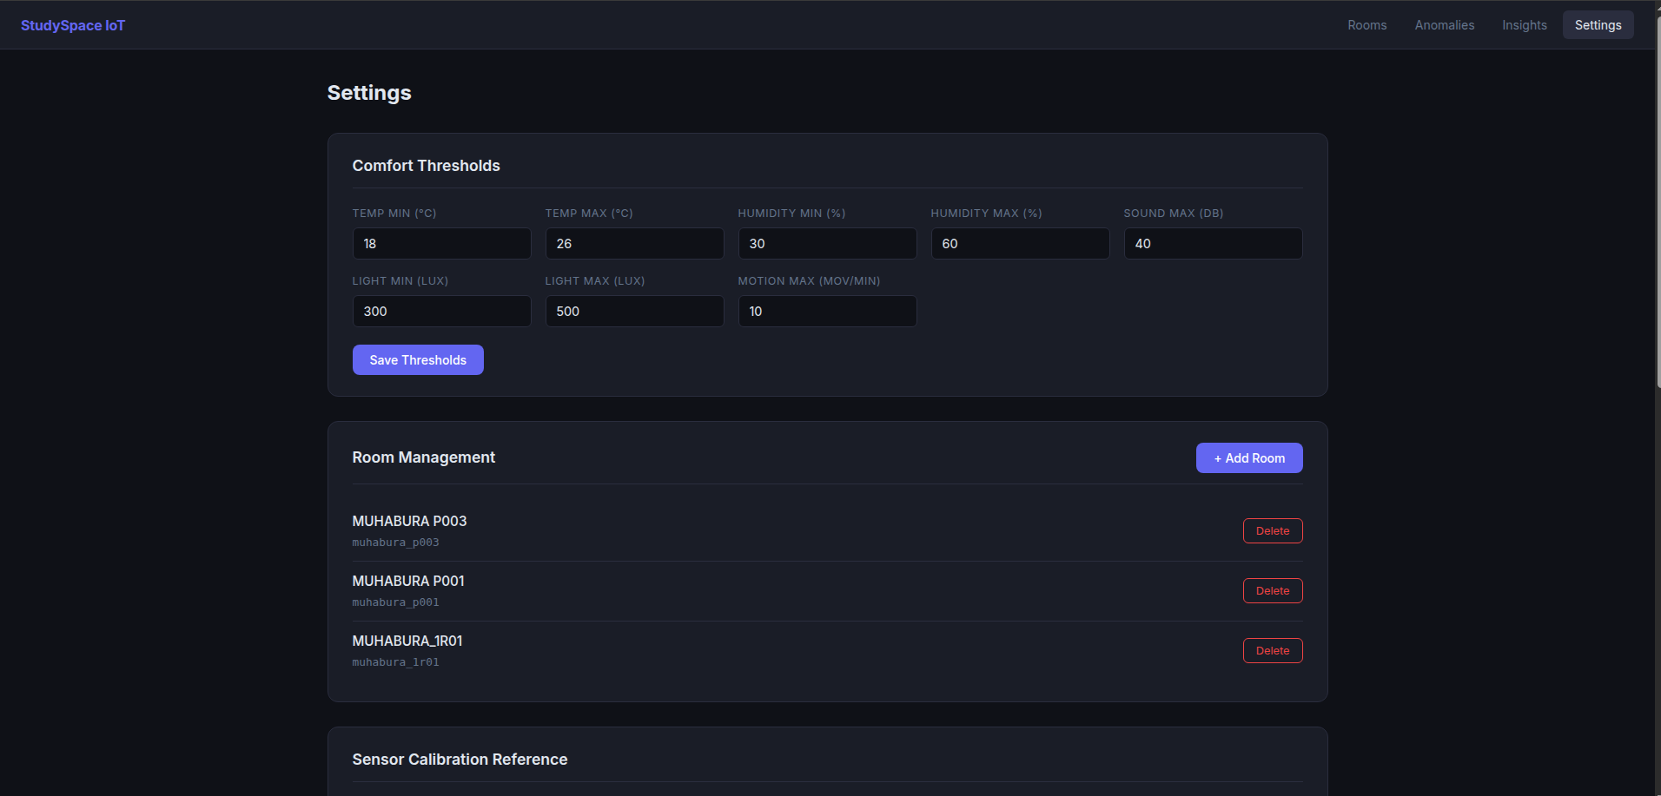
Figure 11 — Settings page

5. Data Analysis & Machine Learning
The analysis is performed in a Jupyter Notebook (analysis/studyspace_analysis.ipynb). It runs once after sufficient data is collected and saves two model files to the backend — comfort_classifier.pkl and feature_scaler.pkl — which the Insights page then uses for live predictions.

5.1 Pipeline Overview
PostgreSQL → Clean → Normalise → Visualise → Correlate
→ Detect Outliers → Train Classifiers → Train Regressors
→ Save .pkl files → Backend serves predictions

5.2 Data Loading & Cleaning
Data is loaded from PostgreSQL using pandas read_sql with the psycopg2 driver (the asyncpg driver used by FastAPI is incompatible with synchronous pandas calls). After loading, rows with missing sensor values are dropped and time features (hour, weekday, is_weekday) are added. Labels are encoded as integers for ML in alphabetical order: comfortable=0, crowded=1, dim=2, humid=3, moderate=4, noisy=5, poor=6, warm=7.

5.3 Normalisation
All five sensor features are scaled to [0, 1] using Min-Max normalisation:
x_scaled = (x − x_min) / (x_max − x_min)
The scaler is fitted once on the training data and saved alongside the model. At prediction time, the same scaler is applied to new readings — this ensures the model always sees the same scale it was trained on.

5.4 Time-Series Visualisation
A sanity check — plots the last 500 readings to confirm sensors behave as expected before training.
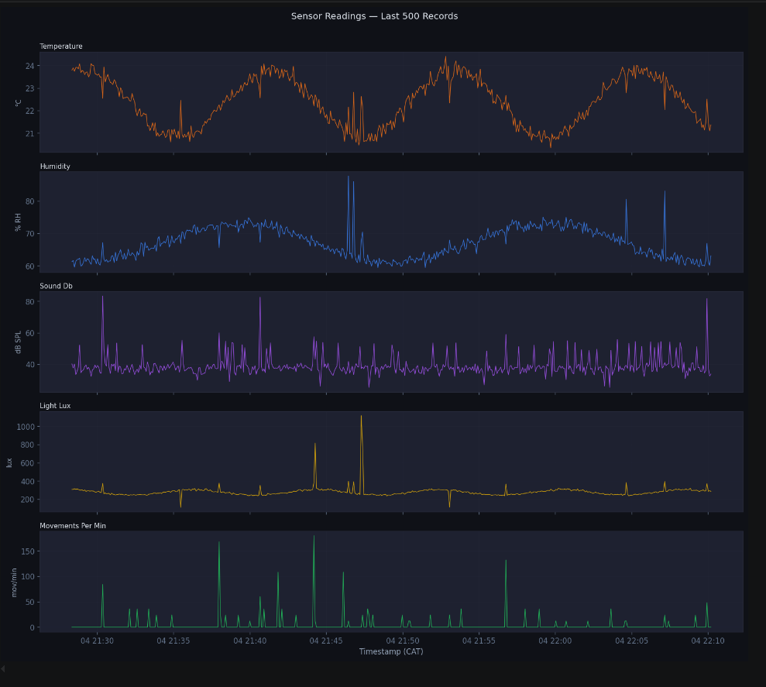
Figure 12 — Time-series sensor readings (last 500 records)

5.5 Correlation Analysis
A Pearson correlation heatmap identifies linear relationships between sensors. Correlation coefficient r ranges from −1 (perfect inverse) to +1 (perfect positive). Values near 0 mean the sensors are independent. This informs feature selection and helps explain why certain labels co-occur.
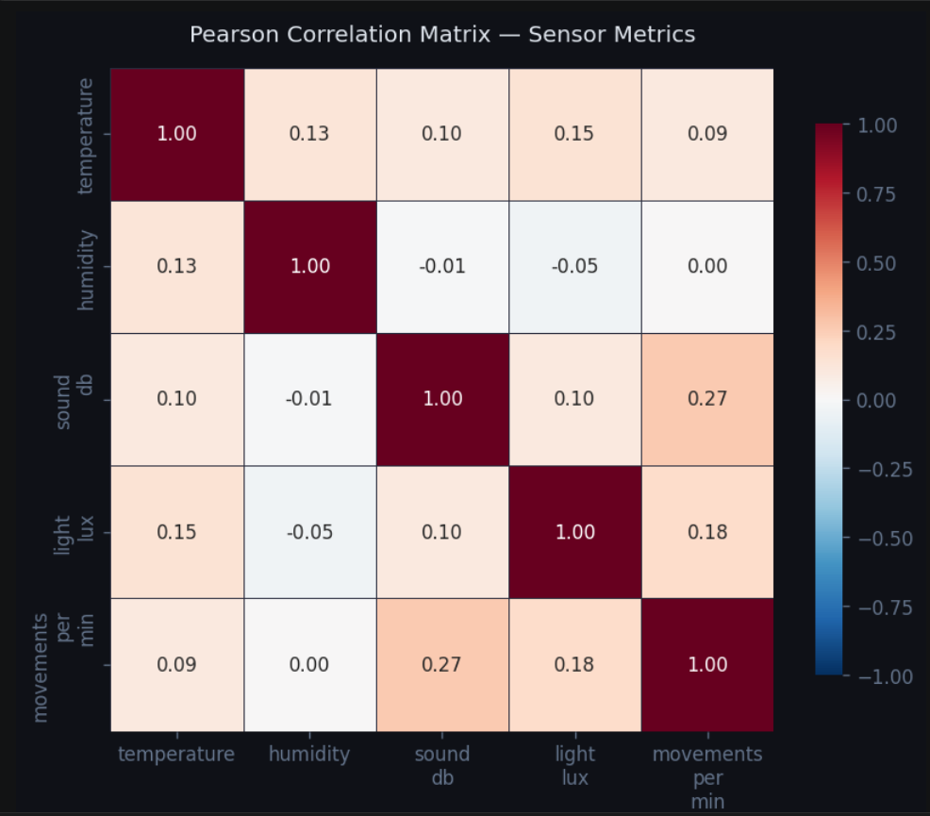
Figure 13 — Pearson correlation matrix

5.6 Outlier Detection (IQR Method)
Outliers are flagged using Tukey's IQR fences: any value below Q1 − 1.5×IQR or above Q3 + 1.5×IQR is an outlier. Approximately 11% of readings are flagged. The clean dataset (outliers removed) is used for regression modelling.
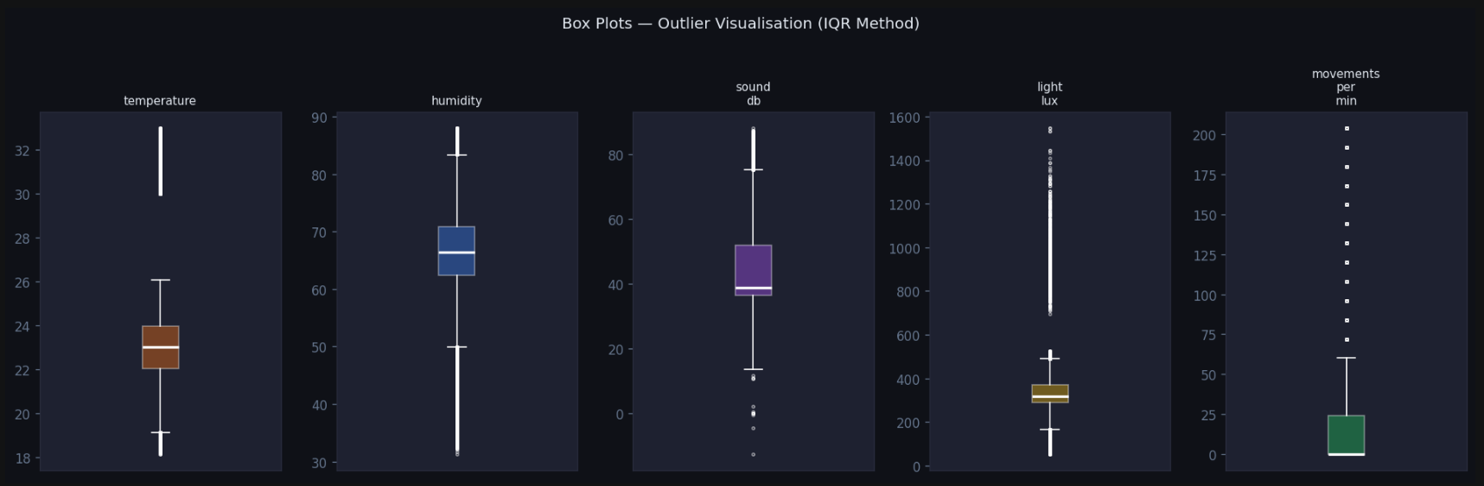
Figure 14 — Box plots showing outlier distribution per metric

5.7 Classification Models
Three classifiers are trained on the labelled dataset to predict one of eight comfort categories from the five sensor features.
Random Forest (99.81% accuracy) — An ensemble of 100 decision trees. Each tree votes for a label and the majority wins. Provides feature importances (what fraction of splits each sensor contributed). Selected as the production model.
Logistic Regression (93.90% accuracy) — A linear model that multiplies each feature by a learned weight, sums them, then applies the softmax function to produce a probability per class. Fast and interpretable but assumes linear decision boundaries.
Decision Tree (99.12% accuracy) — A single tree of up to 6 levels of yes/no questions. Fully transparent — the exact rules can be visualised. Good performance with no hyperparameter tuning.
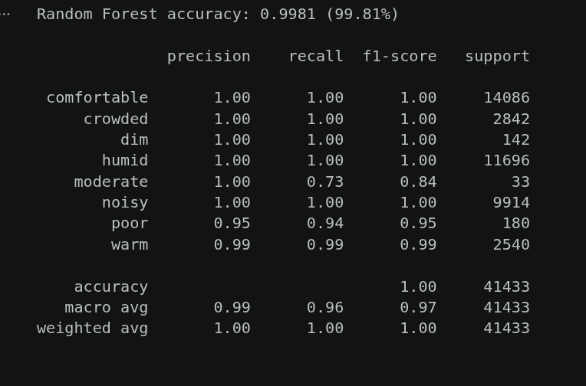
Figure 15 — Random Forest classification report
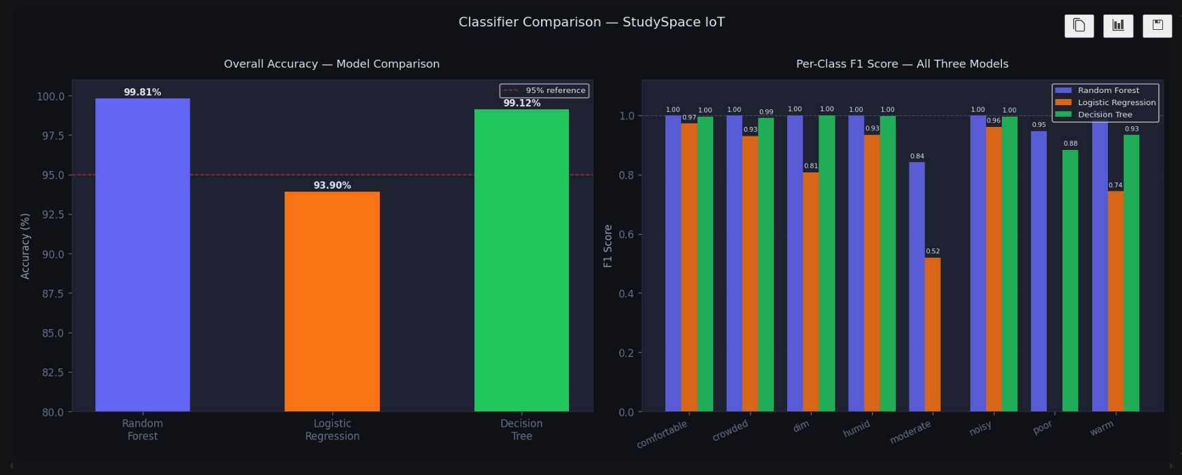
Figure 16 — Model accuracy and per-class F1 comparison

5.8 Confusion Matrix
The confusion matrix shows where the best model (Random Forest) makes mistakes. Rows are actual labels, columns are predicted labels. The diagonal is correct predictions. Off-diagonal cells are errors. With 99.81% accuracy, almost all counts sit on the diagonal.
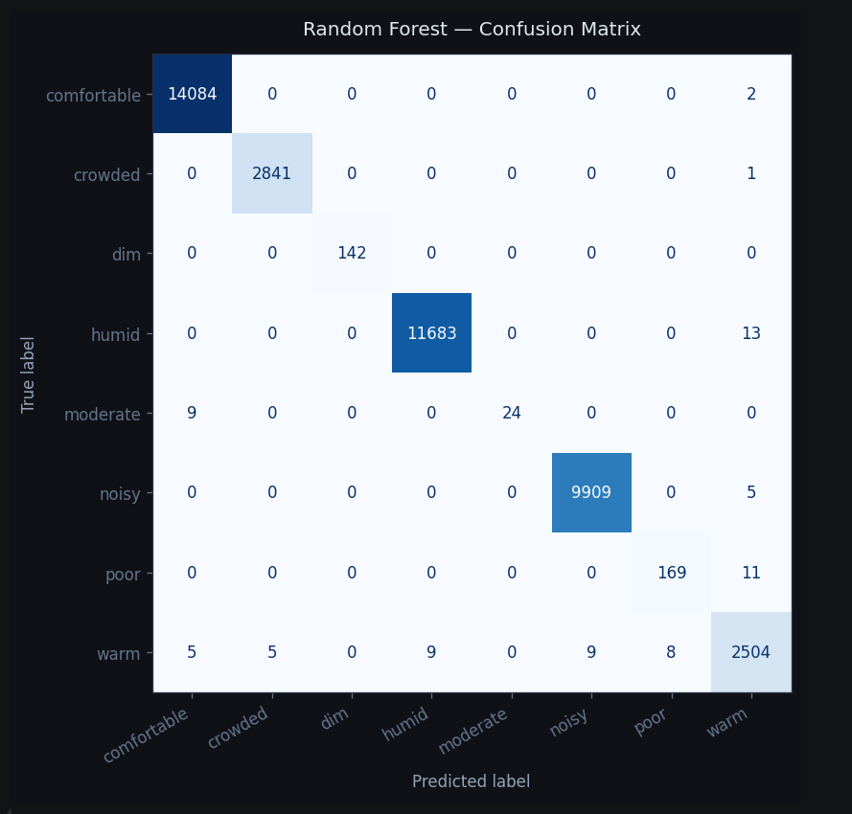
Figure 17 — Random Forest confusion matrix

5.9 Regression Models
Two regression models predict comfort_score (0–100) as a continuous number:
Linear Regression — Fits a weighted sum of the five features. All coefficients are negative — every sensor going up hurts comfort. Sound has the largest impact (−114.4). R²=0.81, RMSE=7.4 points.
Random Forest Regressor — 100 trees each predict a score; the average is the final output. Captures non-linear relationships. R²=0.978, RMSE=2.5 points — off by only 2.5 comfort points on average across the 0–100 scale.
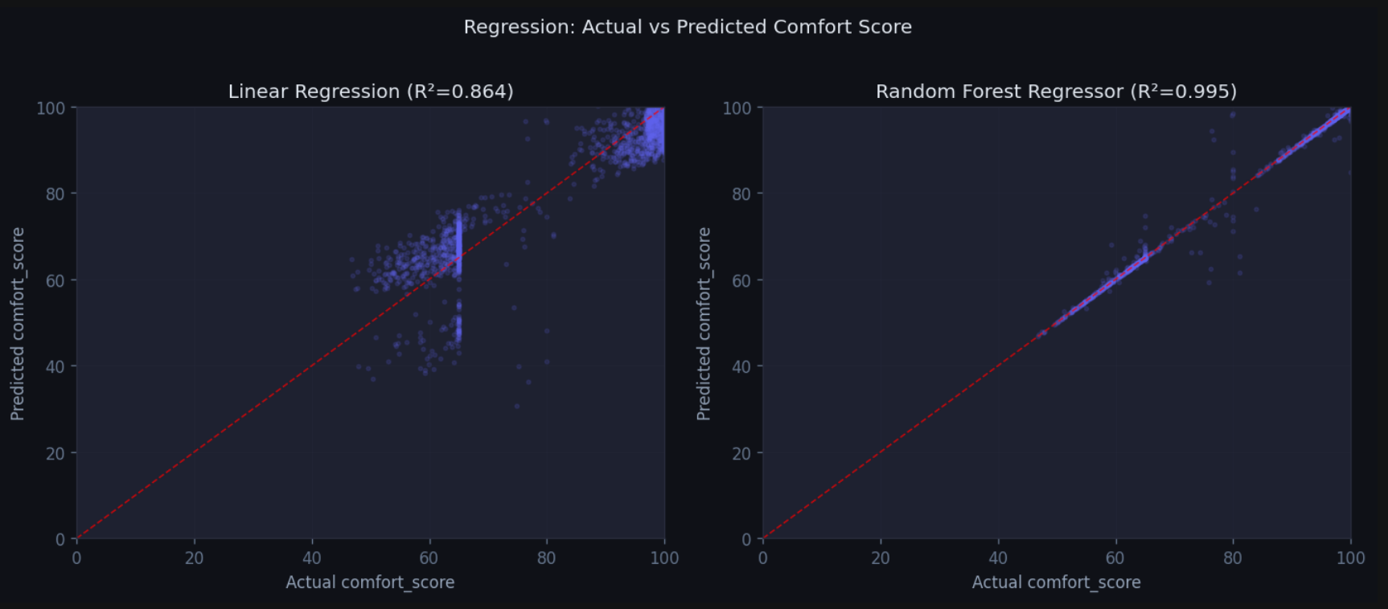
Figure 18 — Actual vs predicted comfort score (Linear vs Random Forest Regressor)

5.10 Saving Models
The trained Random Forest classifier and the fitted MinMaxScaler are serialised with joblib and saved to backend/models/. Both files are required: the model for predictions, the scaler to apply the same normalisation to new readings that was used during training.
joblib.dump(rf_clf, '../backend/models/comfort_classifier.pkl')
joblib.dump(scaler, '../backend/models/feature_scaler.pkl')

6. Conclusion
StudySpace IoT demonstrates a complete IoT pipeline — from hardware sensor nodes through a cloud-connected backend to a machine-learning-powered dashboard. The system successfully classifies study room conditions in real time with 99.81% accuracy using a Random Forest model trained on 207,000 labelled readings, and predicts the composite comfort score to within 2.5 points on a 100-point scale.
The rule-based classification engine and the ML model agree on 99.87% of readings, validating both approaches independently. The three-component comfort score (thermal 40 pts, acoustic 35 pts, visual 25 pts) is grounded in ASHRAE 55-2023, WHO Environmental Noise Guidelines, and EN 12464-1:2021, providing a scientifically defensible measure of study environment quality.
Future work could include CO₂ sensors for air quality, multi-room comparative dashboards, push notification alerts, and student feedback integration to validate and refine the comfort model over time.

