Bike Bear Content Update Mobiuz Studio
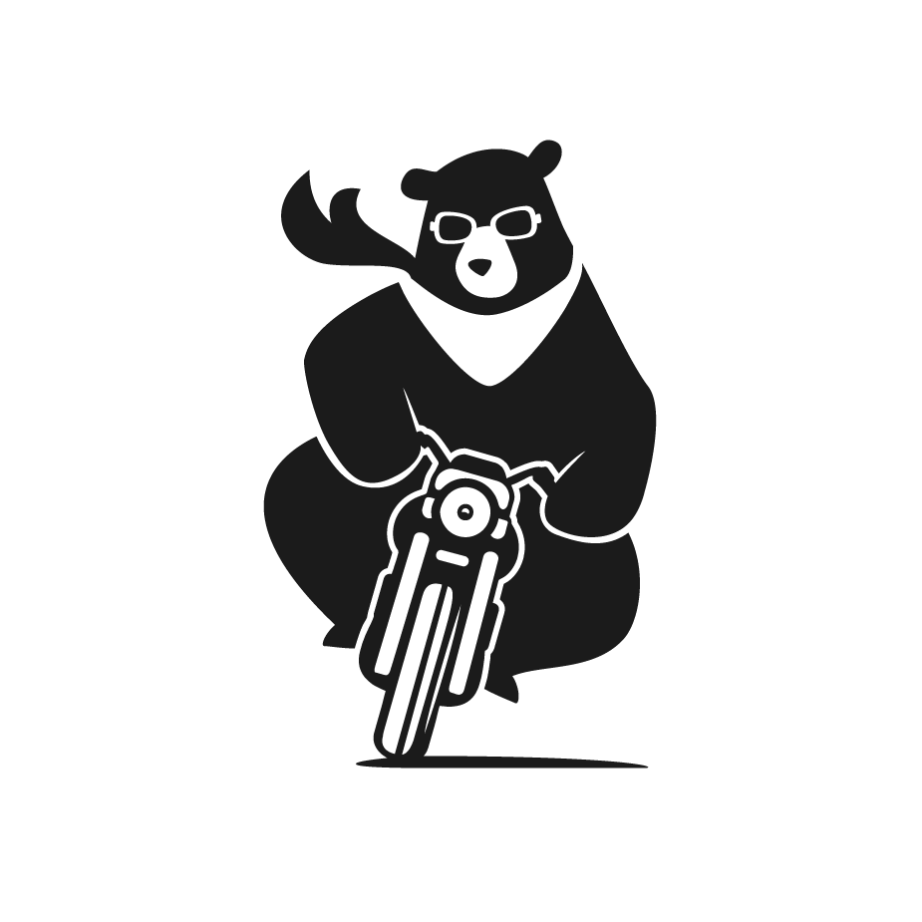

Before You Start
Please take note that cms.mobiuzstudio.com and mobiuzstudio.com are 2 different websites:

A. cms.mobiuzstudio.com is the backend. This is where you log in to update the text, images, videos and works. Your visitors will not see this website.
B. mobiuzstudio.com is the live website that your visitors see. It does not have a login, it takes the content from cms.mobiuzstudio.com and shows it with the website design.

An easy way to think about it: cms.mobiuzstudio.com is the kitchen and mobiuzstudio.com is the dining room. Everything is prepared in the kitchen, and the dining room serves it to your visitors. So whenever you would like to change something on mobiuzstudio.com, you would always do it from cms.mobiuzstudio.com.

How To Login
To access your account, please visit: https://cms.mobiuzstudio.com/mobiuz_cms
where you can enter your username and password. After entering your credentials, click the 'Log in' button to log in. Upon successfully logging in to the website, you will be redirected to the WordPress admin dashboard.
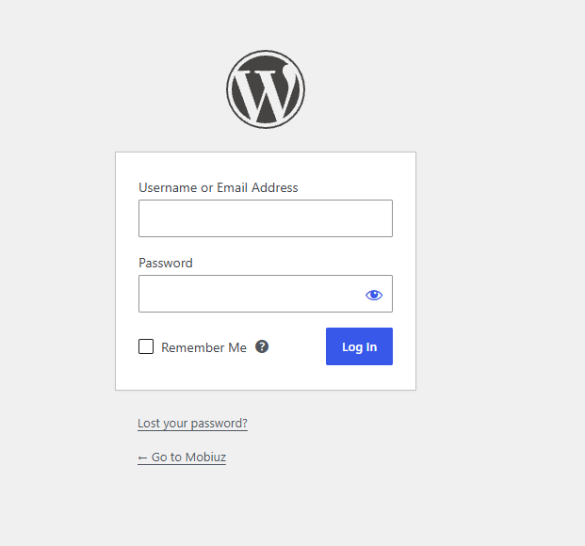

Maintenance Mode
If you need to hide the website from your visitors for a while, you can turn on Maintenance Mode. When it is on, every page on mobiuzstudio.com would show a 'Scheduled Maintenance' screen instead.

To turn it on, click 'Site Settings' at the sidebar, switch 'Maintenance Mode' to On and click 'Update'. It would take about 30 seconds to apply. To bring the website back, switch it to Off and click 'Update' again.

Maintenance Mode only affects mobiuzstudio.com. You can still log in and update the content on cms.mobiuzstudio.com while it is on.
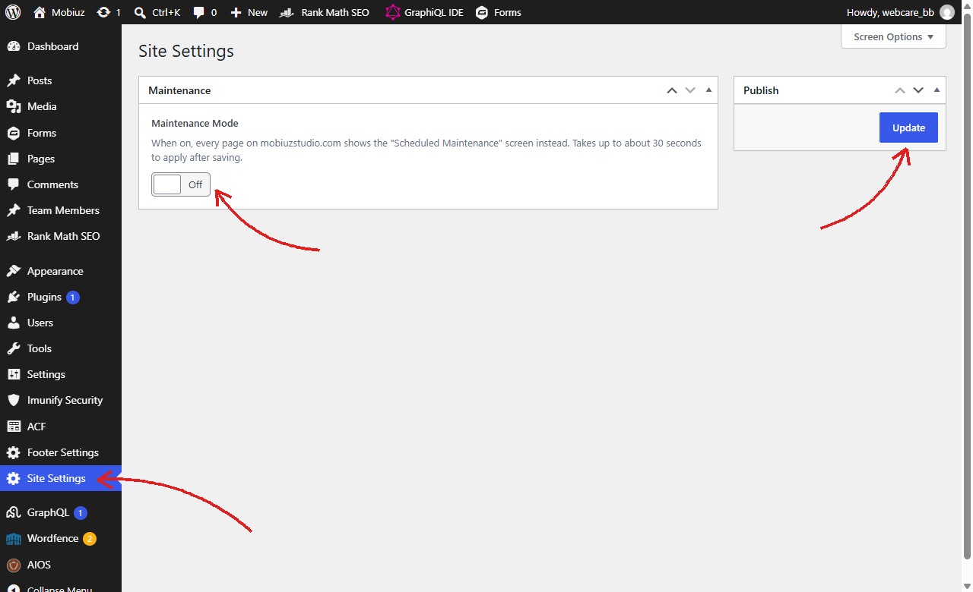
This is what your visitors would see while Maintenance Mode is on:
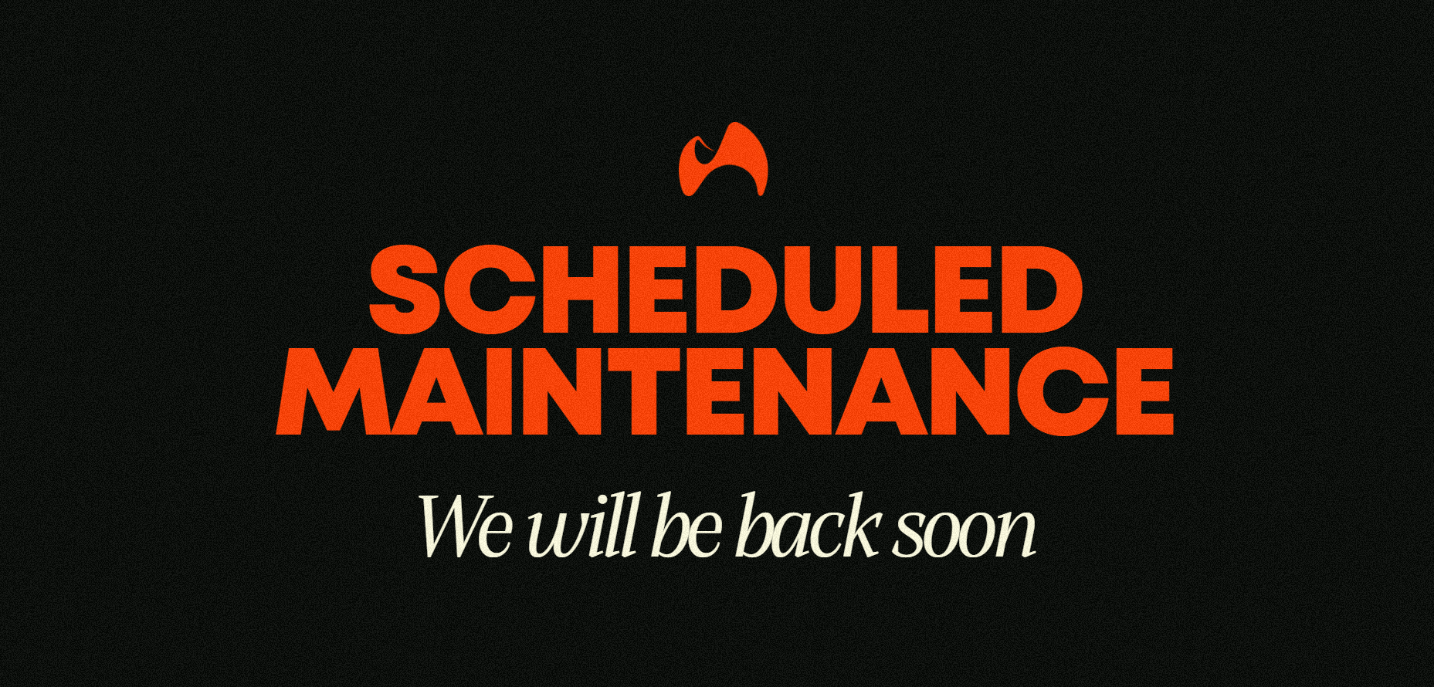

Navigating the Backend
In the backend, you would mainly be updating in 4 places:
A. Pages (Key Pages)
B. Posts ( Inner Pages for Works)
C. Team Member ( The team members that would appear in the about page)
D. Footer Settings ( The contact details and social links at the bottom of every page)

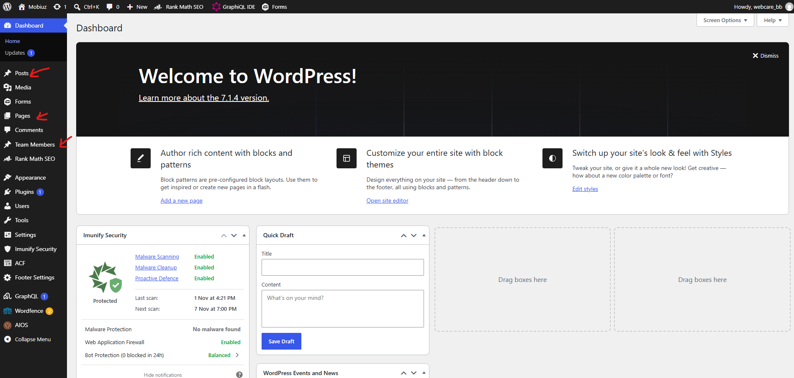

Editing Key Pages
Click Pages and navigate to your desired page to update its contents. Click “Edit”
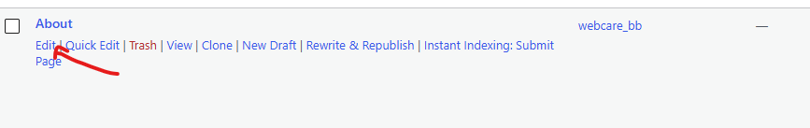

Editing Key Pages Content
The fields shown by the arrows are editable fields that would reflect on the live site.
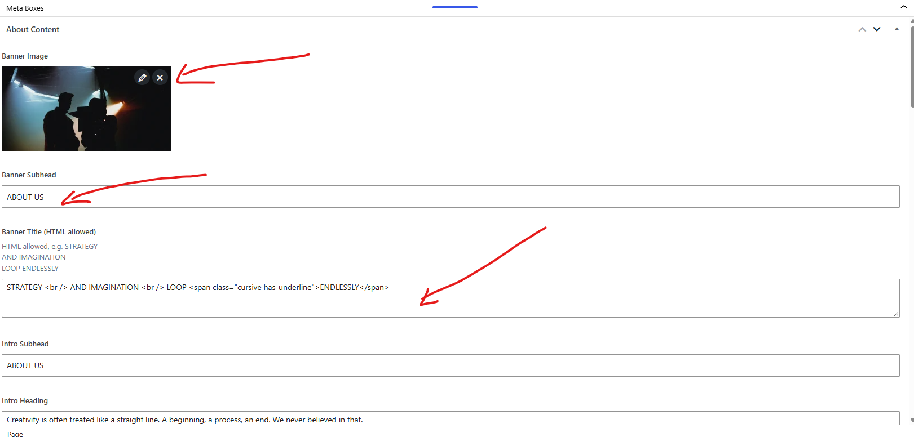

Uploading new media
To upload/edit media navigate to “Media” at the sidebar. The arrows shows a clickable button that would allow you to upload new media to the backend library
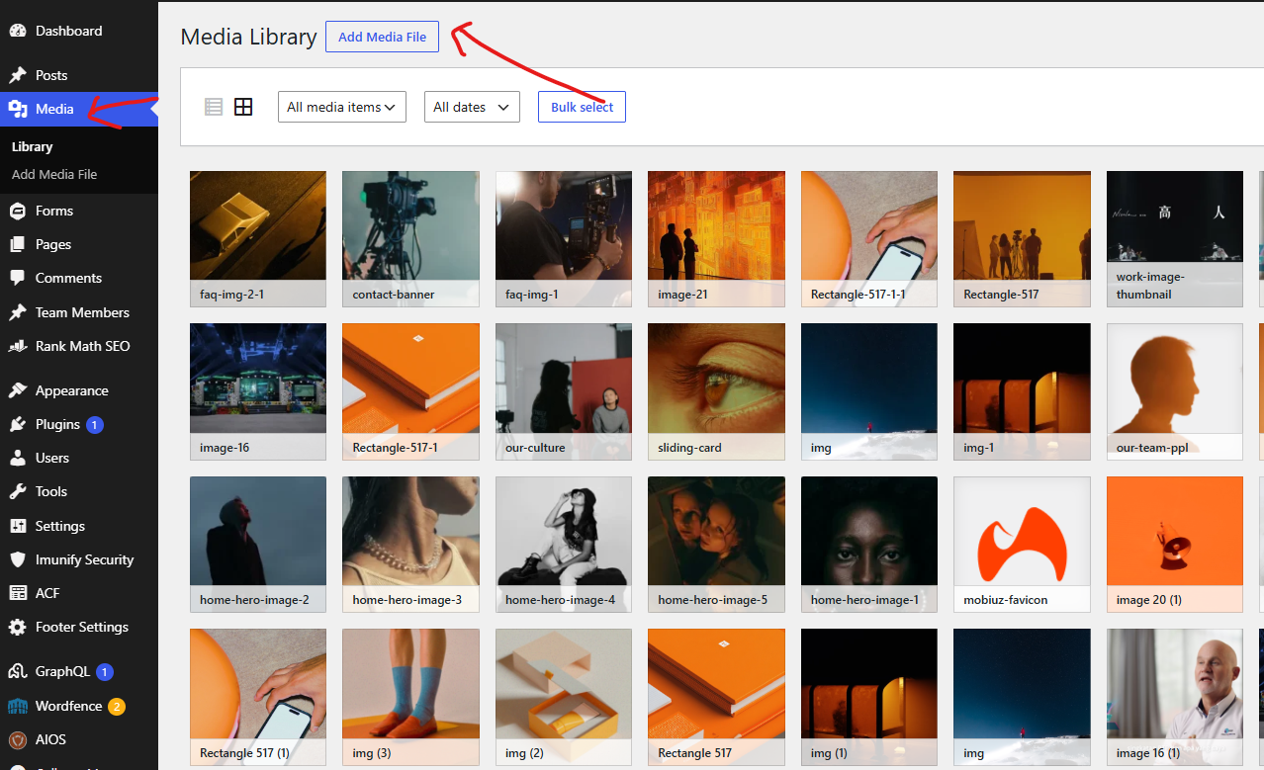

Editing Posts (Works)
On the sidebar on the left you may click the “Posts” link. Inside you will see a list of works that appear here:
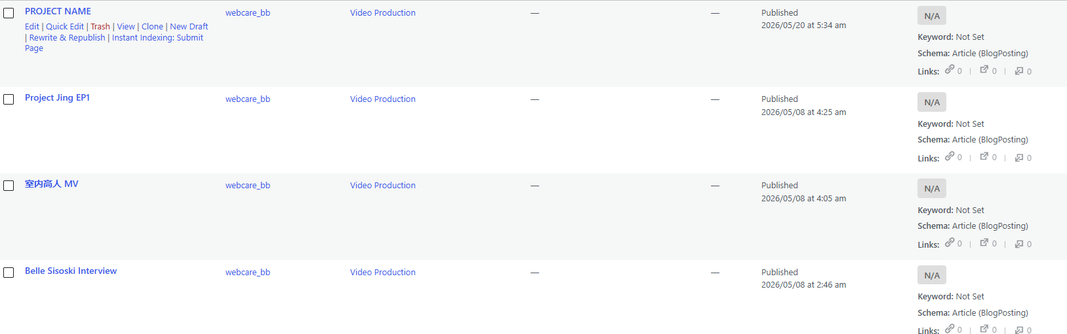
Works can be any of the 4 types: Video Production, Brand Design, Social Media or Experimental Content. They all use the same layout, so the steps are the same for every type.

Uploading a New Work
To add a new work, click 'Posts' then 'Add New Post'. Type the name of the work as the title, then fill in the fields under 'Work Details':

1. Project Name (The client or project name shown under the title)
2. Project Year (The year of the project)
3. Right Side Label (The small label on the right, e.g. video production / interview)
4. Video Link (A YouTube link, Vimeo link or a direct .mp4 video link. You can leave this empty if there is no video, the Featured Image would show at the top instead)
5. Overview Text (The short write up about the work)
6. Image Gallery (The images shown next to the overview)
7. BTS Group (The behind the scenes credits, each with a role and names)
8. Image Banner Hero (The big full width image)
9. Image Masonry (The grid of images near the bottom)

On the right sidebar under 'Categories', tick the type of the work (e.g. 'Brand Design'). Please only tick 1 type. If none is ticked, the work will not show up on the website. You can also set a 'Featured Image' at the top of the sidebar, this would be used as the cover image of the work.

Once done, click 'Publish' (or 'Save' if you are editing an existing work). The work would then be live at mobiuzstudio.com/ followed by the type and the slug of the work, e.g. mobiuzstudio.com/brand-design/your-work (the slug is shown under 'Slug' on the right sidebar).
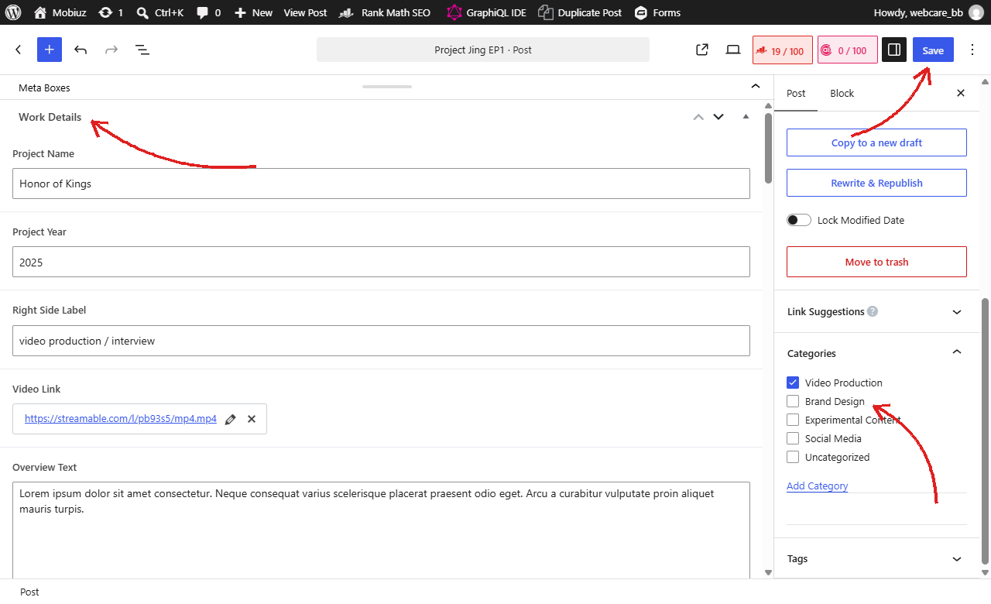

Showing the Work on Its Page
Publishing a work does not add it to the works list on its page by itself. To show it there, click 'Pages' and edit the page for that type (e.g. 'Brand Design'). Scroll down to 'Our Works' and click 'Add Row' at the bottom of the list, then fill in:

1. Work Title (The name shown on the list)
2. Work Image (The thumbnail image)
3. Work Link (Select the work you just published)

Click 'Save' to update. You can also drag the rows by the number on the left to change the order of the works. The 'Next Project' section at the bottom of each work page is automatic, it would show the next 2 works of the same type.
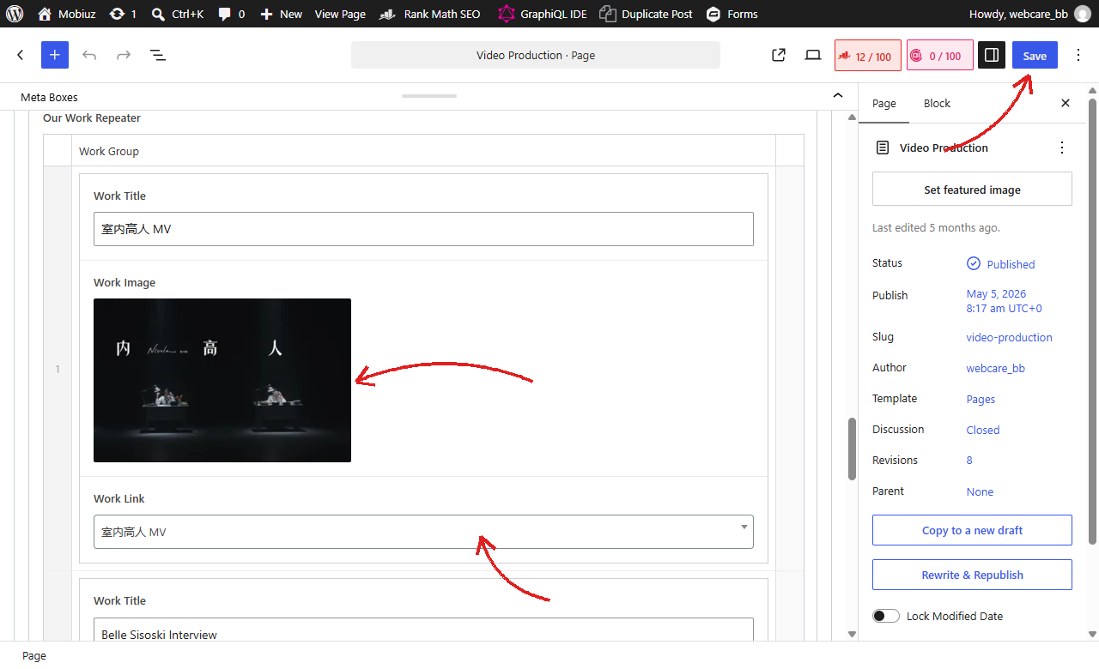

Editing the Footer
The footer is the section at the bottom of every page. To update it, click 'Footer Settings' at the sidebar. The fields here are:

1. Top Title (The big title at the top of the footer)
2. Project Enquiries (The enquiry email address)
3. Address (The office address)
4. Socials (The social media links. Click the pencil icon to edit a link, or 'Add Row' at the bottom to add a new one)

Click 'Update' once you are done. The changes would apply to the footer on every page.
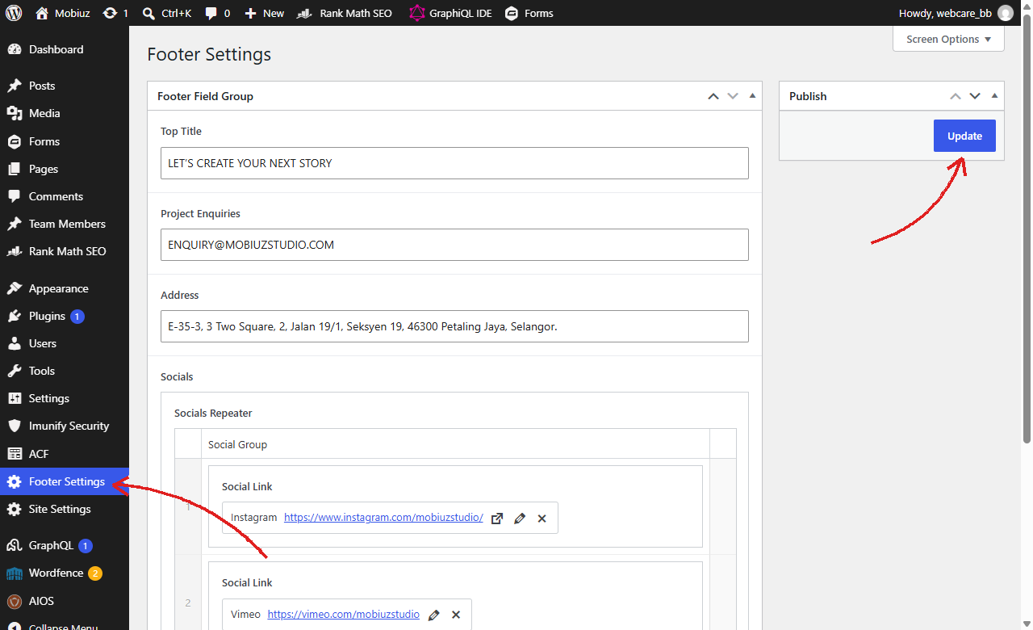

How Long Do Updates Take?
After you click 'Update', 'Save' or 'Publish', the changes would show on mobiuzstudio.com within about 1 minute.

This is because the live website keeps a saved copy of each page so it loads fast for your visitors. About every minute, it checks cms.mobiuzstudio.com for changes and refreshes that copy. If you do not see your changes yet, wait a minute and refresh the page again. You may need to refresh twice, as the first visit is what triggers the update.

Can I Create New Pages?
You can update the content of the existing pages (Home, About, Contact, Video Production, Brand Design, Social Media and Experimental Content) and add new works on your own. However, new pages would need to be designed and built by us.

Each page on the website has its own design that is built into the website, so a new page added from the backend would not have the same look. If you need a new page, please get in touch with Bike Bear and we would help you set it up.

Please also do not delete the existing pages or change their slug, as the live website looks for these pages by their slug. Changing it would cause that page to stop working on the live website.

