Bike Bear Content Update Mobiuz Studio
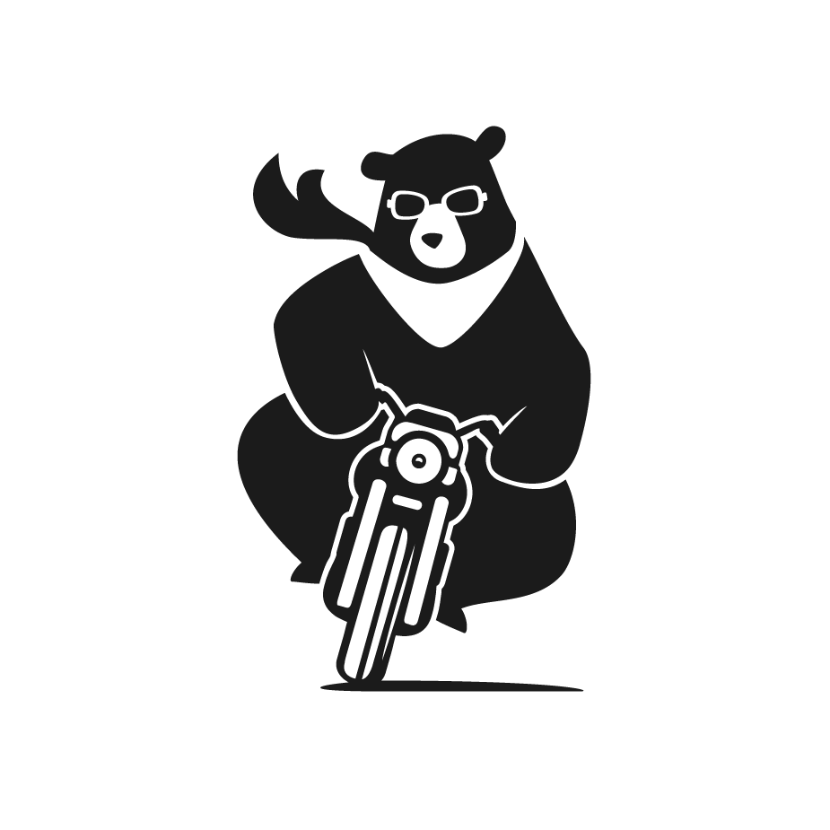

How To Login
To access your account, please visit: https://cms.mobiuzstudio.com/mobiuz_cms
where you can enter your username and password. After entering your credentials, click the 'Log in' button to log in. Upon successfully logging in to the website, you will be redirected to the WordPress admin dashboard.
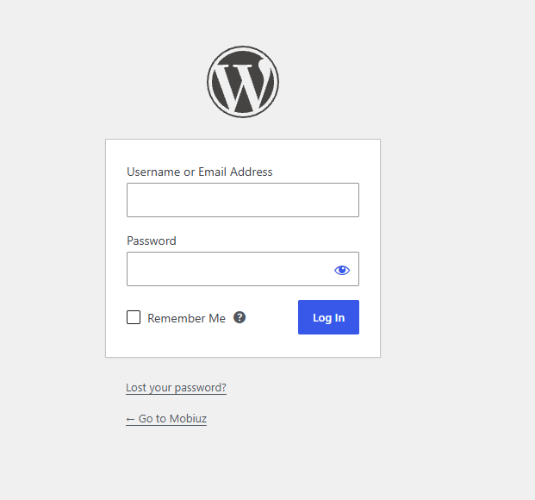

Navigating the Backend
In the backend, you would mainly be updating in 3 places:
A. Pages (Key Pages)
B. Posts ( Inner Pages for Works)
C. Team Member ( The team members that would appear in the about page)

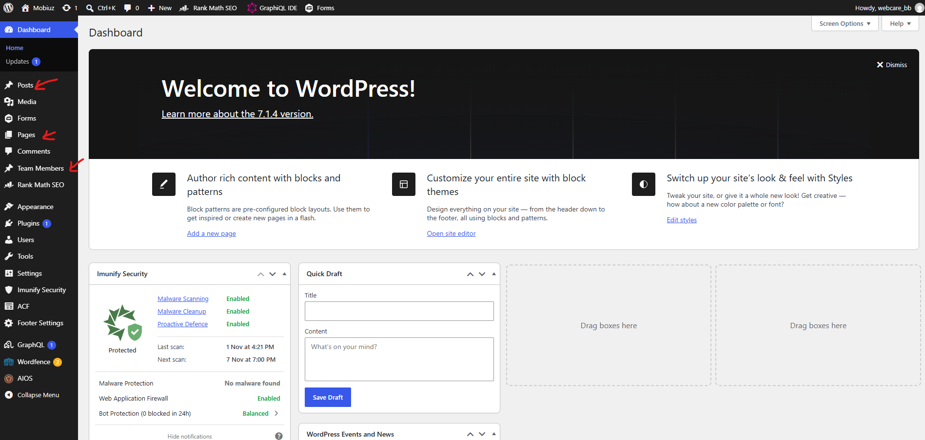

Editing Key Pages
Click Pages and navigate to your desired page to update its contents. Click “Edit”
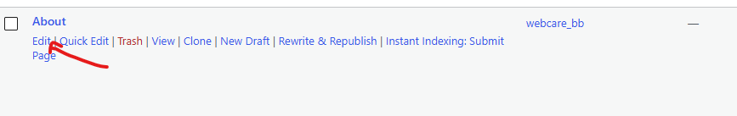

Editing Key Pages Content
The fields shown by the arrows are editable fields that would reflect on the live site.
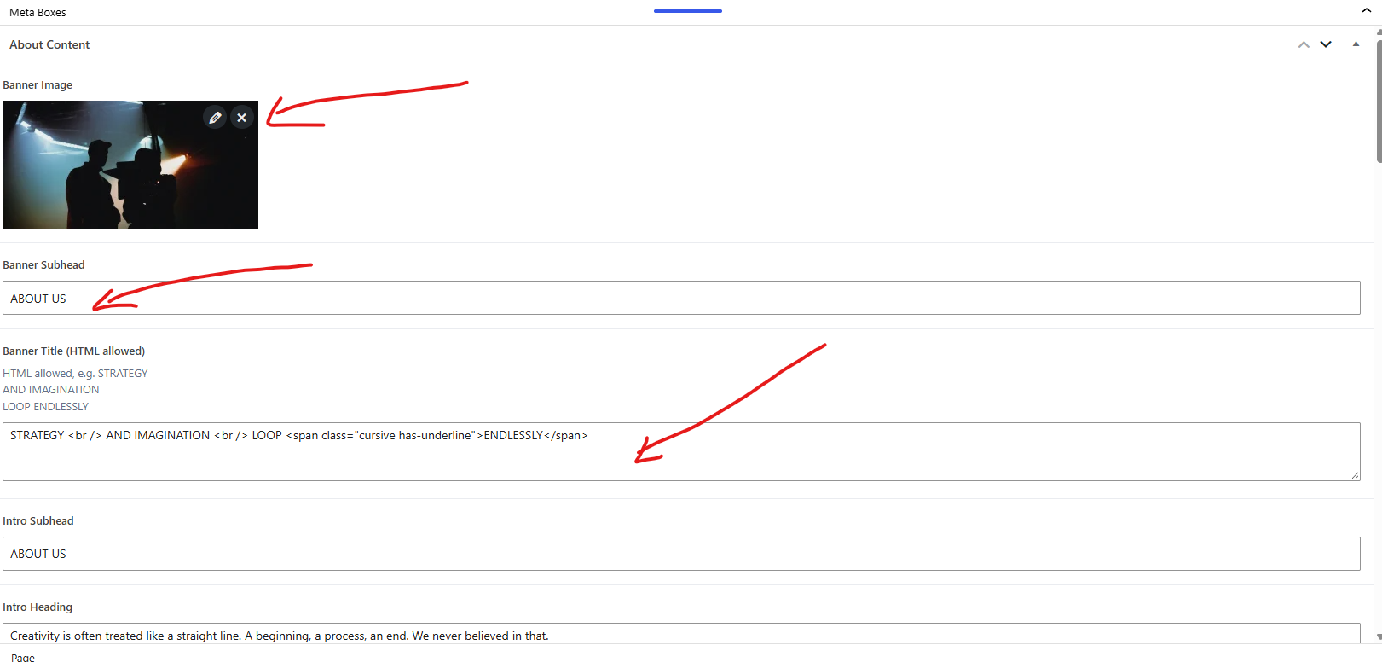

Uploading new media
To upload/edit media navigate to “Media” at the sidebar. The arrows shows a clickable button that would allow you to upload new media to the backend library
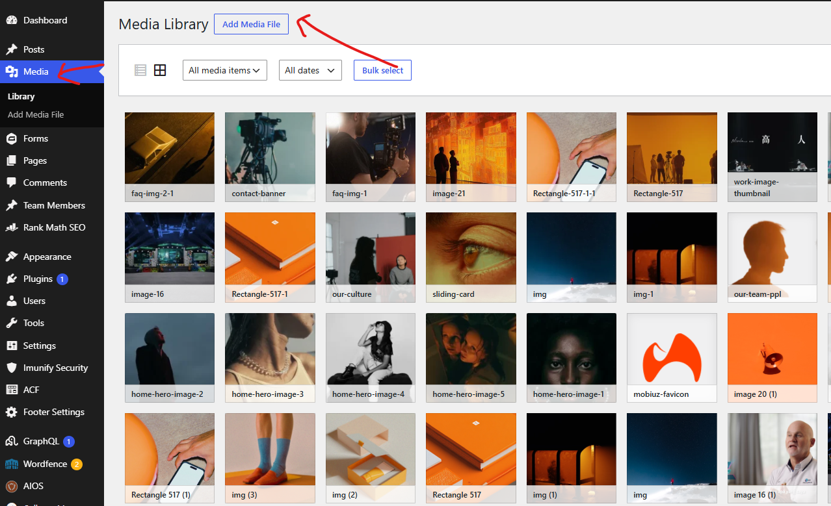

Editing Posts (Works)
On the sidebar on the left you may click the “Posts” link. Inside you will see a list of works that appear here:


