**Occlusion**

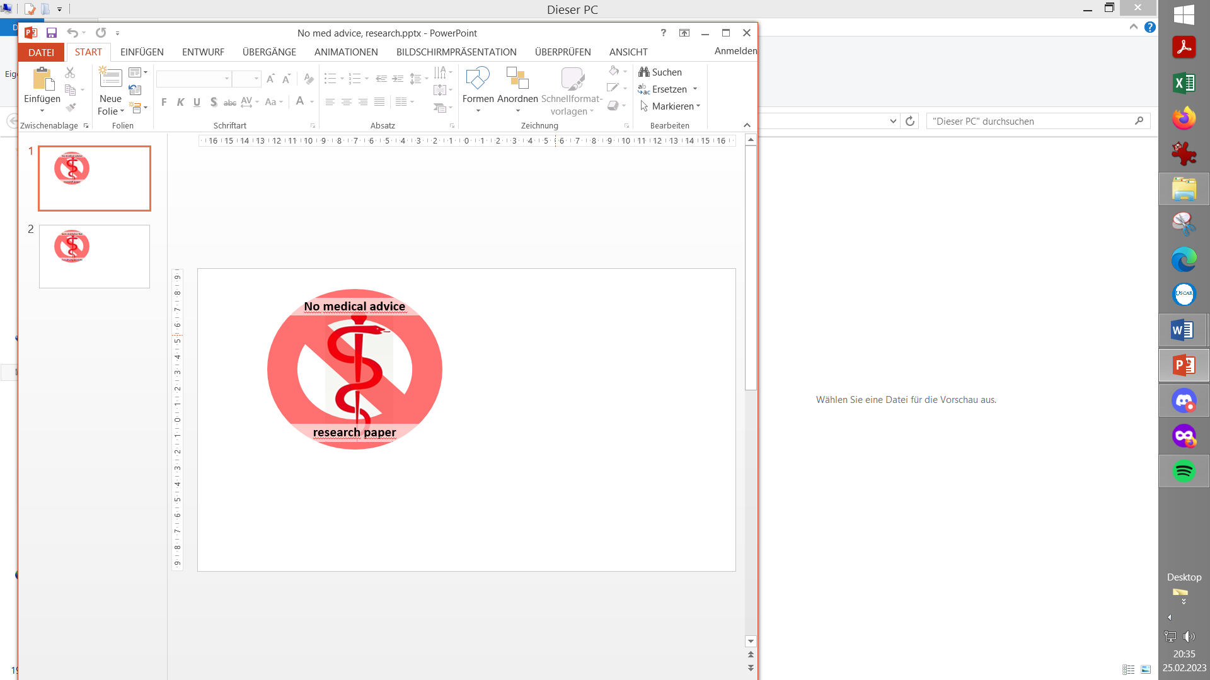

Contribution to the discussion among DIY loopers

The author assumes no liability B/ V.5 Jan’24

1. Signs of an occlusion
2. Ruling out Ketoazidosis
3. Investigating your occlusion

3.1 Identify where the issue is arising from

3.2 Investigating the pump

3.3 Fixes for the pump

3.4 Fixes for the infusion site

4. Considerations for resuming looping

4.1 Suspend the closed loop for 1 DIA, *or:*

4.2 Continue in closed loop with corrected data

5. Considerations for sustainable improvement

5.1 Insulin choice

5.2 Insulin mixes?

5.3 Keeping pump in good shape

5.4 Insertion site management

5.4.1 Partial occlusions managed by the loop

5.4.2 Strategies for sustainable improvement

**1. Signs of an occlusion**

If an occlusion alarm sounds, or if you start wondering why your glucose levels keep rising despite supposedly (judging from the info on your loop system, and/or on the pump) high levels of insulin-delivered and on-bord (iob): Suspect an occlusion

Sometimes also simply the cannula that drips insulin in under your skin might have been pulled, or the pod loosened on the skin.

A good overview article on occlusions is this: <https://www.ncbi.nlm.nih.gov/pmc/articles/PMC5505439/>

To deal with the problem you may want to follow these steps:

**2. Rule out Ketoacidosis** (Negligence is dangerous!)

First, by looking at your loop screen try to figure out, for how long the occlusion problem (the super high glucose values) already exist.

**Caution**: If you did not realize the problem for quite a while, you should test for ketones. If you are in **Ketoacidosis**, either apply a treatment schedule (using an insulin pen, preferably) that you should have from your doctor, or seek **emergency medical treatment**.

A treatment schedule would look like this (source: <https://bdcpantherdiabetes.org/Home/Hyperglycemia> )

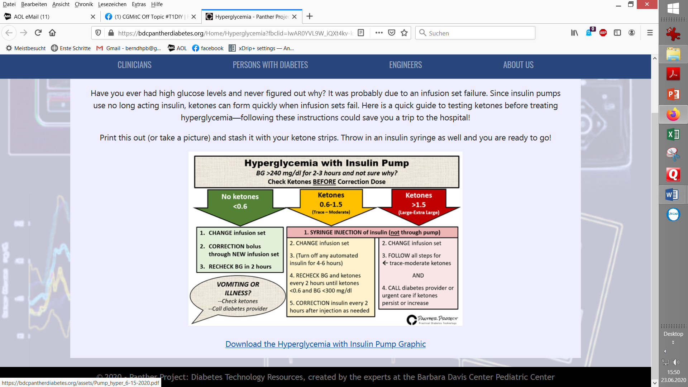

**3. Investigating “your” occlusion**

3.1 Identify where the issue is arising from.

Multiple things can cause an occlusion. To identify the cause and to fix the problem:

(1)..Silence the alarm (if needed).

(2) Look at the infusion set (or pod) whether it still seems attached right, with the steel or teflon-cannula still in your skin. If not: Go to (6) @ headline 3.4.

Also pod users. Continue straight at section 3.4, (6)

The following, (3) – (5), is mostly applicable if you run a tubed pump.

(3) **Disconnect** the tube from the infusion set. (If the problem is in the cannula area, insulin should now be able to flow again:).

(4) From refill menu (AAPS/Action tab) deliver a prime *of up to 5* units (1-.2 units is enough if your vision is good enough that you could recognize small amounts of insulin coming out of the tip in the end of the tubing).

* If insulin comes out at the little tip inside the end of the tubing, *or fills up the end piece and spills over*, you've determined that the occlusion is caused in the area of the cannula, under your skin (This is the most likely case). -> Continue at (6).

* If you still observe occlusion, the issue is within the tube and/or the pump reservoir.

(4.1) To search whether anywhere in the **tubing** there is an occlusion (e.g. a kinck, or clogging-up with gelled insulin/*see also remark at bottom*): Cut segments off the tubing, starting from the end where it goes into the infusion set/cannula. Give 1 U of insulin after each cut. As soon as you see insulin coming out, you identified that the problem is in tubing segment that was cut off last. Investigate it for kinks, opaque gelled-up areas etc.

(4.2) If no insulin came out in (4.1): Remove the (last part of the) tube from the pump. Administer another prime of 4 units of insulin (More units are needed now than in (4.1), as we push through a bigger diameter than the little plastic tube we kept cutting back before)

* If no occlusion: Issue was within the last (or, seen from the pump, first) part of the tube. Put in a new tube, fill it, and reconnect to cannula (consider exchanging it at this point, too).

3.2 Investigating the pump

* If still occluded, the issue is within the **pump** (reservoir, pushrod or pump).

(5) Remove the reservoir and repeat prime. No occlusion has isolated the issue is within reservoir or pushrod. If you still get occlusion: Most likely insulin was spilt or leaked into rubber seal within the pump (bottom near g/box).

* 1. Fixes for the pump

Old spilt insulin becomes a tacky glue. This binds the O/ring and gearbox causing frequent occlusion alarms. Cleaning with a mild 40% alcohol can restore usual pump function

(For pods: Place a new pod)

* 1. Fixes for the infusion site

If the problem is at the **cannula** level:

(6) Remove the infusion set / cannula, or pod.

If the adhesive tape is moist and smells like insulin, or if you feel a little scar tissue ball under the insertion site/*see also remark at bottom*, these are clear signs that the problem was on the cannula/body interface under the skin. Replace the infusion set, selecting a different site.

Also note how long the old cannula (or pod) was in, and try to exchange earlier (this one you just set, and all in the future).

**4. Considerations when resuming Looping after an occlusion**

After an occlusion, your body has less insulin on bord than the iob your loop (e.g. AAPS) is working with. In order to continue looping there are 2 basic options:

4.1 Suspend the closed loop

Suspending the closed loop for the length of 1 DIA will create a good starting point for looping again, with realistic iob and cob info on bord, by then. For this to happen, all given insulin and carbs must be registered also in open loop.

Alternatively, you can (with a bit of risk) also continue closed looping right away:

* 1. Continue in closed loop with corrected data to use

1. Estimate how much insulin was wrongly reported as delivered into the body in the recent hours, and erase that number of units under AAPS/Treatments tab (SMBs, Boli). Ways to estimate:

* If you have an idea when the occlusion happened (e.g. when scratching the area when getting dressed, or during an incident at sports), erase all insulin recorded under treatments for the time after this incident.
* In most cases, you might need to estimate whether zero, or still a small portion of the iob reported by AAPS is available in your body. Then use your ISF to estimate the units of insulin now required to come back down to normal. Note that also the basal is missing since the occlusion, so, on top of the ISF-guided correction, add e.g. 2hrs of basal as in profile.

*Example: Glucose rose to 280. Target is 100, so 180 too high. At ISF of 40, 4.5 U insulin would be needed for correction. Probably 2 U of basal also are missing at this point => Up to 6.5 U are missing. If the occlusion happened under the skin, likely not 100% of insulin was blocked. Try to judge from the observed curve. For instance, if in the last 2 hrs 1/3 might still have gone through, use 2/3 of (4.5 +2) = 4.3 U as your estimate.*

1. Deliver the estimated required insulin, or, to enhance safety, some less (notably if this happens before bedtime, or before driving):
   * If you chose to suspend the loop, deliver the bolus from pump or pen.

Note that in this case, false insulin data will remain on record in AAPS and in Nightscout. So don’t use this day’s data if you do Autotune or any other evaluation that would be compromised.

* + Else, close the loop again now, and deliver via AAPS insulin button.

You may also want to consult the AAPS calculator before delivering the insulin: After you erased the „lost“ insulin, the calculator should make a suggestion which should not be far off what you tried to figure out following suggestion (1) on the precediung page . Use the lower of both estimates and deliver via insulin button or via calculator .

1. Have glucose tablets ready, and make sure your alarms are set on loud. Watch what is happening in the coming hours.

**5. Considerations for sustainable long-term improvement**

5.1 Insulin choice

Occlusion is occasionally observed with all insulins, but seems to happen with Lyumjev or with Fiasp more frequently.

Still, for loopers these are the best insulins (see page 1 of “Insulins_DIA..pdf” in: <https://github.com/bernie4375/HCL-Meal-Mgt.-ISF-and-IC-settings> ). Therefore it is wise to look for ways that principally reduce occlusion incidence.

5.2 Insulin mixes?

Some Loopers had better experience by mixing Fiasp with 50% or more Novorapid, Humalog or other insulin. For a more thorough discussion see https://bionicwookiee.com/2022/03/02/mixing-insulins-256 theory-and-practice/ 257

and also: https://bionicwookiee.com/2023/06/03/arcane-lyumjev-experiments/. . Mixing insulins would be **off-label** use, and can only be tried **at own risk**!

5.3 Keeping pump in good shape

Sometimes it might just be the pump battery getting weak and “not pushing through” or fully stopping. (Or a “sticky” reservoir area, see section 3.3).

5.4 Insertion site management

Very often, occlusions can be partial (and worsen over hours or days) when associated with a little scar tissue ball forming under the insertion site.

This is frequently seen on third days of cannula (or pod) use, but can also happen earlier.

5.4.1 Partial occlusions managed by the loop

A “laissez-faire” problem solution many find sufficient is, to let your loop interpret the situation as decreased insulin sensitivity (=elevated insulin need) and just let e.g. dynamicISF “handle the problem”.

This is not unlike driving your car with a failing transmission for a while, just revving the motor up a bit higher to still get going.

So, the author recommendation is to make use of this “phenomenon” just for early detection that there is (or just might) be a problem with occlusion. Besides seeking an early remedy as already discussed above, more thought should go into how to find a sustainable improvement.

5.4.2 Strategies for a sustainable improvement

To really get a grip on reducing the problem the following strategies were reported to be eventually successful. Unfortunately, many are best if not only feasible when using a tubed pump:

* Changing cannulas (pods) frequently, like always every 48 hours
* Using deeper going needles, different insertion angles, steel <-> Teflon switch ( - unfortunately, there is not much you can change as a pod user).
* Smaller bolus sizes
  + Your pump might allow different delivery speeds
  + Giving (part of) biggest meal boli via pen (do not forget to enter info about it into AAPS right away, for correct iob calculations!)
  + Full Closed Loop (i.e. never big user initiated boli; just series of SMBs)
  + Up-concentrated insulin (U200), see e.g.: <https://www.diabettech.com/lyumjev/living-with-lyumjev-almost-a-year-in-review/> Observe how to adjust profile if you go that route. (Easiest, to do a 50% profile switch, and then clone it to a new profile. But also some safety parameters need adjusting, like half the max iob).
* Using different body sites for insulin entry
* Some report better experience after mixing Lyumjev or Fiasp with another insulin (usually 50%, Humalog or Novorapid). See also 5.2.

(This would be off-label use and can only be tried at own risk).