Probability Survey Report for Lift Irrigation

**Submitted To**

**Department of Water Resource and Irrigation**

**Integrated Energy and Irrigation Special Program**

**Pulchowk, Lalitpur**

**Submitted By**

**Slate-e2 Service-Pertinent JV,**

**Jwagal, Lalitpur**

**{{NAME}} Lift Irrigation Project**

{{PROVINCE}} Province

{{MUNICIPALITY}}-{{WARD}}, {{DISTRICT}}

Contents

LOCATION MAP 2

SALIENT FEATURES OF PROJECT 3

PROJECT SUMMARY 5

PROJECT IDENTIFICATION QUESTIONNAIRE 7

# ANNEXES

PHOTOGRAPHS OF PROJECT

# 

# LOCATION MAP

|  |
| --- |
|  |
|  |
|  |

{{NAME}} Lift Irrigation Project

# SALIENT FEATURES OF PROJECT

|  |  |  |  |
| --- | --- | --- | --- |
| **1** | **Project Classification** | : | Existing |
| **2** | **Category** | : | Lift |
| **3** | **Province** | : | {{PROVINCE}} |
| **4** | **District** | : | {{DISTRICT}} |
| **5** | **Village** | : | {{MUNICIPALITY}}-{{WARD}} |
| **6** | **District Headquarter** | : | {{HEADQUARTER}} |
| **7** | **Accessibility** |  |  |
|  | **a. Nearest Airport** | : | Pokhara International Airport |
|  | **b. Nearest Roadhead** | : | {{NEARROAD}} |
| **8** | **Marketing Facilities (Y/N)** | : | Y |
| **9** | **Elevation (Height Difference)** | : | N/A |
| **10** | **Topographical Map No.** | : | - |
| **11** | **Gross Command Area** | : | N/A |
| **12** | **Net Command Area** | : | N/A |
| **13** | **Water Right Problem (Y/N)** | : | N |
| **14** | **Diversion Structure (Y/N)** | : | N |
| **15** | **Main Rise Length** | : | N/A |
| **16** | **Idle Pipe Length** | : | N/A |
| **17** | **Main Pipe Length** | : | N/A |
| **18** | **Distribution Pipe Length** | : | N/A |
| **19** | **Design Discharge at intake** | : | N/A |
| **20** | **Soil (Suitability of vegetables)** | : | Clay |
| **21** | **Hydrology** |  |  |
|  | **a. Name of Source** | : | Kaligandaki River |
|  | **b. Type of Source** | : | Perennial |
|  | **c. Measured Discharge** | : |  |
|  | **d. Hydrological Region** | : |  |
|  | **e. Catchment Area** | : | Not considered for this level of study |
| **22** | **Geology** |  |  |
|  | **a. Pumping Site Area** | : | Sand |
|  | **b. Geology of Pipe Alignment** | : | Ordinary Soil, Dense Forest, minor slide, miner problems are encountered |
| **23** | **Beneficiaries** |  |  |
|  | **a. Population** | : | {{POPULATION}} |
|  | **b. Household** | : | {{HOUSEHOLD}} |
| **24** | **Recommendation** | : | {{RECOMMENDATION}} |

# PROJECT SUMMARY

**LOCATION**

{{NAME}} Lift Irrigation project is a new one. It is located in the ward number {{WARD}}, {{MUNICIPALITY}} in {{DISTRICT}} district. The Project area is accessible from a nearby road which is {{NEARROAD}} which passes through the project area.

**SOURCE**

Kaligandaki is the source for the project from which the water is to be pumped for irrigation purpose. The source is perennial and has more than sufficient quantity of water in order to fulfill the object of project. There is enough discharge in all seasons for irrigation purpose.

**EXISTING SITE CONDITIONS**

The proposed project area already has a irrigation project under Adhikhola Water Users Association (AKWUA) covering 500hectres of land including this area. The place is easily accessible to the road. The site area is not prone to any kind of danger.

**AGRICULTURE PRACTICES**

Command Area is rain fed and the major crops grown are potato, maize, rice and wheat*.* Vegetables farming is practiced.

**COMMAND AREA**

Terrace type of topography exists in the command area. The Gross Command Area (GCA) and Net Command Area (NCA) of the proposed irrigation project is {{GROSSAREA}} Ha and {{NETAREA}} Ha respectively.

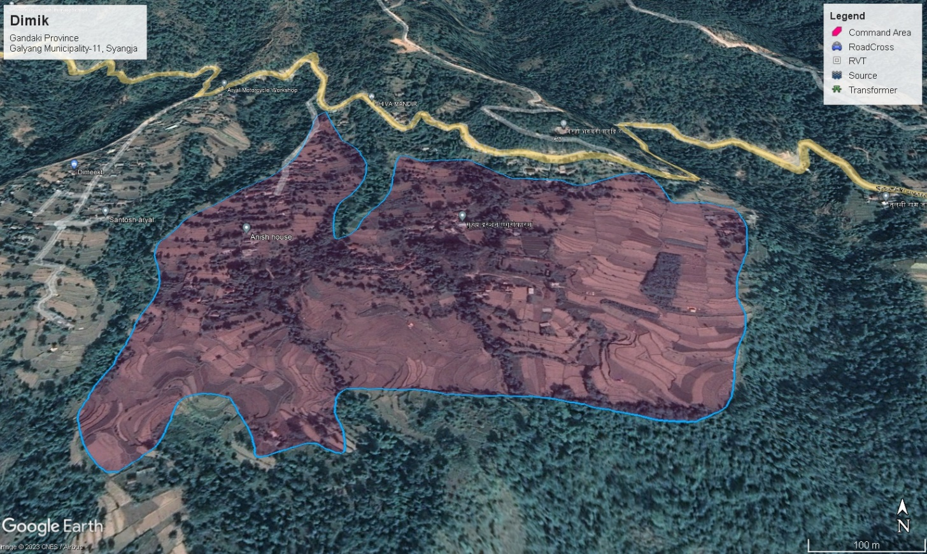

**SOCIAL STRUCTURE AND OCCUPATION**

The Project area comprises of Chhetri and Brahmin as ethnic group mostly. The people are cooperative and helpful.

# PROJECT IDENTIFICATION QUESTIONNAIRE

|  |  |  |  |
| --- | --- | --- | --- |
| **1** | **Project Location** |  |  |
|  | 1. **a. Province** | : | {{PROVINCE}} |
|  | 1. **c. District** | : | {{DISTRICT}} |
|  | 1. **d. Municipality** | : | {{MUNICIPALITY}}-{{WARD}} |
|  | 1. **e. Topo sheet no.** | : | - |
|  | 1. **f. Latitude** | : | {{LATITUDE}} |
|  | 1. **g. Longitude** | : | {{LONGITUDE}} |
|  |  |  |  |
| **2** | **Project Status (New/Improvements/Extensions)** | : | N/A |
|  |  |  |  |
| **3** | **History of Project (If Existing)** | : | Yes |
|  | **Built when** | : | - |
|  | **By whom** | : | - |
|  | **Is there a WUG (Y/N)** | : | Y |
|  | **Are there any shallow Tubewells in the project area** | : | No |
|  |  |  |  |
| **4** | **Type of Project (Drip/Sprinkler/Surface/GW/Lift/Rainwater)** | : | Surface, Lift & Sprinkler Irrigation |
|  |  |  |  |
| **5** | **Command Area** | : |  |
|  | **GCA** | : | {{GROSSAREA}} ha |
|  | **NCA** | : | {{NETAREA}} ha |
|  | **Type (Tar, Terrace, Plain, Sloped,etc)** | : | Sloped |
|  |  |  |  |
| **6** | **Water Source** | : |  |
|  | **Source Name (Gravity / piped or √ lift schemes)** | : | Kaligandaki River |
|  | **Flow at time of visit (m3/s or l/s)** | : | NA |
|  | **Estimated Minimum Discharge(m3/s or l/s)** |  |  |
|  | **Is there any groundwater potential (shallow or deep tube wells dug Wells or conjunctive use ) ?** | : | No |
|  |  |  |  |
| **7** | **Prior water Rights** | : | There is no water right issues and they are ready to contribute & use available water by sharing according to land holding |
|  |  |  |  |
| **8** | **Problems on Existing Schemes** | : | No significant problem. |
|  |  |  |  |
| **9** | **Soil** |  |  |
|  | **Discuss texture and depth of soils with farmers and note general situation note command area and any problems:** | : | clay |
|  |  |  |  |
| **10** | **Existing Land use within command area** |  |  |
|  | **Irrigated Land** | : | {{NETAREA}} ha |
|  | **Rain fed crop land** | : | 0 ha |
|  | **Forest** | : | {{FORESTAREA}} ha |
|  | **Barren Land** | : | 0 ha |
|  | **Total** | : | {{GROSSAREA}} ha |
|  |  |  |  |
| **11** | **Existing Cropping Pattern and Yields** | : |  |
|  |  |  |  |
|  | **Rainfeds crop Land** |  |  |
|  | **Spring Crops** |  |  |
|  | **Maize** | : | 5 muri /Ropani |
|  | **Potato** | : | 800kg/Ropani |
|  | **Wheat** | : | 2 muri/Ropani |
|  | **Rice** |  | 190kg/Ropani |
|  |  |  |  |
|  |  |  |  |
|  | **Irrigated Land** |  | All |
|  |  |  |  |
| **12** | **Food Situation** |  |  |
|  | **Is project in food surplus or deficit area?** | : | Deficit |
|  | **If in deficit area, for how many months is there enough food?** | : | Food supply is adequate only for 10 months |
|  |  |  |  |
| **13** | **Land Tenure and Land Holdings** |  |  |
|  | **Tenure Type** | : | Personal |
|  | **Landless** | : | No |
|  | **Are there any Large landowners?** | : | 10-15 ropani Landowners |
|  | **Average Land Holding** | : | 4-6 ropani |
|  |  |  |  |
| **14** | **Accessibility** |  |  |
|  | **Nearest Road Head** | : | {{NEARROAD}} |
|  | **Distance from Road head to project site (Km/Porter Days** | : | {{NEARROADDISTANCE}} km |
|  |  |  |  |
| **15** | **Marketing** |  |  |
|  | **Nearest Market** | : | {{NEARMARKET}} |
|  | **Distance (Km or Hour)** | : | {{NEARMARKETDISTANCE}} km |
|  |  |  |  |
| **16** | **Agricultural Inputs** |  |  |
|  | **Fertilizers** | : | Urea, Organic |
|  | **Pesticides** | : | DAP/Potash, minimally applied |

# 

# PHOTOGRAPHS OF PROJECT

|  |
| --- |
|  |
| Command Area |

|  |
| --- |
|  |
| Photo with representatives and beneficiaries |
|  |
| Representatives and beneficiaries whom we gave presentation about the project |