On-the-Job Training (OJT) Report
on
KinaHub E-commerce Platform

at
Shivapuri Secondary School
Maharajgunj, Kathmandu
Submitted By:
Bikram Gole
(Grade 10 - Computer Engineering)
Submitted To:
Department of Computer Engineering (9-12)
Asar, 2082

CERTIFICATE OF APPROVAL
This is to certify that the On-the-Job Training (OJT) report entitled 'KinaHub E-commerce Platform' submitted by Mr. Bikram Gole, a student of Grade 10 at Shivapuri Secondary School, is an authentic record of the work carried out by him under my supervision and guidance.
This project demonstrates the practical application of modern web development concepts including frontend design, backend logic, and AI integration. The work was performed as part of the Grade 10 Computer Engineering curriculum and reflects a high level of dedication and technical skill.
This report is approved for the partial fulfillment of the requirements for the Grade 10 level in the Computer Engineering program under the Technical Stream.

__________________________
Supervisor Name
Shivapuri Secondary School

DECLARATION
I, Bikram Gole, a student of Grade 10, hereby declare that the OJT report entitled 'KinaHub E-commerce Platform' submitted to the Department of Computer Engineering, Shivapuri Secondary School, is my original work. The project was developed independently during my practice sessions at school, applying the principles of UI/UX design and programming I have learned in class.
I have followed all the institutional guidelines provided by the school and the National Education Board (NEB) during the preparation of this report. All information used from external sources has been duly acknowledged.

__________________________
Bikram Gole
Date: Asar, 2082

PREFACE
The present report is the outcome of the On-the-Job Training (OJT) project titled 'KinaHub - Local E-commerce & CRM'. It is prepared as a key practical component of the Grade 10 Computer Engineering curriculum at Shivapuri Secondary School.
This report reflects the practical exposure I gained while building a full-stack e-commerce solution. In an era where local businesses are struggling to go digital, KinaHub aims to provide a localized platform that is both technically robust and user-friendly. The training focused on mastering React for the dynamic frontend, Django for the secure backend API, and integrating client-side AI assistants to guide user decisions.
Building KinaHub allowed me to understand the complexities of real-world software, from database management to handling asynchronous operations and state. This experience has deepened my passion for technology and provided me with a solid foundation for my future studies in computer engineering.

ACKNOWLEDGEMENT
I would like to express my sincere gratitude to my school, Shivapuri Secondary School, for providing the technical infrastructure and a supportive environment for this OJT. I am deeply thankful to my teachers in the Department of Computer Engineering for their constant guidance and encouragement throughout the Grade 10 sessions.
I would also like to thank my mentors who helped me troubleshoot complex programming challenges and provided insights into professional coding standards. Their feedback was instrumental in refining the features of KinaHub.
Finally, I am grateful to my family for their unwavering support and for providing me with the motivation to complete this project. Their belief in my potential has been my greatest source of inspiration.

TABLE OF CONTENTS
CERTIFICATE OF APPROVAL
DECLARATION
PREFACE
ACKNOWLEDGEMENT
ABBREVIATIONS
Chapter: 1 Introduction
Chapter: 2 OJT Workplace & Context
Chapter: 3 Technology & Technical Implementation
Chapter: 4 OJT Summary & Learning
Chapter: 5 Conclusion & Future Recommendations
References

ABBREVIATIONS
OJT: On-the-Job Training
CRM: Customer Relationship Management
API: Application Programming Interface
JWT: JSON Web Token
SPA: Single Page Application
DRF: Django REST Framework
ORM: Object-Relational Mapping
LLM: Large Language Model
UI/UX: User Interface / User Experience

Chapter: 1 Introduction

1.1 Project Overview
KinaHub is a modern, local-first e-commerce and CRM platform. While global platforms like Amazon focus on wide-scale logistics, KinaHub is designed to empower local sellers and neighborhoods. It bridges the gap between local physical stores and the digital shopping space.
The project was conceived as a Grade 10 OJT project to demonstrate how modern web technologies can be combined to solve local community problems. KinaHub features a dynamic storefront, a multi-seller cart system, and a specialized 'Kina AI' shopping assistant that provides real-time advice based on localized delivery fees and product data.

1.2 Problem Statement
The current local retail market in Nepal faces several digital barriers:
1. Visibility Gap: Local small-scale stores often lack the technical resources to set up an online storefront, making them invisible to digital-first customers.
2. Logistical Complexity: Customers ordering from multiple nearby stores often face high and disjointed delivery fees because platforms don't optimize for local seller proximity.
3. Lack of Personalized Guidance: Traditional e-commerce platforms offer generic recommendations, whereas local shoppers often need specific advice on value and localized convenience.

1.3 Project Objectives
The primary objectives of the KinaHub project were:
- To build a responsive and interactive frontend using React and Tailwind CSS.
- To implement a secure and scalable backend using the Django REST Framework.
- To integrate an AI assistant using the OpenRouter API to provide rule-based shopping advice.
- To simplify business management for local sellers through an intuitive CRM dashboard.

1.4 Project Scope
The project scope covers the end-to-end development of an e-commerce platform. This includes user authentication (JWT), product listing and categorization, brand management, multi-seller cart optimization, and a comprehensive seller dashboard. The scope is limited to a functional prototype suitable for local testing and school demonstrations.

Chapter: 2 OJT Workplace & Context
The OJT was conducted within the Computer Engineering Department of Shivapuri Secondary School. The environment was designed to simulate a professional development studio. During the sessions, emphasis was placed on systematic software design, including wireframing in Figma before coding. We followed the Agile methodology, breaking down the project into smaller tasks such as 'Cart Implementation', 'API Endpoints', and 'AI Integration'. The school provided the necessary workstations and internet access for real-time API testing and documentation review.

Chapter: 3 Technology & Technical Implementation

3.1 Technology Stack Details
The KinaHub platform is built using a decoupled architecture, ensuring that the frontend and backend can evolve independently. The technical stack includes:
- Frontend: React.js with TypeScript. TypeScript was used to ensure type safety, reducing bugs in complex state management scenarios. Vite was used as the build tool for fast development cycles.
- Backend: Django. We used Django's powerful ORM for database management and the Django REST Framework (DRF) to serve JSON data to the React frontend.
- AI Layer: OpenRouter API. This allows the client-side to communicate with large language models like Gemma and Nemotron without needing heavy server-side processing.

3.2 Backend Data Models
The backend architecture is centered around several key models:
1. Product Model: Stores item names, slugs, prices, stock levels, and store relations. It includes properties like 'current_price' to handle discounts dynamically.
2. Store Model: Manages seller information, including delivery rules, banners, and logos.
3. Category/Brand Models: Allow for structured product organization, essential for the filtering system used in the frontend.
4. Review Model: Implements a verified purchase system where users can leave ratings and media feedback to build community trust.

3.3 Visual Showcase & UI Analysis

Advanced Landing Page Implementation
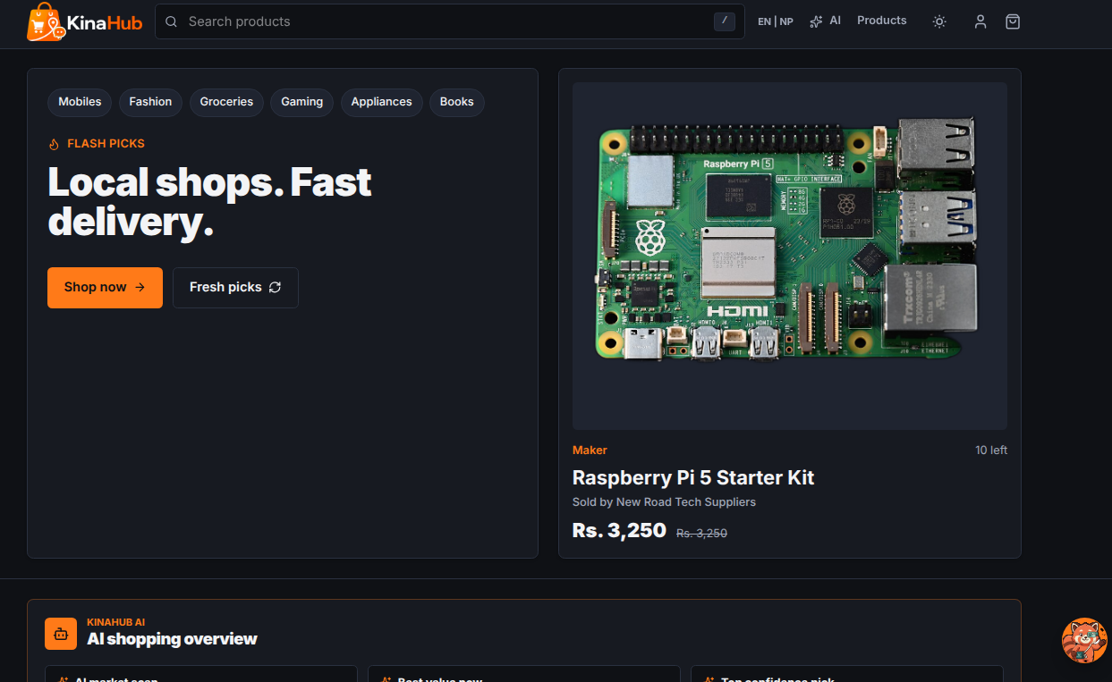
The KinaHub landing page is designed for high impact and clear navigation. It features a responsive navbar using the custom logo_navbar-light.png. Below the hero section, we implemented a 'Featured Products' slider and a localized 'Stores Near You' feed. The implementation uses Framer Motion for scroll-triggered animations, giving the site a modern, professional feel.

Featured Products Section
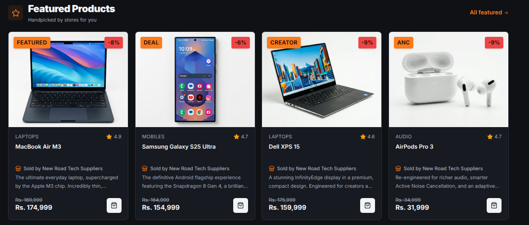
The Featured Products section showcases high-priority items using a curated grid layout. This section is dynamic, fetching data from the backend based on the 'is_featured' flag in the Product model. It utilizes CSS hover effects and transition states to engage users and drive conversions.

Category Discovery System
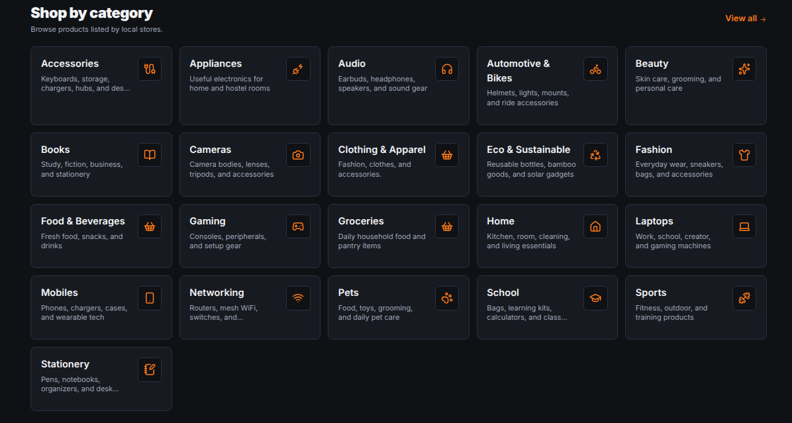
The Categories page provides a structured entry point for users to browse products by type. Each category is represented by a card with intuitive icons and counts. This helps in efficient navigation and reduces cognitive load for the shopper by grouping items logically.

Advanced Filtering & Sorting
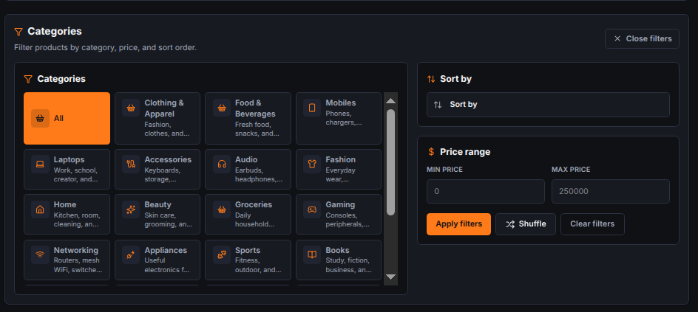
The filtering system allows users to narrow down product lists by price range, brand, and rating. The implementation involves complex frontend state management to synchronize the URL parameters with the UI components, ensuring a 'sharable' and consistent search experience.

Instant Full-Text Search
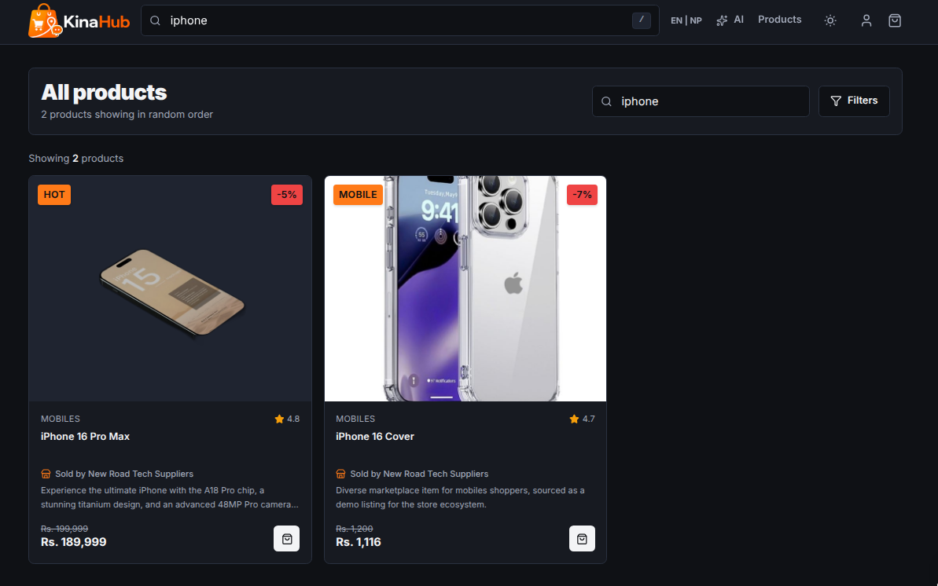
The search interface features an instant, 'as-you-type' result preview. Technically, this is implemented using debounced API calls to the Django backend, which performs full-text search across product names and descriptions, providing a snappy discovery tool.

Kina AI Intelligence Integration
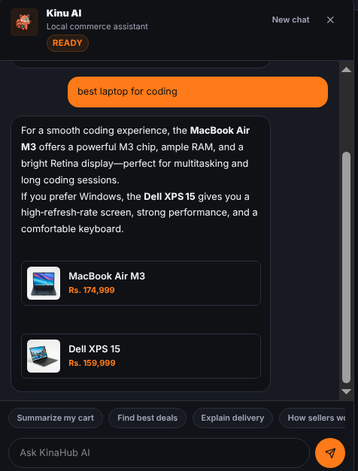
The Kina AI assistant represents a sophisticated integration of external LLMs with local business rules. The assistant doesn't just chat; it reads the current cart state. If it sees items from three different stores, it might suggest, 'If you buy everything from Store X, you can save 300 Rs in delivery fees.' This logic combines hard rule-based checks with natural language responses.

Complex Seller CRM Dashboard
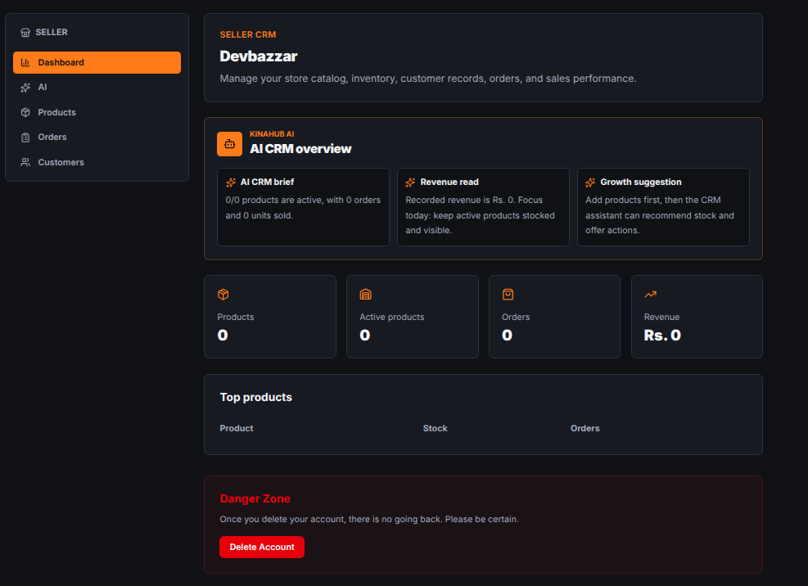
The dashboard is a comprehensive management suite for local sellers. It provides a real-time data visualization of their sales. Technically, this involved creating complex Django aggregation queries to calculate total revenue and top-selling products. The frontend uses a decoupled layout to ensure the seller has a focused, distraction-free environment for stock management.

Detailed Product Architecture
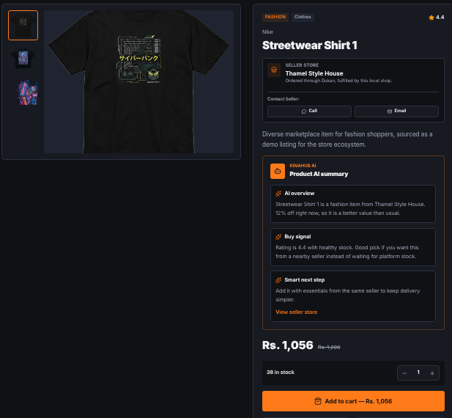
The product detail page is the final step before the cart. It shows the technical specifications stored in the backend. We implemented a dynamic 'Buy Signal' indicator that turns green when the AI determines the product is at a high-value price point. It also calculates 'Estimated Delivery Time' by comparing store and user coordinates (simulated).

Logic-Heavy Multi-Store Cart
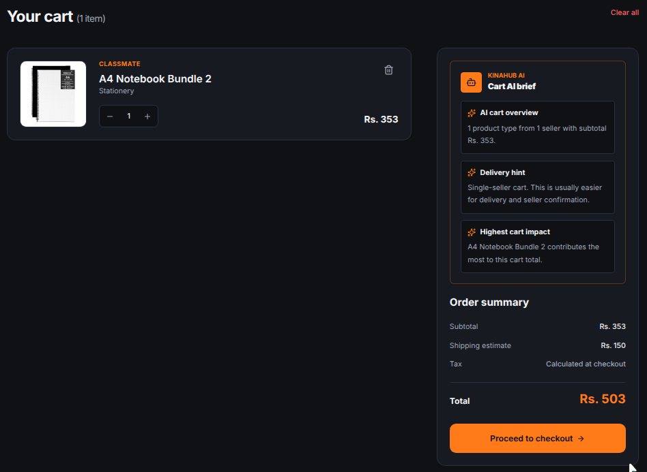
The cart is perhaps the most complex part of the frontend. It uses React Context API to maintain state globally. It handles 'Store Grouping', where items are sorted by the seller they belong to. This allows for clear delivery fee breakdowns. The implementation ensures that when a user adds an item, the AI assistant is immediately notified to provide updated advice.

Secure Multi-Step Checkout
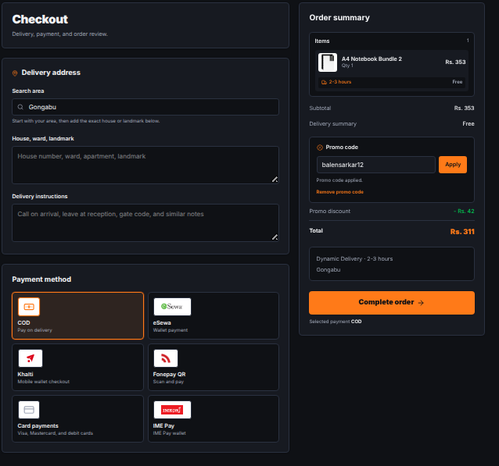
The checkout page is a critical multi-step process designed for high security and low friction. It integrates address validation, delivery method selection, and payment gateway placeholders. The UI ensures that all costs, including the localized delivery fees calculated by the AI, are transparently displayed.

Customer Feedback & Review System
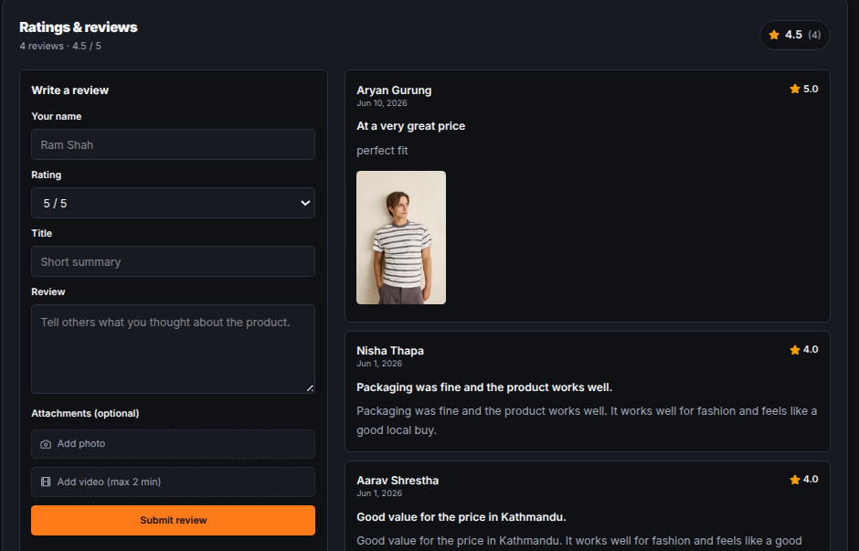
The customer reviews section builds social proof and trust. It supports text, ratings, and media uploads (images/videos). The backend validates that reviewers are verified purchasers to prevent spam, while the frontend uses a clean card-based layout for readability.

Responsive Navigation & Meta Links
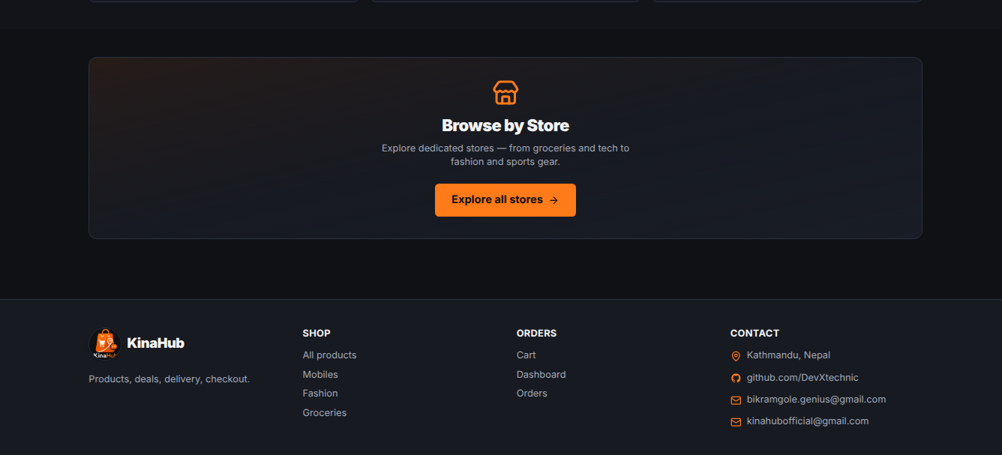
The responsive footer provides essential navigation links, social media integration, and company information. It is designed to be consistent across all pages, ensuring that users always have access to support and policy documents like Privacy and Terms.

Chapter: 4 OJT Summary & Learning

4.1 Observations & Analysis
Throughout the OJT, I observed how modern web development is shifting towards 'client-side intelligence'. By moving complex logic like cart optimization to the frontend, we can provide a snappier experience for the user. I also analyzed how critical 'Slug-based' routing is for SEO and user readability, which led to the implementation of automatic slug generation in the Django models using 'slugify'.

4.2 Technical Skills Acquired
Working on KinaHub, I have mastered several key skills:
- Full-stack Integration: Connecting a Django REST backend with a Vite-powered React frontend.
- Advanced CSS: Using Tailwind CSS for building responsive, theme-aware interfaces.
- AI Orchestration: Designing prompts and handling streaming responses from the OpenRouter API.
- Version Control: Maintaining a clean development history and managing different features via Git.

Chapter: 5 Conclusion & Future Recommendations

5.1 Conclusion
The KinaHub project has successfully achieved its goals of building a functional, local-first e-commerce platform. For a Grade 10 student, this OJT has been a transformative experience, bridging the gap between school-level ICT and professional software engineering. KinaHub stands as a proof-of-concept for how localized tech can empower communities.

5.2 Future Recommendations
For future enhancements, I suggest:
1. Real-time Notifications: Integrating WebSockets to notify sellers of new orders instantly.
2. PWA Features: Converting KinaHub into a Progressive Web App so users can shop offline and receive push notifications.
3. Enhanced AI: Training a specialized model on local product data to provide even more accurate value assessments.

References
1. Django REST Framework (Backend API): https://www.django-rest-framework.org/
2. React (Frontend Library): https://react.dev
3. React Router (Frontend Routing): https://reactrouter.com
4. OpenRouter API (AI Orchestration): https://openrouter.ai
5. Framer Motion (UI Animations): https://www.framer.com/motion
6. Tailwind CSS (Styling Framework): https://tailwindcss.com
7. Lucide React (Iconography System): https://lucide.dev
8. Axios (HTTP Client): https://axios-http.com
9. Cloudinary (Media Management Service): https://cloudinary.com

