On-the-Job Training Report on
KinaHub E-commerce at
Shivapuri Secondary School, Maharajgunj, Kathmandu

Submitted By:
Bikram Gole
(Grade 10-Computer Engineering)

Submitted To:
Department of Computer Engineering(9-12)

Asar, 2082

CERTIFICATE OF APPROVAL
This is to certify that the On-the-Job Training (OJT) report entitled 'KinaHub E-commerce Platform' submitted by Mr. Bikram Gole, a student of Grade 10 at Shivapuri Secondary School, is an authentic record of the work carried out by him under my supervision and guidance.
This project demonstrates the practical application of modern web development concepts including frontend design, backend logic, and AI integration. The work was performed as part of the Grade 10 Computer Engineering curriculum and reflects a high level of dedication and technical skill.
This report is approved for the partial fulfillment of the requirements for the Grade 10 level in the Computer Engineering program under the Technical Stream.
_________________________
Mr. Sagun Babu Adhikari
Shivapuri Secondary School

DECLARATION
I, Bikram Gole, a student of Grade 10, hereby declare that the OJT report entitled 'KinaHub E-commerce Platform' submitted to the Department of Computer Engineering, Shivapuri Secondary School, is my original work. The project was developed independently during my practice sessions at school, applying the principles of UI/UX design and programming I have learned in class.
I have followed all the institutional guidelines provided by the school and the National Education Board (NEB) during the preparation of this report. All information used from external sources has been duly acknowledged.
_________________________
Bikram Gole
Date: Asar, 2082

PREFACE
The present report is the outcome of the On-the-Job Training (OJT) project titled 'KinaHub - Local E-commerce & CRM'. It is prepared as a key practical component of the Grade 10 Computer Engineering curriculum at Shivapuri Secondary School. The training was designed to provide students with hands-on experience in the rapidly evolving field of software development and digital entrepreneurship.
This report reflects the practical exposure I gained while building a full-stack e-commerce solution. In an era where local businesses are struggling to compete with global giants, KinaHub aims to provide a localized platform that is both technically robust and user-friendly. The development process involved mastering React for the dynamic frontend, Django for the secure backend API, and integrating client-side AI assistants to guide user decisions. This OJT has been a bridge between theoretical classroom concepts and the real-world application of engineering principles.
Building KinaHub allowed me to understand the complexities of real-world software, from database management to handling asynchronous operations and global state. Beyond technical skills, it taught me the importance of UI/UX design in creating accessible digital tools for the local community. This experience has deepened my passion for technology and provided me with a solid foundation for my future career in computer engineering.

ACKNOWLEDGEMENT
This OJT report would not have been possible without the support and guidance of several individuals and institutions. First and foremost, I express my heartfelt gratitude to Er. Sagun Babu Adhikari for his continuous guidance, constructive feedback, and mentorship throughout the project. His expertise in modern software architecture and his encouragement helped me improve my technical skills and complete the project successfully.
I would also like to thank Shivapuri Secondary School for providing the technical infrastructure and a supportive environment for this OJT. The Department of Computer Engineering has been instrumental in providing the foundational knowledge required to tackle such a complex project. I am grateful to my teachers for their constant supervision and for pushing me to
explore beyond the standard curriculum.
Finally, I extend my deepest gratitude to my parents and family for their constant support, motivation, and encouragement during this OJT. Their belief in my potential has been my greatest source of inspiration throughout this journey.

TABLE OF CONTENTS
Topic Page No.
CERTIFICATE OF APPROVAL ii
CERTIFICATE OF ON THE JOB TRAINING iii
DECLARATION iv
PREFACE v
ACKNOWLEDGEMENT vi
TABLE OF CONTENTS vii
ABBREVIATIONS viii
Chapter: 1 Introduction 1
1.1 Project Overview 1
1.2 Problem Statement 1
1.3 Project Objectives 2
1.4 Project Scope 2
Chapter: 2 OJT Workplace & Context 3
Chapter: 3 Technology & Technical Implementation 4
3.1 Technology Stack Details 4
3.2 Backend Data Models 5
3.3 Visual Showcase & UI Analysis 6
Chapter: 4 OJT Summary & Learning 15
4.1 Observations & Analysis 15
4.2 Technical Skills Acquired 16
Chapter: 5 Conclusion & Future Recommendations 17
5.1 Conclusion 17
5.2 Future Recommendations 17
References 18

ABBREVIATIONS
OJT | On-the-Job Training
CRM | Customer Relationship Management
API | Application Programming Interface
JWT | JSON Web Token
SPA | Single Page Application
DRF | Django REST Framework
ORM | Object-Relational Mapping
LLM | Large Language Model
UI/UX | User Interface / User Experience

Chapter: 1 Introduction

1.1 Project Overview
KinaHub is a modern, local-first e-commerce and CRM platform. While global platforms like Amazon focus on wide-scale logistics, KinaHub is designed to empower local sellers and neighborhoods. It bridges the gap between local physical stores and the digital shopping space.
The project was conceived as a Grade 10 OJT project to demonstrate how modern web technologies can be combined to solve local community problems. KinaHub features a dynamic storefront, a multi-seller cart system, and a specialized 'Kina AI' shopping assistant that provides real-time advice based on localized delivery fees and product data.

1.2 Problem Statement
The current local retail market in Nepal faces several digital barriers:
- Visibility Gap: Local small-scale stores often lack the technical resources to set up an online storefront, making them invisible to digital-first customers.
- Logistical Complexity: Customers ordering from multiple nearby stores often face high and disjointed delivery fees because platforms do not optimize for local seller proximity.
- Lack of Personalized Guidance: Traditional e-commerce platforms offer generic recommendations, whereas local shoppers often need specific advice on value and localized convenience.

1.3 Project Objectives
The primary objectives of the KinaHub project were:
- To build a responsive and interactive frontend using React and Tailwind CSS.
- To implement a secure and scalable backend using the Django REST Framework.
- To integrate an AI assistant using the OpenRouter API to provide rule-based shopping advice.
- To simplify business management for local sellers through an intuitive CRM dashboard.

1.4 Project Scope
The project scope covers the end-to-end development of an e-commerce platform. This includes user authentication (JWT), product listing and categorization, brand management, multi-seller cart optimization, and a comprehensive seller dashboard. The scope is limited to a functional prototype suitable for local testing and school demonstrations.

Chapter: 2 OJT Workplace & Context
The OJT was conducted within the Computer Engineering Department of Shivapuri Secondary School. The environment was designed to simulate a professional development studio. During the sessions, emphasis was placed on systematic software design, including wireframing in Figma before coding.
We followed the Agile methodology, breaking down the project into smaller tasks such as 'Cart Implementation', 'API Endpoints', and 'AI Integration'. The school provided the necessary workstations and internet access for real-time API testing and documentation review.

Chapter: 3 Technology & Technical Implementation

3.1 Technology Stack Details
The KinaHub platform is built using a decoupled architecture, ensuring that the frontend and backend can evolve independently. The technical stack includes:
- Frontend: React.js with TypeScript. TypeScript was used to ensure type safety, reducing bugs in complex state management scenarios. Vite was used as the build tool for fast development cycles.
- Backend: Django. Django's powerful ORM was used for database management and the Django REST Framework (DRF) serves JSON data to the React frontend.
- AI Layer: OpenRouter API. This allows the client-side to communicate with large language models like Gemma and Nemotron without requiring heavy server-side processing.

3.2 Backend Data Models
The backend architecture is centered around several key models:
- Product Model: Stores item names, slugs, prices, stock levels, and store relations. It includes properties like 'current_price' to handle discounts dynamically.
- Store Model: Manages seller information, including delivery rules, banners, and logos.
- Category/Brand Models: Allow for structured product organization, essential for the filtering system used in the frontend.
- Review Model: Implements a verified purchase system where users can leave ratings and media feedback to build community trust.

3.3 Visual Showcase & UI Analysis
The following sub-sections present each major module of the KinaHub platform with annotated screenshots. Each component was designed with user experience as the primary focus, ensuring that the platform remains accessible and intuitive for local sellers and buyers alike.

3.3.1 Advanced Landing Page Implementation
The KinaHub landing page is designed for high impact and clear navigation.
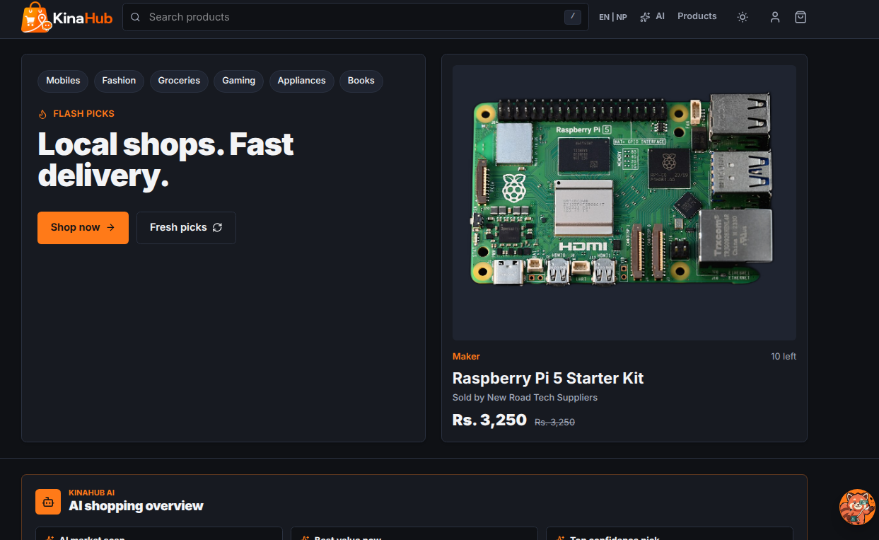

3.3.2 Featured Products Section
The Featured Products section showcases high-priority items using a curated grid layout.
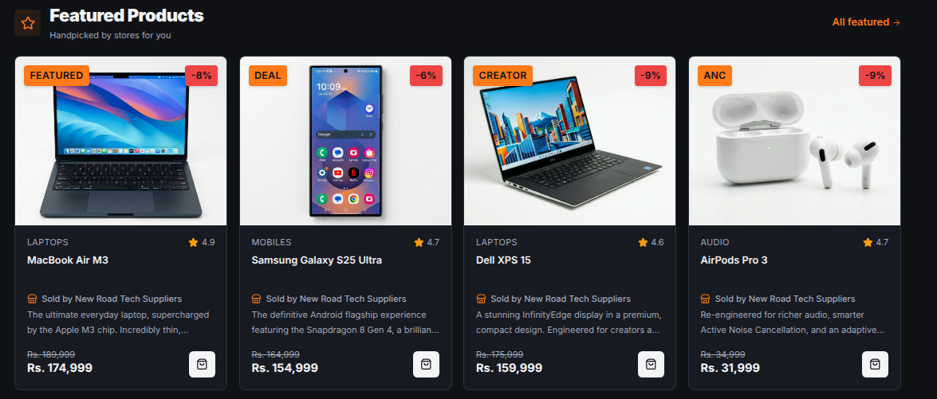

3.3.3 Category Discovery System
The Categories page provides a structured entry point for users to browse products by type.
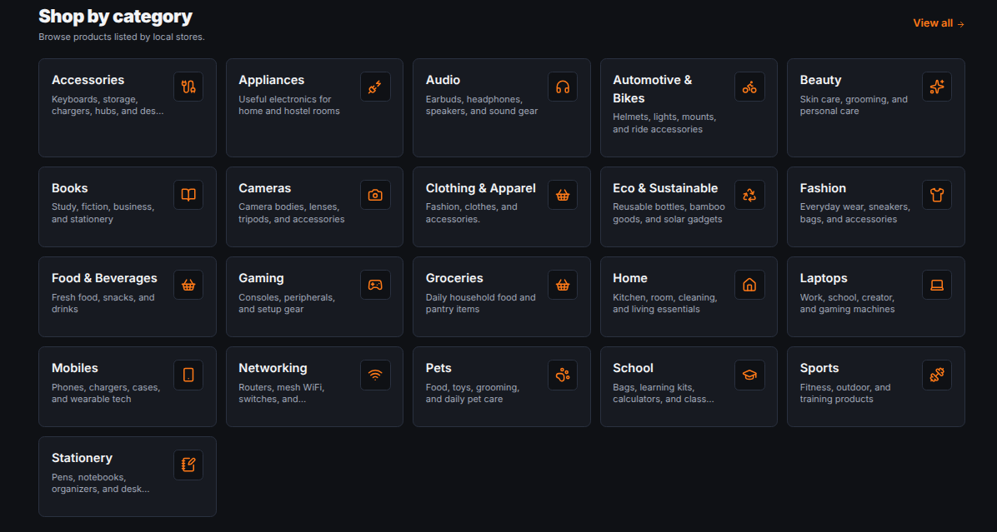

3.3.4 Advanced Filtering & Sorting
The filtering system allows users to narrow down product lists by price range, brand, and rating.
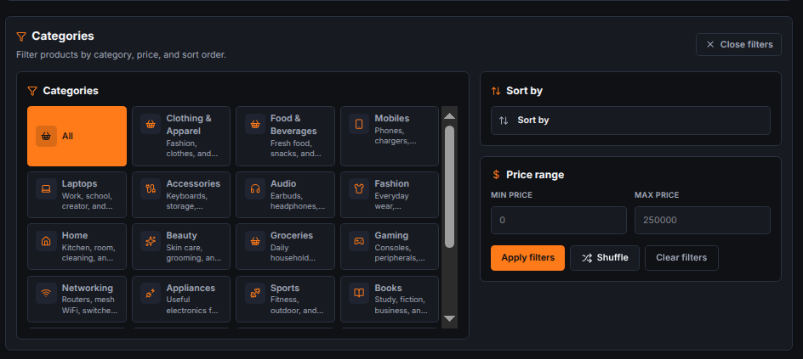

3.3.5 Instant Full-Text Search
The search interface features an instant, as-you-type result preview.
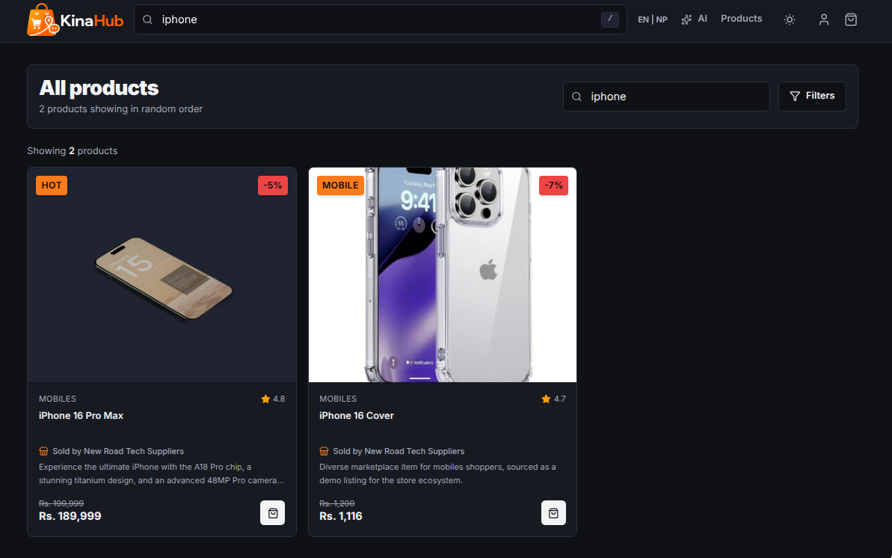

3.3.6 Kina AI Intelligence Integration
The Kina AI assistant represents a sophisticated integration of external LLMs with local business rules.
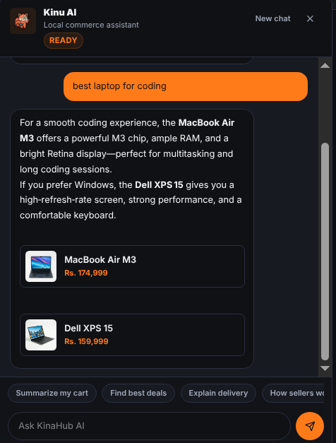

3.3.7 Complex Seller CRM Dashboard
The dashboard is a comprehensive management suite for local sellers.
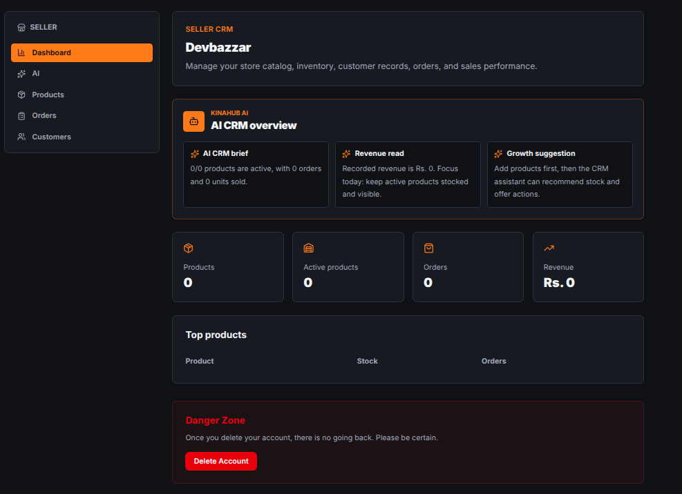

3.3.8 Detailed Product Architecture
The product detail page is the final step before the cart.
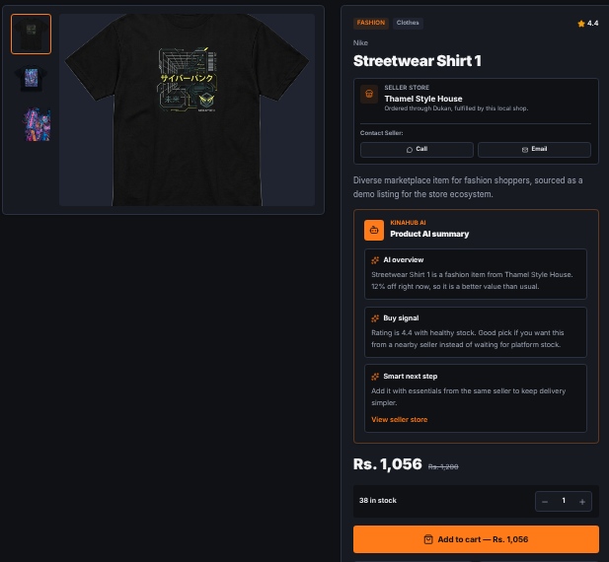

3.3.9 Logic-Heavy Multi-Store Cart
The cart is the most complex part of the frontend.
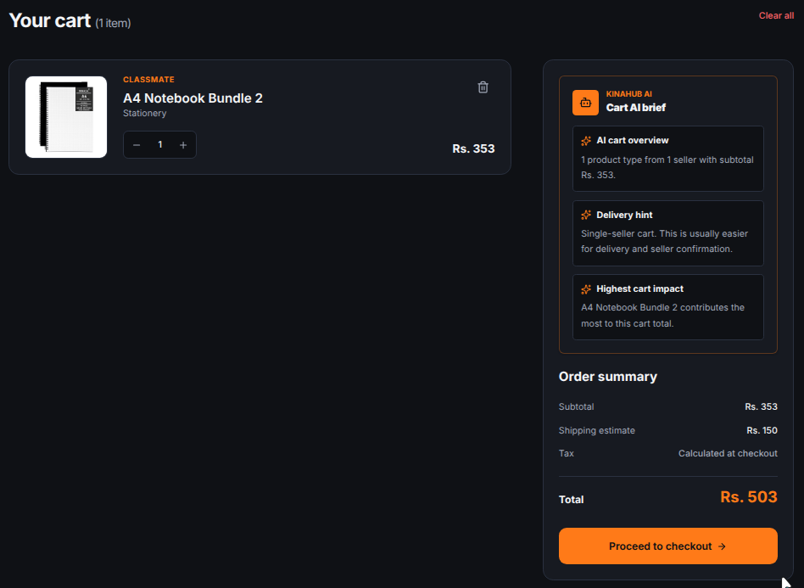

3.3.10 Secure Multi-Step Checkout
The checkout page is a multi-step process designed for high security and low friction.
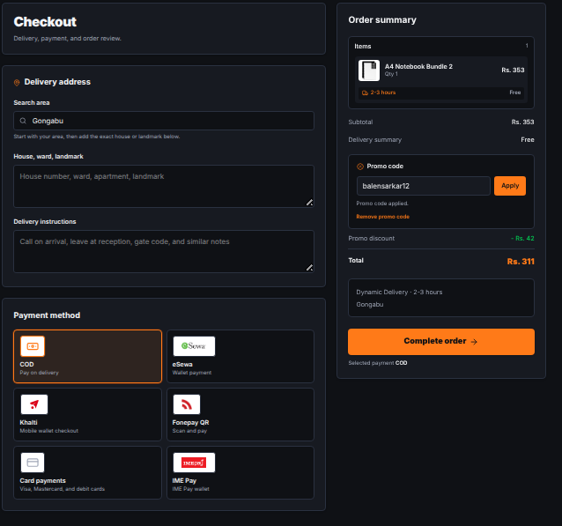

3.3.11 Customer Feedback & Review System
The reviews section builds social proof and trust.
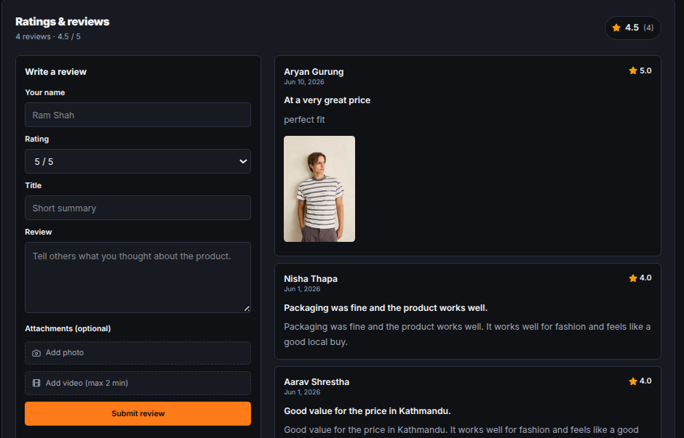

3.3.12 Responsive Navigation & Meta Links
The responsive footer provides essential navigation links, social media integration, and company information.
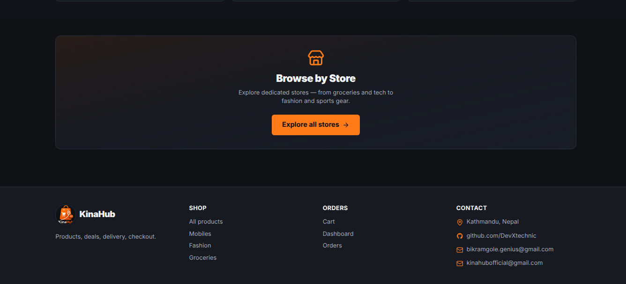

Chapter: 4 OJT Summary & Learning

4.1 Observations & Analysis
Throughout the OJT, I observed how modern web development is shifting towards client-side intelligence. By moving complex logic such as cart optimization to the frontend, a snappier user experience is achievable. I also analysed how critical slug-based routing is for SEO and user readability, which led to the implementation of automatic slug generation in Django using the 'slugify' utility.

4.2 Technical Skills Acquired
Working on KinaHub, I have mastered several key skills:
- Full-stack Integration: Connecting a Django REST backend with a Vite-powered React frontend.
- Advanced CSS: Using Tailwind CSS for building responsive, theme-aware interfaces.
- AI Orchestration: Designing prompts and handling streaming responses from the OpenRouter API.
- Version Control: Maintaining a clean development history and managing different features via Git.

Chapter: 5 Conclusion & Future Recommendations

5.1 Conclusion
The KinaHub project has successfully achieved its goals of building a functional, local-first e-commerce platform. For a Grade 10 student, this OJT has been a transformative experience, bridging the gap between school-level ICT and professional software engineering. KinaHub stands as a proof-of-concept for how localized technology can empower communities, giving local businesses the digital visibility they deserve.

5.2 Future Recommendations
For future enhancements, the following developments are suggested:
- Real-time Notifications: Integrating WebSockets to notify sellers of new orders instantly.
- PWA Features: Converting KinaHub into a Progressive Web App so users can shop offline and receive push notifications.
- Enhanced AI: Training a specialized model on local product data to provide even more accurate value assessments.

References
1. Django REST Framework (Backend API): https://www.django-rest-framework.org/
2. React (Frontend Library): https://react.dev
3. OpenRouter API (AI Orchestration): https://openrouter.ai
4. Framer Motion (UI Animations): https://www.framer.com/motion

