Project Report on
ProjectName at
Shivapuri Secondary School, Maharajgunj, Kathmandu

Submitted By:
Names

Submitted To:
Department of Computer Engineering(9-12)

Ashwin, 2082
PREFACE
The present report is the outcome of the On-the-Job Training (OJT) project titled “GlobaLearn – Language Learning Web App”. It is prepared to fulfill the requirement of the Computer Engineering program under the Technical Stream at the Grade 12 level.
This report reflects the practical exposure I gained while working on UI/UX design projects at Digix Hub Pvt. Ltd. The training primarily focused on designing user interfaces using Figma, where I worked on creating prototypes, layouts, and interactive elements for a language learning platform.
The training provided me with an opportunity to bridge the gap between theoretical knowledge and professional practice. While classroom lessons taught me about UI, UX, and design principles, the OJT allowed me to apply those skills in real projects. The main goal of this OJT was to design a user-friendly and engaging interface for a language learning app that included lessons, quizzes, vocabulary practice, and progress tracking.
The report also documents the additional works we completed during practice sessions, such as logo design, poster design, YouTube UI, and beauty product website mockups. These tasks not only enhanced creativity but also sharpened my technical and collaborative skills.
I am confident that the experience gained through this OJT will be highly valuable in my academic and professional journey.

ACKNOWLEDGEMENT
This OJT report would not have been possible without the support and guidance of several individuals and institutions. First and foremost, I express my heartfelt gratitude to Er. Sagun Babu Adhikari, my supervisor at Digix Hub Pvt. Ltd., for his continuous guidance, constructive feedback, and mentorship throughout the project. His expertise in UI/UX design and encouragement helped me improve my skills and complete the project successfully.
I would also like to thank Digix Hub Pvt. Ltd. for providing me with the opportunity to work in a professional environment where I could learn modern design tools and methods. The entire team at Digix Hub supported me and made the training period productive and enjoyable. I am also grateful to my friends and colleagues for their collaboration, discussions,
and valuable feedback during the project.
Lastly, I extend my deepest gratitude to my parents and family for their constant support, motivation, and encouragement during this OJT. Without them, it would not have been possible to stay focused and achieve my goals.
TABLE OF CONTENTS
Topic Page No.
CERTIFICATE OF APPROVAL....................................................................................ii
CERTIFICATE OF ON THE JOB TRAINING............................................................iii
DECLARATION...............................................................................................................iv
PREFACE...........................................................................................................................v
ACKNOWLEDGEMENT................................................................................................vi
Chapter: 1 Introduction.....................................................................................................1
1.1 Overview.....................................................................................................................1
1.2 Statement of Problems................................................................................................2
1.3 Objectives of Language Learn Web App UI/UX……................................................2
1.4 Scope of Language Learn Web App UI/UX...............................................................3
1.5 Application of Language Learn Web App UI/UX..................................................... 3
Chapter: 2 OJT Workplace...............................................................................................4
2.1 Overview.....................................................................................................................4
2.2 Service and Facilities..................................................................................................5
Chapter:3 OJT Project Technology and Implementation..............................................6
3.1 Technology Overview.............................................................................................6-14
Chapter: 4 OJT Summar.................................................................................................15
4.1 Observation...............................................................................................................15
4.2 Learning Experience.................................................................................................16
4.3 Learnt Skill...............................................................................................................16

Chapter: 5 Conclusion, Recommendation & Suggestion.............................................17
5.1 Conclusion................................................................................................................17
5.2 Limitations................................................................................................................17
5.3 Future Enhancement.................................................................................................18
5.4 Recommendations.....................................................................................................18
5.5 Suggestions...............................................................................................................19
References..........................................................................................................................20

ABBREVIATION
OJT: On the Job Training
NEB: National Education Board
UI: User Interface
UX: User experience
Chapter: 1 Introduction
.1.1 Overview of Web Design
This On-the-Job Training (OJT) was conducted at Digix Hub Pvt. Ltd., Tokha-8, Kathmandu, as a partial requirement for the Class 12 Computer Engineering Technical Stream. The main project undertaken during the training was the design of a Language Learning Web Application (GlobaLearn) focusing on UI/UX design using Figma
The purpose of the training was to bridge the gap between classroom knowledge and practical application. While theoretical classes provided concepts of UI/UX, color theory, typography, and design systems, the OJT enabled me to apply these concepts in real-world projects. The project involved creating wireframes, prototypes, and interactive designs for features like login and registration, language selection, lesson modules, quizzes, vocabulary practice, and progress tracking dashboards.
During the training, I also worked on practice designs, such as poster design, logo recreation, and YouTube channel UI, beauty website homepage, and messaging app design, which helped refine creativity, alignment, spacing, and component usage. Tools such as Figma components, grid/column systems, auto-layout, and prototyping features were extensively used to ensure a clean, professional, and user-friendly interface.
Overall, the OJT provided an enriching experience that enhanced both technical and soft skills. It allowed me to gain confidence in working with modern design tools and understand how professional workflows operate in the IT industry. The training not only improved my design capabilities but also prepared me for future projects by emphasizing creativity, teamwork, and problem-solving.

1.2 Statement of Problem
The statement of problem which caused me to develop this language learning web application are:
- Limited Accessibility: Many learners lack access to user-friendly and structured online platforms for learning languages, which creates barriers in their educational journey.
- Low Engagement: Existing apps are often not visually appealing or interactive, reducing learner motivation and making it harder to sustain consistent learning.
- Lack of Progress Tracking: Students often struggle to measure their learning progress due to the absence of tracking systems like quizzes, reports, and dashboards.
- Complex Interfaces: Some platforms are too complex for beginners, making it difficult for users of different age groups and backgrounds to adapt easily.
- Gap between Theory and Practice: There is a need for a design that connects classroom knowledge with practical, engaging, and accessible digital learning solutions.
1.3 Objectives
The major objectives of the Language Learning Web Application are as follows:
- User-Friendly Design: To design a visually appealing, interactive, and simple interface that makes learning enjoyable for all users.
- Practical Application of Skills: To apply academic knowledge of UI/UX design and web technologies in a real-world project scenario.
- Consistency and Reusability: To develop reusable components and layouts that ensure consistency across lessons, quizzes, and dashboards.

1.4 Scope of Project
The scope of the Language Learning Web Application is as follows:
- UI/UX Design Focus: The project is primarily focused on wireframing, prototyping, and UI/UX design using Figma.
- Learning Modules: It covers the design of lessons, vocabulary sections, quizzes, and user dashboards.
- Prototyping Features: The scope includes adding interactions, animations, and user flows for simulating real usage.
- Design Limitations: The project does not cover backend coding, database integration, or deployment, focusing only on design.
- Future Expansion: The scope leaves room for further development, including real implementation, advanced features, and integration with learning tools.

1.5 Applications
The applications of the Language Learning Web Application are as follows:
- Educational Institutions: Schools and colleges can use the platform to support digital and interactive language education.
- Independent Learners: Self-learners can practice vocabulary, lessons, and quizzes effectively with a structured design.
- E-Learning Platforms: Online education providers can adapt the design to improve student engagement and retention.
- Corporate Training: Businesses can use the platform to train employees in new languages for professional growth.

Chapter: 3 Project Technology and Implementation

3.1 Technologies Used

The main tool used for designing the GlobaLearn – Language Learning Web App was Figma.
- Frame Tool: Used to create layouts for web pages and organize different sections of the application design.

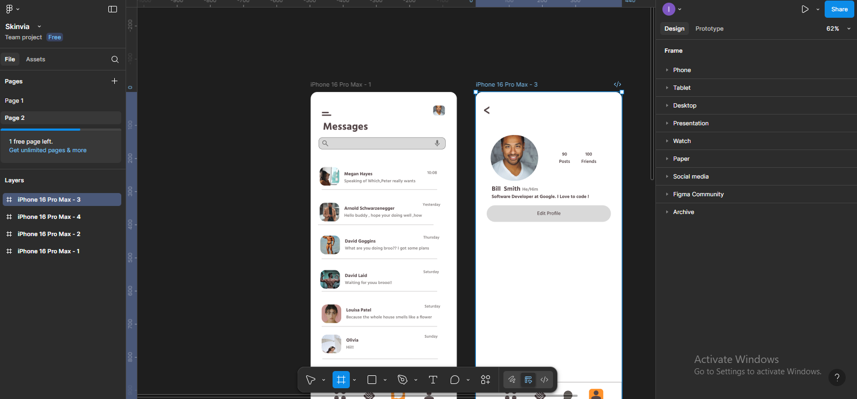

Shape Tool (Rectangle, Circle, Line, etc.): Used to design buttons, cards, icons, and other UI elements.

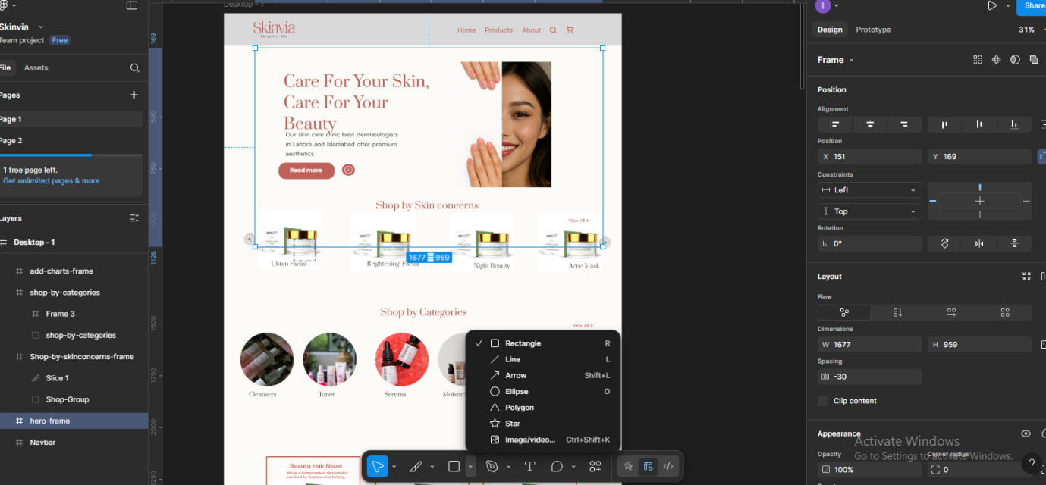

- Components & Assets: Allowed us to create reusable design elements (like buttons, navigation bars, and quiz cards) that maintained consistency across the project.

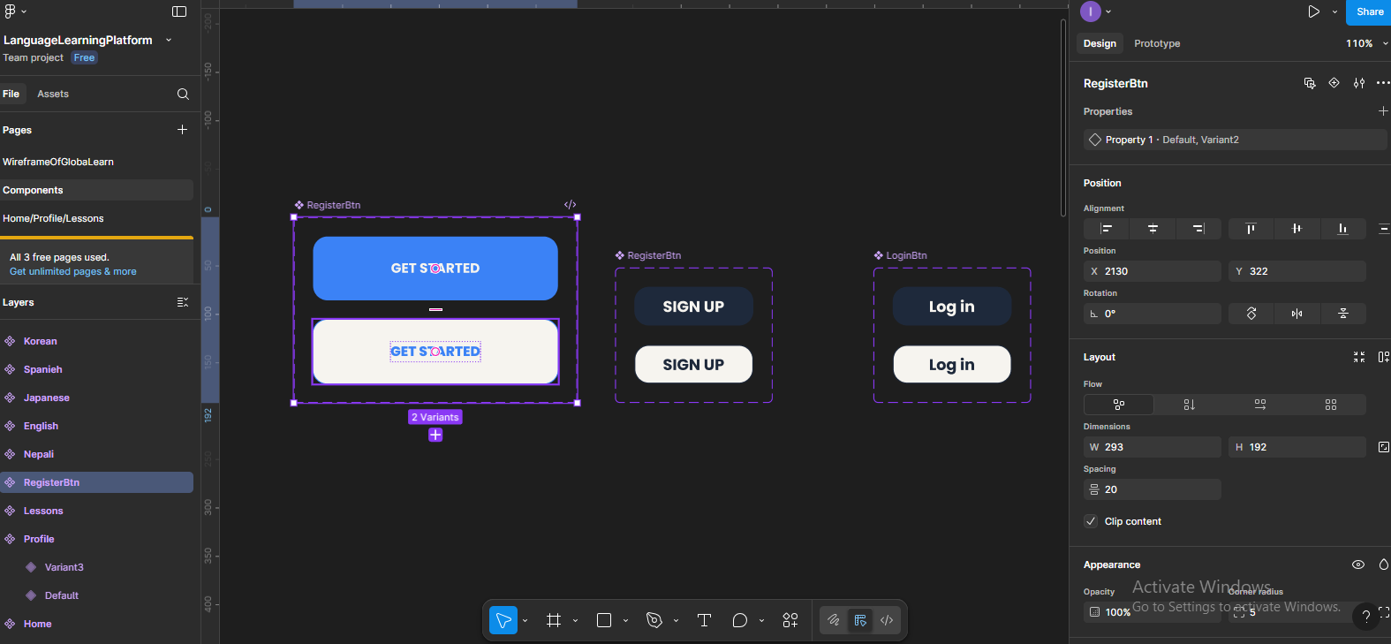

- Prototype Tool: Used to connect different screens and add basic animations and transitions to simulate how users would interact with the app.

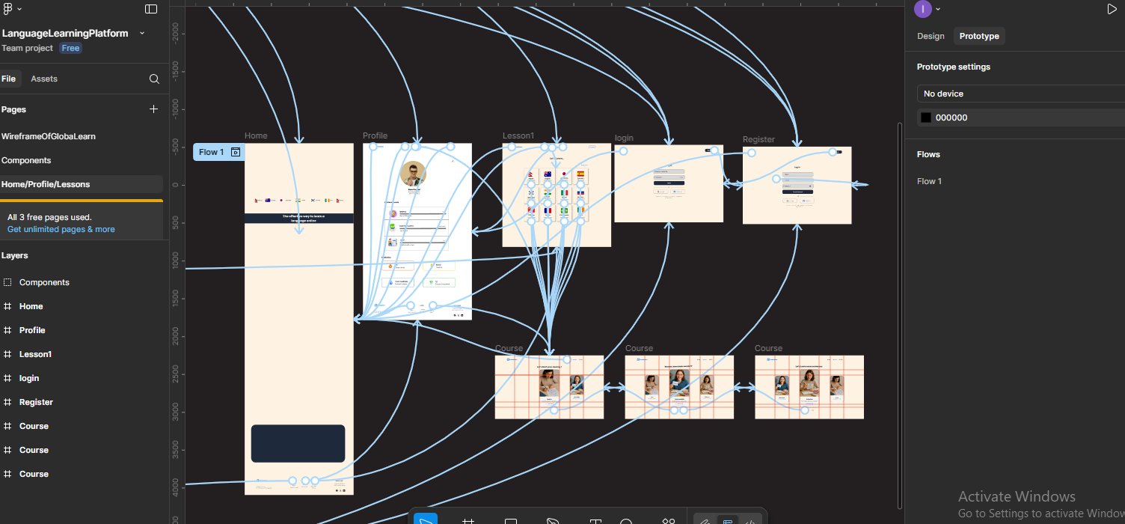

- Column/Grid Tool: Used to align elements properly and maintain responsive, structured layouts.
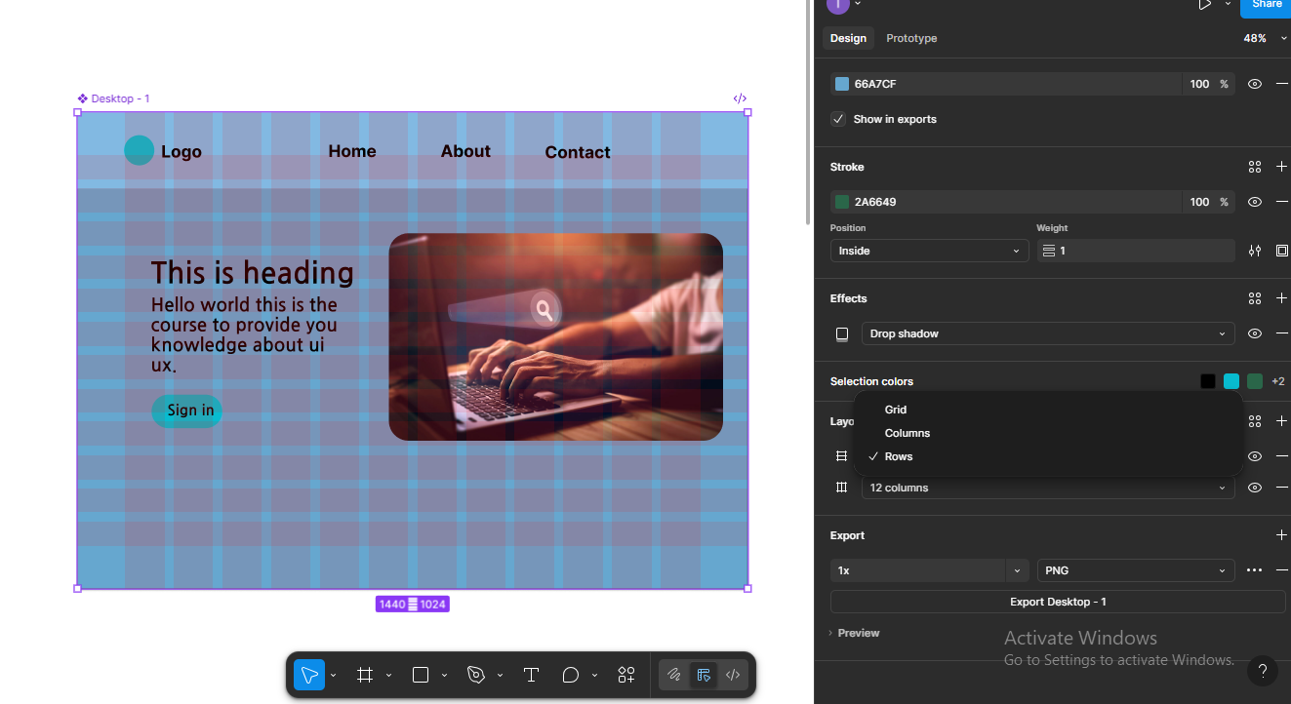

Alignment Tool: Ensured proper positioning of text, buttons, and images for a clean and user-friendly design.

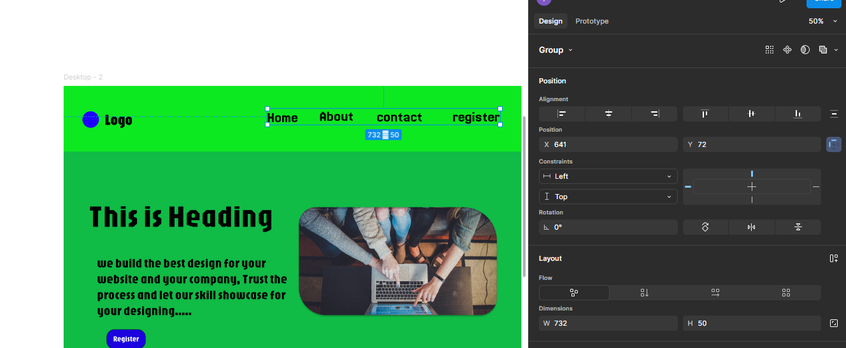

3.2 Works
Apart from the main OJT project, we also worked on practice designs in class to improve our skills. Some of the works include:
- Logo Design (Google Chrome Logo): Recreated the Chrome logo using Figma' s shape and color tools to understand alignment and layering.

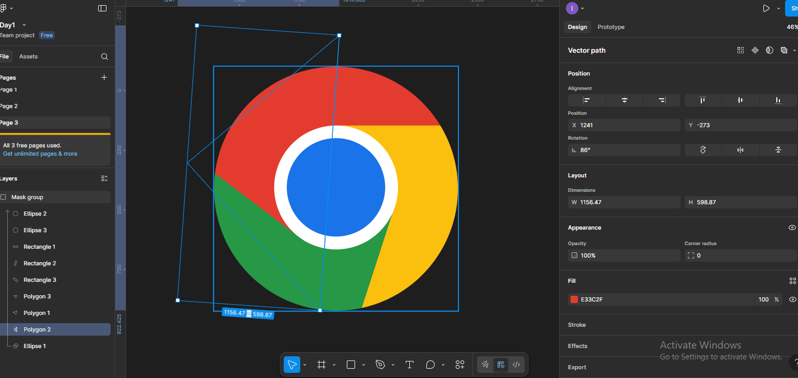

- Website Design for Beauty Products: Designed a sample homepage for a beauty product company with a focus on layout, product cards, and typography.
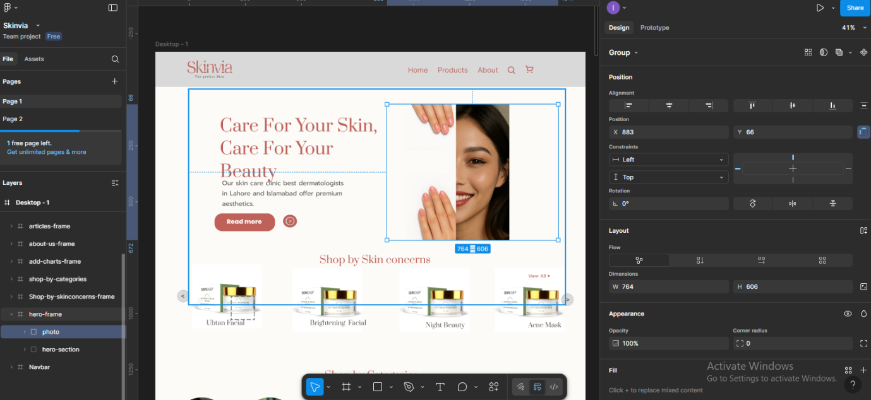

- Messaging App UI Design: Created a prototype for a simple messaging app, including chat bubbles, contact lists, and navigation icons.

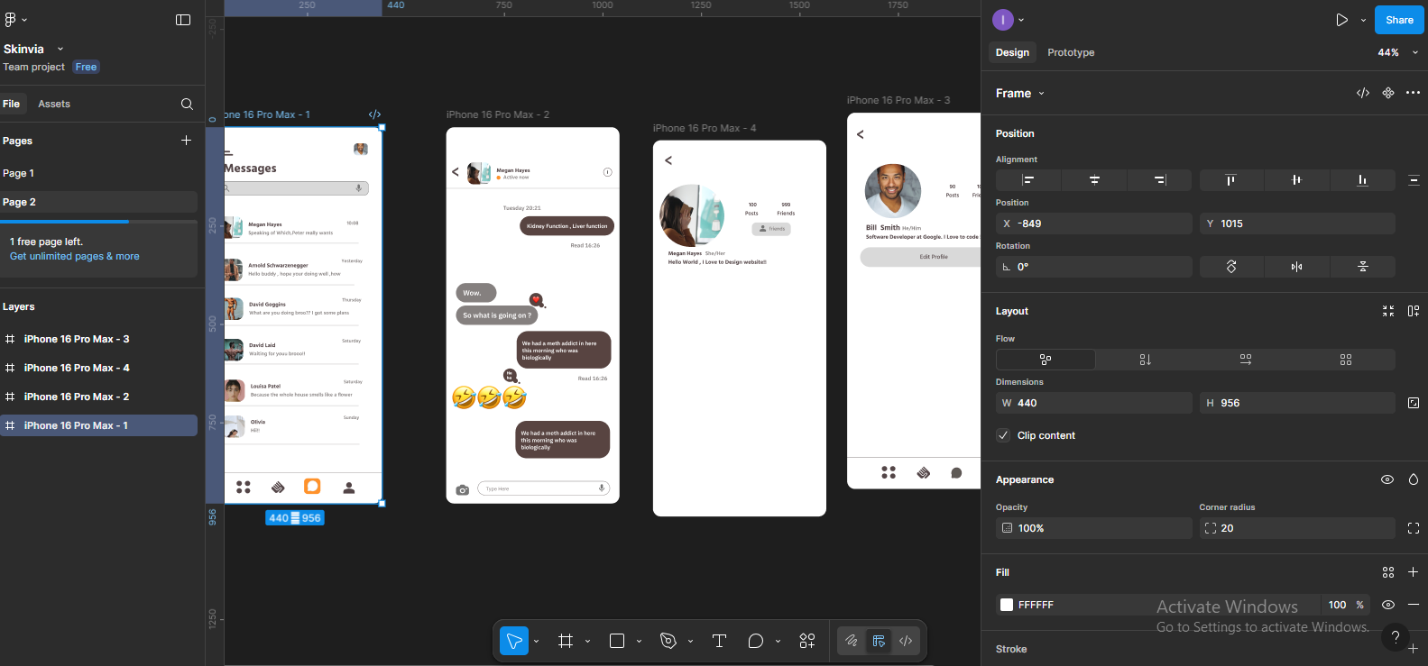

- YouTube Channel UI Design: Created a modern design for a YouTube channel interface, experimenting with video thumbnails, navigation bars, and profile sections to understand content organization and usability.

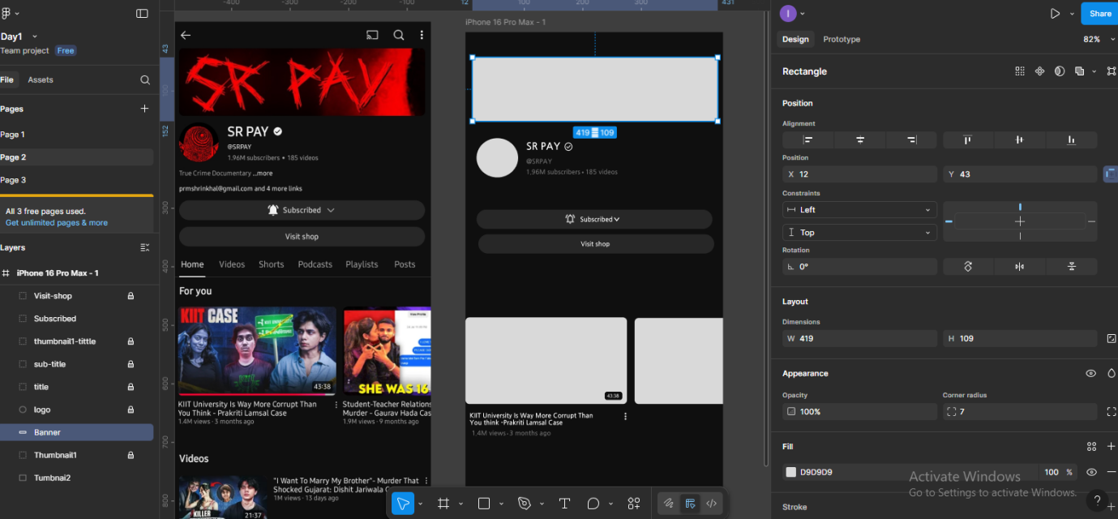

Project: GlobaLearn is a language learning web application design created using Figma during our OJT.

- Landing Page
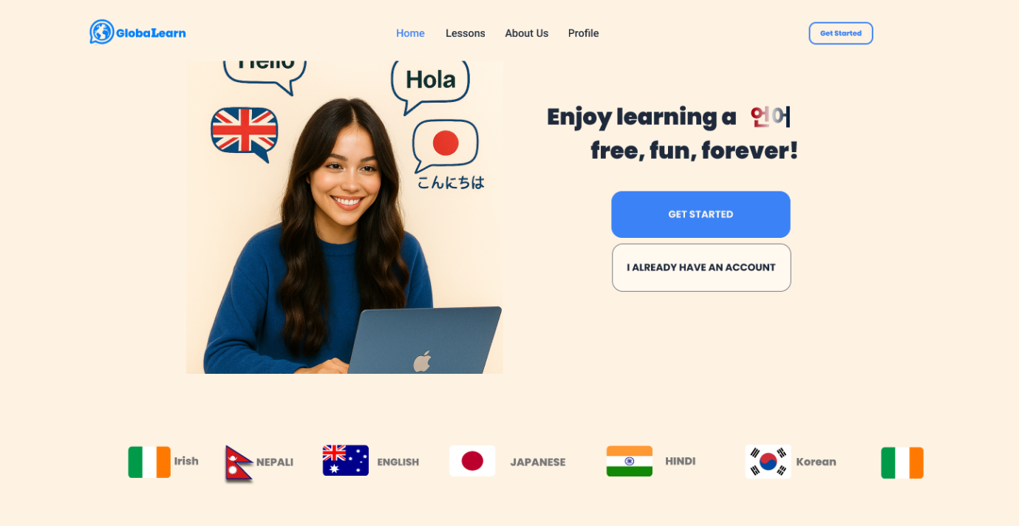

- Login & Register Page

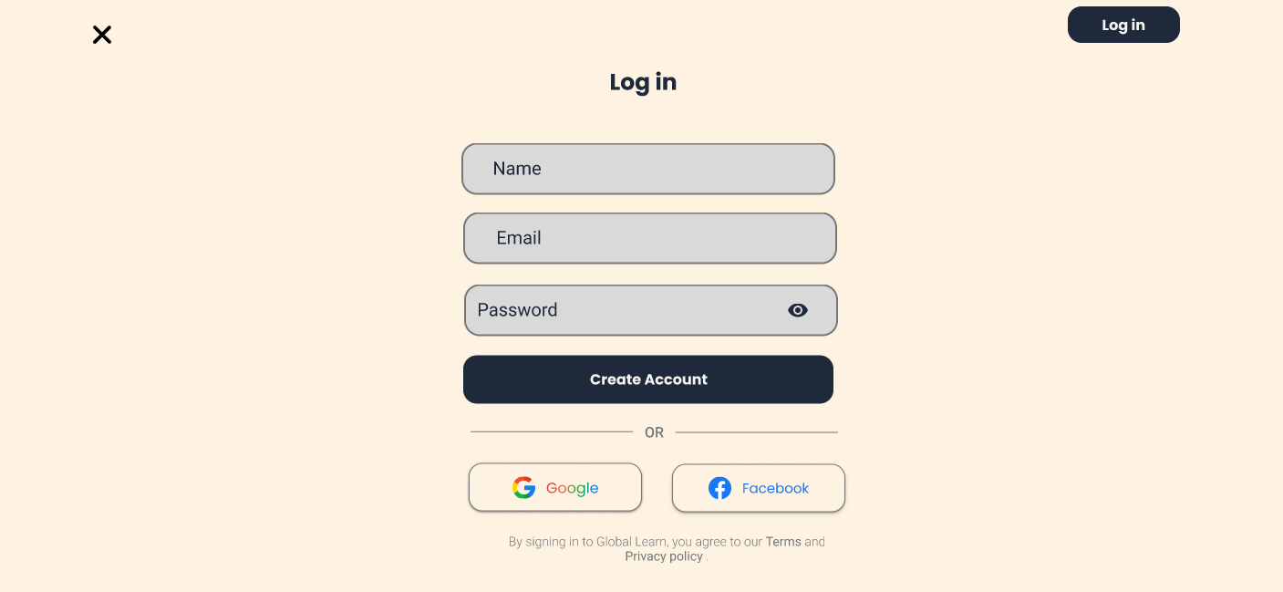

- Language option Page

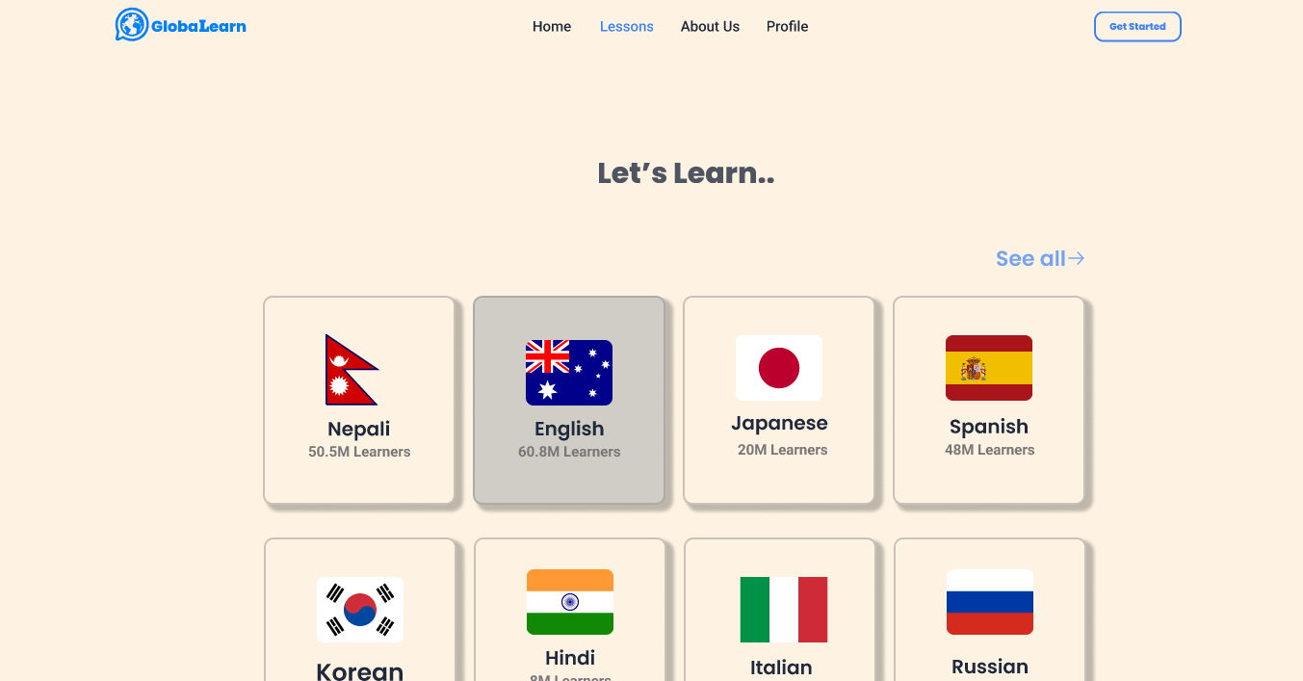

- Lessons Page

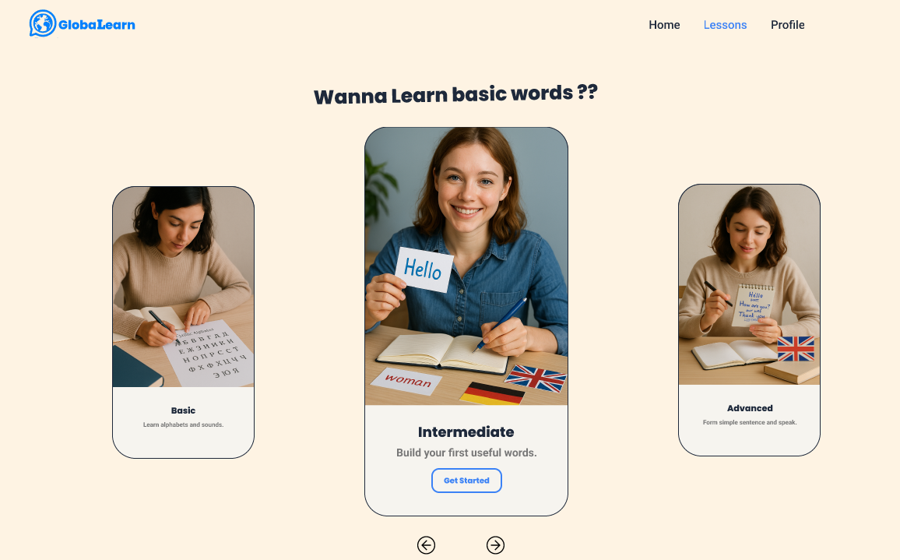

Chapter: 4 OJT Summary

4.1 Observations
During my OJT at Digix Hub Pvt. Ltd., I observed the following:
- The organizational workflow was systematic, with daily stand-up meetings and sprint reviews to track progress.
- The workplace environment was professional and collaborative, encouraging teamwork and peer feedback.
- Supervisors and mentors were approachable and supportive, guiding us in both technical and soft skills.
- Students were given the opportunity to handle real-world projects, which helped in applying classroom knowledge effectively.
- The company maintained a disciplined culture, where time management and task allocation were strictly followed.
- Proper digital resources and tools such as Figma and online plugins were provided to enhance productivity.
- The organization emphasized quality design practices, focusing on UI/UX principles, responsiveness, and accessibility.
- I also observed that every trainee showed great enthusiasm and eagerness to learn throughout the training period.

4.2 Learning Experiences
The experiences I gained during my OJT at Digix Hub Pvt. Ltd. were highly valuable.
- I learned how to apply theoretical UI/UX knowledge in real projects, such as designing lesson modules, dashboards, and quizzes.
- I gained confidence in using Figma tools, including components, auto-layout, grids, prototyping, and interactive animations.
- I experienced the importance of collaboration, communication, and feedback in a professional IT environment.
- I learned how design decisions affect user experience, accessibility, and usability.
- I improved my time management, problem-solving, and design consistency skills by working on multiple projects.
- I experienced professional documentation practices, including maintaining reports, progress logs, and presentations.
- I developed adaptability by handling new challenges and implementing corrections based on mentor guidance.

4.3 Learnt Skills
The major skills I acquired during the OJT are:
- Designing interactive wireframes, prototypes, and UI layouts in Figma.
- Applying color theory, typography, and grid systems in professional design projects.
- Creating and managing reusable components for consistency across multiple pages.
- Designing user-friendly lesson modules, quizzes, and dashboards for an e-learning app.
- Enhancing teamwork, communication, and presentation skills in a professional setting.

Chapter: 5 Conclusion, Recommendation & Suggestion

5.1 Conclusion
This On-the-Job Training (OJT) at Digix Hub Pvt. Ltd. was a highly enriching experience. It helped me bridge the gap between academic knowledge and professional application. Under the supervision of Er. Sagun Babu Adhikari, I gained practical exposure to UI/UX design through the development of the GlobaLearn – Language Learning Web App. The training not only improved my technical skills in Figma but also enhanced my teamwork, communication, and problem-solving abilities. Overall, the OJT played a crucial role in preparing me for future academic and professional challenges.

5.2 Limitations
Although the OJT was highly beneficial, the project had certain limitations:
- The scope was limited to UI/UX design only, without backend coding or deployment.
- Some advanced features like AI-based recommendations could not be implemented within the time frame.
- Internet connectivity issues occasionally slowed down the workflow.
- The project was restricted to prototype-level outputs, not a fully functional application.
- Limited time prevented deeper exploration into other industry tools apart from Figma.

5.3 Future Enhancements
The project has strong potential for future development:
- Integration of backend and database to make the application fully functional.
- Adding gamification features like badges, leaderboards, and rewards for better engagement.
- Implementing AI-powered progress tracking and personalized learning recommendations.
- Designing a mobile-responsive app for wider accessibility.
- Expanding the app to support multiple languages and global learners.

5.4 Recommendations
Based on my OJT experience, I recommend the following improvements:
- Provide trainees with access to more industry-level tools and plugins for design enhancement.
- Allocate more project time to allow students to explore advanced functionalities.
- Conduct regular workshops on the latest UI/UX trends and frameworks.
- Improve resource sharing by maintaining a central digital library of references and tutorials.
- Enhance collaboration sessions between trainees to share ideas and improve creativity.

5.5 Suggestions
- From my three months of training, I would like to suggest:
- Future trainees should practice Figma basics beforehand to adapt quickly.
- The institution should provide faster internet and more technical resources for productivity.
- Students should maintain a daily logbook to keep track of their learning progress.
- More time should be allocated for final project refinement and report preparation.
- Trainees should actively seek feedback from mentors to continuously improve their skills.

Refrences
- Figma : https://www.figma.com
- Pixabay : https://pixabay.com
- Iconify

