AwsSysOps-2A Batch project

Part-1

1. Cloudformation Task :

create a vpc with one public and one priv subnet ( 10.1.0.0/16 , 10.1.1.0/24 (public) , 10.1.2.0/24(priv)

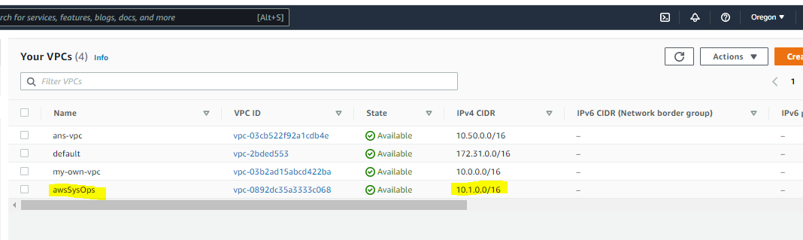

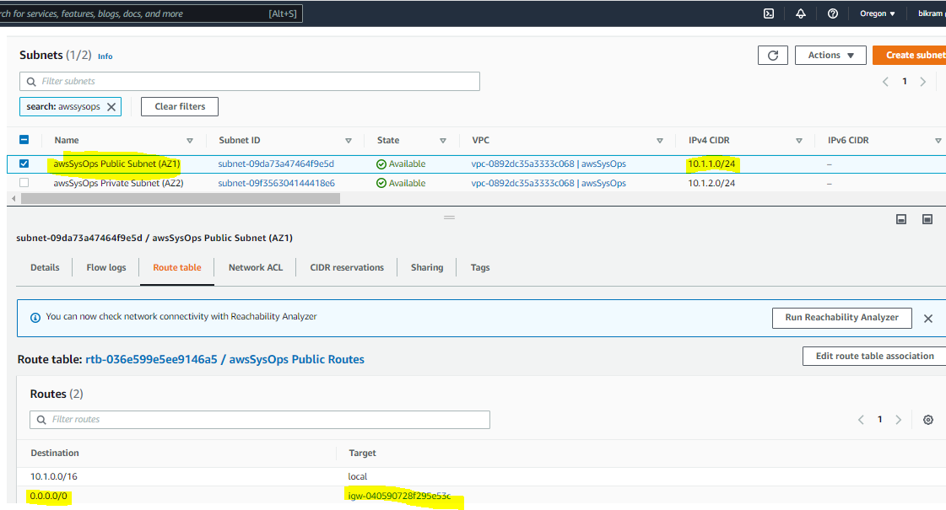

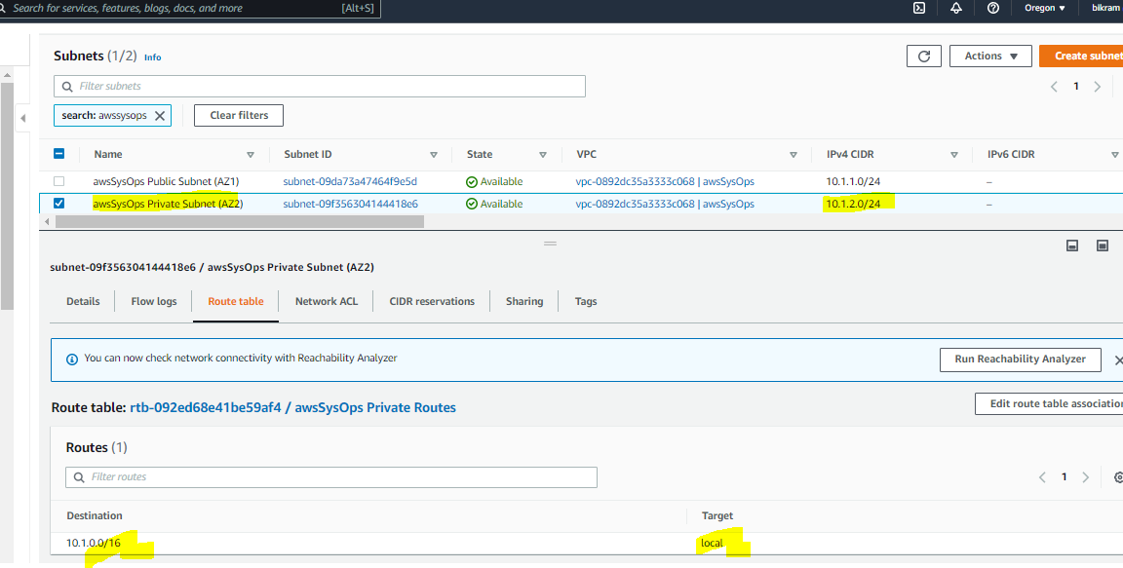

Create IGW and attach to vpc

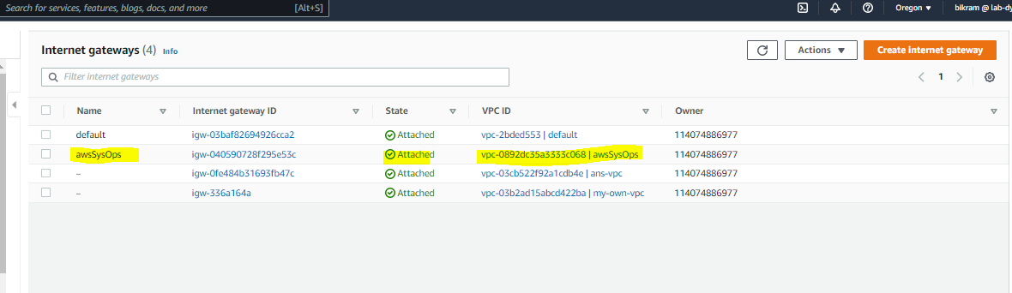

Routetables

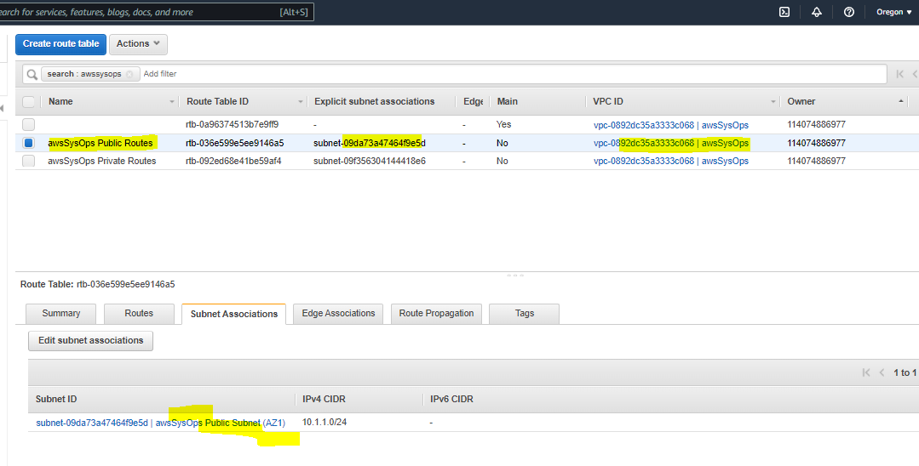

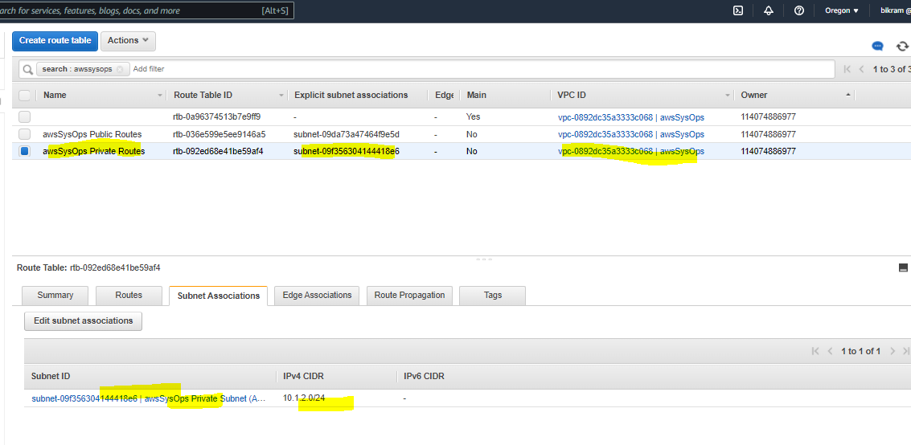

1. Terraform task:

Launch Configuration

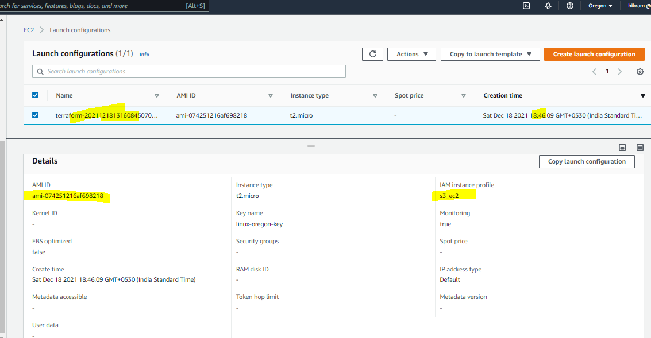

ASG

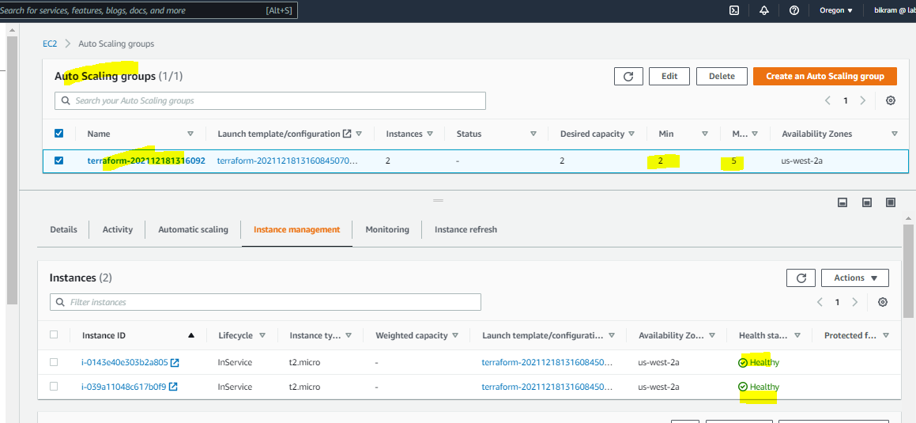

AMI ID

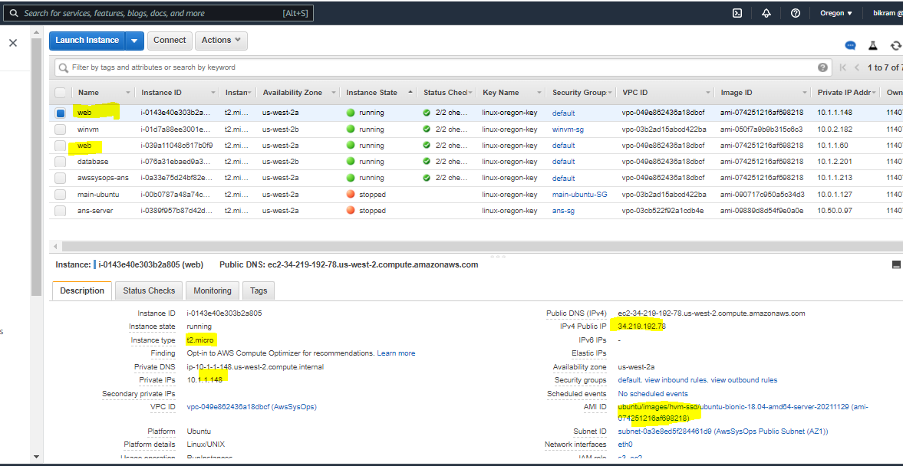

ELB

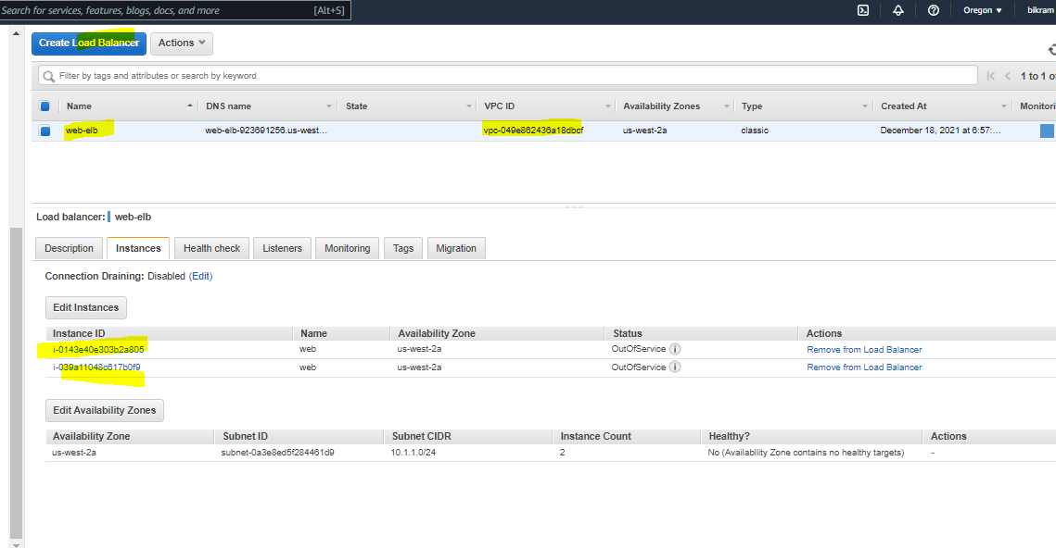

Database in Private subnet

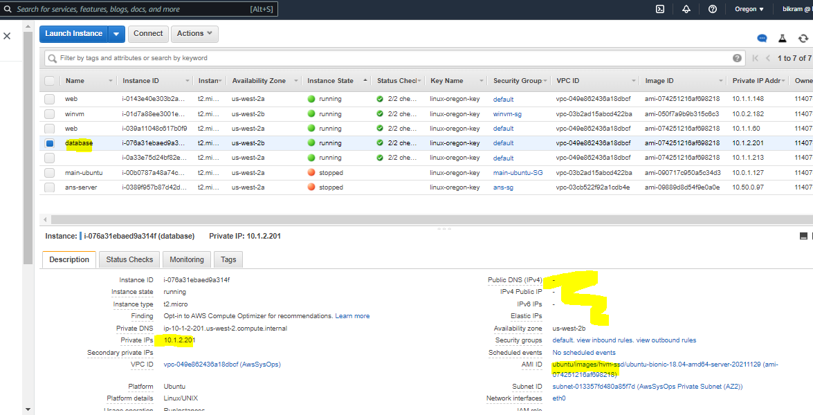

1. Ansible task:

/etc/ansible/ansible.cfg and aws_ec2.yml

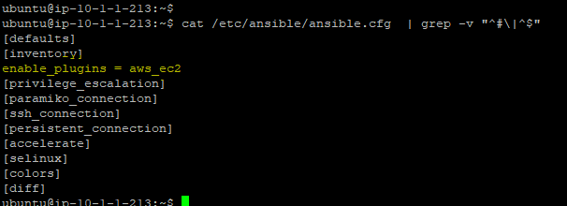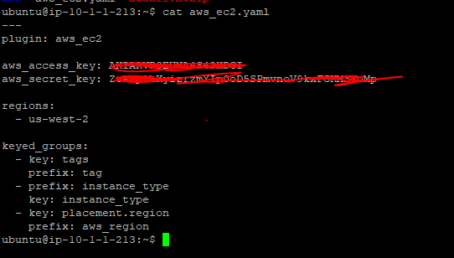

Install_apache.yml

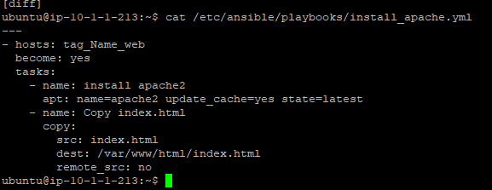

Playbook run result

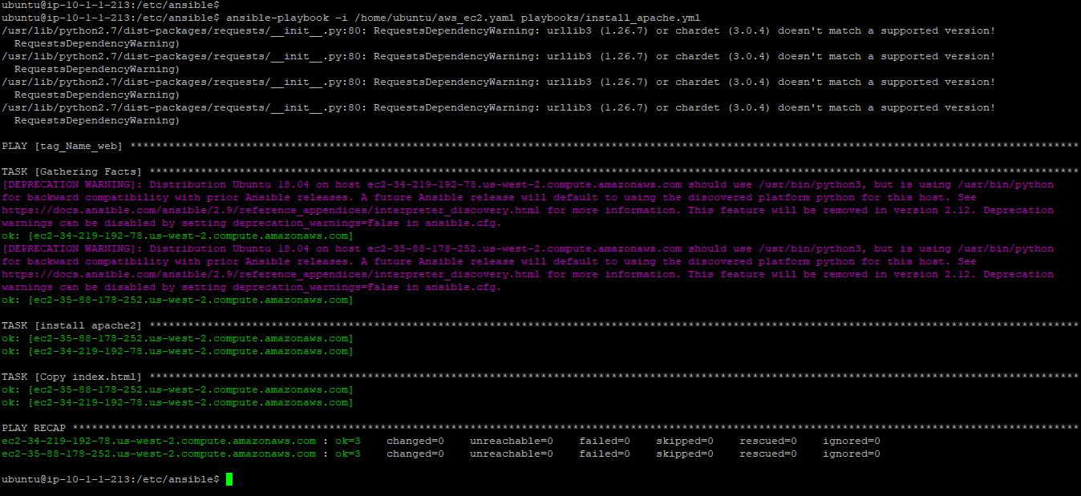

After installing apache instance showing In_service in ELB

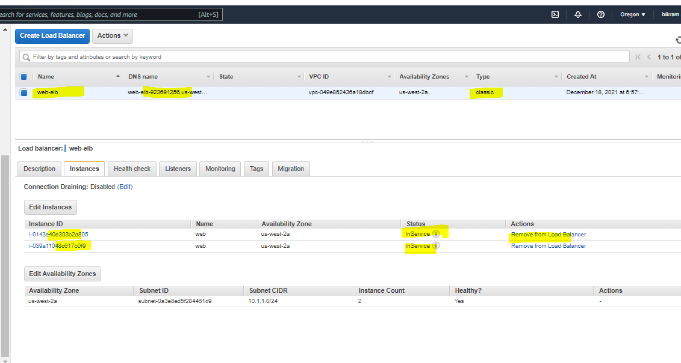

Page is opening successfully

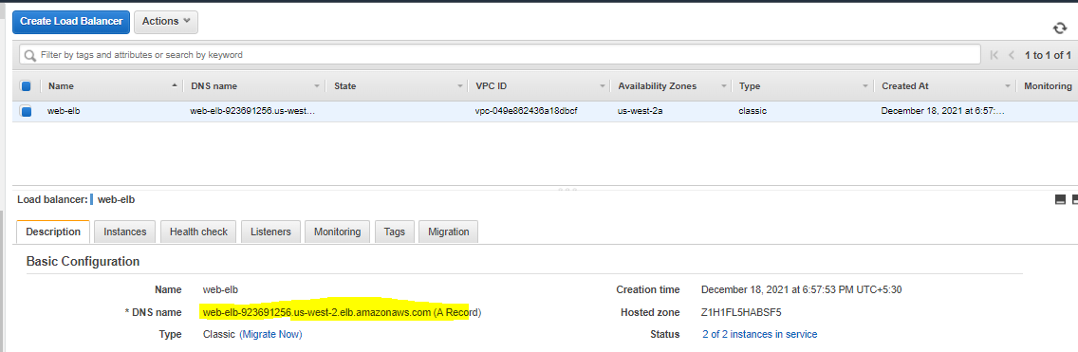

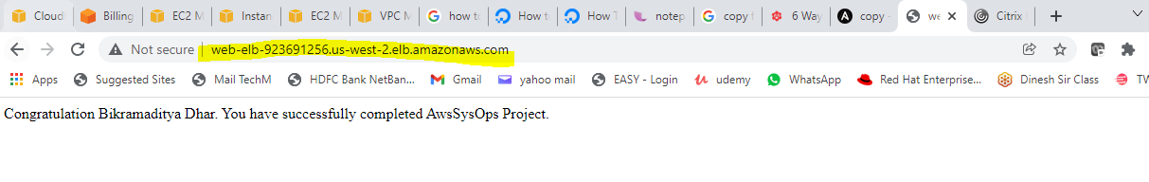

Install mysql on Private Instance

Create a nat-gw in public subnet and then add it to private route table.

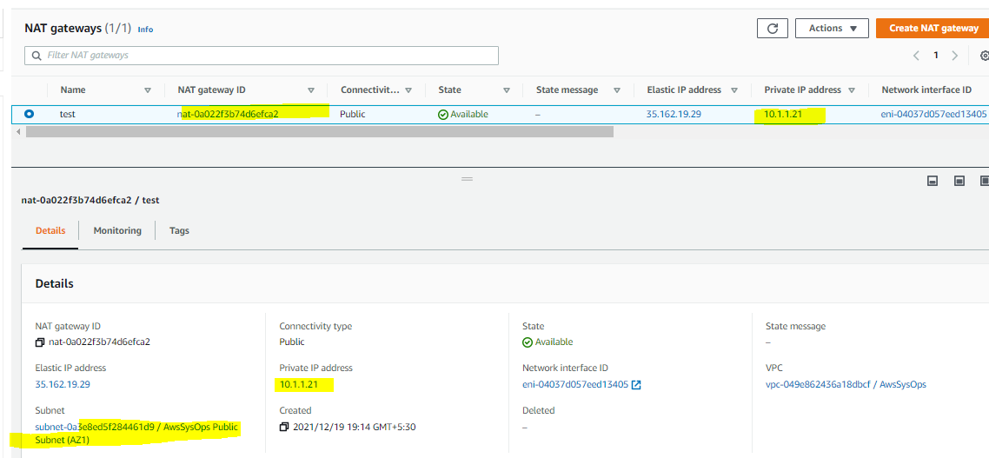

Playbook run:

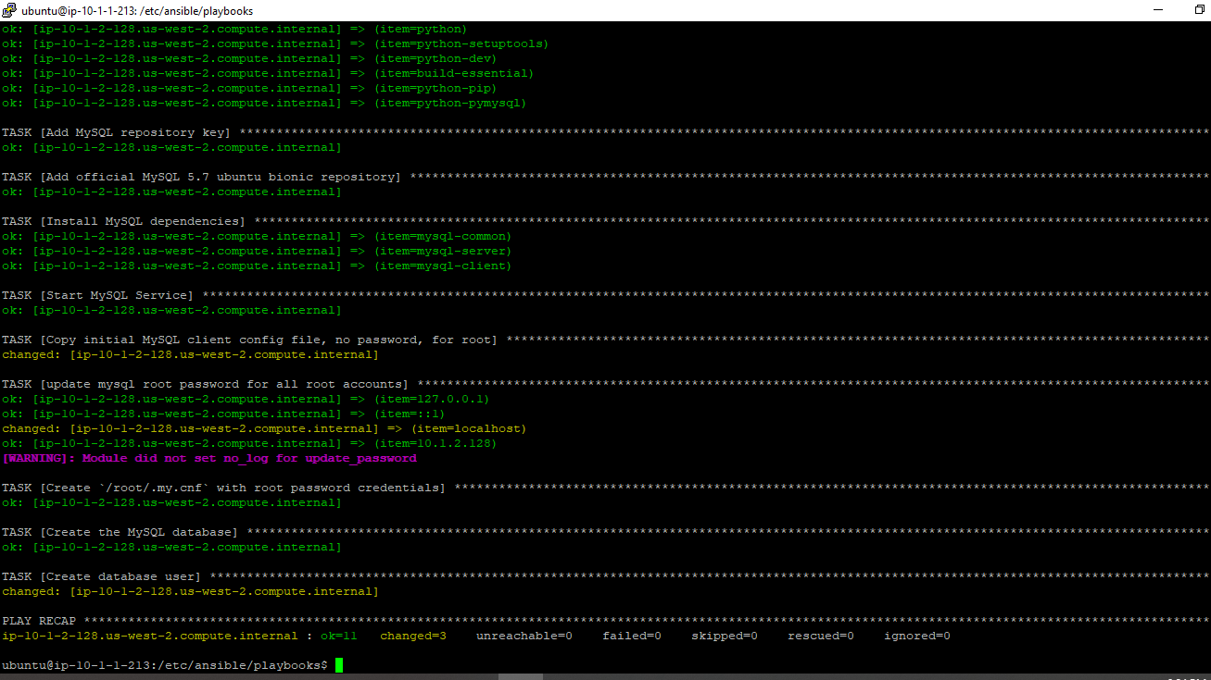

Connect DB

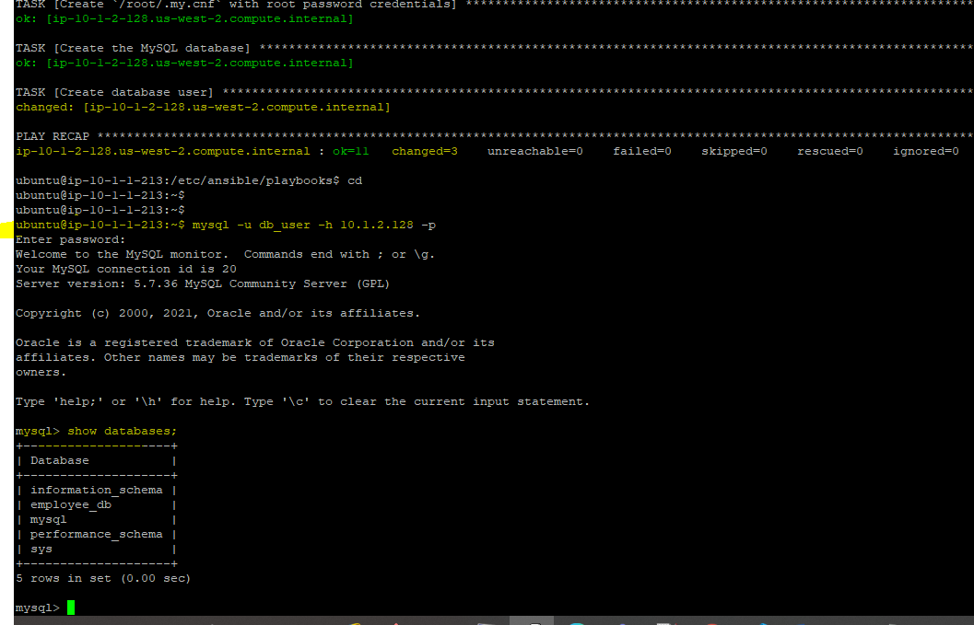

Part-2

**Secure communication and Security Management for application:**

route 53 config for vpc internal communications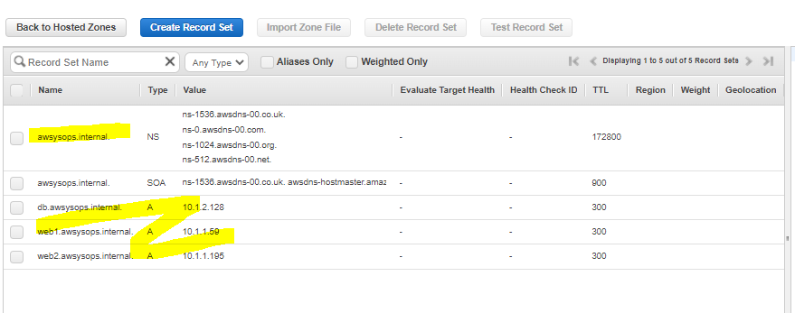

Ping results:

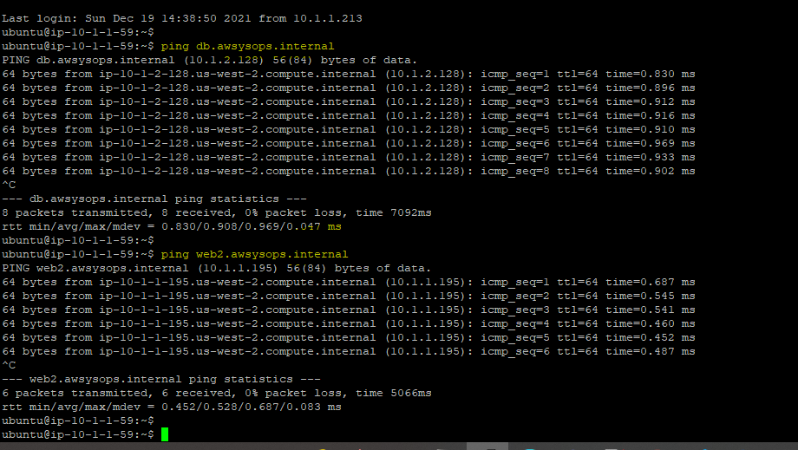

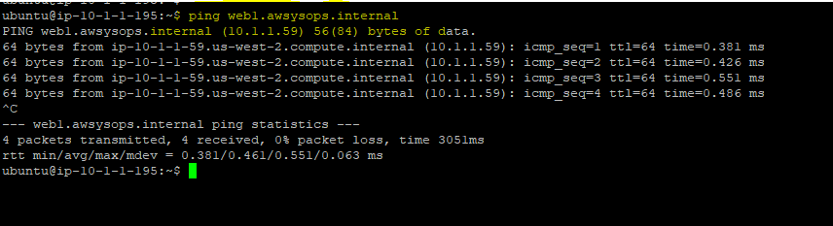

**mysql db should be accessible only from ASG**:

from web1/web2 db is accessible

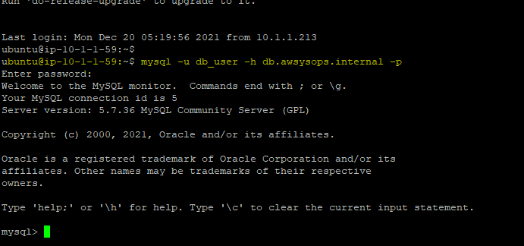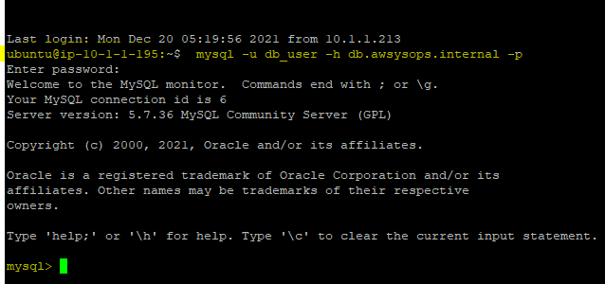

But not accessible from another instance in same vpc

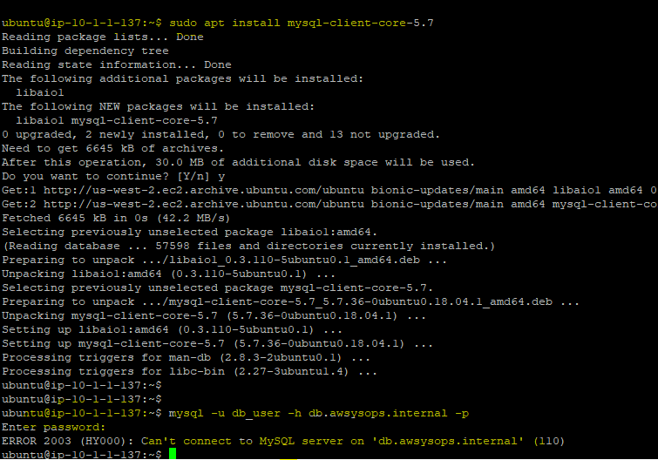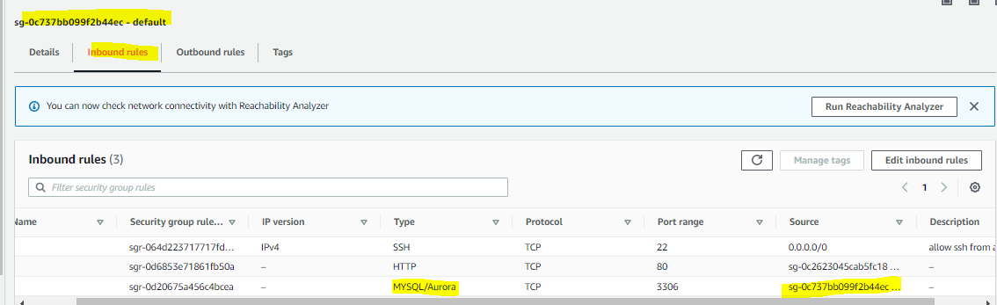

**user to manage app infra like vpc, route 53 and ec2**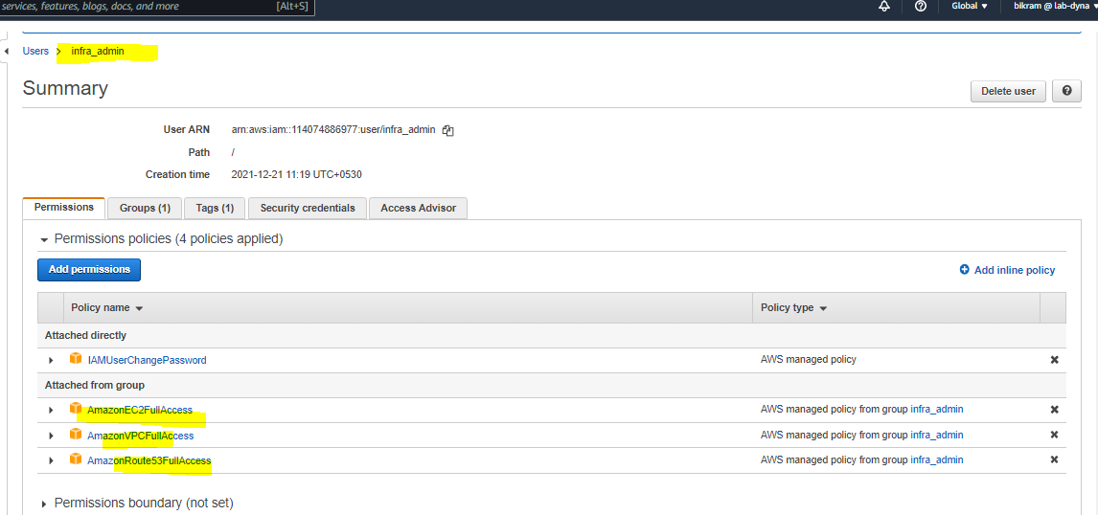

**s3 buckets to store log files ----- name -** [app-logs-bikram1234](https://s3.console.aws.amazon.com/s3/buckets/app-logs-bikram1234)

**all web instances should have permission to access S3**

web1.awsysops.internal  
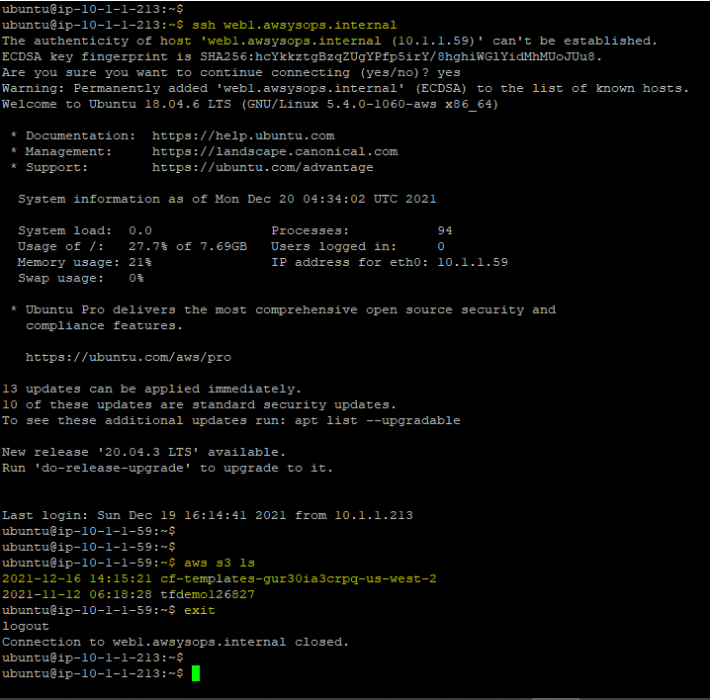

web2.awsysops.internal

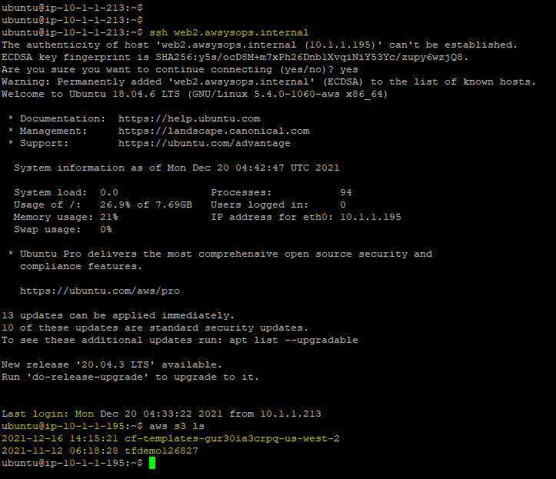

Monitoring App and App Infrastructure:

Network traffic:

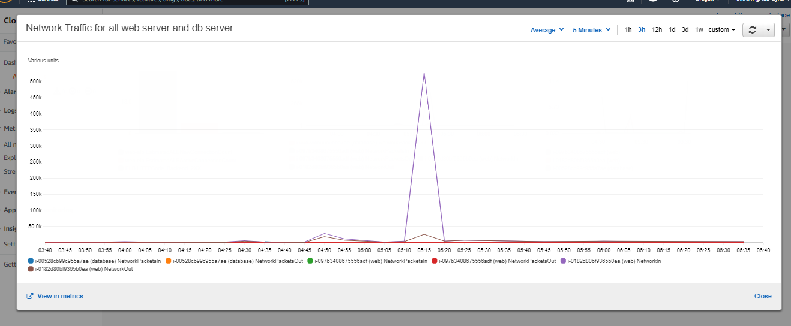

Cpu utilization:::

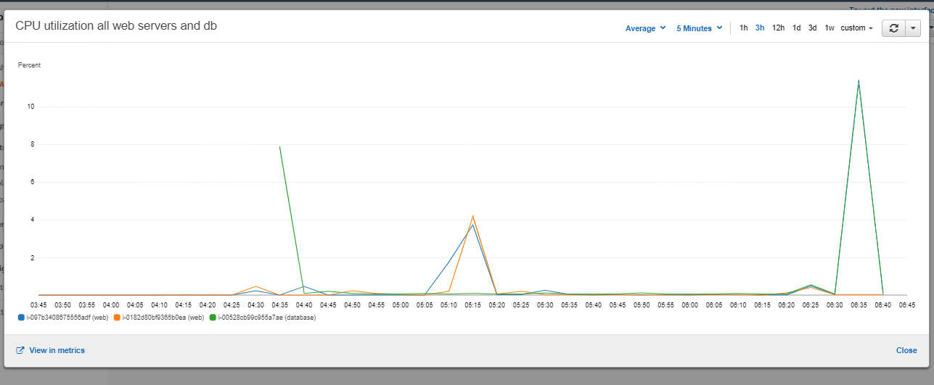

LB traffic:

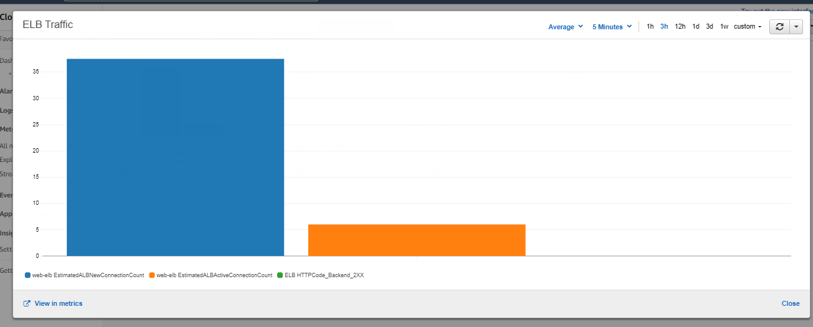

Memory and / disk space utilization

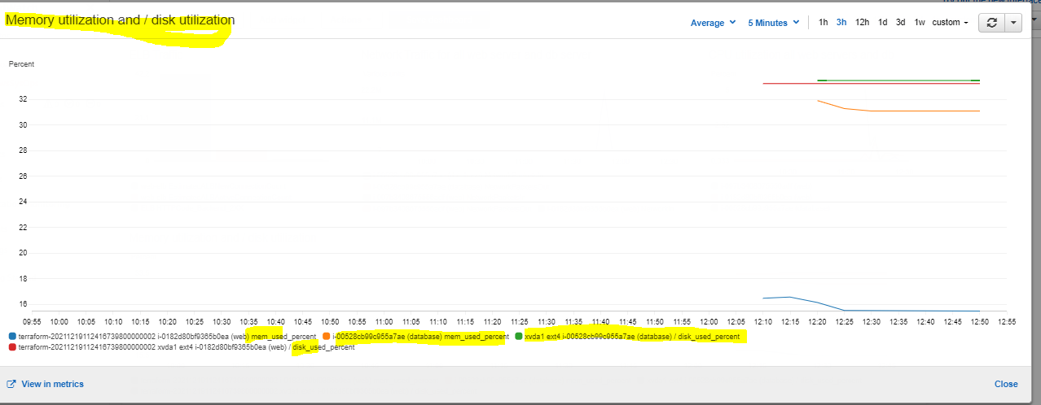

AwsSysOps cloudwatch Dashboard:

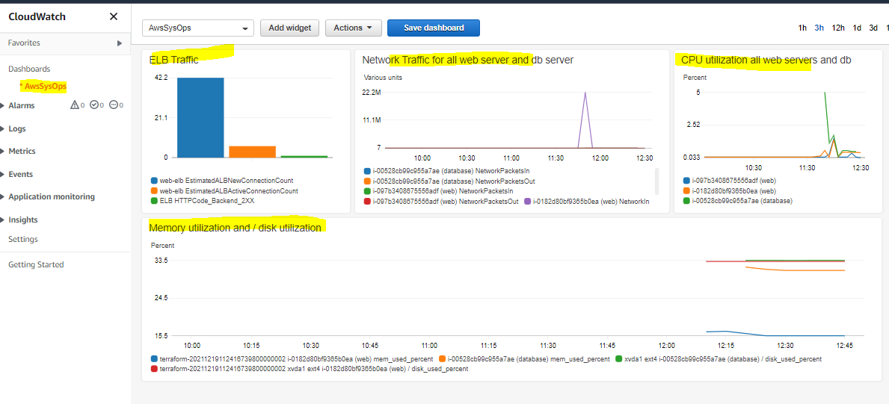

Thank You !!

Bikramaditya Dhar

Emp id - 126827