SYNOPSIS

Submitted by:

Gyan Ranjan.

Kaushal Bhansali.

Ankit Bathla.

Pradhuman Gupta.

“Game Of Stocks”

Introduction

We are going to prepare a mini project using C language which is a game related to Stock Market as this is the most heated topic in the Corporate world.

By the help of this project any one newbee to stock market can get it’s taste and can overcome his fear over investing.

**HAPPY INVESTING!!**

Objectives

* This is a boon for the beginners who want to enter in the field of share market.
* This game will give a brief idea about how stock market works.
* This is going to remove one’s fear of investing in shares.

Inputs:

* New login for companies and customers who want to do trade.
* Entry of Debit/Credit card and starting credits.

outputs:

* Share rates of different companies.
* Profit and loss of individuals.
* Current market statistics.
* Suggestions of current best rising & falling companies.

Overview:

* **Nested Structures** for managing individual’s or company’s profile.
* **Dynamic Memory Allocation** to manage accounts and market statistics.
* **Stacks** for making and deleting entries.
* **File Handling** to maintain individual’s as well as market’s history.

**Flow-Chart**

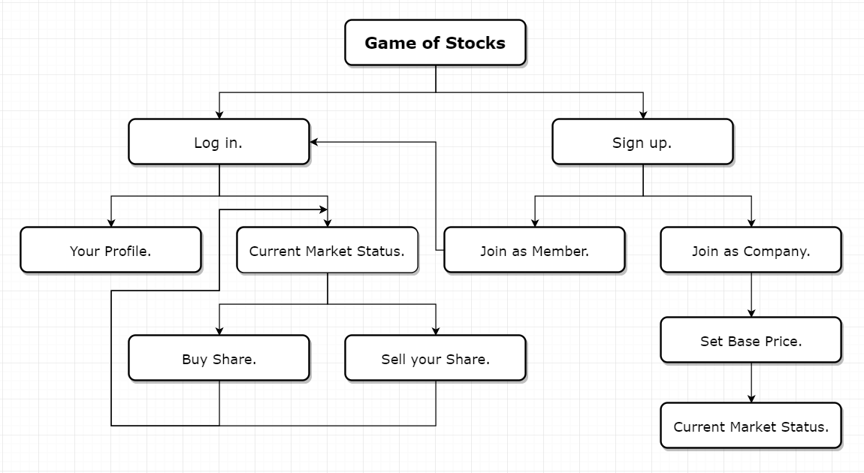

Thank You!