React ‎Friday, ‎August ‎11, ‎2023
------------------------------------------------------------------------------------------------
- ReactJS uses Virtual Dom(JavaScript object),is faster than the regular DOM It uses component and data patterns that improve readability and helps to maintain larger apps.

Why learn ReactJS?
The previous frameworks follow the traditional data flow structure, which uses the DOM (Document Object Model). DOM is an object which is created by the browser each time a web page is loaded. It dynamically adds or removes the data at the back end and when any modifications were done, then each time a new DOM is created for the same page. This repeated creation of DOM makes unnecessary memory wastage and reduces the performance of the application.
First Release version:0.3.0 on 29/05/2013,Initial Public Release
latest Version: 16.8.6 on 27/03/2019 Fix an incorrect bailout in useReducer(), Fix iframe warnings in Safari DevTools, Warn if contextType is set to Context.Consumer instead of Context, Warn if contextType is set to invalid values.
Ways to install ReactJS
- Using the npm command
- Using the create-react-app command
1. Using the npm command
Install NodeJS and NPM
https://www.javatpoint.com/install-nodejs-on-linux-ubuntu-centos
To verify NodeJS and NPM, use the command shown in the below image.
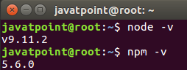

Install React and React DOM
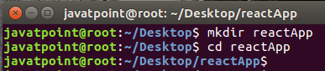
------------------------------------------------------------------------------------------------
React Component Life-Cycle
In ReactJS, every component creation process involves various lifecycle methods. These lifecycle methods are termed as component's lifecycle.
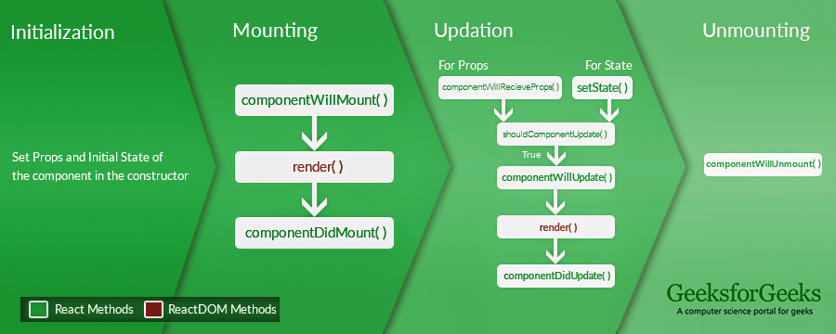
The lifecycle of the component is divided into four phases. They are:
- Initial Phase
- Mounting Phase
- Updating Phase
- Unmounting Phase
1. Initial Phase
- getDefaultProps(): It is used to specify the default value of this.props. It is invoked before the creation of the component or any props from the parent is passed into it.
- getInitialState() : It is used to specify the default value of this.state. It is invoked before the creation of the component.

2. Mounting Phase
- componentWillMount(): This is invoked immediately before a component gets rendered into the DOM. In the case, when you call setState() inside this method, the component will not re-render.
- componentDidMount() : This is invoked immediately after a component gets rendered and placed on the DOM. Now, you can do any DOM querying operations.
- render() :This method is defined in each and every component. It is responsible for returning a single root HTML node element. If you don't want to render anything, you can return a null or false value.
3. Updating Phase
Here, we get new Props and change State.he main aim of this phase is to ensure that the component is displaying the latest version of itself. Unlike the Birth or Death phase, this phase repeats again and again.
- componentWillRecieveProps()
It is invoked when a component receives new props. If you want to update the state in response to prop changes, you should compare this.props and nextProps to perform state transition by using this.setState() method.
- shouldComponentUpdate()
It is invoked when a component decides any changes/updation to the DOM. It allows you to control the component's behavior of updating itself. If this method returns true, the component will update. Otherwise, the component will skip the updating.
- componentWillUpdate()
It is invoked just before the component updating occurs. Here, you can't change the component state by invoking this.setState() method. It will not be called, if shouldComponentUpdate() returns false.
- render()
It is invoked to examine this.props and this.state and return one of the following types: React elements, Arrays and fragments, Booleans or null, String and Number. If shouldComponentUpdate() returns false, the code inside render() will be invoked again to ensure that the component displays itself properly.
- componentDidUpdate()
It is invoked immediately after the component updating occurs. In this method, you can put any code inside this which you want to execute once the updating occurs. This method is not invoked for the initial render.
4. Unmounting Phase
It is called when a component instance is destroyed and unmounted from the DOM
- componentWillUnmount()
- This method is invoked immediately before a component is destroyed and unmounted permanently. It performs any necessary cleanup related task such as invalidating timers, event listener, canceling network requests, or cleaning up DOM elements. If a component instance is unmounted, you cannot mount it again.

React Forms
Forms can perform many tasks that depend on the nature of your business requirements and logic such as authentication of the user, adding user, searching, filtering, booking, ordering, etc. A form can contain text fields, buttons, checkbox, radio button, etc.

Create Project:
npx create-react-app <reactprojectname> command for create the react application.
npm start - for run the react application

props V/s state:
PROPE | STATE
- The Data is passed from one component to another. | - The Data is passed within the component only.
- It is Immutable (cannot be modified). | - It is Mutable ( can be modified).
- Props can be used with state and functional components. | - The state can be used only with the state components/class component (Before 16.0).
- Props are read-only | - The state is both read and write.

**Latest Hooks
***Hooks cannot be used with class components***

Why the need for Hooks?
- Use of ‘this’ keyword:
classes don’t concise efficiently which leads to hot reloading being unreliable which can be solved using Hooks
- Reusable stateful logics
Here is no particular way to reuse stateful component logic to React.
implemented using custom React Hooks and Context API. React Hooks, introduced in
React 16.8, provide a way to add state and lifecycle features to functional components,
making it easier to create reusable stateful logic.
----------------------------------------------------------------------------------

What is React Router?

- React Router is a standard library for routing in React.
- It enables the navigation among views of various components in a React Application, allows changing the browser URL, and keeps the UI in sync with the URL.

Installing React Router

npm i react-router-dom

Importing React Router
// Importing
import { BrowserRouter, Routes, Route } from "react-router-dom";

- BrowserRouter: BrowserRouter is a router implementation that uses the HTML5 history API(pushState, replaceState, and the popstate event) to keep your UI in sync with the URL.
- Routes: It’s a new component introduced in the v6 and an upgrade of the component. The main advantages of Routes over Switch are:
- Link: The link component is used to create links to different routes and implement navigation around the application. It works like an HTML anchor tag.
<Router>
<div className="App">
<ul className="App-header">
<li>
<Link to="/">Home</Link>
</li>
<li>
<Link to="/about">About Us</Link>
</li>
<li>
<Link to="/contact">Contact Us</Link>
</li>
</ul>
<Routes>
<Route exact path='/' element={< Home />}></Route>
<Route exact path='/about' element={< About />}></Route>
<Route exact path='/contact' element={< Contact />}></Route>
</Routes>
</div>
</Router>

Functioal Component V/s Class Component
Functioal Component | Class Component
A functional component Accepts Props As param,returns React Element(JSX)
There is no render method used in functional components.

