const user = {

    username: "hitesh",

    price: 999,

    welcomeMessage: function () {

        // "this" refers to the current context/Information of the `user` object

        console.log(`${this.username}, welcome to the website`);

        console.log(this);

    }

};

// Testing the function and changing the context

// user.welcomeMessage(); // Logs the user object context

// user.username = "sam"; // Changes the value of `username`

// user.welcomeMessage(); // Logs updated context with new username

console.log(this); // Logs the global context

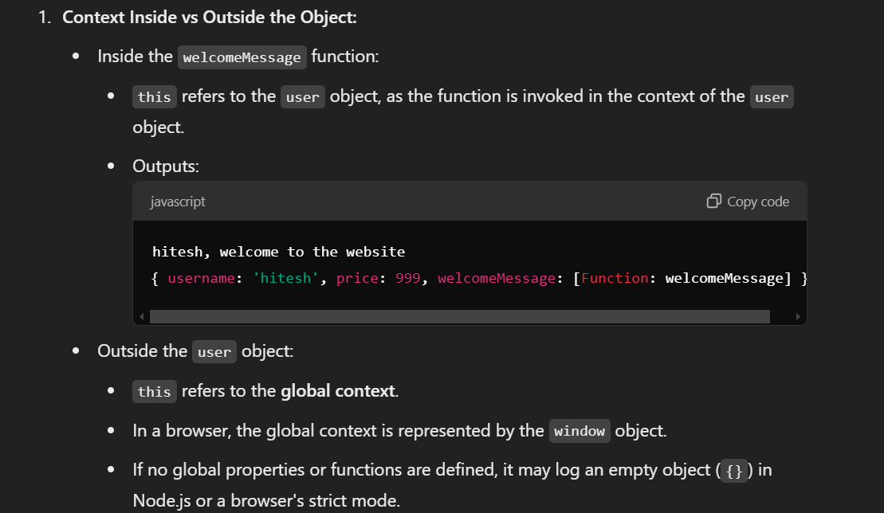





This is what we get in console.log(this) inside a browser :  
  


This is what we get when we console log a `this` inside a function in a node environment :

function chai(){

  console.log(this);

}

Chai()



function chai(){

  let username = "Bikash";

  console.log(this.username);

}

chai()

  // Condition : we wrote a let username inside a function and tried to access it using a this.username we

  could not access it using this.username ? why

  we get output as {} (i.e, undefined) , meaning "this" context is only inside object and does not work inside functions , why?







