PowerP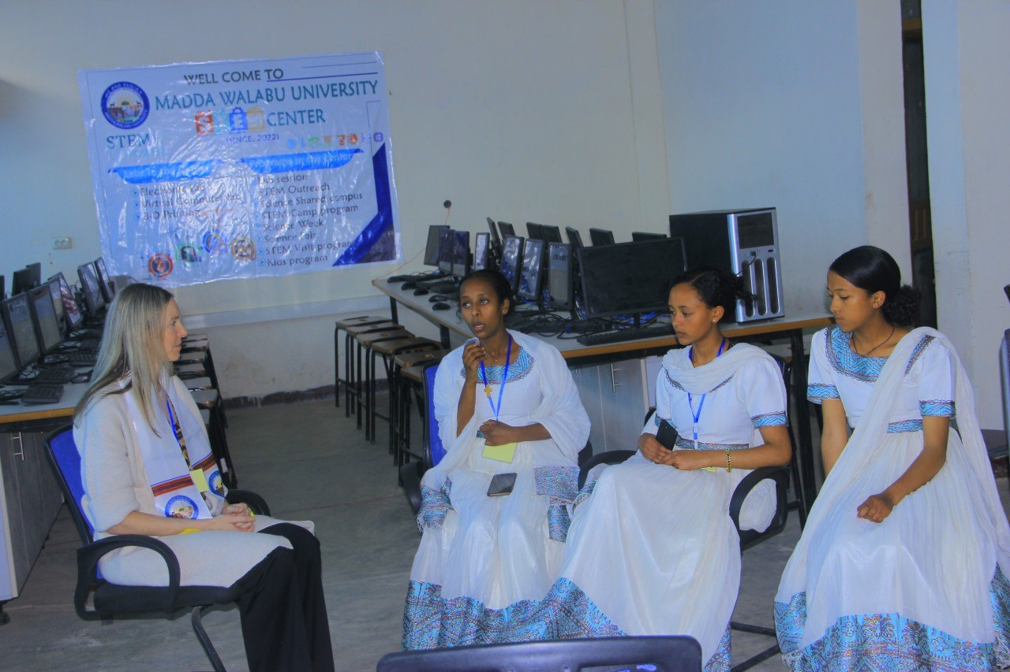o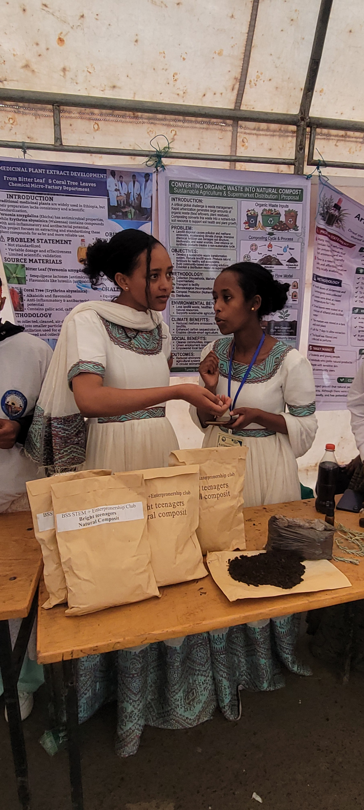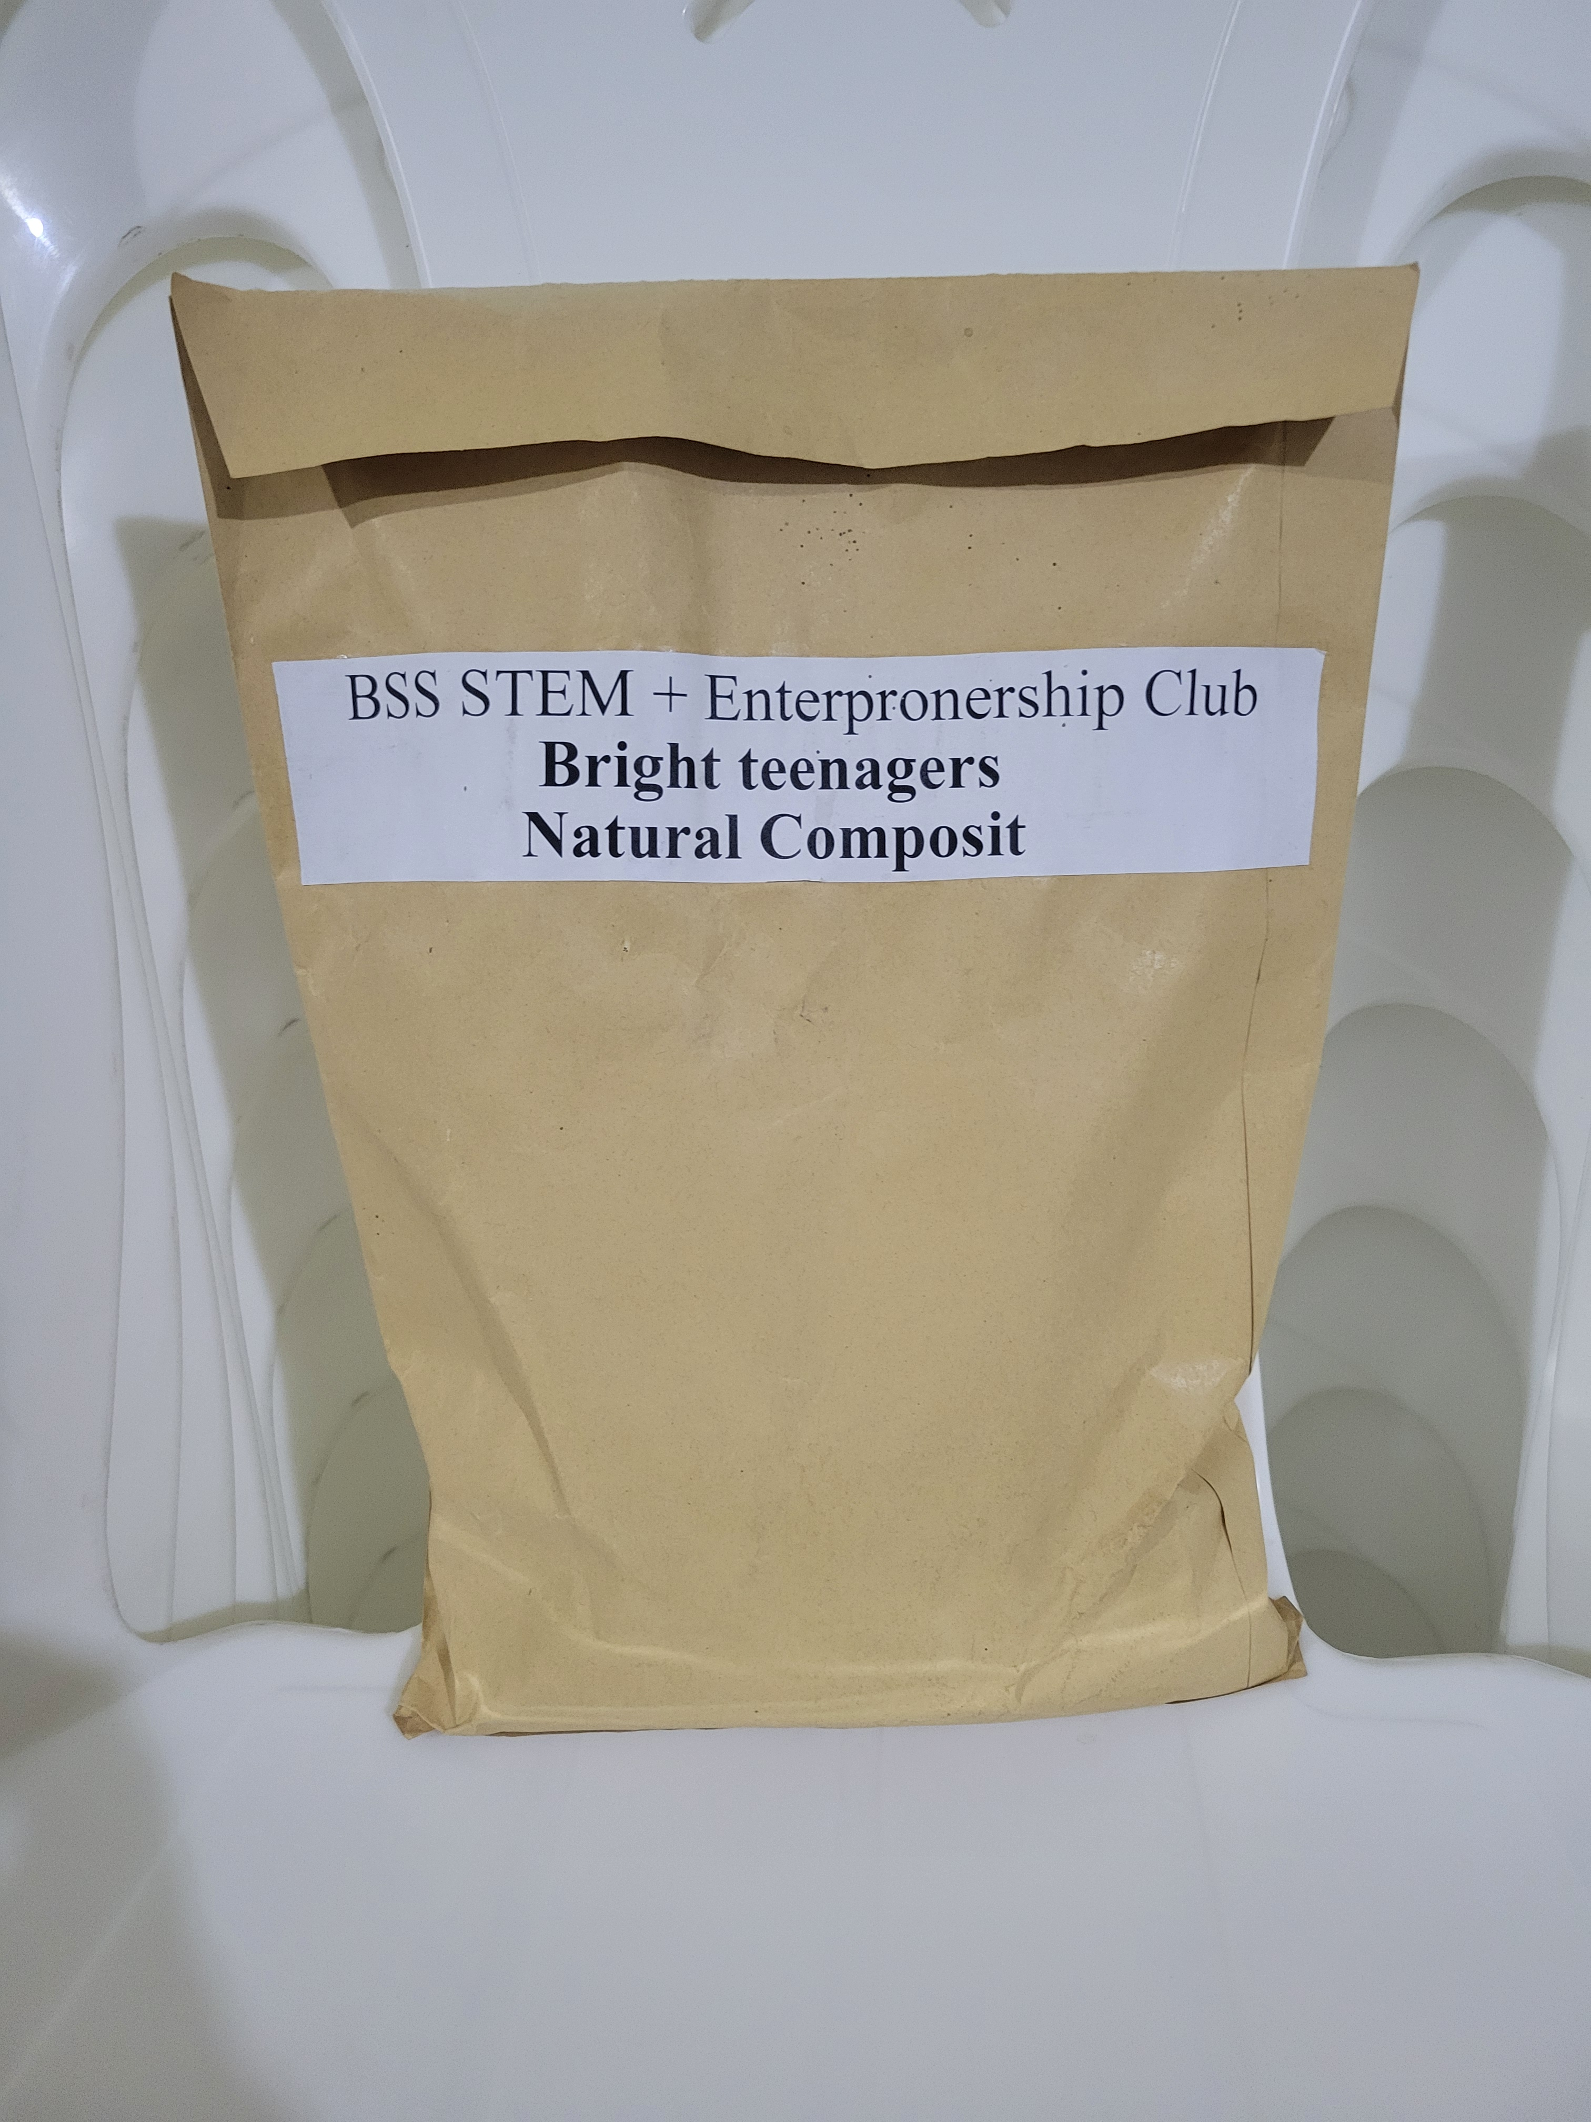int Pitch Deck (10-Minute Presentation)

🌿🌿Coffee Waste + Organic Waste + Liquid Compost Business
Slide 1: Title Slide
Turning Waste Into Wealth
. ➡️️Coffee Waste + Organic Waste = Solid & Liquid Organic Fertilizer
Slide 2: Introduce Yourself
Hello Judges, my name is Mahlet Solomon
I am passionate about solving environmental problems while helping farmers increase productivity.

Our vision is simple:
🌿Transform waste into valuable organic fertilizer.
Slide 3: What Change Are We Making?
➡️Every day, coffee shops, homes, and markets throw away tons of waste.
We convert
. - Coffee waste.
. - Food waste. In to
. - Organic waste.
. #solid compost fertilizer &
. #liquid compost fertilizer
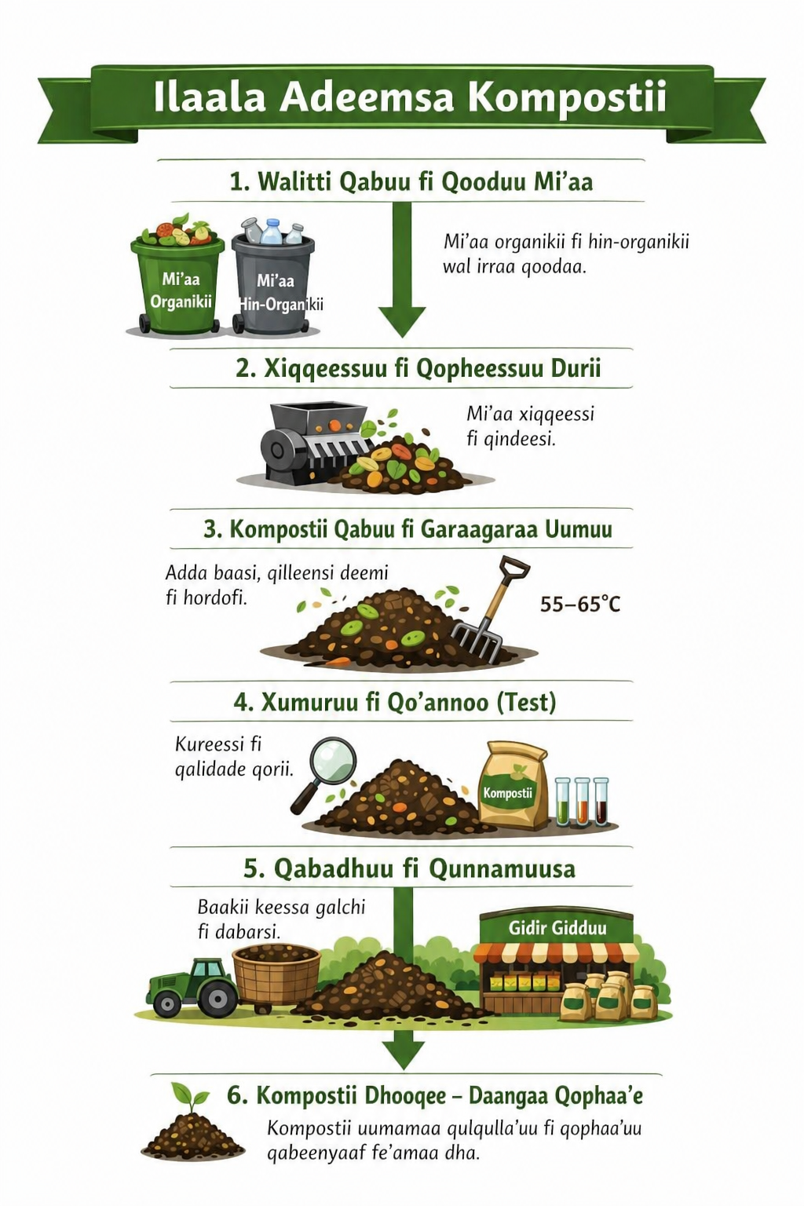l
This creates cleaner cities, healthier farms, and greener communities.
Slide 4: Pain + Gain
Pain:
🌿 Waste causes bad smell and pollution
🌿Farmers face expensive chemical fertilizer prices
. 🌿 Soil fertility is decreasing

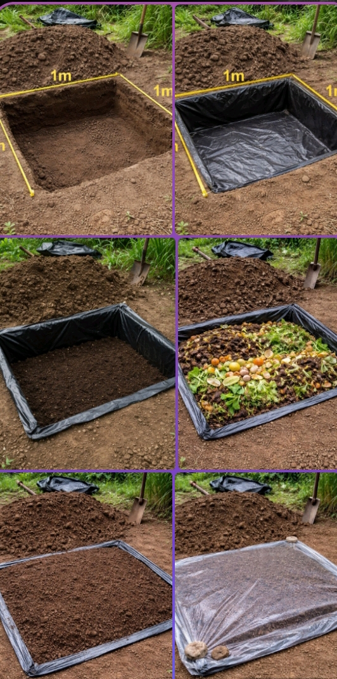
Gain:
. 🌿 Low-cost fertilizer
🌿Healthy soil
🌿 Better crop yield
. 🌿Cleaner environment
Slide 5: Product / Service
➡️We offer 3 products:
. 1. Solid Compost: For farms and garden
. 2. Liquid Compost Fertilizer: Fast nutrient
. absorptionfor crops
. 3. Waste Collection Service:Collect coffee and
. organic waste from businesses

---
Slide 6: Product Demo
Process:
. 🌿Coffee Waste + Organic Waste
Sorting & Shredding.
.

Composting Process
Filtering & Fermentation.
Outputs:
-🌿Bagged Solid Compost
- 🌿Bottled Liquid Compost.
Slide 7: What Is Unique?
Why us?
. ➡️Uses free local waste materials
➡️ Dual products: solid + liquid fertilizer
. ➡️Affordable for farmers
. ➡️Eco-friendly solution
➡️ Supports circular economy
Slide 8: Customer Traction
Current Market Interest:
. ➡️Farmers need cheaper fertilizer
. ➡️ Gardeners need organic products
. ➡️Coffee shops need waste disposal solution
. ➡️Strong demand in agriculture market

Pilot users reported:
. - Better soil texture
. - Strong plant growth
Slide 9: Business Model
How we make money:
. - Sell solid compost per kg / quintal
. - Sell liquid compost per liter
. - Monthly waste collection contracts
. - Supply to farms, nurseries, shops

---
Slide 10: Investment Needed
We seek investment for:
. ➡️Compost machine
. ➡️ Packaging
. ➡️ Bottles
. ➡️Transport
. ➡️ Marketing
. ➡️Expansion
Goal: Scale production across Ethiopia

---
Slide 11: Team
Our Team:
. ➡️ Founder / CEO
. ➡️ Production Manager
. ➡️ Sales & Marketing
. ➡️Operations Team
. ➡️ Farmer Relations
---

Slide 12: Call to Action
. ➡️ Join us in building a greener future.
. ➡️ Invest in waste recycling.
. ➡️ Invest in farmers.
. ➡️ Invest in sustainability.
. ➡️ Thank you.

---
Slide 13: Why You Should Choose Us
. ➡️Real local problem solver
. ➡️High demand market
. ➡️ Low raw material cost
. ➡️ Social + environmental impact
. ➡️ Scalable business model

We are not just selling fertilizer.
We are creating change.

