MANAGER HOME SCREEN :

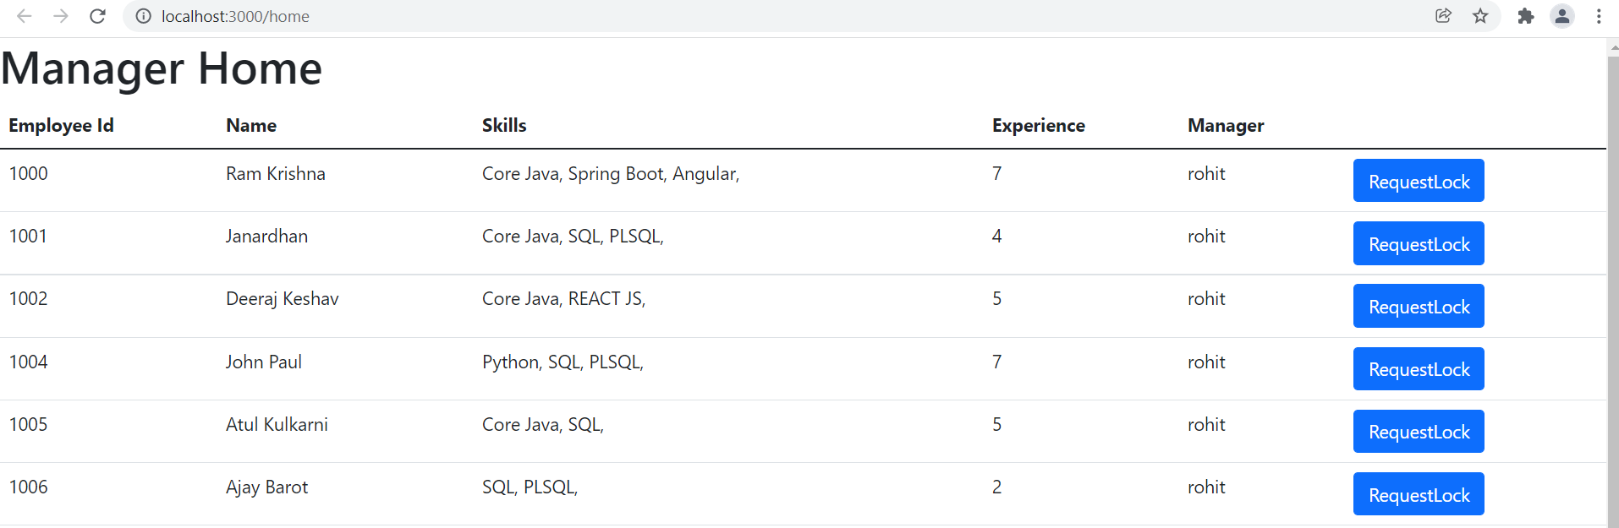

MANAGER - SOFTLOCK POP UP :

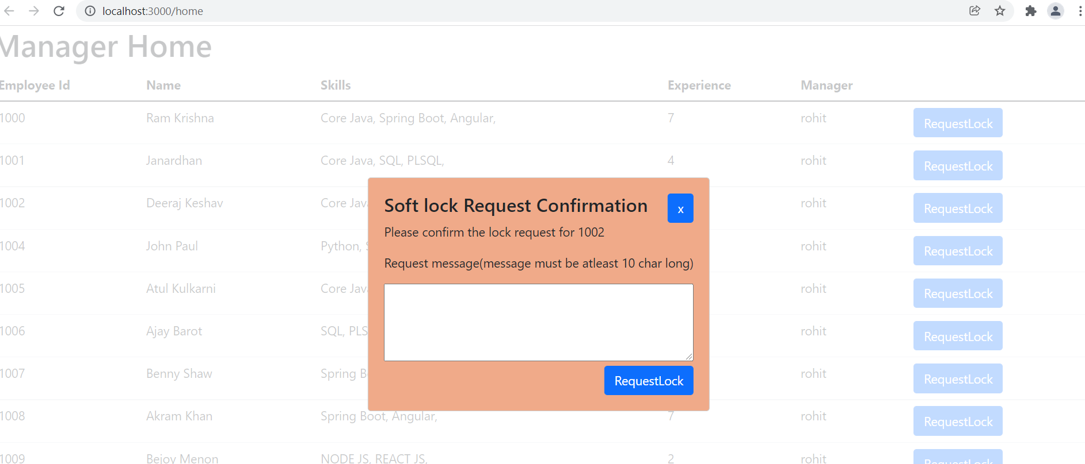

WFM HOME SCREEN :

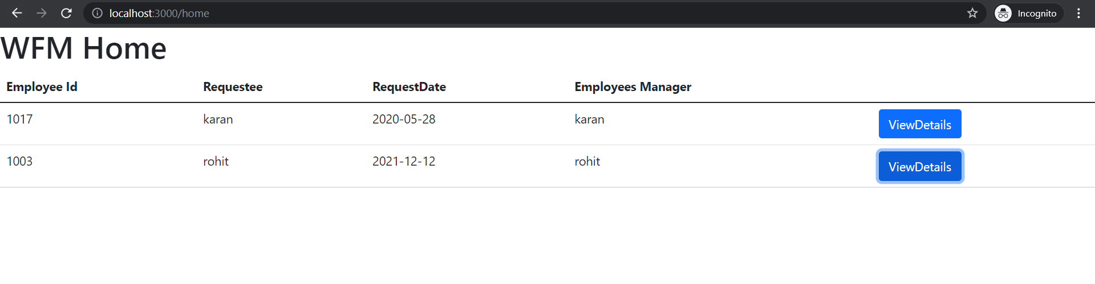

WFM SOFTLOCK POP UP:

