Project Overview
This project involves setting up a Secure CI/CD pipeline for a chosen open-source application. The pipeline integrates multiple security tools to ensure that best practices in security and software development are followed. The pipeline utilizes tools such as GitHub Actions, SAST, DAST, SCA, Container Security, and IaC security scanninG , SIEM & Vulnerability Management to perform static and dynamic analysis, enforce secure coding practices, and ensure the security of the deployed containers.

1. Repo : Owasp - Juice Shop : https://github.com/BilalBaree/Owasp_JuiceShop
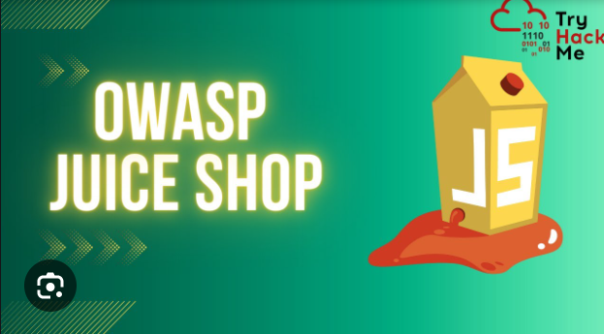

2. Git Branching Strategy
- Git Strategy Chosen: GitHub Flow
  - Justification: GitHub Flow is simple, and its focus on pull requests aligns well with the goals of enforcing security checks and code review mechanisms. This strategy ensures that every change to the codebase goes through a review process before being merged, which allows for better control over the quality and security of the code.
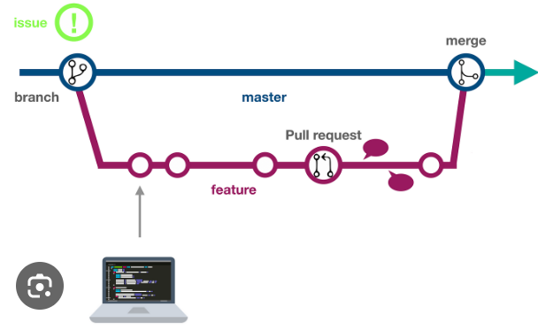

3. CI Tool: GitHub Actions
- CI Tool Chosen: GitHub Actions
  - Justification: GitHub Actions provides seamless integration with GitHub repositories, allowing for automatic workflows for testing, building, and deploying code. It is highly customizable and allows the integration of various security tools into the CI/CD pipeline, which fits the project requirements.
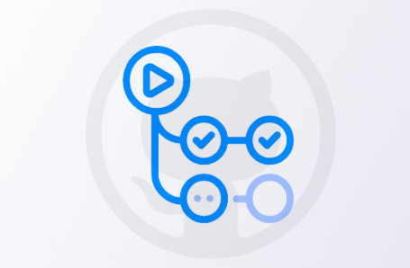

4. Security Checks in CI
The following security checks are integrated into the CI pipeline to ensure that the code adheres to secure practices:

a. Code Reviews and Signed Commits
- Enforce Code Reviews: The pipeline ensures that code reviews are mandatory for pull requests before merging into the main branch.
- Enforce Signed Commits: Each commit in the pipeline must be signed to guarantee authenticity. This check ensures that only trusted contributors can make changes.

b. Role-Based Access Control (RBAC)
- Access Control Enforcement: The pipeline includes a check to verify that role-based access is configured correctly in the GitHub repository. It ensures that only authorized users have write access to critical branches.

c. Audit Logging
- Pipeline Execution Logs: Each pipeline run logs its execution details to an audit log, helping track security-related activities and actions.

# auto-approve:
# runs-on: ubuntu-latest
# if: github.event_name == 'pull_request'
# steps:
# - name: Check if PR author is trusted and target is main
# id: check
# run: |
# echo "PR author: ${{ github.event.pull_request.user.login }}"
# echo "Target branch: ${{ github.event.pull_request.base.ref }}"
# if [[ "${{ github.event.pull_request.user.login }}" == "trusted-user" && "${{ github.event.pull_request.base.ref }}" == "main" ]]; then
# echo "approve=true" >> $GITHUB_OUTPUT
# else
# echo "approve=false" >> $GITHUB_OUTPUT
# fi
- name: Enforce code reviews (Only on pull request)
if: github.event_name == 'pull_request'
uses: hmarr/auto-approve-action@v2
with:
github-token: ${{ secrets.GITHUB_TOKEN }}
- name: Enforce signed commits
run: |
git log ${{ github.event.before }}..${{ github.sha }} --pretty=format:'%h %G? %an' | while read line; do
commit_hash=$(echo $line | cut -d ' ' -f 1)
commit_status=$(echo $line | cut -d ' ' -f 2)
if [[ "$commit_status" != "G" ]]; then
echo "❌ Commit $commit_hash is not signed"
exit 1
fi
done
# 2. Role-based Access Control
access_control:
runs-on: ubuntu-latest
steps:
- name: Check role-based access control
run: |
if [[ "$(curl -H "Authorization: Bearer ${{ secrets.GITHUB_TOKEN }}" \
-s "https://api.github.com/repos/${{ github.repository }}/collaborators" | jq '.[] | select(.permissions.push == true)' | wc -l)" -lt 1 ]]; then
echo "❌ Role-based access is not configured properly."
exit 1
Fi
audit_log:
runs-on: ubuntu-latest
steps:
- name: Log pipeline run
run: |
echo "$(date) - CI/CD pipeline executed for repo: ${{ github.repository }}" >> ./audit_log.txt
cat ./audit_log.txt
- name: Upload Audit Log
uses: actions/upload-artifact@v4
with:
name: audit-log
path: audit_log.txt

5. SAST (Static Application Security Testing)
The pipeline integrates two key SAST tools to identify vulnerabilities in the codebase:

a. TruffleHog (Secrets Scanning)
- Purpose: Detect hardcoded secrets, such as API keys or passwords.
- Positive Case: No secrets are found in the codebase, and the pipeline proceeds without issues.
- Negative Case: Secrets are found, and the pipeline fails, preventing potentially sensitive data from being exposed.

b. Bandit (SQL Injection Detection)
- Purpose: Detect potential SQL injection vulnerabilities within the code.
- Positive Case: No issues are found, and the pipeline proceeds.
- Negative Case: SQL injection vulnerabilities are detected, and the pipeline halts, requiring a fix before proceeding.

sast_analysis:
runs-on: ubuntu-latest
steps:
- name: Checkout code
uses: actions/checkout@v3
- name: Set up Python
uses: actions/setup-python@v5
with:
python-version: '3.x'
- name: Install tools
run: pip install bandit trufflehog jq
- name: Secrets Scanning (TruffleHog)
run: |
trufflehog --json . > secrets_scan_results.json || true
if [[ $(jq length secrets_scan_results.json) -gt 0 ]]; then
echo "❌ Secrets found!"
cat secrets_scan_results.json
exit 1
else
echo "✅ No secrets found."
fi
- name: Upload TruffleHog Report
uses: actions/upload-artifact@v4
with:
name: secrets-scan
path: secrets_scan_results.json
- name: SQL Injection Detection (Bandit)
run: |
bandit -r . -f json -o bandit_report.json -t B107
if grep -q "issue" bandit_report.json; then
echo "❌ SQL Injection issues found!"
cat bandit_report.json
exit 1
fi
- name: Upload Bandit Report
uses: actions/upload-artifact@v4
with:
name: bandit-report
path: bandit_report.json

6. DAST (Dynamic Application Security Testing)
Although DAST tools are not fully implemented, SQLMap and OWASP ZAP are integrated into the pipeline to check for runtime vulnerabilities:

a. SQLMap (SQL Injection Detection)
- Purpose: Identify SQL injection vulnerabilities in the deployed application.
- Positive Case: No SQL injection issues are found, and the pipeline proceeds.
- Negative Case: SQL injection vulnerabilities are identified, and the pipeline fails, preventing deployment.

b. OWASP ZAP (Cross-Site Scripting Detection)
- Purpose: Scan for cross-site scripting (XSS) vulnerabilities in web applications.
- Positive Case: No XSS vulnerabilities are detected.
- Negative Case: XSS vulnerabilities are found, and the pipeline fails until the issues are resolved.

dast_scan:
runs-on: ubuntu-latest
steps:
- name: Checkout code
uses: actions/checkout@v3
- name: Set up Docker Buildx
uses: docker/setup-buildx-action@v2
- name: Pull and start Juice Shop container
run: |
docker pull bkimminich/juice-shop
docker run --rm -d -p 3000:3000 bkimminich/juice-shop
# Wait for the application to be ready
for i in {1..60}; do
if curl --silent --fail http://localhost:3000; then
echo "Juice Shop is ready."
break
else
echo "Waiting for Juice Shop to start..."
sleep 5
fi
done
- name: Install tools
run: |
pip install sqlmap
sudo apt-get update
sudo apt-get install -y openjdk-11-jre python3
wget https://github.com/zaproxy/zaproxy/releases/download/v2.16.1/ZAP_2.16.1_Linux.tar.gz
tar -xzf ZAP_2.16.1_Linux.tar.gz
sudo mv ZAP_2.16.1 /opt/zaproxy
sudo ln -s /opt/zaproxy/zap.sh /usr/local/bin/zap
- name: Run SQLMap for SQLi
run: sqlmap -u "http://localhost:3000" --batch --risk=3 --level=5
- name: Run OWASP ZAP for XSS
run: zap -cmd -quickurl http://localhost:3000 -quickout zap_report.html
- name: Upload ZAP Report
uses: actions/upload-artifact@v4
with:
name: zap-report
path: zap_report.html

7. SCA (Software Composition Analysis)
The pipeline uses Snyk to scan for vulnerable third-party dependencies:

a. Snyk (Vulnerable Packages Scan)
- Purpose: Scan the code for insecure third-party dependencies.
- Positive Case: No critical vulnerabilities are found, allowing the pipeline to proceed.
- Negative Case: Critical vulnerabilities are found, and the pipeline halts to fix the issues.

b. Signed Libraries Verification
- Purpose: Ensure that libraries used in the project are signed to prevent tampering.
- Positive Case: All libraries are signed, and the pipeline proceeds.
- Negative Case: Unsigned libraries are detected, and the pipeline fails.

# 5. SCA Tool: Snyk
sca_scan:
runs-on: ubuntu-latest
steps:
- name: Checkout code
uses: actions/checkout@v3
- name: Set up Node.js
uses: actions/setup-node@v3
with:
node-version: '18.19.0'
- name: Install dependencies
run: npm install
- name: Scan for vulnerable packages (Snyk)
uses: snyk/actions/node@master
with:
args: test . --severity-threshold=high
env:
SNYK_TOKEN: ${{ secrets.SNYK_TOKEN }}
- name: Use signed libraries verification
run: bash scripts/verify-signatures.sh
continue-on-error: true

8. Container Security
The pipeline integrates security scanning for containers, specifically focusing on Docker images:

a. Clair (Root Access Check)
- Purpose: Scan the Docker image for root access privileges.
- Positive Case: No root access is found, and the pipeline continues.
- Negative Case: Root access is detected, and the pipeline fails.

b. Trivy (Read-Only File System)
- Purpose: Ensure that containers use read-only file systems for security.
- Positive Case: The container adheres to the read-only file system policy.
- Negative Case: Violations are found, and the pipeline fails until addressed.

# 7. Container Security Scanning
container-security-scan:
runs-on: ubuntu-latest
steps:
- name: Checkout code
uses: actions/checkout@v3
- name: Set up Docker Buildx
uses: docker/setup-buildx-action@v2
- name: Build Docker image
run: |
docker build -t ${{ secrets.DOCKERHUB_USERNAME }}/juice-shop:latest .
- name: Scan Docker image for Root Access (Clair)
run: |
curl -sL https://github.com/coreos/clair/releases/download/v2.0.9/clairctl-linux-amd64 -o clairctl
chmod +x clairctl
sudo mv clairctl /usr/local/bin/
clairctl analyze --local --image ${{ secrets.DOCKERHUB_USERNAME }}/juice-shop:latest
clairctl report ${{ secrets.DOCKERHUB_USERNAME }}/juice-shop:latest
continue-on-error: true
- name: Scan image for Read-Only File System violations (Trivy)
run: |
docker run --rm -v /var/run/docker.sock:/var/run/docker.sock -v $(pwd):/workspace aquasecurity/trivy fs --severity CRITICAL,HIGH --exit-code 1 --no-progress --ignore-unfixed .
continue-on-error: true
- name: Push Docker image to DockerHub
if: success()
run: |
docker login -u ${{ secrets.DOCKERHUB_USERNAME }} -p ${{ secrets.DOCKERHUB_TOKEN }}
docker push ${{ secrets.DOCKERHUB_USERNAME }}/juice-shop:latest
# 8. Generate and Upload Reports
upload-reports:
runs-on: ubuntu-latest
steps:
- name: Upload Clair report
uses: actions/upload-artifact@v4
with:
name: clair-report
path: clair-report.html
- name: Upload Trivy report
uses: actions/upload-artifact@v4
with:
name: trivy-report
path: trivy-report.json

9. IaC (Infrastructure as Code) Security
The pipeline integrates Checkov and Conftest to enforce best practices and security for infrastructure as code:

a. Checkov (Misconfigurations in IaC)
- Purpose: Scan Terraform configurations for misconfigurations.
- Positive Case: No misconfigurations are found.
- Negative Case: Misconfigurations are found, and the pipeline fails.

b. Conftest (Compliance and Least Privilege)
- Purpose: Ensure compliance with policies such as least privilege.
- Positive Case: Policy compliance is confirmed, and the pipeline continues.
- Negative Case: Policy violations are found, and the pipeline halts for remediation.

# 9. IaC Security Scan
iac-security-scan:
runs-on: ubuntu-latest
steps:
- name: Checkout code
uses: actions/checkout@v3
- name: Set up Python
uses: actions/setup-python@v4
with:
python-version: '3.x'
- name: Install Terraform
uses: hashicorp/setup-terraform@v2
with:
terraform_version: 1.4.6
- name: Install Checkov
run: pip install checkov
- name: Install Conftest
run: |
CONFTAG=$(curl -s https://api.github.com/repos/open-policy-agent/conftest/releases/latest | grep tag_name | cut -d '"' -f 4)
wget https://github.com/open-policy-agent/conftest/releases/download/${CONFTAG}/conftest_${CONFTAG#v}_Linux_x86_64.tar.gz
tar -xzf conftest_${CONFTAG#v}_Linux_x86_64.tar.gz
sudo mv conftest /usr/local/bin
- name: Run Checkov for misconfigurations
run: |
checkov -d ./terraform --skip-check CKV_AWS_355 --skip-check CKV_SECRET_1
- name: Run Conftest with least privilege policy
run: |
conftest test terraform/main.tf --policy policies
- name: Check for secrets in Terraform using Checkov
run: |
checkov -d ./terraform --check CKV_SECRET_1

Integration Of DataDog (SIEM TOOL)
- name: Capture test results and send to Datadog
env:
DD_API_KEY: ${{ secrets.DATADOG_API_KEY }}
run: |
OUTPUT=$(npm test || true)
curl -X POST "https://http-intake.logs.datadoghq.eu/v1/input" \
-H "Content-Type: application/json" \
-H "DD-API-KEY: $DD_API_KEY" \
-d "{\"message\": \"$OUTPUT\", \"ddsource\": \"github-actions\", \"service\": \"ci-tests\"}"

Integration Of Vulnerability Management Tools (CodeQL & Dependabot)

CodeQL
name: "CodeQL Scan"
on:
push:
pull_request:
jobs:
analyze:
name: Analyze
runs-on: ubuntu-latest
permissions:
actions: read
contents: read
security-events: write
strategy:
fail-fast: false
matrix:
language: [ 'javascript-typescript' ]
steps:
- name: Checkout repository
uses: actions/checkout@11bd71901bbe5b1630ceea73d27597364c9af683 #v4.2.2
- name: Initialize CodeQL
uses: github/codeql-action/init@v3
with:
languages: ${{ matrix.language }}
queries: security-extended
config: |
paths-ignore:
- 'data/static/codefixes'
- name: Autobuild
uses: github/codeql-action/autobuild@v3
- name: Perform CodeQL Analysis
uses: github/codeql-action/analyze@v3

Dependabot
version: 1
update_configs:
- package_manager: "javascript"
directory: "/"
update_schedule: "live"
target_branch: "develop"
default_reviewers:
- "bkimminich"
default_labels:
- "dependencies"
ignored_updates:
- match:
dependency_name: "express-jwt"
version_requirement: "0.1.3"
- match:
dependency_name: "sanitize-html"
version_requirement: "1.4.2"
- match:
dependency_name: "unzipper"
version_requirement: "0.9.15"
- match:
dependency_name: "jsonwebtoken"
version_requirement: "0.4.0"
- package_manager: "javascript"
directory: "/frontend"
update_schedule: "live"
target_branch: "develop"
default_reviewers:
- "bkimminich"
default_labels:
- "dependencies"

ScreenShots
Pipeline Execution:
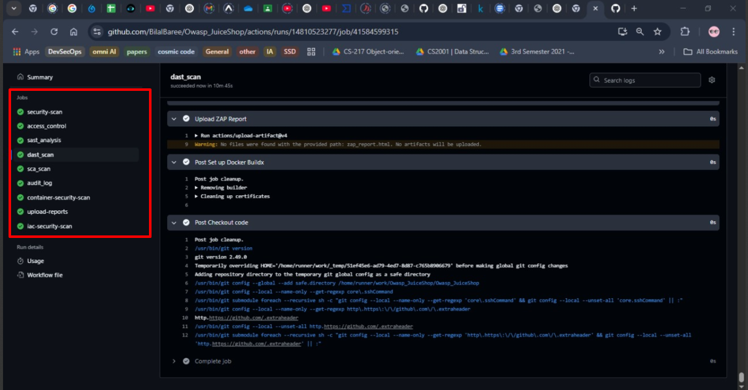
Security Check:
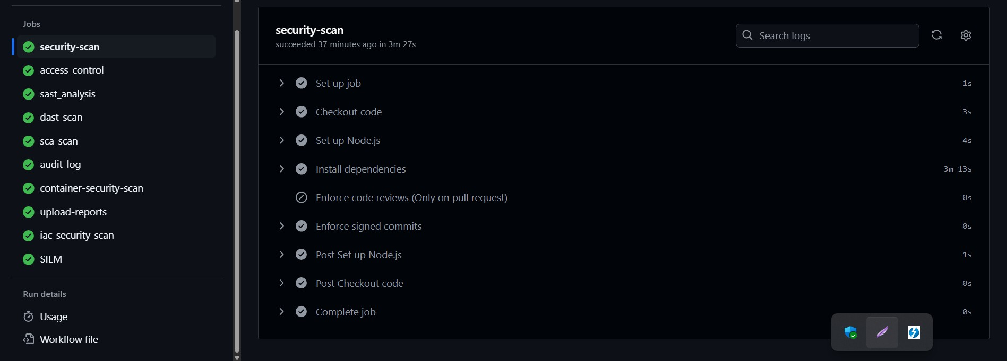

SAST Analysis (Bandit & Trufflehog):
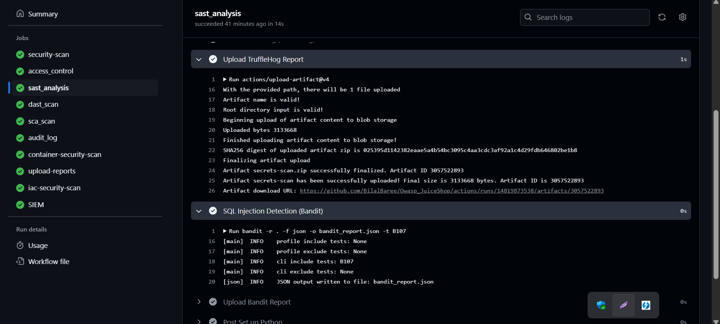
Bandit & Trufflehog SAST Analysis Reports:
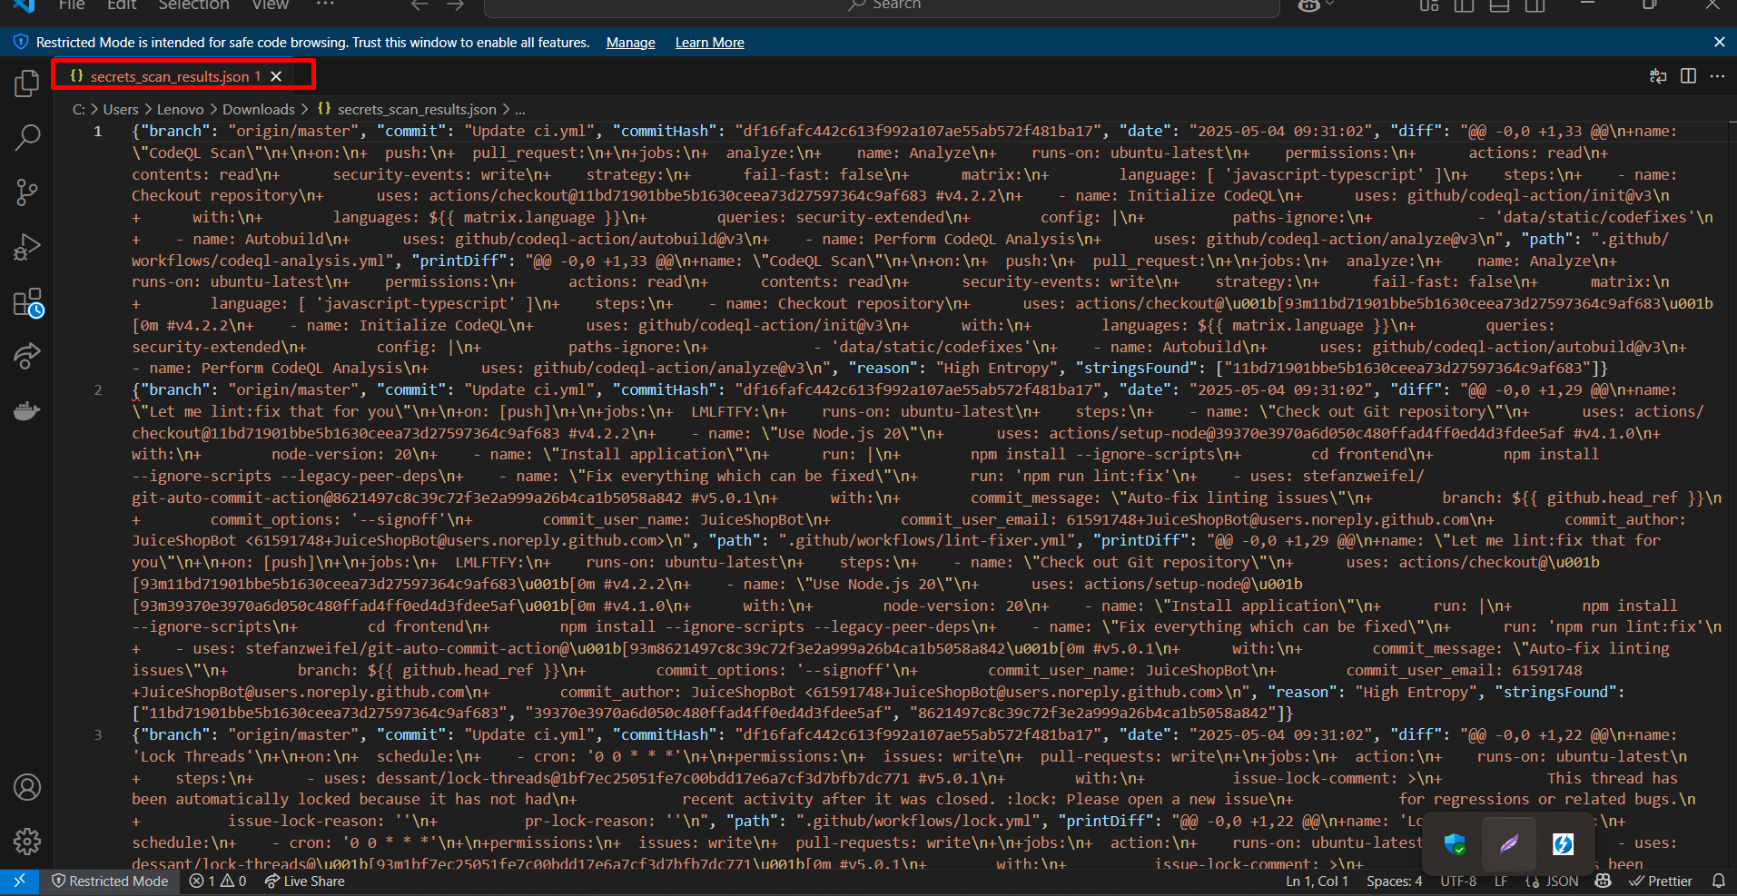
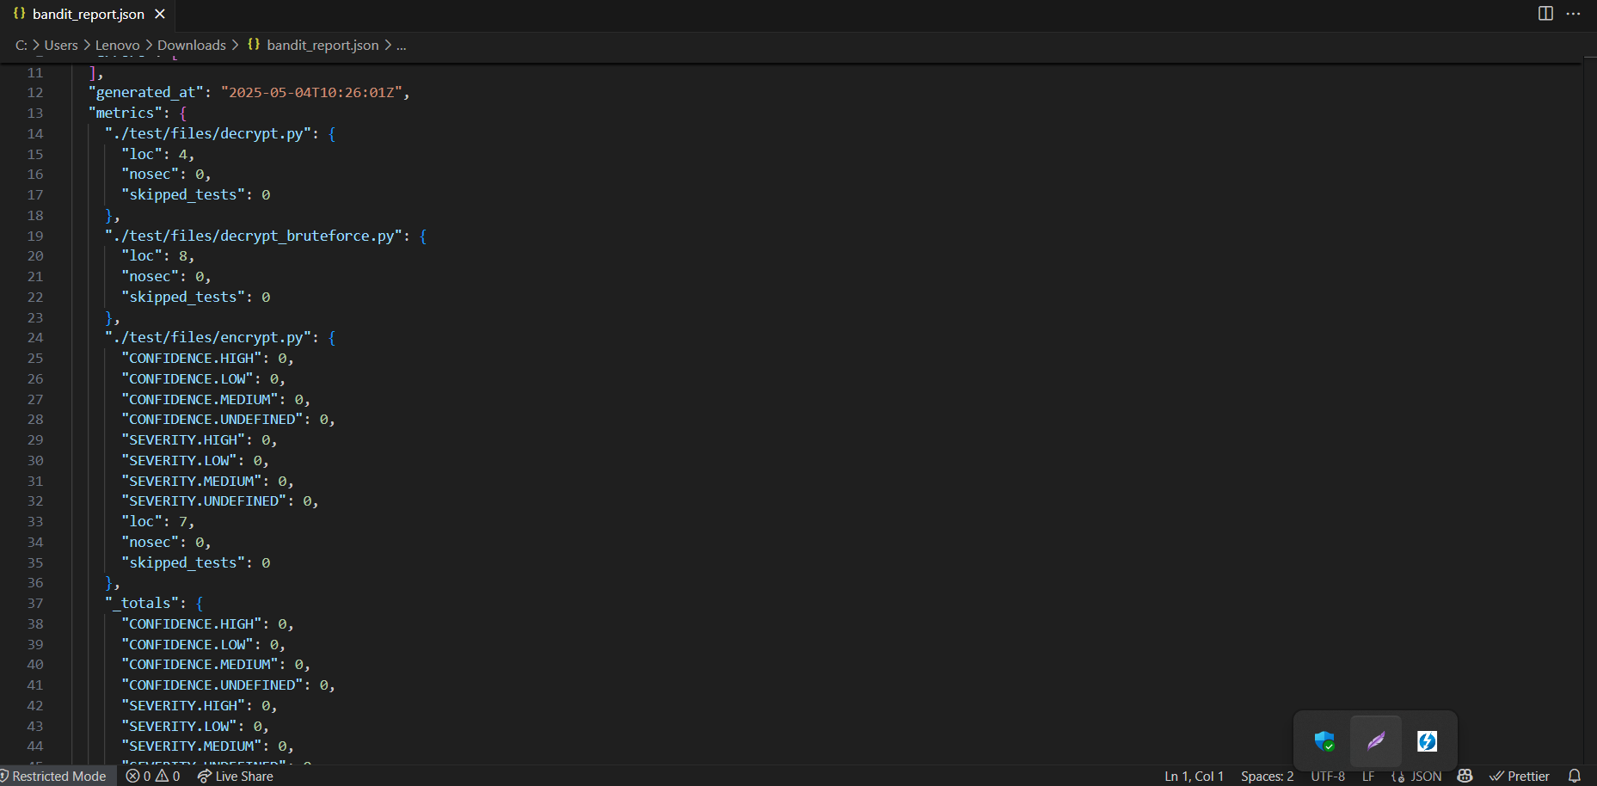
DAST Analysis(SQLMap & Owasp ZAP):
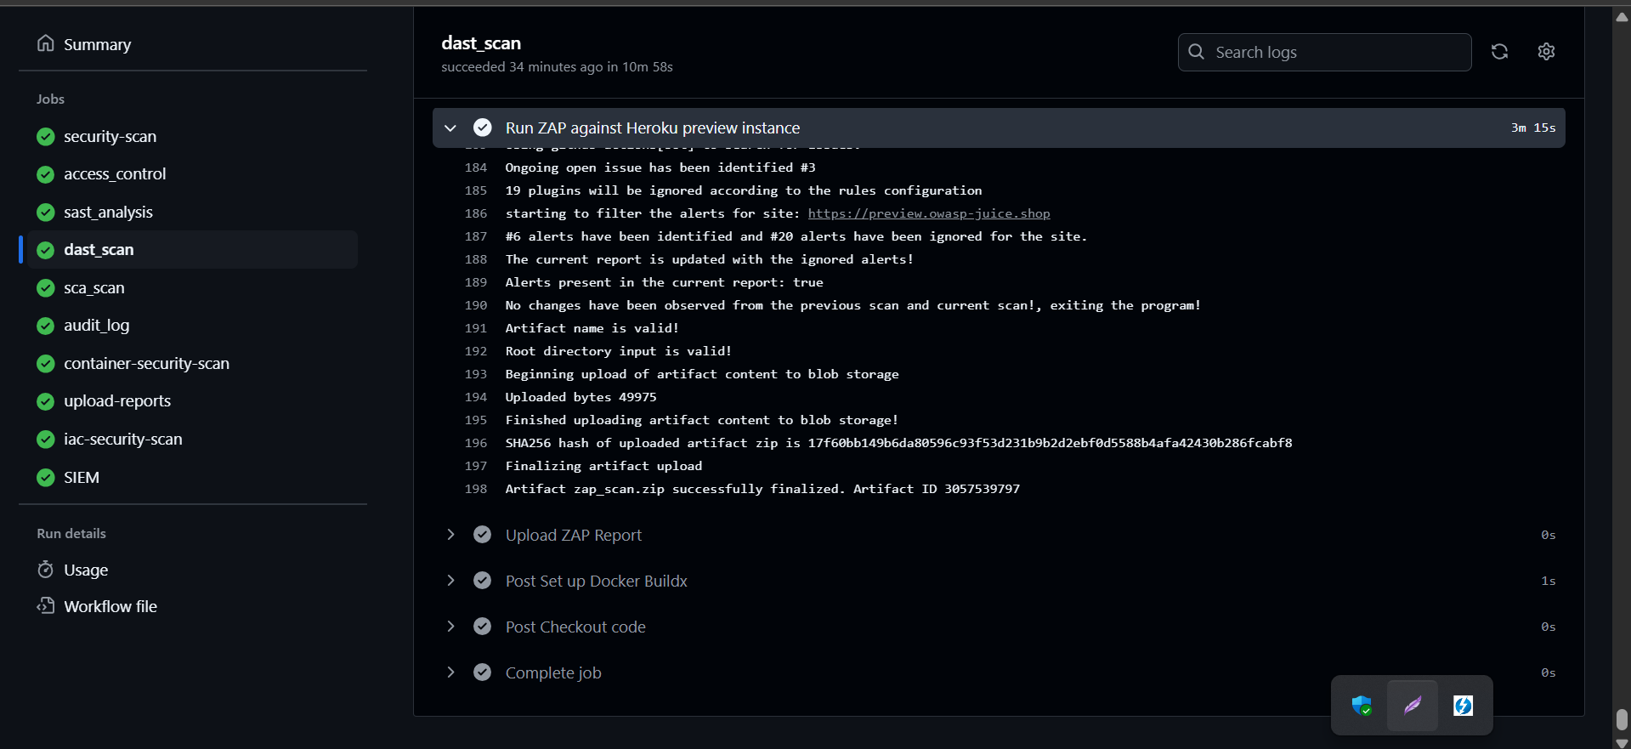
DAST Analysis Reports:
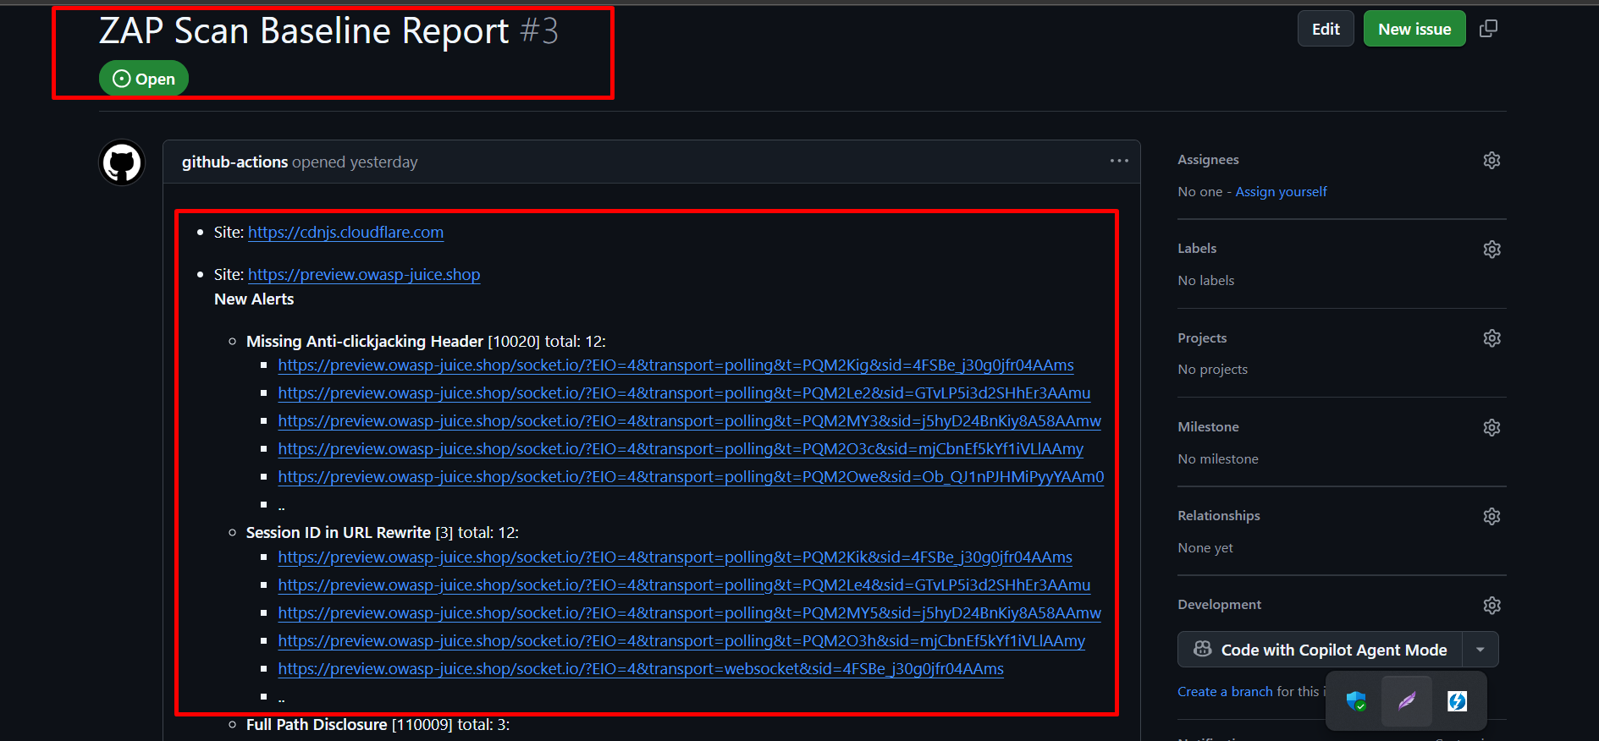
SCA (Snyk):
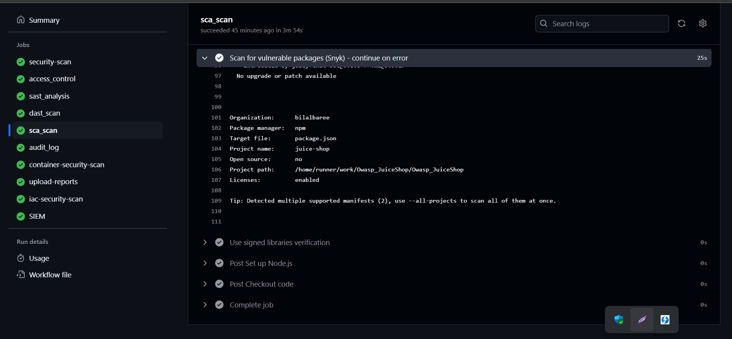
SCA Analysis Reports:
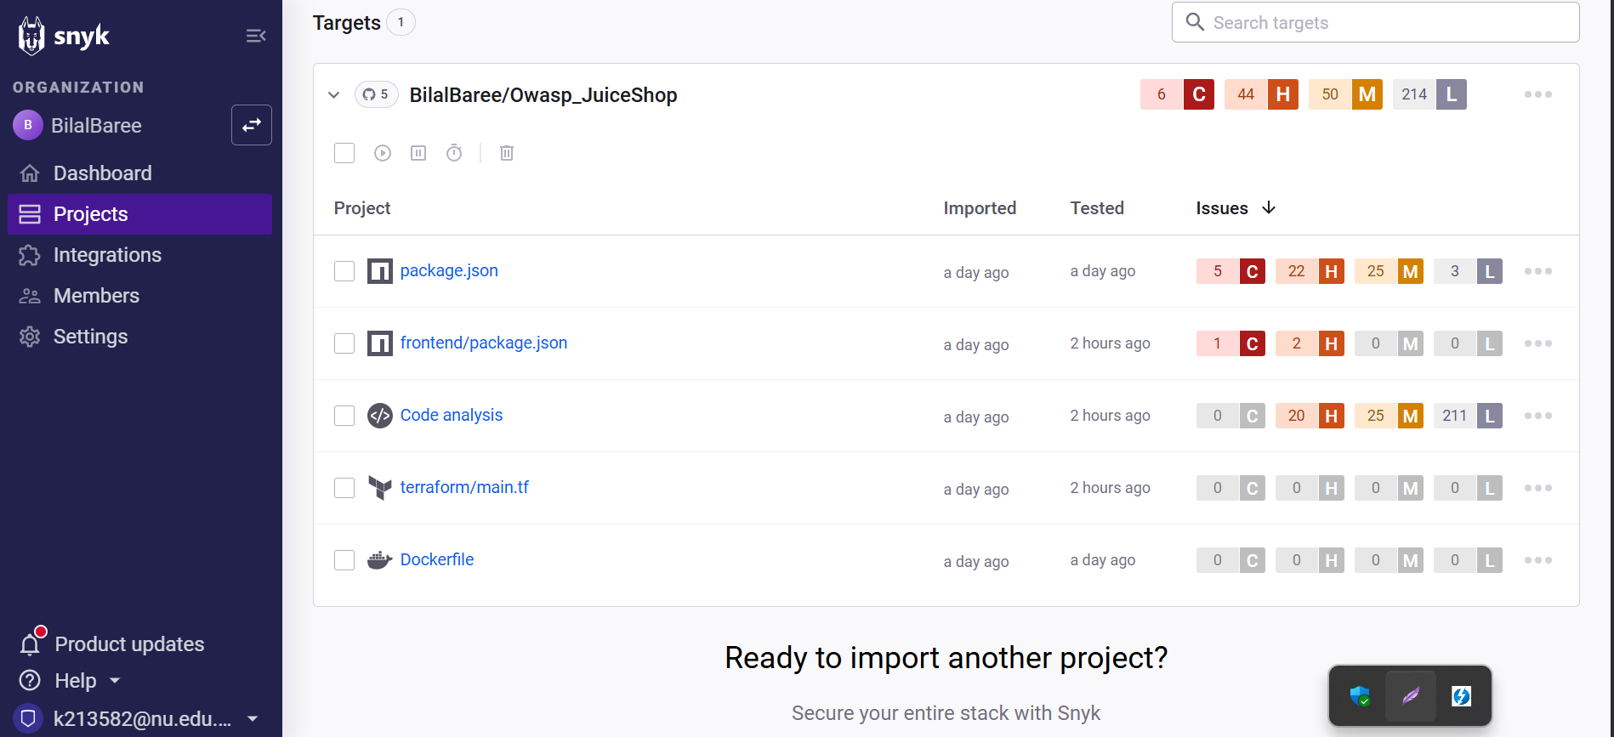
Container & Security (Grype & Trivy):
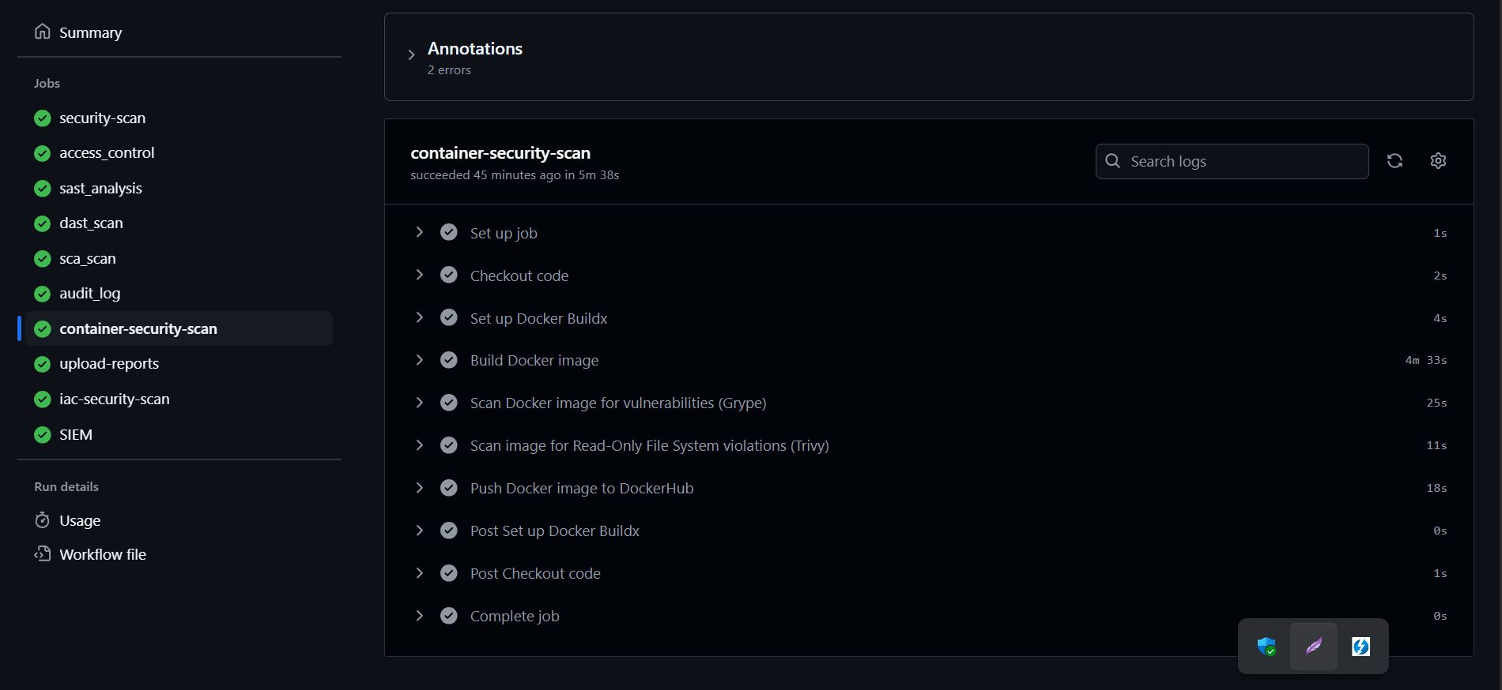
Grype & Trivvy Reports :
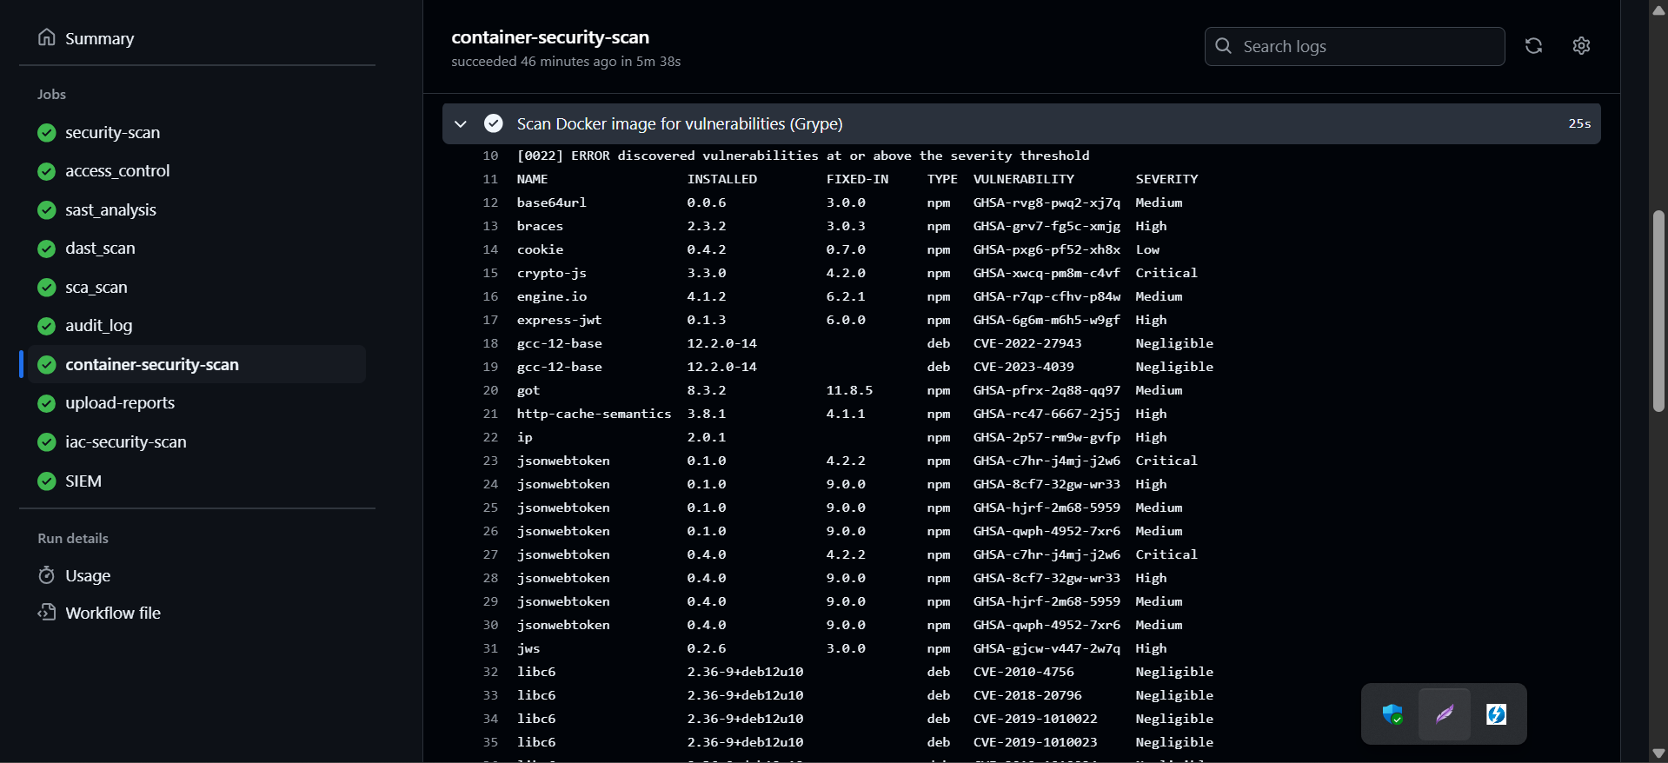
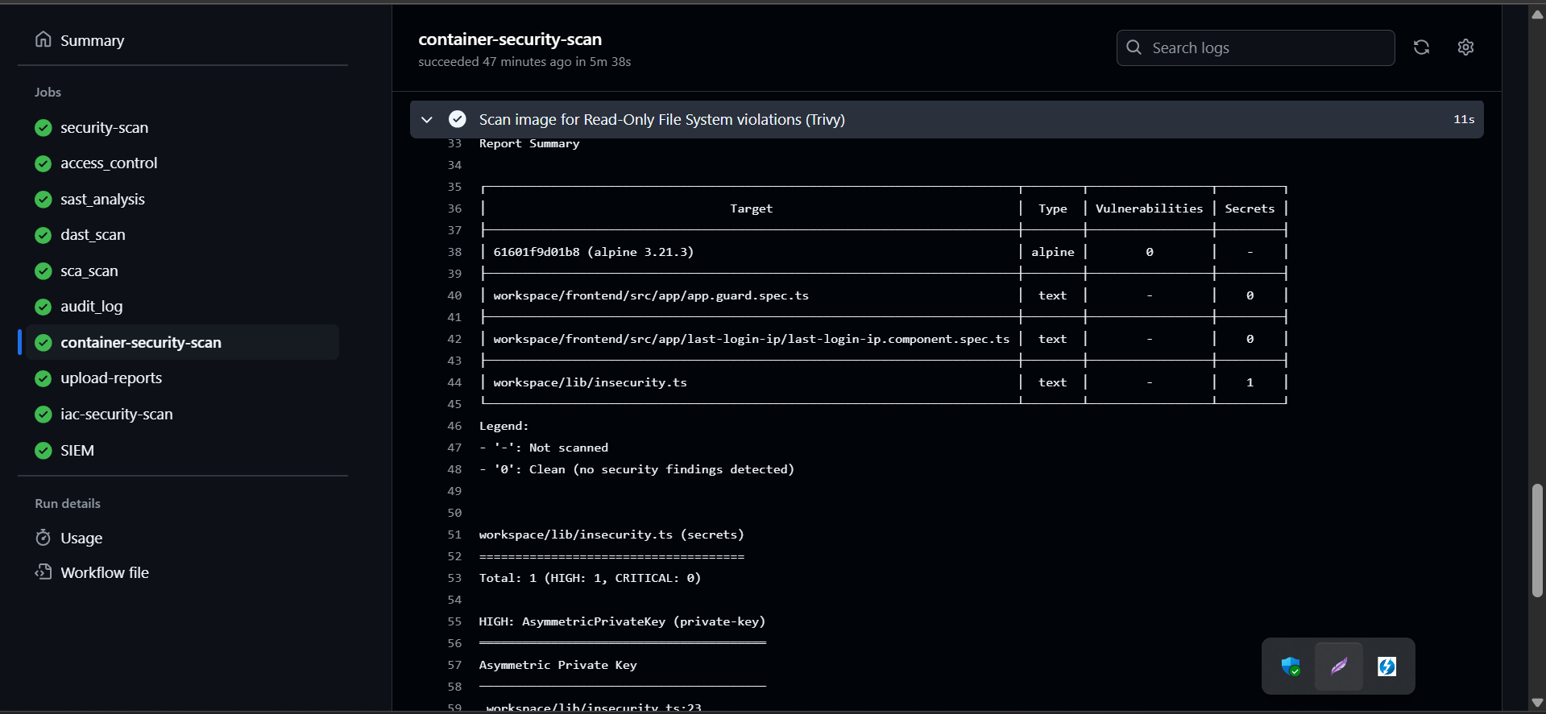
DockerHub Image Upload:
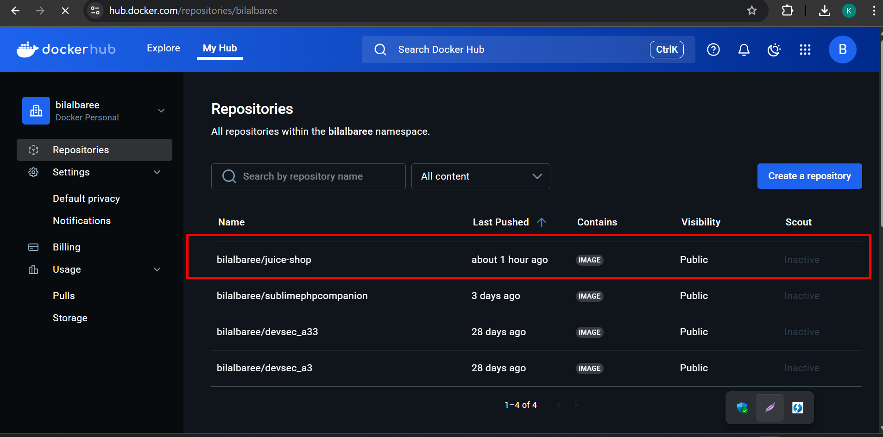
IaC Security (Terraform ):
I cannot run EC2 instances (not free just uploading workflow file)
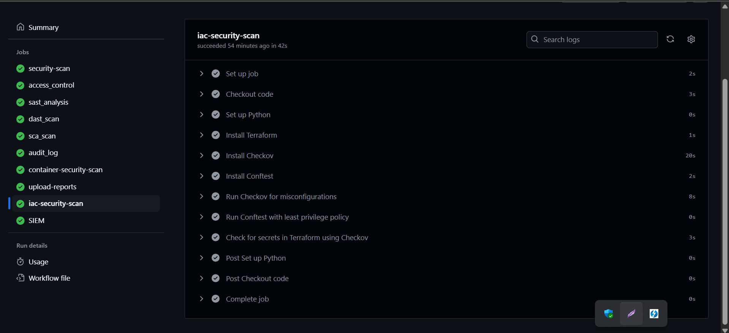
Conftest and Checkov for OPA and Policy Review/Enforcement:
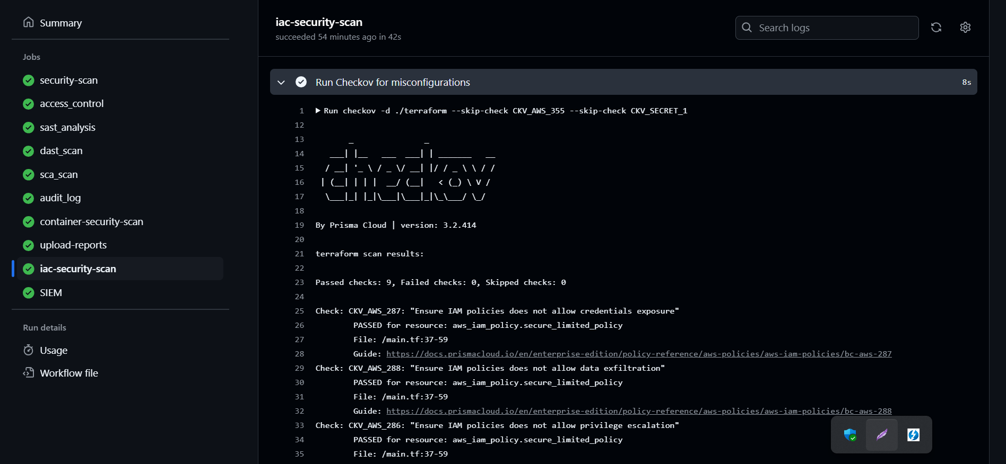
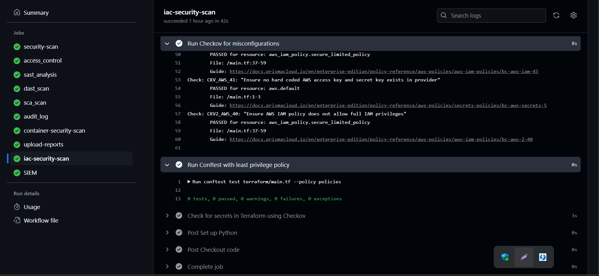
SIEM Tool Integration (DataDog):
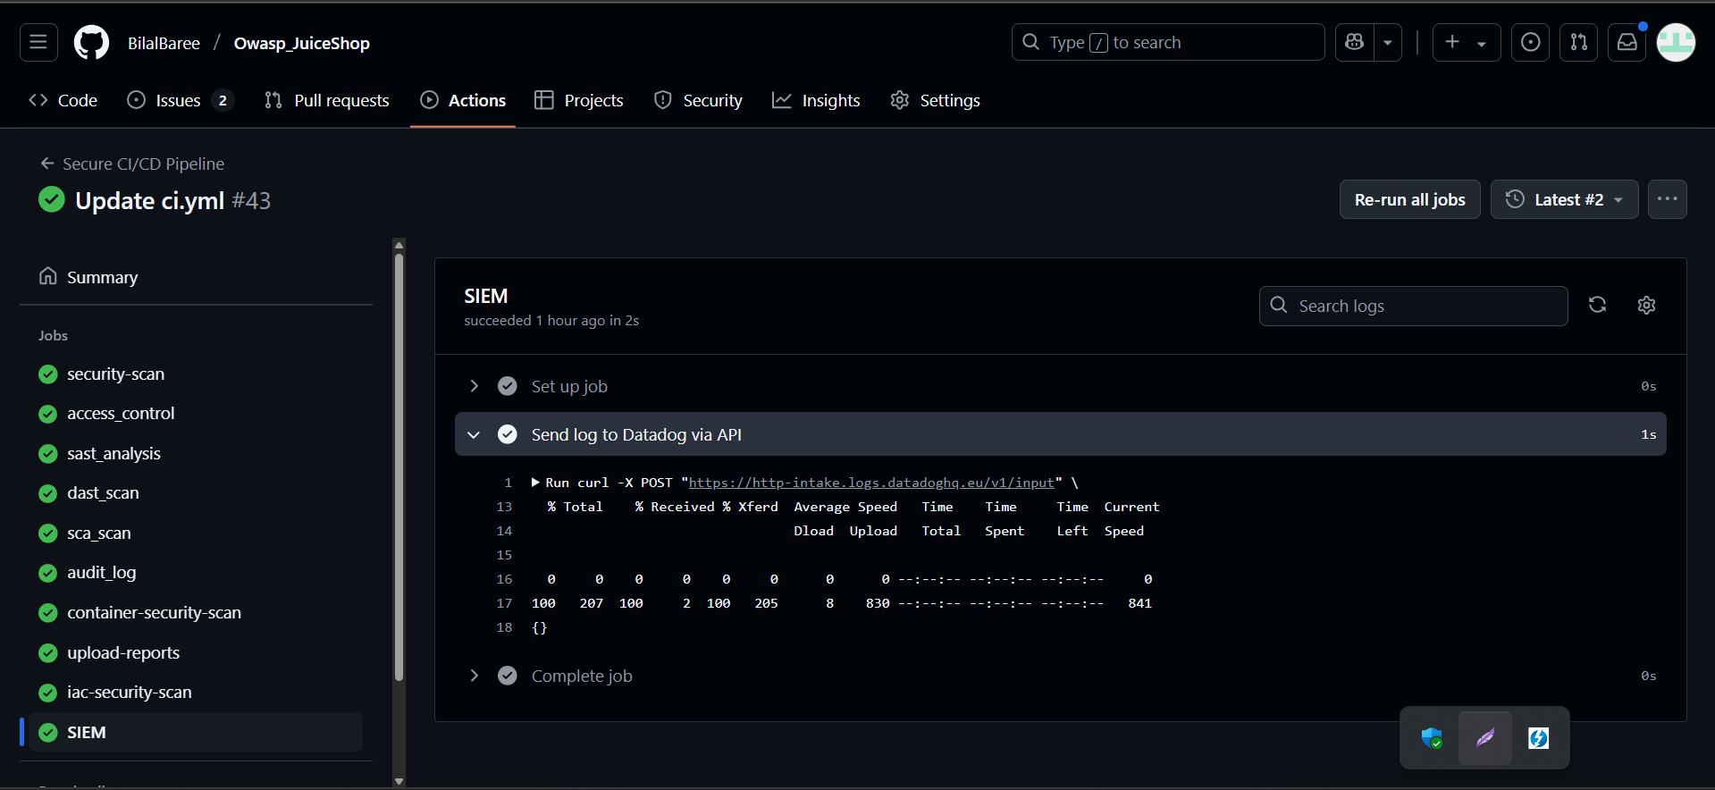
DataDog Log Explorer :
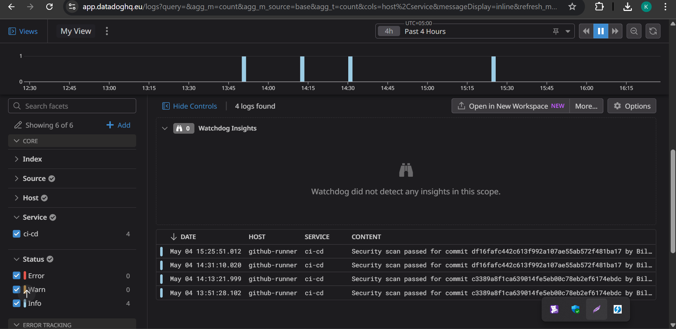
Vulnerability Management (CodeQL & Dependabot):
