NATIONAL COLLEGE OF BUSINESS ADMINISTRATION & ECONOMICS
Sub-Campus, Multan



Final Year Project Report
on

Your Project Title Here

Submitted By: Student Name (Reg. no.)

Supervised By: Supervisor Name

BACHELOR
IN
COMPUTER SCIENCE

September-2022
NATIONAL COLLEGE OF BUSINESS ADMINISTRATION & ECONOMICS
Sub-Campus, Multan

Project Title Here

BY

STUDENT NAME
_____________________________________________________________________

A project submitted to the Department of Computer Science, in partial fulfillment of the requirements for the Degree of

BACHELOR
IN
COMPUTER SCIENCE
_____________________________________________________________________

Project Defense Committee:

____________________________
Chairman

____________________________
Member

____________________________
Member

_________________________________
Pro-Rector
National College of Business
Administration & Economics,

Multan Sub Campus


In the name of ALLAH,
The Most Beneficent,
The Most Merciful,

AUTHOR’S DECLARATION

I, ________ D/S/O -------------, hereby, declare that this work titled “________________________________________________________________” submitted in partial fulfillment of the Degree of Bachelor _________________ at NCBA&E Multan Sub-campus is of my own investigation. Data, results, ideas, analyses, software and conclusions are my own efforts and if adapted then the sources have been acknowledged properly.

I also submit that this project work has not been submitted for obtaining similar degree from any other university/college.

__________________
STUDENT NAME

National College of Business Administration & Economics Multan Sub Campus

Northern Bypass Near WAPDA Town Phase-II Multan

COURSE COMPLETION CERTIFICATE

Ref. No. R&D/Multan/PD-174-2022/01 Dated: 01-09-2022

It is certified that courses requirement of Ms. STUDENT NAME Registration No. 12133175 for the program Bachelor _____________ has been completed and her current CGPA is 0.00.

M. Asim Rajwana Prof. Dr. Tariq Mahmood Ansari, FRSC
Deputy Director Research Pro-Rector

Copy to:

1. The Rector, NCBA&E Lahore
2. The Director, NCBA&E Multan Campus.
3. Notification file.

PROJECT/RESEARCH COMPLEITION CERTIFICATE

It is certified that the project work contained in this thesis entitled “Your Project Title Here” has been carried out and completed by Student Name under my supervision during her BSCS Degree program.

_________________
Supervisor Name
(Supervisor)

DECLARATION

This is to certify that this research work has not been submitted for obtaining similar degree from any other university/college.

(NAME OF THE STUDNET)
February, 2009.

DEDICATED TO

My father who had always been a source of inspiration for me.
My Family and Teachers

Abstract
Abstract of the project here.

ACKNOWLEDGEMENT
I am thankful to Almighty Allah and SWT Who gave me strength to complete my work and blessed me in whole life. I dedicate this humble effort to my Prophet Muhammad (PBUH) who is a torch of knowledge and wisdom for the whole mankind. I would like to express my gratitude to my worthy Supervisor __________, for sharing his ideas and interests with me about my project. His contribution boosted my confidence and helped me in finishing my study in time.
I am thankful to my parents and all family members for their love, support and encouragement to seek knowledge. I would also like to thank faculty members and administrative officers of NCBA&E Multan sub campus who cooperated with me in order to make this project successful, I also want to show my gratefulness to all the participants who spared their precious time in answering my questionnaires.

______________
Student Name

Table of Contents
Contents
Multan Sub Campus ii
AUTHOR’S DECLARATION iv
COURSE COMPLETION CERTIFICATE v
PROJECT/RESEARCH COMPLEITION CERTIFICATE vi
DECLARATION vii
DEDICATED TO viii
ACKNOWLEDGEMENT ix
LIST OF TABLES xiii
LIST OF FIGURES xiv
PAGE SIZE AND FORMAT xvi
CHAPTER 1 xix
INTRODUCTION xix
1.1 Purpose xix
1.2 Scope xix
1.3 Objectives xix
1.4 Overview xix
1.5 Reference Material xix
1.6 Definitions, Acronyms, and Abbreviations xix
CHAPTER 2 xix
SYSTEM OVERVIEW xix
2.1 System Description xix
2.2 System Context xix
2.3 Major Constraints xix
2.4 Assumptions and Dependencies xix
2.5 Technology Stack xx
2.6 System Environment / Deployment Context xx
2.7 System Requirements Summary xx
2.8 Modules Overview xx
CHAPTER 3 xx
SYSTEM ARCHITECTURE xx
3.1 Architectural Design xx
3.1.1 Decomposition Description xx
3.2 Behavioral and Structural Views xx
3.2.1 Use Case Diagrams xx
3.2.2 Sequence Diagrams xx
3.2.3 Class / Component Diagrams xx
3.2.4 Activity Diagrams xx
3.2.5 Data Flow Diagrams (DFD) xx
3.2.6 Entity-Relationship (ER) Diagram xx
3.2.7 State Transition Diagram (if applicable) xx
3.3 Architectural Rationale xxi
CHAPTER 4 xxi
DATA DESIGN xxi
4.1 Data Description xxi
4.2 Data Objects and Attributes xxi
4.3 Database Schema / ER Diagram xxi
4.4 Data Dictionary xxi
4.5 File Structure / Data Storage (if applicable) xxi
CHAPTER 5 xxi
COMPONENT DESIGN xxi
5.1 Component Identification xxi
5.2 Component Interfaces xxi
5.3 Internal Logic / Algorithms xxi
5.4 Hardware Component Design (if applicable) xxi
5.5 Component-Level Diagrams xxii
CHAPTER 6 xxii
HUMAN INTERFACE DESIGN xxii
6.1 User Interface Overview xxii
6.2 Screen Layouts / Wireframes xxii
6.3 Navigation Flow xxii
6.4 Hardware Interface (if applicable) xxii
CHAPTER 7 xxii
SYSTEM IMPLEMENTATION AND TESTING xxii
7.1 Implementation Overview xxii
7.2 Testing Strategy xxii
7.3 Test Cases / Results xxii
7.4 Validation and Verification xxii
CHAPTER 8 xxiii
CONCLUSION AND FUTURE WORK xxiii
8.1 Conclusion xxiii
8.2 Limitations xxiii
8.3 Future Enhancements xxiii
REFERENCES xxiii
APPENDICES (Optional) xxiii
Appendix A – Additional Diagrams or Algorithms xxiii
Appendix B – User Manuals or Interface Snapshots xxiii
Appendix C – Hardware Datasheets / Schematics xxiii
Appendix D – Source Code Snippets xxiii
REFERENCES xxiv
APPENDICES (Optional) xxiv

LIST OF TABLES

TABLE NO. |  | TITLE | PAGE
3.1 | Distribution of SME’s by Sectors in States |  | 69
3.2 | Summary of the variables those were used in this study, their sources and number of items |  | 71
3.3 | Measures of Harmonious Passion and Obsessive Passion Constructs |  | 72
3.4 | Measures of Mastery, Performance Approach and Performance Avoidance Goals Constructs |  | 73
3.5 | Measures of Creativity Construct |  | 75
3.6 | Measures of Independence Construct |  | 76
3.7 | Measures of Ambition Construct |  | 76
3.8 | Measures of Daring Construct |  | 77
3.9 | Scale Reliability |  | 79
3.10 | Goodness-of-Fit Indices Criterion |  | 97
4.1 | Sample Response |  | 111

LIST OF FIGURES

FIGURE NO. TITLE |  | PAGE
2.1 | Western Framework for the Relationship between Values. | 26
2.2 | Relationship between Entrepreneurial passion and behavioral engagements. | 27
2.3 | Relationship between Entrepreneurial Passion, Achievement Motivation Goals and Behavioral Engagements. | 32
2.4 | Burke’s control-view of Identity Process. | 42
2.5 | The Relationship between Entrepreneurial Passion and Behavioral Engagement with Mediating Affect of Achievement Goals. | 48
3.1 | Distribution (%) of SME’s by States in Malaysia. | 68

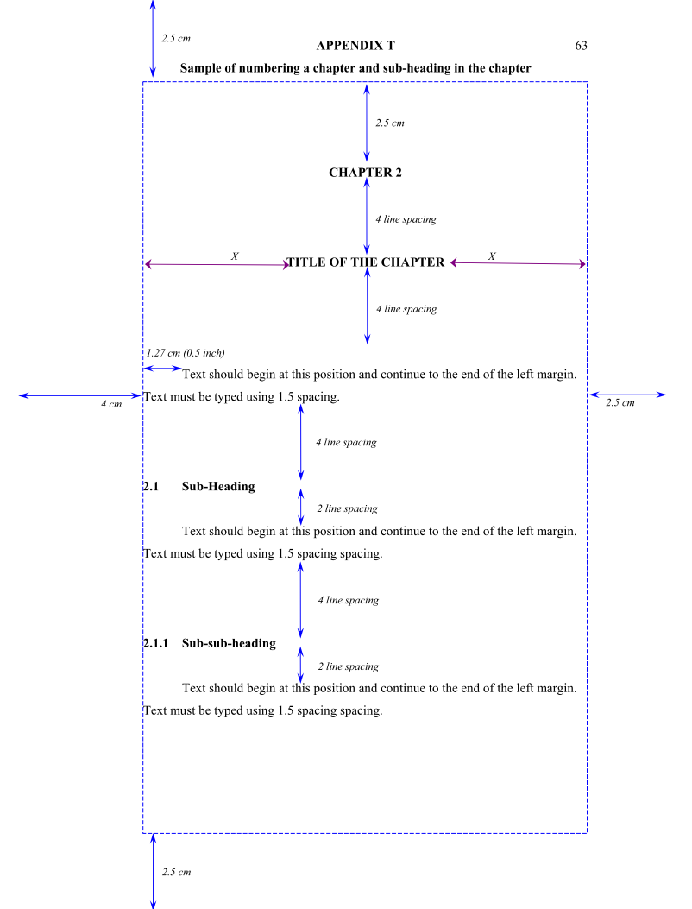

PAGE SIZE AND FORMAT
1- Paper and Size
White simile 80 gram high quality A4 size papers (210 × 297 mm) should be used.
2- Margin
All pages should be set with the same margin. The left margin should be 4 cm (for binding purposes) and 2.5 cm for the top, right and bottom margins.
3- Pagination
Each page of a thesis must be counted and numbered. Pages should be numbered consecutively. The page numbers should be printed at the bottom right hand corner, 1.25 cm from the top edge and 2.5 cm from the right edge. Numbering should be as follows:
- Preliminary pages of a thesis, starting from the title page should be numbered using small letter Roman numeric (i, ii, iii, etc.); the texts should be numbered using Arabic numeric (1, 2, 3, etc. ).
- The first page should be the title page. This page should be counted “í” but should not be printed.
- The first page of the text should be counted “1” but the number should not be printed. Similarly, the first page of all chapters should be counted but the numbers should not be printed.
- If a thesis is made up of a number of parts, separating pages can be inserted but these pages should not be counted and numbered.

4- Numbering the Chapters and Sub-sections
All chapters and their sub-sections must be labelled and numbered. The chapters are numbered using Arabic numeric, i.e. Chapter 1, Chapter 2, Chapter 3, and so on. The sub-sections should not be indented but arranged in a structured manner not more than four levels as follows:
1- First level (Title of the chapter)
2- Second level (Title of the sub-section)
3- Third level (Title of the sub-sub-section)
4- Fourth level (Title of the sub-sub-sub-section)
If the length of a title of a chapter or any level is more than one line, same line spacing as in the text should be used. Sub-sections beyond level four should be labelled using characters. Examples are shown in Appendices T and U.
If a thesis is divided into parts, separation sheets should be used to separate them. The separation sheets should be printed with capital letters, i.e. PART 1, PART 2, PART 3, and so on.
5-Typing
A thesis should be typed using word or text processor. Font type and size that are commonly used for printed academic materials should be used. The same font type should be used throughout the thesis. The character size should not be less than 0.2 cm for capital letters and 0.15 cm for small letters. If Microsoft Word is used, font type Times New Roman with font size 12 or bigger should be used. One and a half line spacing should be used. The text must be printed on one side only.
The title of a chapter should be typed using capital letters and centred. A new chapter must start on a new page. Chapters and their sub-sections must be given titles. The titles should be typed using bold letters and should not be underlined.

6- Spacing and Format
The following guidelines should be observed:
- The spacing between the top margin and the chapter number should be 2.5 cm;
- The spacing between the chapter number and the title, and between the title and the first line of a text should be four (4) line spacing;
- The spacing between the last line of a text with the title of a sub-section should be four (4) line spacing;
- The spacing between the title of a sub-section and the first line of a text should be two (2) line spacing;
- The spacing between paragraphs should be two (2) line spacing;
- The number and the title of sub-section should be aligned with the left margin;
- The first line of a paragraph should be indented by 1.27 cm (0.5 inch) from the left margin;
- A new paragraph should not begin on the last line of a page;
- The spacing between the last line of a text and a table, or a figure or an illustration should be two (2) line spacing;
- The spacing after a full stop should be two (2) character spacing.
- The spacing after a comma (,) should be one (1) character spacing.
7- Computer Printed Copy
A thesis should be typed using word or text processors for fast and easy editing. Hardcopy should be produced using a laser printer or similar quality machines.

8- Lettering and Drawing
Lettering and drawing must be clear and should be reproducible satisfactorily without loss of any information.

CHAPTER 1

INTRODUCTION

1.1 Purpose
State the main purpose of this document and system being designed.

1.2 Scope
Describe the scope, system boundaries, and major features.

1.3 Objectives
List key goals or expected outcomes of the project.

1.4 Overview
Briefly explain the structure of this document.

1.5 Reference Material
Mention any relevant papers, books, or standards.

1.6 Definitions, Acronyms, and Abbreviations
Define key terms used.

CHAPTER 2

SYSTEM OVERVIEW

2.1 System Description
High-level description of the system and its purpose.

2.2 System Context
Describe how the system interacts with its environment.

2.3 Major Constraints
Outline major constraints (hardware, time, cost, etc.).

2.4 Assumptions and Dependencies
List important assumptions made.

2.5 Technology Stack
Specify languages, frameworks, and platforms used.

2.6 System Environment / Deployment Context
Describe operating environment and deployment setup.

2.7 System Requirements Summary
Summarize key functional/non-functional requirements.

2.8 Modules Overview
List all modules/components with short descriptions.

CHAPTER 3

SYSTEM ARCHITECTURE

3.1 Architectural Design
Describe data input/output formats.

3.1.1 Decomposition Description
Explain how system is divided into modules.

3.2 Behavioral and Structural Views
Include relevant UML diagrams such as:

3.2.1 Use Case Diagrams

3.2.2 Sequence Diagrams

3.2.3 Class / Component Diagrams

3.2.4 Activity Diagrams

3.2.5 Data Flow Diagrams (DFD)

3.2.6 Entity-Relationship (ER) Diagram

3.2.7 State Transition Diagram (if applicable)

3.3 Architectural Rationale
Explain why this design/architecture was chosen.

CHAPTER 4

DATA DESIGN

4.1 Data Description
Describe data input/output formats.

4.2 Data Objects and Attributes
Define key data entities and their attributes.

4.3 Database Schema / ER Diagram
Provide data model and relationships.

4.4 Data Dictionary
Define database tables, columns, and datatypes.

4.5 File Structure / Data Storage (if applicable)
For hardware/embedded systems.

CHAPTER 5

COMPONENT DESIGN

5.1 Component Identification
List and briefly describe system components.

5.2 Component Interfaces
Describe input/output and APIs of each component.

5.3 Internal Logic / Algorithms
Provide logic or pseudocode for major modules.

5.4 Hardware Component Design (if applicable)
Include circuit diagrams, sensors, etc. (if applicable).

5.5 Component-Level Diagrams
Provide class or block diagrams at detailed level.

CHAPTER 6

HUMAN INTERFACE DESIGN

6.1 User Interface Overview
Explain UI philosophy and objectives.

6.2 Screen Layouts / Wireframes
Attach mockups or UI screens.

6.3 Navigation Flow
Describe how users navigate between screens.

6.4 Hardware Interface (if applicable)
Describe any physical interface (buttons, sensors, etc.).

CHAPTER 7

SYSTEM IMPLEMENTATION AND TESTING

7.1 Implementation Overview
Describe how modules were implemented and integrated.

7.2 Testing Strategy
Outline testing types (unit, integration, system, user testing).

7.3 Test Cases / Results
Provide representative test cases with expected vs. actual outcomes.

7.4 Validation and Verification
Discuss how design meets system requirements.

CHAPTER 8

CONCLUSION AND FUTURE WORK

8.1 Conclusion
Summarize project outcomes and performance.

8.2 Limitations
Describe any system constraints or issues faced.

8.3 Future Enhancements
Suggest potential improvements or extensions.

REFERENCES
List all references in IEEE or APA format (books, research papers, websites, etc.).

APPENDICES (Optional)

Appendix A – Additional Diagrams or Algorithms

Appendix B – User Manuals or Interface Snapshots

Appendix C – Hardware Datasheets / Schematics

Appendix D – Source Code Snippets

REFERENCES
List all references in IEEE or APA format (books, research papers, websites, etc.).

APPENDICES (Optional)
Appendix A – Additional Diagrams or Algorithms
Appendix B – User Manuals or Interface Snapshots
Appendix C – Hardware Datasheets / Schematics
Appendix D – Source Code Snippets

