Restaurant Automation System

Muhammad Saran
Reg. No Uw-14-cps-bs-062
Mohsin Ali Khan
Reg. No uw-14-cps-bs-064
Syed Farrukh Hussain
Reg. No uw-14-cps-bs-064



Department of Computer Sciences
University of Wah,
Wah Cantt

Session 2014-2018

Restaurant Automation System

Undertaken By

Muhammad Saran
Reg. No uw-14-cps-bs-062
Mohsin Ali Khan
Reg. No uw-14-cps-bs-085
Syed Farrukh Hussain
Reg. No uw-14-cps-bs-064



Supervised By

Ma’am Nazish Yousaf

A DISSERTATION SUBMITTED AS A PARTIAL FULFILLMENT OF THE
REQUIREMENTS FOR THE DEGREE OF BACHELOR OF SCIENCE IN COMPUTER SCIENCE

Department of Computer Sciences
University of Wah
Wah Cantt

Session 2014-2018

Undertaken

We certify that this is our own work. The work has not in whole or in part been presented elsewhere for assessment. Where material has been used from other sources it has been properly acknowledged. If this statement is false, we acknowledge that we will have committed an assessment offence and shall be liable to punishable action under the plagiarism rules of HEC.

______________
Muhammad Saran
Reg. No uw-14-cps-bs-062

Dated _________

______________
Mohsin Ali Khan
Reg. No uw-14-cps-bs-085

Dated: _________

______________
Syed Farrukh Hussain
Reg. No uw-14-cps-bs-064

Dated: _________

Certificate

It is certified that the contents and the form of the report submitted by Muhammad Saran, Mohsin Ali Khan and Syed Farrukh Hussain have been found satisfactory for the requirement of the degree of Bachelor/Master of Science in Computer Science.

Supervised by | Ms. Nazish Yousaf  Lecturer  Department of Computer Science  University of Wah, Wah Cantt | ___________________
Approved by
Examiner: | Lecturer  Department of Computer Science  University of Wah, Wah Cantt | ___________________
Examiner: | Lecturer  Department of Computer Science  University of Wah, Wah Cantt | ___________________
Examiner: | Lecturer  Department of Computer Science  University of Wah, Wah Cantt | ___________________
Head of Department: | Mr. Asim Ali  HOD  Department of Computer Science  University of Wah, Wah Cantt | ___________________

Department of Computer Sciences
University of Wah,
Wah Cantt

Dedication

This thesis is dedicated to our beloved parents

Acknowledgements

In the name of Allah, the Most Gracious and the Most Merciful, all praises to Allah for the strengths and His blessing for this task.
First of all, we would like to thank our parents for their endless love, prayers and encouragement throughout our degree period.
We would also like to thank our most respected teachers and supervisor who helped us and guided us throughout thesis duration.
Sincere thanks to all our friends for their kindness and moral support during our study. Thanks for the friendship and memories.
We would like to thanks our family members for supporting, encouraging, appreciating and praying throughout our thesis duration.

Muhammad Saran
Mohsin Ali Khan
Syed Farrukh Hussain

Abstract
The Restaurant management system is designed to handle all information about customer, tables, and employees. It provides the facilities for restaurants to maintain their record in effective way and searching of customer record is very simple and easily. Existing system depends on paper work has limitations like slow process for checking table availability, reserving table, no data integrity and no security. The proposed system eliminated all the problems caused by existing manual system. The proposed system maintains food order, employees record and customer information efficiently. Admin of restaurant can generate the report by given date and generate the total amount and quantity of orders served. The proposed system enables easy table, order and employee, customer record management and better security, data integrity and saves lots of time.

Table of Contents

Table of Contents
Undertaken 1
Certificate 2
Dedication 3
Acknowledgements 4
Abstract 5
Table of Contents 6
List of Figures 7
List of Tables 8
1 Introduction 1
1.1 Overview 1
1.2 Purpose 1
1.2.1 Scope 1
1.3 Positioning 1
1.3.1 Problem statement 2
1.4 Project introduction 2
1.4.1 Restaurant automation system 2
2 Literature Review 1
3 Problem Analysis 1
3.1 Project idea 1
3.2 Proposed system 1
3.3 Project scope 1
3.4 Developing environment 2
3.4.1 MS Visual studio 2015 2
3.4.2 Operating system 2
3.4.3 Hardware specification of the developing environment 2
3.4.4 Frame work 2
3.4.5 Other software 2
3.5 Software requirements specification 3
3.5.1 Purpose 3
3.5.2 Scope 3
3.5.3 Overall description 4
3.5.4 Specific requirement 5
4 System Analysis 1
4.1 Specific functional requirement 1
4.2 Use Case Diagram 1
4.2.1 Customer 1
4.2.2 Admin 1
4.3 Use Cases in descriptive form 3
4.3.1 Customer Registration 3
4.3.2 Manage Customers 3
4.3.3 Manage Menu Items 3
4.3.4 Manage Tables 3
4.3.5 Manage Events 3
4.3.6 Menu Automation 3
4.3.7 Place Order 3
4.3.8 Pay by Cash 3
4.3.9 Pay Online 4
4.3.10 Product Analysis 4
4.4 Use Cases 4
4.4.1 Use Case 1: Login 4
4.4.2 Use Case 2:Sign Up 5
4.4.3 Use Case 3: Reserve Table 6
4.4.4 Use Case 4: Reserve Event 7
4.4.5 Use Case 5: Place order 9
4.4.6 Use Case 6: Manage Employee 10
4.4.7 Use Case 7: Manage Customer 11
4.4.8 Use Case 8: Log out 12
4.5 User characteristics 14
5 System Design 1
5.1 Interaction Diagram 1
5.2 Class Diagram 2
6 Implementation 1
6.1 Software development model 1
6.2 Entity relationship diagram 1
6.2.1 Entities and attributes 1
6.2.2 Entity Description 1
6.2.3 ERD Description 3
6.2.4 Relationship 3
6.3 Database Tables 3
6.3.1 Table reservation table 3
6.3.2 Employees Table 4
6.3.3 Customers table 4
6.3.4 Bill table 4
6.3.5 Menu table 5
Chapter 7 1
7 Testing 1
7.1 Test case 1
7.1.1 Home Page Navigation Test 1
7.1.2 Reserve Table Page Navigation Test 1
7.1.3 Menu Item Page Navigation test 1
7.1.4 Sign up Page Navigation Test 2
7.1.5 Log in Navigation Test 2

List of Figures

Figure 4 1 Use case Diagram 2
Figure 4 2 SSD for login 5
Figure 4 3 SSD for Signup 6
Figure 4 4 SSD for reserve table 7
Figure 4 5 SSD for reserve event 8
Figure 4 6 SSD for place order 10
Figure 4 7 SSD for Manage customers 12
Figure 4 8 SSD for logout 13

Figure 5 1 Sequence diagram for place order 1
Figure 5 2 Class Diagram 2

Figure 6 1 Entity relationship diagram 2

List of Tables

Table 6 3 1 Order Table 3
Table 6 3 2 Employee Table 4
Table 6 3 3 Customers table 4
Table 6 3 4 Bill table 4
Table 6 3 5 Menu table 5

Chapter 1
Introduction

Introduction

Overview
We intend to fully automate the traditional Restaurant Management System as web in order to gain more flexibility, scalability and ease of use. The existing system is a manual system in which there is a huge risk of miss-management of data and there is no proper coordination between different applications and users. The existing system is less users-friendly and not in reach of distant users. In this reservation system we can check for tables and hall and also check the availability in the required time. In the table reservation system user can reserve the table which is already not occupied by anyone and also can order for food. This system provides different login for end users to keep restrictions.

Purpose
The Restaurant Automation system is a tool for ordering the food the customer reserve table of restaurant through online. It will provide the better management and make easy access to customer detail.

Scope
The proposed project aims to provide a “Restaurant Automation” tool in which the customer ordering the food and booking a table or event. It will provide better management and make easy access to the customer’s information. It will provide an easy way for the customer to go through the menu by simply using our website. Furthermore, the proposed system is not just specified to the restaurant management as mention in first section it is a customizable application because administrator can modify the system according to his/her desire, instead of just a restaurant it can be used for any catering organization having accounting system, online reservation system.

Positioning

Problem statement
The problem of | Manual systems that are difficult to manage
Affects | Workers, customers, administration
The impact of which is | A slow and difficult task to reserve a table, wastage of time.
A successful solution would be | Automate the restaurant for ease of customer, Improve the image of the customer, easy to manage the customers and employees.

Project introduction
This is a customizable GUI based application which contains two views, one is the user based and the other is administrator based view. The user view facilitates the user with number of facilities for example user can check which things are Available. User can also check the restaurant’s table are free to go there or also he can reserve tables from time to time as well as can reserve table for the specific day for example a user wants to reserve the table for future events so these kind of users can also be entertained. Management view is totally different from user view because it includes number of things that is they can customize the app according to their organization’s environment. They can apply the application on the basis of structure of their building. Furthermore, application can generate the report which includes item sales, items cost report, record of the employees.

Restaurant automation system
The Restaurant Automation system is a tool for ordering the food the customer reserve table of restaurant through online. It will provide the better management and make easy access to customer detail.

Chapter 2
Literature Review

Literature Review
We have conducted an extensive literature review on the websites working on the idea of mart automation system in Pakistan. Some of the websites we have selected on the basis of their good enough functionalities are analyzed below,
One of Pakistan’s leading online grocery services, “Pakistan Grocery” [1] has a wide array of grocery items, including fresh meat and fish, fruits, and vegetables. The UK-based facility also allows the customer to send gifts to Lahore, Karachi, and Islamabad in Pakistan. “Door Step” [2] is a one-stop shop for grocery items ranging from cereals to soups to dry fruits and different household products. The website provides free delivery for orders, while the customer has to register first as a member before placing an order.
“RashanLelo” [3] delivers free groceries to your doorstep, with the website having a wide range of grocery items on its list. However, the services offered are exclusively for the people of Karachi. “Gomart.pk” [4] is the largest online food and grocery store, currently operating exclusively in Karachi. The website offers more than 4000 products of over 100 brands. The website claims to offer the best quality products available at the lowest possible prices. The consumer can pay through Cash on Delivery.
A premium online grocery shopping network, “Aaram Shop” [5] offers its consumers in Lahore and Karachi the ease of online grocery shopping through the customer’s preferred nearby retailer. The products available are provided at discounted prices. Setting itself aside from the rest, Aaram Shop offers free cash on delivery in Karachi and Lahore within 2 hours’ delivery time.
Furthermore, the websites mentioned above do not provide the function of product analysis. The facility of online grocery shopping is not available in our area. So, our goal is to automate the “Descent Shopping Mart, Taxila” in our area for online grocery shopping. Our system works on the idea of record management and profitability check in order to extract the best of its functionalities for more profit and better management.

Chapter 3
Problem Analysis

Problem Analysis

Project idea
This newly introduce system, hotel management system which will automate the major operations of hotel. In the table reservation system user can reserve the table and also can order for food. Administration department will control all this. There are two end user for this system one is the Customer and second is the Manager. Customer can access all the system functionalities of the system with some limitation like he can only order something and reserve tables and the manager can access all system functionalities without restrictions. This system provide different login for end users to keep restrictions.
The main objective of the automated system is to keep all the thing in simple way. System will be able to manage many services in quick manner. In the earlier system of the hotel there is large amount of file handling in the hotel .This newly system will overcome those drawback and most importantly the efficiency of information retrieval system.

Proposed system
Restaurant Automation will be web based to make it available for a large number of users. Idea is to facilitate the customers that they can easily order the desired food. There will be complete digital menu of restaurant with prices and availability shows to the customers. Customers can easily select the food from menu and reserve the table for specific time in a specific day. Admin manages all the process.
Application should also provide analysis for the benefit of restaurant owners. In analysis its provide number of quantity of each item and total sale between the selected date.

Project scope
The proposed project aims to provide a “Restaurant Automation” tool in which the customer ordering the food and booking a table or event. It will provide better management and make easy access to the customer’s information. It will provide an easy way for the customer to go through the menu by simply using website. Furthermore, the proposed system is not just specified to the restaurant management as mention in first section it is a customizable application because administrator can modify the system according to his/her desire, instead of just a restaurant it can be used for any catering organization having accounting system, online reservation system.

Developing environment

MS Visual studio 2015
This is integrated development environment for development technologies like asp.net this provide flexibility and easiness for developers to make web application and desktop application also it provide ease in design and managing code.

Operating system
Our website will be able to work online 24 hours a day and will work on all web browsers.

Hardware specification of the developing environment
Monitor resolution 1024x768
Processor Intel
RAM 3 GB
Disk Space 11GB

Frame work

Asp.NET Framework:
Asp.net is a product of Microsoft. It comes after Asp (Active server Pages) but it is more power, robust then ASP and contains much more features then ASP. In ASP.NET users can build fully dynamic websites, Web Applications, Web services etc. In ASP.NET programmers can thousands of .NET Framework Classes to build their Applications. It Uses Object oriented Structure and easy to deploy and configure.

Other software

SQL server Database:
Microsoft SQL server is a very popular, powerful and robust database mostly used by online Websites for storing huge amount of data of different types. In SQL server database it is very easy to manage databases and their relations. It contains relational database structure in which data stores in the form of tables. Although Oracle is also a power full and robust database used today but there are some reasons to use Microsoft SQL server database here. First it’s very difficult to use Express edition of Oracle, secondly Oracle operates on different platforms but SQL server operates more efficiently then oracle in Windows operating system. Because the Database of our final year project is complex we use SQL server for backend because it provides efficient functionality to cope with these complexities

ADO.NET:
ADO.NET is the technology through which we gain access to data sources such as SQL Server. Through ADO.NET .NET applications connect to data sources like SQL server and perform certain operations like retrieve, update or delete the data.ADO.NET is basically object oriented framework through which we gain access to database systems.
Using SQL queries we normally access the data from database. The main characteristic of ADO.NET is that it is very robust and efficient. It also introduces the concept of disconnected data architecture. It makes copy of the data in DATA SET. In traditional databases we make connection with the data to access the data and most of the time connection remain established even we are not using the data that results in waste of resources.ADO.NET solves this problem by introducing the concept of DATA SET, in which it stores the whole copy of database results in generating faster responses.

Software requirements specification

Purpose
This document is made for providing detail description for the “Restaurant Automation” system. This Software Requirement Specification Document will specify requirement of system and describe the purpose and also describe complete declaration for development of the system. It will describe the system requirements in detail along-with system interfaces, system constraints and interaction with external application.

Scope
The proposed project aims to provide a “Restaurant Automation” tool in which the customer ordering the food and booking a table or event. It will provide better management and make easy access to the customer’s information. It will provide an easy way for the customer to go through the menu by simply using his mobile device application or our website. Furthermore, the proposed system is not just specified to the restaurant management as mention in first section it is a customizable application because administrator can modify the system according to his/her desire, instead of just a restaurant it can be used for any catering organization having accounting system, online reservation system.

Overall description

Product perspective
We intend to fully automate the traditional Restaurant Management System as web and android based application in order to gain more flexibility, scalability and ease of use. The existing system is a manual system in which there is a huge risk of miss-management of data and there is no proper coordination between different applications and users. The existing system is less users-friendly and not in reach of distant users.

Product functionality
Our proposed system will replace the existing manual system of “, Maharaja, Wah Cantt”. The proposed system will provide the generic restaurant management system functionalities like customer, table and event reservation, online payment along-with some additional functions like fully automated menu and monthly and annual summary report generation.

User type
Our system has two user levels that will directly interact with the system; administrator/manager and customers. Every user has multiple uses of the system causing different requirements.
- Managers or Administrators will be able to manage the menu item details and the reservation record.
- Customers will be able to reserve an event or a table along-with functionality like view and order any item from the menu. They will also be able to pay for the selected items online.

Specific requirement

User interface
In our system there are two user levels. The user perspective will limit the use of functionalities provided by our system.

Software requirement
- MySQL / Oracle for Database development
- ASP.NET for web application development

Non-Functional requirement

Performance requirement

Availability
Our system must be available 7 days in a week and 24 hours in a day.

Response time
System should respond to the users within one minute.

Security requirements
From an unauthorized access the sensitive data should be protected by using some technology. We use mechanism of log in from this only authorized user can access system by using unique id and password.

Software quality attributes

Maintainability
System must be maintainable. System should deal with new technology or to fix defects.

Portability
Our system must run on any type of Microsoft Windows Environment. System or component will be easily transferred from one environment to another.

Accuracy
System should provide the order total accurately.

Scalability
The growing of work should be handle by the system in a good manner and it should be accommodate the growth of work.

Compatibility
System should be compatible in every environment.

Other requirements

Legal requirements
System must resolve all proprietary issues

Chapter 4
System Analysis

System Analysis

Specific functional requirement
Functional requirements should include functions performed by specific screens, outlines of work-flow performed by the system and other business or compliance requirements the system must meet. System shall record reservation and customer information maintain unique conformation number for each reservation. System will check the availability of tables and menu. System will also generate the report by given date. Following are the functional requirement of system.
- Table reservation.
- Event reservation.
- System maintain record of their customers.
- System maintain record of their Employees.
- System should perform the analysis.
- System recommends menu for the customers.

Use Case Diagram

Customer
Customer is important part of our system. Customer can sign in if customers already having account, Customer have to signup if they don’t have an account. Customer has view the information of menu item and its price range. Customer can reserve a table or an event in advance. Customer will be able to reserve the table and place order and after reservation then logout.

Admin
Admin has complete access to the restaurant management functionality. Manage the restaurant only by the manager and manager is responsible for managing employees and customers. Admin view any information such as customer information, employee information and booking information, analyze them and take the decision accordingly
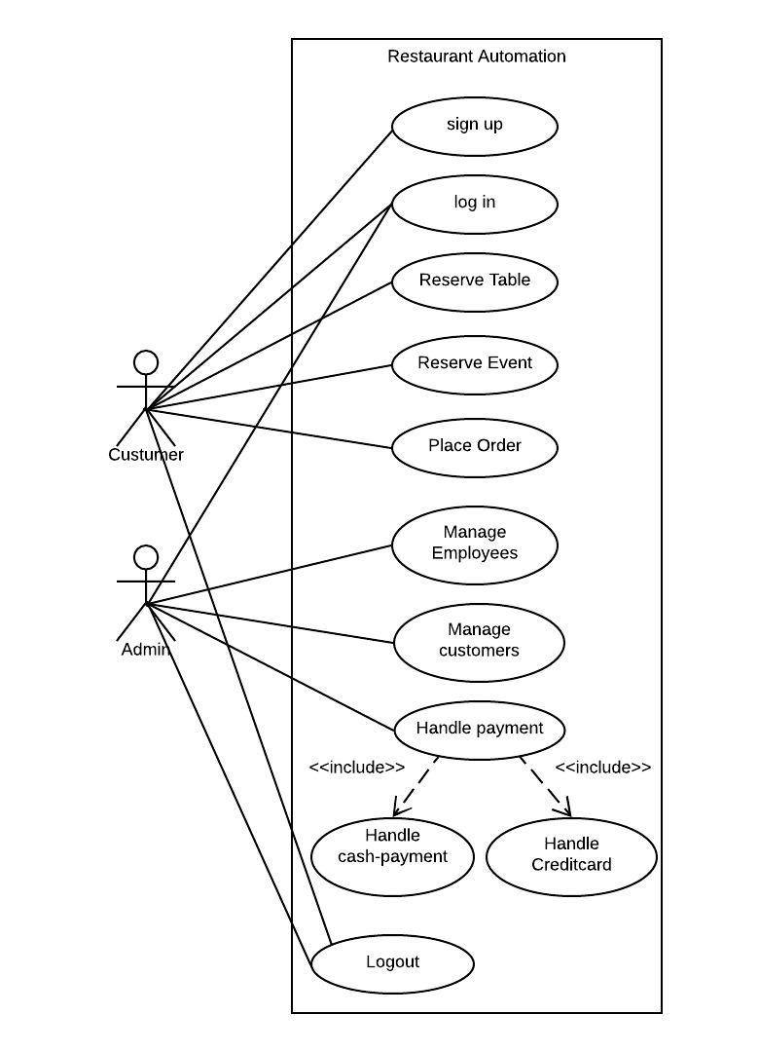
Figure 4 1 Use case Diagram

Use Cases in descriptive form

Customer Registration
The system will provide the customers to register with our system and they should be able to update the data in their profiles anytime.

Manage Customers
The system will provide the administrators with functionality to manage the details of the customers registered on the website.

Manage Menu Items
The system will provide the administrators with functionality to manage (add, update, delete and view) the products on the website

Manage Tables
The system will provide the administrator/manager with the function to manage (add, update, delete and view) the table details.
Customers should be capable to check the availability of tables through system. The system should display information for all tables. The customers can confirm or cancel the booking by using this system.

Manage Events
The system will provide the administrator/manager with the function to manage (add, update, delete and view) the event details.
The system should enable the customers to check for availability of the restaurant for event registration and catering services. The system should allow customer to confirm or cancel the booking.

Menu Automation
The system will provide the administrators with functionality to manage (add, update, delete and view) the order details.
Customers will be able to add or delete items from the menu. The order can contain at least one item or many items. A subtotal will be displayed to the user after addition of each item. After generation of total customer will no longer be able to change any item they have already ordered because the menu system will be locked. In case of inconvenience manager/admin can be consulted.

Place Order
The system will provide the customers with the facility to place order. To place an order, there should at least be one item in the shopping cart. To place the order, customers will have to specify the shipping address and payment mode.

Pay by Cash
The system will provide the customers to select the option of payment by Cash both for online reservation and for at the spot table booking.

Pay Online
The system will make the customers able to pay online for their orders using Credit or Debit Cards.

Product Analysis
The sales summary report generated by the system will provide a product analysis by recommending menu items to the customers from the category from which he/she has been ordering more frequently. The system will also provide a summary of all orders within a specified date range.
- Sales report which generate by system its includes all the analysis like numbers of orders, average orders on each day, gross sales, total net and average amount on each order.
- Annual analysis will tell us the summary of all the selling products and tell the best and worst product. According to the orders record, the home page displays the top ten best-selling products.
- Through this analysis we will understand that which product sell more and which products selling is average after this all the information we will improve marketing.

Use Cases

Use Case 1: Login

Primary Actors:
Customer, Admin

Stakeholders and Interests:
Admin:
Admin wants to login for performing administration operation
Customer:
Customer want to login for order food reserve table or event.

Pre-conditions:
Home page of the restaurant application is loaded.

Success Guarantee:
Customer successfully login and authenticated.

Main Success Scenario:
- Customer enters id and password.
- System authenticates id and password.

Extension (Alternative Flows):
1(a) Customer or Admin enter the wrong password.
- Customer or Admin reenter the password.
2(b) Customer or admin enter the wrong id.
- Customer or Admin reenter the id.

SSD1: login
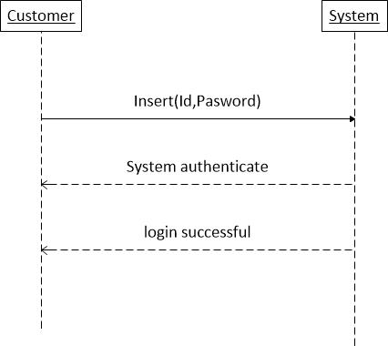
Figure 4 2 SSD for login

Use Case 2:Sign Up

Primary Actors:
Customer

Stakeholders and Interests:
Customer:
Customer wants to register their account to order for food or reserve table.

Pre-conditions:
Home page of the restaurant application must be loaded.

Success Guarantee:
Customer register successfully.

Main Success Scenario:
- User browses to the sign up page.
- System ask user to enter the credentials.
- Customer enter the user name, id, email and DOB.
- Customer enter the password.
- Customer reenter the password.
- System validates the information.

Extension (Alternative Flows):
1(a) System shows an error.
- Customer not sign up if already have an account.
2(b) Customer not signing up.
- Step 4 and 5 repeat until both password are same.

SSD2: Signup
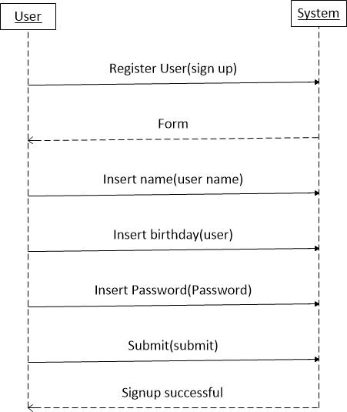
Figure 4 3 SSD for Signup

Use Case 3: Reserve Table
Primary Actor:
Customer
Stakeholders and Interests:
Customer:
Customer wants to reserve the table.
Preconditions:
Customer must be login.
Success Guarantee: Customer successfully reserve the table.
Main Success scenario:
- Customer browses the reserve table page.
- System ask the information like time and date.
- Customer selects time and date.
Extensions (Alternate Flows):
3(a). Customer select wrong/previous date.
1. System ask the customer to enter correct date.
2. Customer responds and enter correct date.

SSD2: Reserve table
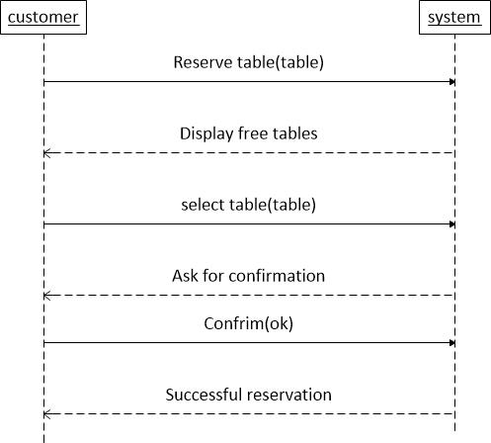
Figure 4 4 SSD for reserve table

Use Case 4: Reserve Event
Primary Actor: Customer
Stakeholders and Interests:
Customer:
Customer can reserve restaurant for some event.
Preconditions:
Customer must be login.
Success Guarantee:
Customer reserve restaurant for event successfully.
Main Success scenario:
- Customer browses the event reservation.
- System ask the information about time and date.
- Customer selects time and date.
Extensions (Alternate Flows):
3(a). Customer select wrong/previous date.
1. System ask the customer to enter correct date.
2. Customer responds and enter correct date.

SSD: reserve event
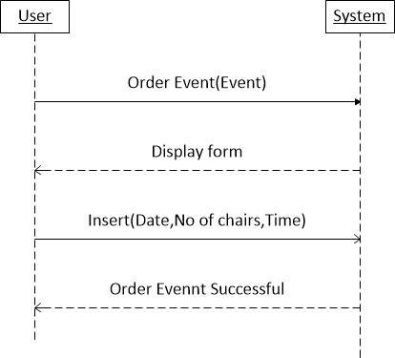
Figure 4 5 SSD for reserve event

Use Case 5: Place order
Primary Actor:
Customer, Admin
Stakeholders and Interests:
Customer:
Wants to see the menu item and their price and then order for desired food.
Admin:
Admin can also order food.
Preconditions:
Customer must have logged in.
Success Guarantee:
Customer place order successfully and get his desire food.
Main Success scenario:
- Customer open the menu items.
- System show the list of available menu items.
- Customers select the desired menu items.
- The system shows the price of item.
- Repeat step 3 and 4 for all the menu items which user want to order.
- System show the total cost of selected items.
Extensions (Alternate Flows):
4(a). Customer do not enter the quantity of item.
- System ask to enter quantity of item.
- If the user did not enter the quantity of item then system shows error.
- Customer enter the quantity and place order.

SSD4: Place order
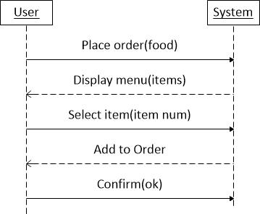
Figure 4 6 SSD for place order

Use Case 6: Manage Employee
Primary Actor:
Admin
Pre-Conditions:
Admin must have logged in.
Post-Conditions:
Admin successfully manages the employee’s information.
Main Success Scenario:
Actor’s Actions | System’s Response
1. Admin selects to manage employees.
 | 2. System display employee’s information.
3. Admin click on the desired employee.
 | 4. System will display the information of the employee.

Extensions (Alternate Flows):
Update Employees:
- Admin selects to update employee’s information.
- Admin edits the information and confirms it.
- System saves information and gives confirmation message.
Alternate Sub-Flow:
2(a) Essential field is left empty
- System gives error message.
- Admin enters the missing data and again save the information.
Delete Employees:
- Admin selects to delete employee’s information.
- System ask from admin to confirmation.
- Admin confirms it.
- System deletes the employee data and displays confirmation message.

Use Case 7: Manage Customer
Primary Actor:
Admin
Pre-Conditions:
Admin must have logged in.
Post-Conditions:
Admin successfully manages the customer’s information.
Main Success Scenario:
Actor’s Actions | System’s Response
1. Admin selects to manage customers.
 | 2. System displays customer’s information.
3. Admin clicks on the desired customer.
 | 4. System will displays the information of the customer.

Extensions (Alternate Flows):
Update customers:
- Admin selects to update customer’s information.
- Admin edits the information and confirms it.
- System saves information and gives confirmation message.
Alternate Sub-Flow:
5(a) Essential field is left empty
- System gives error message.
- Admin enters the missing data and again save the information.
Delete Customers:
- Admin selects to delete customer’s information.
- System ask from admin to confirmation.
- Admin confirms it.
- System deletes the employee data and displays confirmation message.

SSD6: Manage Customer
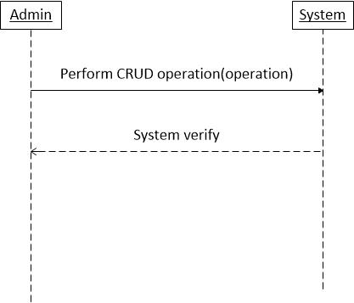
Figure 4 7 SSD for Manage customers

Use Case 8: Log out
Primary Actor:
Customer, Admin
Stakeholders and Interests:
Customer:
Customer wants to logout from the website.
Admin:
Admin wants to log out after performing required operation.
Preconditions:
Customer/Admin must be login.
Success Guarantee:
Customer/Admin successfully logout.
Main Success scenario:
- Customer or Admin press logout option.
- Customer or admin logout.
Extensions (Alternate Flows):
If user is not already logged-in, then he/she can’t log out.

SSD8: Log out
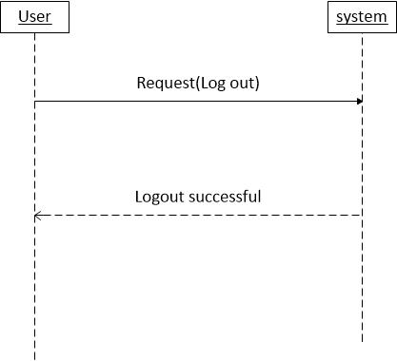
Figure 4 8 SSD for logout

User characteristics
Our system has two user levels that will directly interact with the system; administrator/manager and customers. Every user has multiple uses of the system causing different requirements.
- Managers or Administrators will be able to manage the menu item details and the reservation record.
- Customers will be able to reserve an event or a table along-with functionality like view and order any item from the menu. They will also be able to pay for the selected items online.

Chapter 5
System design

System Design

Interaction Diagram
Customer can place order then system checks that order items are available if everything is good then system place the order successful and shows the customer that order completed. The next step is online payment, user clicks on payment button and follow the procedure to get the work done.
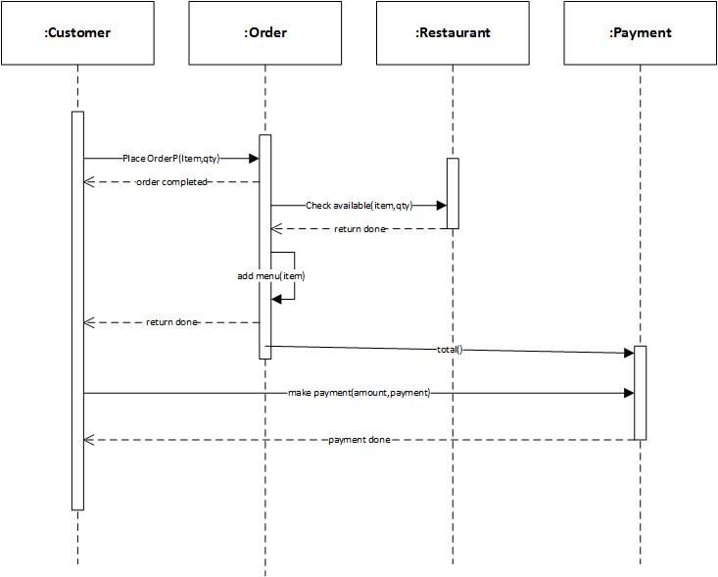
Figure 5 1 Sequence diagram for place order

Class Diagram
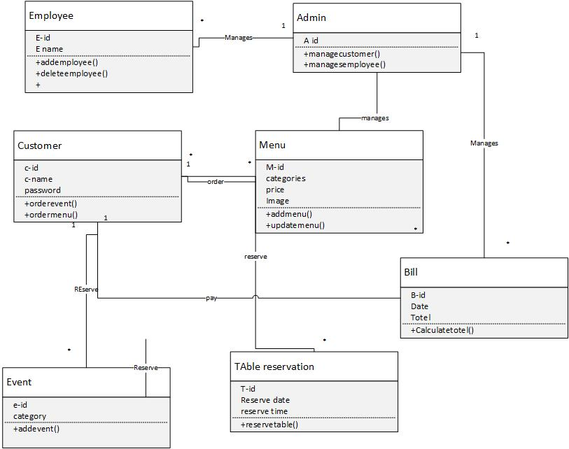

Figure 5 2 Class Diagram

Chapter 6
Implementation

Implementation

Software development model
We use agile model that is based on incremental development and iterative development. First we develop the customer panel and after the completion of customer panel we develop admin panel. We use this model because our requirements are not clear enough initially. Also our requirement changes time to time. Using this development model the end result is our software is high quality and complete in least possible time.

Entity relationship diagram

Entities and attributes
 | Entity | Attributes
1 | Admin | Admin_id, name, password, Image
2 | Customers | C_id, C_Email, C_Password, C_Ph.No, C_Name
3 | Employees | E_id, E_Name, E_Salary, E_Image, E_Gender, E_Join date, E_Mail
4 | Menu | M_id, M_Name, M_Image, M_Price
5 | Table reservation | T_Id, Reservation time, Reservation date, No of chairs
6 | Event | E_id, Category
7 | Bill | B_id, Total bill

Entity Description

Admin:
Admin manages the overall system and supervises the activities being held in the system.

Customers:
Customers can reserve table through signup in the system providing their information like name, ph. No, Email, and password.

Employees
Employees playing an important role in the system. They are working in the system as manages the customer and employees record.

Menu
Menu stores the food items which are available to users.

Table Reservation
Table reservation stores the information about orders like order category, time, no of chairs and date.

Event
Event stores information about Date, Time, and no of hours.

Bill
Bill table generates the bill for customers.

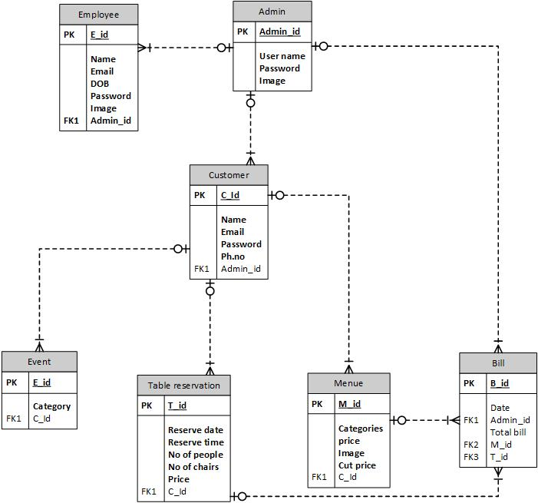
Figure 6 1 Entity relationship diagram

ERD Description
- This ERD as shown in figure above explains the working of restaurant automation system, how the entities participate in the system and how each entity plays role in the system coordinating with each other.
- Each entity is related to other entity forming a network.

Relationship
- Amin manages one or many customers, employees and bill.
- Many employees manages by one admin.
- Customers can select many menu and reservation for many table or event and manages by one admin.
- Many menu selected by one customer.
- Many reservation done by one customer.

Database Tables

Table reservation table
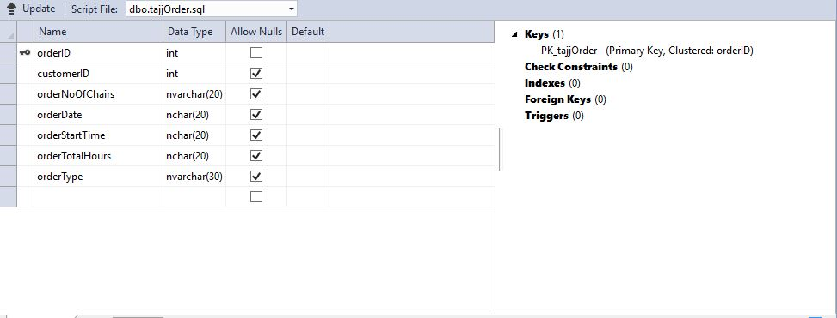
Table 6 3 1 Order Table

Employees Table
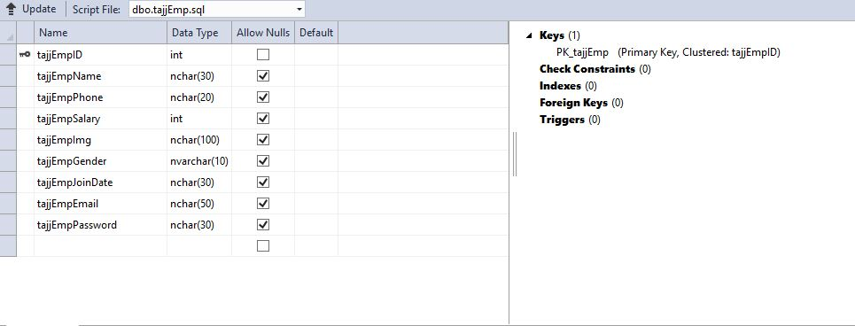
Table 6 3 2 Employee Table

Customers table
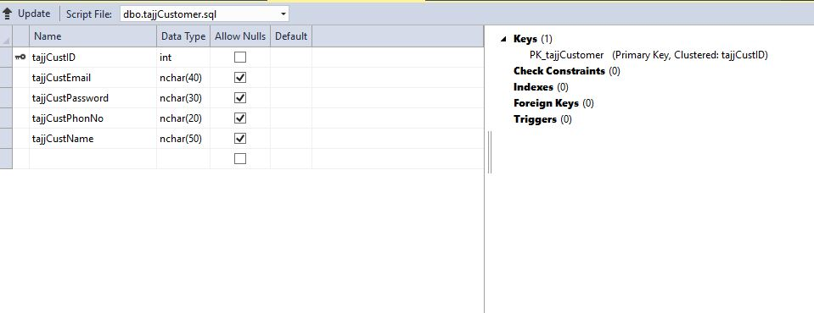
Table 6 3 3 Customers table

Bill table
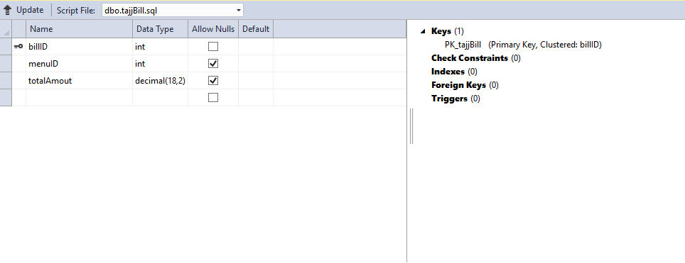
Table 6 3 4 Bill table

Menu table
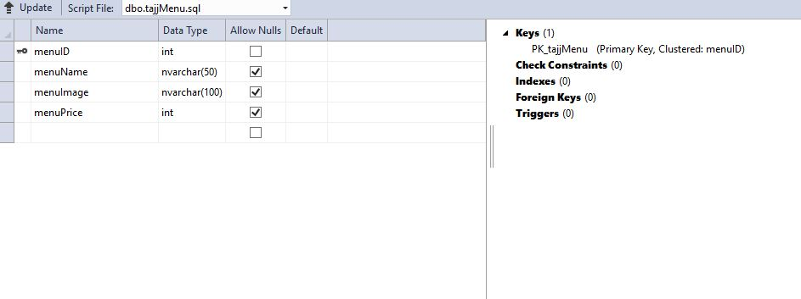

Table 6 3 5 Menu table

Chapter 7
Testing

Testing

Test case

Navigation Test

Home Page Navigation Test

Test Case #: Test Case 1 Test Case Name: Home Page Navigation Test
System: Restaurant Automation Subsystem: Navigation Home

Pre-conditions: Customer must have an internet connection.

Step | Action | Expected System Response | Fail/ Pass
1 | Click “Home” from any page. | Opens home page of the website. | Pass

Post-conditions User will be able to navigate to “Home” page.

Reserve Table Page Navigation Test
Test Case #: Test Case 2 Test Case Name: Reserve Table Page Navigation Test
System: Restaurant Automation Subsystem: Navigation Reserve table

Pre-condition: Customer must have to be logged in.

Step | Action | Expected System Response | Fail/ Pass
1 | Press the submit button. | Fill the text field to reserve the table. | Pass

Post condition:
User will navigate to “Menu Item” page.

Menu Item Page Navigation test
Test Case #: Test Case 3 Test Case Name: Menu Item Page Navigation Test
System: Restaurant automation system Subsystem: Navigation Menu item

Pre-conditions: None

Step | Action | Expected System Response | Fail/ Pass
1 | Selects “Menu items” in menu. | System shows the menu item that are available. | Pass

Post-conditions
User will navigate to “payment page”.

Sign up Page Navigation Test

Test Case #: Test Case 4 Test Case Name: Sign up Page Navigation Test
System: Restaurant automation system Subsystem: Sign up button on navigation bar

Pre-conditions: User must have to be log out from system.

Step | Action | Expected System Response | Fail/ Pass
1 | Selects “Sign up” button. | Sign up page will be open. | Pass

Post-conditions
Sign up page shows to the user.

Log in Page Navigation Test
Test Case #: Test Case 5 Test Case Name: Log in Navigation Page Test
System: Restaurant automation system Subsystem: Log in

Pre-conditions: User must have an account.

Step | Action | Expected System Response | Fail/ Pass
1 | Selects “Login” button. | Login page will be open. | Pass

Post-conditions
User successfully navigated to login page and view login form.

Test Cases for Input Fields

Test Case for Log in Input Fields

Test case 1

Test Case #: Test Case.1 Test Case Name: Sign in
System: Restaurant Automation System Subsystem: Sign in
Designed by: Muhamad Saran Design Date: 04/20/2018
Executed by: Nazish Yousaf Execution Date: 06/20/2018
Short Description: Test the Restaurant Automation log in service.

Pre-conditions: None

Step | Action | Expected System Response | Pass/ Fail | Comment
1 | Enter the correct email id.
2 | Enter the correct password.
3 | Click Sign in button. | The website successfully authenticates the user and main page of Restaurant Automation System will appear. | Pass

Post-conditions
User will be able to perform basic Restaurant Automation System website functions.

Test case 2

Test Case #: Test Case.2 Test Case Name: Sign in
System: Restaurant Automation System Subsystem: Sign in
Designed by: Muhamad Saran Design Date: 04/20/2018
Executed by: Nazish Yousaf Execution Date: 06/20/2018
Short Description: Test the Restaurant Automation log in service.

Pre-conditions: None

Step | Action | Expected System Response | Pass/ Fail | Comment
1 | Enter the correct email id.
2 | Enter the incorrect password. |  | Fail
3 | Click Sign in button. | The website should display an error message of “Incorrect password. Please try again”. | Fail

Post-conditions
User will be able to perform basic Restaurant Automation System website functions.

Test case 3

Test Case #: Test Case.3 Test Case Name: Sign in
System: Restaurant Automation System Subsystem: Sign in
Designed by: Muhamad Saran Design Date: 04/20/2018
Executed by: Nazish Yousaf Execution Date: 06/20/2018
Short Description: Test the Restaurant Automation log in service.

Pre-conditions: None

Step | Action | Expected System Response | Pass/ Fail | Comment
1 | Enter the incorrect email id.
2 | Enter the incorrect password.
3 | Click Sign in button. | The website should display an error message of “Incorrect Email id or password. Please try again”. | Fail

Post-conditions
User will be able to perform basic Restaurant Automation System website functions.

Test Case for Sign up Input Fields

Test case 1

Test Case #: Test Case.1 Test Case Name: Sign up
System: Restaurant Automation System Subsystem: Sign up
Designed by: Muhamad Saran Design Date: 04/20/2018
Executed by: Nazish Yousaf Execution Date: 06/20/2018
Short Description: Test the Restaurant Automation Sign up service.

Pre-conditions: None

Step | Action | Expected System Response | Pass/ Fail | Comment
1 | Enter the name. |  | Pass
2 | Enter the Email. |  | Pass
3 | Enter the Ph. No. |  | Pass
4 | Enter the Password. |  | Pass
5 | Reenter the Password. |  | Pass | Reenter the same password as above
6 | Click the Sign up button. | The website successfully register the user. | Pass

Post-conditions
User will be able to log in using their new account.

Test case 2

Test Case #: Test Case.2 Test Case Name: Sign up
System: Restaurant Automation System Subsystem: Sign in
Designed by: Muhamad Saran Design Date: 04/20/2018
Executed by: Nazish Yousaf Execution Date: 06/20/2018
Short Description: Test the Restaurant Automation Sign up service.

Pre-conditions: None

Step | Action | Expected System Response | Pass/ Fail | Comment
1 | Field is empty. |  | Fail
2 | Enter the Email. |  | Pass
3 | Enter the Ph. No. |  | Pass
4 | Enter the Password. |  | Pass
5 | Reenter the Password. |  | Pass | Reenter the same password as above
6 | Click the Sign up button. | The website should display an error message of “Please fill out the field. | Fail

Post-conditions
User will not be able to Sign up.

Test case 3

Test Case #: Test Case.3 Test Case Name: Sign up
System: Restaurant Automation System Subsystem: Sign in
Designed by: Muhamad Saran Design Date: 04/20/2018
Executed by: Nazish Yousaf Execution Date: 06/20/2018
Short Description: Test the Restaurant Automation Sign up service.

Pre-conditions: None

Step | Action | Expected System Response | Pass/ Fail | Comment
1 | Enter the name. |  | Pass
2 | Field is empty. |  | Fail
3 | Enter the Ph. No. |  | Pass
4 | Enter the Password. |  | Pass
5 | Reenter the Password. |  | Pass | Reenter the same password as above
6 | Click the Sign up button. | The website should display an error message of “Please fill out the field. | Fail

Post-conditions
User will not be able to Sign up.

Test case 4

Test Case #: Test Case.4 Test Case Name: Sign up
System: Restaurant Automation System Subsystem: Sign in
Designed by: Muhamad Saran Design Date: 04/20/2018
Executed by: Nazish Yousaf Execution Date: 06/20/2018
Short Description: Test the Restaurant Automation Sign up service.

Pre-conditions: None

Step | Action | Expected System Response | Pass/ Fail | Comment
1 | Enter the name. |  | Pass
2 | Enter the Email. |  | Pass
3 | Field is empty. |  | Fail
4 | Enter the Password. |  | Pass
5 | Reenter the Password. |  | Pass | Reenter the same password as above
6 | Click the Sign up button. | The website should display an error message of “Please fill out the field. | Fail

Post-conditions
User will not be able to Sign up.

Test case 5

Test Case #: Test Case.5 Test Case Name: Sign up
System: Restaurant Automation System Subsystem: Sign in
Designed by: Muhamad Saran Design Date: 04/20/2018
Executed by: Nazish Yousaf Execution Date: 06/20/2018
Short Description: Test the Restaurant Automation Sign up service.

Pre-conditions: None

Step | Action | Expected System Response | Pass/ Fail | Comment
1 | Enter the name. |  | Pass
2 | Enter the Email. |  | Pass
3 | Enter the Ph. No. |  | Pass
4 | Field is empty. |  | Fail
5 | Reenter the Password. |  | Pass | Reenter the same password as above
6 | Click the Sign up button. | The website should display an error message of “Please fill out the field”. | Fail

Post-conditions
User will not be able to Sign up.

Test case 6

Test Case #: Test Case.6 Test Case Name: Sign up
System: Restaurant Automation System Subsystem: Sign in
Designed by: Muhamad Saran Design Date: 04/20/2018
Executed by: Nazish Yousaf Execution Date: 06/20/2018
Short Description: Test the Restaurant Automation Sign up service.

Pre-conditions: None

Step | Action | Expected System Response | Pass/ Fail | Comment
1 | Enter the name. |  | Pass
2 | Enter the Email. |  | Pass
3 | Enter the Ph. No. |  | Pass
4 | Enter the Password. |  | Pass
5 | Field is empty. |  | Fail | Reenter the same password as above
6 | Click the Sign up button. | The website should display an error message of “Please fill out the field”. | Fail

Post-conditions
User will not be able to Sign up.

Test case 7

Test Case #: Test Case.7 Test Case Name: Sign up
System: Restaurant Automation System Subsystem: Sign in
Designed by: Muhamad Saran Design Date: 04/20/2018
Executed by: Nazish Yousaf Execution Date: 06/20/2018
Short Description: Test the Restaurant Automation Sign up service.

Pre-conditions: None

Step | Action | Expected System Response | Pass/ Fail | Comment
1 | Enter the name. |  | Pass
2 | Enter the Email. |  | Pass
3 | Enter the Ph. No. |  | Pass
4 | Enter the Password. |  | Fail
5 | Reenter the Password. |  | Fail | Reenter the same password as above
6 | Click the Sign up button. | The website should display an error message of “Password are not same”. | Fail

Post-conditions
User will not be able to Sign up.

Test case 8

Test Case #: Test Case.8 Test Case Name: Sign up
System: Restaurant Automation System Subsystem: Sign in
Designed by: Muhamad Saran Design Date: 04/20/2018
Executed by: Nazish Yousaf Execution Date: 06/20/2018
Short Description: Test the Restaurant Automation Sign up service.

Pre-conditions: None

Step | Action | Expected System Response | Pass/ Fail | Comment
1 | Enter the name. |  | Pass
2 | Enter the Email. |  | Fail
3 | Enter the Ph. No. |  | Pass
4 | Enter the Password. |  | Pass
5 | Field is empty. |  | Pass | Reenter the same password as above
6 | Click the Sign up button. | The website should display an error message of “This email already exists”. | Fail

Post-conditions
User will not be able to Sign up.

Test Case for Table Reservation Input Fields

Test case 1

Test Case #: Test Case.1 Test Case Name: Table Reservation
System: Restaurant Automation System Subsystem: Table Reservation
Designed by: Muhamad Saran Design Date: 04/20/2018
Executed by: Nazish Yousaf Execution Date: 06/20/2018
Short Description: Test the Restaurant Automation Table Reservation service.

Pre-conditions: User must be log in.

Step | Action | Expected System Response | Pass/ Fail | Comment
1 | Enter the Date. |  | Pass | Don’t select the date before today.
2 | Enter the Time. |  | Pass | Don’t select the time before current time.
3 | Enter the number of hours. |  | Pass
4 | Enter numbers of chairs. |  | Pass
5 | Enter “Submit” Button | User successfully navigate to the “Menu Item” Page. | Pass

Post-conditions
User will be able to navigate to the “Menu Item” Page.

Test case 2

Test Case #: Test Case.2 Test Case Name: Table Reservation
System: Restaurant Automation System Subsystem: Table Reservation
Designed by: Muhamad Saran Design Date: 04/20/2018
Executed by: Nazish Yousaf Execution Date: 06/20/2018
Short Description: Test the Restaurant Automation Table Reservation service.
.

Pre-conditions: User must be log in.

Step | Action | Expected System Response | Pass/ Fail | Comment
1 | Field is empty. |  | Fail | Don’t select the date before today.
2 | Enter the Time. |  | Pass | Don’t select the time before current time.
3 | Enter the number of hours. |  | Pass
 | Enter numbers of chairs. |  | Pass
 | Enter “Submit” Button | The website should display an error message of “Please fill the empty field”. | Fail

Post-conditions
User will not be able to navigate to the “Menu Item” Page.

Test case 3

Test Case #: Test Case.3 Test Case Name: Table Reservation System: Restaurant Automation System Subsystem: Table Reservation
Designed by: Muhamad Saran Design Date: 04/20/2018
Executed by: Nazish Yousaf Execution Date: 06/20/2018
Short Description: Test the Restaurant Automation Table Reservation service.

Pre-conditions: User must be log in.

Step | Action | Expected System Response | Pass/ Fail | Comment
1 | Enter the Date. |  | Pass | Don’t select the date before today.
2 | Field is empty. |  | Fail | Don’t select the time before current time.
3 | Enter the number of hours. |  | Pass
 | Enter numbers of chairs. |  | Pass
 | Enter “Submit” Button | The website should display an error message of “Please fill the empty field”. | Fail

Post-conditions
User will not be able to navigate to the “Menu Item” Page.

Test case 4

Test Case #: Test Case.4 Test Case Name: Table Reservation
System: Restaurant Automation System Subsystem: Table Reservation
Designed by: Muhamad Saran Design Date: 04/20/2018
Executed by: Nazish Yousaf Execution Date: 06/20/2018
Short Description: Test the Restaurant Automation Table Reservation service.

Pre-conditions: User must be log in.

Step | Action | Expected System Response | Pass/ Fail | Comment
1 | Enter the Date. |  | Pass | Don’t select the date before today.
2 | Enter the Time. |  | Pass | Don’t select the time before current time.
3 | Enter the number of hours. |  | Fail
 | Enter numbers of chairs. |  | Pass
 | Enter “Submit” Button | The website should display an error message of “Please fill the empty field”. | Fail

Post condition:
User will not be able to navigate to the “Menu Item” Page.

Test case 5

Test Case #: Test Case.5 Test Case Name: Table Reservation
System: Restaurant Automation System Subsystem: Table Reservation
Designed by: Muhamad Saran Design Date: 04/20/2018
Executed by: Nazish Yousaf Execution Date: 06/20/2018
Short Description: Test the Restaurant Automation Table Reservation service.

Pre-conditions: User must be log in.

Step | Action | Expected System Response | Pass/ Fail | Comment
1 | Enter the Date. |  | Pass | Don’t select the date before today.
2 | Enter the Time. |  | Pass | Don’t select the time before current time.
3 | Enter the number of hours. |  | Pass
 | Enter numbers of chairs. |  | Fail
 | Enter “Submit” Button | The website should display an error message of “Please fill the empty field”. | Fail

Post-conditions
User will not be able to navigate to the “Menu Item” Page.

Test case 6

Test Case #: Test Case.6 Test Case Name: Table Reservation
System: Restaurant Automation System Subsystem: Table Reservation
Designed by: Muhamad Saran Design Date: 04/20/2018
Executed by: Nazish Yousaf Execution Date: 06/20/2018
Short Description: Test the Restaurant Automation Table Reservation service.

Pre-conditions: User must be log in.

Step | Action | Expected System Response | Pass/ Fail | Comment
1 | Enter the Date. |  | Fail | Don’t select the date before today.
2 | Enter the Time. |  | Pass | Don’t select the time before current time.
3 | Enter the number of hours. |  | Pass
 | Enter numbers of chairs. |  | Pass
 | Enter “Submit” Button | The website should display an error message of “Selected date is not valid”. | Fail

Post-conditions
User will not be able to navigate to the “Menu Item” Page.

Test Case for Table Reservation Input Fields

Test case 1

Test Case #: Test Case.1 Test Case Name: Menu Item
System: Restaurant Automation System Subsystem: Menu Item
Designed by: Muhamad Saran Design Date: 04/20/2018
Executed by: Muhamad Saran Execution Date: 06/20/2018
Short Description: Test the Restaurant Automation Menu Item service.

Pre-conditions: User must be log in.

Step | Action | Expected System Response | Pass/ Fail | Comment
1 | Check the menu items. |  | Pass
2 | Select the quantity. |  | Pass
3 | Get Total |  | Pass
 | Enter “Submit” Button | The website should display a Payment page. | Pass

Post-conditions
User will not be able to navigate to the “Payment” Page.

Test case 2

Test Case #: Test Case.2 Test Case Name: Menu Item
System: Restaurant Automation System Subsystem: Menu Item
Designed by: Muhamad Saran Design Date: 04/20/2018
Executed by: Nazish Yousaf Execution Date: 06/20/2018
Short Description: Test the Restaurant Automation Menu Item service.

Pre-conditions: User must be log in.

Step | Action | Expected System Response | Pass/ Fail | Comment
1 | Don’t Check the menu items. |  | Fail
2 | Select the quantity. |  | Pass
3 | Get Total |  | Pass
 | Enter “Submit” Button | The website should display a message “Please select the menu”. | Fail

Post conditions:
User will not be able to navigate to the “Payment” Page.

Test case 3

Test Case #: Test Case.3 Test Case Name: Menu Item
System: Restaurant Automation System Subsystem: Menu Item
Designed by: Muhamad Saran Design Date: 04/20/2018
Executed by: Nazish Yousaf Execution Date: 06/20/2018
Short Description: Test the Restaurant Automation Menu Item service.

Pre-conditions: User must be log in.

Step | Action | Expected System Response | Pass/ Fail | Comment
1 | Check the menu items. |  | Pass
2 | Don’t Select the quantity. |  | Fail
3 | Get Total |  | Pass
 | Enter “Submit” Button | The website should display a message “Please select the Quantity”. | Fail

Post conditions:
User will not be able to navigate to the “Payment” Page.

Compatibility Testing

Google Chrome
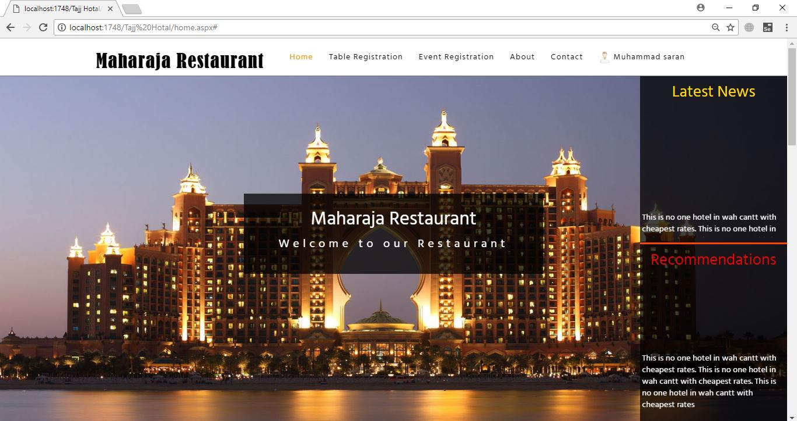

Internet Explore
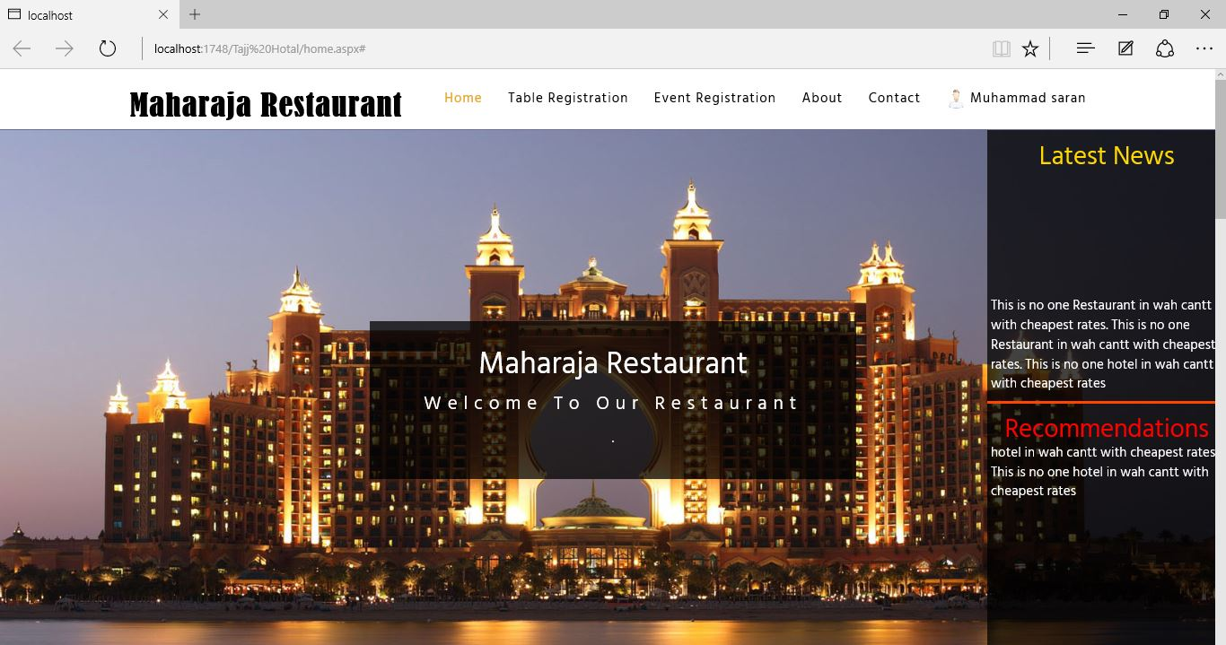

- Mozilla Firefox

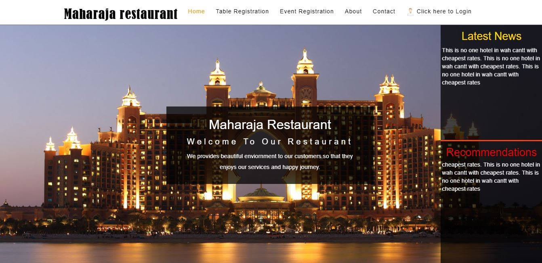

User Manual

User Manual
This section shows latest news about the restaurant
Users of System:
1. Customers
2. Admin

Main page of website:
This text box shows recommendations to customers
Section No.1 having links of different pages

Section2
When user clicks on the table reservation link it shows this form that user must have to fill.to reserve the table
Section 2 is the web page which will appear which is given.
Reservation date
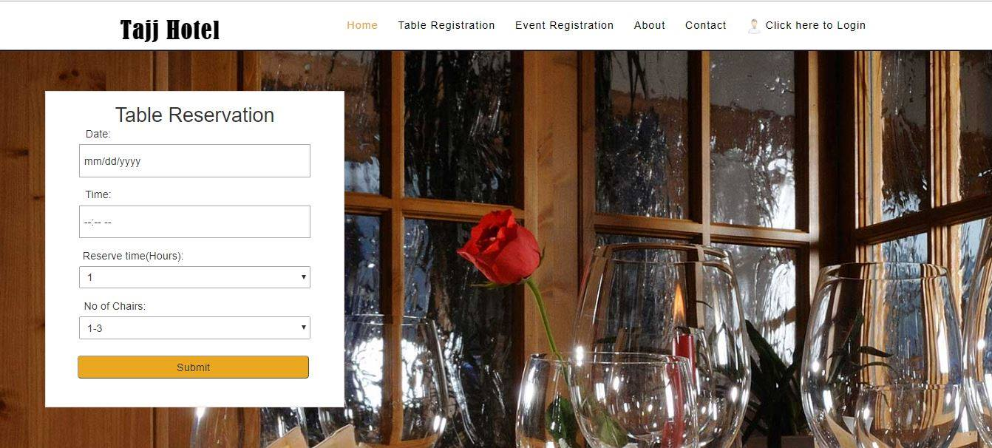
This link have table reservation form when user click on it shows form that user must have to fill to reserve the table
Reservation time
No of chairs that user wants
Submit button to

Section 3
When user clicks on the event reservation link it shows this form that user must have to fill. to reserve the event
Event reservation link on the home page
Section 2 is the web page which will appear which is given.

Section 2.2 is the web page which will appear is given.
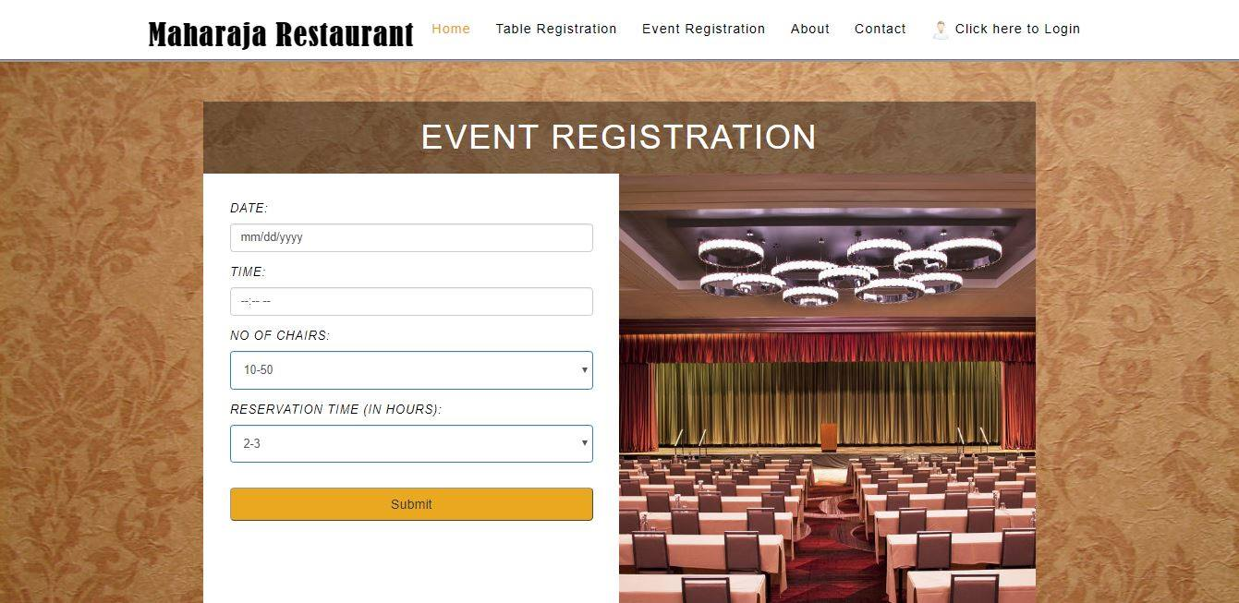
Event reservation form
Reservation time
Time of the reservation
Reservation time
Section 4 (IMPAIRED BOTH).
This link shows information about the restaurant and important details for the ease of customers
Information about the restaurant the web page which will appear is given.

Section contact
This link has contacts of the restaurant management and address of the restaurant
When user clicks on the contacts link it shows address and contacts of the restaurant and management.

Section sign up
When new user visits the web site and want to reserve the table it has to make an account .the given page is showing sign up form
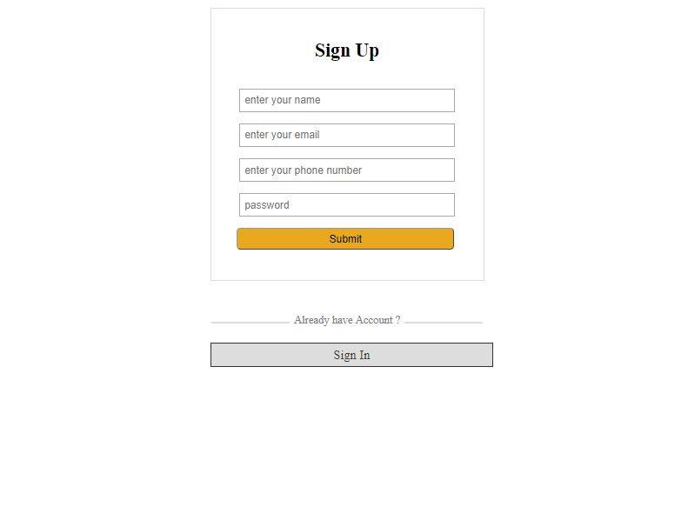
User name
User active email
Users cell no
User password
Submit button to submit the details
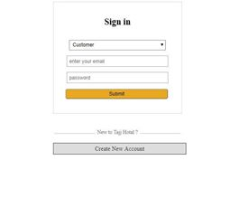
Account type, customer or admin
Password
Email of the user

Menu items
When user sign-in in the account then this form is shown to customer that contains menu items and recommended items
Items that are most purchased by customer.

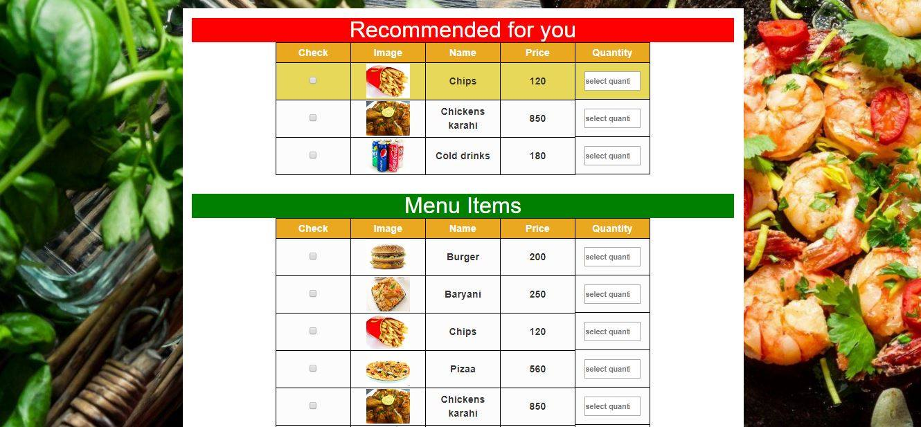
Items that restaurant have for the customers
References
- http://www.pennquarter.citytap.com/gallery.php
- http://southernbellybbq.com/catering/
- https://marlowesf.com/about/
- http://www.costavida.com/menu/
- http://www.pixel-industry.com/html/royal-plate/#

