Devoe Partners

CS261- Mid Term Project Report



**Project Supervisor**

**Sir. Samyan Wahla**

Project Members (CS261F22PID42)

Muhammad Talha 2021-CS-22

Syed Ahsan 2021-CS-37

Bilal Basharat 2021-CS-55

Department of Computer Science

University of Engineering and Technology

Lahore, Pakistan

**Table of Contents**

**1 Overview:**4

1.1 Project’s Description 4

1.2 User’s Requirements 4

**5 Recommendations:**26

5.1 Loading large amount of data in datagridview: 26

5.2 The user profile section: 26

**4 Repository:**27

**1 Overview:**

# 

## **1.1 Project’s Description**

Devoe partners, desktop application, holds the data for sale, and for rental proprties.. This is no less than Zameen.com. User have facilities of

* buy property
* publish add for sale
* search property for rent
* View all adds.
* View adds on different ranges
* Able to sort on base of required property

As in most of the desktop applications Devoe partners also emphasize on signup first before use. After this requirement, now the user can move forward towards the login page. Now, you are on commercial page of your own need. Here Devoe partners offers multiple business options to user. Main purpose of this application is to make the flow of business smooth. We are doing this by offering the same opportunities for clients and for agency states.

## **1.2 User’s Requirements**

To make the smooth flow of business Devoe partners offers couple of options to user. We have provided the maximum whereabouts about a property on 7 different bases.

1. Agency
2. Type
3. Price
4. Location
5. Area
6. Purpose
7. Contact

* **Welcome Screen**

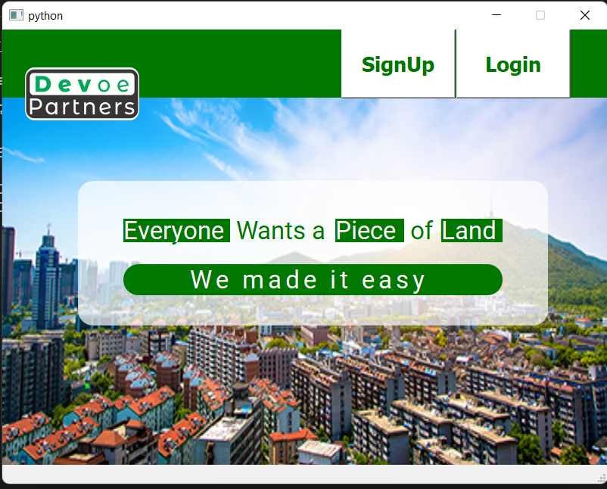

* **Sign In Screen**

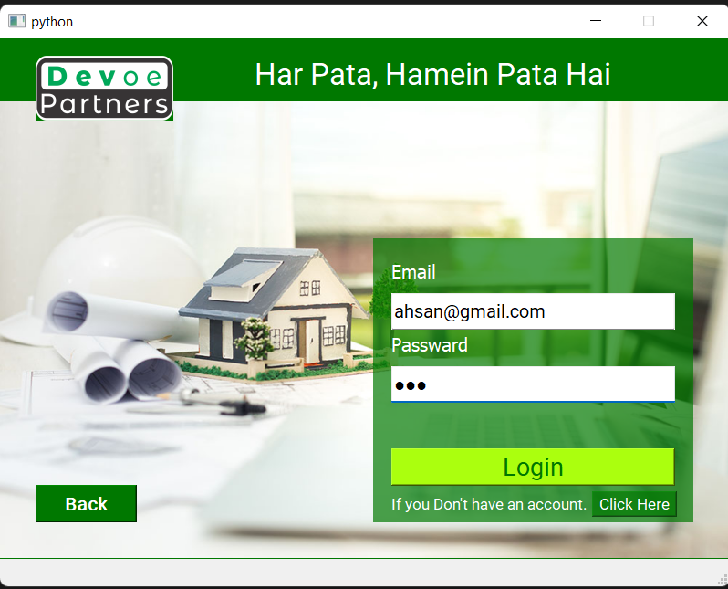

* **User Dashboard**

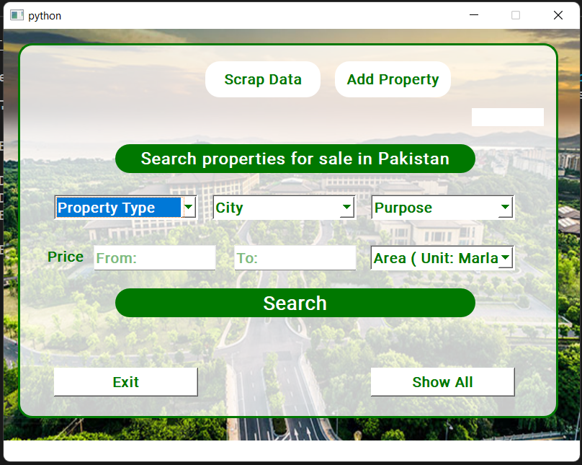

* **Specific Search Data**
* **Specific Search Data**

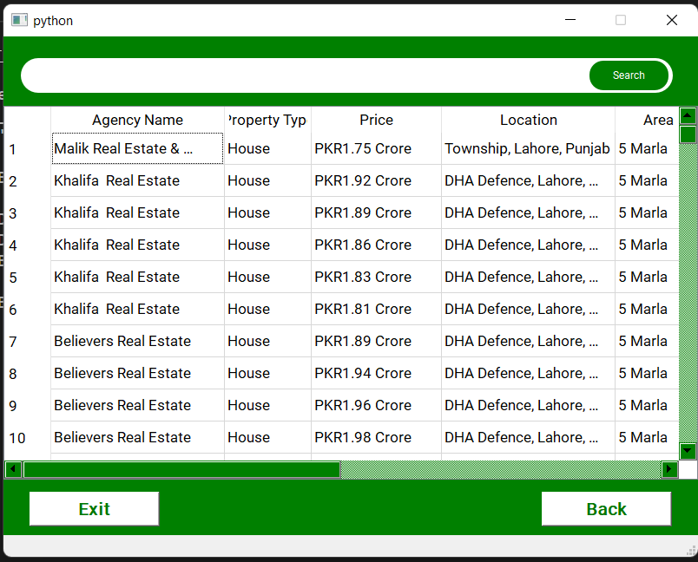

* **All Users Data (with sorting algorithms)**

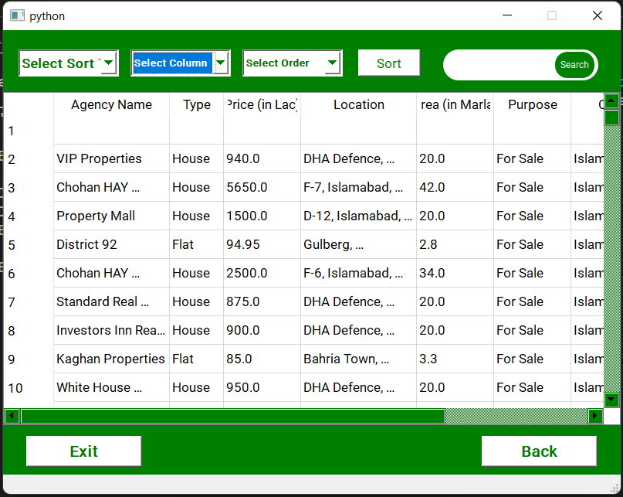

* 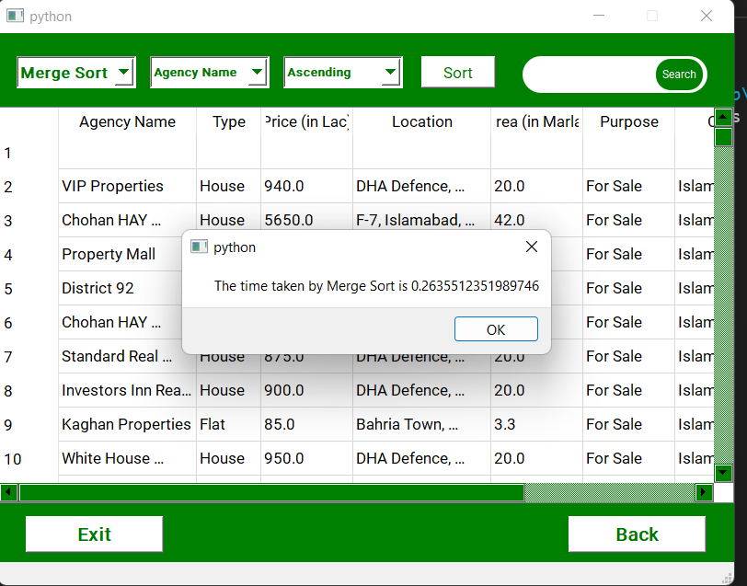**Screen showing algorithm sorting time**