GIT and GITHUB

# Git:

Version Control System is a tools that helps to track changes in code or our project .

Git is a version Control System and it is popular ,free & open Source , fast & scalable .

Git used for primary 2 things :

* **1) To track the history of our code**
* **2) To collaborate with other programmers on project**

# Github:

Website that allows developers to store and manage their code using Git.

We can upload all our work that we have done all the projects and code to a online website which is github and we upload our pics and videos on Instagram etc .

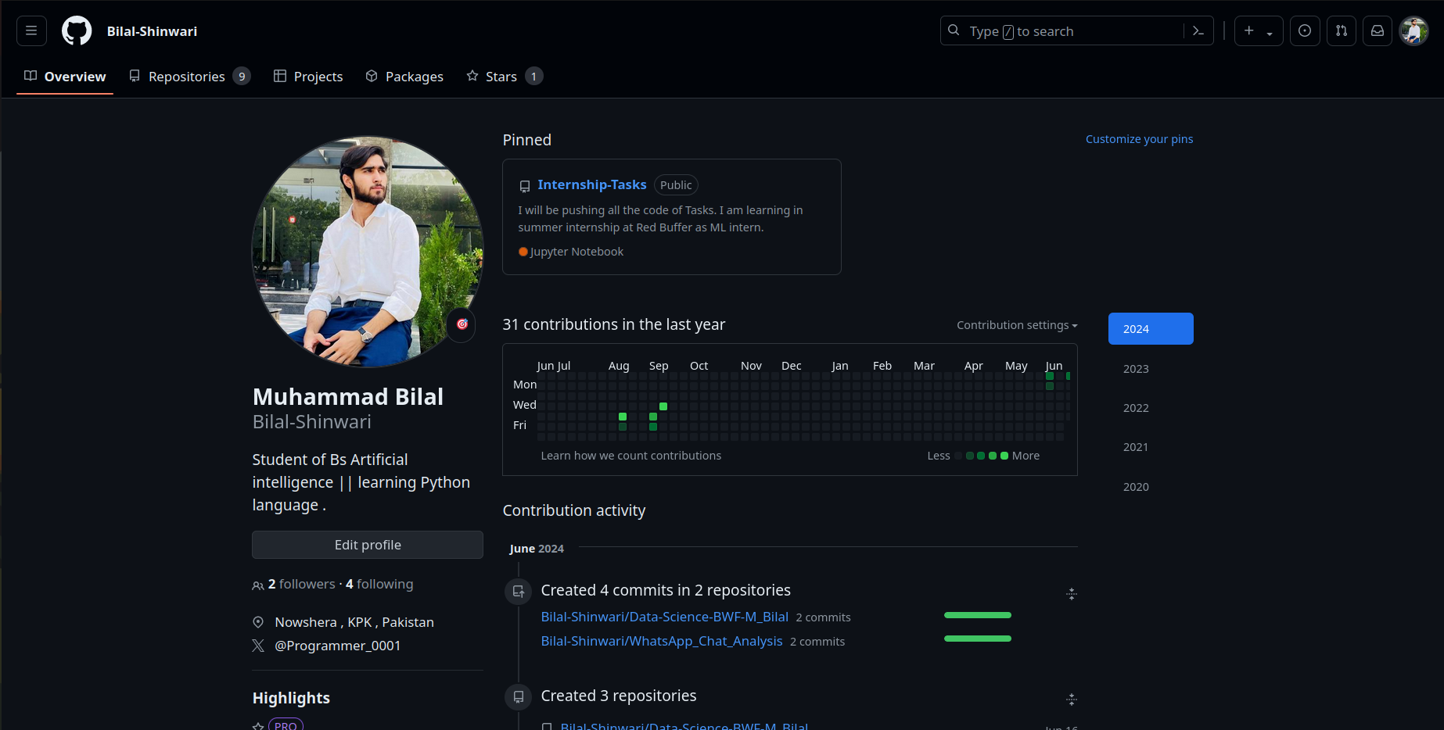

# Github Repository:

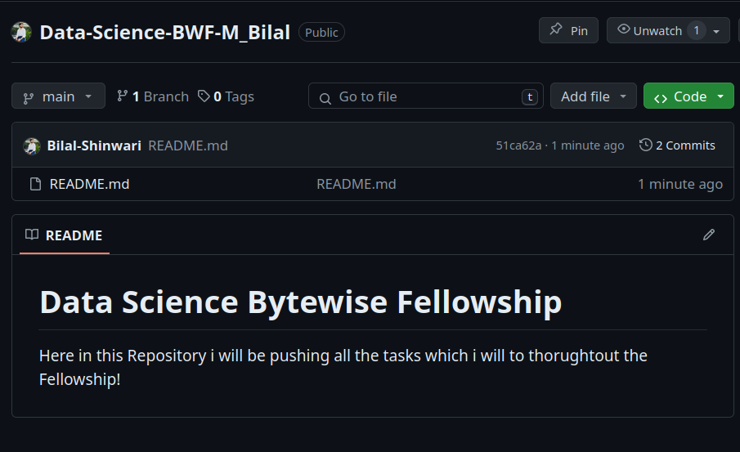

# Configuring Git:

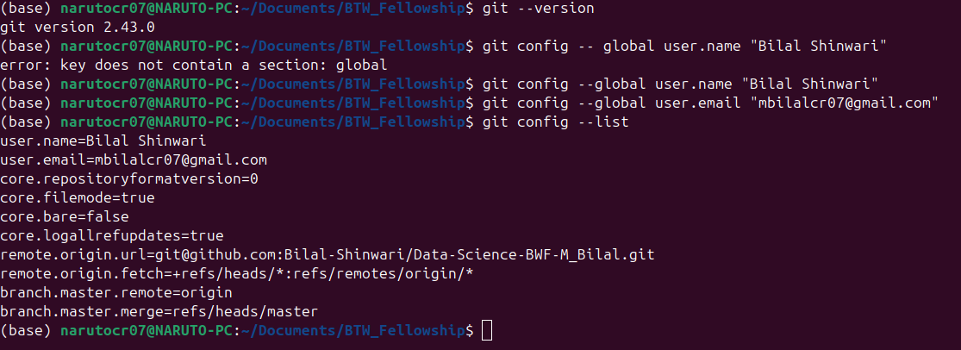

# Git Clone & Status:

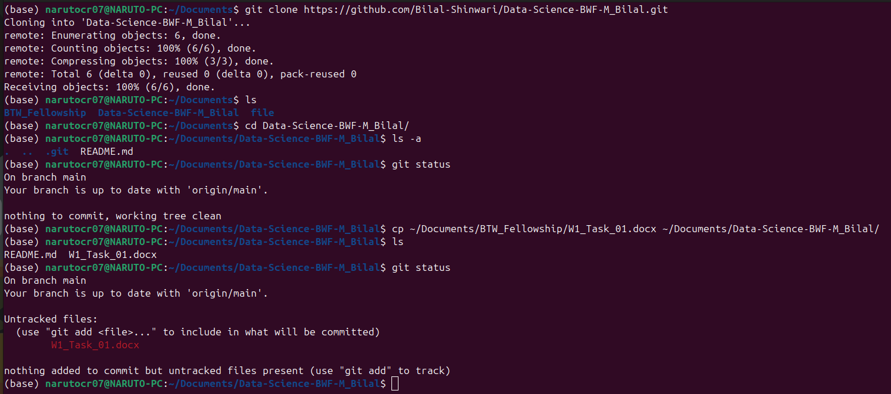

**Clone –** Cloning a repository on our local machine.

**Status -**  Displays the state of the code

we have four states in which the files can be:

untracked: new files that git doesn't yet track

modified: changed

staged: file is ready to be committed

unmodified: unchanged

# Git Add and Commit:

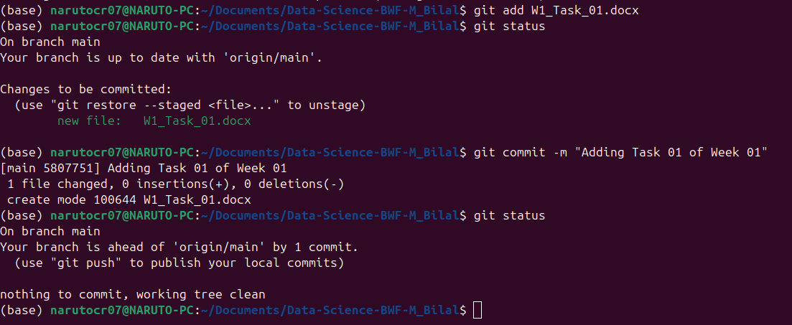

**Add –** adds new or changed files in your working directory to the Git staging area.

**Commit –** it is the record of change or it means to save the changes.

# Git Push:

Upload local repository content to remote repository

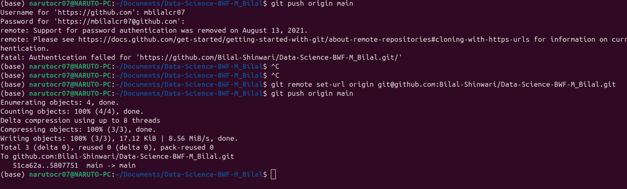

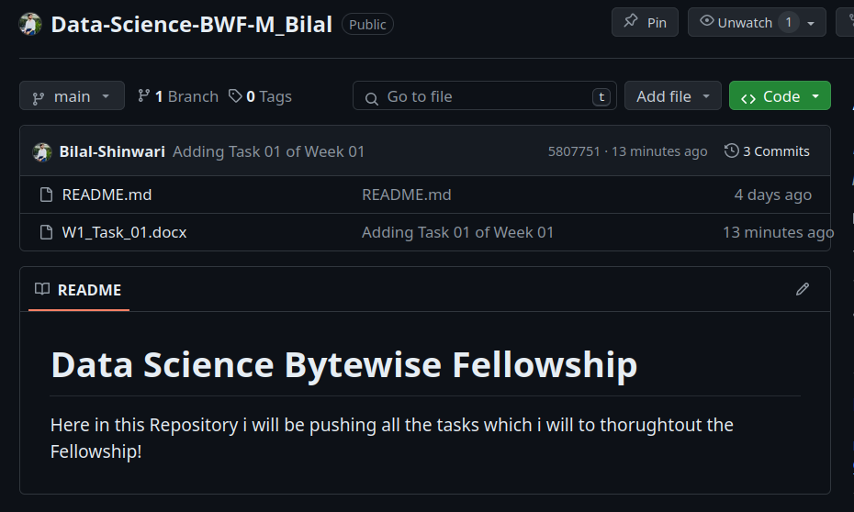

# Git Init:

Used to create a new git repository but it will be local repo.



To push that local repository to remote repository so first we have to set the remote repo link and we can do it with following command.

* **git remote add origin <link>**
* **git remote -v (to verify remote)**
* **git branch (to check branch)**
* **git branch -M main (to rename branch)**
* **git push origin main**

# Branch Commands:

* git branch (to check branches)
* git branch -M <new name of branch> (to rename branch)
* git checkout -b <branch name> (to create new branch)
* git checkout <branch name> (to navigate to that branch)
* git branch -d <branch name> (to delete branch)

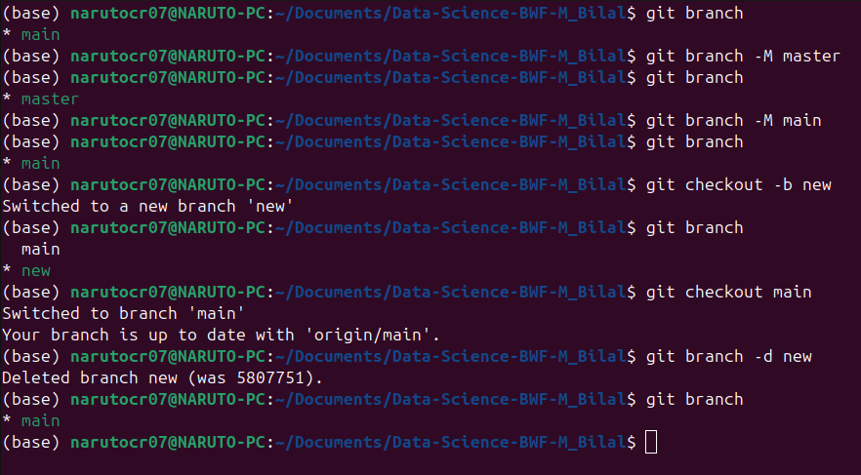

# **Merging Code:**

Way 1:

git diff <branch name > (to compare commits,branches,files & more)

git merge <branch name> (to merge 2 branches)

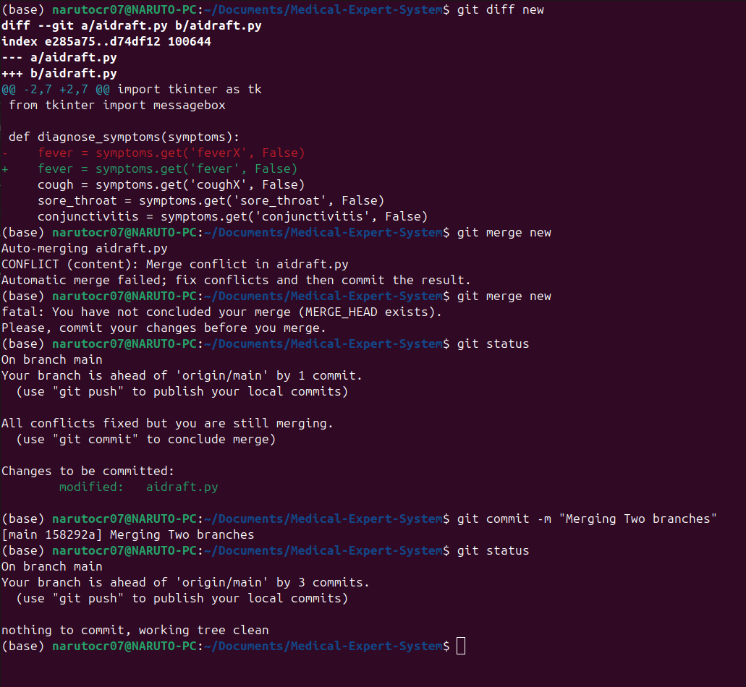

Way 2:

create a PR (Pull Request in the Github) – it lets you tell others about changes you’ve pushed to a branch in a repository on GitHub.

# Pull Command:

git pull origin main

Used to fetch and download content from a remote repo and immediately update the local repo to match that content.

# Undoing changes:

Case 1: staged changes

* git reset <file name>
* git reset (if we have more then one file)

Case 2: committed changes (for one commit)

* git reset HEAD~1

Case 3: committed changes (for many commits)

* git reset <commit hash>
* git reset –hard <commit has> (hard means that reset the chages in vs-code also not only in git )

# Fork:

It is a new repository that shares code and visibility settings with the original “upstream” repository

fork is a rough copy and I can be done in github.

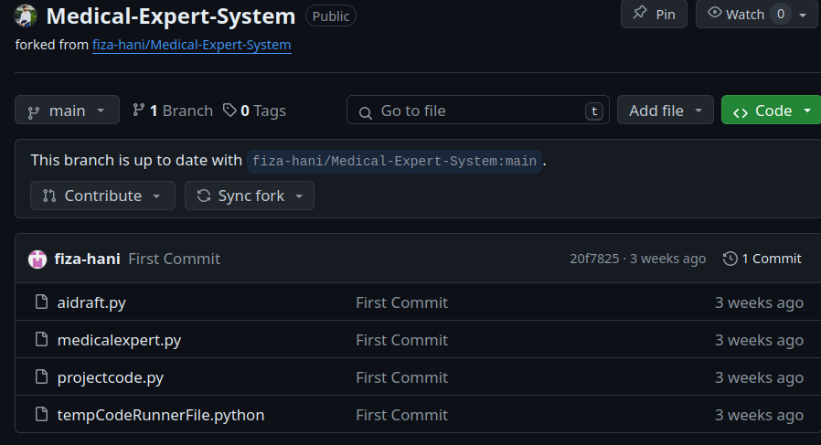

# Ignoring:

Preventing unintentional staging or committing of files.

So we have to make .gitignore file and we have to put all the files in that which we don’t want to commit.

